Module Name: Learning in the Digital Era
Module Code: ACCA4025

Student Name: BEREN EREN
Student ID: 2525363
Group: 2

Lecturer`s Name: Koushik Modak

Link to e-portfolio: https://2525363beren.wixsite.com/e-portfolio-creator
University of Wales Trinity Saint David
London Campus

ACCA4025
Learning in the Digital Era
Assignment 1: E-Portfolio

Table of Contents
Introduction 3
Task 1: Written summary 3
a) Written summary 3
b) Reflection 5
Task 2: Mind Map and Academic poster 6
a) Team Activity 6
b) Professional Academic poster 7
Task 3: Automatic Referencing tool 7
a) Unit 3 Topic summary 8
b) RefWorks utilisation 8
Task 4: e-Portfolio creation and review 12
a) e-Portfolio creation 12
b) Reason for use 16
Conclusion 16

Link to e-portfolio: https://2525363beren.wixsite.com/e-portfolio-creator
Screenshot of homepage:
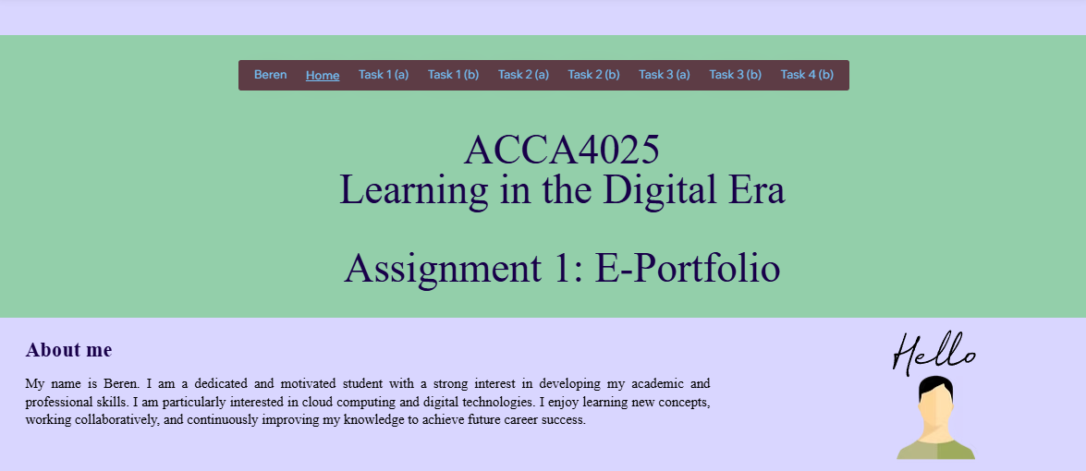

Introduction
In today`s digital age, technology plays a major role in shaping how people and organizations work and communicate. One of the most important developments in this area is cloud computing, which allows users to access data and services anytime and from anywhere. This has made it easier for businesses and educational institutions to operate more efficiently and stay connected. This assignment focuses on cloud computing, looking at how it is used and why it has become so important. It will discuss its role in improving collaboration, communication, and productivity, as well as the skills required to use it effectively and some of the challenges that come with it.

Task 1: Written summary

a) Written summary
Cloud computing is considered as an important aspect regarding the recent information technology (IT) industry. Cloud computing supports different types of services like extensive computing, application hosting and data storage with the help of internet-supported platforms. In order to ensure an effective career regarding cloud computing, a combination of professional, academic and technical skills needs to be developed by the students at the time of their academic career [1]. This type of development ensures the adoption towards modern day evolution in the technology environment after graduation by the individuals, making them skilful towards employment. An effective skill regarding cloud computing is technology and cloud platform related technical knowledge [2]. Concepts like cloud architecture, networking, security and virtualization need to be understood by the professionals while working in a company after graduation [3].

Figure 1: Cloud computing platforms [2]
Graduates must also understand and be familiar with popular service providers of cloud computing like Google Cloud Platform, Microsoft Azure and Amazon Web Services (AWS), for effective deployment, management and designing of cloud related solutions. Scripting and programming skills related development like learning about a definite language also helps in cloud process automation [4]. Learning about Java or Python programming language helps in effectively managing the infrastructures that are necessary while undertaking responsibility in a multinational company.
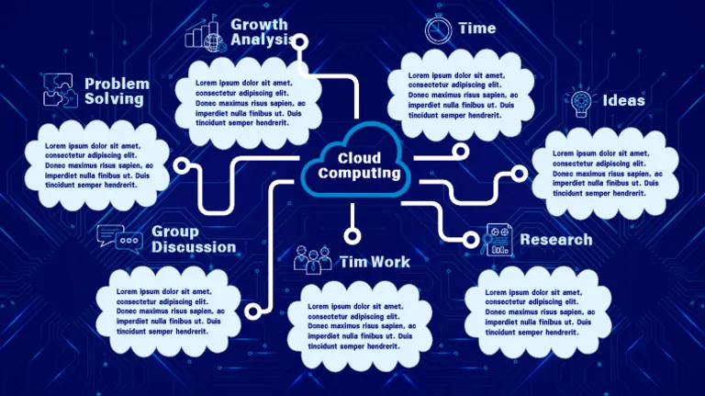
Figure 2: Cloud computing benefits [5]
Analytical thinking and problem solving are other types of skills that are necessary to be developed by the individuals at the time of their graduation. This type of skills further helps the cloud engineers to solve complex challenges and technical issues in their work places that focus on performance issues, security risks and system failures [5]. Teamwork and communication skills development at the time of graduation are also necessary while dealing with complex projects of cloud computing, specifically in the job environment supporting the chosen career.

b) Reflection
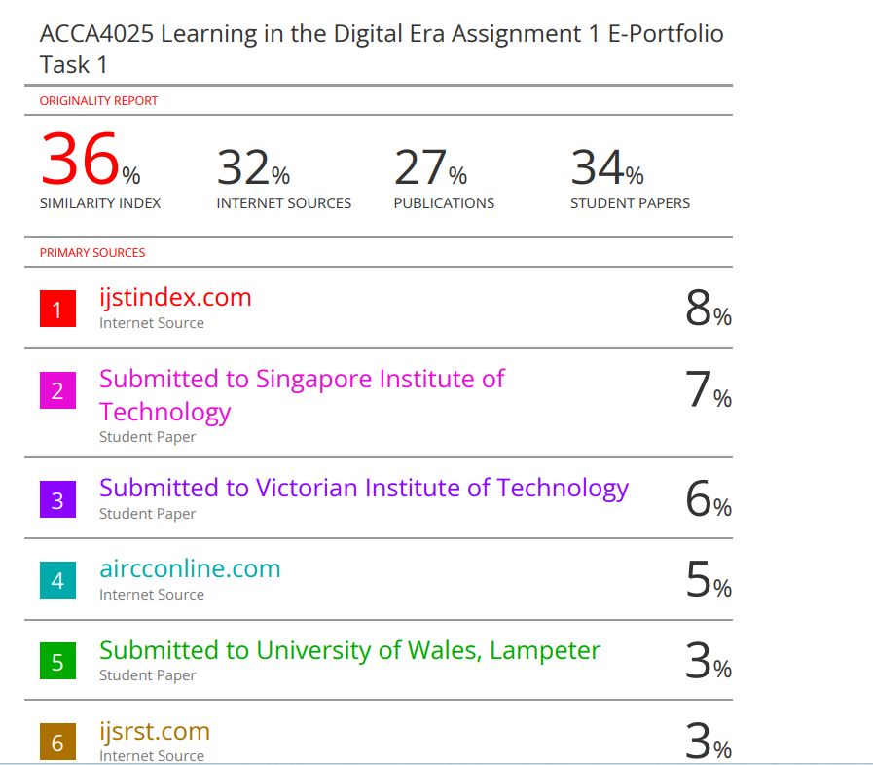
Figure 3: Similarity score
I believe this 36% similarity is acceptable because it mainly appears in the reference list, and it is reflecting properly cited sources rather than copied content. Regardless of the score being acceptable and relatively low to consider as plagiarism, I must focus on sources to be properly cited and academic phrases. This type of similarity score has majorly come from references. But in the future, I need to improve my paraphrasing skills by borrowing ideas from other articles and websites and clearly utilising my own words in order to improve my writing.
Considering the GAC (Generic Assessment Criteria) as a guidance, 68% would be awarded by myself to me as I have understood the topic and utilised credible references with proper structuring while writing about the written summary.

Task 2: Mind Map and Academic poster

a) Team Activity
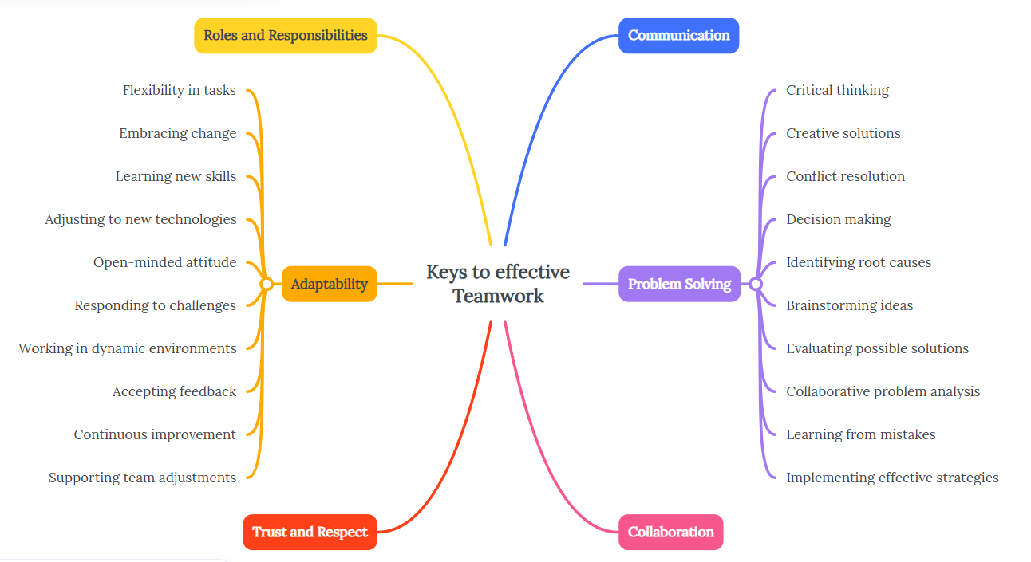Mindmeister link to continue the group work: https://mm.tt/map/3962976550?t=7Wq6E7pt8T

b) Professional Academic poster
Poster Link: https://2525363beren.wixsite.com/my-site-1
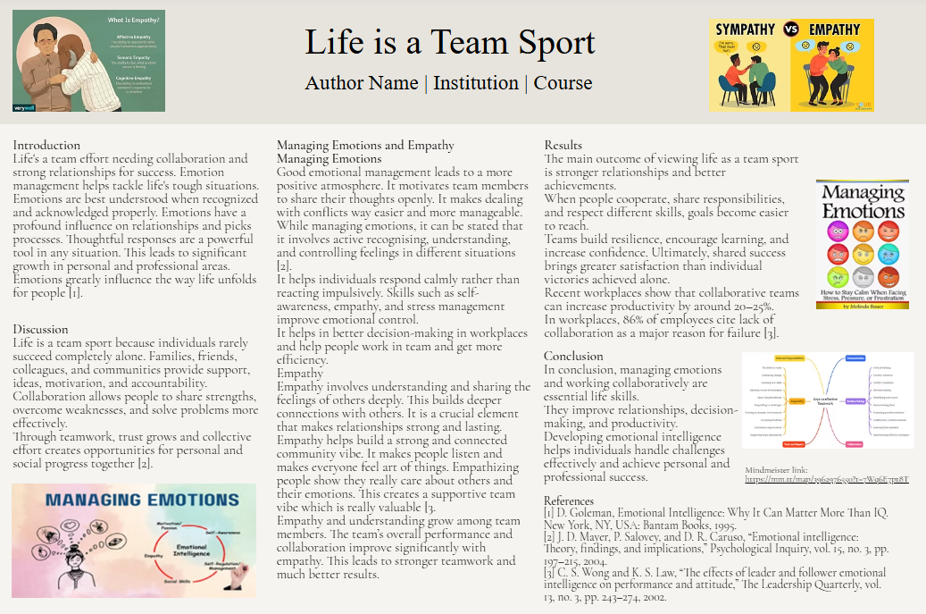

Task 3: Automatic Referencing tool

a) Unit 3 Topic summary
From different topics from Unit 3, the “Topic 1: Forming a team” has been considered. For effective teamwork development, formation of a team is necessary, specifically considering the correct word places where it is necessary for virtual collaboration among the employees [6]. Team formation process mainly indicates bringing every individual together from different types of experience, background and skills to a definite goal or objective. Considering both professional and academic environments this helps in effective collaboration among the individuals and is necessary for any type of problem solving or execution [7]. According to the present research, team dynamics in a virtual basis indicates the influence of interaction, sharing and communication by team members' behaviours and personal characteristics at the time of remote working situation. Communication among virtual teams mainly focuses on digital technologies like collaborative tools, video conferencing and platforms for messaging [8]. Due to hindrance in face-to-face interaction among the team members, virtual team dynamics is necessary to maintain shared expectations, proper communication and transparency at the process of team formation.
The development of the team over the period of time is also highlighted by Tuckman’s team development stages. According to the research, the model indicates 5 different stages as forming, norming, storming, adjourning and performing. These types of stages are necessary in order to identify the roles and to allocate responsibilities to the different team members as per their credibility. This also helps in ensuring a positive and open relationship among the individual, leading to efficient teamwork foundation in the future stages. Formation of the team also helps through different types of communication channels, reducing confusion and complexity among the team members [9]. This helps to develop a collaborative and associative environment of working for every member, making them feel extremely comfortable to work even in remote settings. Team formation is therefore identified as an initial and major step towards the effective collaboration among the employees. Formation of a team not only helps in identifying about the roles of the individuals from the initial stage but also ensures clear communication and trustworthiness in the organisation [10]. This helps in seamless running of the company or even in cases of academic projects working different types of teams virtually in the current scenario.

b) RefWorks utilisation
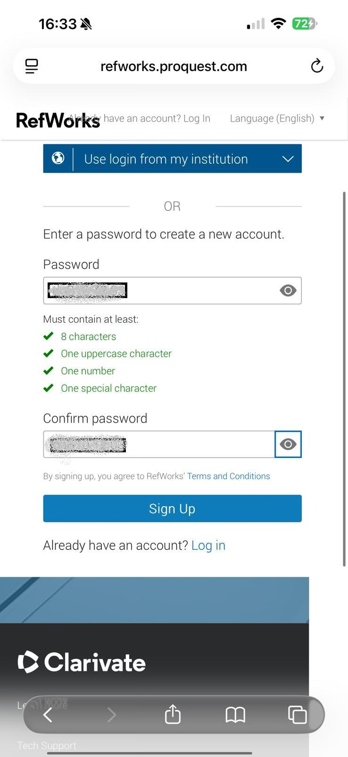
First, I had to login to the RefWorks site by utilising the university ID and Password in order to gain access and add it to Ms Word.
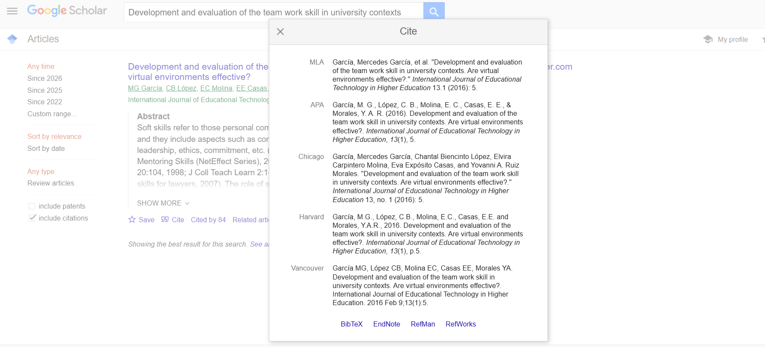
Then credible references are searched in Google scholar by using keywords and are imported to RefWorks by clicking on the link below.
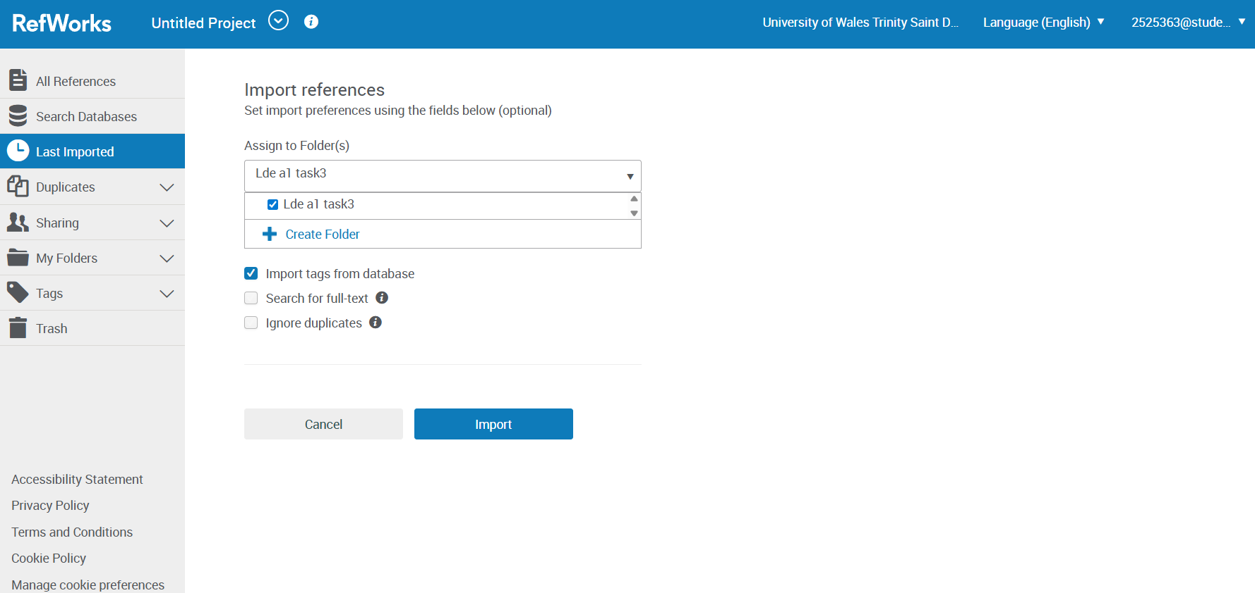
The definite folder as “Lde a1 task3” is selected to import the references one by one. This is to further utilise it directly in Ms word for the automatic referencing.
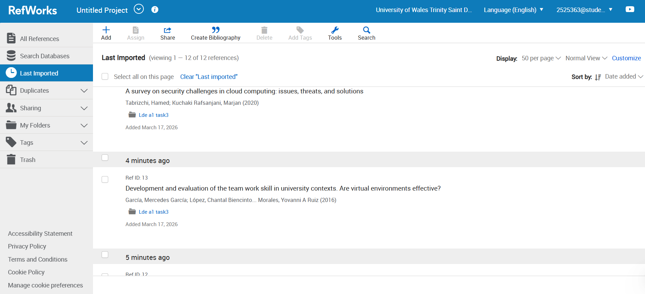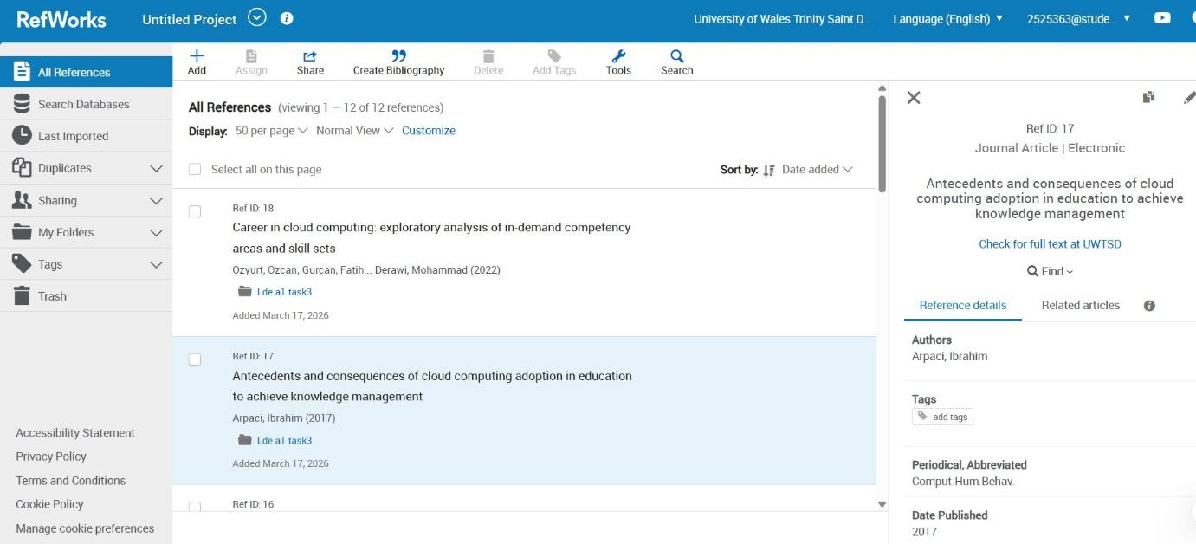
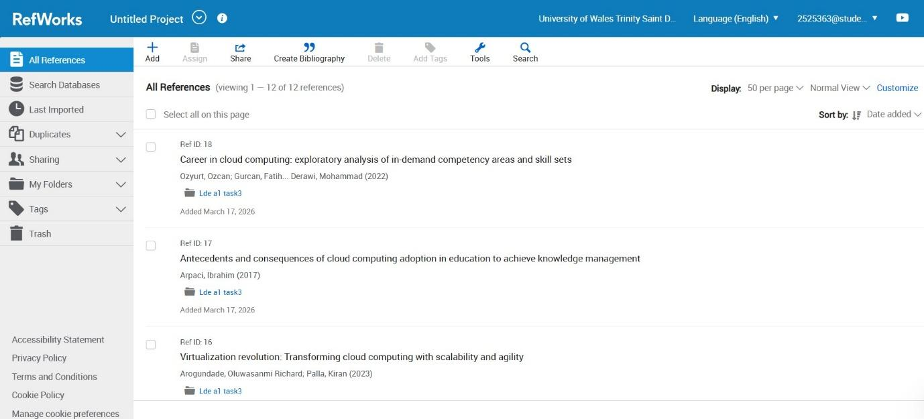
The imported reference list has been accessed from the “Last Imported” tab on the RefWorks website.
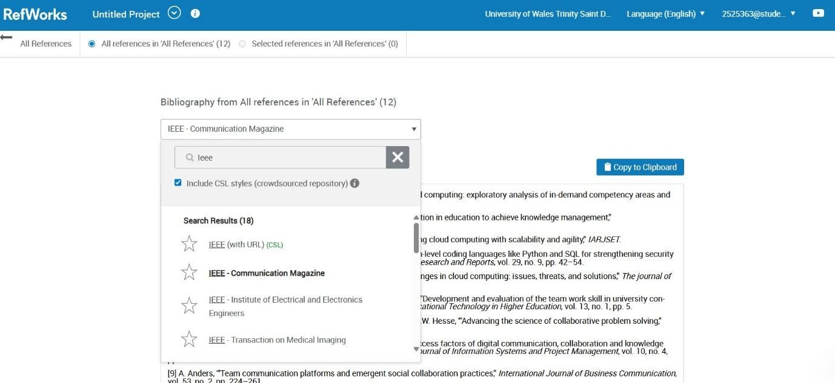
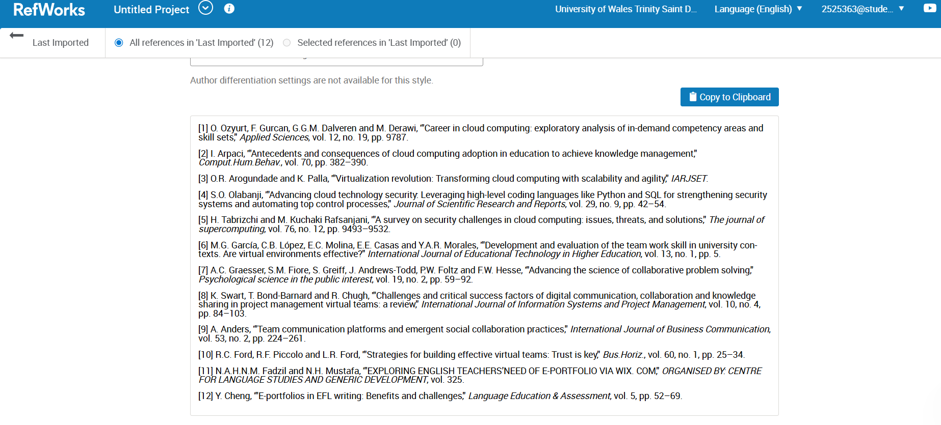
The reference list is further copied by using the “Copy to Clipboard” option and pasted in the Ms Word document and on the e-portfolio platform.

Task 4: e-Portfolio creation and review

a) e-Portfolio creation
Link to e-portfolio: https://2525363beren.wixsite.com/e-portfolio-creator
Screenshots of the e-portfolio:
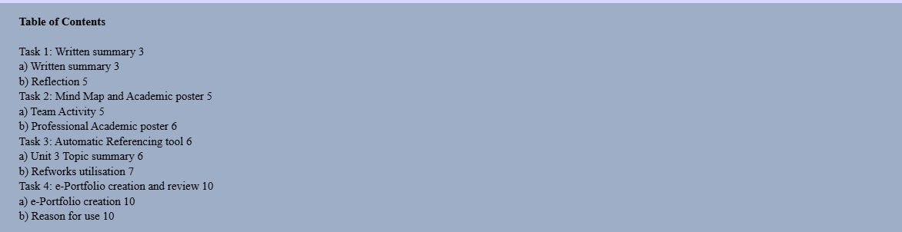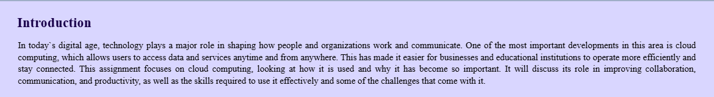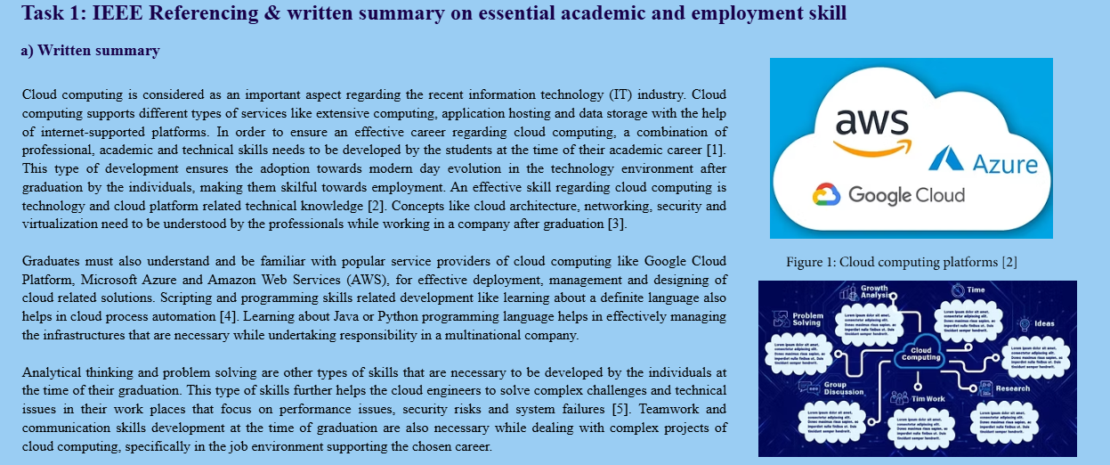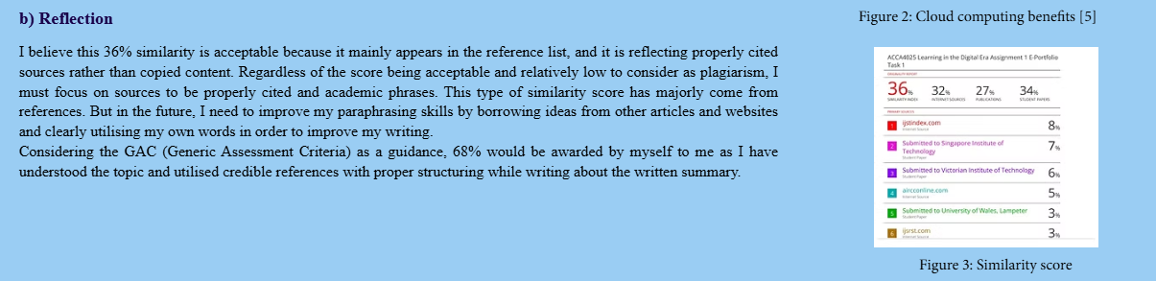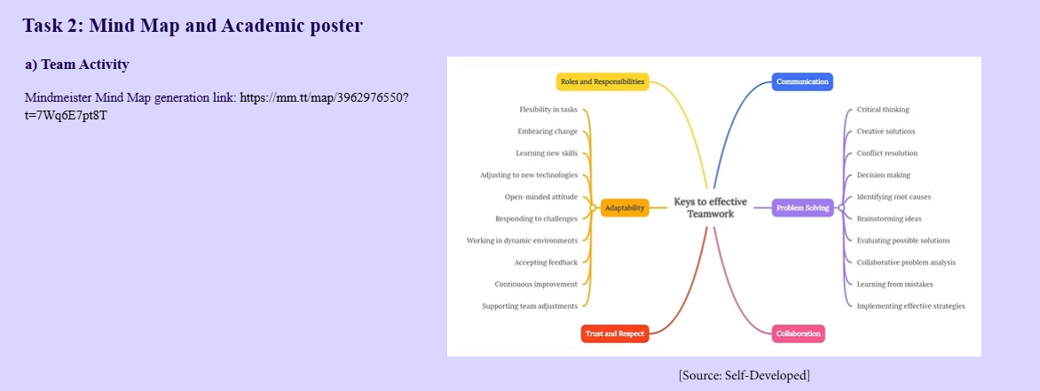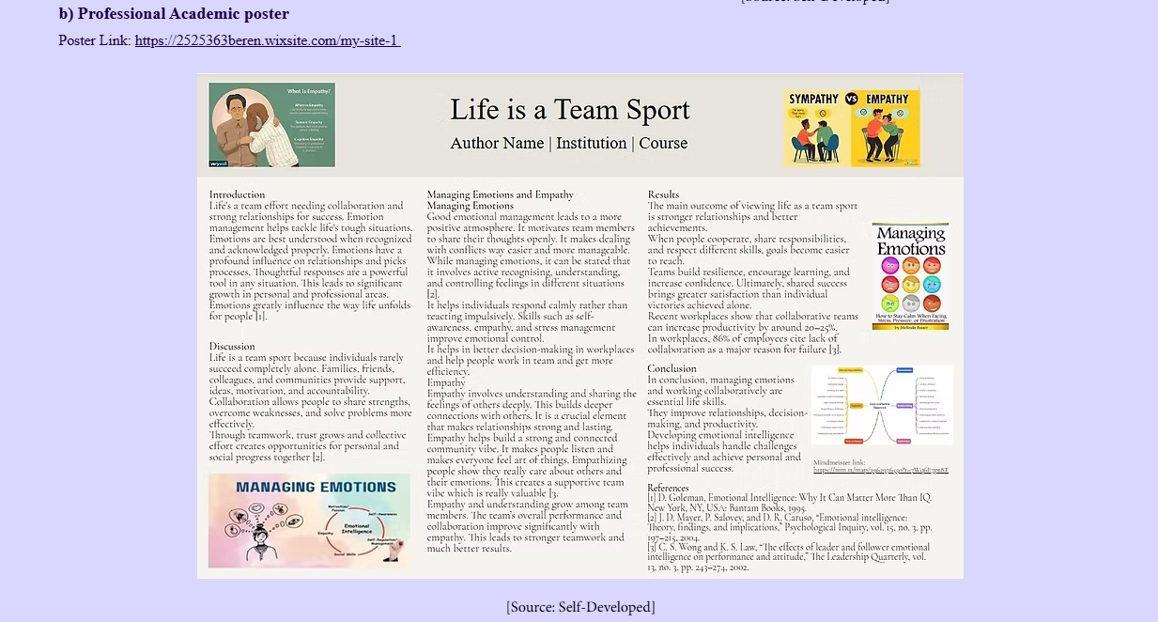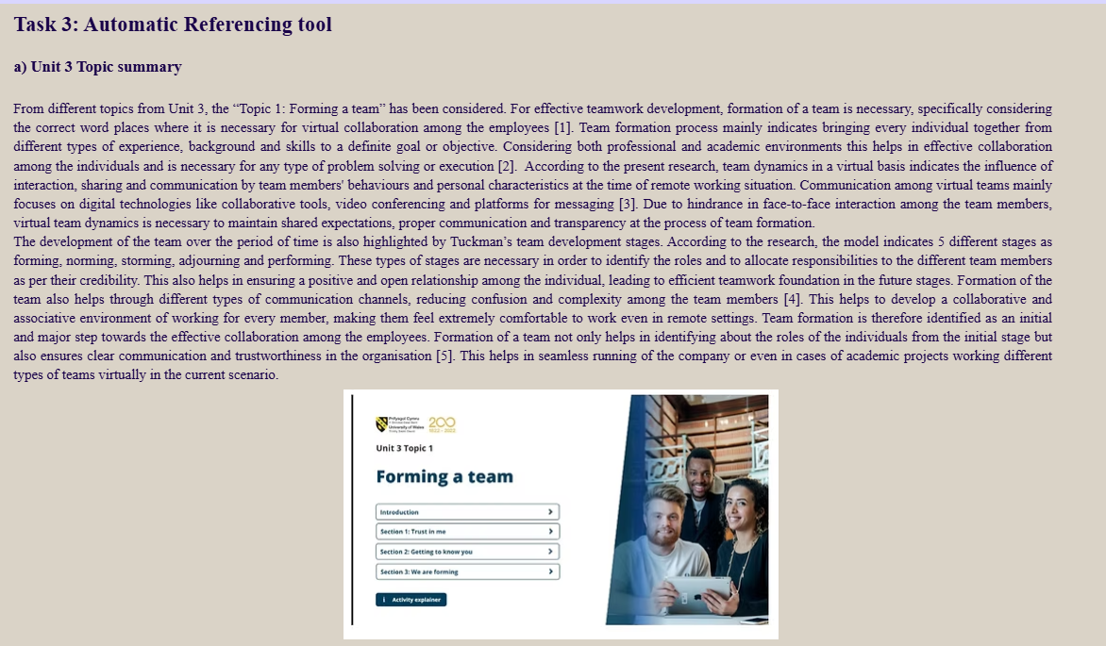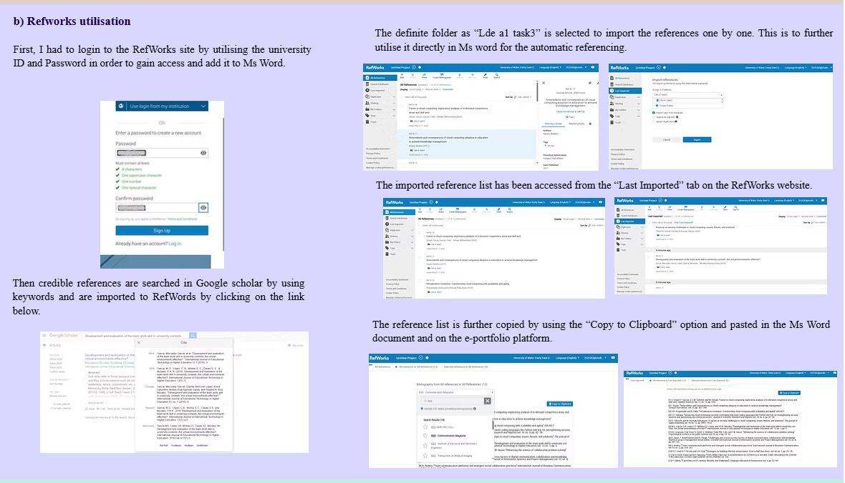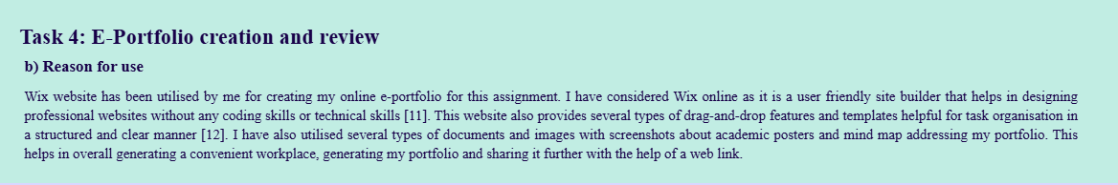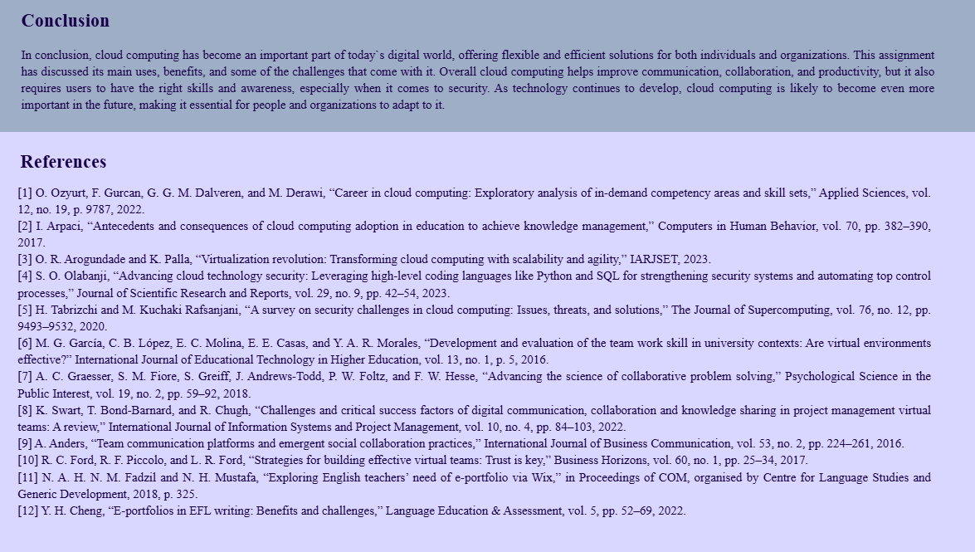

b) Reason for use
Wix website has been utilised by me for creating my online e-portfolio for this assignment. I have considered Wix online as it is a user friendly site builder that helps in designing professional websites without any coding skills or technical skills [11]. This website also provides several types of drag-and-drop features and templates helpful for task organisation in a structured and clear manner [12]. I have also utilised several types of documents and images with screenshots about academic posters and mind map addressing my portfolio. This helps in overall generating a convenient workplace, generating my portfolio and sharing it further with the help of a web link.

Conclusion
In conclusion, cloud computing has become an important part of today`s digital world, offering flexible and efficient solutions for both individuals and organizations. This assignment has discussed its main uses, benefits, and some of the challenges that come with it. Overall cloud computing helps improve communication, collaboration, and productivity, but it also requires users to have the right skills and awareness, especially when it comes to security. As technology continues to develop, cloud computing is likely to become even more important in the future, making it essential for people and organizations to adapt to it.

References
[1] O. Ozyurt, F. Gurcan, G. G. M. Dalveren, and M. Derawi, “Career in cloud computing: Exploratory analysis of in-demand competency areas and skill sets,” Applied Sciences, vol. 12, no. 19, p. 9787, 2022.
[2] I. Arpaci, “Antecedents and consequences of cloud computing adoption in education to achieve knowledge management,” Computers in Human Behavior, vol. 70, pp. 382–390, 2017.
[3] O. R. Arogundade and K. Palla, “Virtualization revolution: Transforming cloud computing with scalability and agility,” IARJSET, 2023.
[4] S. O. Olabanji, “Advancing cloud technology security: Leveraging high-level coding languages like Python and SQL for strengthening security systems and automating top control processes,” Journal of Scientific Research and Reports, vol. 29, no. 9, pp. 42–54, 2023.
[5] H. Tabrizchi and M. Kuchaki Rafsanjani, “A survey on security challenges in cloud computing: Issues, threats, and solutions,” The Journal of Supercomputing, vol. 76, no. 12, pp. 9493–9532, 2020.
[6] M. G. García, C. B. López, E. C. Molina, E. E. Casas, and Y. A. R. Morales, “Development and evaluation of the team work skill in university contexts: Are virtual environments effective?” International Journal of Educational Technology in Higher Education, vol. 13, no. 1, p. 5, 2016.
[7] A. C. Graesser, S. M. Fiore, S. Greiff, J. Andrews-Todd, P. W. Foltz, and F. W. Hesse, “Advancing the science of collaborative problem solving,” Psychological Science in the Public Interest, vol. 19, no. 2, pp. 59–92, 2018.
[8] K. Swart, T. Bond-Barnard, and R. Chugh, “Challenges and critical success factors of digital communication, collaboration and knowledge sharing in project management virtual teams: A review,” International Journal of Information Systems and Project Management, vol. 10, no. 4, pp. 84–103, 2022.
[9] A. Anders, “Team communication platforms and emergent social collaboration practices,” International Journal of Business Communication, vol. 53, no. 2, pp. 224–261, 2016.
[10] R. C. Ford, R. F. Piccolo, and L. R. Ford, “Strategies for building effective virtual teams: Trust is key,” Business Horizons, vol. 60, no. 1, pp. 25–34, 2017.
[11] N. A. H. N. M. Fadzil and N. H. Mustafa, “Exploring English teachers’ need of e-portfolio via Wix,” in Proceedings of COM, organised by Centre for Language Studies and Generic Development, 2018, p. 325.
[12] Y. H. Cheng, “E-portfolios in EFL writing: Benefits and challenges,” Language Education & Assessment, vol. 5, pp. 52–69, 2022.

