

BMPS4009 & BMPL4007
Learning in the Digital Era

Evidence of Learning (E-Portfolio)

Student Name: Diana E Androne
Student ID:2129591

Table of Contents
Summery 3
Mind Map (Connecting Digital Learning and Public Service) 4
Reflection 5
Poster on Importance of Team Playing in Public Service 6
Introduction 6
Literature 6
Availability of New Ideas 7
Increase Efficiency and Quality of Services 8
Higher Morale 8
Group Cohesion 9
Increase Innovation 9
Less Managerial Interference 10
Healthy Competition 10
Conclusion 10
References 11

Summary
Aiming for higher education is a journey that should be started from the college level where students think about their career and purpose in life which starts with a lot of background research about the field to be chosen including the area of interest, personal goals, lifestyle preference in future and the availability of job opportunities in this subject (Kompf and Denicolo, 2013). Also, choosing the right institution for this subject is important while developing a sense of responsibility to take care of health, balancing study, co-curricular activities, personal life, etc., and preparing the mindset to face all these alone in a foreign place ensuring career growth (Pickard, 2014).
Connection building through effective communication is a must not only in planning for higher study but also while pursuing that dream in real life as without adaptability and flexibility it is near impossible to build new connections, and utilize resources for academic and personal development (Domesova, Hussain and Khaneja, 2021). Also, looking after physical and mental health is essential while preparing for higher study as without knowing how to cook, manage own financial calculations, maintain personal hygiene and cleanliness while balancing the academic life, a student’s dream of being a highly skilled and qualified professional for future get dimmed as any kind of imbalance directly affects the personal and professional growth of the student (Uk higher education research yearbook, 2013).
Learning a new language when choosing a foreign institution will also take time which should be started earlier in the planning process while prioritizing the professional skill development which will play a key factor in getting the targeted job or position like, effective communication, time management, problem-solving and critical thinking while ensuring good grades will bring the student to their dream career achievement (Angelova, 2020).

Mind Map (Connecting Digital Learning and Public Service)
Concepts of Digital Learning consists of the virtual Classroom which brings all learners or trainers on one platform, sharing ideas give access to the digital learning experience thus resulting in adaptability to new methods or environments. While in Gamification, stimulation collectively, scenario analysis, role play, etc. encourage communication, creativity, and innovation and results in increased productivity, and new idea development (Clark and Mayer, 2016). On the other hand, the massive Open Online Course is the most used teaching method in which learning through previously shoot videos, documents, and quizzes on digital platforms like Udemy, allows the learner flexibility with diversified content-making while improving organization and connection-building capacity.
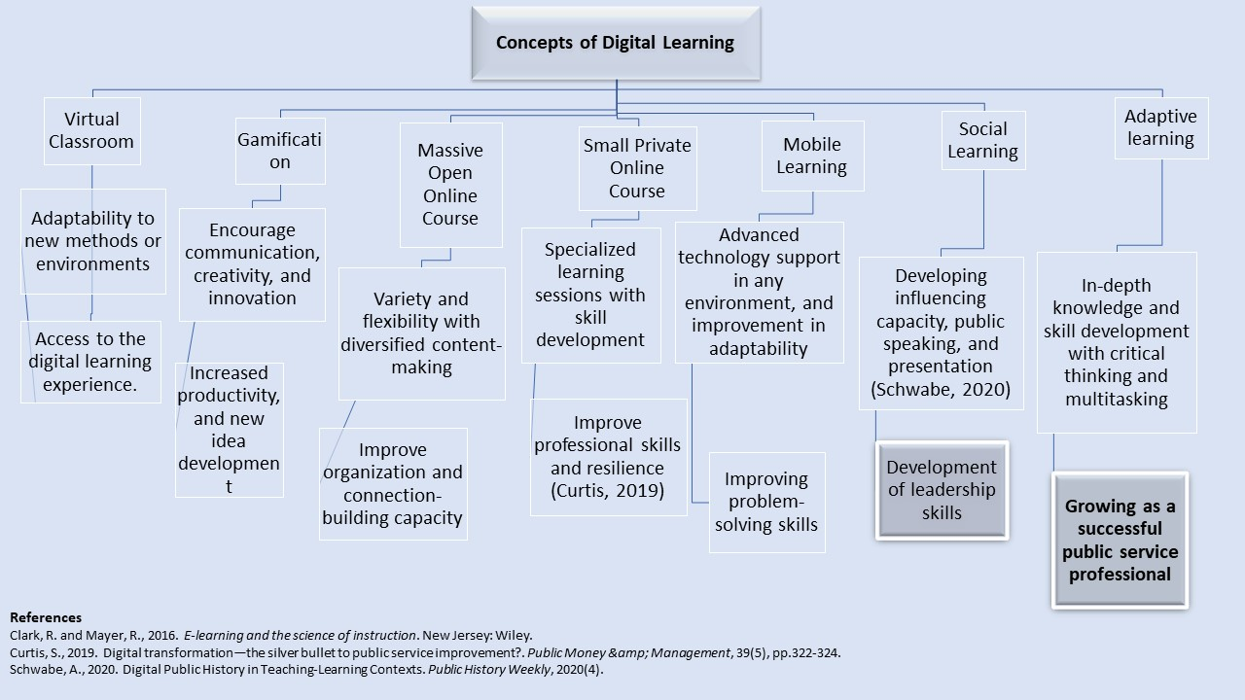
Small Private Online Course is an interactive learning method aimed at smaller groups with special tools and highly specified knowledge. This contributes to specialized learning sessions with skill development, with the improvement in professional skills and resilience (Curtis, 2019). Mobile Learning is a flexible learning way for people with low resources contributing to advancement in technological proficiency in any environment, and improvement in adaptability while serving an audience which results in improving problem-solving in different situations. Social Learning is informal and complementary learning in collaboration with other trainers on digital platforms contributing to developing influencing capacity, public speaking, and presentation with leadership skills (Schwabe, 2020). Lastly in, adaptive learning, sessions or workshops are specially designed based on the learner’s needs with in-depth knowledge facilitating skill development with critical thinking and multitasking.

Reflection
While preparing this mind map for connecting the pathways of the different digital learning methods preparing me for my future career in public service, I have done in-depth research to dig deeper into the field of higher studies. Through the excellent supervision of my supervisors to understand better the ways to develop my skills for the right kick start of my career as a public service professional. Later, I started to formulate the plan of growing my knowledge with different pedagogical approaches with the related skill development to grow as a professional public service holder thus completing my mind map.

Poster on Importance of Team Playing in Public Service

Introduction
A student’s dream of being a highly skilled and qualified professional for future needs balance between academic activities, co-curricular activities, and personal healthcare which may incorporate digital learning which brings all learners or trainers on one platform, sharing ideas give access, especially useful for students to learn from any places like home education institution. It develops their self-driven learning passion with technological literacy while making the contents using different technological tools or software and improves their sense of responsibility and punctuality. Public Service needs effective team working skills for achieving its goals ensuring efficiency while providing Service general people perform faster and more efficiently in the team rather than individually (Ali, Joyes and Ellison, 2014). Public Service consists of various types of teams with different shapes and sizes according to their job nature public Service types of leadership and length of services provided.

Literature
The learning methods improve the student’s research skills through group discussions and report writings while self-learning with full engagement while attending and planning their learning methods, and times and organizing the session plans with the teachers (Clark and Mayer, 2016). It also develops their self-driven learning passion with technological literacy while making the contents using different technological tools or software and improved sense of responsibility and punctuality with better critical-thinking ability in the case study and experiential learning sessions with the development of problem-solving skills through a variety of learning sessions. Blended learning is regarded as the most modern and effective learning method as this includes both the traditional and technological uses of pedagogical methods while breaking down the traditional rules of teaching methods and broadening the horizon of digital learning into the traditional teaching system. As this process is more simulating and student-friendly, this method came out to be the most effective learning method with flexibility while assuring the quality of learning by directly improving the learner’s experiences in learning sessions while sustaining the information weed in the learner’s brain for a comparatively long time than the traditional learning process (Schwabe, 2020).
The improvement in team working skills during the pandemic was facilitated by the blended learning which has introduced to the world in the year 2000 for both academic and training purposes in the United Kingdom, North America, and Australia referring to the inclusion of both online learning and offline learning methods using different pedagogical combinations and technological tools together (Aminah, 2020). It includes both synchronous and asynchronous modes of learning while combining both formal and informal ways of learning for professional development which increase learners’ inclusion rate in the learning sessions while improving the quality of the learning sessions through different simulating tools and experiential pedagogical methods where the traditional learning process is used decide the technological methods like question-answer sessions, quiz after the lecture, face to face group discussion, experiential learning lessons, like, field visit, group project, etc. (Chaeruman, 2019) The second key element is digital learning facilitating various learning tools through a variety of digital platforms, consisting, of videos, PowerPoint presentations, websites, e-books, etc. (Azis, 2020) These two elements are mainly combined in the blended learning process in which most methods are teacher controlled with the combination of some student-controlled methods in which students have the partial authority with their teachers to design and decide their learning process and tools according to their preferences and needs (Clark and Mayer, 2016).

Availability of New Ideas
As skill development in the COVID-19 lockdown facilitated by the blended learning sessions, it helped the students in many ways. For the students blended learning not only increases student inclusion rate through the simulating learning lessons but also improves the concentration span of the students with the combination of a variety of resources including current research, news reports, case studies, etc. This method provides the autonomy to the students to make decisions about the learning stations while planning to achieve the goals for their personal development with significant improvement in professional skills as well. Thus, making them more responsible for tracking their improvement and self-driven resulting in facilitating the ability to self-advocate while being organized and passionate about their development (Ulmane-Ozoliņa, 2015). It fastens the assessment and feedback process of the students’ performance in a learning session and other academic activities improving both teacher and students’ time efficiency. It also encourages the student to efficient learning with flexibility through the assessment of their learning pace thus focusing on their improvement areas while preparing for their future professional life with high skill and knowledge(Aminah, 2020). With this development in both personal and professional level while entering public service different types of unexpected situation arises in a different type of service provision thus, while working in a team, the diversity of people in the team, facilitates the availability of brand new and fresh ideas to solve the newly arrived problem more effectively with a short period (Locker, 2013).

Increase Efficiency and Quality of Services
While new ideas are kinds able from different kinds of team members, team efficiency in groups allows for improving the ability to accomplish different types of tasks and manage different unexpected situations, like accidents, while ensuring that the highly skilled team members get the most chances of working on this problem and contribute solve the problem a lot faster than before (Luu et al., 2019).

Higher Morale
Providing services for general people needs huge and continuous motivation, and a high level of energy which can be provided from a team working experience (Ali, Joyes and Ellison, 2014). While prioritizing team working and employees’ ideas are acknowledged and utilized thus making him feel a valued member of the team who is contributing to the success of this organization and something special to offer to the country does give him huge morale boost up to serve with more dedication and passion. For teachers, this method is more affordable while saving their valuable time with flexibility enabling the learners to join the learning session from anywhere and collect the learning tools easily. The tools used by early use in blended learning methods are of global quality while effective interaction between learners and instructors through different Electronic communication modes like email, chat rooms, etc. help the student to track their progress easily from anywhere while working on their development skills (Curtis, 2019). Blended learning also improves the quality overall facilitating the collaboration between teachers and professionals while engaging more students with better information access and feedback focusing on customized and deep learning according to the student’s needs. Blended learning facilitates the overall improved condition of the teaching environment while reducing the isolation rate with more opportunities for collaboration thus improving time efficiency and role differentiation for each learner and teacher resulting in meaningful professional development (Chaeruman, 2019).

Group Cohesion
A successful service provision for the mass need a proper synchronization and group Cohesion vial and individual puts forth first for the organization or personal benefit while helping the other members to work efficiently to achieve the goal of the team (Woodfield and Kennie, 2008).

Increase Innovation
Incorporating a new idea when in a newly arising problem pushes the public service workers for professionals to be more innovative while performing in their team with increased efficiency and motivation in time (Locker, 2013).

Less Managerial Interference
When team synchronization is optimum, the managerial interference needs less time as they sort out all sorts of problems with newly arrived unexpected problems within their team using their ideas and skills thus facilitating a strong bond between the team members with effective communication and understanding in every service provision task (Luu et al., 2019).

Healthy Competition
When team members are highly motivated to contribute to service provision while giving new ideas and solving problems together, a healthy environment for competition to contribute to the team’s success from each of the team members and urges and motivation for the development of personal and professional skills are seen.

Conclusion
Connection building through effective communication is a must not only in planning for higher study but also while pursuing that dream in real life with the development of adaptability and flexibility. While blended learning fastens the assessment and feedback process of the students’ performance in a learning session and other academic activities improving both teacher and students’ time efficiency. And when prioritizing team working and employees’ ideas are acknowledged and utilized thus making them feel a valued member of the team who is contributing to the success of this organization.
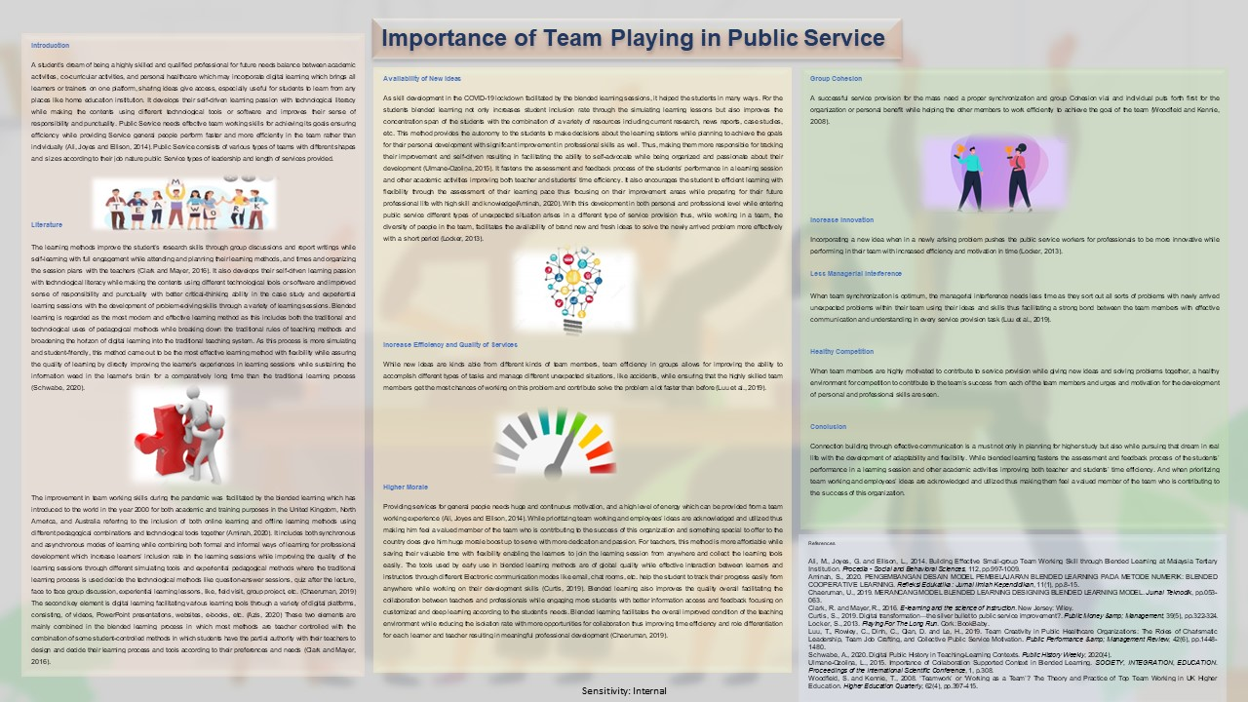

References
2013. Uk higher education research yearbook. [Place of publication not identified]: Evidence, A Thomson Reute.
Ali, M., Joyes, G. and Ellison, L., 2014. Building Effective Small-group Team Working Skill through Blended Learning at Malaysia Tertiary Institution. Procedia - Social and Behavioral Sciences, 112, pp.997-1009.
Aminah, S., 2020. PENGEMBANGAN DESAIN MODEL PEMBELAJARAN BLENDED LEARNING PADA METODE NUMERIK: BLENDED COOPERATIVE LEARNING. Refleksi Edukatika : Jurnal Ilmiah Kependidikan, 11(1), pp.8-15.
Angelova, M., 2020. Students’ Attitudes to the Online University Course of Management in the Context of COVID-19. International Journal of Technology in Education and Science, 4(4), pp.283-292.
Azis, Y., 2020. Sharing Time Learning (Face to Face and Online Learning) in Blended Learning. International Journal of Psychosocial Rehabilitation, 24(02), pp.466-474.
Chaeruman, U., 2019. MERANCANG MODEL BLENDED LEARNING DESIGNING BLENDED LEARNING MODEL. Jurnal Teknodik, pp.053-063.
Clark, R. and Mayer, R., 2016. E-learning and the science of instruction. New Jersey: Wiley.
Curtis, S., 2019. Digital transformation—the silver bullet to public service improvement?. Public Money &amp; Management, 39(5), pp.322-324.
Domesova, K., Hussain, S. and Khaneja, S., 2021. AN INVESTIGATION OF CZECH STUDENTS' PERCEPTIONS TOWARDS UK HIGHER EDUCATION – BENEFITS AND POST-BREXIT ISSUE. European Journal of Education Studies, 8(12).
Kompf, M. and Denicolo, P., 2013. Critical issues in higher education. Rotterdam: SensePublishers.
Locker, S., 2013. Playing For The Long Run. Cork: BookBaby.
Luu, T., Rowley, C., Dinh, C., Qian, D. and Le, H., 2019. Team Creativity in Public Healthcare Organizations: The Roles of Charismatic Leadership, Team Job Crafting, and Collective Public Service Motivation. Public Performance &amp; Management Review, 42(6), pp.1448-1480.
Pickard, S., 2014. Higher Education in the UK and the US. Brill.
Schwabe, A., 2020. Digital Public History in Teaching-Learning Contexts. Public History Weekly, 2020(4).
Ulmane-Ozoliņa, L., 2015. Importance of Collaboration Supported Context in Blended Learning. SOCIETY, INTEGRATION, EDUCATION. Proceedings of the International Scientific Conference, 1, p.308.
Woodfield, S. and Kennie, T., 2008. ‘Teamwork’ or ‘Working as a Team’? The Theory and Practice of Top Team Working in UK Higher Education. Higher Education Quarterly, 62(4), pp.397-415.

