

Methods and Search Strategy Academic Poster

Student name: Albert Malula
Student ID: 2310030

Module name: Independent Project
Module code: BMHP6020

Dissertation Title
Investigating the Impact of Therapy Intensity on Patient Recovery Outcomes for Anxiety and Depression in the UK Healthcare Industry: A Case Study of NHS England’s Talking Therapies (IAPT) Services
01 Introduction and Research Aim  Research Aim: Investigating the Impact of Therapy Intensity on Patient Recovery Outcomes for Anxiety and Depression in the UK Healthcare Industry: A Case Study of NHS England’s Talking Therapies (IAPT) Services  This poster will prepare for defining the research method and research strategies. It will discuss the searching strategies, research validation and analysis section also. Moreover, this poster will also include inclusion, exclusion criteria and an ethical consideration section. | 02 Search Strategy  A search strategy in the secondary research is a preplanned approach to finding the appropriate and dependable literature based on preexisting keywords, databases and inclusion criteria. A systematic search methodology was utilised in this research involving academic databases and NHS sources; by including the following key words: therapy intensity, IAPT services, anxiety, and depression, to ensure that only the relevant evidence was picked (Martin et al., 2022).
03 Searching for Information  The data collection was done in a structured, step-by-step process utilising academic databases and the NHS resources. The keywords were used covering the intensity of the therapy, IAPT, anxiety and depression. Recent, peer-reviewed and UK-relevant studies were filtered on inclusion and exclusion criteria (england.nhs.uk, 2025). The strategy was used to guarantee the use of quality and pertinent evidence to guide the research  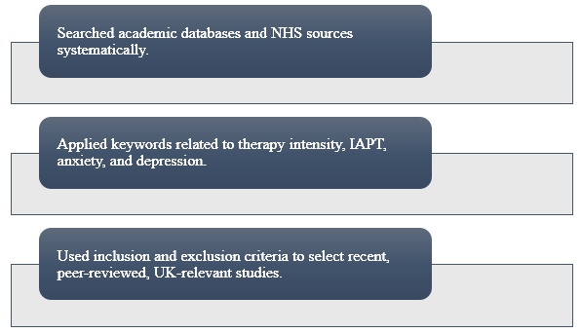  Figure: Searching Strategies | 04 Picture / Graph / Visual Aid / Statistics  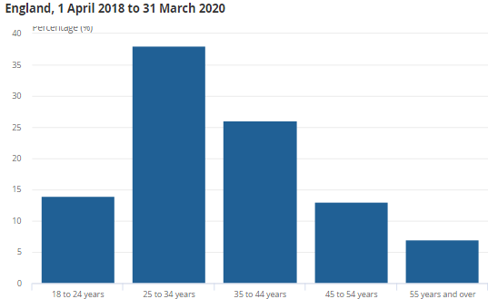  This visual shows some of the most important statistics about NHS Talking Therapies (IAPT). It attracts attention to the volume of the services and the results of recovery (nhs.uk, 2025). It helps to gain awareness of the role of therapy intensity optimisation and can be extended in the primary dissertation to investigate the differences in outcomes and service quality.  Figure: Age breakdown of prisoners referred to NHS Talking Therapies England  (Source: Lili, 2023)
05 Research Validation and Analysis
In secondary research, research validation is the ability of data sources in the study to be credible, reliable and of a sound methodology. Confirmation of research increases reliability and minimises bias, but the use of prior data prevents control of quality. In secondary research analysis, the systematic review of the literature and thematic analysis help to identify repetitive patterns, concepts and relationships that become the central ones in the topic of Chapter 4 findings.
06 Inclusion Criteria  The inclusion criteria were peer-reviewed sources that were published in the past 10 years, UK-based studies, literature related to the NHS and articles accessible fully online and immediately relevant to the study of therapy intensity, anxiety and depression in the context of psychological therapy services. | 07 Exclusion Criteria  Exclusivity criteria consisted of the sources being published more than a decade ago, studies that did not take place in the UK, non-peer-reviewed literature, articles that were not entirely available on the internet, and literature that was not relevant to NHS Talking Therapies, therapy intensity, anxiety or depression.
08 Ethical Considerations

References
england.nhs.UK (2025) NHS Choices. NHS. Available at: https://www.england.nhs.uk/mental-health/adults/nhs-talking-therapies/ (Accessed: 9 February 2026).
Lili Bui, E. F. (2023). Experiences of men who access NHS Talking Therapies from prison: 1 April 2018 to 31 March 2020, Experiences of men who access NHS Talking Therapies from prison - Office for National Statistics. Office for National Statistics.’ Available at: https://www.ons.gov.uk/peoplepopulationandcommunity/healthandsocialcare/mentalhealth/articles/experiencesofmenwhoaccessnhstalkingtherapiesfromprison/1april2018to31march2020 (Accessed: 9 February 2026).
Martin, C., Iqbal, Z., Airey, N.D. and Marks, L. (2022) ‘Improving Access to Psychological Therapies (IAPT) has potential but is not sufficient: How can it better meet the range of primary care mental health needs?.’ British Journal of Clinical Psychology, 61(1), pp.157-174. Available at: https://doi.org/10.1111/bjc.12314
nhs.uk (2025) NHS Choices. NHS. Available at: https://www.nhs.uk/tests-and-treatments/talking-therapies/ (Accessed: 9 February 2026).

