BA Leadership and Management

Module:
Understanding and Engaging in the Customer Experience
Module code: BMSW 5103

Assignment Title:
Customer Relationship Management Emerging Themes



Student: Abdul Wahid Ullah
Student Number: 1912519
Date _10/03/2022

Lecturer Olu Agedbite

TABLE OF CONTENTS

- Table of Contents. Page: 2

- Introduction 3

- Customer Relationship Management (CRM). 3 - 4

- Touch Points 4 - 5

- Customer Experience (CE). 5 - 6

- Brand Experience. 6 - 7

- Quality Models. 7 - 8

- Conclusion. 9

- Recommendations. 9

- References. 10 - 11

- Appendices 12 -14

2. INTRODUCTION

Customers all over this planet tend to want the best products and services with strong values in business, that offer legal and ethical standards, corporate social responsibilities and sustainability. (Samsung 2022). In this fast-changing digital world, consumers have become more engaged especially in the ‘Internet of Things’, (IoT). Stated by Kotler et al., (2019) that all around the world, industry, and companies in the new age of social and digital market, take an avid interest in their customers’ needs and wants. By evolving and engaging relationships with a brand, that not only sells a product, but takes you on a customer journey from: the prepurchase stage to the purchase stage through to the post purchase stage according to Lemon and Verhoef (2016).
This report looks at customer experience and the impacts of emerging themes of quality practices, touch points, brand experience and customer relationship management in the mobile phone industry. The report looks at one of the market leaders in the mobile phone industry, Apple Inc.
According to IMDb (2020), Steve Jobs returned to Apple Inc after he got fired in the 1980’s. He became the CEO of Apple and then revolutionised his ideas, such as the iMac, iPod, iTunes, iPhone, and iPad launched between the late 90’s and early 2000’s. Apple today have now diversified in the manufacturing of mobile phones, computers, laptops, tablets, computer peripherals and software. (Britannica 2022).

3. Customer Relationship Management (CRM)

CRM is seen as a ‘bottom-up’ practice that focuses on the intelligent mining of customer data for tactical purposes (Ellis, 2011). It is also seen as a ‘top -down’ view. It is considered as a core customer-centric business strategy that aims to win and keep profitable customers (Ellis, 2011).

There are 4 steps in CRM:

- A wide knowledge of the marketplace and recognising customers’ needs
- Designing a customer marketing strategy
- Establishing a marketing programme
- Engaging with customers and managing commercially successful consumer relationships

Whilst diligently working through on all the first three steps, the fourth step is the vital juncture for constructing and managing customer relationships and its fruition. Kotler et al., (2019)

“Customer relationship management (CRM). The overall process of building and maintaining profitable customer relationships by delivering superior customer values and satisfaction”. (Kotler et al, 2019, p,14)

Apple Inc’s CRM system is successful and envied, as demonstrated with its Apple ID. By purchasing an iPhone or any Apple product, Apple prompts the consumer to create an Apple ID. This in turn activates the phone with its unique ID and allows access to your phone and other Apple devices you may have. Now the personal ID and data is mined and stored in the Apple’s CRM systems. Apple then recognises the algorithms and records any purchases and web browsing content used to entice the customer into buying apps, other Apple products or items. Apple demonstrates an understanding of the customer’s needs. By delivering what is on the box, it continues relevance of its products and the continued importance of customer service.
By building great customer relationships, customers are eager and feel comfortable using Apple’s products, through their sophisticated innovation and desirable devices. (Akujuo, 2022)

4. Touch Points

Touch points constitutes principal interactions that occur along a customer journey with a company. Touch points are the times where the customer makes contact that connects with the company or brand at defined points, called the customer experience journey. These interactions influence a customer experience and brand perception like Apple Inc. By identifying key touch points, Apple Inc capitalises on these touch points and offer optimum in the customer’s journey experience. (See Appendix 1.)

Touch Points Examples

- Social Media, Facebook, Twitter, Instagram
- Advertisement/online
- Reviews
- Word of mouth
- Ecommerce
- Apple commercial customer loyalty programme (Gokey, 2014)
- Catalogue
- Recommendations
- Point of sale of a product

According to (Schmitt, 2003), touch points are made at distinctive points in the customers journey. These touch points can be associated directly with the company itself or by purchasing a product direct from the Apple Store, Apple Website, or contacts via third party. These touch points are a customer’s journey with the firm, of a customer’s life.

Apple Inc have mastered and capitalised on the success of customer touch points and the journey with its customer experience. By introducing its iPod and iTunes products in 2001, (Porter, 2018). Customers have to register at a subscription, to access to the music library. Another touch point and Apple mining data. Furthermore, having any Apple products, the customer can register with the same Apple ID and stored in the Apple iCloud and operate various Apple devices. This enables Apple entering the customer in Apples prestigious CRM systems, according to Apple (2022). Apples touch points and customer corridor can be explored through the customer data information (CDI)

- Identify touch points
- Set up data collection rules
- Define input processes and data collection rules
- Data enhancement, consolidation, and data protection

Thus, acquiring customers data and personal information which is secured and protected by government legislation, such the Data Protection act of 2018, which is now the revised General Data Protection Regulations (GDPR). Whereby, using strict data protection protocol. GOV.UK (2022).

5. Customer Experience (CE)

Customer experience (CE) is a multidimensional construct. It can be seen from a,

- customer point of view according to Schmitt, (2011) – or a co-creation perspective according to (Chandler and Lusch 2015) - the customer experience is a blend of a customer’s interaction with other actors in a broader ecosystem, while recognizing the customer’s role in the co-construction of the experience. This interaction with other actors is based on value propositions.

- the firms’ perspective (Barry et al, 2002; Stuart and Tax 2004) – the firm is responsible for constructing and designing an experience for the customer.

Apple Inc is responsible for conducting, creating, and then executing the experience for the customer. The onus is on the customer to take whatever offers or deals the company has to offer or not. So, in essence, customer experience are customers that interact in many ways that then establishes customers social, emotional, behavioural, and cognitive senses in the whole prepurchase to post purchase journey in an accordance with Lemon and Verhoef (2016). The whole customer experience is a wider construct of the customers interplay and interactions with value, reliability, and being faithful to the Apple Inc brand.

As stated by in a blog Future Stores (2011), Apple’s customer experience has a very special bond between the company, Apple Inc and its customers. Apple stores around the world offer an array of the best technical and coolest equipment and gadgets from its iPhone, wearable devices such as Apple watch and MacBook Pros computers, and the iPad. Every year the Apple iPhone is upgraded in better technology, camera, longer battery life and its aesthetic looks, from iPhone 1 to the X - the evolution of the iPhone. (see appendix 2).
At the Apple store customers get to browse and experience the best products. Apple representatives are known as genius or geeks that provides product knowledge, and then understanding the customers’ needs and wants will entice you to buy its product.
All Apple Store workers are trained to walk customers by 5 distinct steps that spells out the acronym APPLE.

A = APPROACH customer with a warm welcome

P = PROBE politely and understand customers’ needs

P = PRESENT a solution for the customer to take home today

L = LISTEN to issues and resolve them

E = END with a farewell and an opportunity to comeback

With these principles and disciplines, Apple associates deliver the best products on the market and one of the best customer experiences, that others envy!
The customers journey through Apple’s touch points, solidifies their bond with customer and brand experience and customer relationship management (CRM) which are the important mechanics of the integral cogs between the seller and the buyer.

6. Brand Experience

A brand can be seen as a recognisable symbol (see Appendix 3). Wealthy and trusted, market leaders in the world, are also recognised by their competitors as well as the customer. But to become a true global brand they must show and demonstrate social responsibilities towards the environment, sustainability, and the communities in their operations according to (Carter and Lee, 2012).

Brand experience, however, is the relationship between customers touch points and the organisation of the customer’s life. It is a holistic view that mixes customer experience, user and brand identity whilst interacting with a brand. The brand experience relates to the tangible, cognitive and emotional experience customers that correlate to the interactions with a brand. (Bonderud, 2022)

These experiences, through touch points, let consumers react to new product launches, advertisement campaigns and word of mouth recommendations. Customers and brand experience encompasses all the feelings of the product before, during and after whilst linked with a brand. It is imperative to have a strong relationship that resonates with consumers with the brand experience through positive vibes and having an effective brand experience versus customer experience. (Bonderud, 2022). (See figure 4).

Apple Inc’s brand experience is the benchmark and envy of other competitors such as Nokia, who were once the market leaders in the mobile phone industry. Nokia failed to move away from their Symbian software and compete with the launch of its iPhone in 2007. Nokia had sold half of the world’s smart phones by the end of 2007. But by 2010 Nokia’s ambition to destroy the iPhone failed due to a multitude of reasons such as a culture of fear, arrogance of their top-level managers and leadership, the lack of scope, future vision, and inferior technology to Apple’s specification. Nokia’s demise by 2013 was only expected.

Apple Inc’s consumers brand experiences is one of the best in the world. From iPod, iTunes, iMac, iPad, iPhone, Apple Pay (paying for goods with your phone or watch) and Apple TV+. Apple TV (2022). From all touch points to from websites, advertisements, Apple Stores, to the products and its packaging create a great brand experience that solidifies Apple’s style, innovation and practicality and effectiveness of their products. (Bonderud, 2022). Apple consumers are loyal and devoted to Apple products and peripherals. They become ambassadors of the brand and endorse and recommend Apple products. On the other hand, you have the hardcore Apple devotees called ‘MacHeads or Macolytes’ who are the Apple zealot’s – those that cannot wait to tell others of the new products on the market or to be launched. (Kotler et al, 2019). This is great customer experience and brand loyalty working at its best.

7. Quality Models

What is quality? According to Kotler, et al, (2019 p.238):
“Quality can be defined as ‘no defects’ “

Quality diversly affects commodities and services as it associates with consumer satisfaction and consumer value. To summarise it is a combination of customer value and customer satisfaction to satisfy customer needs and wants. (Kotler et al, 2019)

Many scholars have written on quality theories and models. Here we look at two scholars, Dr. Joseph M. Juran - The Quality Trilogy Model and the Quality Roadmap, and the late Phillip B. Crosby – Crosby’s Cost of Quality, Four Absolutes of Quality Management.

Juran’s Quality Trilogy.

Dr Joseph M. Juran is recognised as one of the world gurus on quality models. Dr. Juran’s theory is used to construct a quality system and to enable and help with Strategic quality Management.
.
This concept is based on three fundamentals of qualities which consists of:
- Quality planning: the process to supply products and make goods that meets the customer’s needs. At this point the company must be fixed on who their target market is. Their needs to manufacture commodities or services and deliver the goods or services. By executing the plans to the operating department. Persistent waste is prevalent if quality planning is inadequate.
- Quality control: in this Quality Trilogy the operators inspect and utilise this process to highlight and end sub-standard commodities from getting worse, by resolving any issues and juxtapose with actual performance plans.
- Quality improvements: the third element of the Trilogy that waste should be reflected as a chance to contemplate for quality improvements. By implementing high standards that are superior to any other levels. Quality improvements encircles a change for the better and fit for use and to stop chronic waste at this juncture.
According to Agedbite (2021) Juran’s Quality Planning Road Map is used for product and process development. (See Appendix 5.)
This process is used by teams or individual persons globally, a catalogued list for understanding consumer requirements and constructing measurements based on customers’ requirements. To manufacture the best effective product design and maintaining the process of consumer needs. (Agedbite, 2021)

In essence the Juran Trilogy is a part of the control process, which work together with operating forces and are responsible for the status quo. This process is called corrective action or trouble shooting. Juran’s framework helps organisations to implement the 3 pillars which include:
- Developing a strong and the best foundation and business strategy
- Understanding and implementing ‘enablers’ – the universal principles
- Sustaining real business results. Juran (2022)

Crosby’s Four Absolute of Quality Management
Crosby’s (1979) states that organisations should pay attention to consumer needs prevention of product defects. Crosby interprets quality and non-quality as, “Quality is conformance to requirements; while non-quality is non-conformance.” According to Crosby, to achieve quality it costs money but when quality is not achieved it costs more. Furthermore, when an organisation designs and constructs a product right the first time without defects, quality is free. However, it would cost more to scrap or redo the product of poor-quality product. Crosby (1979)
Crosby posits his theories about quality as; Four Absolutes of Quality Management.

- Quality means conformance to requirements, not goodness.
- The system of quality is prevention, not appraisal.
- The performance standard is zero defects, not "that's close enough."
- The measurement of quality is the price of nonconformance, not indexes. (Quality Guru, 2022)

How do these quality models effect Apple Inc and its CRM?

There are emerging themes that arise from these quality models. All the models resonate about customer satisfaction. Whilst delivering a great quality product the organisation must be engaged with customers’ expectations. What resonate the most is the Apple brand. Customers feel good by owning a sophisticated, cool, great product, with no frills, simple packaging. Which acts on Apple’s Supplier Responsibility commitment. Apple (2022).
Innovating new ideas, it also fulfils customer needs and wants, such as iPod, iPhone, iPad, Siri, Apple Pay and now Apple TV. Apple’s famous distinctive store are recognised world-wide. Filled with Apple devices on huge tables. A trained Apple representative are always at hand. This focusses on great customer experience. The report identifies that it does engage with its customers who are loyal with Apples IOS software. With these expectations being met by their customers. Apple and its CRM, improve customer relations, increase revenue, and optimise marketing by targeting market segmentation. Thus, using the information to target prospective customers. This will help optimise Apples resources effectively and efficiently.
According to Kotler et al, (2019) it is an ideology by achieving organisational goals and with emerging themes. That rely on the target markets expectations of needs and wants and by delivering better product and services than the competitors. See SWOT analyses. (Appendix 6)

However, the latter can be stated about Nokia. For not having an effective CRM that would’ve engaged with its customers’ expectations. Plus, the fearful emotional climate from top managers to middle managers and external factors. Nokia being too complacent saw Apple’s IOS system simply crush the outdated Symbian operating system. (Huy, 2015).

8. Conclusion

Modern organisations and Apple Inc look at quality as an investment. They hold quality efforts for bottom-line results. In essence the quality is evident in the product and service that Apple Inc provides with the best, coolest products with matching customer satisfaction and service. With a great customer experience that has held Apple Inc as one the biggest successful mobile company in the world.
Evidently, Apple Inc can and will survive if it harvests new customers and retains satisfied customers. This will only be achieved if the customer needs and expectations are always met. Apple’s Quality is determined by the extent to which a product and service successfully serves its purposes year in year out.

9. Recommendations

Customer expectations have increasingly changed over the years and continues to do so. Whilst fierce competition from Android and brand loyalty have become more prevalent in the phone industry. New technologies’ that progressively changes on daily basis customers demands for new products and services also changes too. Apple therefore need to build on their successful quality management review systems by not being complacent. This will only build a more cohesive bond with customers and the organisation.
.

REFERENCES

2020. Why are consumer touchpoints so important?. [image] Available at: <https://digitalschoolofmarketing.co.za/blog/why-are-consumer-touchpoints-so-important/> [Accessed 29 March 2022].
2022. [image] Available at: <https://www.cbj.ca/wp-content/uploads/2018/08/Apple-Inc-logo-black.png> [Accessed 28 March 2022].
2022. Philip Crosby: The Man Who Said “Quality is Free”. [Blog] Available at: <https://www.qualitygurus.com/philip-crosby/> [Accessed 28 March 2022].
2022. iPhone 1 to X. [image] Available at: <https://qph.fs.quoracdn.net/main-qimg-718395c167a83708ce34e3bc48e900fc> [Accessed 28 March 2022].
Agedbite, O., 2021. Quality Models and Theories.
Akujuo, V., 2022. Apple CRM Case Study: The Secret Behind Apple’s Tremendous Growth. [online] CRMside. Available at: <https://crmside.com/apple-crm-case-study/> [Accessed 28 March 2022].
Apple Support. 2022. Introduction to iCloud. [online] Available at: <https://support.apple.com/en-gb/guide/icloud/mm74e822f6de/icloud> [Accessed 29 March 2022].
Apple Support. 2022. Introduction to iCloud. [online] Available at: <https://support.apple.com/en-gb/guide/icloud/mm74e822f6de/icloud> [Accessed 28 March 2022].
Apple TV. 2022. Apple TV+. [online] Available at: <https://tv.apple.com/gb?ign-itscg=MC_20000&ign-itsct=atvp_brand_omd&mttn3pid=Google%20AdWords&mttnagencyid=a5e&mttncc=UK&mttnsiteid=143238&mttnsubad=OUK2019801_1--c&mttnsubkw=1233652260084184__GCilv9hN_&mttnsubplmnt=> [Accessed 29 March 2022]
Apple. 2022. Supplier Responsibility. [online] Available at: <https://www.apple.com/supplier-responsibility/> [Accessed 28 March 2022].
Baer Performance Marketing. 2012. Apple Surprises Fans with Celebrity Endorsements - Baer Performance Marketing. [online] Available at: <https://baerpm.com/2012/05/18/apple-surprises-fans-with-celebrity-endorsements/#:~:text=The%20ads%20are%20unique%2C%20however%2C%20because%20the%20use,are%20merely%20there%20to%20interact%20with%20the%20phone.?msclkid=4f7f47f9af5211ecba1f58c71f77f626> [Accessed 28 March 2022].
Berry, L. Carbone, P. and Haeckel, S. H. (2002), “Managing the Total Customer Experience,” MIT Sloan Management
Bonderud, D., 2022. Everything You Need to Know About Brand Experience. [Blog] HubSpot, Available at: <https://blog.hubspot.com/marketing/brand-experience> [Accessed 28 March 2022].
Chandler, J. D. and Lusch, R. F. (2015), “Service Systems: A Broadened Framework and Research Agenda on Value
Crosby, P.B. (1979). Quality Is Free, McGraw-Hill, New York, NY.
Ellis, N. (2011). Business-to-Business Marketing: Relationships,
Encyclopedia Britannica. 2022. Apple Inc. | History, Products, Headquarters, & Facts. [online] Available at: <https://www.britannica.com/topic/Apple-Inc#ref92993> [Accessed 28 March 2022].
Future Stores Seattle 2022. 2022. Apple's Customer Experience Strategy: Turn Stores into “Town Squares”. [online] Available at: <https://futurestores.wbresearch.com/blog/apple-store-town-square-customer-experience> [Accessed 28 March 2022].
Gokey, M., 2014. Apple Loyalty Program incentives target the big spenders: education and IT companies. [online] Tech Times. Available at: <https://www.techtimes.com/articles/4287/20140312/apple-loyalty-program-incentives-target-the-big-spenders-education-and-it-companies.htm> [Accessed 28 March 2022].
Homburg, C., Jozić, D. and Kuehnl, C., 2015. Customer experience management: toward implementing an evolving marketing concept. Journal of the Academy of Marketing Science, 45(3), pp.377-401.
Huy, Q., 2015. Who Killed Nokia? Nokia Did. [online] INSEAD Knowledge. Available at: <https://knowledge.insead.edu/strategy/who-killed-nokia-nokia-did-4268> [Accessed 28 March 2022].
IMDb. 2022. Steve Jobs - IMDb. [online] Available at: <https://www.imdb.com/name/nm0423418/bio> [Accessed 28 March 2022].
Juran. 2022. The Juran Model | Juran. [online] Available at: <https://www.juran.com/approach/the-juran-model/> [Accessed 28 March 2022].
Kotler, PT, Armstrong, G, Harris, LC, & He, H 2019, Principles of Marketing, Pearson Education Limited, Harlow, United Kingdom. Available from: ProQuest Ebook Central. [29 March 2022].
Kotler, PT, Armstrong, G, Harris, LC, & He, H 2019, Principles of Marketing, Pearson Education Limited, Harlow, United Kingdom. Available from: ProQuest Ebook Central. [28 March 2022].
Lee, K. and Carter, S., 2012. Global marketing management. Oxford: Oxford University Press, p.57.
Lemon, K. and Verhoef, P., 2016. Understanding Customer Experience Throughout the Customer Journey. Journal of Marketing, 80(6), pp.69-96.
Lessons Learned from the Theatre,” Journal of Operations Management, 22 (6), 609–27.
Medium. 2018. Why did Nokia fail and what can you learn from it?. [online] Available at: <https://medium.com/multiplier-magazine/why-did-nokia-fail-81110d981787> [Accessed 29 March 2022].
Networks & Strategies, Oxford University Press
Porter, S., 2018. Five big things that have made Apple. [online] BBC News. Available at: <https://www.bbc.co.uk/news/business-45044963> [Accessed 28 March 2022].
Propositions, Engagement, and Service Experience,” Journal of Service Research, 18 (1), 6–22
Review, 43 (3), 85–89.
Samsung uk. 2022. Samsung Sustainability & Environmental Strategy | Samsung UK. [online] Available at: <https://www.samsung.com/uk/sustainability/overview/> [Accessed 29 March 2022].
Schmitt, B., 1999. Experiential Marketing. Journal of Marketing Management, 15(1-3), pp.53-67.
Schmitt, B., 2003, Customer Experience Management: A Revolutionary Approach to Connecting With Your Customers. New York. The Free Press.
Stuart, Ian F. and Stephen S. Tax (2004), “Toward an Integrative Approach to Designing Service Experiences:

Appendices

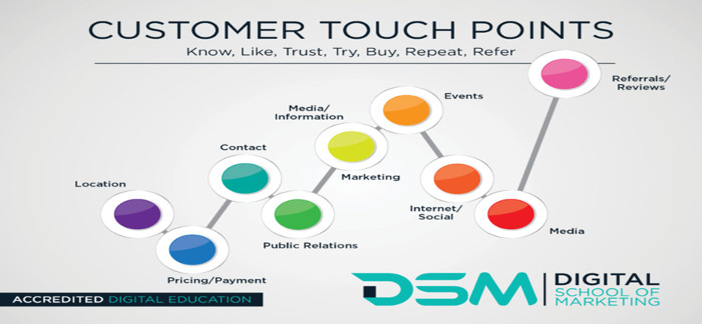
Appendix1.

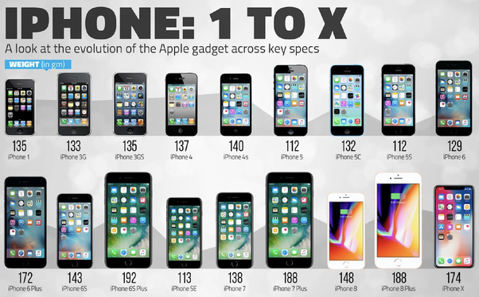
Appendix 2.


Appendix 3.

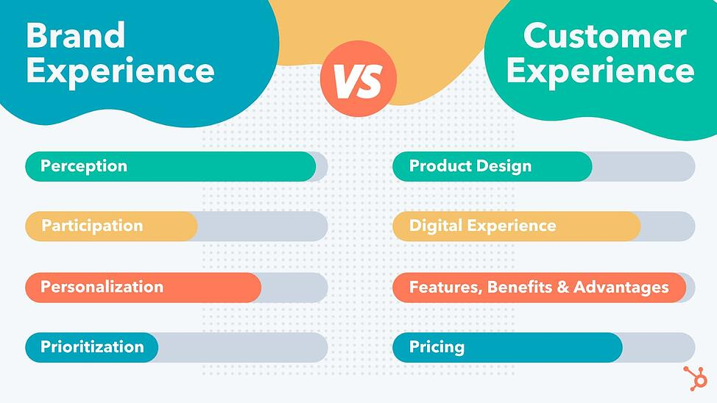
Appendix 4.

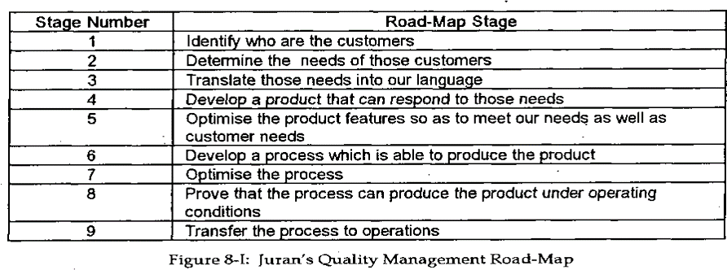
Appendix 5.

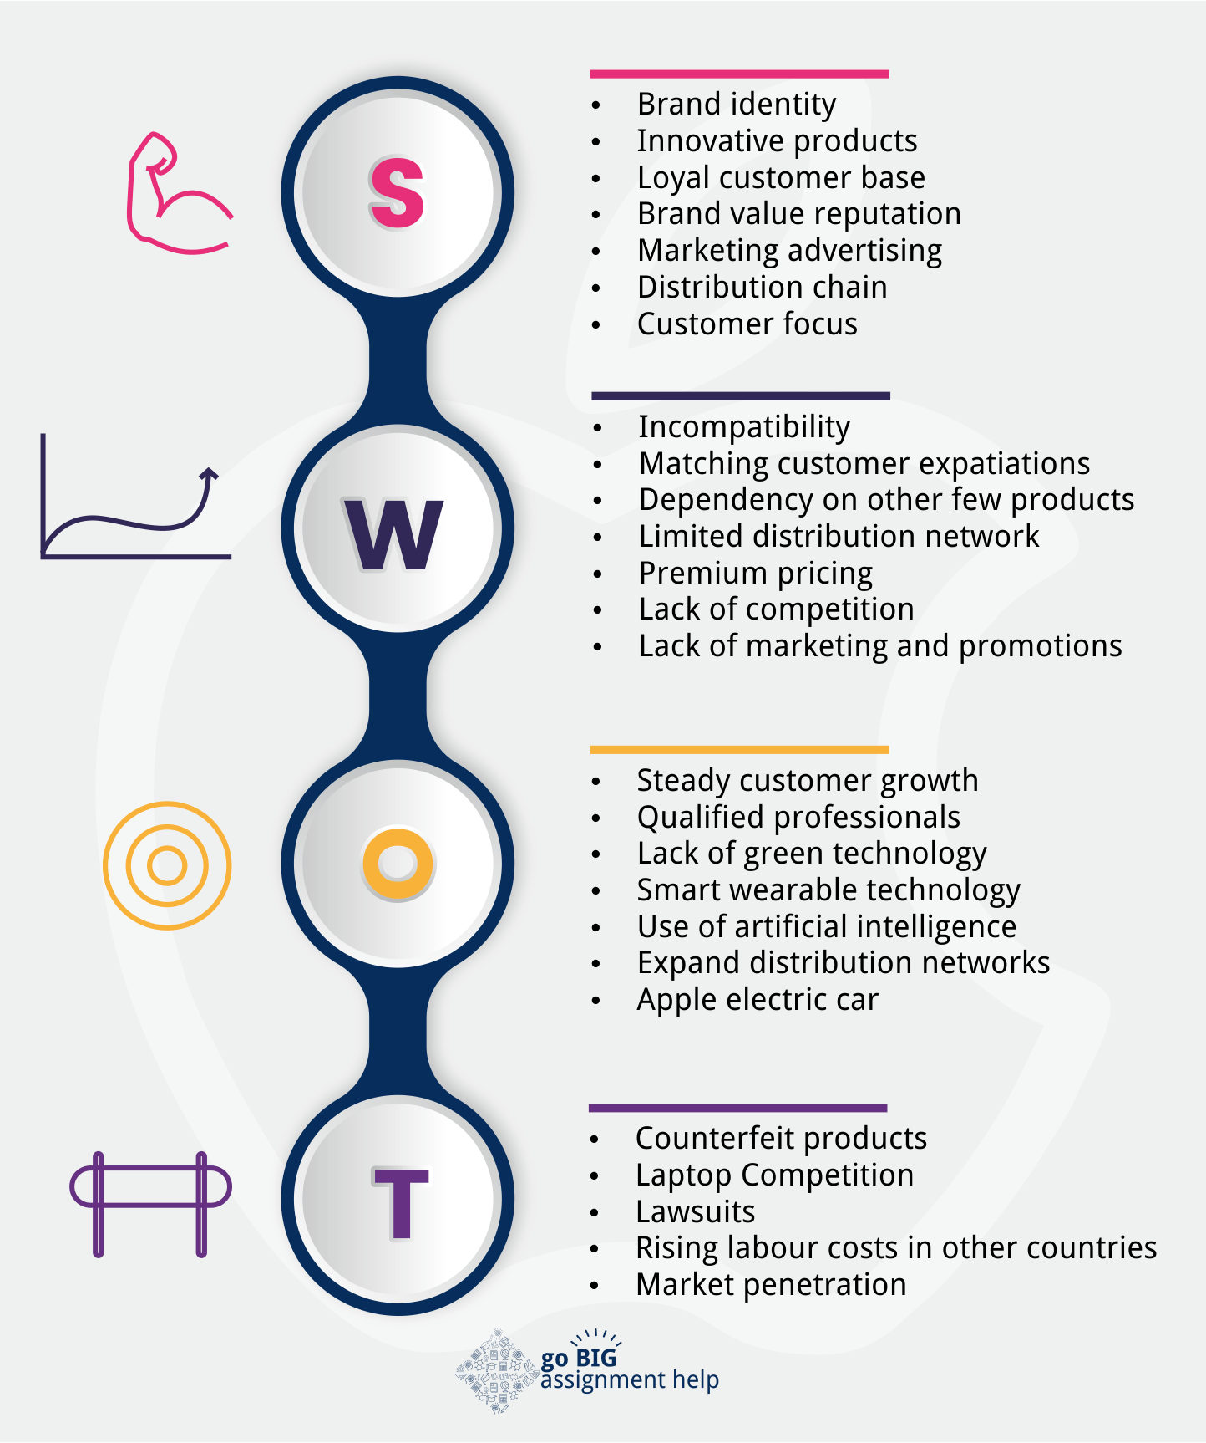
Appendix 6.

