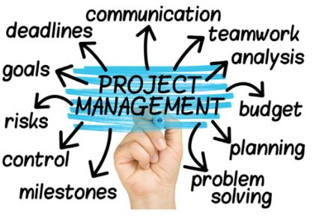
Project Planning and Management in work place adapting to impacts of the Coronavirus outbreak in DRL Partitions Limited
Lecturer: Shehla Khan
Student: Beata Beck 1807727 | 7/3/20 | Project Planning and Management in workplace.

TABLE OF CONTENTS

1.0 Introduction | 2
- What is project management and project lifecycle? | 2-3
2.1 Initiation and planning | 3-4
- Quad chart and stakeholder’s analysis | 4-6
2.3 Work breakdown structure and Gantt chart | 7-8
2.4 Risk Analysis and Pestle Analysis | 8-10
2.5 Monitoring and Evaluation | 10-11
3.0 Conclusion | 12
4.0 References | 13-14

INTRODUCTION
The aim of this project is to provide a critical evaluation of project management tools and techniques and apply them to evaluate the impact of the Coronavirus outbreak on the company, DRL Partitions Limited.
To achieve the aim the researcher investigated the following tools and techniques and applied them to the chosen company.
Firstly, the researcher prepared a project life cycle. This tool provided useful information in terms of project dynamics over time. Secondly, the researcher analysed shareholders and briefly explained their impact and internal involvement in this project and within DRL Partitions Limited. Using a Quad Chart, the researcher managed to visualise achievable steps for the structure of the project. This included to draw scope and desired outcome. Next part of this work has been dedicated to the critical explanation of Work Breakdown Structure (WBS) and Gantt Chart. WBS helped to breakdown the project tasks into little pieces and analyse the various scenarios, however the Gantt Chart helped to schedule certain activities and monitor those activities in time. In the last part of the project the researcher conducted a risk analysis assessment which linked to the iron triangle tool and pestle analysis grid. Those instruments showed which part of the project has been completed and can be moved to another stage which is devoted to evaluation and monitoring. Also the risk tools helped to evaluate certain actions to avoid disappointments like delays in handling the project on time. Through Kolb’s Experimental Cycle the researcher evaluated soft outcomes of the project. However, Herzberg’s Motivational Factors measured hard outcomes.

- WHAT IS PROJECT MANAGEMENT AND PROJECT LIFECYCLE?
In order to distinguish between the project and project management it is important to develop different definitions for the two terms. A project can be the accomplishment of a specific objective, which involves a series of activities and tasks which consume resources. It must be completed within a set specification, having definite start and end dates. However, project management can be defined as the process of controlling the achievement of the project aims. Utilising the existing organisational structures and resources, it seeks to manage the project by applying a collection of tools and techniques, without adversely disturbing the routine operation of the company. (A K Munns, B F Bjeirmi; 1996).
In other words, the project management is the shared set of values, principles, processes and techniques. A project has a beginning, middle and end, all are very important but for different reasons. These three elements make up the cycle. The cycle consists of five stages: initiation, planning, execution, monitoring and closing. Theses stages create a Project Lifecycle.
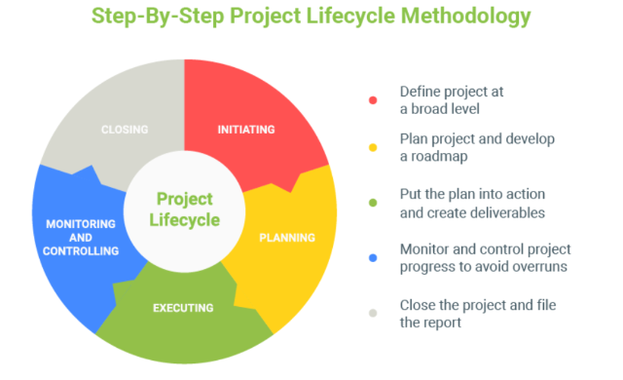
Looking at the benefits of the Project Lifecycle the researcher sees that this tool is simple and easy to understand. It helps to understand what resources, people and skills are needed to complete the project. Also, every stage of the project can be reviewed and if necessary, it can be stopped, changed or continue and obtain to sign off. However, product life cycle is “too clean a picture” this mean that more complex projects might need different tools to comply with the company rigid strategies.
  - INITIATION AND PLANNING
The project initiation stage is the 1st phase in the Project Management Life Cycle, it involves starting up a new project. This phase is also called IDEA.
The researcher mentioned before that this project will be based on the analysis of the project tools and techniques and then applied to the company DRL Partitions Limited.
DRL Partitions Limited is a welsh manufacturer based in Llanelli. The company offers design, manufacture, installation, service and repair for moveable walls, doors and mobile screens. DRL is not a large company and employs only 20 people including the directors, however the company is growing steadily, and their operable partitions are known not just in the UK but worldwide. The company is well known in Europe, Middle East, Africa and Asia. In March 2020, the government put restrictions for free movement for all non-essential businesses. The company long adopted structure had to change immediately. Due to the government restrictions the company lost 60% of weekly sales. The planning for the Coronavirus outbreak project specified deliverables objectives which include, cutting the operational costs and provide safety for employees. These actions will help to meet the stakeholder’s expectations and will minimise the risk of infection.
  - QUAD CHART AND STAKEHOLDERS ANALYSIS
To find out if all above is achievable, the researcher used Quad Chart and Stakeholder analysis. Quad Chart is a one-page visual and descriptive summary of the project. It explains what the project is all about in detail. Basically, by splitting it into four to five sections. The quad chart assists by putting different ideas in one structured piece. The biggest advantage of quad chart in the project is clearer, understandable and easy to view from the start. However, the major disadvantage of the chart is that it may oversimplify data which can cause a misleading view, especially in complex projects.
Quad Chart includes the following four boxes:
Project Scoping is a very important and often the most difficult part of the quad chart. It breaks down projects into aims and objectives and manages the expectations of stakeholders. It helps to stay on the track and avoids common problems occurring during the project, for example, overrunning the budget or being behind the schedule of the project.
Stakeholders list identifies all stakeholders for the project. In other words, this is the list of people who potentially is affected or could be affected by the organisations action.
Desired Outcomes (Critical Success Factors) simply guides and are obvious elements of the project. This is what the company wants to achieve. This outcome can be measurable or not.
Measures of Success (Secondary Benefits) “Successful organisations take guesswork out of this process: they define what success looks like, so they know when they have achieved it” (www. mybeeye.com). This can be seen in customers happiness, employee’s performance and in company sales.
The researcher prepared a Quad Chart for DRL Partitions Limited regarding their response to the Coronavirus outbreak in terms of sale, working hours and employee’s safety.
Secondary benefits
Space for new ideas and design – Tarian Moveable Covid -19 protective screens

The second adopted tool in the planning phase is the stakeholder’s analysis. This analysis requires a close look at each stakeholder to get more information in order to understand the impact, involvement, communication canals and preferences. The most important benefit of stakeholder’s analysis is to identify the most powerful stakeholder. This will ensure secure the support and valuable input which may be given. The researcher grouped stakeholders for internal and external. Internal stakeholders have a big impact in the company, and it is important to keep them informed and happy. External stakeholders are not directly connected to the company however they can a little involvement in the project.
The biggest disadvantage of stakeholder’s analysis is impossible to satisfy all stakeholders in 100%. Consequently, managing becomes a “balancing act” in other words, the project manager needs to focus on the most important stakeholders’ group and rest of them satisfy if possible.
The researcher prepared DRL Partitions Limited Stakeholders Analysis with the breakdown of high, medium and low in terms of impact. The most important stakeholders include employees, customers and suppliers. All of them play the most important part in this project. Without employees, the company wouldn’t manage to deliver orders to customers. Customers generate profit for the company which pay the company bills and suppliers. Development Bank of Wales (DBW) has got low impact in the project. However, the company needs to inform how DRL respond to the Coronavirus outbreak because DBW helped DRL to start up the business and loaned money which is still due to pay. Business Wales has got low impact in the project, although it was the first organisation which was interested in factories in Wales during the Covid – 19. Business Wales provided useful information to DRL in terms of financial support from Welsh Government. This included information about grants, loans and non-payments of rent and business rates.
Priority | Stakeholders | Perspective | Action
High | Employees | Delivering scheduled jobs on time.  Superb customer service.  Feeling safe in workplace | Planning the workload ahead.  Working from home as much as possible. Applying new guidelines for manufacturers, coaching others and maintaining social distancing.
High | Customers | Very important in keeping company going through the crisis. | Delivering jobs as per agreed contract.  Updating of any changes in delays.  Effective communication is a key to keep customers happy.
High | Suppliers | Very important to pay company suppliers on time. This will help to  keep the stock of materials at the correct levels. | Planning suppliers’ bill payments ahead.  Regularly updating the suppliers of any changes in delayed payments
Satisfied | Development Bank of Wales | Delivering regular payments regarding DBW loan. | Applying for loan holiday payment
Low | Business Wales | Delivering a new designing idea.  Informing how the Covid -19 affected the workload. | Applying for government business support.

  - WORK BREAKDOWN STRUCTURE AND GANTT CHART
In this part of the project the project manager focused on creating deliverables and monitoring the project timeline. For this purpose, the project manager used the following techniques and tools:
Work Breakdown Structure (WBS) technique breaking work into small tasks so the work is more manageable and approachable. The Project Management Institute (PMI) Project Management Book of Knowledge (PMBOK) defines WBS as a “deliverable orientated hierarchical decomposition of the work to be executed by the project team.” The biggest advantage of this technique method is that members of the project clearly sees how the work affects the success of the project. WBS shows organizational part of the project and a scheduled control. “Notably, work breakdown structure focuses on deliverables rather than the activities required to achieve those milestones” (www.planview.com) access 03/07/2020
DRL Partitions Limited WBS example shows two deliverable tasks set at the beginning of lockdown. DRL Partitions wants reduces the operational costs and wants to deliver safety measures. Each of those deliverable displays a list of activities which need to be complete in certain time. Using this tool, the company can improve planning, budget, decrease risk, this is achieved through visual structure of WBS which makes it easier to find areas of risk and remove them faster. On another hand, this method shows possible missing components in the project structure and unfortunately the project manager can find gaps in accuracy.
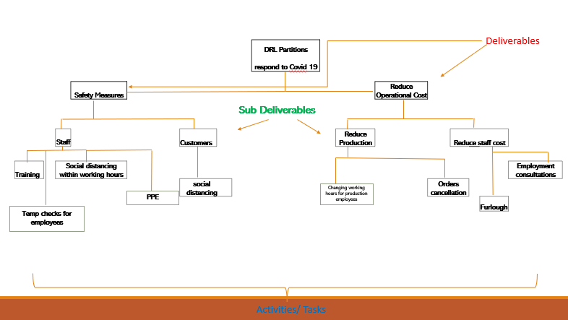
Activities allocated to deliverable tasks are called sub-deliverables and has been presented on Gantt chart analysis. Gantt chart helps the business to stay on top of the established targets. The main advantage of the Gantt chart is easy scheduled tasks which has got clear and visual representation of the project plan. It helps to see the percentage of completed tasks. This chart is easy to maintain and coordinate with rest of the team. The main disadvantage of the Gantt chart it is require more efforts for creating and managing. Also, the Gantt chart needs to be updated and maintain otherwise won’t be effective. Despite the few cons it is still a powerful tool in managing projects and teams. Below the researcher presented the Gantt chart “timetable” for sub-deliveries in DRL Partitions Limited.
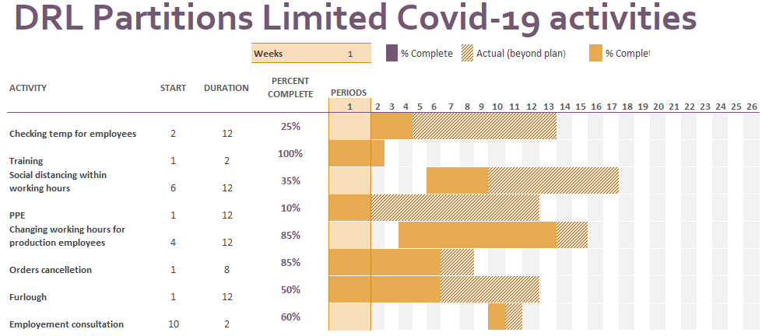

  - RISK ANALYSIS AND PESTLE ANALYSIS
What is Risk?
Risk is the possibility that the project may not be achieved. Risk may cause delays in handling projects due to high costs or time, people resources and material resources. An effective risk analysis allows to identify the projects strengths, weaknesses, opportunities and threats. There are two categories of risk. Internal risk which occurs as part of the project itself and something can usually be done about this. This risk can be measured via a SWOT analysis. External risk applies to the external factors and can be analysed via PESTLE technique.
To identify the risk the researcher had to examine once again the project aims and objectives and based on that, the researcher potentially examines what could go wrong. The risk analysis has many benefits. Firstly, the organisation can see if it meets or exceeded the financial expectation, secondly the risk analysis delivers better quality data for decision making. Looking further, a good risk analysis creates a point of discussion between project teams. This discussion can create positive relationships and also build on team motivation and strengths for completing the project successfully, despite knowing of the risk.
DRL Partitions Limited Risk analysis in response to Covid-19
Impact  (H/M/L) | Likelihood  (H/M/L) | Risk | Mitigating Action
High | High | Protecting office and workshop employee’s health (Internal) | - working from home (office employees)  - shorter working hours (workshop)  - measuring temp daily  - applying 2m social distance  - providing service cleaning  - hand sanitizer for all
High | Low | Shortage in direct materials (External) | - buying from local suppliers
High | Medium | Government rules (External) | - following government law,  - updating employees regarding government law changes
High | High | Cancelled orders from customers | - employees on furlough  - decrease in ordering materials

One of the useful tools to assess the decision-making process is Iron Triangle. The triangle demonstrates that quality cost and time are interrelated. Focussing or fixing one point of the triangle impacts the other two points (Lock, 2007, p21). In other words if one part of the triangle is fixed the other two points have to move, so if quality is fixed, time and/or cost may need to increase.
This tool is an effective way of answering the questions in terms of Quality, Cost and Time. Was it on schedule? within the budget? and delivered on time? Benefits of Iron Triangle can be both positive and negative. According to Roger Atkinson iron triangle measures only three elements of the project where in his opinion the project should be measured from broader perspective. For example, how effective is or has its improved efficiency? Also, it doesn’t measure customer satisfaction (apppm.man.stu.dk)
Iron Triangle
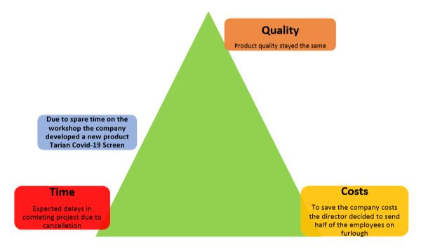

  - MONITORING AND EVALUATION
Monitoring and evaluation are the last part of the project. Benefits of this stage helps quantify the goals and sub goals. It provides a way to evaluate the vital connexion between implementers and beneficiaries on the ground and decision – makers. Evaluation provides experience in terms of resources, methods and technology.
In this stage the evaluation depends on nature & type of project: Two outcomes are possible. Hard outcome provides half the picture and is measurable, also has solid visible result in numbers and figures. Soft outcome provides the important details that give the real insight in people experiences, process and changes in attitude.
All above can be measured via different tools. For example, soft evaluation can be measure via Kolb’s Experimental Cycle, however hard evaluation can be measured in profit and increase in revenue within company.
DRL Partitions Limited managed to monitor the outcomes through the following tools:
Hard Evaluation and Monitoring
- Cancelled projects decreased the company profit. This activity is measured on weekly basis and is seen in company profit or loss.
- Sending half of the workshop employees on furlough caused problems in producing goods but mostly decreased employees’ motivation to work.
"The growth or motivator factors that are intrinsic to the job are: achievement, recognition for achievement, the work itself, responsibility, and growth or advancement. The dissatisfaction avoidance or hygiene (KITA) factors that are extrinsic to the job include: company policy and administration, supervision, interpersonal relationships, working conditions, salary, status, and security." (Herzberg, 1968)
Due to government slogan “stay home, safe lives and protect NHS” many employees are still afraid to come back to work. Even the company provided the best safety measurements.
Soft Evaluation and Monitoring has been measured through Kolb’s Experimental Cycle. Where Concrete Experience is related to Furlough employees and safety in the workplace
Reflective observation reflects to employees’ feedbacks, adopting rota shifts in the workshop,
Concluding reflects to providing training for employees.
Planning reflects to putting procedures in place like 2m social distance, supplying PPE equipment and measure temperature.

- CONCLUSION
This project explained how important project management in the organisation is. The researcher took the reader through the project lifecycle, risk and risk management in order to create the strategy for the project to be successful. By applying the proper techniques and tools and considering the iron triangle the researcher reached the goal of the project. The deliverable has been identified, assessed and evaluated.
However, team project needs to keep in mind that when the project seems to not achieve the goal, they need to know when to stop it before they are going to spend beyond the budget.

4.0 REFERENCES:
- 2020. [online] Available at: <https://www.youtube.com/watch?v=JHSHOAfV-uw> [Accessed 3 July 2020].
- 2020. [online] Available at: <https://www.youtube.com/watch?v=PXCo92Iag3g> [Accessed 1 July 2020].
- 2020. [online] Available at: <https://www-dawsonera. com.ezproxy.uwtsd.ac.uk/abstract/9780749461584> [Accessed 2 July 2020].
- Apppm.man.dtu.dk. 2020. Limitations Of The Iron Triangle - Apppm. [online] Available at: <http://apppm.man.dtu.dk/index.php/Limitations_of_the_iron_triangle> [Accessed 3 July 2020].
- Assets.publishing.service.gov.uk. 2020. [online] Available at: <https://assets.publishing.service.gov.uk/media/57a08bd1ed915d3cfd000f68/WKS081002_Annex5.pdf> [Accessed 3 July 2020].
- Axelerate.com. 2020. 10 Benefits Of Project Risk Management. [online] Available at: <https://www.axelerate.com/post/10-benefits-of-project-risk-management> [Accessed 3 July 2020].
- Excel Templates. 2020. 10 Responsibility Assignment Matrix Excel Template - Excel Templates. [online] Available at: <http://www.exceltemplate123.us/responsibility-assignment-matrix-excel-template-j2011/> [Accessed 3 July 2020].
- Heagney, J. (2012). Fundamentals of project management. (Online) New York: American Management Association.
- Hsrd.research.va.gov. 2020. Project And Award Quad Chart Guidelines. [online] Available at: <https://www.hsrd.research.va.gov/funding/quad_charts.cfm> [Accessed 29 June 2020]. access at 23:41
- Inloox.com. 2020. The 62 Most Inspiring Project Management Quotes - Inloox. [online] Available at: <https://www.inloox.com/company/blog/articles/the-62-most-inspiring-project-management-quotes/> [Accessed 2 July 2020].
- International Journal of Project Management Vol. 14, No. 2, pp. 81-87, 199 Copyright © 1996 Elsevier Science Ltd and IPMA Printed in Great Britain. All rights reserved 0263-7863/96 $15.00 + 0.00
- Izquierdo, R., 2020. A Beginner’S Guide To Workload Management. [online] MSN. Available at: <https://www.msn.com/en-us/money/small-business/a-beginners-guide-to-workload-management/ar-BB14obLQ> [Accessed 30 July 2020].
- Managementstudyguide.com. 2020. Project Management - Definition And Important Concepts. [online] Available at: <https://www.managementstudyguide.com/project-management.htm> [Accessed 2 July 2020].
- Managementstudyguide.com. 2020. What Is Management. [online] Available at: <https://www.managementstudyguide.com/what_is_management.htm> [Accessed 16 June 2020].
- Maylor, H. (2011). Project Management. 4th ed. Harlow, England: FT Prentice Hall.
- Planview. 2020. What Is Work Breakdown Structure? | Planview Leankit. [online] Available at: <https://www.planview.com/resources/articles/work-breakdown-structure/> [Accessed 3 July 2020].
- Productplan.com. 2020. What Is A Stakeholder Analysis? | Definition & How To Video. [online] Available at: <https://www.productplan.com/videos/stakeholder-analysis/> [Accessed 29 July 2020].
- Roberts, P. (2011). Effective project management. London, UK Philadelphia, PA: Kogan Page.
- Team, T., 2020. How To Measure Project Success And Avoid The Top 6 Pitfalls. [online] Mybeeye.com. Available at: <https://www.mybeeye.com/blog/how-to-measure-project-success-and-avoid-the-top-6-pitfalls> [Accessed 2 July 2020].
- Wrike.com. 2020. What Is Work Breakdown Structure In Project Management?. [online] Available at: <https://www.wrike.com/project-management-guide/faq/what-is-work-breakdown-structure-in-project-management/> [Accessed 19 June 2020].
- Www-dawsonera-com.ezproxy.uwtsd.ac.uk. 2020. [online] Available at: <https://www-dawsonera-com.ezproxy.uwtsd.ac.uk/abstract/9780814417492> [Accessed 2 July 2020].
- Www-dawsonera-com.ezproxy.uwtsd.ac.uk. 2020. [online] Available at: <https://www-dawsonera-com.ezproxy.uwtsd.ac.uk/abstract/978027374352> [Accessed 2 July 2020].

