Q1. Evaluate the concept of evidence-based practice (EBP) and provide two examples of where Technivara could use it to ensure sound decision-making in people practice. (AC 1.1)

Evidence based practice (EBP) reflects the idea that quality decision-making is informed by the most reliable evidence and guided by critical thinking (Barends, Rousseau and Briner, 2014). People professionals should take multiple sources of evidence into account including professional expertise and judgement, stakeholder and employee views, scientific research and organisational data (CIPD, 2025a). Furthermore, evidence should be carefully examined and evaluated for validity, reliability, relevance, bias and limitations before informing decisions (Barends, Rousseau and Briner, 2014). This can be realised through a systematic six-step evaluation process of the evidence: ask questions, acquire, appraise, aggregate, apply and assess outcomes (Elder and Nikodem, 2023; CIPD, 2025).

Technivara presently operates in a traditional way which lacks data-driven and evidence based practices. Consequently, decisions may be influenced by personal opinions, subjective judgement and trends rather than robust evidence. Introducing a systematic, rational framework to gather, critically appraise and apply evidence will allow Technivara to reduce bias and reliance on intuition in decisions (Briner, Denyer and Rousseau, 2009; Friedman, 2023). This aids improved decision quality whilst also reducing legal and ethical risk by enabling fairness and consistency in people decisions (CIPD, 2025). EBP also encourages alignment between strategic people decisions and business objectives which could help Technivara meet their expansion goals (Armstrong and Taylor, 2014).

One limitation is that the quality and accessibility of data may be restricted by Technivara’s paper-based systems. This reflects bounded rationality where decision-makers are unable to take every relevant piece of information into account (Simon, 1990). It may be time and resource intensive to implement a new system and analytics to overcome this. Additionally, it is important for both qualitative and quantitative data to be considered for EBP to be effective. This could come from primary or secondary sources. Cultural resistance is another barrier as employees and decision-makers may resist change as a result of the traditional leadership and culture presently in place (Armstrong and Taylor 2014). People practitioners are paramount to ensuring effective change management to reduce the impact of this.

New roles will likely be required as Technivara expand therefore EBP will aid recruitment and overcome reliance on traditional, subjective methods. For example, decision-making accuracy would be improved by analysing internal turnover and skills gap data, external benchmarking, introducing validated selection methods and structured interviews (Linos and Reinhard, 2015). Schmidt and Hunter (1998), illustrate that structured recruitment and selection methods show higher validity in predicting performance than unplanned methods. Applied effectively, this will help reduce bias, enable strategic alignment of people and goals whilst improving hiring quality.

Technivara could also use evidence-based methods to inform reward and pay decisions (CIPD, 2025b). EBP would enable pay, promotions and bonuses to be issued based on appraised evidence which would support retention, morale and trust. Stakeholders would also be provided with valuable financial insight and performance based metrics to inform decisions. An EBP approach could include looking at internal pay data, identifying gaps, comparing against external benchmarking data and salary guides (Rose, 2014). This quantitative data could be combined with qualitative information gathered through employee feedback surveys and 121s. Ultimately, EBP would then enable structured, objective criteria to be set for reward, pay, promotions and bonuses.

Q2. Evaluate one appropriate analysis tool and one appropriate analysis method that Technivara might apply to recognise and diagnose issues, challenges and opportunities. (AC 1.2)

SWOT provides an effective analysis tool for Technivara to explore its internal strengths and weaknesses along with external opportunities and threats (Waite et al, 2021). It enables managers and people professionals to understand organisational position, diagnose underlying issues, challenges and strategic opportunities, for example, during the planned expansion and modernisation (CIPD, 2025c).

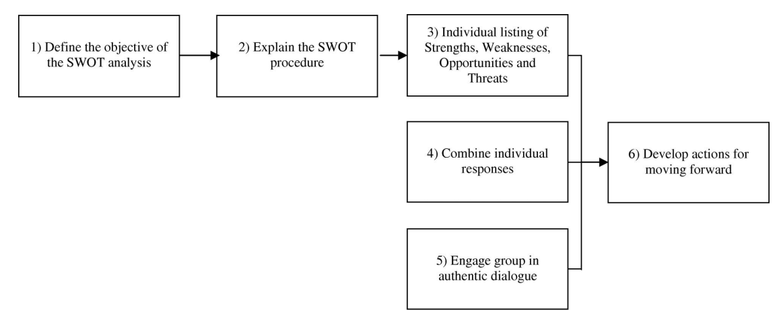

Figure 1 – SWOT process (Chermack and Kasshanna, 2007)

Recognising strengths such as sustained company growth over the last sixteen years and high employee and client retention enables Technivara to diagnose organisational stability and workforce capability. Both of these act as a platform for growth and help determine readiness for expansion. Analysing weaknesses, including outdated paper-based systems, traditional practices and limited use of evidence based-approaches allow managers to identify challenges such as operational inefficiencies and cultural barriers that could hinder expansion or modernisation (CIPD, 2025c). Opportunities, such as market expansion, technological integration, onboarding new talent and introducing EBP could allow Technivara to identify areas for workforce development and strategic investment. Finally, identifying threats including skills shortages, potential change resistance, external competition and legal or ethical risks allows Technivara to diagnose vulnerabilities and plan mitigating strategies (Tinsager and Smith, 2022).

SWOT is a rational, simplistic tool that will provide structured insight for Technivara to better understand readiness for expansion, opportunities and anticipated risks within their sector whilst supporting decision-making. However, the effectiveness of SWOT as an analysis tool is hindered by reliance on opinion, limited input and traditional approaches as opposed to being enhanced by EBP approaches and data-driven metrics. SWOT should integrate qualitative and quantitative evidence, reflecting the four types of data required for effective EBP (CIPD, 2025d). However, SWOT is static and can oversimplify cultural and behavioural challenges, so Technivara should use additional tools for comprehensive diagnosis.

Structured interviews is one analysis method that Technivara could use to recognise and diagnose issues, challenges and opportunities. Typically, the same questions would be asked in a set order to collect information on experiences, behaviours, perceptions and skills (Armstrong and Taylor, 2014). This initially provides qualitative data. Exit interviews could be conducted with leavers to help Technivara understand what has prompted them to leave. For example, by establishing views on current systems, pay and reward structures, culture, leadership methods, growth plans, skills and training. Exit interviews allow one final opportunity to persuade the employee to stay, for example, by addressing the problems discussed, but this is often too late to make a difference (HR-Inform, 2021). Marchington et al (2025) highlight two limitations of exit interviews. Firstly, the quality of the data may be restricted as leavers do not wish to share honest feedback. Secondly, leavers are often viewed uniformly instead of considering variations in their demographic characteristics, service length etc. That said, it is possible for this to be captured and analysed to enhance the quality of the data.

Technivara could also introduce stay interviews to understand feedback from current employees and stakeholders (Finnegan, 2018). These may be time-consuming to plan, carry out and analyse but would provide strong insight into causation along with both qualitative data through descriptive analysis and quantitative data through correlation and trend analysis, enhancing the overall validity of the findings (CIPD, 2025e). Both exit and stay interviews would enable Technivara to identify issues, challenges and opportunities which in turn would support strategic decision making e.g. modernisation, risk mitigation and workforce planning to support growth.

Q3. Explain the main principles of critical thinking including how these might apply to your own and others’ ideas to assist objective and rational debate at Technivara (AC 1.3)

Critical thinking involves using logical, objective and evidence-informed reasoning to evaluate ideas and information (CIPD, 2019). Within Technivara, strategic decisions are influenced by intuition and personal judgement resulting from a traditional leadership style and outdated paper-based systems. Subsequently, there is an increased risk of bias, bounded rationality, inconsistent outcomes and decisions (Simon, 1990; Barends, Rousseau and Briner, 2014). Applying critical thinking would allow me, as People Practice Advisor, and others within the organisation to evaluate ideas objectively whilst assisting rational debate at Technivara.

Objective reasoning is one key principle of critical thinking and involves separating emotion and personal belief from factual evidence. Ruggiero (2012) notes that people often feel as opposed to think which can hinder rational debate. Feelings are described as subjective and rise unconsciously whereas thinking is a conscious mental processes used to understand information, find solutions and overcome problems. As People Practice Advisor, I would critically assess my own thoughts and ideas before presenting them and also ensure that others ideas are evaluated against data as opposed to be taken at face value. I could also ask clarifying questions and encourage them to reflect on their own assumptions. This will help ensure fairness and consistency whilst encouraging structured debate.

Building on this, critical thinking also requires questioning evidence and sources to confirm their validity, reliability and relevance (Barends, Rousseau and Briner, 2014). Within my own role, I would use triangulation to support this by gathering and comparing data from multiple sources. For example, I could look at available internal metrics, gather employee feedback and carry out external benchmarking. This would allow correlation and validity to be assessed before I present my ideas and findings (CIPD, 2025e).

Another principle of critical thinking is bias awareness, which is crucial when evaluating evidence, my own ideas and opinion and those of others. At Technivara, traditional leadership and reliance on personal judgement increases the risk of both conscious and unconscious bias reflecting deliberate preferences and ingrained assumptions (Barends, Rousseau and Briner, 2014). As People Practice Advisor, I would actively question my own assumptions and opinions through self-reflection and check against reliable evidence sources to ensure validity and reasoned judgement. Woodhams and Perkins (2022) highlight the importance of applying critical thinking to online sources by examining bias as underlying or hidden personal or political interests may introduce bias or compromise validity. I would make informed decisions, ask questions and use triangulation to enhance validity.

Applying these principles will promote objective, rational debate at Technivara whilst improving the quality of people decisions, supporting EVP and providing organisational insight (CIPD, 2025).

Q4. Explain two decision-making processes that Technivara could apply to ensure that effective outcomes are achieved. (AC 1.4)

Structured decision-making will be essential as Technivara expands and modernises, moving away from traditional approaches and paper-based systems. De Bono (1999, cited in Serrat, 2017) outlines a Six Thinking Hats model which Technivara could apply to strengthen decision-making and outcomes within people practice. The model promotes parallel thinking, allowing HR problems to be examined through multiple perspectives (Woodhams and Perkins, 2022). Team members metaphorically wear the same hat at the same time, focusing on one shared viewpoint, before collectively cycling through all six. This could help inform HR decisions in areas such as recruitment, engagement, workforce planning or implementing a new system. For this example, workforce planning will be explored.
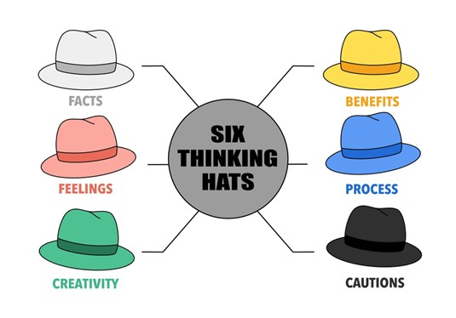
Figure 2 (Singapore Institute of Management, 2025).

The white hat signifies facts and data, and would encourage evidence-based decision making using internal HR metrics such as retention and turnover rates, skills gaps, headcount and projected resource requirements. The red hat allows intuition, emotion and gut feelings to be expressed openly which is important because decisions are not purely data based. For example, by enabling thought sharing on morale, changes to role etc. The green hat would promote a creative response to problems and decisions, for example, the people team could brainstorm ideas for recruitment, training and upskilling or internal redeployment. The black hat would enable identification of risks such as skills gaps, budget restraints or morale impacts. It would also encourage evaluation and critical thinking to overcome these (Woodhams and Perkins, 2022). The yellow hat would elicit positive thinking, encouraging teams to identify benefits of the proposed changes such as improved morale, engagement, improved training and productivity (Serrat, 2017). Finally, the blue hat represents control, allowing the group to decide which hat to use at each stage thereby maintaining structural alignment.

The success of this approach may be limited by Technivara’s traditional culture and potential resistance to change and it requires strong facilitation, aided by the people team. However, by balancing evidence, emotion, risk and creativity it enables informed people decisions and effective outcomes.

Technivara could also use the Kepner-Tregoe (KT) model which offers a rational, systematic approach to problem solving and is suited for complex decisions (Parra et al., 2023). The model is grounded in critical thinking and typically has four steps as outlined in Figure 3.

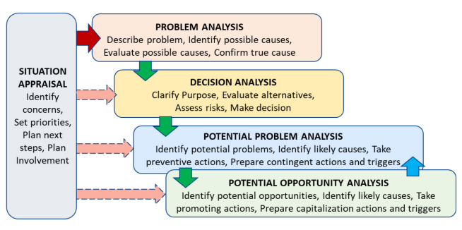
Figure 3 (Markopoulos et al., 2022).

For illustrative purposes, these steps could be applied to Technivara’s challenge of having paper-based HR processes. Situation appraisal would enable Technivara to identify and prioritise the problem which, in this example, is the need for system modernisation. Problem analysis would then identify the root cause of the problem such as limited data, poor record-keeping, outdated processes and inefficient manual processes (Parra et al., 2023). Decision analysis would evaluate HR system options factoring in criteria such as cost, usability, reporting tools, compliance and scalability. Potential problem analysis would anticipate risks such as resistance to change and training gaps whilst allowing mitigation strategies to be developed e.g. training and phased rollout (Markopoulos et al., 2022). Finally, opportunity analysis allows for positive outcomes to be identified, for example, improved accuracy, data-driven insights, cost-saving and improved efficiencies. The KT model would ensure systematic exploration of issues, solutions, risks, mitigation strategies and opportunities which would encourage evidence-based, informed decisions within Technivara.

Q5. Assess two different ethical perspectives including how these could be used at Technivara to inform and influence decision-making. (AC 1.5)

Deontology, often referred to as Kantian or rights-based ethics, is one ethical perspective that could be applied to decision-making at Technivara. This perspective centres on the idea that we have a moral duty to help those in need thereby emphasising equality, respect and honesty (Clark, 2015). This closely aligns with the CIPD code of conduct and can be adopted by the people team and senior leaders to ensure ethical practice when making decisions and determining actions (CIPD, 2023). Deontological approaches help safeguard employee needs and interests whilst promoting fairness and consistency.

Technivara could apply this lens to ensure equal treatment across recruitment, pay, reward and performance decisions during the proposed expansion. This would encourage a shift from traditional, informal decision-making to a more structured, fair process. A deontological approach would enable the people team and leaders to consider moral duties in every decision, shaping judgements and decisions across day-to-day actions and strategic outcomes (Clark, 2015). Decisions underpinned by fairness and consistency will also enhance legal and ethical compliance. When modernising HR systems, this approach would ensure that employee data is handled lawfully and confidentially whilst encouraging morale attentiveness (Shahzad et al., 2024. Furthermore, it would encourage transparent and fair decisions regarding recruitment and workforce planning during the expansion.

However, this perspective is often criticised for its rigidity as strict adherence to ethical rules can produce morally questionable outcomes in complex scenarios (Holt, 2020). Applying the same procedure to every scenario without considering individual or situational context can slow decision-making and organisational changes. For example, thoroughly checking all pay or promotion changes for fairness and equality before implementation may reduce business efficiency and hinder morale.

Another ethical perspective, utilitarianism, could inform and influence Technivara’s decision-making by prioritising actions that achieve the greatest benefit for the largest number of people (Schumann, 2001). This approach bases morality on the consequences of decisions rather than an adherence to moral duties as seen in deontological approaches. This approach would be particularly useful for Technivara in shaping strategic decisions for growth whilst aligning with performance goals and supporting fair HR practices (Smith and Mitchell, 2022a). For example, workforce planning decisions could prioritise the development and deployment of skills needed to support growth even if this requires restructuring certain roles or brings uncertainty. Utilitarianism focuses on cost benefit analysis and closely aligns to evidence-based practice as decisions are informed by data, metrics and measurable outcomes (Smith and Mitchell, 2022a). This means that decisions are justified by ethical reasoning whilst ensuring they bring the greatest benefit to the most people. This could be applied to modernisation as introducing a HR system will have a majority benefit through increasing efficiency, compliance and data quality.
That said, it is important for people teams and leaders to ensure that the marginal voices and employee well-being are considered in decision-making. This helps mitigate the limitations of utilitarianism, which can reduce fairness, individual rights and morality. Technivara should apply ethical perspectives in a way that supports growth and modernisation whilst maintaining trust, wellbeing and professional integrity (CIPD, 2025f).

Q6. Appraise two different ways that Technivara could measure financial and non-financial performance, providing one example of each. (AC 3.1)

One financial performance measure Technivara could apply is the profit and loss (P&L) statement. As a private-sector organisation, this is a relevant tool for assessing financial health as it summarises revenue, production costs, operating expenses and overall profit or loss over a given time period (Stobierski, 2020). Additionally, net profit margin would provide a clearer picture of performance by showing the proportion of revenue remaining after all costs and deductions. This would strengthen P&L analysis by highlighting Technivara’s actual profitability and how effectively the organisation manages costs relative to revenue (Marr, 2012). This would be particularly important for Technivara as they enter a period of growth and modernisation. Net profit margin would be more informative than looking at gross profit alone and would enable Technivara to assess whether turnover growth is generating sufficient return (Stobierski, 2020).

For example, implementing a new HR system will incur costs such as software, implementation and training costs and may temporality hinder productivity. Monitoring net profitability would help Technivara to evaluate whether these initial investments have brought long-term financial benefits such as improved efficiency, reduced overtime and more informed pay and workforce planning decisions. Sustained net profitability would indicate that investments are financially beneficial thereby reinforcing evidence based HR decisions e.g. within recruitment, training and retention.

One benefit of net profit analysis is that it allows financial performance to be compared over time. However, as it is typically reviewed monthly, this retrospective view may restrict prompt decision making (Marr, 2012). Therefore. Technivara should also use non-financial measures, such as the employee turnover rate, to provide a more balanced understanding of performance. This would involve calculating the percentage of employees who exit Technivara within a defined time period, against the total workforce (Taylor and Woodhams, 2022).

As Technivara expands, monitoring employee turnover rate is essential because high turnover levels can disrupt growth plans, hinder productivity, weaken culture and morale and create skills gaps (Al-Suraihi et al., 2021). While some turnover can be beneficial, such as removing underperforming team members and allowing for fresh perspectives via new starters, excessive turnover can create instability. Although this metric serves as an early warning indicator, it is simplistic in nature and does not provide detailed insight into why employees leave. Therefore, Technivara should use qualitative methods such as exit interviews for a more complete insight and to undertake informed mitigating actions (Fukui et al., 2025).

Q7. Explain how people practices could add value at Technivara and identify two methods that might be used to measure the impact of these people practices. (AC 3.2)

Burke (2023) highlights that organisations should recognise the value of people practices in developing human capital, enhancing decision-making and supporting strategic goals. At Technivara, people practices could add measurable value by matching workforce skills with strategic goals whilst driving productivity and strengthening organisational culture. Robust hiring methods that assess skill and cultural alignment will enhance fit, reduce hiring time and support growth plans. Additionally, providing realistic job previews and maintaining transparency through the recruitment process will foster trust and increase the likelihood of the employee staying long-term (Smith and Mitchell, 2022b). This will be further strengthened by effective induction and onboarding processes.

People practice encompasses wider retention strategies that could add value at Technivara by retaining talent and skills within the business and mitigating turnover costs. For example, the people team could identify and support the delivery of training and development opportunities, ensure transparency in pay and promotion and provide clearly defined career pathways. These initiatives will ensure employees are equipped with the skills and capabilities needed to support Technivara’s growth and modernisation plans. Additionally, people practices that drive engagement, such as consulting and involving employees in changes, can boost morale and buy-in. When coupled with clear reward and career development structures, people practices could add value at Technivara by improving retention, driving performance and encouraging alignment with strategic goals.

To measure the impact of these people practices, Technivara could use return on investment (ROI) analysis which is commonly used in private-sector organisations. ROI is expressed as a percentage and would measure how much value initiatives including recruitment, training, engagement and reward generate compared with their costs (Findlay et al., 2018). For example, when delivering a new training programme Technivara could use ROI to assess whether the benefits of the programme outweigh the costs of planning, delivering and supporting the programme. Tangible benefits such as cost savings, increased efficiency and revenue may be easier to quantify than intangible benefits such as reduced errors, improved retention and engagement. One criticism of ROI is that intangible benefits are difficult to quantify thereby impacting accuracy and relying on assumption. It is also calculated after the event, offering a retrospective view as opposed to cost-benefit analysis which aims to predict future results. That said, ROI would allow the people teams to demonstrate the value of HR practices in supporting strategic plans, performance and decisions.

Technivara could also implement key performance indicators (KPIs) to measure the value generated by people practices and to ensure alignment with organisational goals (CIPD, 2026). KPIs could provide metrics across multiple areas including recruitment (time to hire, cost per hire, quality of hire), retention (turnover and retention rates), training and development (completion rates, ROI) and engagement (absenteeism rates, employee engagement scores) (Parmenter, 2014). KPIs could enable the people team to identify issues early and implement mitigate strategies to reduce potential negative impacts (Agile HR Analytics, 2026). One limitation is that effective KPI reporting requires robust technology and reporting tools. The could be addressed by implementing the digital HR system which would facilitate data-driven decisions, improve accessibility to insights, enable benchmarking (internal and external) and strengthen the evidence of the value people practices deliver.

Q8. Table 1 shows Technivara's turnover and recruitment data for 2024. Sue has asked you to convert the data into percentage form, for each of the departments, to show: leavers as a % of the total number of employees, vacancies as % of the total number of employees, positions filled as a % of the total number of employees (AC 2.1)
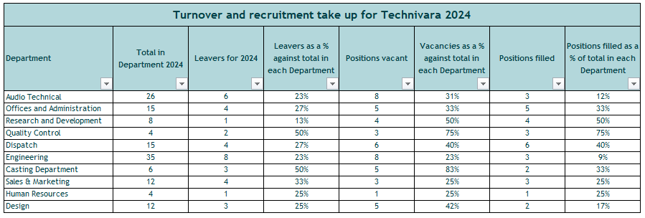

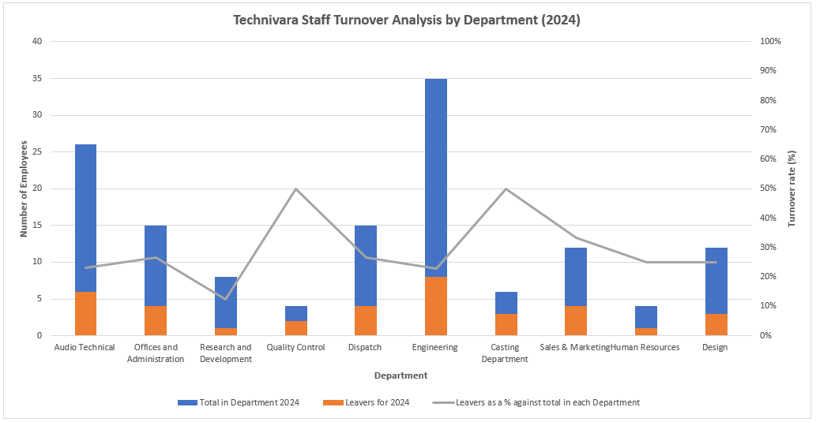
Q9. When you have completed Table 1, present your findings using a minimum of three different types of diagrammatical forms. (AC 2.2)
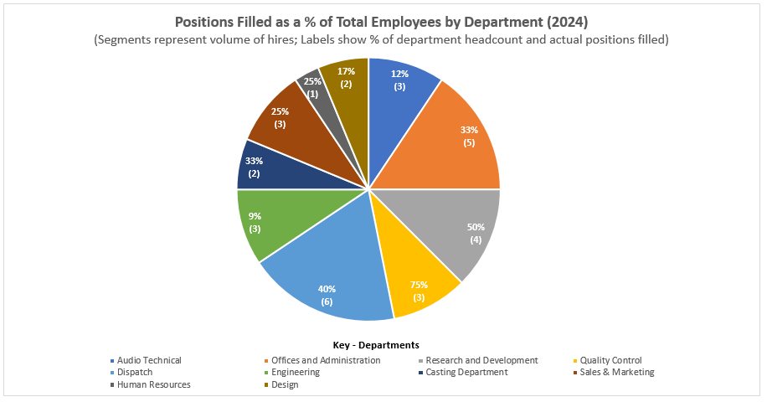
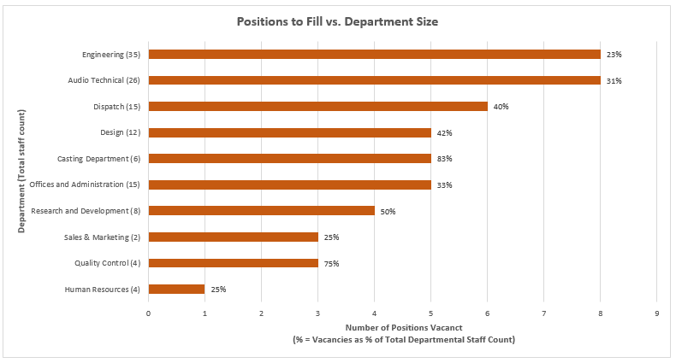

Q10. Table 2 contains evaluation feedback from 42 employees who attended a recent learning and development activity. Sue would like you to review the feedback and identify patterns, themes or trends that might be occurring and make recommendations based on your findings. (AC 2.3)

Bibliography:

Agile HR Analytics (2026) HR performance KPIs: key metrics to drive organisational impact. Available at: https://www.agile-hr-analytics.com/hr-performance-kpis-guide/ (Accessed: 31 January 2026).

Al-Suraihi, W.A., Samikon, S.A., Al-Suraihi, A.A. and Ibrahim, I. (2021) ‘Employee turnover: causes, importance and retention strategies’, European Journal of Business and Management Research, 6(3), pp. 1–10. Available at: https://doi.org/10.24018/ejbmr.2021.6.3.893

Armstrong, M. and Taylor, S. (2014) Armstrong’s handbook of human resource management practice. 13th edn. London: Kogan Page.

Barends, E., Rousseau, D.M. and Briner, R.B. (2014) Evidence-based practice: the basic principles. Centre for Evidence-Based Management (CEBMa). Available at: https://cebma.org/assets/Uploads/Evidence-Based-Practice-The-Basic-Principles.pdf (Accessed: 24 January 2026).

Briner, R.B., Denyer, D. and Rousseau, D.M. (2009) Evidence-based management: concept cleanup time? Academy of Management Perspectives, 23(4), pp. 19-32. Available at: https://cebma.org/assets/Uploads/Briner-Denyer-Rousseau-Evidence-based-management-Concept-cleanup-time.pdf (Accessed: 24 January 2026).

Burke, E. (2023) People and the creation of value: why organisations need to up their game on understanding, measuring and leveraging human capital. Available at: https://www.cipd.org/globalassets/media/knowledge/knowledge-hub/reports/people-and-the-creation-of-value_tcm18-19955.pdf (Accessed: 31 January 2026).

Chermack, T.J. and Kasshanna, B.K. (2007) ‘The use and misuse of SWOT analysis and implications for HRD professionals’, Human Resource Development International, 10(4), pp. 383–399. Available at: https://chermackscenarios.com/wp-content/uploads/2020/10/The-Use-and-Misuse-of-SWOT-Analysis-and-Implications-for-HRD-Professionals.pdf (Accessed: 24 January 2026).

CIPD (2019) ‘Critical thinking’. CIPD podcast [Podcast]. Available at: https://www.cipd.org/uk/knowledge/podcasts/critical-thinking/ (Accessed: 26 January 2026).

CIPD (2023) CIPD code of conduct and ethics. London: Chartered Institute of Personnel and Development. Available at: https://www.cipd.org/globalassets/media/comms/code-of-conduct/2023-cipd-code-of-conduct-and-ethics.pdf (Accessed: 28 January 2026).

CIPD (2025a) Evidence-based profession. Available at: https://www.cipd.org/uk/knowledge/guides/evidence-based-profession/ (Accessed: 24 January 2026).

CIPD (2025b) Reward: an introduction. Factsheet. Available at: https://www.cipd.org/uk/knowledge/factsheets/reward-factsheet/ (Accessed: 24 January 2026).

CIPD (2025c) SWOT analysis. Factsheet. Available at: https://www.cipd.org/uk/knowledge/factsheets/swot-analysis-factsheet/ (Accessed: 24 January 2026).

CIPD (2025d) Evidence-based practice for effective decision-making. Factsheet. Available at: https://www.cipd.org/en/knowledge/factsheets/evidence-based-practice-factsheet/ (Accessed: 24 January 2026).

CIPD (2025e) People analytics. Factsheet. Available at: https://www.cipd.org/uk/knowledge/factsheets/analytics-factsheet/ (Accessed: 26 January 2026).

CIPD (2025f) Ethical practice and the role of people professionals. Available at: https://www.cipd.org/uk/knowledge/factsheets/ethics-role-hr-factsheet/ (Accessed: 28 January 2026).

CIPD (2026) Performance management factsheet. Available at: https://www.cipd.org/uk/knowledge/factsheets/performance-factsheet/ (Accessed: 31 January 2026).

Clark, S.J.A. (2015) Ethical decision making: eight perspectives on workplace dilemmas. London: CIPD Publishing. Available at: https://www.cipd.org/globalassets/media/comms/the-people-profession/profession-map-pdfs/ethical-decision-making-2015-eight-perspectives-on-workplace-dilemmas_tcm29-9564.pdf (Accessed: 28 January 2026).

Findlay, P., Thompson, P., Cooper, C. and Pascoe-Deslauriers, R. (2018) Creating and capturing value at work: Who benefits? Part 2 – measurements report. Available at: https://www.cipd.org/globalassets/media/knowledge/knowledge-hub/reports/creating-and-capturing-value-at-work_2018-who-benefits-part-2_tcm18-37078.pdf (Accessed: 31 January 2026).

Finnegan, R.P. (2018) The power of stay interviews for engagement and retention. 2nd edn. Society for Human Resource Management (SHRM).

Friedman, H.H. (2023) Cognitive biases and their influence on critical thinking and scientific reasoning: a practical guide for students and teachers. SSRN Electronic Journal. Available at: https://www.researchgate.net/publication/316486755_Cognitive_Biases_and_Their_Influence_on_Critical_Thinking_and_Scientific_Reasoning_A_Practical_Guide_for_Students_and_Teachers (Accessed: 24 January 2026).

Fukui, S., Garabrant, J., Greenfield, J., Salyers, M.P., Morse, G. and Bass, E. (2025) ‘Using exit surveys to elicit turnover reasons among behavioral health employees for organizational interventions’, Psychiatric Rehabilitation Journal, 48(3), pp. 208-213. Available at: https://pmc.ncbi.nlm.nih.gov/articles/PMC12312671/ (Accessed: 31 January 2026).

Holt, D. (2020) Deontology: strengths & weaknesses. Available at: https://viva.pressbooks.pub/phi220ethics/chapter/deontology-pros-cons/ (Accessed: 28 January 2026).

HR-Inform (2021) Stay interviews – a valuable retention tool. Available at: https://www.hr-inform.co.uk/news-article/stay-interviews-a-valuable-retention-tool (Accessed: 26 January 2026).

Linos, E. and Reinhard, J. (2015) A head for hiring: the behavioural science of recruitment and selection. CIPD. Available at: https://www.cipd.org/globalassets/media/knowledge/knowledge-hub/reports/a-head-for-hiring_2015-behavioural-science-of-recruitment-and-selection_tcm18-9557.pdf (Accessed: 24 January 2026).

Marchington, M., Wilkinson, A., Donnelly, R. and Kynighou, A. (2025) Human resource management at work: the definitive guide. 8th edn. London: Kogan Page.

Markopoulos, E., Refflinghaus, J., Roell, M. and Vanharanta, H. (2022) ‘Understanding situationality using the Kepner‑Tregoe Method in the Company Democracy Model to increase employee engagement and knowledge contribution’, Creativity, Innovation and Entrepreneurship, 31, pp. 196-207. Available at: https://doi.org/10.54941/ahfe1001522

Marr, B. (2012) Key performance indicators: the 75 measures every manager needs to know. 1st edn. Harlow: Pearson.

Parmenter, D. (2014) Human resources key performance indicators. Available at: https://www.researchgate.net/publication/269829585_Human_Resources_Key_Performance_Indicators (Accessed: 31 January 2026).

Parra, X., Tort-Martorell, X., Alvarez-Gomez, F. and Ruiz-Viñals, C. (2023) ‘Chronological evolution of the information-driven decision-making process (1950-2020)’, Journal of the Knowledge Economy, 14(3), pp. 2363-2394. Available at: https://doi.org/10.1007/s13132-022-00917-y

Reid Elder, S. and Nikodem, M. (2023) ‘Considering the application and relevance of evidence-based HR’. People Management. Available at: https://www.peoplemanagement.co.uk/article/1845833/considering-application-relevance-evidence-based-hr (Accessed: 24 January 2026).

Rose, M. (2014) Reward management. London: Kogan Page Ltd. Available at: https://nibmehub.com/opac-service/pdf/read/Reward%20Management-%20Rose-%20M..pdf (Accessed: 24 January 2026).

Ruggiero, V.R. (2012) Beyond feelings: a guide to critical thinking. 9th edn. McGraw-Hill.

Schmidt, F.L. and Hunter, J.E. (1998) ‘The validity and utility of selection methods in personnel psychology: practical and theoretical implications of 85 years of research findings’, Psychological Bulletin, 124(2), pp.262-274. Available at: https://docslib.org/doc/4277464/the-validity-and-utility-of-selection-methods-in-personnel-psychology-practical-and-theoretical-implications-of-85-years-of-research-findings (Accessed: 24 January 2026).

Schumann, P.L. (2001) ‘A moral principles framework for human resource management ethics’, Human Resource Management Review, 11(1–2), pp. 93-111. Available at: https://doi.org/10.1016/S1053-4822(00)00042-5

Shahzad, K., Hong, Y., Muller, A., DeSisto, M. and Rizvi, F. (2024) ‘An investigation of the relationship between ethics-oriented HRM systems, moral attentiveness, and deviant workplace behavior’, Journal of Business Ethics, 192(3), pp. 591–608. Available at: https://doi.org/10.1007/s10551-023-05513-x

Singapore Institute of Management (SIM) (2025) Six thinking hats technique: boost decision making & solve workplace problems. Available at: https://www.sim.edu.sg/articles-inspirations/six-thinking-hats-technique-boost-decision-making-solve-workplace-problems (Accessed: 25 January 2026).

Serrat, O. (2017) ‘Wearing six thinking hats’, in Knowledge solutions, Singapore: Springer, pp. 615-618. Available at: https://link.springer.com/chapter/10.1007/978-981-10-0983-9_67 (Accessed: 25 January 2026).

Simon, H.A. (1990) ‘Bounded rationality’, in Eatwell, J., Milgate, M. and Newman, P. (eds) Utility and probability. London: Palgrave Macmillan, pp. 15-18. Available at: https://link.springer.com/chapter/10.1007/978-1-349-20568-4_5 (Accessed: 24 January 2026).

Smith, J. and Mitchell, J. (2022a) ‘The behaviour of the people professional’, in Taylor, S. and Woodhams, C. (eds) Studying human resource management. 3rd edn. London: Kogan Page pp. 141-172.
Smith, J. and Mitchell, J. (2022b) ‘Shaping people practice to benefit your organisation’, in Taylor, S. and Woodhams, C. (eds) Studying human resource management. London: Routledge, pp. 89-112.
Stobierski, T. (2020) 13 financial performance measures managers should monitor. Harvard Business School Online. Available at: https://online.hbs.edu/blog/post/financial-performance-measures (Accessed: 31 January 2026).

Taylor, S. and Woodhams, C. (2022) Studying human resource management. 3rd edn. London: Kogan Page.

Tinsager, A. and Smith, B. (2022) ‘Managing employee reactions to change’, in Taylor, P. and Woodhams, E. (eds) Organisational change and development. London: Routledge, pp. 41-64.
Waite, K., Beevers, K., Tomlinson, K., Small, N. and Hussain, S. (2021) People practice: a complete guide. London: Kogan Page.
Woodhams, C. and Perkins, G. (2022) ‘Research and evidence-based practice in HRM’, in Taylor, S. and Woodhams, C. (eds) Studying human resource management. 3rd edn. Kogan Page.

