Application of Maths using Matlab

Richard Hankinson
P137603

Mathematics (Electronics)

Wales Institute for Science and Art
University of Wales Trinity Saint David



Part1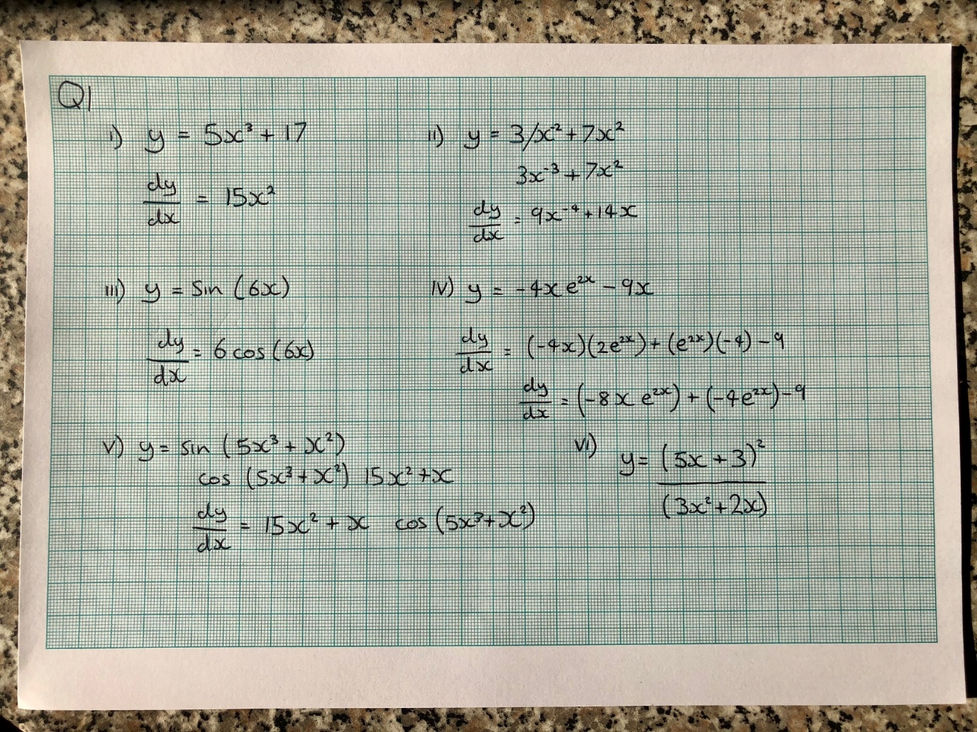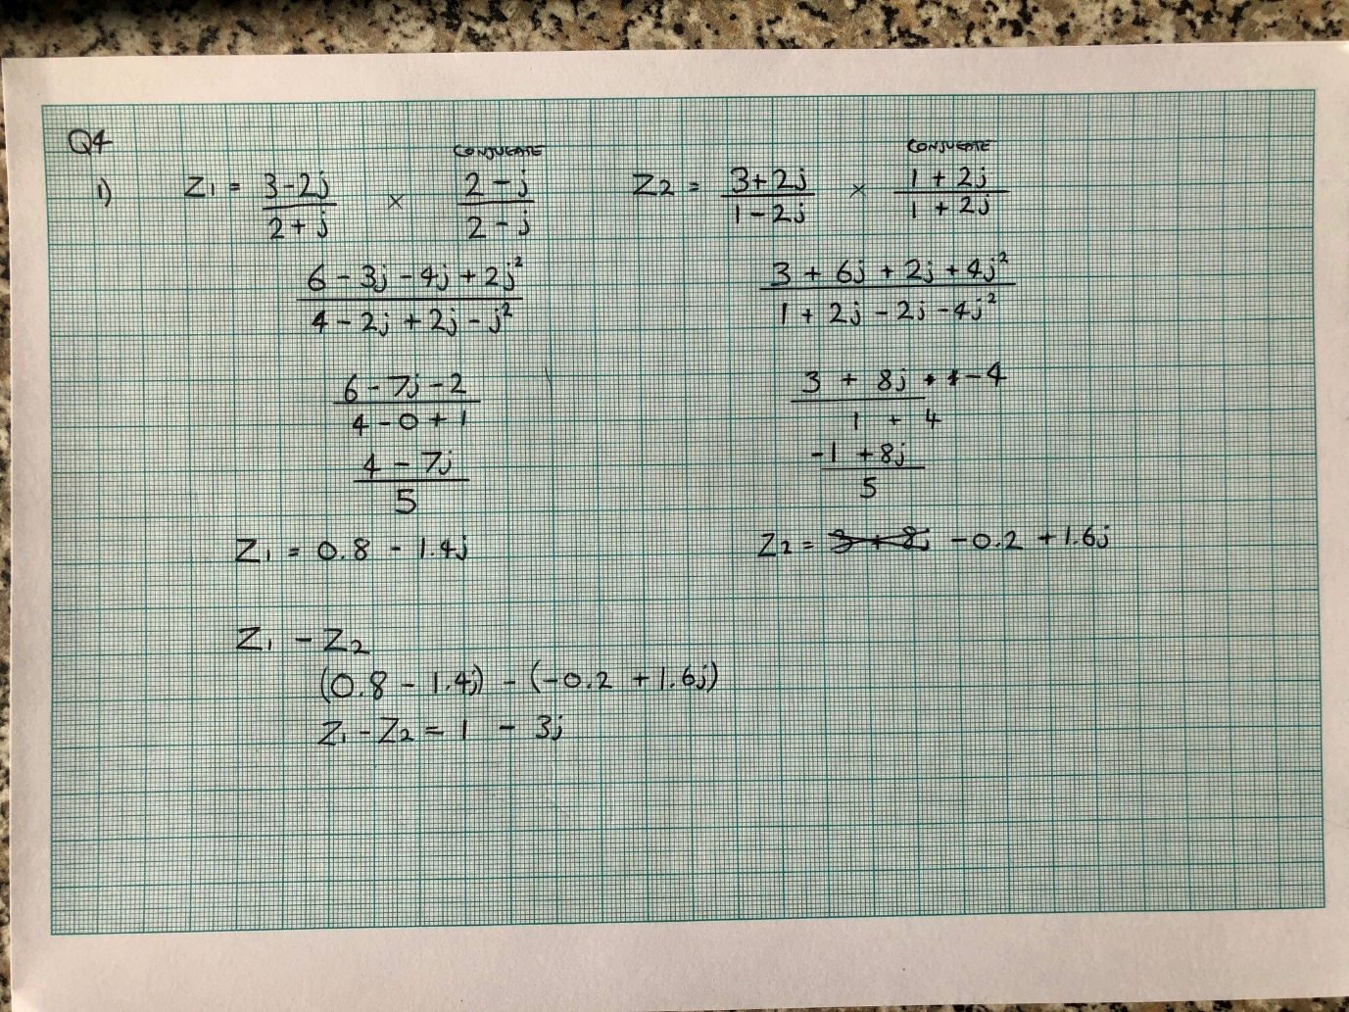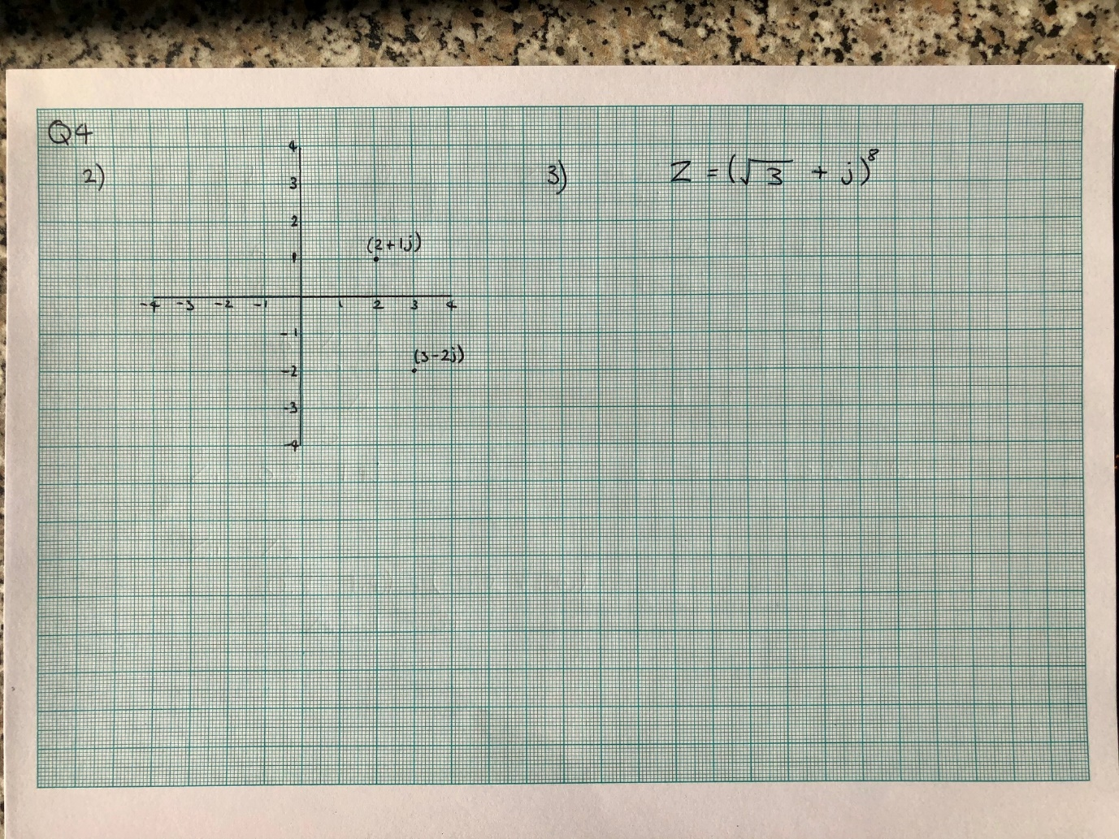
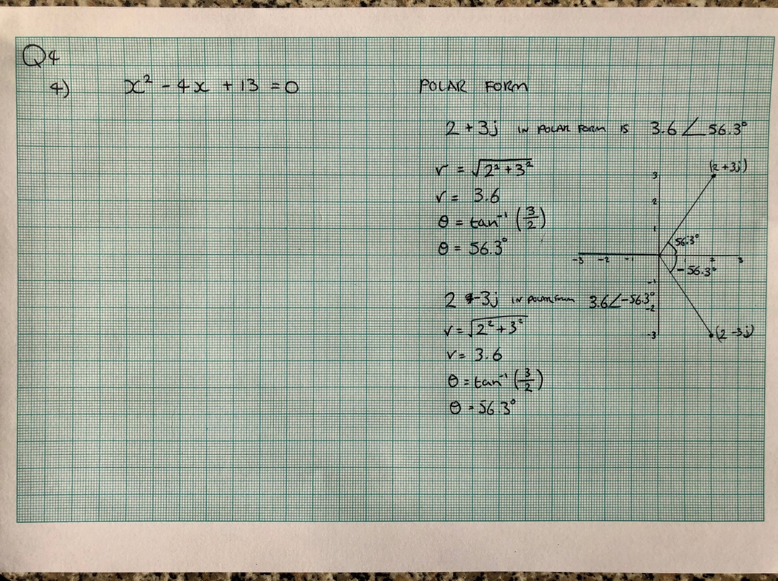

Part 2
- For questions 1 and 2 of Part 1 of this assessment use Matlab to check your results.
Question 1
i)
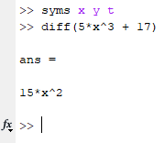
ii)
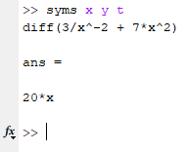
iii)
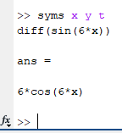
iv)
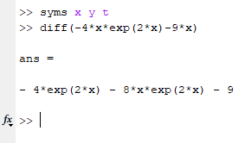

v)
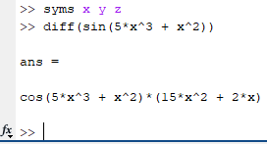
vi)
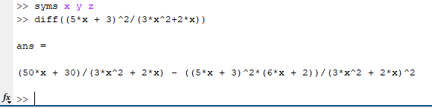

Question 2
i)
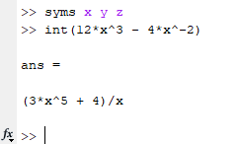

- If a = 2.12 use Matlab to evaluate $(a+a^{3})^{3}, \ln{a}, 7a+5a^{3}\text{ ,}{ cos3a and e}^{\sin{4}a}$.
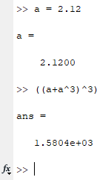
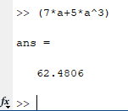
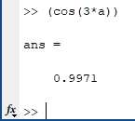

[10]

3. Use solve to find both roots of the equation $y=2x^{2}-4x-6$ correct to four
decimal places.
(Start with clear all and syms )
[10]

4. Find the gradient m and constant c in the equation of the straight line which
is a least squares approximation to

x 2.0 3.0 4.0 5.0 6.0 7.0
y 13.8 20.2 26 32.4 37.6 44

Calculate the y values according to the least squares line and draw the graphs
of the original points and the line. Estimate the value of y at $x=4.5$.

[20]

5. For the two vectors a=(3,4,1) and b=(2,5,7) find the dot product of a and b and the cross product of a with b (a x b).

Dot product
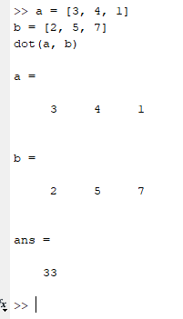

Cross product
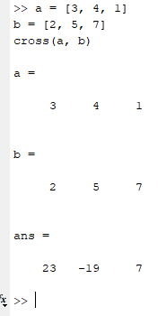

[10]

6. Find the determinant of the matrix A $=\left[\begin{matrix}2 & 1 & 3 \\ 1 & -2 & 2 \\ 3 & 1 & -1\end{matrix}\right]$
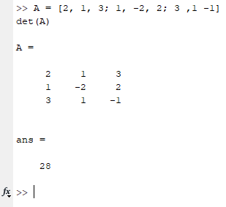
[5]

7. Use Matlab to solve the following set of simultaneous equations

1x -2y + 4z = 9
2x + 3y + 1z = 12
1x + 6y - 2z = 7

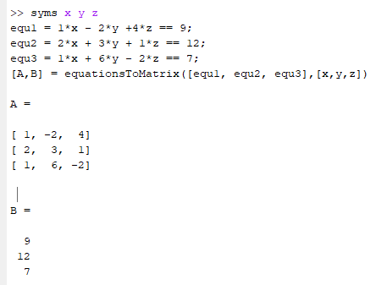

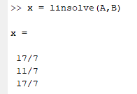

X = 17/7 (2.43)
Y = 11/7 (1.57)
X = 17/7 (2.43)

Substitute fractions for decimal values
2.43 – 3.14 + 9.72 = 9.01
4.86 + 4.71 + 2.43 = 12
2.43 + 9.42 -4.86 = 6.99

