A critical evaluation of next teaching and learning steps focusing on a case study of an individual learner or a group of learners based on an observed critical incident

Zarah Yandell - 0952863
University of Wales Trinity St David
ECAD6007

Introduction
It is common practice in areas such as schools and workplaces for there to be some form of reward system where people can be recognised for completing adequate work or displaying desirable behaviour. There will also be procedures in place that handle negative situations such as undesirable behaviour and unsatisfactory work. But how much of an impact do these theories and techniques have on pupils to control the way they behave in a classroom?
The aim of this report is to identify a Critical Incident (CI) observed in a classroom and investigate theories that could explain why the incident happened, and also to investigate how these theories have developed over time stating the scientific evidence which supports them.
These theories will be applied to the CI to demonstrate how they might explain why the incident happened, but also the limitations of the theories that do not fit the CI. It will also suggest other techniques and theories that may be more suitable to the situation giving a balanced argument towards which could be better, behaviourist approached such as rewards and punishments, or a more humanistic approaches like celebration and encouragement.
Following the theories will be a section of critical refection where 3 models of refection will be used to identify what happened, what were the key learning points, and how can they be applied to my own learning journey into qualifying as a teacher based on the teaching standards.

Observation School and Class context
The school attended was a Secondary High School that educates young people between the ages of 11 – 18 covering Key Stages 3, 4 and 5. The school is located close to Cardiff City Centre where the catchment area covers a high percentage of those with economic and social disadvantages.
At the time of the ESTYN report reference (February 2017), there were no pupils enrolled that spoke Welsh as a first language, approximately 70% of pupils speak English as a second language and there are over 60 different languages spoken by the pupils and teachers alike. The school was rated Excellent by ESTYN across all aspects reported.
For the bridging day, the same class was observed for 4 lessons and consisted of 22 Year 8 pupils of mid-low ability. The level of ability was decided based on their level of engagement with online classes during the lockdown period between April and July. The classroom layout was 2 pupils per table 4 tables per row (3 rows), this seating arrangement due to Covid-19 restrictions made it so pupils were seated in alphabetical order by surname. It was made clear in the first lesson by the teacher that there would be a group of 3 pupils that are consistently chatty and will disrupt the class, one pupil of which will be the subject of the (CI) analysis, Pupil J.
Refer to Appendix 1 for class observation reports for 4 lessons.

Methodology
There are 2 Observation Models appropriate to this type of research, Participant Observation (PO) and Non-Participant Observation (NPO). Linking these to the CI being investigated in a classroom environment, PO would be where the investigator would pose as an appropriate staff member and be involved without the participants being aware of their identity. A real example is this comes from Patrick (1977) who infiltrated a Glaswegian gang. His identity as a researcher was kept hidden from gang members and he participated in gang activities for 4 months.
NPO is where a researcher will observe the situation from a far and not be involved in any way with the participants. King (1979) did exactly this when observing a classroom, he found that without having to identify himself, the pupils recognised any adult as a teacher or teaching assistant and was therefore able to maintain a social distance without participating.
For the CI observation investigated in this report, the observation model applied was NPO as there was no interaction between the pupils and I. It was important that the pupils acted naturally so their classes and behaviours could be observed without any risk of demand characteristics or observer bias. I chose to sit on a table at the back of the room away from any pupils, however I required the teacher to introduce me as a student coming to observe the lesson to see techniques used by the teacher. This meant the pupils did not see any reason to act different because of my presence.
A case study is where a certain incident or event can be observed and investigated without manipulating the situation with variables like an experiment would. Given that the CI needed to be based in a natural, real life setting, a Case Study is the perfect methodology for this investigation.
The advantages and disadvantages of case studies are:
Advantages | Disadvantages
A situation can be observed in context but without any influence from the observer | Can make theoretical assumptions, but would need to have scientific evidence to support it
Real life people in real life situations can be observed greatly reducing the opportunity for demand characteristics | If observer is present for the live case study, participants may display demand characteristics knowing that the observer is there for a reason
Can establish cause and effect in context | Observer bias is a possibility if PO is used as a model
Is a valuable methodology when control is taken away from the researcher / observer | It is difficult to generalise the findings from cash studies to other situation for example, the results found in a British School may be incredibly different to those observed in another country
Provides in depth qualitative data to be investigated
Case study research can be more easily available to the public assuming confidentiality for participants
Will not require a team of researchers

A point to mention is that because of Covid-19 restrictions, the results could differ from those that would be seen if restrictions were not in place for example, the table and seating arrangements would be different as pupils would be able to choose where and by who they sit.

Four Purposes
The CI investigated regards how Pupil J engaged with the school’s rewards and punishment system. The following information was provided by the bridging contact in the school, they advised details of how positive and negative behaviours are addressed.
Achievement Points (AP) are awarded when pupils display characteristics or behaviours that meet or exceeds the school’s expectations. The expectations are based on ‘PRIDE’ where pupils exhibit positive behaviours based on being Prepared, Respectful, Independent, Dedicated and Empathetic. These values demonstrate several of the 4 purposes of the new curriculum.
According to ‘Successful Futures: Independent Review of Curriculum and Assessment Arrangements in Wales’, Professor Graham Donaldson states that “ The school curriculum should be designed to help all children and young people to develop in relation to clear and agreed purposes.” The 4 recommended purposes of the curriculum are about developing learners into:
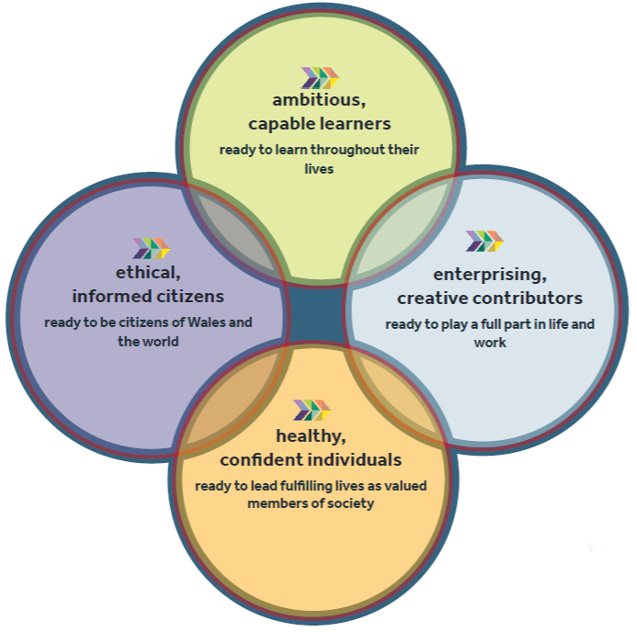
Image taken from 'Successful Futures: A Summary of Prof. Graham Donaldson's report’
By rewarding the pupils with AP’s for positive behaviours based on ‘PRIDE’, teachers are encouraging pupils to continue that behaviour as they will associate is with a positive experience. By breaking down each of the 5 ‘PRIDE’ attributes pupil receive AP’s for, they establish ways in which pupils are demonstrating the behaviours shown in the four purposes. Below is one example for each attribute, the full breakdown of each purpose set by Donaldson can be found in Appendix 2:

- Prepared
  - Being healthy, confident individuals who know how to find the information and support to keep safe and well.
- Respectful
  - Being ethically informed citizens who respect the needs and rights of others, as a member of a diverse society.
- Independent
  - Being healthy, confident individuals who have the skills and knowledge to manage everyday life as independently as they can.
- Dedicated
  - Being ambitious, capable learners who set themselves high standards and seek and enjoy the challenge.
- Empathetic
  - Becoming enterprising, creative contributors who express ideas and emotions through different media and give their energy and skills so that others may benefit.

Behaviour points (BP) are given when pupils don't meet the school’s expectations by displaying behaviours such as being disruptive and producing inadequate work. Multiple behaviour points lead to pupils having their behaviour monitored and reported on closely each lesson by the class teacher and parents are also made aware.
This report will analyse how the teacher set an activity where pupils were asked to find as many words possible using letters from the word ‘Environment’. 3 AP’s would be awarded to pupils who came 1st, 2^{nd,} and 3rd however, the pupils desired a different amount of points depending on the position achieved. The teacher amended the points and awarded 1st place 5 AP’s, 2nd place 3 AP’s and 3rd place 1 AP. This shows how pupils want to be rewarded for their efforts based on how well they did in the task. The CI to analyse will be how Pupil J, who displayed disruptive and disengaged behaviour throughout the lesson earning a BP changed their attitude when the task with rewards was set. Pupil J was awarded 3 AP’s for coming 2nd in the activity.

Literature Review
J.B. Watson (1913) investigated the theory that behaviours could be learned by manipulating nature around a participant. In the ‘Baby Albert’ experiment, Watson introduced a rabbit to a baby whilst making a loud bang. Baby Albert learned fear because he associated the being afraid of the loud bang with the rabbit and with repetition, baby Albert would express fear when he saw a rabbit even if no noise occurred, therefore a conditioned behaviour was learned.
During the 1890’s, Ivan Pavlov studied Classical Conditioning, a phenomenon he noticed whilst studying the digestive system of dogs. The definition of conditioned is to “have a significant influence on or determine (the manner or outcome of something)”. The behaviour noticed was how the dogs began to salivate, an unconditioned response (UCR), when they were brought food, an unconditioned stimulus (USC). To create a conditioned response (CR) where a behaviour is learned, Pavlov added a whistle, a conditioned stimulus (CS), which would be blown at feeding time. The dogs began to associate the sound of the whistle with being fed and after repeating this process multiple times, Pavlov condition the dogs to salivate when the whistle was blown without the food being present making the salivation a CR, a behaviour which was learned. However, it was noted that after many times where the whistle sounded without food, the behaviour was forgotten, and the dogs no longer salivated. Pavlov called this the extinction phase as the learned / conditioned behaviour was no longer present. This study can be linked to the CI as it reinforces the theory that pupils can positively change their behaviour if they anticipate there being a positive experience as the outcome, the AP being the conditioned stimulus (CS), and the change in behaviour from disengaged and disrupted to engaged and being successful at the task being the conditioned response (CR). Although not seen in this incident, it can be presumed that if the AP awarded for positive work and behaviour was not consistently practiced, the behaviour would eventually become unconditioned / extinct.
One limitation of this theory is that it was experimented on dogs, and however well the theory should also apply to humans, this idea cannot be absolute due to the complex nature of the human brain and human behaviour making it deterministic, meaning that it does not take into consideration the idea of an individual’s free will.
B.F. Skinner, an advocate for behaviourism researched further into the idea of conditioning but implied that Classical Condition was too simplistic to describe the complexities of human behaviour. Skinner’s experiments with rats were about observing their behaviour in an environment as opposed to introducing stimuli to learn a behaviour. This eliminates the limitation of Pavlov’s experiment as free will can be observed.
Skinner had a theory that when a behaviour is followed by a positive experience, it is more likely to be repeated, similarly if a behaviour is followed by a negative experience it is less likely to be repeated. He called this reinforcement, where a behaviour is reinforced by a positive / negative experience or consequence, the behaviour is either strengthened or weakened. To study this theory (1948), Skinner designed a box (see figure below) which contained a lever that would dispense food if pushed, Skinner did not prompt the rats to push the level however, they learned this themselves by accidently hitting it. The rats continued to push the lever supporting the theory that a behaviour can be learned when followed by a positive experience that the subject finds rewarding, this is Positive Reinforcement. The Skinner box also had built into it an electrical grid which would shock the rat if they did not press the lever. The rats eventually learned that if they pressed the lever quick enough, they would not receive a shock. This is Negative Reinforcement where a behaviour avoids a negative experience / consequence. Skinner call this Operant Conditioning.
The same with Classical Conditioning however, if the reinforcement is not consistent, the learned behaviour will eventually become extinct.
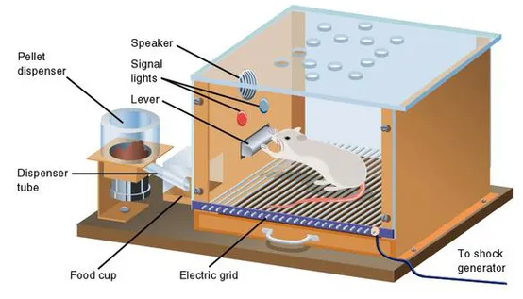
The opposite of reinforcement is punishment where a negative experience can be applied to an undesired response, decreasing the chance of that behaviour being repeated. There are many limitations to using punishment as a way of learning behaviour, one being that punishment will not eliminate a behaviour, it will simply suppress it until a time where the punishment is no longer present. Punishment can also inhibit classical conditioning negatively for example, if a pupil is shouted at for not spelling a word correct, the pupil can learn fear the teacher or being incorrect, not ideal in education.
Skinners Box used to study Operant Conditioning
Linking this to the CI, Operant Conditioning explains why Pupil J changed their behaviour when the task was set because they knew that completing the activity well would lead to receiving between 1-5 AP’s. However, this theory does not explain the undesirable behaviour displayed throughout the lesson which lead to them receiving the BP, regardless of being threatened with punishment, the behaviour did not change.
Classical and Operant Conditioning are great in theory as a way of modifying behaviour, however it must be considered that reinforcing behaviour by giving rewards is bribery, and how sustainable can bribing pupils be in the long term?
In 1977, psychologists Richard Ryan and Edward Deci developed the Self-Determination Theory of Motivation which challenged the belief that the best way to improve human behaviour was to reinforce it with rewards and punishments. In an experiment with psychology students, 2 groups were tasked with solving a Soma Cube Puzzle, group 1 was paid whilst group 2 was not. The groups were separated and given a timeframe to complete the task, when that time had finished, Deci left participant in the room alone. They observed that the paid group drifted away from the task whereas those who were not paid continued to complete the puzzle. Deci concluded that those who were rewarded for completed the task with cash were not influenced by Intrinsic Motivation (IM) whereas those asked without reward were. IM is defined as doing something because it is interesting and enjoyable as opposed to doing something with an incentive / reward. This addresses the limitation of Skinner’s theories because it explains why rewards and punishments may not always change behaviour as there can be other motivational factors to consider such as satisfaction for completing the task well.
Alfie Kohn developed this theory further throughout the 1990’s by applying it to human behaviour in parenting and education. In an interview at the ASCD Annual Conference in 1995, Kohn stated:

“Rewards and punishments are both ways of manipulating behaviour. They are two forms of doing things to students. And to that extent, all of the research that says it's counterproductive to say to students, “Do this or here is what I'm going to do to you,” also applies to saying, “Do this and you'll get that.” Ed Deci and Rich Ryan at the University of Rochester are right when they call rewards “control through seduction.””

Kohn suggests rather than bribing pupils to behave and be engaged, it is up to educators to make the content of the curriculum interesting and engaging so that pupil’s will see the value of learning received / satisfaction of completing a task to be the reward in itself, rather than using the rewards they are offered as a way to manipulate and control behaviour. Most schools will have some form of reward / punishment system in place as this is traditionally the norm, but is it right to manipulate pupils into compliance and learning?
To avoid bribing pupils to behave in ways desired by teachers, Kohn suggests 3 techniques that are more humanistic as an alternative to rewards and punishments:
- Setting goals together in a conversation giving pupils an opportunity to work towards hitting a target and allowing them to feel the satisfaction of achieving that goal.
- Show appreciation for their behaviour and actions and avoid offering to give something for their performance that can be taken away if they don’t perform.
- Give encouragement throughout the process, acknowledge, and celebrate with them when their achievement has been reached. Make a fuss of their effort and ask, “how does it make you feel that you’ve achieved this?”

Reflection / Evaluation and Next Steps
Reflecting on the theories and ideas presented, it’s clear to see that the topic of using rewards and punishments to control behaviour is highly subjective depending on the teacher, the pupil, and the situation. Critical reflection allows us to take a step back and challenge the way we think about how to evaluate the CI by asking ourselves probing questions. This will also give great opportunity to think about what key learning to take from the incident, what could have been done better and speculate how it can be applied into our own practices.
Reflective models are used to critically reflect on incidents in stages, there are many models available and all have strengths, weaknesses, and situations where they are more suitable. Refer to Appendix 3 for descriptive images of each reflection model used below can be applied to other situations.

Gibbs Reflective Cycle (1988)
Positives:
- Basic starting point
- Easy to understand the 6 stages
Negatives:
- Does not allowing viewing from a different perspective
- Does not inhibit probing questions

Description:
Pupil J became engaged with the task once a reward was offered for doing well.

Feelings:
Did pupil J finally feel challenged in the lesson, was that why she engaged when AP was offered?

Evaluation:
Positive that Pupil J did respond to the AP's, negative that Pupil J didn't change their behaviour when threatened with BP's.

Analysis:
Pupils respond differently to rewards / punishments depending on what the reward / punishment is for example BP’s vs lunch time detention.

Conclusion:
When Pupil J didn't change behaviour when threatened with BP, teacher could have tried a different punishment or had a private conversation as a humanistic approach to understand the behaviour in a restorative conversation when goals could have been set.

Action Plan:
Have different forms of punishment ready to use if one does not work.
Offer more encouragement and support to show you are grateful and praise when they behave well to help the pupil repeat the positive behaviour

Schön’s Reflective Model (1991)
Good for:
- Reflection in the moment and reflecting on the facts
- Emphasises the difference between 2 different reflection types
Negatives:
- Does not provide guidance on how to apply the 2 reflection methods into your own practice.

Driscoll Model (1994)
Positives:
- Good as an organisational model
- East to follow and has probing, cued questions
Negatives:
- Mostly considers reflection of the incident rather than about yourself and your progression.
What?
- Pupil J displayed negative behaviour throughout the lesson and did not change when warned about being punished by receiving a BP, however Pupil J did change behaviour when asked to complete an activity where AP’s were awarded.
- Other pupils asked the teacher for more AP’s depending on how well they did, showing how all pupils wanted AP’s
- Pupils were pleased when teacher agreed to give more AP’s
- Class went quiet for duration on the activity where everyone was engaged
So what?
- This showed how pupils did not change behaviour due to punishment but did for an award.
- Different pupils will respond differently depending on the reward / punishment being offered
Now what?
- I take from this experience that using reinforcement or punishment in a classroom cannot be one size fits all
- Learn about individual pupils to understand what technique would work best for them
- Remember pupils are not pets, try to have a more humanistic approach first and avoid using rewards and punishments if possible so it is not seen and bribery, and pupil’s see the value of the learning and how their behaviour effects that.
- Encouragement and support to the individual could stop the behaviour from happening in the first place

Conclusion
This investigation began with a non-participant observation of a classroom where 1 pupil stood out by displaying consistent disruptive and disengaged behaviour throughout the lesson. When threatened and eventually punished, their behaviour did not change therefore no behaviour modification took place. However, when given the opportunity to being rewarding by completing a task, their behaviour completely changed posing the question, are rewards and punishments good techniques to use when attempting to control behaviour in a classroom?
The answer is it depends. From investigating this case study, theories based on conditioning demonstrate how rewards and punishments can be effective, but there are depending factors such as time of day, how the teacher uses rewards / punishments and if the rewards / punishments are applicable to that pupil. If a pupil decides they won’t show up to detention, what is the point on using it as a punishment, it means nothing to them. Also, it is determined that rewards can be damaging to learning and behaviour in the long run, if a pupil associates behaviour with a rewards, it is not proven that the behaviour is repeated when the reward is no longer offered. Rewards teach pupils that they can be bribed to do something, in the case of Pupil J, they responded to this reward and came 2nd place in the activity, but that doesn’t mean their behaviour has changed long term.
My key learning from this investigation is that every pupil responds differently to rewards and punishments, and therefore its up to me to ensure standards are set regarding acceptable behaviour from the start and ensure a more humanistic approach of encouragement and support are used before bribery. By being more humanistic, a teacher will be able to build positive relationships with pupils where there is no fear of getting it wrong, where you don’t allow pupils to have control over your teaching environment by craving attention and you giving it to them by raising your voice. Going into PTE1, I will learn and apply different behaviour management techniques to ensure the classroom is under control and is a positive learning environment for all pupils.

Appendices
Appendix 1 – Classroom Observation / Field Notes
Date and time, year group:
30th September 2020, 8.50am, Year 8
Lesson details: (Context and focus -/AoLE/subject- is it near start of end of unit of study? Indoors/outdoors? Ability range? Any particularly relevant information).
Science and Technology lesson looking specifically at the environment. This was the start of the unit. Class was indoors, 22 pupils, 2 pupils per table in rows and columns. Mid-low-level ability pupil, abilities were decided based on the engagement levels with class work during the lockdown period between April and July. Mid-low engagement = mid to low ability. Teacher made it clear to me that there are a group of pupils that are consistently disruptive.

Classroom culture
(What is the classroom ‘vibe.’? What do attitudes, dispositions, behaviours towards learning seem like at this point in time?)
It does seem like most of the classroom are engaged and ready to learn, perhaps this is because it is the first lesson of the day. However, there are 3 pupils that are clearly disengaged and chatty as confirmed by the teacher at the start of the lesson. Of the 3, 2 were clearly avoiding participating in activities, I got the vibe that the 3rd pupil wanted to work but was being influenced by the other 2. These pupils will be referred to as J, X and Y, J being the most consistent pupil to show negative behaviours and attitudes.

Objectives
(What happens in the environment that communicates the purpose of the experiences? What can be observed regarding the way lesson activities relate to these purposes?
Very clear learning objectives were given at the start of the lesson, these objectives covered the whole topic and not just the first lesson. The objectives were vague in nature, this is because after this introductory lesson, the teacher asked the class to list what they would like to cover in this topic. For this reason, I do not feel the objectives could be too specific as she wanted to make sure the pupils state their opinions before confirming the specific topic learning objectives.

Direction
(What can be observed that helps learners understand what they are engaging in? What in the environment helps them understand how to achieve well)?
After giving the learning objectives, the teacher made clear to the class what the end of topic assignment would be showing them clearly what pupils needed to work towards to be successful in this topic.

Access and challenge
(What can be observed in the environment that enables engagement of learners? What can be observed regarding levels of challenge?
There were a range of activities set in this lesson that made it possible for all pupils to engage. Because however the class ability has been based on engagement over lockdown as opposed to assessments where pupils can show their ability, there were some pupils in the classroom that were above this level.

Assessment
(Can anything be observed about how student’s existing knowledge is used? Can anything be observed regarding the development of knowledge during or after the experience)?
The first activity was for pupils to list everything they can think about the word Environment as a way to demonstrate what they already know. Teacher then asked pupils to say what they wrote down but rather than just listing these, she asked the pupils to elaborate by asking questions like “what does that mean?”
The final activity linked well with the numeracy aspect of the curriculum as she asked pupils to write down as many words as possible that they can find using the letters from ‘The Environment’.

Specifics / Critical Incidents
(Are there moments which cause you to consider aspects of practice when you come across them in future teaching)?
Teacher had very good control of the class and at no point during the lesson had to raise her voice to gain control back. She did countdown to silence from 5 seconds.
She used lots of positive words throughout the lesson such as amazing, excellent, fantastic etc.
Teacher praised students for getting settled into the class and having their books out ready for the class to begin.
Teacher moved around the class during activities to make sure all pupils were participated.
Teacher set time limits for activities and gave a warning 30 seconds before the end of activity.
Using Achievement Points as a prize for finding the most words in the end of lesson activity.
Giving 2 warnings about bad behaviour before giving a behaviour point. Teacher stated to the misbehaving pupils that they would be removed from the classroom if they continued their negative behaviour.
Pupil’s behaviour did not change when threatened with punishment, but behaviour did improve when offered the opportunity to be rewarded with achievement points for the end activity.

Date and time, year group:
30th September 2020, 8.50am, Year 8
Lesson details: (Context and focus -/AoLE/subject- is it near start of end of unit of study? Indoors/outdoors? Ability range? Any particularly relevant information).
Welsh lesson, middle of the unit. Class was indoors, 22 pupils, 2 pupils per table in rows and columns. Mid-low-level ability pupil, abilities were decided based on the engagement levels with class work during the lockdown period between April and July. Mid-low engagement = mid to low ability.
Classroom culture
(What is the classroom ‘vibe.’? What do attitudes, dispositions, behaviours towards learning seem like at this point in time?)
More vocal engagement from all pupils in this lesson, to be expect from a languages class.
Objectives
(What happens in the environment that communicates the purpose of the experiences? What can be observed regarding the way lesson activities relate to these purposes?
Learning objectives given 10 minutes before the end of the class
Verbal objective mentioned – need to be able to read Welsh as a skill.
Pupils are tracking learning in their books; however, the teacher is telling them what to write and not checking if they have actually achieved it.
Direction
(What can be observed that helps learners understand what they are engaging in? What in the environment helps them understand how to achieve well)?
Teacher explained that the reason for the first task was so that they would be able to complete the same sentence containing their own information by the end of the lesson.
Mentioned that there are resources on MS Teams pupils can use for the assessment.
Access and challenge
(What can be observed in the environment that enables engagement of learners? What can be observed regarding levels of challenge?
There was a lot of talking out loud, not necessarily about Welsh and the teacher did not encourage hands up.
Levels of challenge determined by how much of the sentence had been completed by the end of the lesson.
Assessment
(Can anything be observed about how student’s existing knowledge is used? Can anything be observed regarding the development of knowledge during or after the experience)?
Pupils were asked to read the paragraph with no context at the start of the lesson, they were then asked “what do you think this lesson is about and why are some things highlighted in red?”
Pupils then volunteers to read out loud to check pronunciation.
Specifics / Critical Incidents
(Are there moments which cause you to consider aspects of practice when you come across them in future teaching)?
Teacher was not following through with a punishment when pupils did now be quiet when asked
Pupil was obviously using their phone in class above the desk, either the teacher did not notice or did nothing about it. Pupil was however not bothering other student as they were in previous lesson.
Disruptive pupil from 1st lesson volunteers to read the paragraph showing more interest in this class.
The male pupils appeared to be less interested than the female pupils.
Teacher threatened BP’s for swinging on chairs, pupils stopped after warning.
Teacher did not walk around the room during activities.

Date and time, year group:
30th September 2020, 8.50am, Year 8
Lesson details: (Context and focus -/AoLE/subject- is it near start of end of unit of study? Indoors/outdoors? Ability range? Any particularly relevant information).
Textile lesson, second lesson of the unit. Class was indoors, 22 pupils, 2 pupils per table in rows and columns. Mid-low-level ability pupil, abilities were decided based on the engagement levels with class work during the lockdown period between April and July. Mid-low engagement = mid to low ability.
Textiles classes were cancelled last term due to Covid-19 so pupils have had a long time between lessons.
Classroom culture
(What is the classroom ‘vibe.’? What do attitudes, dispositions, behaviours towards learning seem like at this point in time?)
The teacher made her expectations very clear that she was not going to take any of their bad behaviour without there being consequences.
I got the impression that pupils respected this and therefore control of the classroom was entirely with the teacher.
Objectives
(What happens in the environment that communicates the purpose of the experiences? What can be observed regarding the way lesson activities relate to these purposes?
Recapped the objectives of lesson 1 – assessment of prior knowledge, lesson 2 objective, aims and brief given at the start of the lesson.
Direction
(What can be observed that helps learners understand what they are engaging in? What in the environment helps them understand how to achieve well)?
Teacher went through the assessment criteria with the pupil’s and asked them to underline key words they can refer back to.
Access and challenge
(What can be observed in the environment that enables engagement of learners? What can be observed regarding levels of challenge?
The teacher uses negative reinforcement to encourage engagement by saying the more you wate my time, the more minutes will be taken from your lunch break. Teacher did not use the BP / AP system as her technique got better results with regards to classroom behaviour.
Assessment
(Can anything be observed about how student’s existing knowledge is used? Can anything be observed regarding the development of knowledge during or after the experience)?
The lesson previously tested their prior knowledge. No levels are set at this point because the pupils have not had a textile lesson in many months due to Covid-19
Specifics / Critical Incidents
(Are there moments which cause you to consider aspects of practice when you come across them in future teaching)?
The importance of setting behaviour standards right at the start.
Pupils behaved better when they knew they would lose their lunch break as opposed to getting BP’s
Pupil J well behaved the whole lesson, I believe this is because she knows she can’t get away with it with this teacher.
Teacher made a pupil stand up for swinging on his chair after 1 warning.
Because pupil J in engaged with the lesson, another pupil shines through with negative behaviour, pupil plays on phone where teacher notices and makes her put the phone on teachers’ desk.
Teacher gave pupils the opportunity to earn back minutes taken from lunch by asking for good behaviour.
Date and time, year group:
30th September 2020, 8.50am, Year 8
Lesson details: (Context and focus -/AoLE/subject- is it near start of end of unit of study? Indoors/outdoors? Ability range? Any particularly relevant information).
English lesson missile of unit. Class was indoors, 22 pupils, 2 pupils per table in rows and columns. Mid-low-level ability pupil, abilities were decided based on the engagement levels with class work during the lockdown period between April and July. Mid-low engagement = mid to low ability.
Classroom culture
(What is the classroom ‘vibe.’? What do attitudes, dispositions, behaviours towards learning seem like at this point in time?)
Most pupils seem engaged with the lesson, teacher comes off as quite informal and friendly compared to the other teacher this day.
Objectives
(What happens in the environment that communicates the purpose of the experiences? What can be observed regarding the way lesson activities relate to these purposes?
Half through the lesson, teacher asked “why are we learning to write speeches?” Objective decided by the pupil instead of teacher.
Direction
(What can be observed that helps learners understand what they are engaging in? What in the environment helps them understand how to achieve well)?
No direction observed.
Access and challenge
(What can be observed in the environment that enables engagement of learners? What can be observed regarding levels of challenge?
Teacher was encouraging pupils to read aloud their speeches that they have started.
Assessment
(Can anything be observed about how student’s existing knowledge is used? Can anything be observed regarding the development of knowledge during or after the experience)?
No mention of assignment or success criteria.
It was mentioned however that this topic should have been covered in year 7.
Specifics / Critical Incidents
(Are there moments which cause you to consider aspects of practice when you come across them in future teaching)?
This teacher is clearly more likable with pupils. I think this is because the teacher is not using any kind of reinforcement positive or negative and is coming across as quite formal.
There was 1 point where teacher threatened to remove a person from class without mentioning BPs first.
Because the teacher was casual, pupils felt it was appropriate to ask her “were you naughty in school?”.
Is asking pupils questions but is not necessarily giving them an opportunity to give details answers.

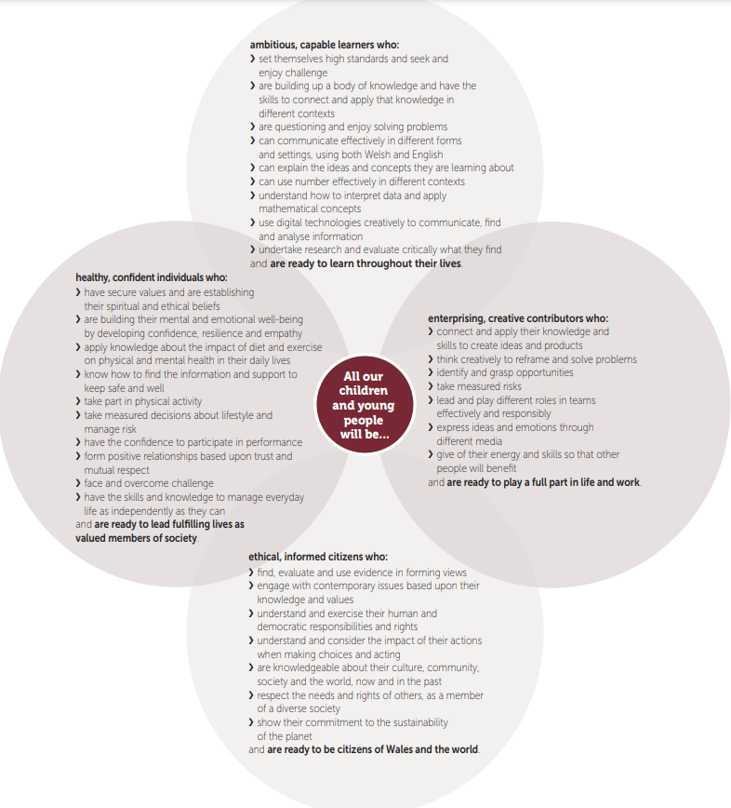
Appendix 2 – breakdown of exampled relating 2 each of Donaldson’s 4 purposes of the curriculum:
Image taken from Successful Futures Report

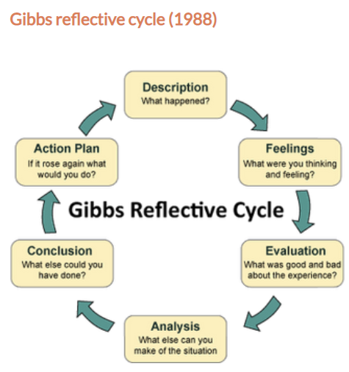
Appendix 3 - Descriptive images for reflection models:
Gibbs Reflective Cycle (1988)
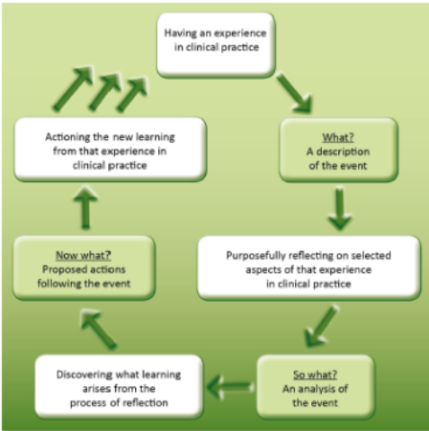
Driscoll Reflective Model (1994)
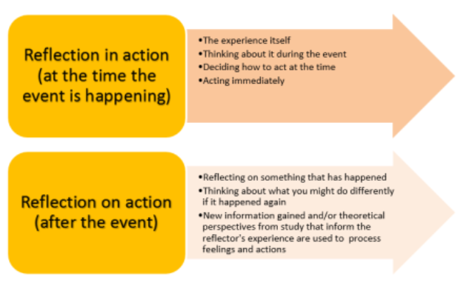
Schön Reflective Model (1991)

References

Brandt. R. (1995, March 27). Punished by Rewards? A Conversation with Alfie Kohn. Association Supervision and Curriculum Development. Available at: http://www.ascd.org/publications/educational-leadership/sept95/vol53/num01/Punished-by-Rewards%C2%A2-A-Conversation-with-Alfie-Kohn.aspx Accessed 26.10.2020

Cohen, L., Manion, K. and Morrison, K.R.B. (2011) Research Methods in Education 7th ed. London; New York. Routledge.

Cowley, S., (2001). Getting the Buggers to Behave 2. London. Continuum

Donaldson, G., (2015). Successful Futures. Crown Copyright. Cardiff. Available at: https://gov.wales/sites/default/files/publications/2018-03/successful-futures.pdf Accessed 30.09.2020

Donaldson, G., (2015). Successful Futures: Summery Report. Crown Copyright. Cardiff. Available at: https://gov.wales/sites/default/files/publications/2018-03/succesful-futures-a-summary-of-professor-graham-donaldsons-report.pdf Accessed on 21.10.2020

Estyn. (2017). A Report on xxxxxxxx High School. Cardiff. Estyn. Available at https://www.estyn.gov.wales/provider/6814042 Accessed 30.09.2020

Lifelong Learning with OT, Unnamed OT MSc Student. (2016) Guide to models of reflection – when & why should you use different ones? [Blog]. 2 May. Available at https://lifelonglearningwithot.wordpress.com/2016/05/02/different-models-of-reflection-using-them-to-help-me-reflect/ Accessed: 27.10.2020

McLeod, S. A. (2018, August 21). Classical conditioning. Simply Psychology. Available at: https://www.simplypsychology.org/classical-conditioning.html Accessed 21.10.2020

McLeod, S. A. (2018, January 21). Skinner - operant conditioning. Simply Psychology. Available at: https://www.simplypsychology.org/operant-conditioning.html Accessed 21.10.2020

O’Hara, D. (2017, December 18). The intrinsic motivation of Richard Ryan and Edward Deci. America Psychological Association. Available at: https://www.apa.org/members/content/intrinsic-motivation Accessed 26.10.2020

Saylor Dot Org. (date not specified). 7.1 Learning by Association: Classical Conditioning. Available at: https://saylordotorg.github.io/text_introduction-to-psychology/s11-01-learning-by-association-classi.html Accessed: 21.10.2020

The Parenting Junkie. (2019). What do Reward Systems Really Teach? Do they Actually Work? [Video]. Available at: https://www.youtube.com/watch?v=9EKlFXaCtYA Accessed: 25.10.2020

U of G Library. (2018) What is a Critical Reflection? Introducing the “What, So What, Now What” Model. [Video] Available at: https://www.youtube.com/watch?v=vGyjF9Ngd8Y Accessed: 27.10.2020

