L4 UCM Assignment 1
Module: Learning in the Digital Era
Title: Assignment 1: E-Portfolio
Student Name: Andrew Spence (2008447)
Course: Computing: Games Development

Table of Contents

E-Portfolio 2
Task 1 - Written Summary 3
Task 2 - Mind Map 6
Task 3 - Video Presentation 8
Task 4 - Academic Poster 8

E-Portfolio
https://andy9smith2.wixsite.com/website

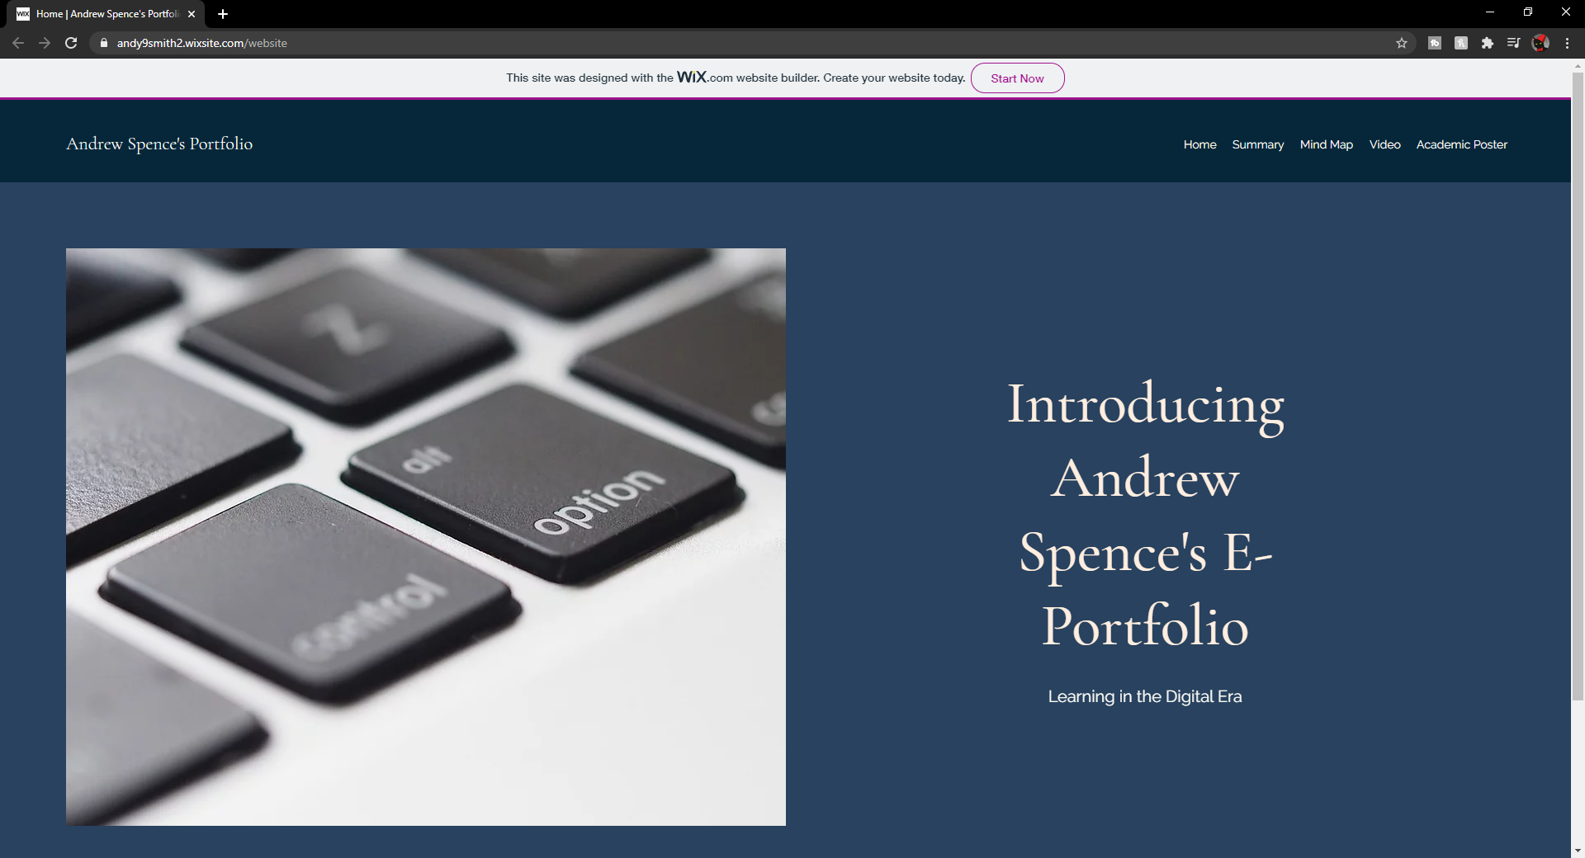

Task 1 - Written Summary
https://andy9smith2.wixsite.com/website/summary
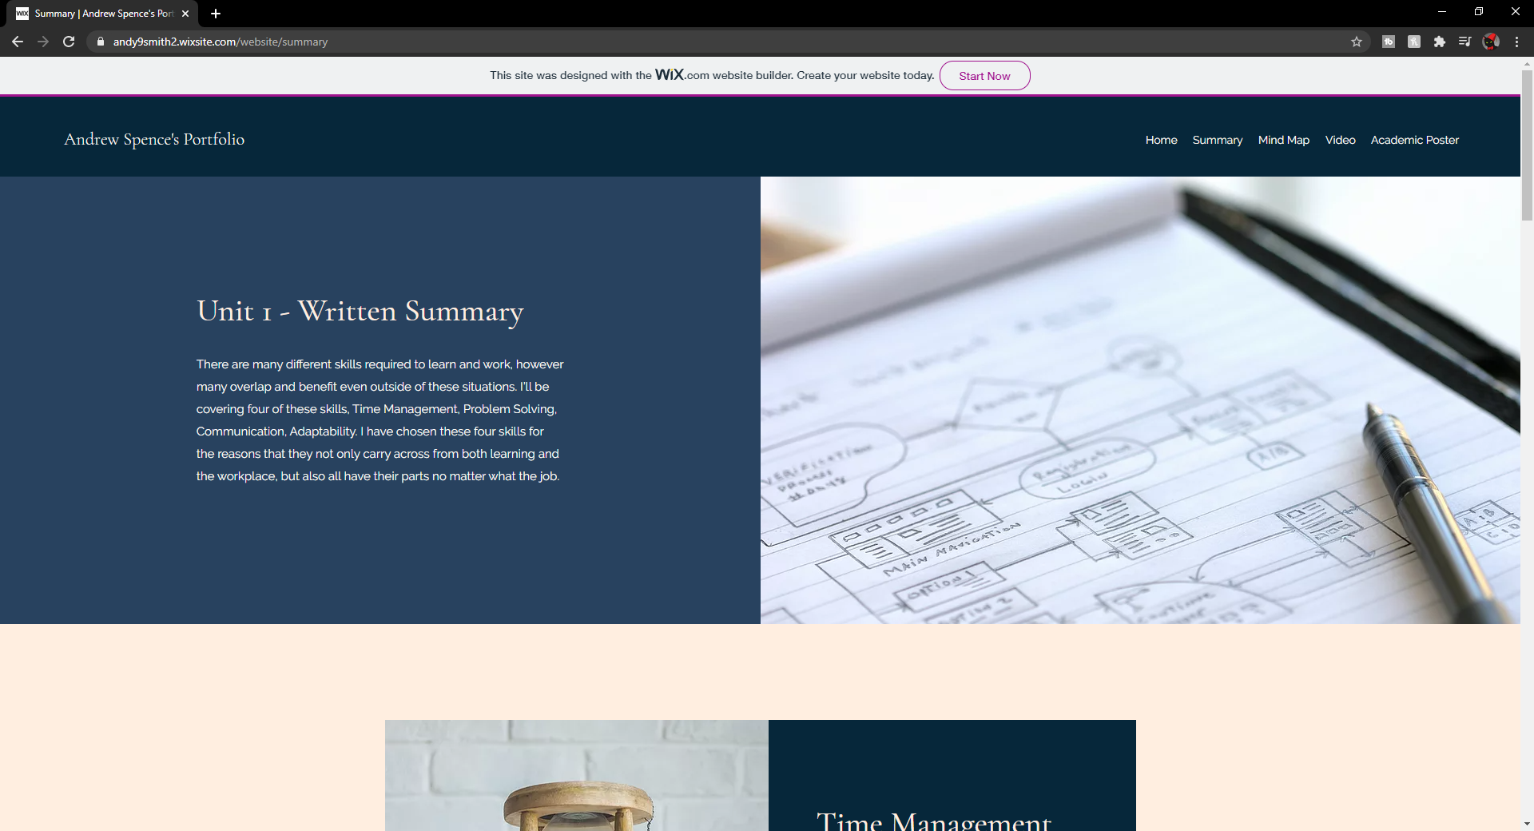
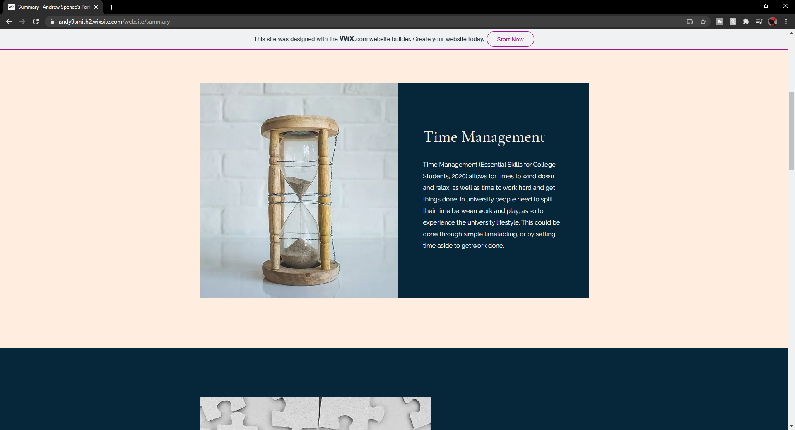
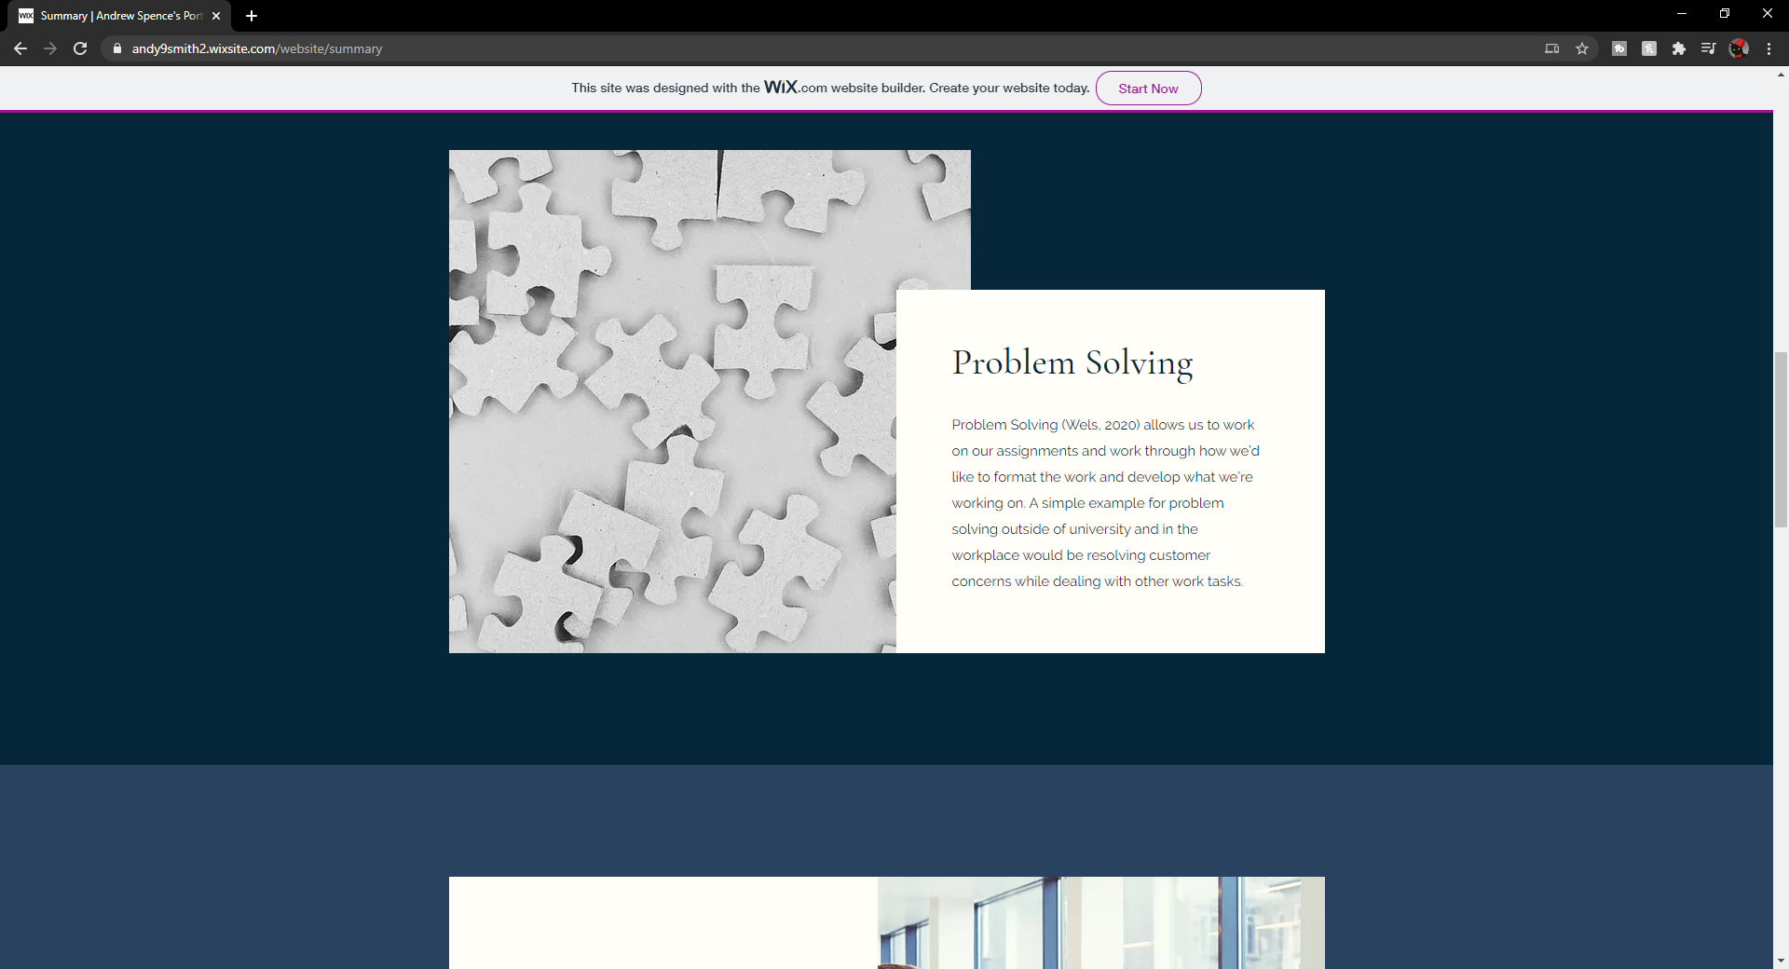
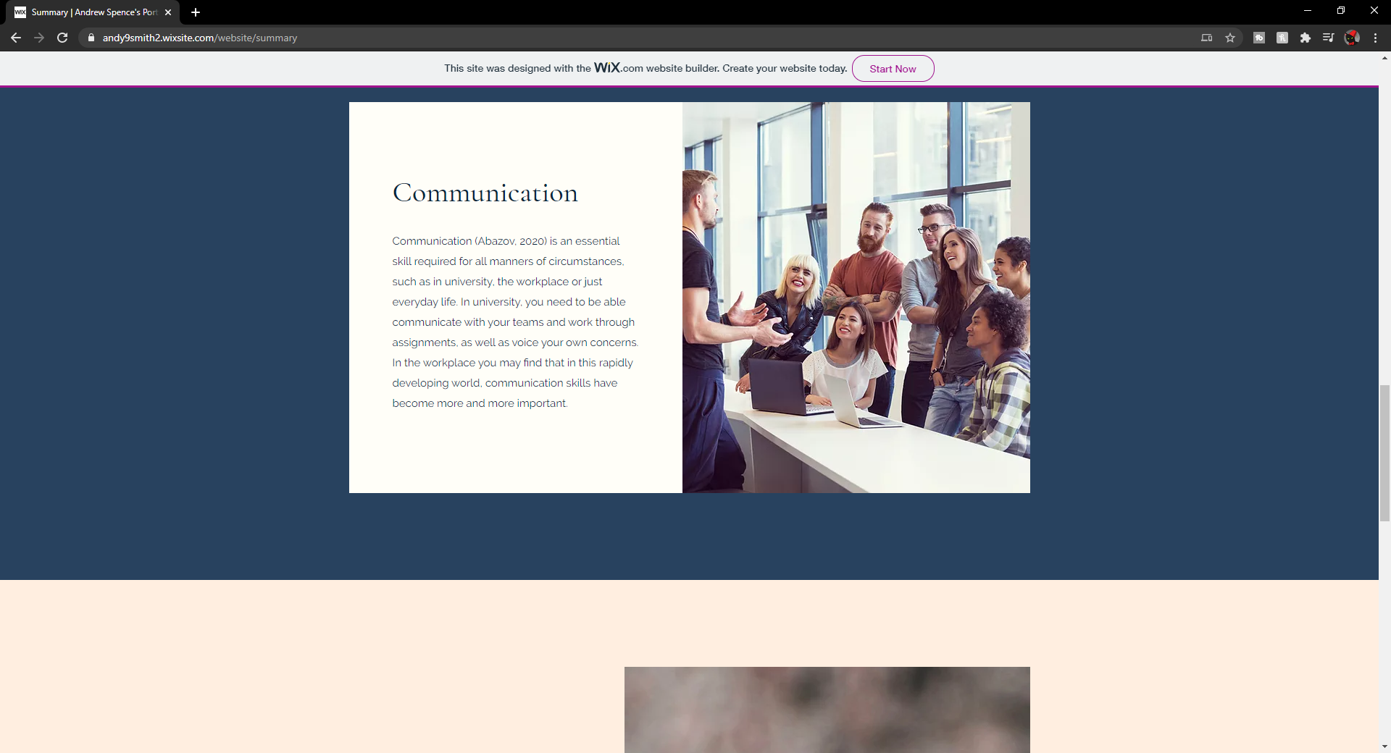
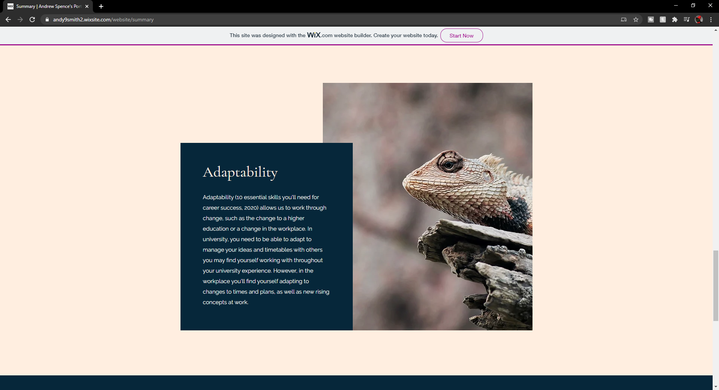
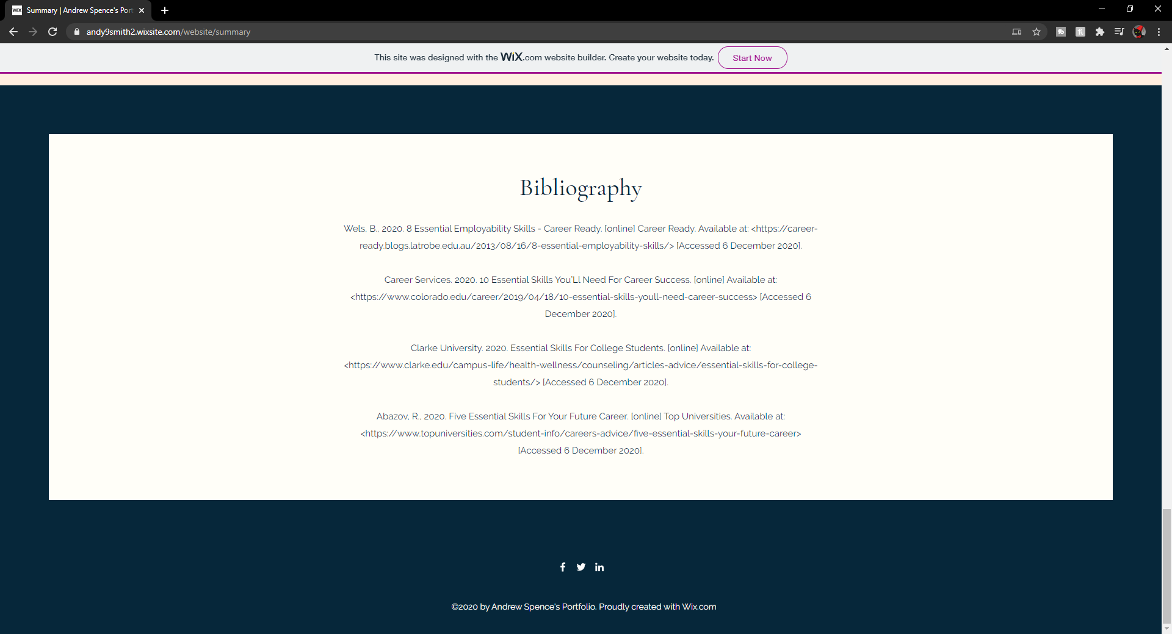

Task 2 - Mind Map
https://andy9smith2.wixsite.com/website/mind-map
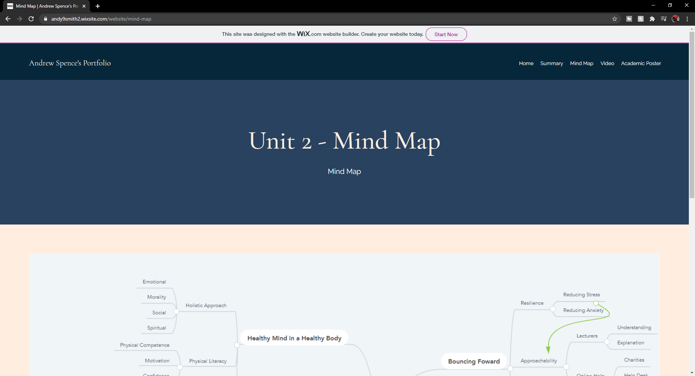
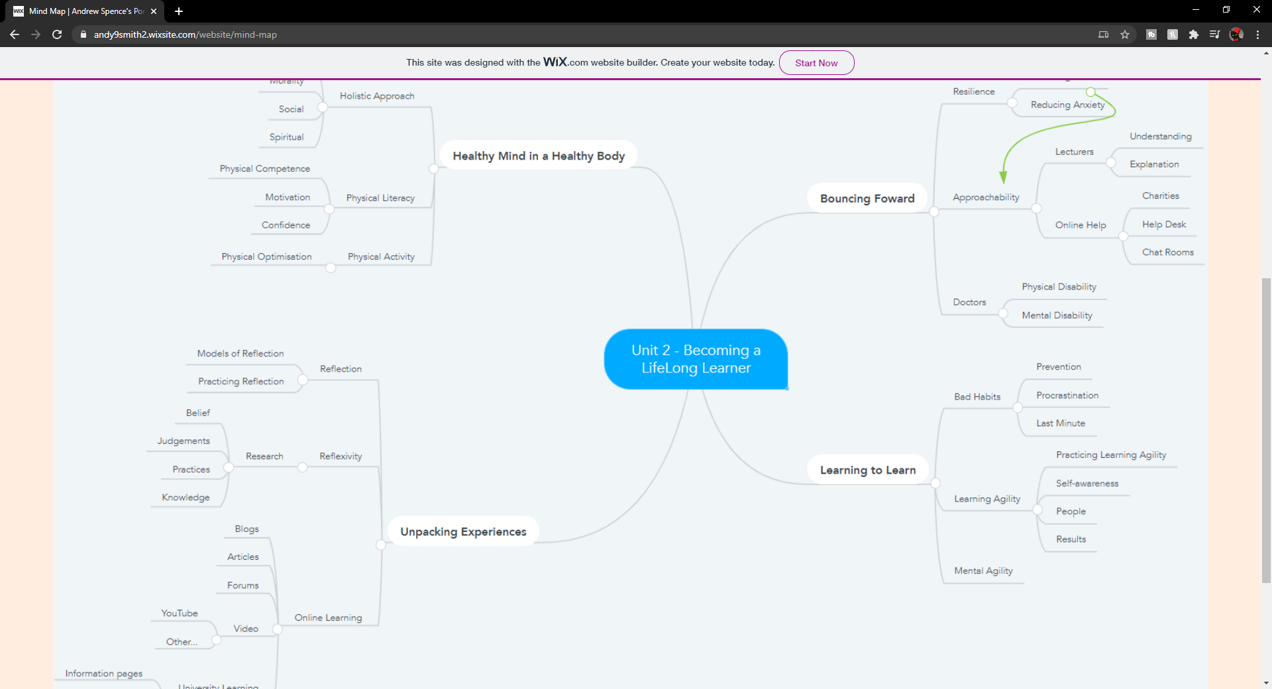
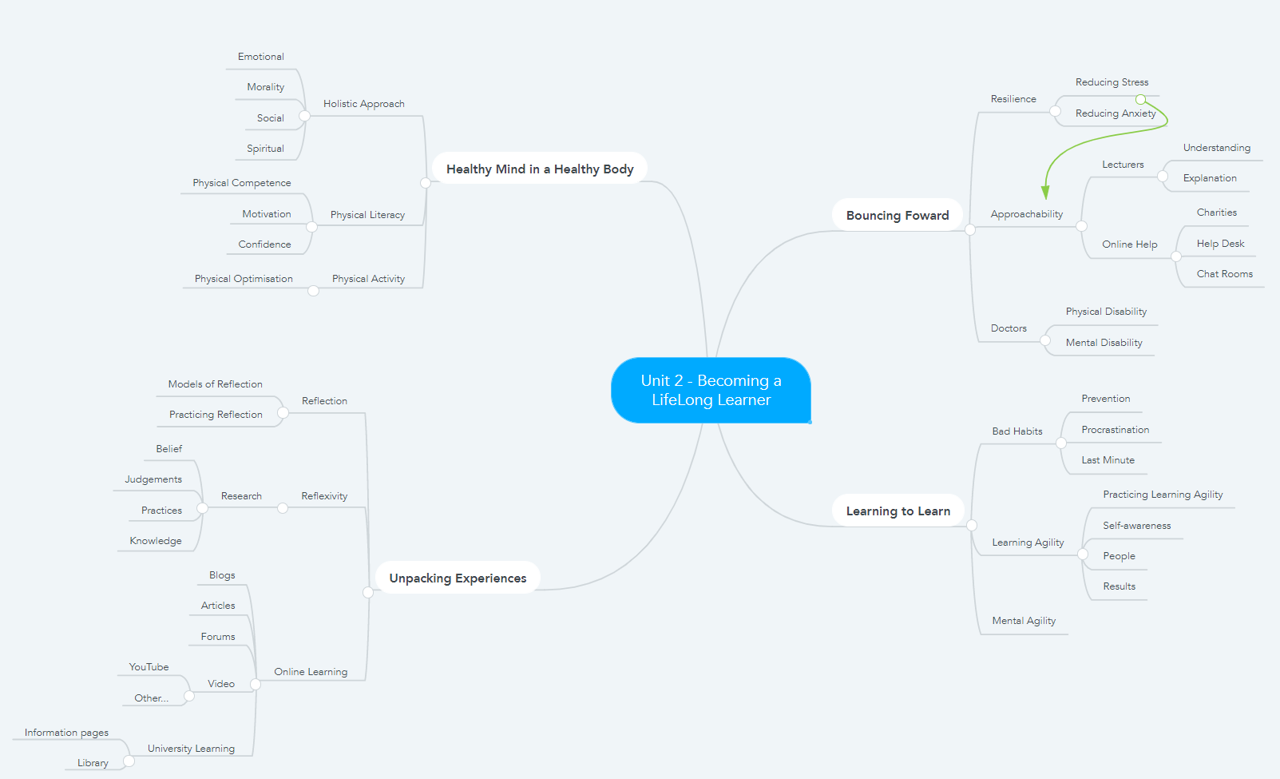

Task 3 - Video Presentation
https://andy9smith2.wixsite.com/website/video
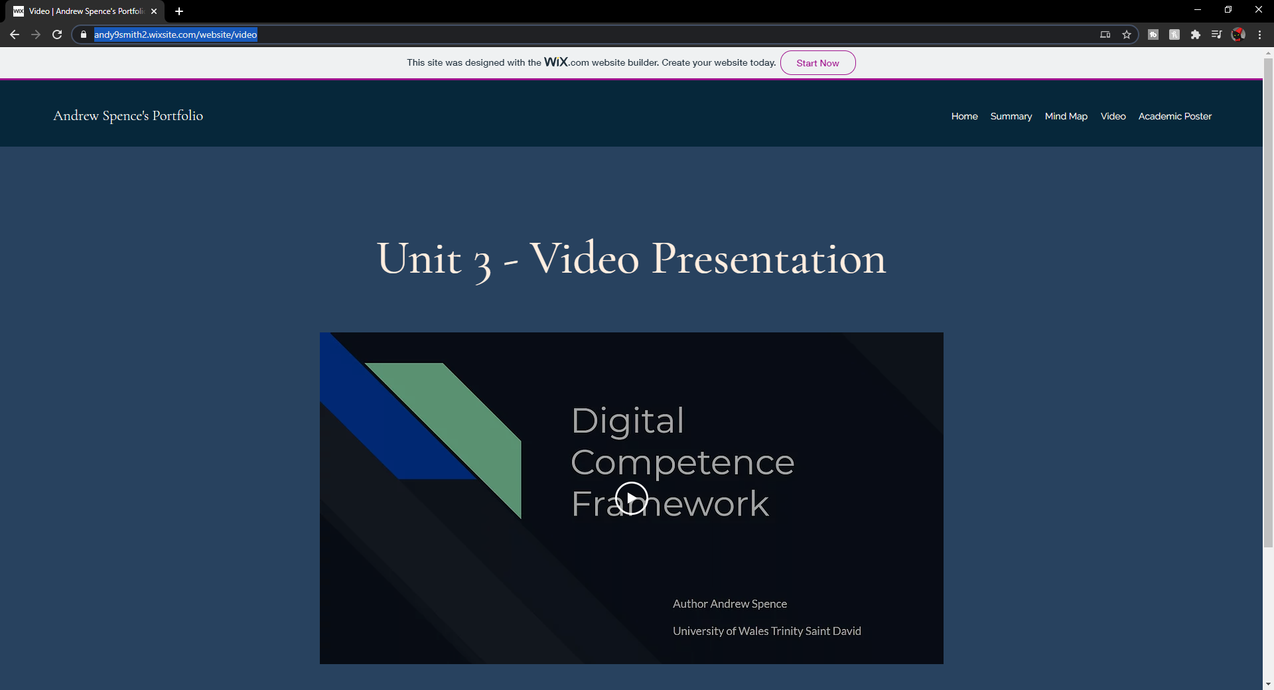

Task 4 - Academic Poster
https://andy9smith2.wixsite.com/website/academic-poster


