Effective TeamWork and Communication
Assessment 1

Word count: 2,113

Table of Contents
Introduction 2
Communication Models 2
Communication Skills 6
Technology in Communication 7
Conclusion 8
References 9

Introduction
The day-to-day running of a company vitally depends on internal communication, which refers to exchanging information within the organisation and includes talking to each other in the hallways and meetings, as well as disseminating information through emails and newsletters (Zaumane, 2018). Bauer and Lim (2019, p. 2470) argue that internal communication is very important because it can be seen as the “sharing of information to create a sense of community in an organisation.” This report focuses on internal communication, overall discussing the complex process of communication and its importance in the functioning of the organisation. The report specifically discusses models of communication, communication skills, and the advantages and disadvantages of technology in communication. This is supported by real-world examples of poor communication and the theory is used to make suggestions about how this could be improved.

Communication Models
This section discusses three models of communication that are primarily used to model and visually represent the communication encounter to simplify it so that it can be better understood (Robbins, Coulter and De Cenzo, 2019). These three standard models of the communication process are the transmission, interactive, and transactional models. Each of these offers different views on the communication process, although the transmission and interactive models are similar, with the latter building on the former as the understanding of communication has improved (Kuznar and Yager, 2020). In these models, the participants in the communication encounter are the senders and/or receivers of the messages and these messages can be both or either verbal or nonverbal content that is being sent/received from these participants (Boddy, 2020).
The first model is the transmission or linear model of communication is a simple one, as depicted in Figure 1, in which the sender encodes a message that is then sent by way of a communication channel that is then decoded by the receiver (Boddy, 2020). As shown, this model includes 3 elements: the sender (speaker), the receiver (listener), and the message. In this model, the focus is on the sender of the information as well as the message being sent, while the receiver is presented as a passive recipient of the message (Kuznar and Yager, 2020).

Figure 1: The Transmission Model of Communication (Kuznar and Yager, 2020, p. 3)
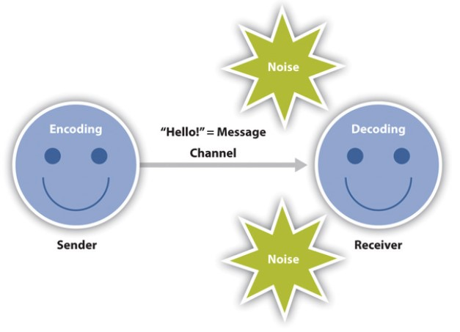
This model is linear because it shows ‘straight-line communication’ that is one-way and there is no way for providing immediate feedback. This is usually the case when the information is being communicated using mass communication channels such as newspapers. This is the same that happens when the information is being disseminated in the organisation using channels such as newsletters: the organisation/human resource (HR) department is the sender, and the message is included in the newsletter with the information that they want to provide to employees. However, there is no means of immediate feedback from the employee when he or she reads the newsletter. The message is intentionally transmitted by the sender to the receiver, who is seen as the target or endpoint, not as a participant in the communication process and neither is communication seen as an ongoing process (Kuznar and Yager, 2020). There is often the assumption that the message that is sent is successfully received by the target and that he or she understands the message. However, there is a lot of poor communication in organisations because many methods used are just for transmitting information from managers and supervisors to employees.
This is one of my experiences of communication in my organisation, where information is transmitted via company-wide emails and newsletters that employees often do not read. Therefore, the message cannot be said to be effectively communicated because many employees just do not engage with these information sources. Additionally, where employees read these emails and newsletters, there is often confusion about what is needed or what is being communicated. Sometimes this means that the message is just discarded, while at other times, other channels of communication need to be used to clarify the issue. There is poor communication a lot of times in organisations, because information goes one way (top-down) and there is no form of two-way communication (Boddy, 2020). Even when there is some kind of feedback mechanism where employees make some comments, managers and supervisors seem to hear only what they want to hear (Boddy, 2020).
Overall, the linear model is becoming less relevant as technology advances, as discussed in the final section. Before the growth of these new technologies, however, the linear model was mostly replaced by the interactive model in understanding the communication encounter. As shown in Figure 2, the interactive or interaction model of communication sees participants as taking turns as sender and receiver and includes the concept of having feedback within the communication encounter and this makes communication a two-way process (Boddy, 2020). Within this process, the focus is less on the message and more on the creation of meaning by sending messages and receiving feedback and this is affected by both the physical and psychological contexts in which the communication takes place that can introduce ‘noise’ into the communication encounter (Boddy, 2020).

Figure 2: The Interactive Model of Communication (Kuznar and Yager, 2020, p. 3)
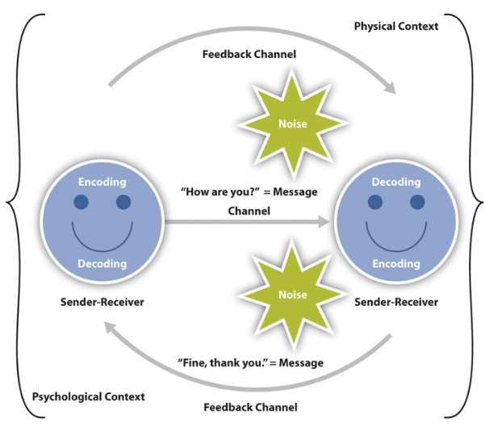

There have been technologies supporting the interaction model for a long time, including the telephone, and people speaking to each other are also interacting with each other in the communication encounter, spending and responding to messages. This model focuses on the communication process itself and the success of the communication encounter is not measured by whether a single message is sent or received but whether meaning is created and transmitted.
This model can also give some insight into poor communication in organisations as sometimes the physical contexts affect the communication process. For example, I have had experiences of team meetings being kept in conference rooms that are too hot or cold or with uncomfortable chairs and this negatively affects the extent to which employees engage with the message that is being sent or interact in the communication process. At the end of these meetings, myself and others have to be putting together notes with each other to decipher what has happened or the key points of the discussion because during the meeting itself we were more focused on keeping warm, cool, or comfortable. This indicates that the physical context undermined the creation of meaning and this can be seen as a failure in the communication encounter (Kreps, 2020). Even more important I think is the impact of the psychological context, such as stress and anxiety at work, which will affect communication. This model seems to be the one that is used most in understanding internal communication in organisations, where the focus is on the creation of meaning (Zaumane, 2018).
The final model is the transactional model, which is the most recently developed and argues that the communication encounter is about more than transmitting information and creating meaning (Robbins, Coulter and De Cenzo, 2019). It is very different from the other two models because it looks at the participants, context, and even what communication means differently from these other models (Boddy, 2020). As shown in Figure 3, this model presents two communicators that simultaneously act as message sender and message receiver.

Figure 3: The Transactional Model of Communication (Kuznar and Yager, 2020, p. 4)
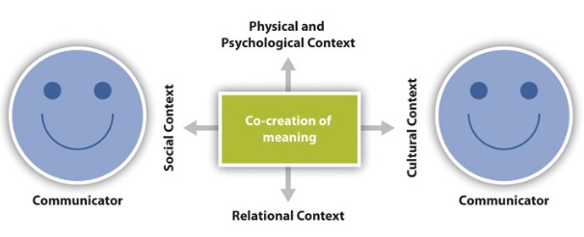
The transmission model represents the communication process as being very dynamic and having many goals beyond information transmission and meaning creation, including communicating to form relationships, alliances, and communities, as well as to shape individual self-concepts (Kreps, 2020). It is also used to understand internal communication in the organisation, as seen in research that identifies internal communication as the ‘glue’ holding organisations together (Zaumane, 2018) and creating a sense of community (Bauer and Lim, 2019) and so this goes beyond the concept of using communication for creating and transmitting meaning.

Communication Skills
Managing and working within organisations depend on transmitting and understanding messages as part of the basic goal of creating meaning so that employees can work together but this does not always happen because achieving a common understanding is not easy (Boddy, 2020). It is easy for poor communication to take place and thus it is necessary to focus on developing the very important skill of communication (Robbins, Coulter and De Cenzo, 2019). In this section, four main communication skills are discussed: active listening, non-verbal communication, clarity, and effective feedback.
First, to understand what is being communicated, individuals have to engage in active listening and it has been identified as being one of the most important skills needed by a good communicator. This is discussed by Jonsdottir and Fridriksdottir (2020), who argue that active listening is “a higher form of listening to gain a deeper understanding of the message and the context” (p. 179) and is both an attitude and a set of technical skills. In terms of the attitude, it is about being empathetic and being interested in what the other communicator is saying, while in terms of skills, it includes body language, using open and clarifying questions, summarising, and reflecting on someone what they are saying to check to understand, and using silence to encourage the other person to speak, repeat, contemplate, or revise (Jonsdottir and Fridriksdottir, 2020).
Second, as identified above, non-verbal communication, which includes tone of voice, body language, eye contact, and so on helps to both transmit messages and create relationships and overall effect of what is being communicated and what is received (Boddy, 2020; Jonsdottir and Fridriksdottir, 2020). In addition to using this kind of communication for making oneself better understood, other people’s own body language, tone, and so on should be paid attention to because it helps to understand more fully what is being communicated (Boddy, 2020).
Third, messages should be clear and concise in organisational communication, regardless of the channel. These messages should also be complete enough to allow both parties to reach a mutual understanding, which implies that those sending messages should try to anticipate how other people may interpret the message and try to make sure that potential sources of confusion are dealt with (Boddy, 2020). Unclear messages or communication have been shown to lead to problems in organisations and can lead to failures in delivering the organisational mission (Sutcliffe, Lewton and Rosenthal, 2004).
Finally, as noted in the more advanced communication models, feedback is a key part of any communication encounter. Effective communicators have to be able to both provide and receive feedback appropriately (Boddy, 2020). On one hand, both managers and peers should be able to give good constructive feedback, whether in a structured form like weekly status updates or informal discussions with colleagues (Boddy, 2020). For example, managers that give good future-focused feedback improve employee performance (Gnepp et al., 2020). On the other hand, a good communicator needs to be able to accept and act on feedback, and should even encourage feedback to see where improvements may need to be made (Boddy, 2020).

Technology in Communication
As noted above, there are many new information and communication technologies (ICTs) that are used in general and in organisations over the last 30 years, including the Internet, email, social media, and many other digital communication tools. These have a lot of advantages, including greater efficiency in communication largely because of faster methods of communication, like email and instant messaging and the ability to communicate in real-time with anyone, anywhere using tools like Skype and Zoom that make distance communication easier and cheaper (Boddy, 2020). However, while ICTs have made communication cheaper, easier, and more flexible, it has also has disadvantages, including more stress in the communication encounter (Reinke et al., 2016). ICTs are also not always reliable, and even when they are working well, there is still poor communication for several reasons (Boddy, 2020). A key reason for this is that ICTs make communication less personal, for example, when technologies like phones are being used that means there is no face-to-face communication and body language will be hard to read although it is still 'rich' because the tone of voice and the general manner of the message is still transmitted and immediate feedback is possible (Boddy, 2020). Where asynchronous methods of communication are used, such as email, the problems of non-personal communication increase but at the same time, they are good for facilitating certain types of communication and can be sent at any time to any place (Boddy 2020).

Conclusion
This report has discussed internal communication within organisations, beginning by discussing three traditional models of communication: transmission, interaction, and transaction models. The report has also discussed four key communication skills, namely active listening, non-verbal communication, clarity, and effective feedback, and some primary advantages and disadvantages of technology in communication were also identified.

References
Bauer, S., and Lim, D. (2019) ‘Effect of communication practices on volunteer organization identification and retention’, Sustainability, 11(9), pp. 2467-2483.
Boddy, D. (2020) Management: using practice and theory to develop skill. London: Pearson.
Gnepp, J. et al. (2020) ‘The future of feedback: Motivating performance improvement through future-focused feedback’, PloS one, 15(6), e0234444.
Jonsdottir, I. and Fridriksdottir, K. (2020) ‘Active listening: is it the forgotten dimension in managerial communication?’ International Journal of Listening, 34(3), pp. 178-188.
Kreps, G. (2020) ‘Engaged communication scholarship: the challenge to translate 'communication research into practice’, in O’Hair, M. and O’Hair, J. (eds.) The handbook of applied communication research. John Wiley & Sons, pp. 93-102.
Kuznar, L. and Yager, M. (2020). The development of communication models, quick look. Joint Staff J39, Strategic Multi-layer Assessment Washington, DC United States.
Reinke, K. et al. (2016) ‘ICT-based communication events as triggers of stress: a mixed methods study’, in International Conference on Information Systems (ICIS), 2016, Dublin Proceedings. AIS Electronic Library.
Robbins, S., Coulter, M., and De Cenzo, D. (2019) Fundamentals of management. 11th edn. London: Pearson.
Sutcliffe, K., Lewton, E., and Rosenthal, M. (2004) ‘Communication failures: an insidious contributor to medical mishaps’, Academic Medicine, 79(2), pp. 186-194.
Zaumane, I. (2018) ‘Internal communication challenges in 21st-century organisation: leadership perspective’, IJRDO-Journal of Business Management, 4(2), pp. 92-101.

