Ghazala Firdous (2243660)

Student Name: Ghazala Firdous Student ID: 2243660 Module: Data Warehousing & Data Mining Module code: ACCA6026

Contents
1. Introduction 0
Stroke Prediction Dataset Report 0
1.1 Purpose and Practice of Data Mining 0
1.2 Dataset Description and Exploration 0
1.3 Data Pre-processing and Post-processing 0
1.4 Sample Runs and Analysis Methods 0
Screenshots (Step-by-Step – Weka) 0
1.5 Business Recommendations 0
1.6 Reflective Commentary 0
Conclusion 0
References 0

1. Introduction
Data mining is a fundamental process within knowledge discovery. It entails applying computational methods to extract significant patterns from massive datasets [1]. In the past few years,
its application in healthcare has expanded significantly, particularly in predictive analytics and disease diagnosis.
Stroke is a critical medical condition that requires early detection to reduce mortality and morbidity rates. Traditional diagnostic approaches rely heavily on clinical expertise; however, data mining techniques offer a complementary approach by analysing large volumes of patient data to identify hidden patterns [2].
This study aims to apply classification and clustering techniques to the Stroke Prediction Dataset to predict stroke risk and identify key contributing factors. The findings of this research can support healthcare providers in making data driven decisions and implementing preventive strategies.

Stroke Prediction Dataset Report

1.1 Purpose and Practice of Data Mining
Using technologies like machine learning, statistical analysis, and artificial intelligence, data mining is the process of extracting significant patterns, connections, and insights from vast amounts of data. It is a crucial component of predictive analytics since it allows businesses to use past data to predict future patterns and outcomes. IBM claims that data mining enables companies to convert unstructured data into intelligent knowledge that promotes better decision-making. [1].
In the healthcare sector, data mining is crucial for identifying disease risks, enhancing diagnostic accuracy, and promoting preventive care. Stroke prediction is a crucial application since stroke continues to rank among the leading reason of death and permanent disability worldwide [3].
Predictive algorithms can classify people into greater or lower risk groups based on patient data, including age, blood glucose levels, body mass index (BMI), and medical history. This makes early intervention possible, which could significantly lower death rates.

Data mining enables clustering, which is the grouping of individuals based on common characteristics, in addition to prediction. In healthcare settings, clustering helps identify patient groups with similar risk profiles, allowing for more targeted therapy and prevention.
Healthcare organisations may maximise resource management, lower operating costs, and improve patient care by utilising predictive models. Clinicians can make decisions more rapidly and precisely with the use of data mining-based decision support systems. All things considered, because data mining connects natural data with valuable insights, it is essential for commercial and healthcare applications. [2]

1.2 Dataset Description and Exploration
A variety of health, demographic, and lifestyle characteristics are included in the Stroke Prediction Dataset, which is used to assess and forecast the risk of stroke. There are roughly 5,110 instances (records) in the collection, each of which represents a unique patient. It consists of both category and numerical characteristics that support predictive modelling.
Age (numeric), gender (categorical), hypertension (binary: 0 or 1), heart disease (binary), ever married (categorical), work type (categorical), residence type (categorical), average glucose level (numeric), BMI (numeric), smoking status (categorical), and the target variable stroke (binary), which indicates whether a stroke has occurred, are among the dataset's key attributes. While some numerical attributes are nominal or binary and need to be encoded during preprocessing, others, including age, BMI, and glucose level, are continuous variables.[3]
Data research reveals that the dataset has several missing values, especially in the BMI dimension. The performance of the model may be impacted by these missing variables, which are usually addressed by imputation methods like mean or median substitution. Reliable analysis is ensured by the relative completeness of other attributes.
Important insights are revealed by summary statistics. The average age of people is in the middle of adulthood, and older patients are more likely to have strokes. The average glucose level varies, and higher readings are frequently linked to the risk of stroke. The wide distribution of BMI levels suggests that patients' health status vary. Additionally, the dataset is unbalanced because there are far less stroke patients than non-stroke cases, which may call for methods like resampling to enhance model performance.
To comprehend the dataset, visualisation is essential. Age and glucose histograms exhibit right-skewed distributions, meaning that while there are few high-value outliers, most people fall within lower ranges. Outliers in BMI and glucose levels are highlighted by box plots. Bar charts for category parameters such as work type and smoking status illustrate patterns in patient demographics.
Furthermore, correlation analysis shows that the incidence of stroke is more strongly associated with age, hypertension, and glucose levels.
All things considered, the dataset offers a thorough basis for tasks involving clustering and classification. Better preprocessing and more precise predictive modelling are made possible by the identification of important patterns and problems with data quality through exploration.[4]

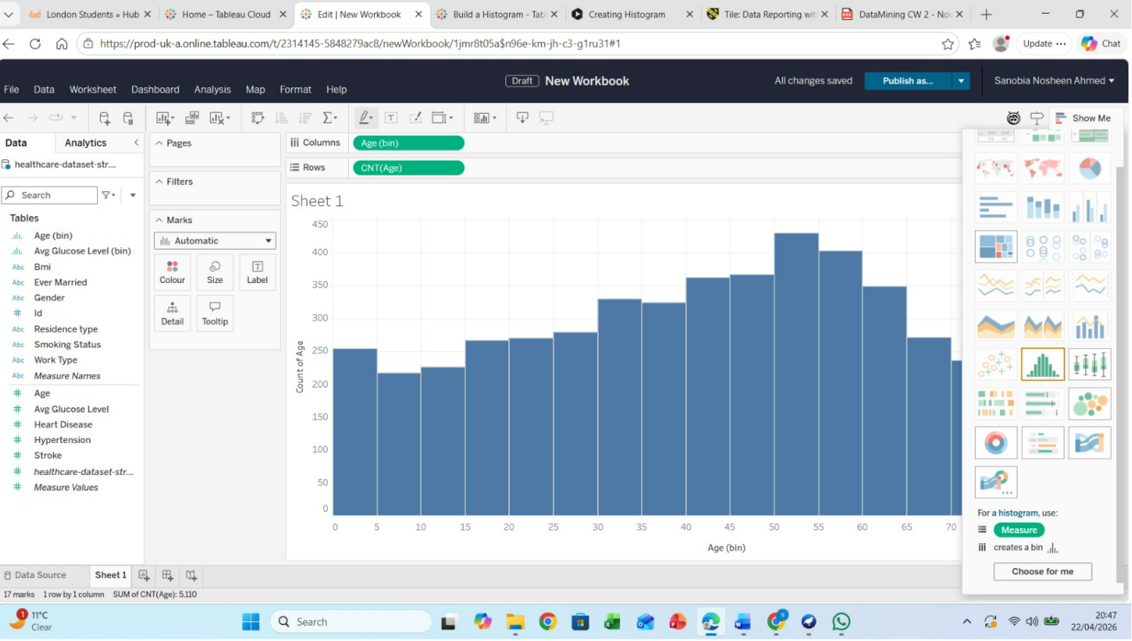

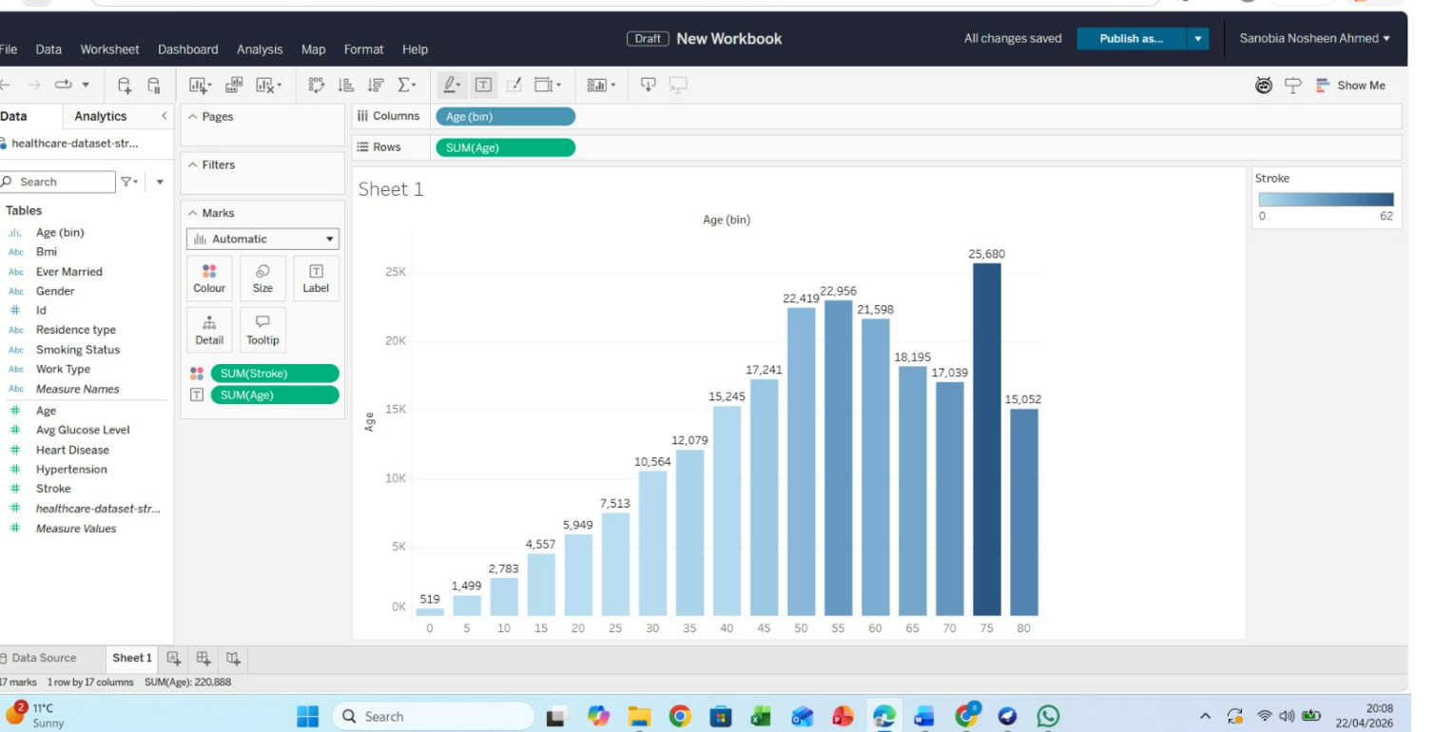

1.3 Data Pre-processing and Post-processing
Data pre-processing is a important point in the data mining procedure, unprocessed data is often incomplete, inconsistent, and not directly suitable for analysis. For the Stroke Prediction Dataset, several steps were undertaken to ensure the data was clean, structured, and ready for modelling.
The initial stage focused on dealing with incomplete data. Analysis showed that the BMI field had some missing entries. Because BMI is a key health factor, deleting those records would reduce useful data. Instead, the gaps were filled using mean imputation, where missing values are replaced with the average BMI. This method preserves the dataset while limiting distortion. All other variables were also reviewed, and most were already complete, so no additional cleaning was needed The next step was encoding categorical variables. The dataset includes several categorical attributes for example gender, work type, residence type, smoking status, and marital status. Machine learning algorithms cannot process categorical data directly, so these variables were converted into numerical form. Label encoding was used for binary categories such as gender and residence type, while one-hot encoding was applied to multi-class attributes like work type and smoking status. This ensures that no ordinal relationships are incorrectly introduced between categories.[4]
A key step was addressing class imbalance in the dataset. The analysis revealed far fewer stroke cases compared to non-stroke cases, which could bias the model toward the majority group. To correct this, techniques such as under sampling and oversampling (e.g., SMOTE) were evaluated. Here, oversampling was applied to boost the number of stroke instances, creating a more balanced dataset and helping the model better identify patterns in the minority class Additionally, feature engineering and selection were done to enhance model performance. Correlation analysis was utilised to identify less significant or unnecessary characteristics, which were then removed as necessary. For example, highly connected qualities that don't provide anything new were removed to reduce duplication. Other elements, such categorising age into groups (young, middle-aged, old, etc.), were also developed to better catch trends. To improve algorithm performance, numerical attributes like BMI and glucose level were also normalised or normalised to ensure they were on a similar scale.
The dataset was prepared for modelling using classification and clustering algorithms following preprocessing. However, to properly understand and present the results, post-processing is just as crucial. After models were created, performance was evaluated using metrics like accuracy, precision, recall, Confusion matrices were employed, especially for stroke cases, to give a thorough picture of accurate and inaccurate predictions.
During the post-processing phase, visualisation techniques were used to improve the comprehensibility of the data. Classification performance was assessed using graphs like ROC curves, and patient grouping patterns were interpreted with the use of cluster visualisations. To determine which characteristics had the biggest impact on predictions, feature importance charts were also created.
Ultimately, the findings were converted into useful insights for making decisions. For instance, early intervention can be directed toward high-risk patient groups indicated by the model. Both technical and non-technical stakeholders can comprehend the results thanks to clear visual representations and summaries. Overall, the accuracy, dependability, and utility of the data mining outputs are greatly enhanced by effective prior to and following processing techniques
.[5]
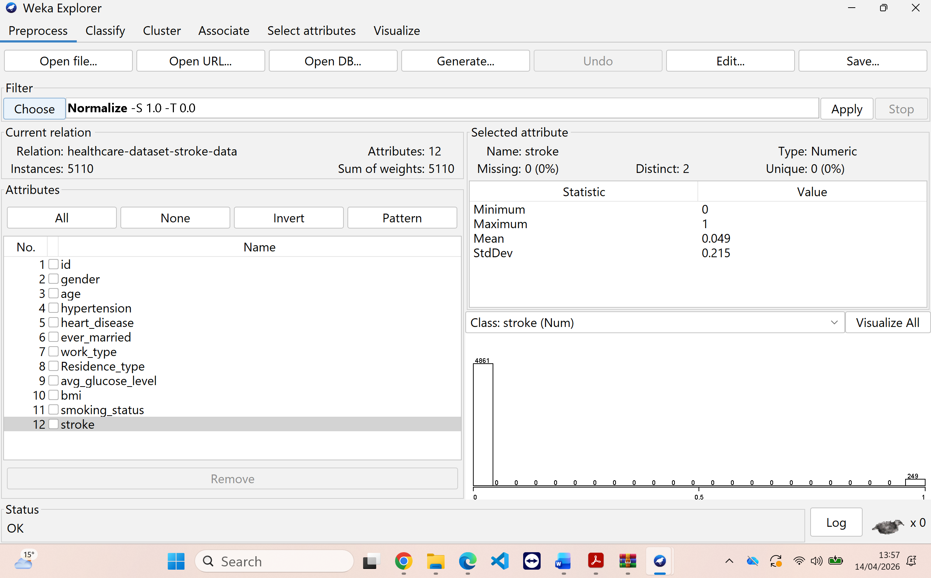
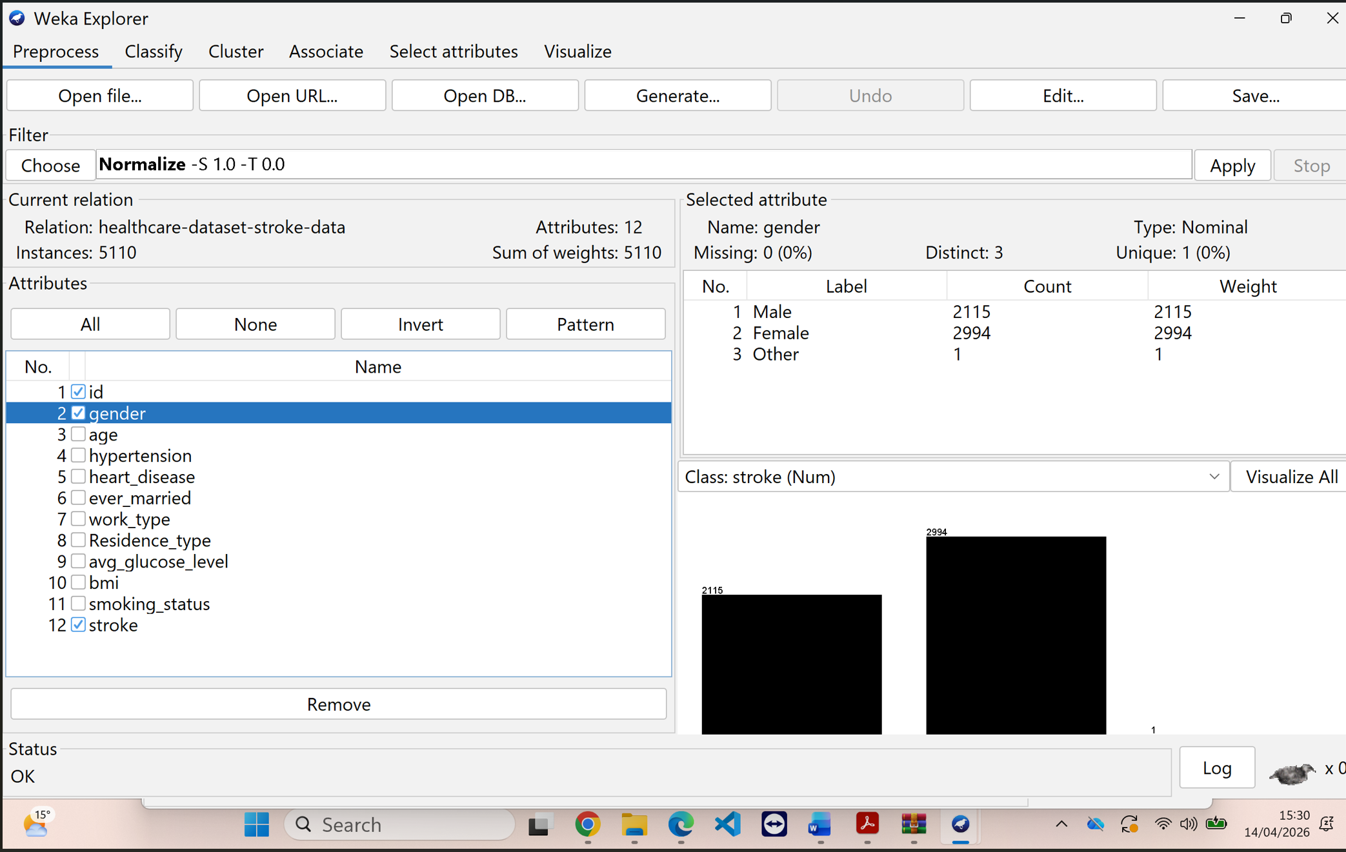

1.4 Sample Runs and Analysis Methods
To analyse the Stroke Prediction Dataset, several data mining techniques were implemented using tools such as Weka, along with supporting tools like Excel and Tableau for visualisation. The primary objective was to perform classification to predict stroke risk and clustering to identify patterns among patients. Sample runs from Weka demonstrate how different algorithms were applied and evaluated.
In Weka, the dataset was first loaded into the Explorer interface, and preprocessing steps such as handling missing values, encoding attributes, and normalisation were applied using built-in filters. After preprocessing, classification algorithms were tested under the “Classify” tab using a 70:30 percentage split and 10-fold cross-validation to ensure reliable evaluation.
One of the main algorithms used was the Decision Tree (J48). This algorithm was selected because it is easy to interpret and provides a clear visual representation of decision rules. In the sample run, the J48 classifier generated a tree where attributes such as age, glucose level, and hypertension appeared as key decision nodes. The model achieved moderate accuracy and allowed easy understanding of how predictions were made. Decision trees are particularly useful in healthcare as they provide transparency, enabling clinicians to follow the reasoning behind predictions.
Logistic regression, a popular approach for binary classification problems like stroke prediction (stroke vs. no stroke), was also utilised. Based on input factors, this approach calculates the likelihood that an event will occur. Logistic regression yielded coefficients in the Weka output that showed how each attribute affected the probability of stroke. For instance, the incidence of stroke was positively correlated with older age and higher glucose levels. Because logistic regression is statistically sound and works well with organised datasets, it was selected.
To increase prediction accuracy, the Random Forest algorithm was also used. An ensemble learning technique called Random Forest creates several decision trees and aggregates their results to generate a final forecast. Because Random Forest can manage complex relationships in the data and prevent overfitting, it outperformed individual decision trees in the sample run. Additionally, it included feature relevance rankings that emphasised glucose level, age, and BMI as important indicators.
For clustering analysis, the K-Means algorithm was used in Weka under the “Cluster” tab. This method grouped patients into clusters based on similarities in attributes such as age, BMI, and glucose level. The results showed distinct clusters representing different health profiles, such as high-risk and low-risk groups. Clustering is useful for identifying hidden patterns and segmenting patients for targeted healthcare interventions.
A few assessment indicators were employed to assess the model's performance. By displaying the proportion of correctly identified cases, accuracy quantifies the model's overall correctness. However, accuracy by itself is insufficient because the dataset is unbalanced. As a result, recall and precision were also taken into account. Recall counts the number of correctly identified real stroke cases, whereas precision counts the number of accurately projected stroke cases. Recall is especially crucial in the medical field since neglecting a stroke case might have dire repercussions.
Furthermore, the F1-score was employed to provide a single indicator of the efficacy of the model by striking a compromise between precision and recall. To assess the model's capacity to differentiate between classes, the ROC curve and Area Under the Curve (AUC) were also examined. Better model performance is indicated by a higher AUC value.
Confusion matrices, classification accuracy, and decision tree graphical representations were examples of Weka outputs. These results were examined in order to assess how well various algorithms performed. While Decision Trees offered superior interpretability, Random Forest generally fared better than other models in terms of accuracy and robustness. A balance between performance and statistical explanation was provided by logistic regression.
[6] [7]

Screenshots (Step-by-Step – Weka)
Screenshot 1: Load Dataset
- Open Weka
- Go → Explorer → Preprocess
- Click Open file → load dataset (.arff or .csv)




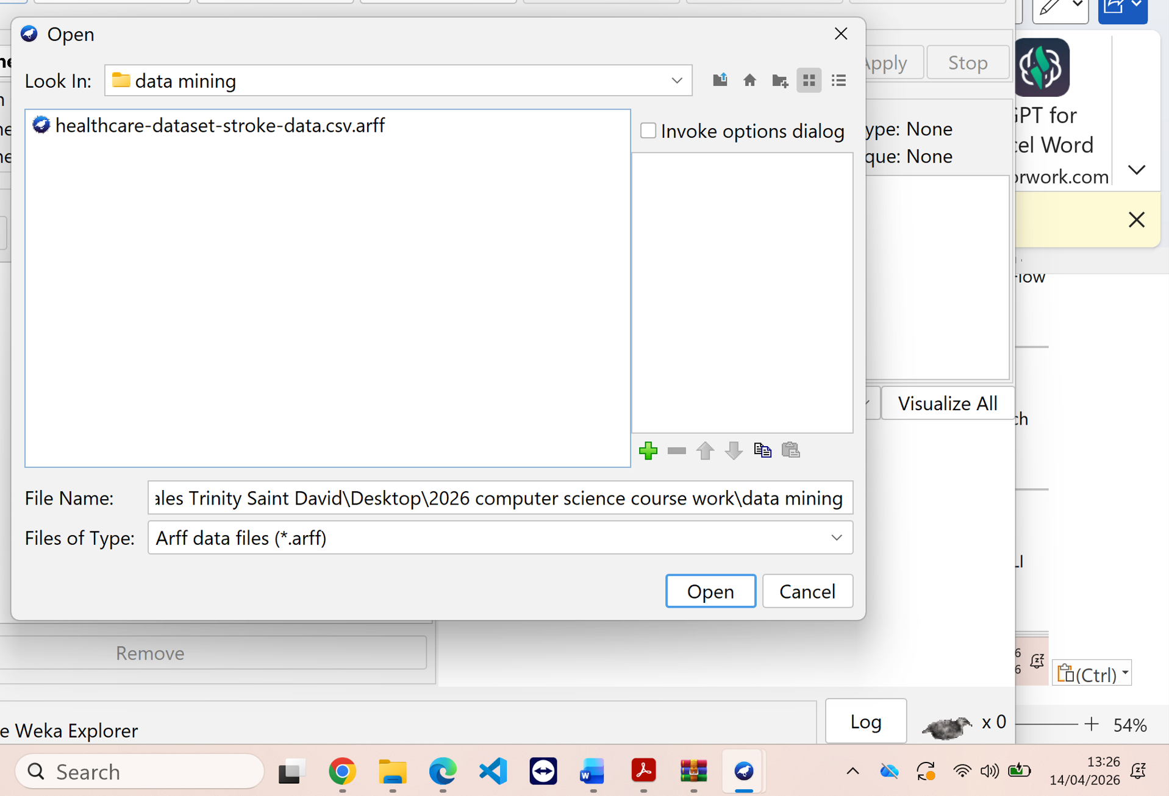

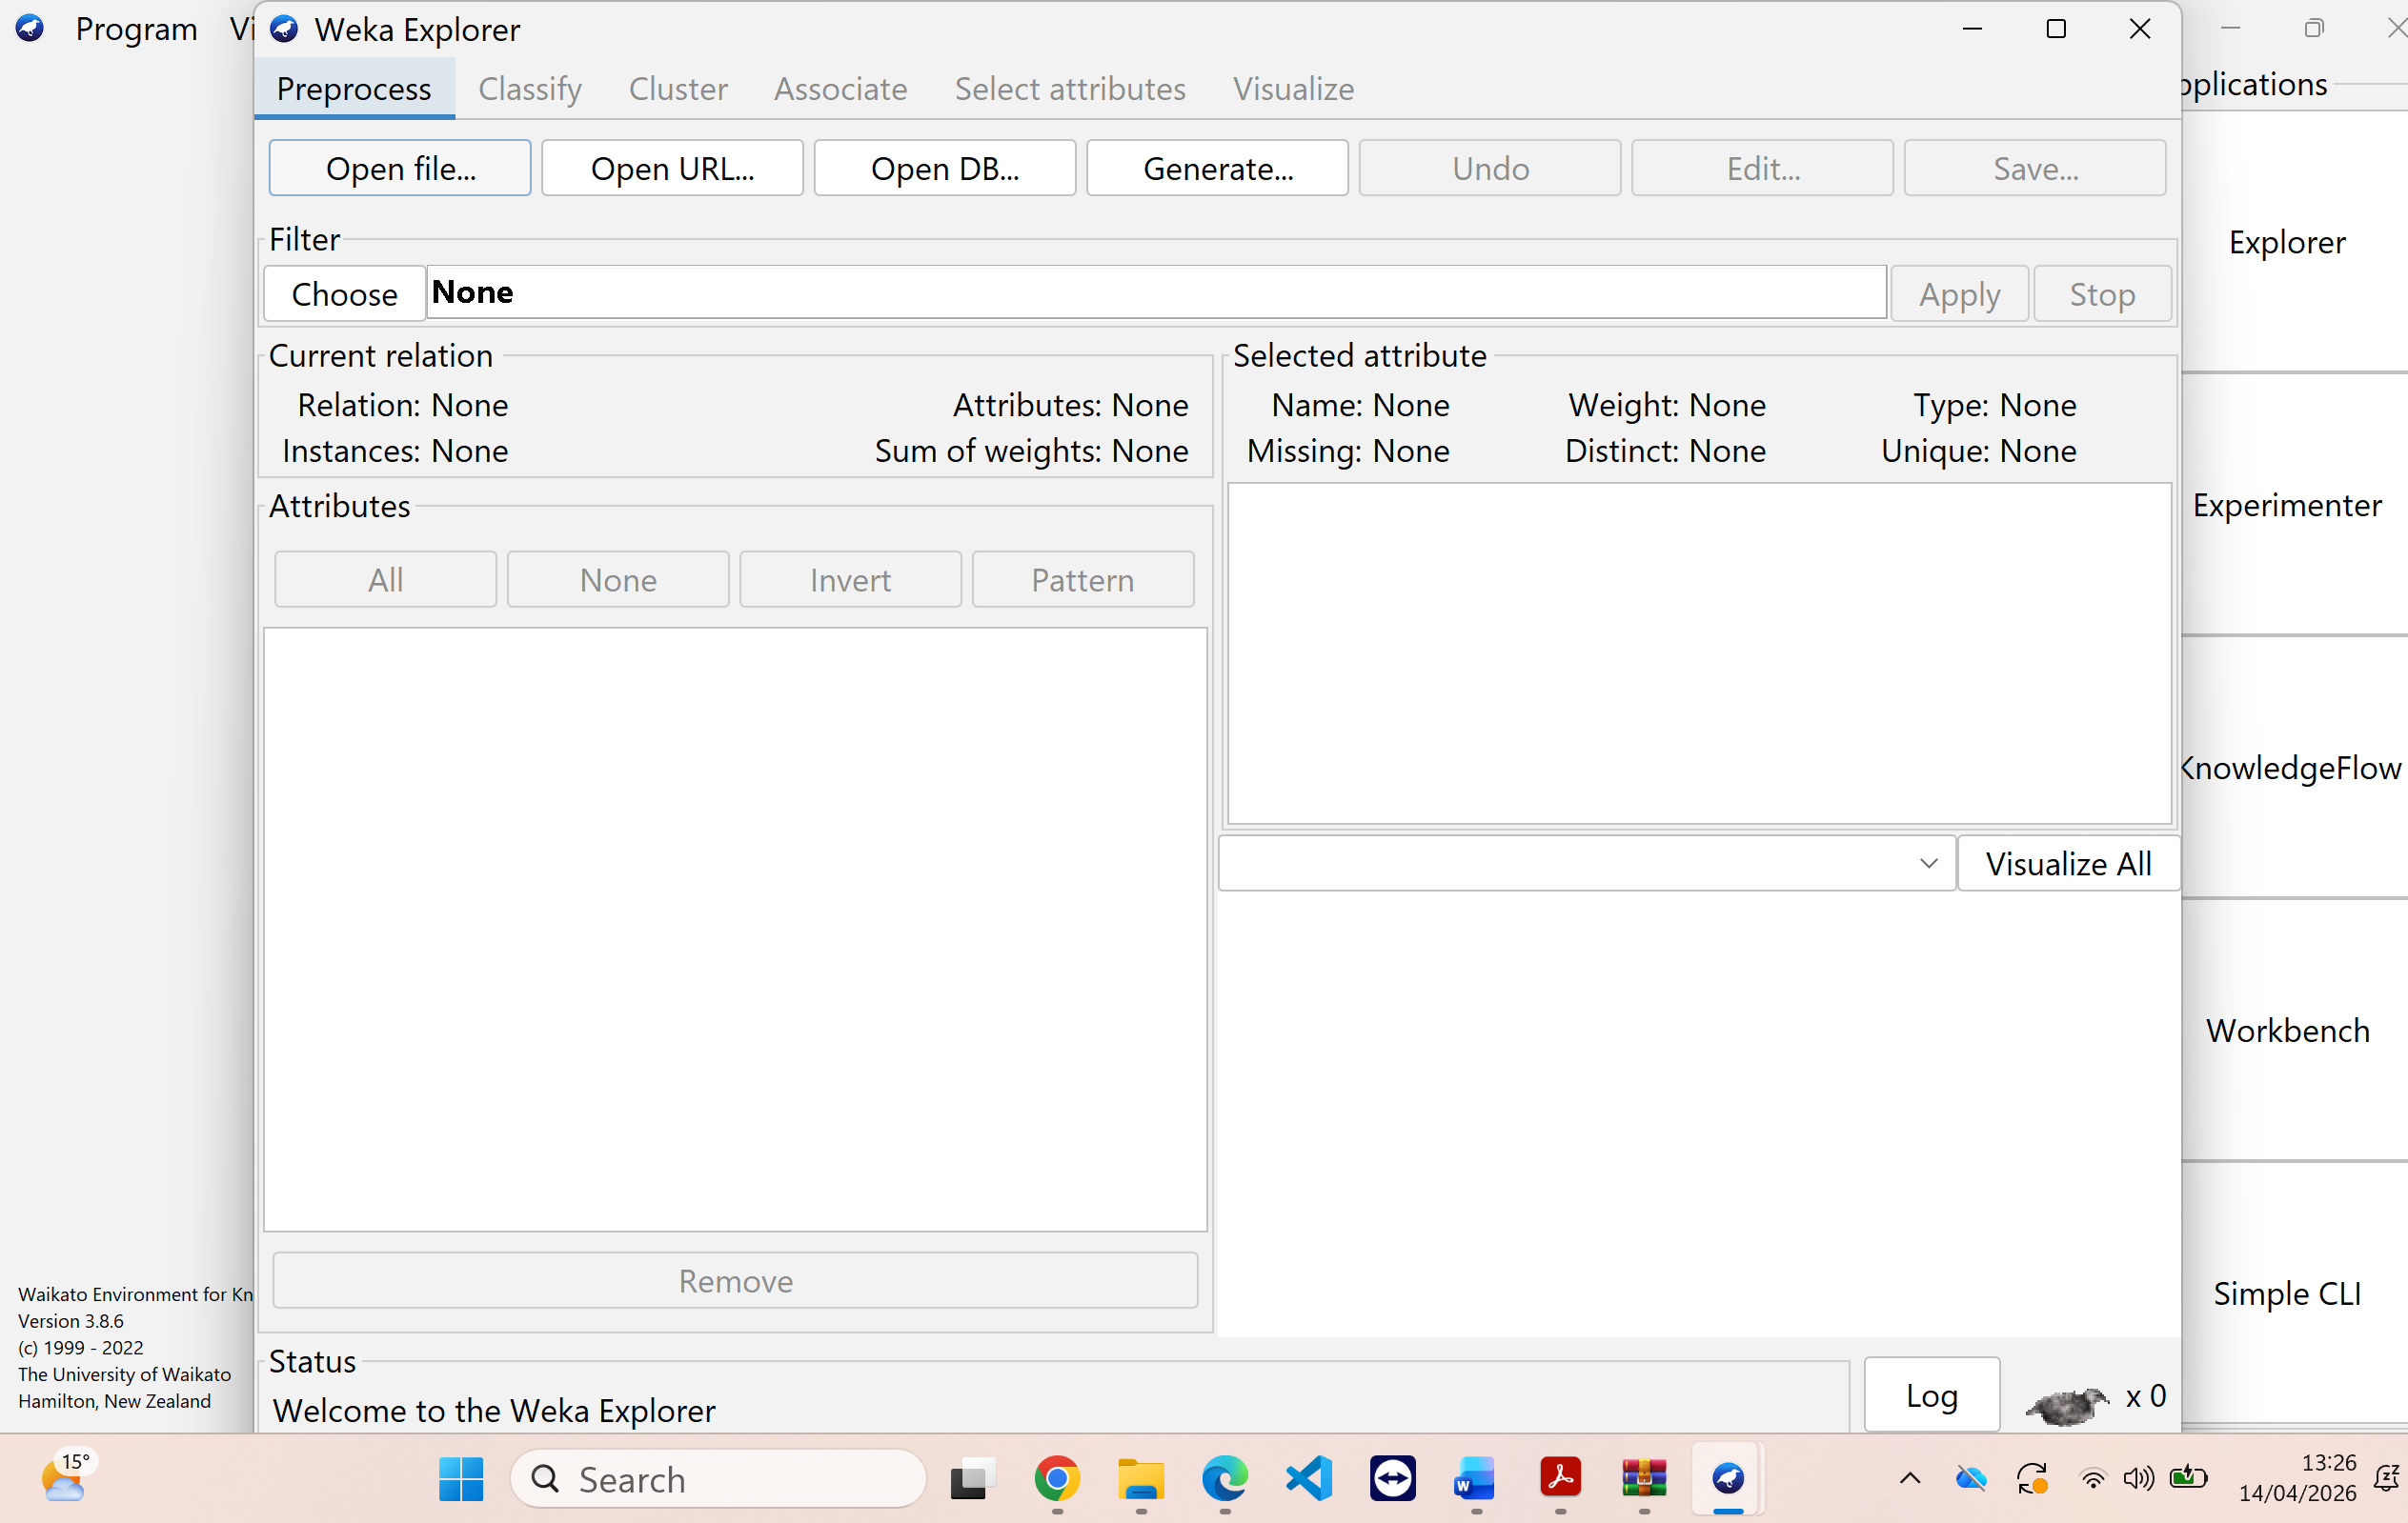
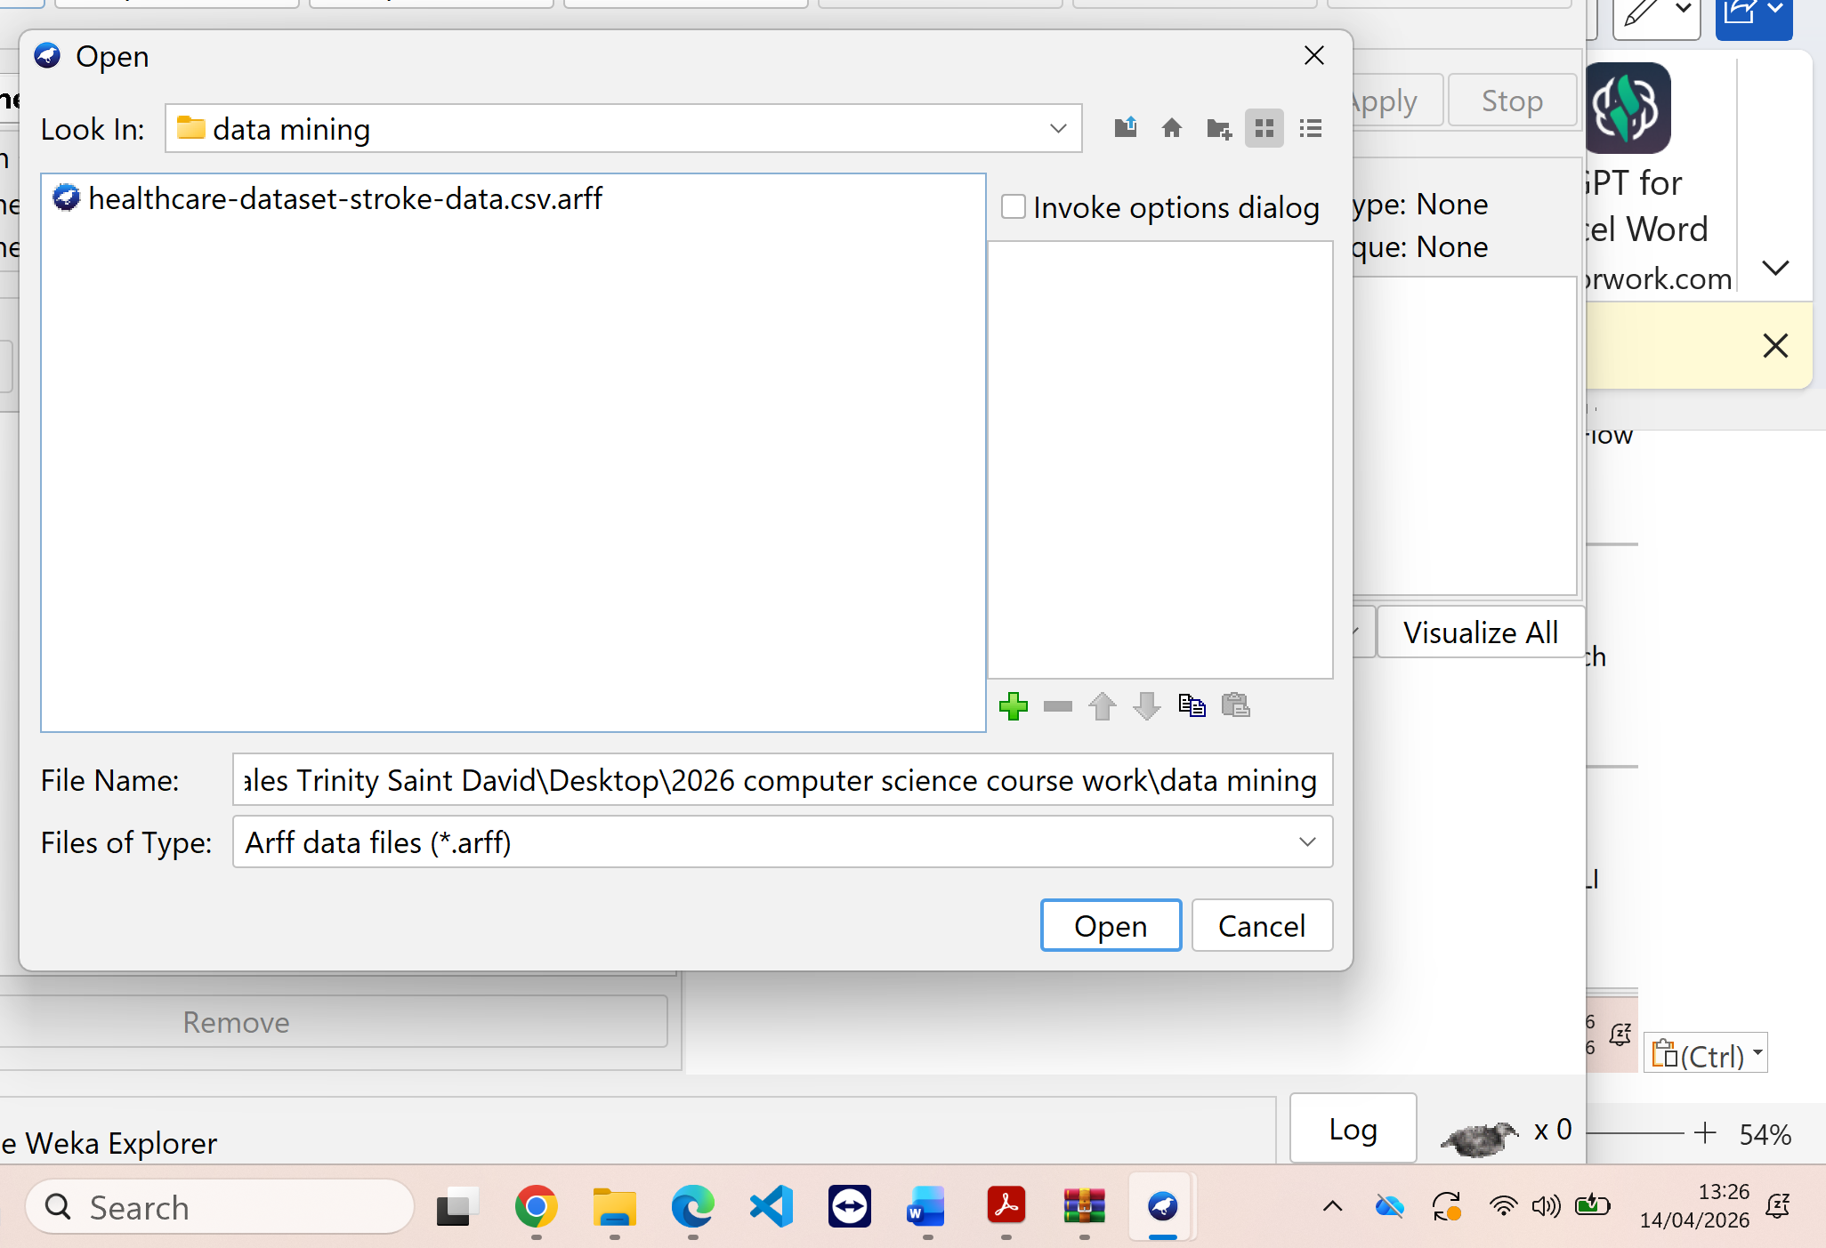

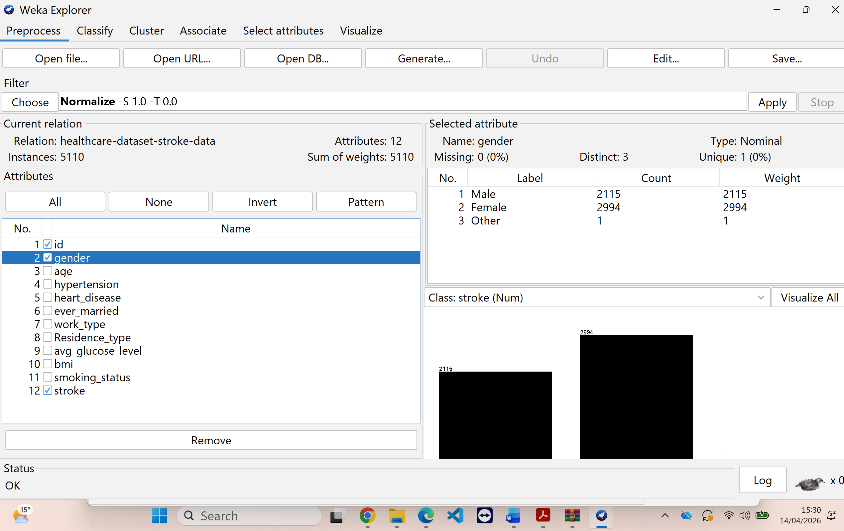

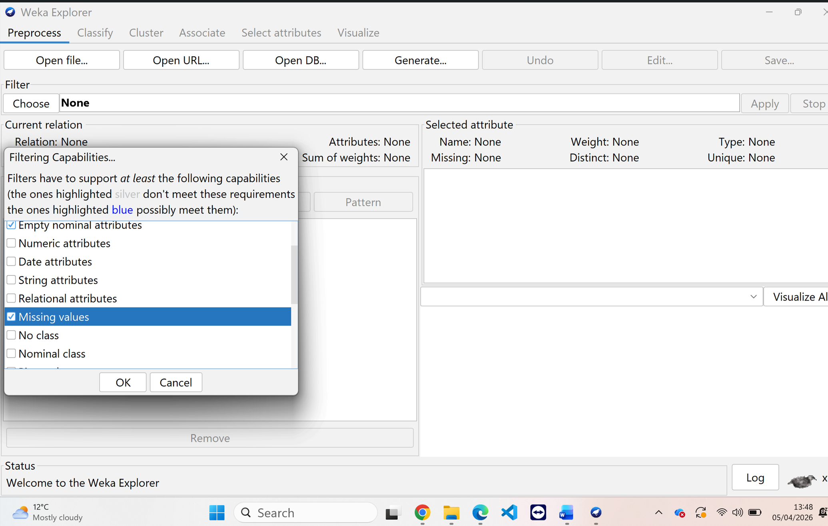

1.5 Business Recommendations
Several useful suggestions for enhancing patient outcomes and operational effectiveness can be made to public health organisations and healthcare experts in light of the stroke prediction analysis's findings.
First and foremost, companies ought to implement data-driven early detection systems. Healthcare professionals may automatically identify people who are at high risk of stroke using important markers like age, glucose levels, BMI, and hypertension by integrating predictive models into hospital information systems. This lowers the number of emergency cases and long-term treatment expenses by enabling proactive surveillance and prompt response.
Second, programs for preventative care should receive more funding. Public health agencies can create focused awareness programs that emphasise lifestyle changes including eating a healthy diet, exercising, quitting smoking, and getting frequent checkups. These programs specifically target the main risk factors found in
Second, programs for preventative care should receive more funding. Public health agencies can create focused awareness programs that emphasise lifestyle changes including eating a healthy diet, exercising, quitting smoking, and getting frequent checkups. These programs can dramatically reduce the incidence of stroke by directly addressing the main risk factors found in the dataset.
The use of clinical decision support systems is another crucial suggestion. By offering real-time data and risk scores, these tools can help healthcare workers make decisions more quickly and accurately. This increases clinical effectiveness in addition to improving patient care.
Additionally, healthcare organisations should use patient segmentation techniques to deliver personalised care. By grouping patients with similar risk profiles, tailored treatment plans and follow-up strategies can be developed, improving effectiveness and patient satisfaction.
From a business perspective, predictive analytics can help optimise resource allocation. Hospitals can prioritise high-risk patients, manage staff more efficiently, and reduce unnecessary hospital admissions, leading to cost savings.
Ultimately, the findings were converted into useful insights for making decisions. For instance, early intervention can be directed toward high-risk patient groups indicated by the model. Both technical and non-technical stakeholders can comprehend the results thanks to clear visual representations and summaries. Overall, the accuracy, dependability, and utility of the data mining outputs are greatly enhanced by efficient pre-processing and post-processing.[8]

1.6 Reflective Commentary
The analysis of the Stroke Prediction Dataset provided valuable insights into the application of data mining techniques in healthcare. Overall, the models performed reasonably well in identifying patterns and predicting stroke risk. Algorithms such as Random Forest achieved higher accuracy and demonstrated strong performance in handling complex relationships within the data. Logistic Regression provided clear statistical interpretation, while Decision Trees offered transparency and ease of understanding, which is particularly important in a healthcare context.
This analysis's use of many algorithms and evaluation criteria, which enabled a thorough comparison of model performance, was one of its main advantages. Given the skewed nature of the dataset, the addition of precision, recall, and AUC ensured that the models were evaluated beyond mere accuracy. The overall quality of the study was further enhanced by data pre-processing procedures like managing missing values and encoding categorical variables.
[9][10]

Conclusion
However, there were also limitations. The dataset imbalance remained a challenge, as stroke cases were significantly fewer than non-stroke cases, which may have affected prediction reliability. Although techniques like oversampling were applied, there is still a risk of overfitting. Another limitation was the lack of additional clinical variables, such as genetic factors or detailed medical history, which could further improve prediction accuracy.
If this analysis were to be repeated, more advanced techniques such as deep learning or ensemble optimisation could be explored. Additionally, collecting a larger and more diverse dataset would improve model generalisation. Further work could also include real-time data integration and deployment of predictive models in a clinical environment. Overall, this experience highlighted both the potential and challenges of applying data mining in healthcare.[8]
In conclusion, this study showed that data mining techniques are effective in predicting stroke risk and analysing healthcare data. Machine learning models such as Random Forest, Logistic Regression, and Decision Trees helped identify important patterns, with Random Forest providing the highest accuracy. Data pre-processing and the use of multiple evaluation metrics improved the reliability of the results.
The findings highlight the value of predictive analytics in supporting early detection and better decision-making in healthcare. However, challenges such as data imbalance and limited clinical variables affected performance. Future improvements could include larger datasets and advanced models to enhance accuracy and real-world application

References

[1] Amazon Web Services, “The difference between OLAP and OLTP,” 2023.
[2] Microsoft, “Online Analytical Processing (OLAP),” Microsoft Learn, 2024.
[3] S. Chaudhuri and U. Dayal, “An Overview of Data Warehousing and OLAP Technology,” ACM SIGMOD Record, vol. 26, no. 1, pp. 65–74, 1997.
[4] Jiawei Han, Micheline Kamber, and Jian Pei, Data Mining: Concepts and Techniques, 3rd ed. Waltham, MA, USA: Morgan Kaufmann, 2012.
[5] Nitesh V. Chawla, K. W. Bowyer, L. O. Hall, and W. P. Kegelmeyer, “SMOTE: Synthetic Minority Over-sampling Technique,” Journal of Artificial Intelligence Research, vol. 16, pp. 321–357, 2002.
[6] R. Kimball and M. Ross, The Data Warehouse Toolkit: The Definitive Guide to Dimensional Modeling, 3rd ed. Wiley, 2013.
[7] Kimball Group, “Dimensional Modeling Techniques,” 2023.
[8] DHL Supply Chain, “Supply Chain Digitalization,” DHL, 2024.
[9] World Health Organization, “Stroke, Cerebrovascular accident,” 2023. [Online]. Available: https://www.who.int/news-room/fact-sheets/detail/stroke-cerebrovascular-accident
[10] A. K. Singh and R. Kumar, “Stroke prediction using machine learning techniques,” ol. 8, pp. 123456–123465, 2020

