INTERNATIONAL MARKETING ASSESSMENT

COURSE CODE: SBMA 7108

NAME: AYOOLA ADEBOBAJO OLANIYI

STUDENT ID: 1710674

LECTURER: TUSHARA BALENDRAN

Table of Contents
Topics Pages
Introduction…………………………………………………………………………....4
Background Information about the Toyota Company.………………5
Vision and Mission of Company……………………………………………….6
Toyota’s Global Financial Performance…………………………………….6
- Toyota’s Income Statement 2014 – 2018
- Toyota’s Financial By Region: Nigeria vs. United States
- Toyota’s Car Sales By Region
Situational Analysis of Toyota: Nigeria vs. United States………….9
Macro Environment of Toyota Corporation: Nigeria vs. USA…….9
The PESTEL Model……………………………………………………………………10
- Political Environment
- Economic Environment
- Socio-Cultural Environment
  - The Hofstede’s Model
- Technological Environment
- Ecological Environment
- Legal Environment
Limitations of the PESTEL Model.…………………………………………..15
Recommendations to Toyota of PESTEL Model………………………16
Porter’s Five Force Model of Toyota………………………………………16
Purposes of Porter’s Five force Model…………………………………..16
- Threat of New Entrants
- Bargaining Power of Suppliers
- Rivalry Among Existing Firms
- Bargaining Power of Customers
- Threat of Substitutes
Advantages of Porter’s Five Force Model………………………………18
Topics Pages
Disadvantages of Porter’s Five Force Model………………………….18
Recommendations for Toyota of Porter’s Five Force Model….19
SWOT Analysis of Toyota Business: Nigeria vs. USA………………19
Purposes of SWOT Analysis………………………………………………….19
The STP Model: Application to Nigeria and United States…….22
Purposes of the STP Model………………………………………………….22
Market Segmentation…………………………………………………………22
Marketing Targeting……………………………………………………………24
Marketing Positioning…………………………………………………………24
The Marketing Mix of Toyota………………………………………………25
Purposes of the Marketing Mix……………………………………………25
- Product
- Price
- Place
  - Types of Market Coverage
  - Market Entry Methods
- Promotion
  - Promotional Strategies for Toyota Sienna
- People
- Process
- Physical Evidence
Directional Development (Future Strategies) of Toyota………31
The Ansoff Matrix………………………………………………………………31
Recommendations…………………………………………………………….32
- The Product Life Cycle of Toyota Sienna
Conclusion ………………………………………………………………………..33
References ………………………………………………………………………..34
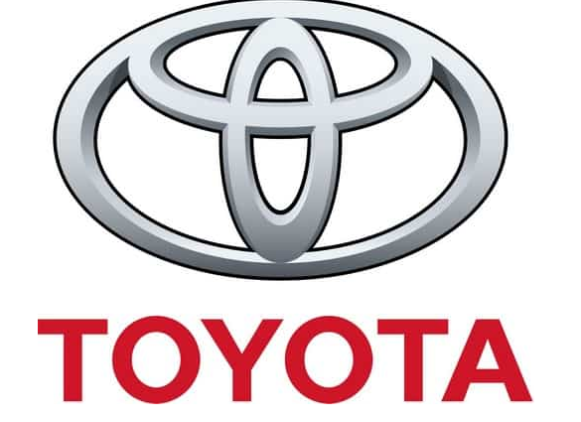

TOYOTA SIENNA: NIGERIA VERSUS U.S.A.

- 1ntroduction:
In this study, I will be comparing and contrasting the marketing strategies used by the Toyota Corporation, manufacturer and marketer of Toyota Sienna in Nigeria and the United States of America. Most importantly, I will be reviewing a number of models to explain how the business of this niche product is done in both countries. These models include the PESTEL and SWOT Analysis, the STP Model, Porters 5 Force Model, the Ansoff Matrix and the Product Life Cycle.
The PESTEL Analysis will reveal factors in the external environment of the Company which has ability to influence the performance of the firm while the SWOT Analysis will examine the strengths and weaknesses of the firm as well as opportunities and threats facing Toyota. The Porters Five Force Model will review competitive actions within the organisation while the Ansoff model will explain the Directional Development or Future Strategies of the firm.
- Background Information about the Toyota Company
The Toyota Corporation, established as an independent company, by Kiichiro Toyoda in 1926 with the help of his father Sakichi Toyoda has its head-quarters in Japan. The Company is, unarguably, the biggest vehicle producer globally conducting operations and selling Toyota branded vehicles in over 170 countries worldwide. It has on its pay roll over 300,000 workers world over.
The Toyota Company has existed for 75 years and the story of this organization will not be completely told if a mention is not made about the fact that the Company all started from a business deal entered into in the United Kingdom between Kiichiro Toyoda, a Japanese family, who were highly successful in the spinning and weaving business and the Platt Brothers in Oldham, Britain. Kiichiro, following the advice of his father, Sakichi, sold the patent rights of his family automatic loom design to the Platt Brothers in the early 1900s and with the money raised from the sale of the patent, was able to invest in the research and development of car prototypes and this led to the manufacture, in 1936, of the first Toyota AA Saloon car.
Despite the challenges which the world economy faces, the future of the Toyota vehicle business has remained very bright. For instance, the Toyota President, Akio Toyoda in 2017, commended, the way Toyota as an organization and its employees as an institution had responded to the challenges and adversity of the immediate past. He said,
“The Corporation’s Vision on a global basis demonstrates our resolve to persevere despite the challenges and the adversities that the future might bring our way. It is also a clear definition of our will to be a successful company and to exceed the highest expectations of our customers, our business partners, our friends and neighbours in the community at large, our work colleagues and everyone who comes in contact with Toyota in any way. It also reassures us of our awareness of sustainable growth as the result of becoming the company we have become.”
- The Vision and Mission of the Company
The Toyota Company has gotten a very rich culture and a dynamic vision and mission statements:
- The Vision: be the ‘most recognised, respected and loved company’
- The Mission: To offer quality and durable vehicles for customers and be socially responsible to stakeholders and environment.

- Toyota’s Global Financial Performance Data
- Toyota’s Income Statement: 2014 to 2018
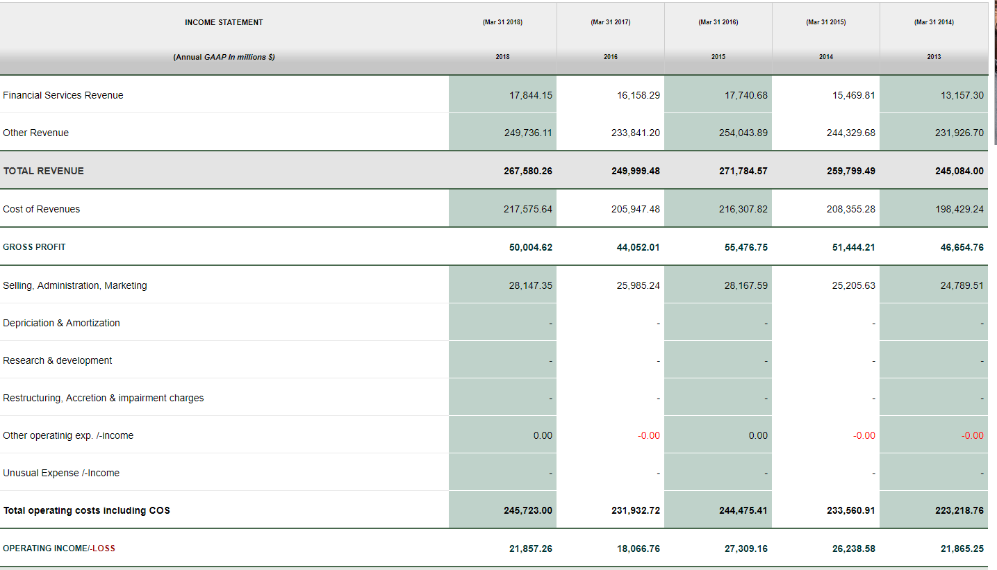
Toyota Corporations’ Global Financial Data
From the above table, we can see that the Toyota Corporation experienced a steady revenue growth 2013 and 2015, For instance, versus 2013; 2014 revenue was up 6% while the growth in 2015 was 4.6%. These growths were due to new product development particularly the Hybrid Toyota Prius and its expansion into new markets outside Japan and the United States of America. However, there was a sharp decline of -8% in revenue for the motor corporation in 2016 largely blamed on the cost of customer incentives in Toyota’s key United States market. That decline in 2016 was temporary, as the Company bounced back in the fiscal year of 2017 when revenue jumped up to 7% due to two main reasons:
- First, Toyota decided to focus strategically on enhancing efficiencies rather than massively producing and selling bulk volumes.
- Second, Toyota’s was able to curtail extra costs and operate efficiently due to its just-in-time manufacturing.
Besides, Toyota’s net revenues also showed impressive results buoyed by favourable exchange rates and helped by new tax laws promulgated by the United States. Net revenue in 2014 was up 16% versus previous year; it marginally increased by 4.5% in 2015 but declined by a whopping -24% in 2016. Net revenue recovered in 2017 at + 34.9%. Buoyed by a half year result of +13.2%, the 2018 full year profit is forecast to be $17 billion or 1.95 trillion yen.
- Toyota’s Financial Data by Region : Nigeria and United States of America
Toyota’s financial data for Nigeria cannot be immediately sourced but the market is, however, poised to deliver 520, 000 unit sales of cars in 2018 up 7% over 2017. (Toyota Projected Sales data, 2018). On the other hand, the data below shows USA’s financial performance data from 2012 to 201. The USA market is the second largest for Toyota cars outside Japan and this market has consistently shown revenue growth since 2012. For example, in 2016, the US business grew by over 4% (see data below).
 |  | Year Ended March 31,
 |  | 2012 |  |  |  | 2013 |  |  |  | 2014 |  |  |  | 2015 |  |  |  | 2016
 |  | (Yen in millions, except share and per share data)
Consolidated Statement of Income Data:
Automotive:
Revenues |  |  | 16,994,546 |  |  |  | 20,419,100 |  |  |  | 23,781,404 |  |  |  | 25,062,129 |  |  |  | 25,977,416
Operating income |  |  | 21,683 |  |  |  | 944,704 |  |  |  | 1,938,778 |  |  |  | 2,325,310 |  |  |  | 2,448,998
Financial Services:
Revenues |  |  | 1,100,324 |  |  |  | 1,170,670 |  |  |  | 1,421,047 |  |  |  | 1,661,149 |  |  |  | 1,896,224
Operating income |  |  | 306,438 |  |  |  | 315,820 |  |  |  | 294,891 |  |  |  | 361,833 |  |  |  | 339,226
All Other:
Revenues |  |  | 1,048,915 |  |  |  | 1,066,461 |  |  |  | 1,151,280 |  |  |  | 1,255,791 |  |  |  | 1,177,387
Operating income |  |  | 42,062 |  |  |  | 53,616 |  |  |  | 64,270 |  |  |  | 65,650 |  |  |  | 66,507
Elimination of intersegment:
Revenues |  |  | (560,132 | ) |  |  | (592,039 | ) |  |  | (661,820 | ) |  |  | (744,548 | ) |  |  | (647,909 | )
Operating income |  |  | (14,556 | ) |  |  | 6,748 |  |  |  | (5,827 | ) |  |  | (2,229 | ) |  |  | (760 | )
Total Company:
Revenues |  |  | 18,583,653 |  |  |  | 22,064,192 |  |  |  | 25,691,911 |  |  |  | 27,234,521 |  |  |  | 28,403,118
Operating income |  |  | 355,627 |  |  |  | 1,320,888 |  |  |  | 2,292,112 |  |  |  | 2,750,564 |  |  |  | 2,853,971
Income before income taxes and equity in earnings of affiliated companies |  |  | 432,873 |  |  |  | 1,403,649 |  |  |  | 2,441,080 |  |  |  | 2,892,828 |  |  |  | 2,983,381
Net income attributable to Toyota Motor Corporation |  |  | 283,559 |  |  |  | 962,163 |  |  |  | 1,823,119 |  |  |  | 2,173,338 |  |  |  | 2,312,694
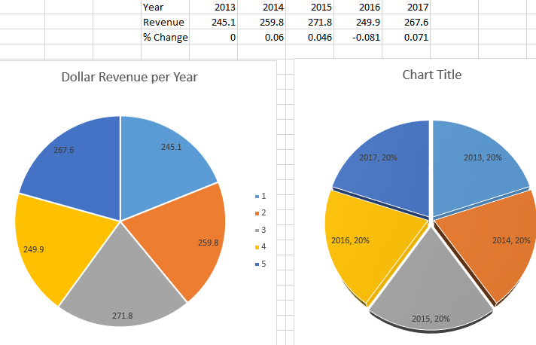
C. Toyota Car Sales By Region
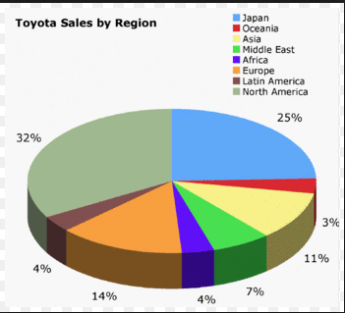
The statitistics above shows a breakdown of Toyota ‘s global car sales in 2018 by region. Of the about 90 million cars forecasted to be sold, expected sales from North America is 21 million Toyota cars; expected sales from Asia (Japan and Oceania Asia) is 39 million and Europe is expected to sell around 15 million cars. Africa accounts for 4% of the total sales or 4 million units of Cars. Of the total Africa continent sales, Nigeria is expected to deliver about 520,000 cars in 2018.
- Situational Analysis of Toyota: Nigeria versus United States of America
In doing the Situational Analysis of the Toyota Company for Nigeria and the United States of America, I will answer the question where is the Toyota business now in both countries?. In answering, I will analyse two models: the PESTEL and the Porters 5 Force Models
  - The Macro Environment of Toyota Motor Corporation in Nigeria and the United States of America
Basically, an organisation does business in an environment that is very complex. One comprised of forces which could influence the business in a significant way. So, it is imperative that the organisation examines its business environment. So, the macro environment factors which in both nations include Political, Economic, Social, Technological, Environmental and Legal factors may not affect the firms in a similar manner in both countries.
  - The PESTEL Analysis
Purpose of PESTEL - The PESTEL analysis serves a number of purposes; First, it enables the Company to assess its market and its competition. Second, it helps the organisation to identify critical forces that can ‘influence performance of the firm; its demand and supply situations as well as its costs structure’ (Koffer and Schlesinger, 1991). Third, PESTEL provides decision-makers a knowledge of the changes happening within a stipulated market. This way the management of the organisation is able to make better and informed business decisions.
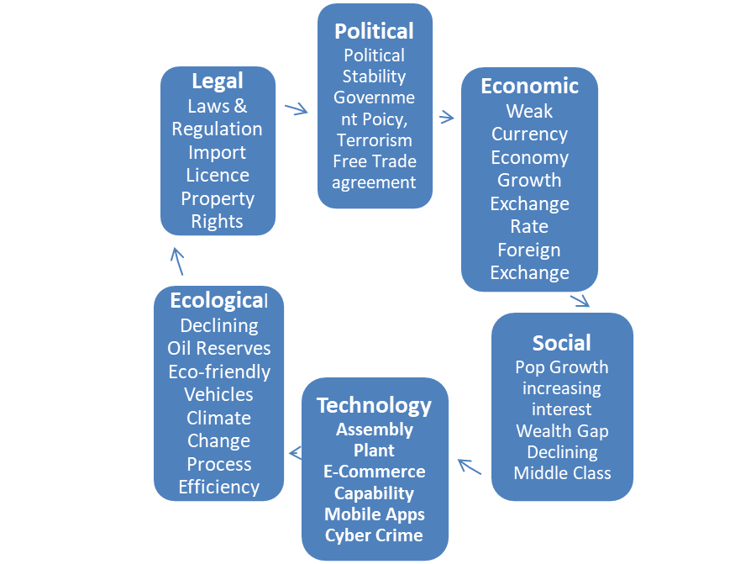
Pestel Analysis Model diagram created by Ayoola Olaniyi
5.2a. The Political Environment of Toyota in Nigeria and the United States
According to Kotler & Armstrong (2010, p.108), ‘’politics is the first factor to consider when analysing forces that influences a company seeking to get into a foreign market because an organisation’s operations are heavily influenced by the political environment’’. So, Toyota is affected by the political factors in its environment. This factor highlights the implications of government actions on the corporation and this factor is completely unfavourable to the Toyota business in Nigeria. First, the Toyota business is negatively affected by political instability in its enironment. For instance, there is the problem of terrorism in some key markets of Nigeria. Second, the crisis within political parties, which has led to serious tensions in various parts of the country, substantially affect the market of Toyota vehicles in Nigeria because the economic indices are not positive. Third, government legislations, particularly as it affects importations and import duties, are a major constraint on the expansion of the Toyota business in Nigeria whereas in the United States of America, the political environment is favourable because it presents a massive opportunity for growth and expansion i.e. there is the opportunityy for free trade agreements. As a matter of fact, the free trade agreement with many other nation i.e. Japan present opportunities for improved market penetration. There is also government support for ecofriendly vehicles which enables the Toyota Company to enhance its products for the satisfaction of their customers. The political stability of the United States presents a massive opportunity for Toyota to grow with almost no political tension.
5.2b. The Economic Environment of Toyota in Nigeria and the United States
Khanna, Palepu & Sinha, 2005 suggest that, ‘’in order to get a grasp of a nation’s macro economics, it is imperative to analyze the Gross Domestic Product (GDP), per capita income growth rates, population composition and a few more others’’. These economic factors influence Toyota’s business operations. These factors will usually determine the effects of economic circumstances on operations. Thus, in Nigeria, the economic environment is not favourable to the Toyota business. For instance, a weaker Nigeria Naira to the Dollar constitute a significant economic force in the economic environment of the Toyota Corporation. Also, the Nigerian nation is so much indebted externally that her extenal reserves is so low and can hardly support one month of imports. However, despite these limitations, Nigeria is expexted to sell in 2018 over 520,000 Toyota Cars or +9.7% versus 2017. This rapid growth experienced in Nigeria has thrown up an opportunity for Toyota to improve revenues. Conversely, the economic environment in the United States of America is very favourable. For instance, the gradual growth of the U.S. economy is a massive opportunity for the growth of Toyota business which is the second biggest market outside of Japan.
5.2c. The Socio-Cultural Environment of Toyota in Nigeria and the United States
Yuksel, 2013 explained that the ‘’Social factors can be defined as those socio-cultural elements of a population that dictate the ways individuals or groups live within that society’’. Barney & Hesterty, (2008, p33) added that ‘’firms should consider these forces because having a knowledge of the socio-cultural factors will help businesses decide the level of their product changes and core clients’’ No doubt, socio-cultural factors influence Toyota’s business. In Nigeria, these factors that include increasing customer interest in Toyota vehicles especially the Sienna is favourable. Interest in Toyota cars is growing in Nigeria. And this is positive for the business. The situation in the United States is near similar to that of Nigeria. First, the socio-cultural environment in the United States is very favourable to the Toyota business. Second, just like Nigeria, there is growing customer interests in the hybrid models and the electric cars. However, there is the need for the Company to consider the broadening gap in the wealth of the people, not just in Nigeria but also in the United States of America. This is a threat because it suggests a declining middle class which is the main revenue source of Toyota all over the world.
The Hofstede Model will explain the socio-cultural environment of Toyota business a bit more. It will describe the effects a society's culture has on people’s values and the relationship between the values and the members’ behavior.
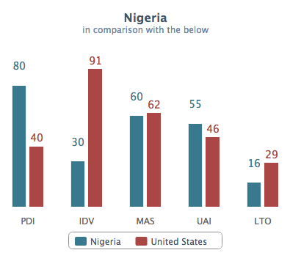
Hodstede Six Dimensions of Culture: Nigeria versus United States
- Power Distance Index; this explains the extent to which consumers are willing to be upwardly influenced., With a score of 80 for Nigeria and 40 for United States, the average Nigerian consumer accepts powere inequality as the norm while the avaerage United States consumer believes it should be erased. This has implication for Toyota Sienna because while the average Nigerian buyer believes the car is fr the upper class, the typical USA buyer believes, it is for everyone.
- Individualism vs Collectivism: this addresses the extent to which a society is dependent upon its members. Nigeria, with a score of 30 can be said to be a collectivistic society i.e. there is close affinity with the family. For example, the average buyer of a car will consider the size of his or her family before making the purchase decision. The Toyota Sienna, because of its 7 and 8 seater model will benefit from this. The USA, with a score of 91 is mainly an individualistic society and so buyer considerations will be as such. Sporty cars will appeaal largely to buyers in this society.
- Masculinity versus Feminity: A masculine society is driven by competition, a sense of achievement and success while the Feminine society is mainly driven by quality of life. With a score of 60, Nigeria is masculine in nature meaning that people live in order to work. It follows that people will work in order to have the best things of life. Since Toyota Sienna is a prestigious vehicle, the avearge Nigerian buyer will strive to get it because having one is a sign of success. This is also true of the United States with a score of 62.
- Uncertainty Avoidance Index: this is how much the societal members feel threatened by unknown circumstances, unknown future ana as such, will find a way to deal with the unknown fears like saving for the raining day. Saving for a future that is clearly unknown will affect purchase behaviour i.e. buyers will be hesitant to spend. Meanwhile, Nigeria’s score of 55 does clearly show a preference but the USA score of 46 means that the average American buyer will take a few risks or will be willing to spend a bit more believing the future is ahead of him or her.
- Short Term Versus Long Term Orientation: this speaks to whether we will focus on the future, the prresent or the past or should we be long term or short term in our thinking?. To achieve result will require perseverance. A score of 16 means that the average buyer in Nigeria will less likely think long term or plan for the future while buyers in United States, with a score of 29, will be more pragmatic long term.
- Indulgence Versus Restraint: this describes the extent to which people try to control their desires and impulses. When it is weak, it is called indulgence and when it is strong, ii called restraint. With a score of 84, the Nigeria culture is classified as indulgence meaning that buyers will be willing to realise their impulses, desire, enjoy life, have fun and spend money as they wish. Toyota Sienna will benefit from this culture as the average Nigeria buyer will be willing to realise his or her dreams. The USA, with a score of 68, will behave similarly.
5.2d. The Technological Environment of Toyota in Nigeria and the United States Kotler & Armstrong (2010, p.107) says ‘Technological forces are definitely worth putting into consideration because they are very important in making current products obsolete’. Technological factors influence in a major way the ability of the Toyota Company to operate particularly because it is a technical operations. This factor influences technological trends. In Nigeria, added to the fact that the Toyota Company has no manufacturing or assembly plant there, technology in the sence of car manufacture is not developed. To this extent, the technological environment is not favourable. In the United States, technology is advanced. There is a massive opportunity to improve its e-commerce capabilities or to exploit third-party e-commerce service providers for sales of some of its products, such as spare parts. Also, Toyota has the opportunity to enhance its mobile apps to increase customer engagement and loyalty. Technological environment, in the USA. is favourable. However, firm needs to solve the problem of cybercrime and corporate cyber-espionage which has constituted threats to her business via appropriate technological security solutions.
5.2e. The Ecological Environment of Toyota in Nigeria and the United States
According to Yuksei, 2013, ‘’ecological analysis is important so as to develop a business model that is sustainable overtime, identify potential opportunities and seek out collaboration’’. The Toyota Company needs to be concerned with the impact of the ecological environment on its business operations. These are concerns that has to do with the natural environment of the business. In Nigeria, this factor is completely very unfavourable for the Toyota business. For instance, the decline in oil reserves and oil revenue has a major effect on business and revenue growth. Cars can only be bought in an environment where business is booming and there is prosperity. In the United States of American also, just as in Nigeria, the problem of declining oil reserves influences business negatively. However, Toyota has massive opportunities to roll out more environmentally friendly products, such as electric cars or cars with excellent fuel efficiency. This is not possible in Nigeria where access to power is near impossible. Thus, the ecological environment for Toyota in USA can be said to be favourable. Climate change is another ecological factor that needs to be of major concern to Toyota in both countries. The company, nevertheless, can enhance its sustainability performance by improving process efficiency especially in the USA.
5.2f. The Legal Environment + Toyota in Nigeria and the United States
Melling and Mann, 2012 opined that ‘’government legislations are usually stable, however, unexpected flunctuations and changes could affect a firm’s operations’’ The Legal systems of Nigeria or the United States of America can impact Toyota’s business in a major way. These are the laws and regulations that can affect the business in many ways than one. In Nigeria, for instance, consumer laws are very complex. Importers of Toyota cars are faced with import regulations, excise duties and increasing tarriffs. The cost of clear-ing cars from the ports are mind boggling. All of these factors have significant implications on sales and importations of the vehicles in Nigeria. For this, the legal environment of the Toyota business in Nigeria is unfavourable. In the United States of America, however, the legal environment is favourable, For instance, the Toyota business can continue to operate and grow with little or no fear that her intellectual property rights will be infringed upon because government is able to protect businesses. Thus, the company is able to offer durable and more beneficial vehicles that will exceed consumer expectations.
  - Limitations of The PESTEL Model
- Environmental factors are based on assumptions because they change from time to time. This will affect the transparency of the analysis and render it subsceptible to discrepancies. Therefore, to do an analysis close to acceptable standard, an R&D expert may be engaged and that will add to costs otherwise a bad analysis might lead to the firm’s failure.
- Environmental changes can impact business operations substantially and if PESTLE analysis is not done into detail, uncertainties can occur.
- A simple presentation of PESTLE analysis is not adequate to fully comprehend all the obstacles facing the organisation because the findings might be weak, error prone and deceitful. Except the forcess are closely examined and the level of impact measured, the findings may be useless.
- Doing research and analysis requires time, effort, patience and money. Sourcing external data can be a tedious assignment and so organisations must be prepared to provide the resources to achieve accurate analysis.

  - Recommendations to Toyota of PESTEL Analysis
Despite the limitations of the PESTEL analysis highlighted above and the fact that they are not all favourable, I believe that the analysis has thrown up massive opportunities for Toyota. The firm can:
1. dedicate substantial investment funds to new product development. The introduction of the hybrid model was a success to build upon.
2. invest to enhance market presence not just in USA but also in Nigeria.
3. must address threats posed by the widening wealth gap and increasing cybercrime. Toyota can produce cars for different social income class.
- The Porter’s Five Forces Model as it relates to Toyota Sienna
The Porter’s Five Force model presents five key factors that describes the actions of competition in Toyota’s industry. The forces shown below in a diagram will examine the Toyota business in Nigeria and the United States
  - Purposes of the Porte’rs Five Force Model:
First, it singles out and also analyses five competing forces. Second, it helps to determine an industry’s strengths and weaknesses, and third, the model is applied so as to search for profitability and attractiveness.
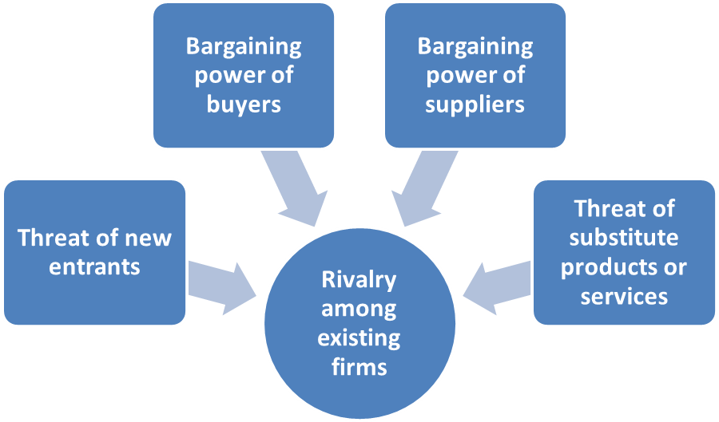
The Porter’s Five Force Model diagram created by Ayoola Olaniyi
6.1a Threat of New Entrants (Low)
New entrants into the vehicle manufacturing industry is low. This is because there are industry entry barriers that will make that impossible. For instance, new entrants will require huge capital resources and access to distribution networks. Current vehicle brands, in the United States of America, for instance, enjoy large economies of scale and that is a barrier to new entrants. Toyota dealers in Nigeria do not benefit from this because Toyota vehicles are imported into the country. Even at that, threat of new entrants into the industry is very low because government controls importation. Potential importers of automobiles can only do so if issued with import licences. In the United States where manufacturing or assembly plants exist, it is completely difficult for new entrants into the industry. Besides, other barriers to entry include product differentiation of key vehicle producers, possible retaliation from existing producers and tough regulations in some key markets.
6.1b. Bargaining Power of Suppliers (Low)
In the vehicle making industry, bargaining power of suppliers is low. This is because of the existence of a large pool of suppliers of various parts. Switching cost for the supplier of spare parts will vary depending on the type of supplier and the nature of products they supply. With regards to Nigeria, there are many supplier of Toyota spare parts even though Toyota has no manufacturing plant in the country. In the United States of America, however, due to its reliance on lean and just-in-time manufacturing, suppliers that are located near to producing plants have greater bargaining power.
6.1c. Rivalry among Existing Firms (High)
Rivalry among existing firms is high. In the global automobile industry, Toyota competes with a number of other automobile firms. In Nigeria, for example, Toyota competes with Honda, Volkswagen, General Motor, Mitsubishi, Nissan, Hyundai etc. In the United States, in addition to the list above, there are many more rivals such as Daimler, BMW, Honda, Ford Motor Company, SAIC Motor etc. However, Toyota leads in the marketplace, globally, in terms of sales, but due to government’s protectionist policy, General Motor’s 17.8% market share is greater than Toyota’s 17.3% in the United States of America market. When compared with Nigeria, the rivalry within the firm is higher as there are many manufacturing plants in USA while only the Volkswagen plant exists in Nigeria.
6.1d. The bargaining Power of the Customers (High)
The power of the customers to bargain in the automobile industry is high. This is because the customers are open to several options and can switch between vehicles meaning that switching costs are low. In Nigeria, for example, there are a number of competing firms that can make similar vehicles available at the same or even reduced prices. Customers are clearly very knowledgeable and can access any information; they can select options best suited to them. These factors are also true of the United States of America and have helped to strengthen the bargaining powers of the buyers of Toyota vehicles. However, despite the formidable level of competition in the industry, Toyota has been able to retain customer loyalty due to its strength in technology and design innovation.
- Threat of Substitutes: (Medium)
Threat of substitutes before Toyota is Medium. There are many substitutes for the Toyota products making switching costs also quite low. In a number of cases, people have reverted to using substitutes because they are cheaper. In Nigeria, for instance, the middle class and lower middle class consumers often fall back to using public transportation system because they are cheap. To remove the threat of substitutes and offer low cost vehicles in the United States of America, Toyota introduced models that are fuel efficient, ecofriendly and smaller for the families. In nigeria, Toyota has introduced the hybrid models.
6.2 Advantages of the Porters Five Force Model
- It outlines a detailed step by step method of looking at competitive forces within an organisation.
- It presents a reasonable solution to considering competition in the marketplace.
6.3 Disadvantages of the Porters Five Force Model
- The framework is incomplete because it does not address all the likely business issues that can be found in a multi-dimensional marketplace.
- The assumptions of the model addresses simple business environments only and fails to address highly regulated and/or controlled competitive markets
- This model does not put into consideration the use of relevant data in measuring competitive activities in the market. Also, it considers none of the various economic forces that are present in a digital economy.
Recommendations For Toyota of Porter’s Five Force Model
For organisations whose businesses are international in nature like the Toyota Company, the ease of entry and competition within can significantly affect profitability. The lower the threat of entry the more attractive, the industry becomes. In other words, high levels provide the greatest threat.
If the threat of substitutes is high, profitability levels will be low because customers would be able to easily switch to alternatives so any of the forces with high level will provide the greatest level of threat to the organisation. So in the case of Toyota, rivalry among existing firms and the bargaining power of the customers provide the greatest threats.
- SWOT Analysis of Toyota Business: Nigeria Versus United States of America
7.1 Purposes of the SWOT Model: The SWOT Model serves some purposes: First, it enables the organisation study and understand the external and internal environment of the firm through identifying and measureing the strengths and weaknesses of the firm as well as the opportunities and threats facing it. Second, the SWOT also helps to find out factors that has the capacity to influence the performance of the firm thus making available to the firm useful information and data in the course of business planning.
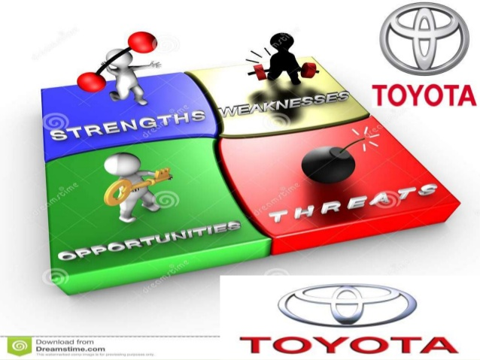
Diagram showing Elements of the SWOT Model
NIGERIA | UNITED STATES OF AMERICA
STRENGTHS  - Strong image of the brand and rapid product innovations.  - Biggest vehicle seller in Nigeria. Projected sales of 520k vehicles in 2018.  - Best known for being value for money, quality, reliable, safe and durable  - Strong distribution network geared towards meeting customer needs and achieving high revenues  - Effective sales and after sales customer service.  WEAKNESSES  - Weak presence in developing countries of Nigeria where Toyota has no known manufacturing or assembly plant.  - Shortage of capable and qualified employees requiring huge resources to hire and train. The use of expatriates very costly.  - Need to import more Toyota cars. Nigeria with a working class population of over 60 million can sell over a million Toyota cars yearly | STRENGTHS  - Strong Research & Development in leading edge technology leading to innovative vehicles. Company boasts of 15 research centres in 8 diverse countries including USA.  - Invested US$9.6 billion in R&D in 2017 or 3.8% of revenues.  - Toyota’s financial capability is massive; reason why it is known as Toyota Bank (Aghazadeh, 2003). Its financial growth in revenue and profitability over the year outstanding,  - Toyota Company’s revenues have  increased at a CAGR (Compound  Annual Growth Rate) of 5.5% in  the year 2017/2018  - Most valuable and recognizable automobile brands in the world. Overall worldwide brand ranking of 7 and a brand value of $50.3 billion (according to Interbrand/Forbes).  - Efficient Just-in-Time Production system (TPS), which eliminates wastes from the production process.  - Strong brand reputation and rapid innovation capabilities.  - Has 17.3% of the United States market share second only to General Motors  WEAKNESSES  - High recall rate of key Toyota vehicles over the years in the United States I.e. recalled in 2009/2010 about 9 million vehicles and about 8 million cars in 2012.  - Toyota uses the just-in-time system which gives competitive edge, but too much dependence of the system can affect the product quality if the supplier provision does not meet the requirements of the firm.
OPPORTUNITIES  - Opportunity to fully hold on to their market leader position in the growing Nigerian market.  - There is a massive opportunity to roll out new products and services that would excite new customers.  - Need to recruit, retain and retrain capable personnel  - Growing overhead costs and administration budgets (Toyota Financial data, 2017).  - Establish a manufacturing plant in Nigeria with the capacity to support the production of Hybrid and low emission vehicles in Nigeria and the West Africa Coast.  THREATS  - Increased taxation in the near future will impact profitability.  - Proliferation of substitute or alternative vehicles  - Pricing Challenges as incomes of middle class people are eroded  - Direct Competition of Honda equally big with hybrid models.  - Foreign exchange - appreciating yen against other currencies means lower profits for Toyota.  - Political instability and terrorism in Nigeria disrupting foreign importations and nationwide distribution of vehicles thus limiting Toyota’s unit sales and profitability.  . | OPPORTUNITIES  - The need not to lose market shares in strongholds has led to increased positive attitude towards “green” vehicles  - Changing customer needs leading to new car models which would, satisfy varying consumers’ tastes and needs.  - Massive opportunity to expand the existing products and services into new markets.  THREATS  - Declining fuel prices that could make fuel-efficient hybrid and electric cars become less attractive in future  - Potential increased taxation in the near future will affect profitability.  - Proliferation of competitive products and services.  - Pricing challenges as direct substitutes are competitively priced  - Rising raw material prices which are key to manufacturing particularly prices of spares parts  - Foreign exchange - appreciating yen against other currencies means lower profits for Toyota.

- The STP Model – Application to Toyota Sienna in Nigeria and the United States.
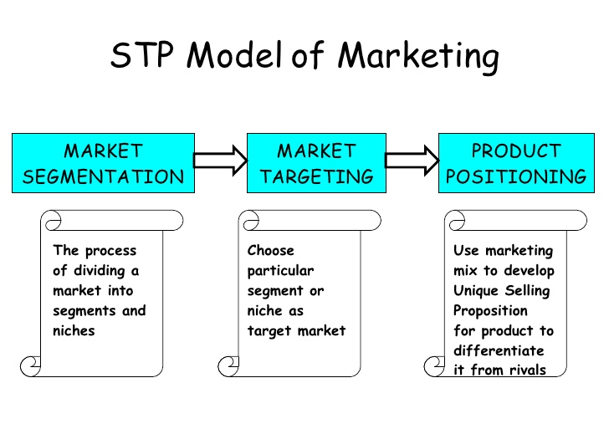
Diagram showing the STP Marketing Strategy Model
8.1 The Purpose of the STP model: it is a strategic tool in selling the niche Sienna car. The model is useful in creating marketing communication plans that will help marketers create relevant messages to engage with many audiences in marketing Toyota Sienna. The model helps in passing commercially appealing messages to the audiences who are searching for Toyota products of which the Toyota Sienna takes centre stage. These audiences can be found within different segments.
8.2 Market Segmentattion: marketers can identify niches with specific needs, find new customers, deliver more focused and effective marketing messages to the audiences within the different segments. The needs of each segment are similar so marketing messages should be designed for each segment to emphasise relevant benefits and features required rather than one size fits all for all customer types.
The Nigerian and the United States market can be segmented by Demography, Geography, Psychographics and Life Styles, Commitment Levels, Benefits and Usage Patterns. I will now relate each market segment with the sales of Toyota Sienna in both Nigeria and United States of America.
8.2a Demographic Segmentation - In Nigeria, for instance, the marketers of the Sienna have been able to break the vehicle’s market into different sectors based on the demand of the buyers. Demographically, the Toyota Sienna can be demanded on the basis of marital status. The married wants the vehicle because it is roomy and designed for the family. The high income earners in the affluent societies also demand the vehicle because they are able to afford it. Besides, occupations that require that passengers and luggage be simultaneously moved also find the car relevant. In addition, gender also plays a big role. Usually, women influence 80% of purchase decisions and make 50% of new vehicle purchases (Edmunds.com) so targeting women with the Sienna, like is done in the USA, is a brilliant marketing strategy. By and large, the same elements influencing demographic segmentation in Nigeria will influence the demand for Toyota Sienna also in the United States. Prestige brands like the Sienna are promoted to the upper class of the Nigerian and American societies (Lexus.com, 2016).
8.2b Geographic Segmentation - this involves drilling down by Country, region, area, urban or rural location, population density or even climate. In Nigeria, Toyota Sienna is largely promoted to the people of Northern Nigeria because that area is mostly populated by Muslims. The Nigerian Muslim believes in having larger families and so the Toyota Sienna is the ideal vehicle to have (foreignpolicy.com).
This strategy of geographic placement of Toyota Sienna is also true of the United States of America. Indiana, the manufacturing place of Toyota Sienna. The economy is buoyant and though the population is far below that of California, the demand for Toyota Sienna here is high and compared to Idaho and New Mexico, two areas with low population and low economic activities, Indiana presents an upscale market to be targeted by Toyota.
8.2c Psychographic Segmentation - Psychographic segmentation involves promoting the Toyota Sienna Car and others like the Land Cruiser or Lexus to elites and for prestige purposes (Lexus.com, 2016). This can also be referred to as behavioral segmentation when it targets customers who are concerned with eco-friendly and energy saving cars such as the hybrid vehicles. In Nigeria and the United States of America, the Toyota Sienna is promoted to customers with luxurious life styles, high social class and rich personality.
8.3 Market Targeting.
By definition, market targeting is the process of identifying precisely which segment an organisation will direct its advertising efforts to. Once that segment and the customers therein are known, the company will place its goods and services in that segment. There are three main types i.e. undifferentiated, differentiated, concentrated market targeting.
- Undifferentiated marketing usually target the whole market with one product. It can be referred to as mass marketing. But because the Toyota company has lots of models, some of them premium cars, this approach will not be ideal for the company in any market. Undifferentiated strategy is usually cheaper because only one product is to be produced, distributed and marketed and also because the firm is not targeting multiple market groups. The disadvantage, however, is the problem of producing just one product that will be profitable enough.
- Differentiated marketing is when a firm targets several segments of the market. Under differentiated marketing, a firm develops products and services with separate elements of the marketing mix for each of the segments chosen by the firm. This is the strategy adopted by Toyota to sell the Toyota Sienna in Nigeria and the United States of America.
- Concentrated marketing takes place when an organisation targets only one segment of the market with all of its marketing effort. The firm will present one product that caters for the needs of that specific segment. The Toyota promotes the premium Lexus brand in this segment of the market to target the rich and the upper class in Nigeria’s Lagos and Abuja as well as the United States’s Indiana. Usually, costs can be very low; however, it may reduce the number of customers that the firm is targeting. Besides, the firm needs to be sure that they have selected the correct segment of the market.

8.4 Market Positioning: This is a marketing strategy which positions a brand in a prominent place in the mind of the customer relative to competitive brands.The Toyota Company has used sales promtion to position the Toyota Sienna in the minds of the customers. This is actuallyToyota the strategy for the brand image in Nigeria and the United States of America. This is responsible for the growth, in the United States, of the 2018 Toyota Sienna XLE by 3.3%(Statista.com). Effective promotions will assist the buyer to reach a purchase decision; it will enable the distribution points to go up, the product price may go up and new products may be introduced.
9. The Toyota Marketing Mix
By definition, the Marketing Mix refers ‘’to the set of actions or tactics, that an organisation will use to promote its brand or product in the market place (Kotler, 2007). In other words, it is the totaity of controllable factors that a firm deploys to influence the buying behaviour of potential consumers. These include Product, Price, Promotion and Place. McCarthy, (1978), said that ‘’the elements of the marketing mix can be grouped into four variables such as Product, Price, Place and Promotion’’. Later three other Ps were added and these are People, Process and Physical Evidence. To sell and market Toyota Sienna in Nigeria and the United States of America, the Toyota Company effectively deploys the seven P’s of the marketing mix.
9.1 The Purpose of the Marketing Mix: It plays a major role in creating the right marketing strategy for a business as well as help in its implementation. This is because the role of the product, promotion, price and place in the overall marketing approach cannot be over- emphasized. Also, the marketing mix helps to determine which marketing strategy is right for the firm as its marketing mix decisions will also have an impact on its positioning, targeting and segmentation decisions.
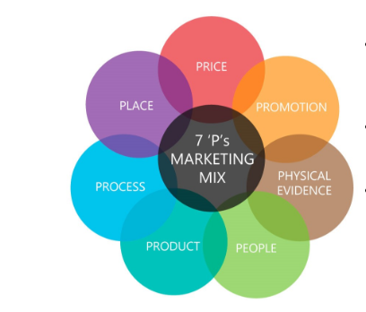
Diagram showing the 7Ps of the Marketing Mix
9.1a Product: The increase in the price of fuel globally, growing ecological concerns as well as market saturation and growing families are potential threats to car makers and Toyota Sienna car which is in its fourth generation is presented to address one or two of the gaps. In Nigeria, the Toyota Sienna was introduced to meet the needs of families whose size is growing whereas in the United States, the product serves the psychographic needs of the American elite customers. The fact that the product has grown over the years, in both countries, transforming from one model to another gives an assurance that Toyota Sienna is still at the growth to maturity stages in both countries.
9.1b Price: The Toyota Company implements two pricing strategies in Nigeria – one is Car for the low-income people and two is Car for the people who intend to be different from others. Kotler, 2007, says ‘’Companies bringing out a new product face the challenge of setting prices for the first time. They can choose between two broad strategies market-skimming pricing and market-penetration pricing’’ (Kotler, 2007). To sell the Toyota Sienna, in Nigeria, the Toyota Company employs “discount pricing” meaning that both trade and cash discounts method are used whereas in the United States of America penetration pricing is used. The reason why the Toyota Sienna is priced this way is because of the pervasive presence of the General Motors alternatives. A 7.1% increase in unit sales of Toyota Sienna in 2017 suggests that the USA pricing strategy is right.
9.1c. Place: Some products could succeed in a particular market but fail in another. The place where the product is sold may be a major determinant of the buying behaviour. In key markets of Nigeria like Lagos, Abuja, Port Harcourt, there are Auto Mart. These are places where different brands of vehicles are sold. In United States of America, a producing place of Toyota Sienna, the company depends on representatives or agents to move the vehicles to the arms of reach the ultimate customers who on their own part make contact with the product via catalogues. 38% Americans place vehicle orders out of cataloques (Statista.com)
The Market Coverage of Toyota Sienna in Nigeria and the United States is wide. In Nigeria, selling is done mostly through agents and intermediaries while in the United States, it is done via a combination of direct sales and intermediaries
Types of Market Coverage: there are three types:
- Intensive distribution – this makes distribution of goods and services possible on a very wide scale i.e. selling in all places even at lower prices. Large producers of convenience products bought often e.g. chewing gum, candy use this method to reach their customers nationwide or globally.
- Selective distribution – this is a method used to sell high niche products and it involves selling to just a few select customers. This is the strategy used by the Toyota Company in Nigeria. Just a handful of distributors are appointed to sell Toyota vehicles and these have also gone ahead to appoint agents in strategic locations across the nation. In the United States for example, Toyota does not actively seek to sell their vehicles to just any kind of car dealers because this would damage their brand. They do selective distribution and this has made establishing consumer and customer relationships relatively easy.
- Exclusive distribution - this method limits product distribution to only one reseller. The reseller will have exclusive rights to sell the firm’s products and services, and in return, also be the sole supplier. High end or prestigious products use this strategy because you are the sole supplier and the intermediary is the sole reseller i.e. Lexus
Market Entry Methods : There are a number of market entry methods which are used in Nigeria and in the USA
- Agents – these sell the Toyota Sienna to the final customers but they take no title of the goods. In Nigeria, these include road side retailers and Auto Marts
- Distributors – there are major distributors of Toyota vehicles in Nigeria including the Sienna. These include companies like Toyota Nigeria Limited, Elizade Nigeria Limited. They are merchant wholesalers who import the vehicles and sell. They extend the agency agreement to take title of the goods they sell.
- Freight Forwarders - There are also Freight Forwarders who act on behalf of Toyota in Nigeria to provide documentation and delivery service between Japan, the manufacturing country and Nigeria, the final destination. This is because Toyota vehicles are mainly imports.
- Piggybacking – Toyota Nigeria also sell Honda vehicles so the Toyota Company also use its Nigeria distributor to sell Honda cars, a competing brand, as a form of strategic alliance
In the United States of America, apart from implementing all the above entry methods which are similar to Nigeria, the Toyota Company also uses Licencing and Franchising. Hill (2007) said ‘’exporting is regularly used by organisations at the beginning of their business operations because of the low risk involved, but later on they will change to another method of reaching their core customers’’.
- Licensing – According to Hill, 2007, p.489, ‘’Licensing is an agreement whereby a licensor grant the privileges to intangible property to another unit for a specified period, and the licensor receives a royalty fee from the licensee in exchange.’’ Hill, 2007, p.489 identifies ‘’the intangible assets as formulas, process, designs, patents, inventions, copyright and trademarks’’.
- Franchising – the dictionary defines franchising as "a process of doing business wherein a franchisor allows proven methods of doing business to a franchisee for a fee and a ratio of sales or profits’’. Franchising introduces the small independent entrepreneur to a proven business concept. It transfers the right to use the company name and all that may be identifiable with the company. Toyota franchises in Nigeria and the United States expect its franchisees to meet its new standards for showrooms and customer satisfaction. Hill, (2007, p.490) agreeing said that "franchising is essentially a specialized form of certifying in which the franchisor sells intangible property and also assists the franchisee to manage the business in an ongoing basis".
9.1d Promotion: Promotion is communicating with the customers of the firm. It gives information that help them to reach a purchase decision. Tools like Advertising, Public Relations, Sales Promotion, Personal Selling and most recently the Social Media are all available to the firm to put across their message to the correct audiences in the manner they would like to hear it. The Toyota Sienna producer in US uses Public Relations and advertising while Nigeria adopts personal selling and advertising.
Comparisons of Toyota Sienna’s Promotional Strategies – Nigeria vs USA
I will attempt to compare and contrast the promotional strategies used by the manufacturer to sell Toyota Sienna in Nigeria and the United States.
First, the similarities in the Promotional Strategy of both countries:
Nigeria and United States of America are identical in some of the techniques both countries deploy to marketing the Toyota Sienna Car:
• First is the use of classified newspapers and automobile expositions. (Toyota Dealers’ Conference 2017).
• Second, are other media which are used to create awareness of a firm’s products and services like radio, print advertising, billboards, pamphlets; signs, tele-marketing and television.
• Third, prominent and most efficient are bill boards in strategic locations. It catches people’s attention because of the duration of the bill boards. As people see it, the more it creates a memorable scene.
• Fourth, is the use of Newspaper, a periodic publication to carry advertisements of Toyota Sienna to a wide variety of fields such as politics, business, sports and art.
• Fifth, Auto or Motor Fairs which is a public exhibition where the latest Toyota Sienna model is displayed to the public is another way of marketing the car in Nigeria and the United States. It helps in making the Sienna popular in the two countries.
• Sixth, the features of the Toyota Sienna Car are also an important part of the promotional campaign in Nigeria and the U.S.A. The manufacturers or the licensed distributors tell the buyers the features of the car so as to convince them to buy.
Second, the differences in the Promotional Strategy of both countries:
• First, Nigeria uses more of traditional advertising media whereas the United States of America focus more on digital media. Although going by the recent economic recession in Nigeria, Toyota Sienna dealers have started going digital in their bid to advertise the product, the impact is hardly seen.
• Second, mass media is predominant in Nigeria while USA prefers specialized media. The USA experiences high agency accountability whereas Nigeria has low agency accountability.
• Fourth, Nigeria has limited internet access while there is unlimited internet connection in U.S.A thus the customer can access information as required.
• Fifth, USA has a good record of successful integrated communication strategy but not so in Nigeria due to factors like bad network services, epileptic power supply and complete lack of network services in some areas of the country.
9.1e People: These are the persons who make the products and service a success. They also include the ones who have the strength to tarnish or build the image of the Sienna. People also refer to the employees of the organization with whom customers come into contact. The employees of the firm deliver the service so the right calibre of people must be hired and trained so that superior service can be delivered to the customers. Therefore, the staffs of the Toyota Company in the USA and the ones in Nigeria, though may be different, they are product informed, well trained and motivated, they possess the right communication skills in their bid to build the image of the firm. However, there is gap in technical knowledge. While the American engineer is technically able to work in the production plant, the engineer in Nigeria is better able to fix bolts and nuts only. No doubt, there is room for improvement for the Nigerian Toyota Company, particularly, in the area of technology and innovation..
9.1f Process: This will refer to the means and method of offering the Toyota Sienna to the customers. It also refers to the processes and systems within the organization that affects its marketing process. For instance, the methods of handling sales, processing of orders and after sale service are taken very seriously in both countries (Nigeria and USA). However, some adjustments will be required by Nigeria to tighten up the business so as to minimize costs and maximise profits.
9.1g Physical Evidence: This is the element within the store, that is, the store front, the uniforms employees wear, signboard, customer believe greatly what they see in the organization. Comparing these variables between US and Nigeria, Toyota Nigeria has a lot to do in the area of clean and tidy environment, well-structured premises and acquiring befitting furniture that befits the product and that will captivate the minds of potential customers of Toyota Sienna. In Nigeria just like in USA, the employees wear uniforms not just the factory workers but also the sales and customer service as well as after sales service personnel. However, there is a massive difference in the web sites of both countries. While the website of Toyota USA opens with ‘Our strong commitment to the US’ showing an impactful picture of an assembly plant and followed it up with ‘ What drives us forward’ i.e. what motivates the people and ends with an invitation to potential employees to ‘Join the team’, the Toyota Nigeria website opens to a question ‘What is happening in Toyota’ showing a range of different Toyota vehicles.
10. The Directional Development (Future Strategies) of Toyota
Toyota is not the only car producing firm in the world. In fact, Toyota is not the only mini van producer, the category of the Toyota Sienna. I will, therefore, like to propose for the future of the Sienna, a directional development strategy using the Ansoff matrix not just for Nigeria but also for the United States of America.
11. The Ansoff Matrix
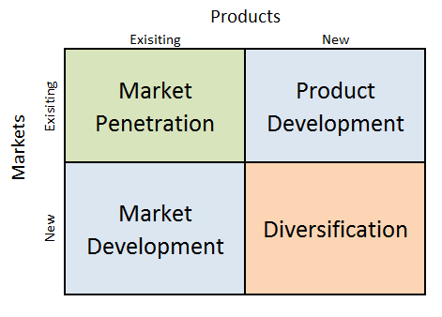
The Ansoff Matrix Diagram
- Market Penetration - The Toyota Company should expand advertising for existing Toyota Sienna vehicles not just in Nigeria but also in the United States. In addition, the Toyota Sienna should be used to target more segments especially the Psychographic segments of Benefits, Usage and Commitment as well as the Business to Business markets.
- Product Development - Toyota should create new features for the existing Toyota Sienna as well as for new models, not just in Nigeria but also in the United States of America. This is to ensure that the vehicle is differentiated from its closest rivals.
- Market Development - There is need to expand distribution in Nigeria and in the United States of America; first for existing products in the existing market where they are. This may require adding new agents & distributors in both countries or granting additional franchises as is the case with United States. In addition, Toyota should stretch their resources a bit more for Toyota Sienna by targeting new markets and entering new segments.
- Diversification – There is no research to support the fact that the eisting Toyota Sienna satisfies the Life style segment. Therefore, the Toyota Company should consider introducing new Sienna with new features for new markets or new segments i.e. the Life Style and Benefit segments.
Recommendations
This study provides insights into the different strategies employed by Toyota to sell more Toyota Sienna model in Nigeria and the United States by comparing and contrasting them. It also reviewed the different business models available to the Company. I will make some recommendations to the Company by visiting the Product Life Cycle of the Toyota Company with particular focus on Toyota Sienna:
The Product Life Cycle
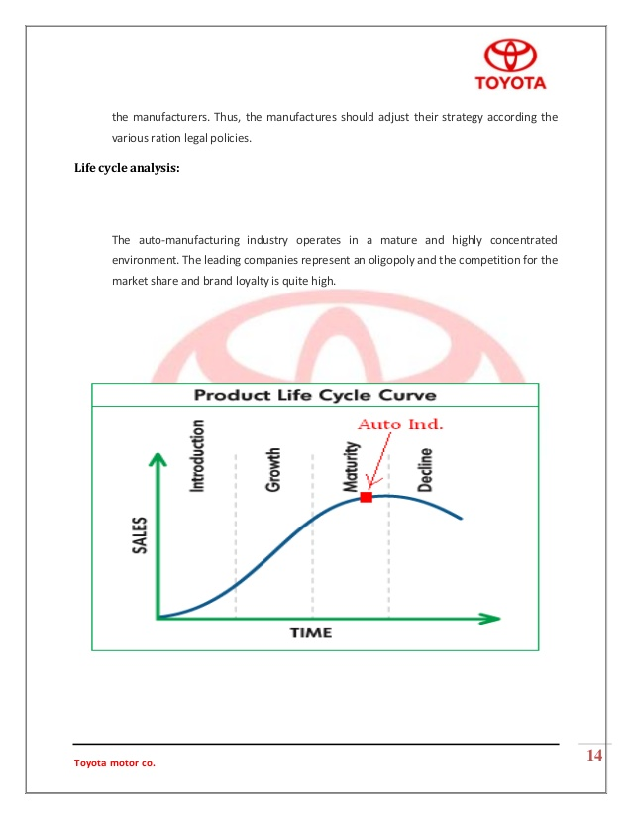
Diagram showing the Product Life Cycle of Toyota Sienna
The Toyota Sienna is in-between the growth and the maturity stages of its Product Life cycle. The United States 2018 year-to-date Sienna car sales of 102,000 and the projected sales of 22,000 for Nigeria in the same period shows that the sales of Toyota Sienna is rapidly increasing (Statista.com).
Toyota’s Senior Managing Officer Masayoshi Shirayanagi said: “Our minivan Sienna is making giant strides and as for the fixed cost reduction activities, we are steadily making progress toward achieving our challenge-level target, which we are determined to achieve by the end of this fiscal year through further efforts across regions.” (First Qter June ,2018 Report)
Also, the shift in the Company’s marketing strategy for the Sienna is a testament that the product is in its maturity stage. The marketing strategy being used for the Sienna by Toyota currently suggests a product in-between the Growth and maturity stages working hard to appeal to customers who desire more power and luxury. Such strategies include market penetration, market development, market appeal, product development and product differentiation.
Therefore, going forward, to maximise sales for the Toyota Sienna brand, the company needs to embark on the following: product improvement by adding new features to existing and new models, extend the product line into models that are sleek and sustain and maintain the introductory price strategy for the product. In addition, the Toyota Company has directed attention from achieving market acceptance via publicity and customer education efforts to differentiating its luxury cars from those of competitors.
Conclusion
The question now is to what extent do I agree with the approach used by Nigeria and United States of America in marketing the Toyota Sienna?
Considering the niche marketing strategies that both countries have used, I am of the opinion that the strategies are right and suitable for the type of niche product in this study, that is, the Toyota Sienna.
First, the strategies do not only serve the specialist and prestigious consumers at high margins, it also serves the smaller market or segments which the Toyota Company wishes to focus and concentrate on particularly.
Second, the strategy is all about getting the target customers to like and procure Toyota Sienna, a niche product, it uses successfully cheap media for advertising thus gaining mileage for the product.
Third, the Company has also successfully achieved high sales at high prices by leveraging on the speed of the selected consumers.
References:
- Aghazadeh, S.M. (2003). JIT inventory and competition in the global environment: a comparative study of American and Japanese values in auto industry. Cross Cultural Management, 10, 29-42
- Business Dictionary, 2015 Integrated Marketing Communication
- Datamonitor (2007). Toyota Motor Corporation, Inc. - SWOT Analysis. [Online] Available: http://web.ebscohost.com (01 Nov, 2007)
- Georg Muller, Dec, 2017, ‘The Strategy and Tactics of Pricing’ Sixth edition
- Gillespie, A. (2007). PESTEL analysis of the macro-environment. Foundations of Economics, Oxford University Press, USA.
- Grönroos, C. (1994). From Marketing Mix to Relationship Marketing Towards a Paradigm Shift in Marketing. Management Decision, 32, 4-20
- Hill, Charles W.L, 2007, ‘’ Strategic management : an integrated approach’’ Milton, Qld. : John Wiley &​ Sons, 2007 [ie 2006]
- Housing Industry Association (2011). An Introduction to PESTLE Analysis. HIA Ltd.
- https://www.strategicmanagementinsight.com/swot-analyses/toyota-swot-analysis.html
- Khanna, T, Palepu K.G, & Sinha, J, 2005, ‘Strategies that fit emerging markets’
- Kotler, P & Armstrong, G.M, (2010), ‘’Principles of Marketing’’, Prentice Hall, 2010
- Kotler, P & Keller, K.L, ‘’A Framework For Marketing Management’’. Essays and Research Papers
- Marketing for Schools and Colleges by Aderopo O. Kazeem, Asukwo Imoh and Godiya F.Hassan Rasmed Publications Limited,2014. ISBN - 978-978-52607-3-1
- Melling amd Mann, F.A, 2012 ‘’ ‘Judicial and Political Decision-Making: The Uncertain Boundary’ (the F.A. Mann Lecture 2011)
- Murphey, M., & Gause, R. (1974). UCF Research Guides. Industry Analysis. PESTLE Analysis. Business Horizons, 17(5), 27-38.
- New Generation Marketing for schools and Colleges by Iwajomo Folaremi, 2016 from Ode-Irele in Irele Local Government of Ondo State, Nigeria – ISBN 9789789504292.
- Porter, M. (1999-2010). QuickMBA. Retrieved from http://www.quickmba.com/strategy/competitive-advanage/4
- Roper, K. (2012, November). BIM Implementation: PESTEL Drivers & Barriers (Cross-national Analysis). In World Workplace 2012. IFMA.
- Toyota Motor Corporation Annual Report 2015.
- Toyota Motor Corporation (2015). Toyota Environmental Activities Grant Program.
- Toyota Motor Corporation (2015). Toyota’s Strategy for Environmental Technologies.
- Yuksei, C.C and Carles, J, (2013), ‘’ The role of geography in the success of the balearic tourism industry’’

