MDL Operations
Sustainable Initiative Report

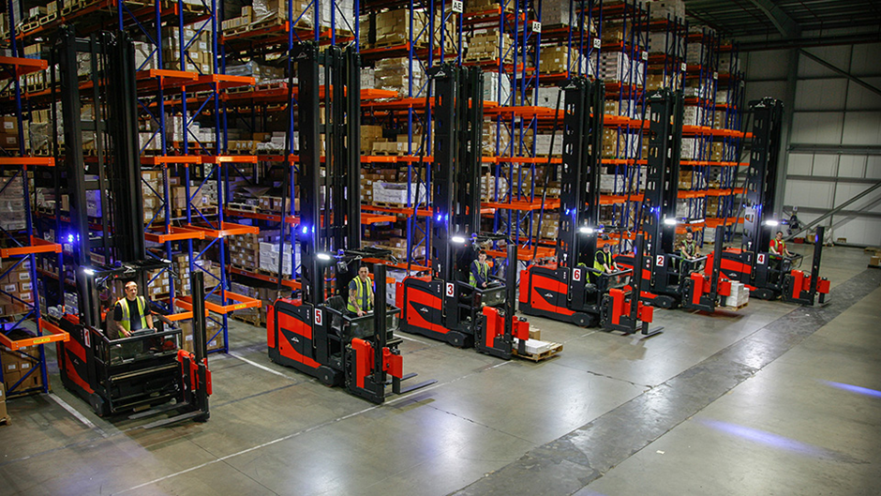
1604713
Antony Swistun
BMSP7003 Assessment 2
Contents
Aim of the report. 1
Identification of area to address. 1
Image 1. 1
Image 1 Index. 1
Image 2. 1
Image 2 Index. 2
Image 3. 2
List of the December 2021 top selling titles distributed by Macmillan. 2
The remaining top selling titles December 2021. 2
The proposal. 3
Benefits to stakeholders. 3
Time schedule and resources. 1
Assessment plan. 1
Plan. 1
Do. 1
Check. 1
Act. 1
Conclusion 1
References 1
Bibliography 3

Aim of the report.
The aim of this report is to explore a sustainability initiative within the bulk operations area of the distribution centre of Macmillan Distribution Ltd (MDL), that will improve productivity by reducing time wastage in the locating, picking and order processing, and help to improve the cost effectiveness of the department.
The initiative will look at improving best practice methods, operational product flows between departments, and the operational impact within those departments using a range of sustainable supply chain management principles (SSMP), such as: flow, coordination, stakeholder, relationship, value, efficiency, and performance focuses.
While many companies look to make short term gains, this initiative can be used to create that short term gain (after the initial transition period) but will also become a longer-term gain due to the time, and monetary savings accumulated over time.

Identification of area to address.

With the creation of a new warehouse management system (WMS) currently underway, the author is looking to improve the operational efficiencies that will lead to a reduction in “operator dead time”, the time wasted travelling between storage and picking locations, travel time of stock between departments, and the processes used to identify locations of the company’s “fast seller titles” such as Harry Potter, A pinch of Nom, and The Gruffalo.
When it comes to understanding and alleviating sustainability issues (such as carbon footprints or energy intensity) in logistics, most attention is usually given to transportation. Warehousing (or storage) has comparatively received less consideration from researchers and practitioners. However, it has been a victim of ‘green wash’ and decorated with titles of green-warehousing or eco-warehousing and the practices that are required to achieve such aspirations are hard to find. (Tayyab Waqas Amjed, 2013)
Sustainable supply chain management (SSCM), as quoted by (Srivastava, 2007) is “Environmental thinking into supply-chain management, including product design, material sourcing and selection, manufacturing processes, delivery of the final product to the consumers as well as the end-of-life management of the product after its useful life.”
The area to be addressed in this report is the bulk storage locations for the top 10 titles, this proposed area will be in area 7 of image 1. The positives that can be created by consolidating them into one area, close to the shipping department, area 3 in image 1, ensuring a faster delivery flow between the departments, reducing lead times (pallets picked up, and taken to the shipping department for consolidation, profiling and shipping), ensuring that the stakeholders (bulk and shipping staff) can complete the orders with increased accuracy, efficiency, and increased productivity, while reducing the risk of damages in transit within the warehouse .
In image 1 below, you can see an aerial view of the site, along with identification numbers that will be used to identify each bay in correlation with the corresponding index.
The current route taken to take stock to the shipping department (3 in image 1), is shown with the green lines. The green lines can clearly indicate the distances travelled with each pallet, from each of the respective storage bays, Bay A, Bay B, units 1, 2, and 2a (Annex).
This creates a lot of wasted operator hours when accumulated over the space of a week, yet alone a year. The same is created when the pallets have been processed in goods in, (1 in image 1), and taken to the respective bays for locating, also using the same green routes throughout the warehouse system.
Picking is considered to be the costliest process in a warehouse as it accounts for 55 percent of the operating costs. It mostly includes activities related to replenishment of picking area (or forward area) and case picking when a full-pallet-load is not ordered by the customer. Picking is classified into two main categories namely, picker-to stock (in-the-aisle) system and stock-to-picker (end-of-aisle) system. In former system the picker needs to travel or ride to the storage location. An order picker may travel six miles a day through various aisles in a warehouse and 75 percent of his time is spent in non-value-added activities (searching: 10 percent, writing: 5 percent and walking/riding: 50 percent) while the actual picking is only 25 percent of the entire process. (Tayyab Waqas Amjed, 2013)

Image 1.
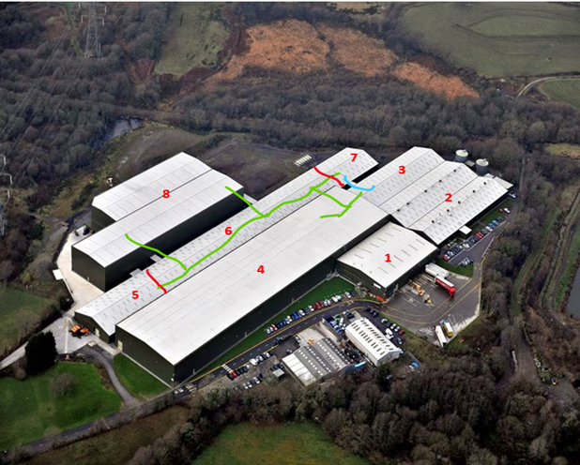 (Pitch Publishing, 2020)
Bay B PD area
Bay B PD area
Bay A PD area

Image 1 Index.
1 | Goods In / Out | 5 |  | Unit 1
2 | Conveyor Department | 6 |  | Unit 2
3 | Shipping / Finishing | 7 |  | Unit 2 Annex
4 | Bay A | 8 |  | Bay B
 | Units 1, 2 and Annex Boundaries |  |  | Current travel route
 | Proposed travel route |  | PD | Pallet Distribution areas

Image 2.
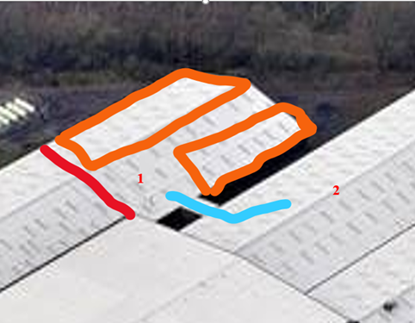 (Pitch Publishing, 2020)

Image 2 Index.
1 | Unit 2 Annex | 2 | Shipping
 | Unit Boundary |  | New truck route
 | Proposed area for new block stacks of fast selling titles

Image 2 above, shows a close up arial view of the area to be used in the proposal, (1 in image 2, and 7 in image 1). This area has been identified due to its proximity to both goods in (1 in image 1), and the shipping departments, (2 in image 2, and 3 in image 1). The footprint of the proposed area to be used in seen in orange, and the direct truck route is seen in blue.

Image 3.
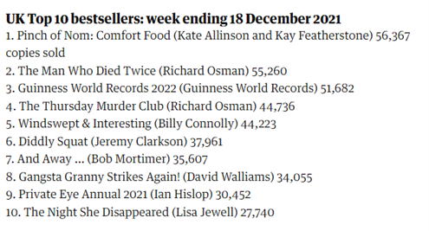 (The Guardian, 2022)

List of the December 2021 top selling titles distributed by Macmillan.
In image 3 above, the UK top 10 bestselling titles are shown, with the number of copies of each that have been sold in the UK. Out of this list, 5 titles listed are distributed by Macmillan, these are: -
Title | Copies sold
A Pinch of Nom: Comfort food | 55,367
Guinness World Records 2022 | 51,682
Windswept and Interesting (Billy Connelly) | 44,223
Gangsta Granny Strike Again | 34,055
The Night She Disappeared | 27,740

The remaining top selling titles December 2021.
The data for the remaining top 5 titles distributed by Macmillan was supplied by the nights bulk team section leader.
Title | Copies sold
Harry Potter 7 book Box set | 26,038
The Song of Achilles | 25,992
The Gruffalo’s Child | 24,890
The Tales of Acorn Wood, Fox’s socks | 22,271
Lean in 15 | 19,186

The proposal.
The author proposes using the Annex area of unit 2 to locate the top 10 fastest selling titles as they are mainly picked in multiples of full pallet quantities, for larger UK based retailers such as Tesco, Asda/Walmart, and Amazon. As well as distribution to numerous countries around the world.
As seen in image 2 above, there are two areas highlighted in orange, the longest of these areas can be used to store 26 rows of pallets, 3 pallets high, and 10 pallets deep, holding 780 full pallets. The opposite side of the bay can also hold the same quantity; however, some room has been cut for employee safety when carrying out operations movements. This smaller area has been assigned to hold 15 rows, 3 pallets high, and 10 pallets deep, holding 450 pallets, totalling 1,230 pallets.
The stock can be picked by either a counterbalance, or an OPT (order pick truck), however a counterbalance would be preferred due to lifting capacity (more than 1 pallet at a time), and its ability to take the stock directly into the shipping department, unlike the OPT that has a taller mast so will have to rely on bulk team runners to take the stock to shipping.
Due to the replenishment tasks in units 1 and 2 being a fraction of those in bays A and B, the operator in the unit 2 Annex would be picking these larger orders well in advance of if picked from Bay A and Bay B.
Due to the differences in pack sizes, weight, and quantities, one order can contain significantly more pallet picks than another. This also has a knock-on effect with time taken to locate stock, pick, profile, loads, and ship an order.
E.g. Title A’s pallet would consist of 25 cases, containing 48 copies per case, totalling 1,200 copies per pallet. Title B’s pallet would contain 75 cases, containing 8 copies per case, totalling 600 copies per pallet. Title C’s pallet is of heavy stock, only containing 5 cases, containing 1 copy per case, totalling 5 copies per pallet.

Benefits to stakeholders.
By locating these faster selling titles in the unit 2 Annex, (7 in image 1), transportation time to the Annex from goods in is only thirty seconds, unlike three and a half minutes to reach the closest area of Bay B, (8 in image 1). This will save time for the goods-in runners who transport the pallets to the bays to be located.
By locating the pallets in block stacks, it makes the task of picking the order significantly quicker, and easier. The picker has access to as much of the title as needed in the same area, no need to travel from the location to the PD area (Pallet drop off areas), and on to the next location, potentially the opposite end of the bay, numerous times. This could mean a 10-pallet order only taking 15-20 minutes to pick, compared to over 60 minutes in Bay A, or Bay B.
By reducing the times of locating, and picking the order, it gives the shipping / finishing teams the opportunity to complete the profiling and shipping of the order well in advance of the estimated dispatch time / date, ensuring that the company does not incur late shipment fines and reputational loses from the customers.
A bonus for the finishing team is the usage of a direct truck route from the Annex into the shipping area, the proposed route is already present, however not used as a direct travel route as the runners check the Bay A PD area when on their way to the shipping dept.
Another bonus is that the pallets can be stored with the shroud, and pallet tops still bound on the pallets, this will further reduce the time taken to profile the pallets as they would only need to weigh them and not require additional wrapping, as the products are already securely protected for transportation, also minimising the risk of damage to the stock, internally, and externally in transit. This would also significantly reduce the amount of plastic shrouding used to cover the pallets, saving the company money long term.

Time schedule and resources.
Time schedule of 3 days. This would be broken down to 3 personnel on each shift, 2 VNA operators, and 1 runner on a counterbalance or motorised pallet truck. 3 operators is 24 hours per shift, 2 shifts a day (day and night) totals 48 hours. So 3 personnel over the 3-day period would equate to 144 operator hours to complete the stock transfer ready for operations. However, once a title is located, it is available immediately to be picked for orders, so the time scale does not reflect the availability of the stock.
As there is a bulk maintenance team already on the night shift, the resources for nights would remain the same as currently used for operations. There would however need to be some cooperation between night shift, day shift bulk departments, and the IT department to ensure one operator in Bay A, and Bay B are available, plus an additional runner to help with the transition to ensure that the correct stock, and volume of stock is to be removed from Bay A, and Bay B, to be located into the unit 2 Annex, and that IT can set up the locations on the system ready for locating and picking.
The timescale of three days to move all the necessary stock is only that high due to the fact that stock will have to be picked by VNA (very narrow aisle) trucks, that are restricted in speed and manoeuvrability due to using a wire guiding system in the aisles. It should be the only time that would be non-productive, after this time the goods in runners would take the title directly to the Annex for locating once it arrives at the site and is processed.
Reports will be run weekly to identify stock coming into the warehouse, orders placed, and when any titles require rotation. This report will be made available to the managers and section leaders of the goods in, bulk, and shipping departments to ensure they are ready to handle the deliveries, orders to be processed, and if any additional trailers are required from the third-party hauliers. Once the new WMS is operational, the reports can be integrated into the new system, so that the system automatically generates the reports for the bulk maintenance team to act upon the findings within it.
After the transition period of three days, any further time used would be productive dependant on the above report, the bulk maintenance team would be all that is required to complete stock movements, enabling the two additional day shift operators can return to their usual duties. As the night shift bulk maintenance team also carry out stock checks, they can monitor damages, stock levels, and notify the management of any potential issues that may arise.

Assessment plan.
The initial assessment plan would use the Demming cycle to assess the suitability of the proposal.
Plan. This would be done by planning the proposal with the day, and nightshift bulk departments, shipping departments, goods in, maintenance, and the IT department. The departments would work together to assess the area in the unit 2 Annex with the maintenance team to check for structural issues that may become problematic.
The bulk departments would run workload reports to identify those fastest selling titles, and communicate with goods in as to when, and how much new stock of the titles is due in. the finishing teams and goods in would need to discuss leaving the shrouding on the pallets after initial delivery, this is to reduce the time spent in shipping once the orders are completed.
Once all parties are satisfied, the next phase can proceed.
Do. As stated above, the allocated time for the transfer of stock is 3 days, or 144 operator hours. Requiring 3 operators on both day, and night shift, and an IT team member to set up the locations ready for put aways and picking as soon as the stock is available. The bulk team will provide the operators, and the machinery required.
The maintenance team will rectify any issues found before the transfer begins.
Check. The checking process can begin when the first titles are being located, this will continue for every subsequent title, checking quantities are correct, any damages, any issues with the location, and if that title has dropped out of the top 10 fastest sellers.
Act. If any issue arises, they can be rectified as soon as possible (dependant on the issue), if a title drops out of the top 10, the title can be replaced with the new title, again completed by the nights bulk maintenance team as part of their duties.
If there are any issues regarding the proposal, they can be addressed to see if it is still a viable option, if not, and it cannot be rectified, it can be replaced with an alternative if one is available or return to the previous method.

Conclusion
If implemented, the proposal would save the company money on plastic shrouding savings, and mainly through the travel time saved per shift for each operator.

References
Katie Bailey, D. B., 2021. The COVID-19 Pandemic: What can we learn from past research in organizations and management?. International Journal of Management Reviews, 01, 23(1), pp. 3-6.
Line Industries, 2021. MDL Connect. [Online]
Available at: https://line.industries/work/mdlconnect
[Accessed 18 12 2021].
Linnenluecke, M. K., 2017. Resilience in Business and Management Research: A Review of Influential Publications and a Research Agenda. International Journal of Management Reviews, 19(1), pp. 4-30.
Macmillan MDL, 2021. Macmillan Sustainability. [Online]
Available at: https://sustainability.macmillan.com/
[Accessed 17 11 2021].
Macmillan Publishers Ltd, 2021. Macmillan Suatainability. [Online]
Available at: https://sustainability.macmillan.com/#emissionsbreakdown
[Accessed 21 06 2021].
Maicol Bartolini, E. B. E. H., 2019. Green warehousing: Systematic literature review and bibliometric analysis. Journal of Cleaner Production, 07, Volume 226, pp. 242-258.
Malinowska, M., 2019. 2019 7th International Conference on Traffic and Logistic Engineering (ICTLE 2019). An Approach to Develop the Sustainable Warehousing Assessment Model, 22 10, Volume 269, pp. 1-5.
MDL, 2021. warehouse. [Online]
Available at: https://www.macmillandistribution.co.uk/warehouse
Natalia Ortiz-de-Mandojana, P. B., 2016. The long-term benefits of organizational resilience through sustainable business practices. Strategic Management Journal, 08, 37(8), pp. 1615-1631.
Payman Ahi, C. S., 2013. A comparative literature analysis of definitions for green and sustainable supply chain management. Journal of Cleaner Production, Volume 52, pp. 329-341.
Pitch Publishing, 2020. PITCH MOVE TO MDL FROM JULY. [Online]
Available at: https://www.pitchpublishing.co.uk/content/pitch-move-mdl-july
[Accessed 05 01 2022].
S. J. Fowler, C. H., 2007. Incorporating sustainable business practices into company strategy. Business strategy and the environment, 01, 16(1), pp. 26-38.
Srivastava, S. K., 2007. Green supply-chain management: A state-of-the-art literature review. International Journal of Management Review, 03, 9(1), pp. 53-80.
Tayyab Waqas Amjed, N. J. H., 2013. A model for sustainable warehousing: From theory to best practices. s.l., s.n.
The Guardian, 2022. Pinch of Nom narrowly beats Richard Osman to top christmas book chart. [Online]
Available at: https://www.theguardian.com/books/2021/dec/21/pinch-of-nom-narrowly-beats-richard-osman-to-top-christmas-book-chart
[Accessed 06 01 2022].
Yvonne Scherrer, C.-H. D. P. B., 2007. Toward integrating sustainability into business strategy. Business strategy and the environment, 16(7), pp. 459-460.

Bibliography
Katie Bailey, D. B., 2021. The COVID-19 Pandemic: What can we learn from past research in organizations and management?. International Journal of Management Reviews, 01, 23(1), pp. 3-6.
Line Industries, 2021. MDL Connect. [Online]
Available at: https://line.industries/work/mdlconnect
[Accessed 18 12 2021].
Linnenluecke, M. K., 2017. Resilience in Business and Management Research: A Review of Influential Publications and a Research Agenda. International Journal of Management Reviews, 19(1), pp. 4-30.
Macmillan MDL, 2021. Macmillan Sustainability. [Online]
Available at: https://sustainability.macmillan.com/
[Accessed 17 11 2021].
Macmillan Publishers Ltd, 2021. Macmillan Suatainability. [Online]
Available at: https://sustainability.macmillan.com/#emissionsbreakdown
[Accessed 21 06 2021].
Maicol Bartolini, E. B. E. H., 2019. Green warehousing: Systematic literature review and bibliometric analysis. Journal of Cleaner Production, 07, Volume 226, pp. 242-258.
Malinowska, M., 2019. 2019 7th International Conference on Traffic and Logistic Engineering (ICTLE 2019). An Approach to Develop the Sustainable Warehousing Assessment Model, 22 10, Volume 269, pp. 1-5.
MDL, 2021. warehouse. [Online]
Available at: https://www.macmillandistribution.co.uk/warehouse
Natalia Ortiz-de-Mandojana, P. B., 2016. The long-term benefits of organizational resilience through sustainable business practices. Strategic Management Journal, 08, 37(8), pp. 1615-1631.
Payman Ahi, C. S., 2013. A comparative literature analysis of definitions for green and sustainable supply chain management. Journal of Cleaner Production, Volume 52, pp. 329-341.
S. J. Fowler, C. H., 2007. Incorporating sustainable business practices into company strategy. Business strategy and the environment, 01, 16(1), pp. 26-38.
Srivastava, S. K., 2007. Green supply-chain management: A state-of-the-art literature review. International Journal of Management Review, 03, 9(1), pp. 53-80.
Tayyab Waqas Amjed, N. J. H., 2013. A model for sustainable warehousing: From theory to best practices. s.l., s.n.
Yvonne Scherrer, C.-H. D. P. B., 2007. Toward integrating sustainability into business strategy. Business strategy and the environment, 16(7), pp. 459-460.

