Digital Skills (Assignment 1)

My Screenshots/Photos
- Please add 4–6 screenshots or photos of your digital life.
- You can use your phone or laptop.
- For each screenshot, write one or two sentences explaining what it shows.

Screenshot/Photo 1
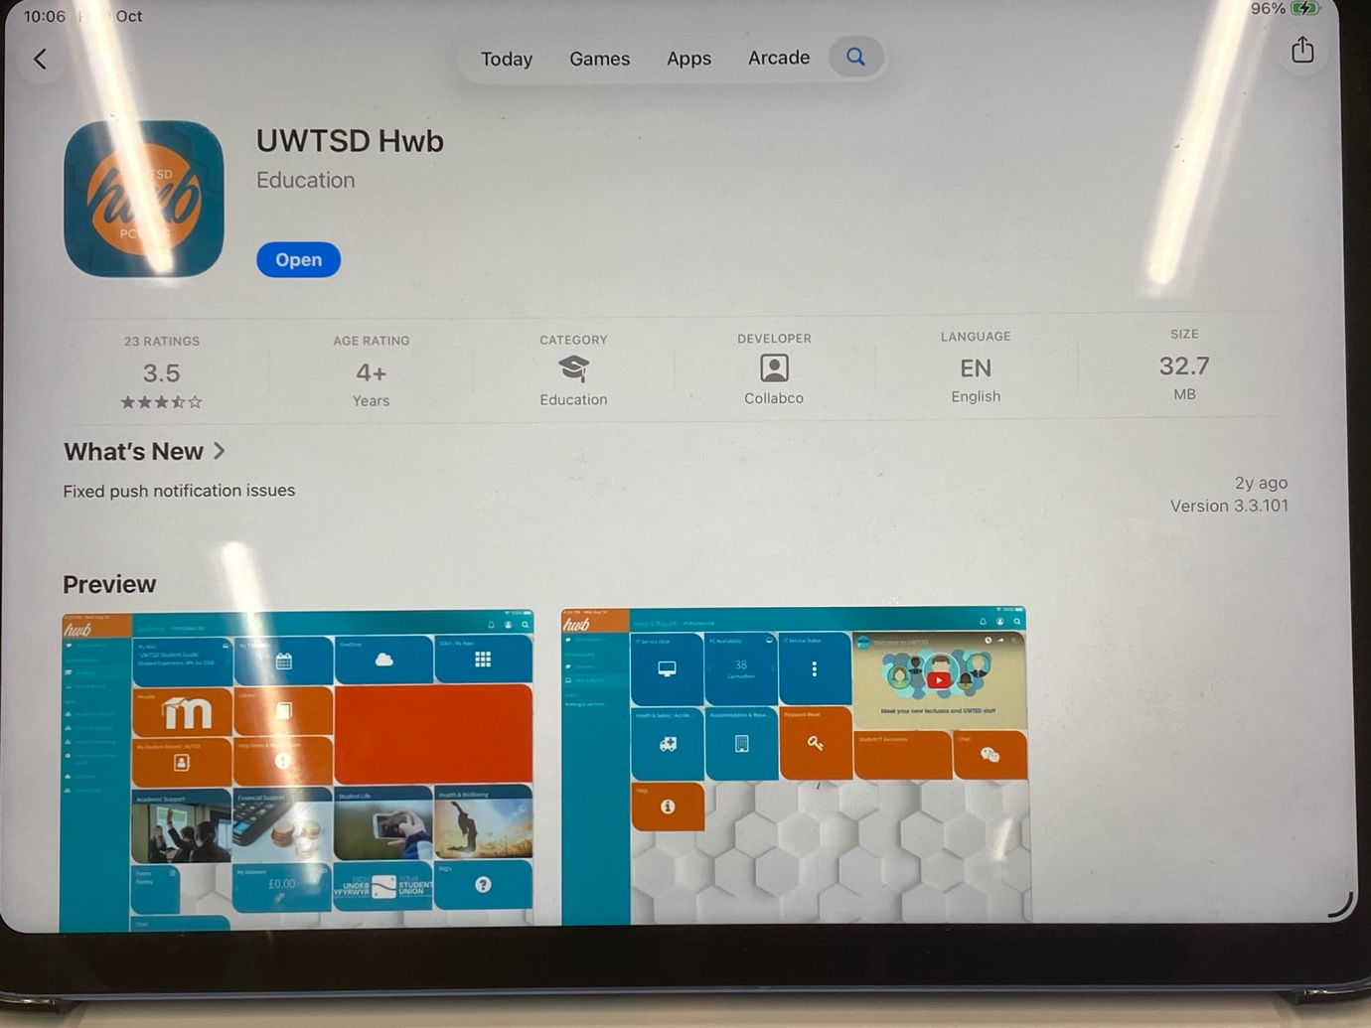
I downloaded the UWTSD hub app onto my iPad as I was initially not able to upload documents onto the template from my mobile device. I was later able to overcome this issue and insert images without any difficulty.

Screenshot/Photo 2
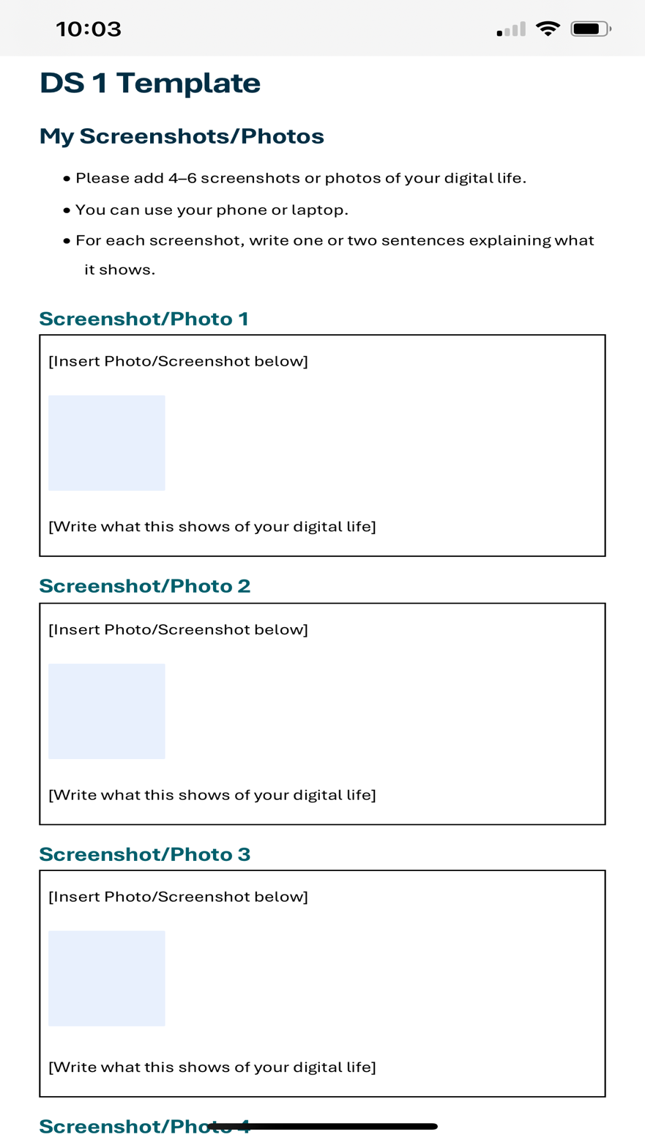
I took a screenshot of the template that we must use to submit work. As I do not have windows 365 on my iPad it did not allow for inserting saved images into the document. I will use this image to help me repeat the process on my laptop at home.

Screenshot/Photo 3
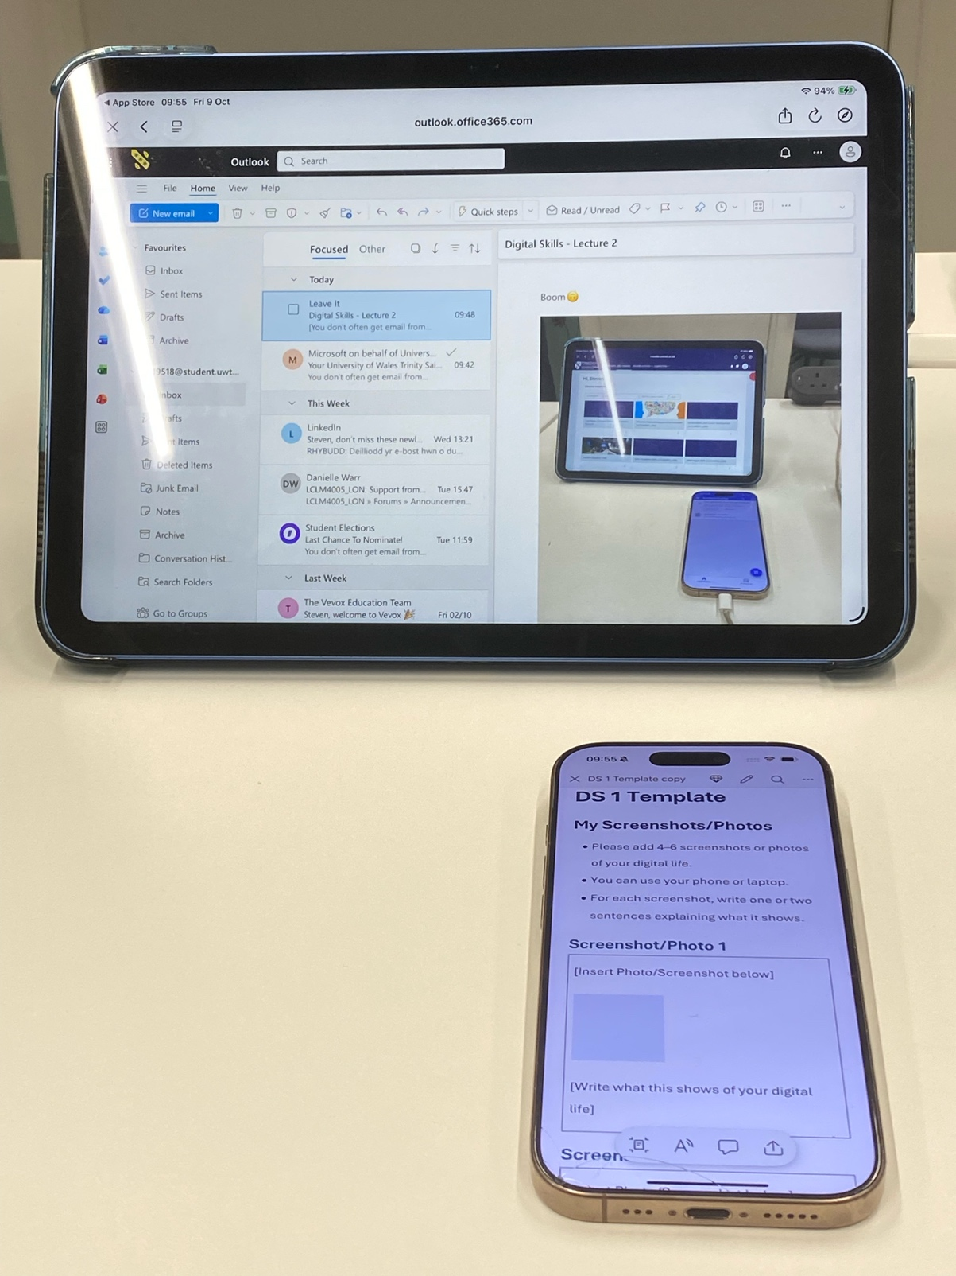
I took a picture to support my digital journey and emailed it to my student email. In the image below you can see that I was able to preview the image that I sent to myself.

Screenshot/Photo 4
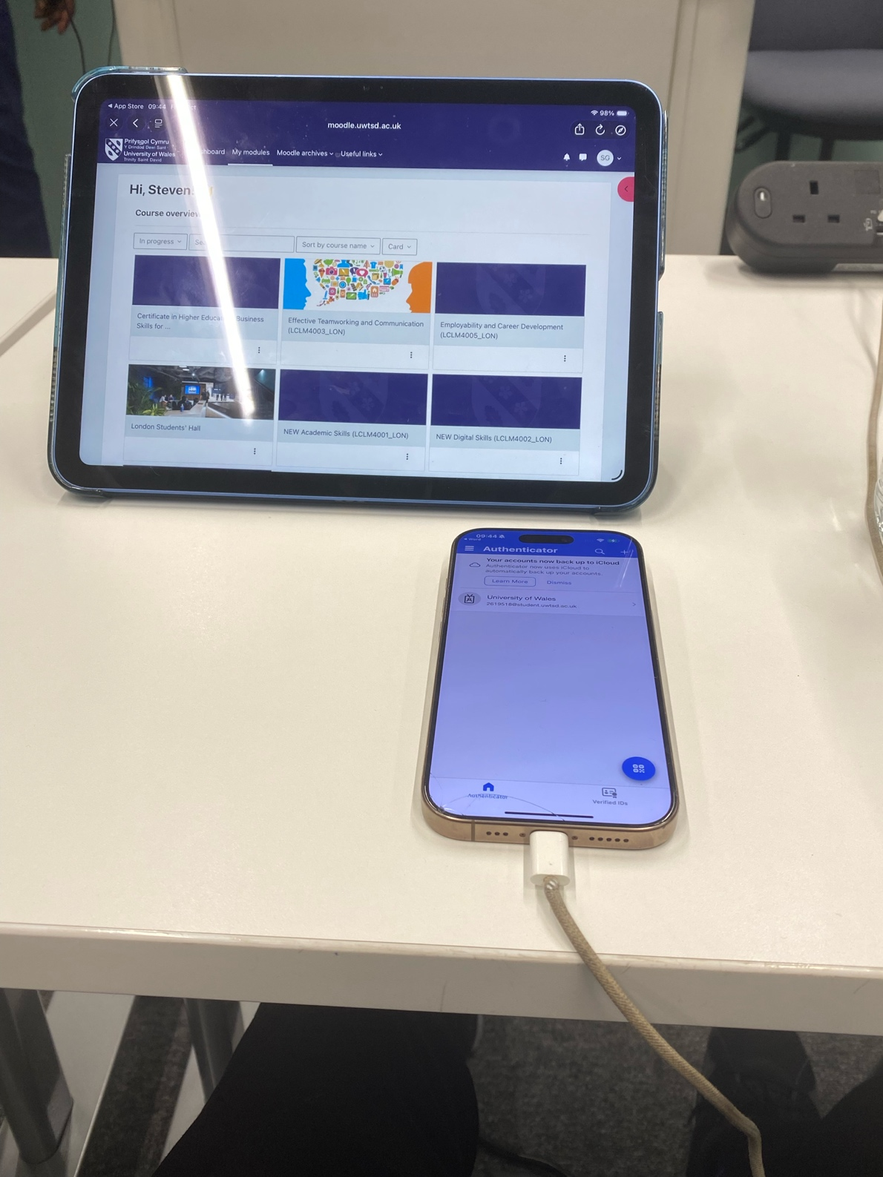
I used Moodle to look at the course assessment criteria and navigate the digital skills tasks that we are working on for today.

Screenshot/Photo 5
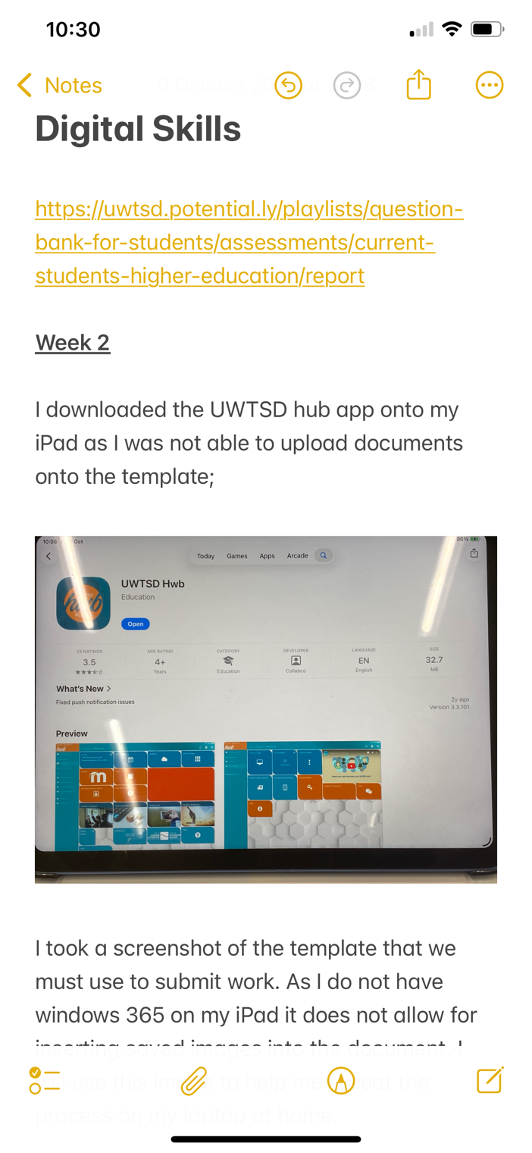
To overcome not having access to a device that I could use to insert images into word documents, I decided to use the ‘Notes’ app so that I could paste images from my photo album into the notes directly.

Screenshot/Photo 6
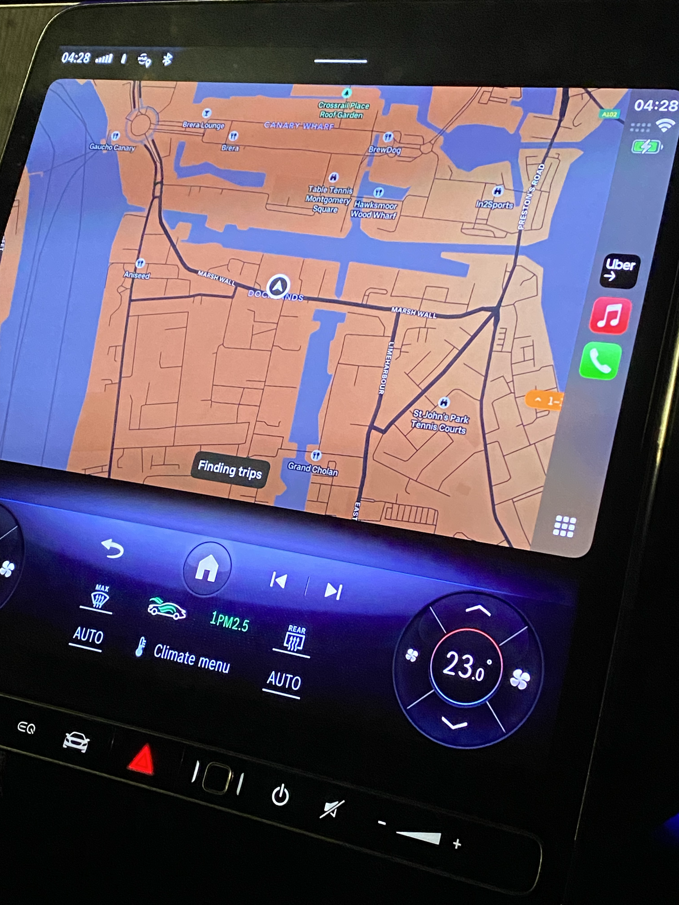
Lastly from the image above you can see that my digital life is heavily connected to my job and integrates seamlessly by connecting my work app with Apple CarPlay technology. This allows my car to almost act as a remote control that is able to mirror key features from my mobile device. I can control media playback, navigation and various other controls with just a motion or a voice command. I can browse the internet and stream media from my cars infotainment system. The streaming app I last watched was Netflix which has an extensive selection of movies and series covering many popular genres.

My Short Reflection
- Write 5–8 simple sentences about your digital life.
- You can use the sentence starters below if helpful.
I use digital tools for progression, scheduling, leisure and necessity. Digital information is readily accessible at your fingertips and makes researching information effortless. Any topic or task has the information that I require in digestible bite size pieces just waiting to be discovered. I regularly rely on short instruction/tutorial videos to allow me to carry out tasks that would otherwise have had to be carried out by a skilled tradesman.
I rely on preset digital alarms as far as scheduling to start my day and ensure that I get my child up and ready for school on time. I hope this module will allow me to become more proficient in engaging with new apps and platforms that have a lot to offer once you overcome the starting phase.
I often use digital streaming and media apps to unwind in my leisure time. Apps such as YouTube, Netflix, Disney+ and Apple TV have extensive libraries of shows and movies to enjoy.
My job is completely reliant upon digital technology from mapping, bookings and even checking that payments have arrived in my account.

