Olivia Jenkins 1910165
UWTSD | School of Engineering

Technical Report | Engineering Application and Study Skills M4X02063

University of Wales Trinity Saint David
School of Engineering
Technical Report of 29/10/2019
Olivia Jenkins
1910165
Motorsport Engineering BEng
Engineering Applications and Study Skills (M4X02063)

Contents
1. Introduction 3
2. Background Research 3
3. Methodology 4
3.1 Equipment used: 4
3.2 Methodology: 4
3.2.1 Dimensions: 4
3.2.2 Drilling: 4
3.2.3 Threading 4
3.2.4 Sawing 4
3.2.5 DX6 crossover vice machine 4
4. Discussion and Conclusions 5
5. References 5

Introduction
On the 29th of October 2019, a machine workshop session was taught by instructor Dave Cooper. The aim of this workshop session was to allow students to learn how to use multiple machine workshop instruments and become comfortable using them by completing an individual task to accurately saw and cut holes into a given piece of metal according to a dimensioned technical drawing. This report will step through the methodology of this session; what safety regulations had to be followed in the machine workshop, what equipment was used and how the equipment was used to complete the task. This will be followed by a discussion on what was achieved and learned during the session and a conclusion stating if the aim of this session was completed.

2. Background Research
Before entering and using the facilities within an engineering workshop the Health and Safety guidelines provided by the UWTSD must be read and a method statement and risk assessment is completed online to be signed off to allow a student to safely use the machine workshop facilities prior to the session. Many rules and regulations are in place to minimize the risk to oneself and the others in the workshop. These rules are given in a booklet including all the Health and Safety guidelines for inside any engineering workshop, the Machine Shop Drill, Turning and Milling safety rules. An example of some of the rules include keeping hands and face away from all moving parts and not operating the machines under the influence of alcohol or drugs. These guidelines must be read and understood before entering the machine workshop.
The advised Personal Protection Equipment (PPE) rules must always be followed in the machine shop when using the facilities. This includes:
- Protective Goggles
- No loose Jewelry or hazardous clothing accessories that dangle such as headphones or cords
- Hair tied back
- Protective clothing such as dust coats/overalls and steel toe cap footwear
(UWTSD Health & Safety Guidelines, 2019)

Methodology

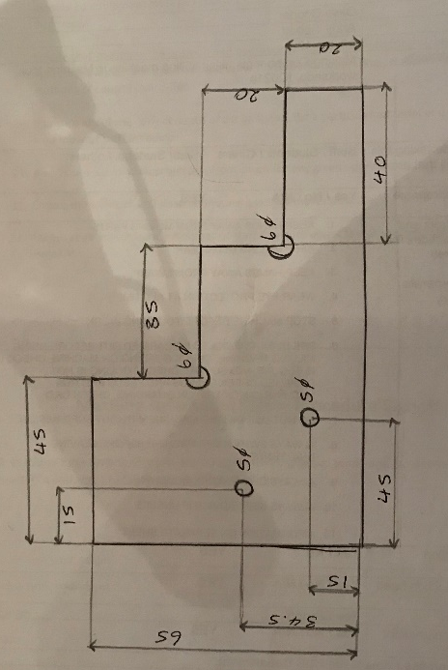
Equipment used:
- Rectangle piece of metal measuring approx. 70mm x 130mm
- Height gauge
- Even flat surface table
- Right angle block
- Drill machine
- Central drill
- 5mm diameter drill
- 6mm diameter drill
- Threading bolts
- oil
- Saw
Figure 1 Jenkins, Olivia. Dimensions, 2019. JPEG file.
- Clasp
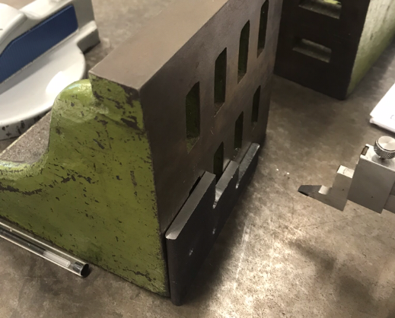
- DX6 crossover vice machine

Methodology:

Dimensions:
The dimensions as shown in figure 1 are accurately drawn onto the metal block, indicating where it should be cut and drilled, measured using the height gauge. This is measured on a center flat table so that the measurements aren’t obtruded by a non-flat surface, as demonstrated in figure 2, where all the dimensions are in millimeter.
Figure 2 Jenkins, Olivia. Measuring, 2019. JPEG file.

Drilling:
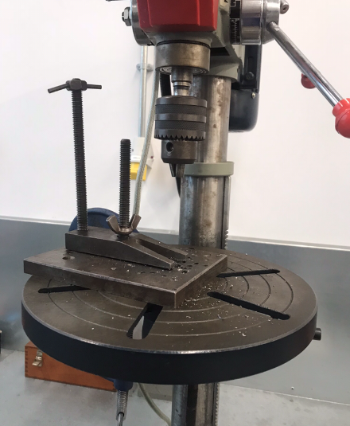
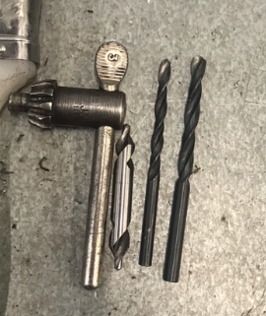
Using the drilling machine, the metal block is tightly clasped in. On the first 5mm diameter hole the center drill is put in and once the plastic safety guide is put over the drilling station the center drill is drilled where the hole was drawn in. Once the center drill is halfway through the block it is replaced with the 5mm diameter drill and drilled all the way through. This is repeated for the other 5mm hole and the 6mm holes, except using the 6mm diameter drill instead of the 5mm.
Figure 4 Jenkins, Olivia. Drilling machine, 2019. JPEG file.
Figure 3 Jenkins, Olivia. Drill bits, 2019. JPEG file
Figure 3 shows from left to right center drill, 5mm diameter drill, 6mm diameter drill.

Threading
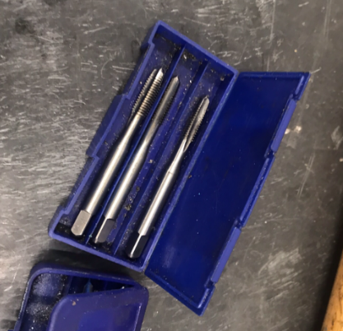
Figure 5 Jenkins, Olivia. Threading bolts, 2019. JPEG file.

Next the two 5mm holes are threaded, using threaded bolts. Placing the now drilled metal block horizontally into the clasp, the two 5mm holes are manually threading using a threading bolt (figure 5). Appling a tiny amount of oil onto the bolt, the bolt is manually twisted through the hole creating a thread.

Sawing
The drawn dimensions that need to be cut are manually sawed using a hacksaw. Safely sawing away from oneself to meet the required dimensions.

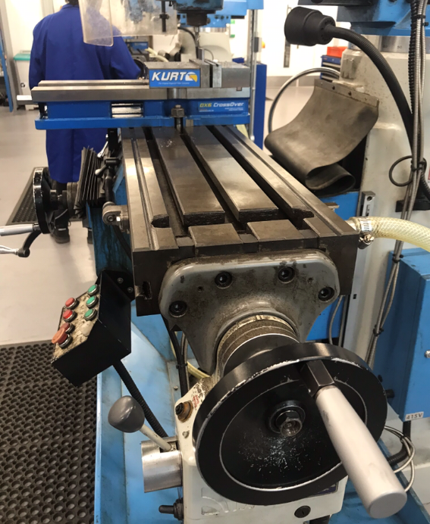
DX6 crossover vice machine
Figure 6 Jenkins, Olivia. Crossover vice machine, 2019. JPEG file.
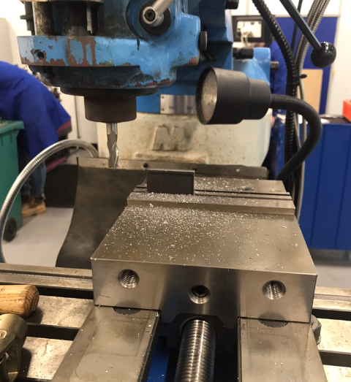
After sawing the dimensions of the metal block are measured to observe any imperfections in the straightness of the edges and the length, as sawing by hand there is bound to be room for human error. Using the vice machine allows the machine to get each dimension correct to the nearest mm. By altering how the block is clasped (Horizontally or vertically) and using the X Y and Z axis to cut down and straighten up any inadequate measurements as shown in figures 7 and 8.
Figure 7 Jenkins, Olivia. Crossover vice machine 2, 2019. JPEG file.

Discussion and Conclusions
By the end of this session I had been able to follow the dimensions of a technical drawing and using multiple tools for the first time accurately cut and drill down a block of metal to replicate the technical drawing as closely as possible. From this session alone I learned how to use a height gauge, drilling machine, vice machine including practicing cutting from all axis and how to safely use a saw.
From the practical lab sessions, I have taken with me useful knowledge of tools that are used by engineers on a regular basis in order to create and the need for safety regulations and PPE within a workshop. I can utilize these new skills for further projects in the university to design and create.

References
- University of Wales Trinity Saint David, UWTSD (2019) Health & Safety Guidelines.

