

MODULE NAME: bmsw4013
Student Name: saleh ahmed2010208
Lecturer Name: zita draper

Element 1 – Essay: Effective Study Strategies for Students in the Digital Era

Introduction
In today's digital world, students have unique experiences and opportunities that can change how they study, and as educational technology advances, we need to adapt our learning strategies (Haleem, et al., 2022). This essay focuses on effective study methods for students, based on educational theories and models. It also looks at the pros and cons of these methods and provides practical examples to help ensure students succeed.

Main body
Effective study strategies in the digital era are identified in various educational theories and models such as spaced repetition, feedback, testing, active learning, Gamification, and digital tools which increase learning outcomes (Xu et al., 2023).

Active learning
Active learning is the main strategy that highlights student meetings through participation in the learning process (Dzaiy & Abdullah, 2024). Active Learning fosters assignation and deepens understanding through participation. This research illustrates that students involved in active learning perform better academically, it may encourage anxiety in less confident students and requires skilled facilitation from trainers.

Constructivism
Constructivism is a learning theory that suggests that learners construct their knowledge through experiences, and techniques such as group discussions and peer teaching inspire profound comprehension and retention, the development of serious thinking skills (McLeod, 2023). Based on introducing features such as rewards and challenges, students are stimulated to stay committed to their studies (Instructional Coaches Corner, 2021).
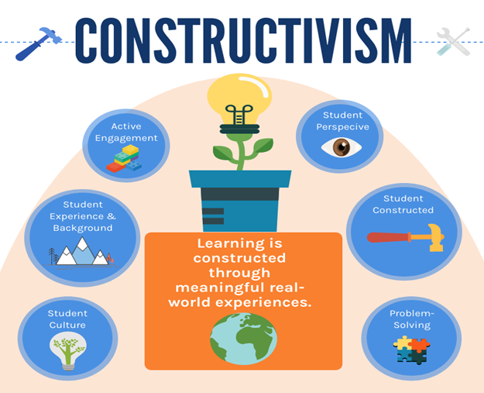
Figure 1: Constructivism model
(Source: Instructional Coaches Corner, 2021)

Spaced repetition
Spaced repetition is based on cognitive load theory and the spacing effect, which advises that information is engaged more effectively when study sessions are spaced out over time. This method stops cognitive overload, permitting students to come back to the material at intervals, which strengthens long-term memory retention. According to Wood (2024), spaced repetition increases memory retention by re-entering material at intervals. These studies specify that this method suggestively increases long-term recall, and demands self-discipline, and students might struggle to maintain a reliable study schedule.

Gamification
The incorporation of Gamification essentials draws on motivational theories, signifying that game-similar features can improve student arrangement and motivation (Christopoulos & Mystakidis, 2023). Gamification raises motivation through appealing game-like elements, evidence illustrating that students who enjoy their learning process are more likely to succeed, poorly designed gamification can shift focus from learning to rewards, risking artificial understanding (Khoshnoodifar, Ashouri, & Taheri, 2023).

Digital tools
Digital tools reflect real time cognition, which highlights that cognitive processes are boost through external resources and cooperative efforts. Apps for taking notes centres online platform resulting students organise information, share resources, and work together in real-time, thus gaining learning experience. According to Syaputra and Hasanah (2022), it facilitate organisation in efficient cooperation, tools such as Google Docs stimulate teamwork and effectual information sharing, while studies disclose that organised note-taking leads to better outcomes.

Benefits of study strategies
By following these strategies through definite actions, for active learning, they can join study groups or involve in peer-teaching sessions. In terms of spaced repetition can be practiced using apps such as Anki, which timetable reviews based on individual progress. To leverage digital tools, students can use platforms such as Trello for project management and organisation. For gamification, students can join in educational games or challenges, such as quiz competitions that increase learning while keeping meetings high (Point Loma, 2024). These strategies will increase their academic performances well as develop skills modern workforce.
Conclusion
In the above study, accepting actual study strategies like active learning, spaced repetition, digital tools, and gamification can suggestively increase student appointment and retention. Based on understanding the profits and potential drawbacks of each approach, students can tailor their study habits to maximise learning outcomes in both academic and real-world settings. The substance of operative study strategies lies in cognitive and constructivist theories of learning. Cognitive theory highlights the mental processes elaborate in learning, like memory, insight, and attention. Techniques like spaced repetition and recovery practice leverage these cognitive processes to increase retention and understanding. Digital tools can simplify cooperative learning, permitting students to construct knowledge through communication and feedback. Based mixing these theories into study strategies, students can attach technology to generate more operative and modified learning experiences.

Reference list
Christopoulos, A. and Mystakidis, S., 2023. Gamification in education. Encyclopedia, 3(4), pp.1223-1243.
Dzaiy, A.H.S. and Abdullah, S.A., 2024. The use of active learning strategies to foster effective teaching in higher education institutions. Zanco Journal of Human Sciences, 28(4), pp.328-351.
Haleem, A., Javaid, M., Qadri, M.A. and Suman, R., 2022. Understanding the role of digital technologies in education: A review. Sustainable operations and computers, 3, pp.275-285.
Instructional Coaches Corner. (2021). Constructivism - Instructional Coaches Corner. [online] Available at: https://www.instructionalcoaches.com/portfolio/constructivism/ [Accessed: 26 October 2024].
Khoshnoodifar, M., Ashouri, A. and Taheri, M., 2023. Effectiveness of gamification in enhancing learning and attitudes: a study of statistics education for health school students. Journal of Advances in Medical Education & Professionalism, 11(4), p.230.
Mcleod, S., 2023. Constructivism learning theory & philosophy of education. Retrieved September, 12, p.2023.
Point Loma (2024). 5 Strategies to Engage Students In the Digital Age. [online] Point Loma Nazarene University. Available at: https://www.pointloma.edu/resources/education/5-strategies-engage-students-digital-age [Accessed: 26 October 2024].
Syaputra, A. and Hasanah, E., 2022. Learning Strategies In The Digital Era. International Journal of Educational Management and Innovation, 3(1), pp.74-83.
Wood, A. (2024). 10 Innovative Learning Strategies for the Digital Age - Learner Bubble. [online] Learner Bubble. Available at: https://www.learnerbubble.com/10-innovative-learning-strategies-for-the-digital-age/ [Accessed: 29 October 2024].
Xu, M., Luo, Y., Zhang, Y., Xia, R., Qian, H. and Zou, X., 2023. Game-based learning in medical education. Frontiers in public health, 11, p.1113682.

Report: An Essential Skills for Students Success

Introduction
Effective communication is a serious skill for student, manipulating academic performance, personal relationships, and future career opportunities (Brennan, 2008). This skill encompasses verbal, non-verbal, and written forms of appearance, permitting students to articulate ideas clearly and be involved in meaningful discussions. This report discovers the significance of vital thinking in higher education, its key concepts, and relevant theories that reinforce its reputation.

Applicable Theories and Models
One main concept related to actual communication is the “Transactional Model of Communication”, which highlights that communication is an energetic and communicating process. In this model, the contributor and receiver endlessly influence each other, emphasising the importance of feedback and active listening (Lapum et al., 2020). This collaboration adopts a deeper understanding and boosts collaboration, important in group projects and classroom discussions. Another useful theory is “Bandura's Social Learning Theory”, which suggests that students learn by observing others. Effective communicators often help as role models, and representatives how to express thoughts, ask questions, and deliver productive (McLeod, 2024). Based on perceiving aristocrats and instructors, students can perfect their communication techniques, improving their overall academic experience. One more relevant theory is that “Emotional Intelligence (EI)” plays an important role in actual communication, students with high EI can better understand and manage their emotions and the emotions of others, leading to enhanced interactions (Mental Health America, 2023). This is particularly applicable in varied learning environments, where understanding and adaptability are vital for encouraging a supportive atmosphere.
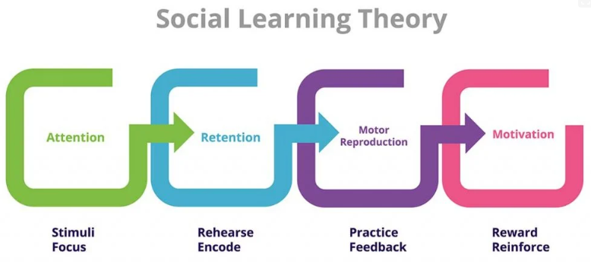
Figure 2: Bandura's Social Learning Theory
(Source: McLeod, 2024)
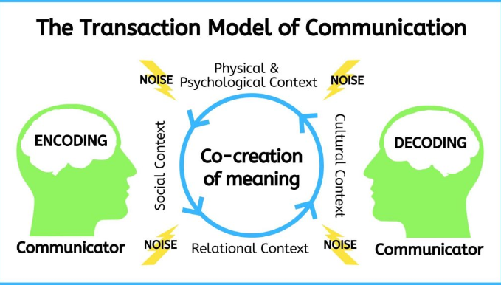
Figure 1: The transactional model of communication
(Source: Lapum et al., 2020)

Analyse the effectiveness of the skill and its impact
The effectiveness of communication as a skill for student success is reflective, as it directly influences learning outcomes and personal development (Shah, Syeda, and Naseer, 2020). Strong communicators are better prepared to clear their ideas, cooperate in teams, and be involved in serious discussions, leading to improved academic performance. Effective communication raises relationships with peers and educators, generating a supportive learning environment that can recover motivation and retention of knowledge. Alternative tools including technology-based communication platforms such as discussion boards, video conferencing and many more also play an important role. These tools can improve communication by giving students varied ways to express themselves, particularly for those who may struggle in face-to-face interactions. For example, asynchronous tools permit for reflection and more considerate responses, while graphic tools can aid in conveying complex ideas. However, dependence on technology can sometimes hamper the development of interpersonal skills, as it may decrease opportunities for impulsive dialogue and non-verbal cues. Balancing traditional communication skills with modern tools is vital for rounded student development. While communication remains a foundational skill, integrating it with alternative tools can improve its effectiveness, making students both academically and professionally successful in a varied and digital world (Alenezi, Wardat, and Akour, 2023). Effective communication plays a dynamic role in student success across various real-world contexts, for example, in group projects, clear communication permits students to share ideas, represent tasks, and resolve struggles efficiently. For instance, a team working on a presentation benefit when members actively listen and deliver positive feedback, increasing the quality of their work and fostering a cooperative essence.

Apply concepts in a real-world context
According to Karuru, Setiawan, and Junaida (2023), students who coherent their thoughts well can be involved more deeply with the material in classroom discussions. For instance, a student who asks perceptive questions during a lecture not only explains their understanding but also inspires further discussion, benefiting their peers. Strong communication skills are important during internships or job interviews, a student who can assuredly present their envelopment and articulate their goals is more likely to leave a positive impression on possible employers. For example, a well-prepared student who practices effective responses to common interview questions determines professionalism and self-awareness. Overall, in diverse settings, effective communication adopts inclusivity so that students who take their communication styles can bond cultural gaps, increasing collaboration and learning experiences. These practical examples demonstrate how operative communication directly supports academic achievement and prepares students for future challenges.

Conclusion
In above the study, effective communication is a vital skill for student success, supported by numerous theories and models. Based on developing this skill, students can increase their academic performance, build stronger relationships, and make up for future professional challenges. Capitalising time on increasing communication abilities not only advantages students during their education but also equips them for lifelong success. Based on mixing serious thinking with alternative tools such as emotional intelligence and cooperation, students are better fortified to tackle complex problems and work effectively in teams. Real-world applications in fields like business and healthcare validate the touchable benefits of serious thinking, ultimately making students successful careers and informed decision-making in their personal and professional lives.

References
Alenezi, M., Wardat, S. and Akour, M., 2023. The need of integrating digital education in higher education: Challenges and opportunities. Sustainability, 15(6), p.4782.
Brennan, J.B., 2008. College and career effectiveness skills and their impact on student success and learning (Doctoral dissertation, Fielding Graduate University).
Karuru, P., Setiawan, A.F. and Junaida, S., 2023. Improving Students’ Higher Order Thinking Skills Through a Question and Answer Method. RETORIKA: Jurnal Ilmu Bahasa, 9(3), pp.340-349.
Lapum, E.B.J., St-Amant, O., Hughes, M. and Garmaise-Yee, J., 2020. Transaction model of communication.
McLeod, S. (2024). Albert bandura’s social learning theory. [online] Simply Psychology. Available at: https://www.simplypsychology.org/bandura.html.
Mental Health America (2023). What is emotional intelligence and how does it apply to the workplace? [online] Mental Health America. Available at: https://mhanational.org/what-emotional-intelligence-and-how-does-it-apply-workplace.
Shah, A.A., Syeda, Z.F. and Naseer, S., 2020. University students’ communication skills as a determinant of academic achievement. sjesr, 3(2), pp.107-114.

MICROSOFT TEAMS
Microsoft teams is the most essential digital tools for students and facilitators to deliver their study and lectures. In this faculty teams can make communicate one to one or groups to deliver the guidance, task and supporting materials or instructions. (martin and tap 2019) It is the latest hub which sets out to become a platform to conservation channels into connect, collaborative, educative topic by making modules, academic distribution.
For institutions it become the normal processor to organise, set up meeting, collaborate with all the workforce to follow up day to day activities instructions including strategic guidance. Since Covid -19 started the whole of the world came to standstill with lockdown only exception left for educational authority and organisational working pattern virtual learning collaborating with management of the schedule routine working life became reality ( Hedderman n v63 i1p26-27). needing complete change of working, teaching in particular medical sector as the hospital admission was rapidly ballooning and needed engaging in illustrative knowledge sharing Oct; 7(3):e67–e70. doi: 10.7861/fhj.2020-0071.
https://uowtsd-my.sharepoint.com/:v:/r/personal/2010208_student_uwtsd_ac_uk/Documents/Recording-20241108_100531.webm?csf=1&web=1&e=XIDycY&nav=eyJyZWZlcnJhbEluZm8iOnsicmVmZXJyYWxBcHAiOiJTdHJlYW1XZWJBcHAiLCJyZWZlcnJhbFZpZXciOiJTaGFyZURpYWxvZy1MaW5rIiwicmVmZXJyYWxBcHBQbGF0Zm9ybSI6IldlYiIsInJlZmVycmFsTW9kZSI6InZpZXcifX0%3D

References
Martin, L. and Tapp, D., 2019. Teaching with Teams: An introduction to teaching an undergraduate law module using Microsoft Teams. Innovative Practice in Higher Education Journal, 3(3), pp.58-66.
ITNOW, Volume 63, Issue 1, Spring 2021, Pages 26–27, https://doi.org/10.1093/itnow/bwab010
Published: 16 February 2021
Keep calm and carry on learning: using Microsoft Teams to deliver a medical education programme during the COVID-19 pandemic
Daisy Henderson ^{A,✉}, Hannah Woodcock ^{B}, Jay Mehta ^{C}, Nuzhath Khan ^{D}, Victoria Shivji ^{E}, Charlotte Richardson ^{D}, Haleema Aya ^{F}, Shier Ziser ^{F}, Gabriele Pollara ^{G}, Aine Burns ^{H}

