Community Engagement

Portfolio

Student Name : Rusu Catalin Nicolae
Student number :2122702
Module name: Community Engagement
Programme Name: BA (Hons) Business Management
Module Code: LCBB4011
Name of lecturer: Charles Oham
Date of Submission/ Deadline: 24.08.2024 / 01.09.2024

Table of Contents

Contents
Introduction 2
Element 1: Community Outreach 3
Element 2: Stakeholder Mapping Exercise 5
Element 3: Community Engagement Plan 11
Element 4: Practical Discussion 16
Conclusion 24

Introduction
Community engagement is the activity of involving local people, different organisations, and other concerned stakeholders in decision-making and exercises that affect their ways of living and future (Kia, 2021). Community engagement guarantees for right planning and execution, the needs, wants, and issues of all the members of the community are of chief importance.
The objective of the document is :
- To study and see the effectiveness of community engagement in the Coastal area of Sussex.
- The goal is to develop a sustainable development plan and make residents conscious about sustainable development.

Element 1: Community Outreach
Community outreach is a vital component of a sustainable development project at the local community level (Kia, 2021).
Recently I had the opportunity to connect with the local communities in the East Sussex Coastal area to discuss the effect of climate change, especially in the Sea area. During the first day of the workshop, the citizens of the town were overloaded by the technicalities of the problem (Allen, 2019). It seemed they could not understand what was delivered to them. Our organisation, which is known by the name of “EcoUK”, made partnerships with the local business people to discuss the economic factors and effects on tourism and fishing. Our focus was to save both the economy and environment of that area. This method helped us in making a link between scientific information and real life results (Allen, 2019). Community engagement is a two-way street, where both the organisers and local people learnt a lot. Here. scientific knowledge was shared from our side, while we got insight about customary environmental information and complicated social dynamics that govern the environmental decision making process (Chu et al., 2021).
The stakeholders in the project are :
- Community members
- Government departments in the local area
- Schools and colleges
- Business corporations
- Religious groups
- Local health centres
- Local artist with ethics
- NGO for environmental causes
Because the majority of communities are heterogeneous, there will be a need to use multiple approaches to outreach. The below mentioned approaches will be applied throughout the project to develop the community engagement plan in a holistic manner. The digital platforms will be used so that the residents can access the progress data and all the information about the project. The reason to use conventional digital media is to include even those residents who don't use the internet actively. In order to get local innovative ideas and feedback, community meetings will be held.
Public reach can be hiked by collaborating with already existing organisations.
Digital platforms:
Utilisation of online channels like media platforms, local newspapers, local forums, and an official project website for sharing information and receiving feedback. However, a concern of certain of the digital divide within the community must be addressed.

Traditional media:
Traditional advertising methods where local newspapers, radio stations, and bulletin boards would be used to target the less active internet users (Allen, 2019).
Community meetings: Encouraging people to come together in town meetings, and residents or neighbour’s meetings to encourage conversations, discussions, and advice for the program.
Partnerships with local organisations: By partnering with schools, religious institutions, and community centres to increase the reach within the community based on established networks.
Ethical concerns will play an essential role in the outreach program. The leaders should have permission before using individuals and they should be allowed to quit at any time (Allen, 2019). The importance of language and cultural differences within a community should not be underestimated during this project. Material should be provided in different languages and the help of cultural negotiators in case of cultural clashes (Day, 2006). The economic factors will affect the outreach strategy and the project too. To increase the turnout of people living in lower income levels, transportation and childcare will be provided (Gilchrist, 2009). The outreach strategies will depend on social considerations like solidarity, politics, and the history of the society (Day, 2006). Detailed research on the overall community profile of the area and their past projects for environmental causes to get insight into reactivity and issues. To guarantee inclusivity, numerous engagement techniques can be applied which are:
- Identifying the strengths, opportunities, problems, and concerns by various mapping activities.
- The use of art to foster the exploration and discussion of ideas and issues symbolically (Gilchrist, 2009).
- Apps and portals, that can be used for data collection and analysis, for monitoring.

The partnership of Aviva with BITC, extending the place program of BITC to more communities in the UK. The collaboration aimed to address challenges in different fields like education, employment, housing issues and so on. The positive result of these initiatives encompass the success in reinforcing the local partnerships to address particular problems in communities. The main focus of this program were Norwich and Sheffield (PRBN, 2023). Another important example is the partnerships of GSK with the Save the children program that show such partnerships can bring change. This program promoted hand hygiene and enhanced healthcare access to marginalised communities and regions. It also showed the vitality of setting right objectives, adaptability in getting long term success in community engagement programs (Shilpa Pai Mizar, 2019).

Element 2: Stakeholder Mapping Exercise

A stakeholder mapping is a diagrammatic representation where stakeholders are place in four quadrants based on interest and influence/power. With the help of stakeholder mapping, it becomes easier to identify the influence asserted by different stakeholders and also engage them in bringing change within the community (Freeman,2023). I, along with my colleagues, prepared the stakeholder mapping by identifying the different stakeholders. During community meetings, I outlined the benefit of these mapping to all the stakeholders as well as the general public as being transparent about everything is our policy.
Key stakeholder groups identified included:
Fishermen's Association will be Located near the harbour and symbolised by the fishing boat icon. The Tourism Board will be represented by a sun umbrella icon along the beach area. For existing associations and possible cooperation, I utilised connecting lines. For example, a large straight line linked the Fishermen’s Association with the Environmental Groups to show their effort for sustainable fishing ( Arnstein, 2020). The infographic also included communication preferences for each group:
- Fishermen's Association: Personal face to face communicates at the docks.
- Tourism Board: Monthly letters, Facebook and other social media account posts.
- Local Government: Presentations, managerial staff and employees meetings in the town hall.
- Environmental Groups: By organising field trips and workshops.

Picture 1 . RNLI Eastbourne (Source: Created by learner)
- Residents: Community notice board and articles in the local newspapers.

Picture 2 . Eastbourne Senior Centre (Source: Created by learner)
- Business Owners: Business conferences, personal consultations.
- Schools: Through talk and educational sessions, and after school schemes.
Making this infographic was also quite an eye-opening experience for me. This made me comprehend that communities are socially very diverse. It is vital to communicate to the various segments in a way that best suits them (Arnstein, 2020). The infographic also showed us areas of weakness in the engagement strategy. We had not effectively targeted the seasonal workers that are immensely relevant in the tourism industry during peak time. This made us plan for specific outreach sessions in the middle of the peak season (Chu et al., 2021).
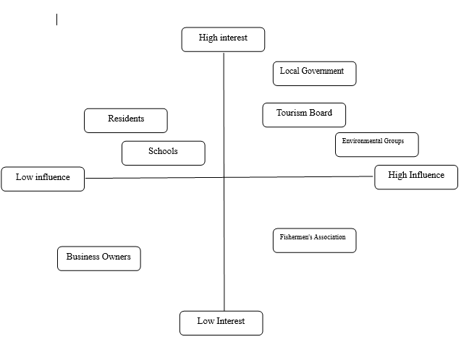
Figure 1: Stakeholder mapping
(Source: Created by learner)

In the above stakeholder analysis, it can be seen the stakeholders have different levels of interest and influence and they should be assigned specific attention. Therefore, I divided four quadrants into categories like- keep informed, monitor closely, keep satisfied and manage closely (Bahadorestani et al.,2020). Local community, local government and investors need to be managed closely because they have a considerable amount of power as well as resources to support the community development project related to sustainable practices. Therefore, they become one of the most influential stakeholders and their engagement becomes crucial during project execution to give information about the community goals (Navarro et al.,2023). The second category is cultural organisations and I put NGOs in the keep satisfied category. They are mostly latent and do not have direct interest but if they see their cause associated with the community because they wield substantial power to impact the project. For instance, an NGO that is fighting for environmental causes will feel more connected to sustainable measures at the community level if they are consulted (Brand et al.,2020). Those that I have kept in the monitor closely category have little interest in the project or have power over it. However, monitoring them becomes important as they can become important influencers in achieving project objectives. For instance, a writer can reach out to people and influence them to adopt the project if he is popular among the masses (Greenwood,2023). Lastly, the keep informed category comprises stakeholders who are interested in the project but do not have the power or influence to bring any change.
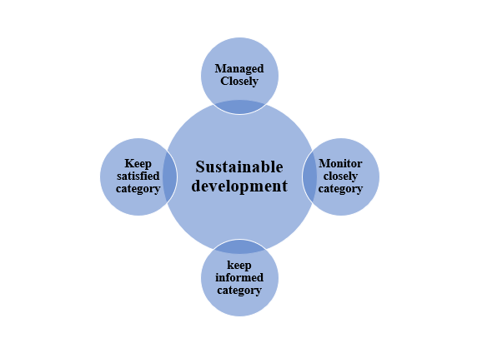
Figure 2 : Flowchart
(Source: Created by learner)

Community engagement plan for sustainable development at the local community level:
Goals and objectives:
- Enhance the consciousness of the community about sustainable development principles by our organisation on the coastal area for a better future (Quick and Feldman, 2021).
- Our organisation will drive steps for the active participation of all the members of the community in the planning and execution for the protection of the coastal area.
- Guarantee equal representation of all the categories in the community to address the concerns of everyone by our organisation (Rochester et al., 2012).
- The organisation will develop long-lasting capability and potentiality for sustainable practice adaptation

Element 3: Community Engagement Plan
Principles and standards:
From starting to the end of the project, I along with the other members of the organisation did maintain transparency. Clear communication about all the elements of the project were given to the citizens of the town. Each and every member of the organisation is accountable towards the citizens of the town and for this Periodic reporting will be conducted on developments and evaluating issues (Mayo, 2019).

Adaptable strategies:
Multi approach communication:
The organisation employed both digital and conventional methods for communication purposes. Social media campaigns were done to connect the young minds of that area. I suggested that the contact methods should be made as per demographic liking.
Participatory decision-making:
As the convener of the program, I, along with my colleagues, held regular town hall meetings and discussions to provide information and get feedback. Coastal monitoring sessions and climate action sessions by the youth were organised by our organisation to include citizens at every step of the project (Day, 2006).
Collaborative problem solving:
The organisation created working groups with different stakeholders to represent their voices. A futuristic and sustainable infrastructure plan was developed with the help of the local government.
Possible partnerships:
The organisation collaborated with the local college and local school or any other educational institutions for providing them courses on climate science and sustainable skills for the future. A green business certification program was developed by partnering with the chamber of commerce of the coastal region.

Inclusivity and diversity:
The organisation gave transportation, medical, and child care for marginalised communities for participation. Proper accessibility facilities for disabled people were given at meeting venues from the organisers. As per the core team suggestions, meetings and discussions included working people at different time slots (Mees et al., 2022).
Capacity building:
- Run training workshops or sessions about sustainable practices related to the project.
- Skill development for the members that meet the goals of the project.
Youth engagement:
- Collaboration with local schools and colleges to educate on sustainability
- Develop youth ambassador initiatives to motivate others (Banks et al., 2016).
Inclusive plan:
- Give transportation, medical, and child care for marginalised communities for participation.
- Proper accessibility facilities for disabled people should be given at meeting venues.
Cultural integration:
- Partnerships with local artists to extend the awareness program.
- Blend the old traditional knowledge systems into modern sustainable practices.
Collaborations:
- Concerned departments of the local government and officials.
- Educational institutions ranging from school level to university level to connect with all the future human resources.
- Business corporations that are interested in the cause (Banks et al., 2016).
Monitoring and evaluation:
- Create key performance indicators (KPIs) to evaluate progress at both individual and group levels.
- Organise regular surveys among the community to understand the contentment of the members on any aspect of the project (Mayo, 2019).
Summarised action plan
Some actions of the plan have been completed while some others are ongoing as mentioned in the table :
Phase | Action | Completion time | Responsibility
Launch | Stakeholder mapping | Completed in the 1st month | Project squad
Launch | Creation of an advisory board | Completed in the 1st-2nd month | Project squad and community heads
Planning | Strategy for communication | Completed in the 2nd month | Communication Group
Planning | Curriculum for Capacity Enhancement Program | Completed in the 2nd-3rd month | Education experts
Execution | Develop different channels of outreach | Started in the 3rd month and completed in the last | Communication Group
Execution | Town hall meeting for further planning and guidance | Started in the 3rd month and completed in the last | Project squad and advisory committee
Execution | Starting of capacity building sessions | Started in the 4th month and completed in the last | Education experts
Execution | Youth development steps | Ongoing | Youth engagement manager
Evaluation | Held survey within the community | Ongoing | Research Group
Evaluation | Quarterly review meeting | Completed in the 3rd month | All groups and stakeholders
Adaptation | Adjustment of strategies and planning | Ongoing | Project squad and advisory committee
Scaling | Extend the successful steps further to continuous development | Ongoing | All groups
Table 1: Action plan
(Source: Created by learner)

Element 4: Practical Discussion

Better understanding of local context:
The main advantage of stakeholder engagement is the understanding of the local scenarios. At first, I approached the climatic issues of the town from a technical viewpoint.
For example, during a group-work with the Fishermen’s Association, they informed us that their worries with regards to changes in fish numbers were not solely related to a small quantity of catches.


Picture 3. Fishermen's Association (Source: Created by learner)
There was a significant cultural factor linked with it (Day, 2006). This leads to better and targeted solutions because of the new understanding of the problem condition. Instead of suggesting general fishing bans, we adapted our fishing behaviours as a group that came from the community, including those that still adhere to the traditional fishing techniques but meet the requirements of conservation (Patel et al., 2023).

Improved and Heightened Community Participation:
Final result was a combined approach by making a lower seawall with replaced dunes and different local plants. This served two purposes like productive control of erosion and growing the beauty of the coastline attached to the town. As the whole town was involved at every stage of this project, we saw great pride and ownership after completion.

Picture 4 :Town Hall Eastbourne (Source: Created by learner)



Picture 5. Eastbourne Sightseeing Buss Company ( Source: Created by learner)

Diverse viewpoints bring creative solutions:
Stakeholder engagement a variety of knowledge, experience, and ideas that will help develop solutions to certain problems. This was apparent in our endeavours to diversify the local economy in the light of unfavourable repercussions of climate change on our traditional industries (Moon, 2004). This resulted in the making of the underwater sculpture park whereby the sculptures were designed to act as artificial reefs and form part of the tourist attractions (Mees et al., 2022).

Developing trust and social capital:
The participation of the stakeholders is useful in building trust between the various segments of the community and the authorities. This high social capital may turn out to be vital specially when dealing with long-term and complicated issues such as climate change adaptation (Quick and Feldman, 2021).One of the major moments was ‘Green Business Expo’ being hosted jointly by the Chamber of Commerce and Environmental groups.

Impartial results:
Connecting with different stakeholders enabled us to take concerns of all the stakeholders particularly minority communities and this approach led to more equitable results. For instance, interviews with the elderly people allowed identifying the existing threats connected with frequent heat waves (Moon, 2004). This resulted in the formation of a community cooling centre with transportation for those with disabilities. Likewise, interactions with seasonal workers contributed to the development of provision of emergency housing in case of natural disasters.

Enhanced Community Resilience:
One of the most valuable consequences is the creation of the increased community resilience due to the engagement with the stakeholders. When a community comes together to prevail over challenges, it improves social relations and returns with effective methods of fixing the issues and increased feelings of success (Nursey-Bray, 2021).

Personal Reflections and Learnings
Patience is crucial: Establishing trust and making people work together in groups require some time. There were moments which were quite irritating but I had to realise that forcing the process will do more harm than good (Nursey-Bray, 2021).
No engagement plan is invulnerable after the first meeting with the community. Every voice matters . In our program, some of the great ideas arose from unexpected persons. Engagement is ongoing: Community engagement is not something that is done only once, but doing things continually (Patel et al., 2023). Open and active communication helps in retaining the trust of the people involved. It is worthy to note that engaging stakeholders in activities that will enhance the community's progress is not without difficulties. Sustainable development at a local community level will depend upon the active engagement of various stakeholders. As a community member engaging with stakeholders will be helpful as they can provide insights on the community (Mia et al.,2022). The stakeholders who play a major role in contributing to community development are- NGOs, local and state governments, local communities, media and so on. There are many benefits associated with engaging stakeholders in community engagement-
- Idea generators - Involving stakeholders can be beneficial for engaging the local communities as they have a good understanding of the local context and can give ideas for development (Bacq and Aguilera,2022). For instance, local government officials can suggest ways to recycle waste within a community by encouraging community-based waste management techniques like solid and liquid waste collection and disposal.
- Reality checkers- Stakeholders have knowledge regarding the viability of a project and how to engage the local community to achieve the project goals and objectives. For instance, NGOs are organisations that are at the forefront in raising awareness about various environmental issues (Dmytriyev et al.,2021).
- Financial supporters- community development projects require funding and economic support which can be provided by investors. Investors nowadays are required to abide by ESG and EPR frameworks which pushes them to invest in community development projects while performing business operations (Danso et al.,2020).
- Spreading awareness- The media plays a very important role as a stakeholder in spreading awareness about local community projects as well as helping attract public concern about the conditions of a local community (Talbot et al.,2021).

Engaging communities in community development projects can be challenging due to the differences in opinions, needs and wants.
Some of the challenges related to community engagement are :
- A lack of Trust - During community engagement the most striking problem comes in the form of generating trust among the community members. Many time they are sceptical about whether their voices will be heard or not (Heckert et al.,2020).
- Digital exclusion- The local community is mostly unaware of digital modes of communication and prefers a traditional way of living. Therefore before engaging the community in developmental projects digital awareness should be spread and digital tools need to be taught (Lehtinen and Altonen,2020). For instance, social media tools like WhatsApp and Facebook provide a platform where people can post about their activities also raise community demands.

The core principles in community engagement will include building trust by communicating the importance of sustainability, maintaining inclusivity by engaging each and every community member and considering their opinions in decision-making (Wieland et al.,2020). Some of the effective techniques to realise these core principles are- conducting community meetings to have face-to-face conversations and avoid conflict of interest, employing focus groups who will communicate the development projects as well as community interest between stakeholders and communities (Khaledi et al.,2023).

Evaluation through model:
The Charity Evaluation Triangle is generally used to evaluate the effectiveness of charitable organisations. It can also be applied to analyse the community engagement program for climate change. This model has three key aspects which are Impact, Cost-Effectiveness, and Robustness of Evidence (Prentice and Brudney, 2021). Applying this model to the community engagement plan, gives important information about strengths and fields of enhancement.
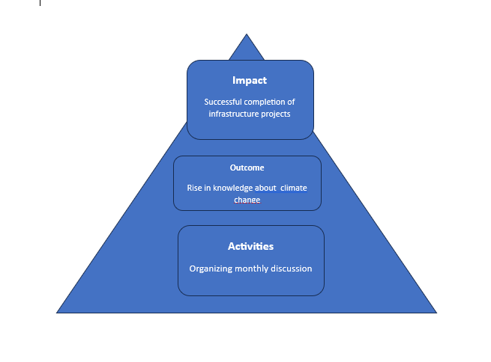

Figure 3 : Charity Evaluation Triangle
(Source: Created by learner)
Analysis of the diagram:
Activities:
- Facilitate members-based discussions and workshops on water coasts surveillance.
- Organise design charrettes during which external stakeholders can participate in the development of infrastructures.
- Holding sessions for designed and planned climate actions with the young people at the centre.
- Create translation facilities for the communities.

Outcomes:
- Rising local capability of climate change fight.
- Improved partnerships among all the stakeholders.
- Having a higher level of involvement of the people in the community in environmental causes.
- Sustained emergence of new place-based and people-centred approaches.
Impacts:
- Eradication of the susceptibility of the community to climate change in the long-run.
- Long term economic diversification.
- Improved ecosystem health and rise in biodiversity.
- Increased capacity and solidarity of the target communities

These plans are in line with the Charity Evaluation Triangle. Activities are concerned with participation and learning, outcomes are seen in terms of shift in knowledge and behaviour, while impacts are seen in terms of enduring changes in community well-being and sustainability. The structure enables a more obvious distinction of the plan’s efficiency and easily detects weaknesses or shifts that need to be addressed as the community progresses.

Impact:
The outcomes of the undertaken community engagement activities have been quite wide-ranging and profound. Engaging the stakeholders, it has been quite clear that there have been positive changes in climate change responsiveness, community enabling, and proactive adaptation strategies.
One important impact is the enhanced level of awareness of climate change among various groups. the “Climate Café” sessions, as well as youth-led activities that have encouraged people’s acts of concern for the environment, including those who are not directly related to the cause (Prentice and Brudney, 2021). For example, the high school student’s ‘’Blue Carbon’’ program engaged in carbon sequestration and also raising awareness within the community about the marine environment.
The participatory process that led to the construction of a multi-functional structure ‘hybrid seawall and dune restoration’ is an area where the impact for engagement is most noticeable in terms of the project’s tangible by-product. This solution not only solves the problem of erosion but also improves the looks of the natural surroundings, an example of how public participation in the decision making process leads to better solutions.
Further, the diversification of the local economy that can also be seen with projects such as the underwater sculpture park show use of engagement to develop creative ways to manage the environment and economy.

Cost-Effectiveness:
Though the community engagement is time-consuming and resource intensive, strategies have been rather beneficial in several aspects. Through partnerships, capacities, and volunteers at a minimal cost compared to the sophisticated model, initiatives have been completed at lower costs.
For example, the community ideas platform has produced a large number of low cost, high value interventions (Prentice and Brudney, 2021). The idea of collection of rainwater brought by the retired engineer is turned into a pilot project with very low financial cost, bringing higher returns in water conservation.
Also, engagement has decreased peoples resistance to enhanced adaptation measures where expenditures saved linked with delay and disputes. A good example is the wide support for the achievement of carbon neutrality in the town, a move that might have made subsequent processes easier (Liket et al., 2022).
However, there's areas for advancement in case measuring the economic results from the engagement initiatives. Establishing stronger metrics for cost saving and economic effects will give an efficient tool for evaluation of cost assessment.

Robustness of Evidence:
Although the evidence for effectiveness of the program is mainly qualitative, it is also strong. There is growing support for the identified community engagement approach. The organisation has recorded higher compliance levels of climate change interventions, better cooperation from warring factions such as environmental groups and commerce and effective, workable reception of projects by the people.
The reasonable response of the storm surge that occurred during the unforeseen incidents in the previous year justify the increased community resiliency (Liket et al., 2022). The orchestrated and rapid response demonstrated the results of the engagement initiatives in growing multidimensional networks and enhancing interactional channels.
The organisation has also noted the extra efforts, which include participation in the beach clean-up activities as well as the rising support for the ‘Green Business’ accreditation programs. These indications point towards the change in the attitudes and practices of the community.
However, to support these conclusions, improved and more formalised methods of data collection and analysis are required. Sector-wide surveys showing year-on-year shifts in the attitude, behaviour and resilience of the community would offer even better proof of long term effects.
To further improve, focuses should be on:
- Creating quantitative metrics to assess the economic impacts and cost effective system.
- More accurate and systematic methodologies for enhancing the quality of the outcomes.
- Find ways to extend the successful initiatives and on how to disseminate information to other groups.
Applying the Charity Evaluation Triangle on the community engagement case shows that there are huge positives on all counts, reasonable value for money, and growing evidence of efficiency (Liket et al., 2022). The approach has promoted innovation, the community’s ability to respond to climate change, and provision of climate change adaptation.

Conclusion :

In conclusion, the engagement Plan is a solid working document for compliance with the aims to foster local sustainable development and implement meaningful community engagement. By establishing goals to achieve, using ethical standards to guide the work, and designing strategies that would allow to make a beneficial project for the community members. Having a diverse and inclusive plan will foster ownership among all the community members.

Presentation:
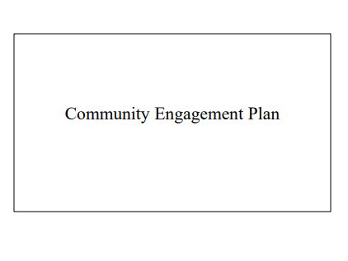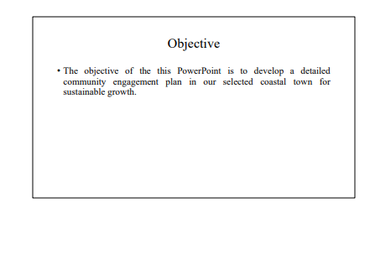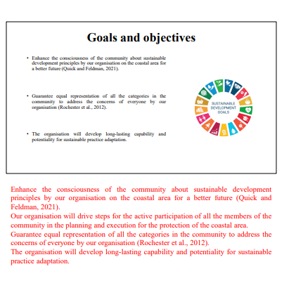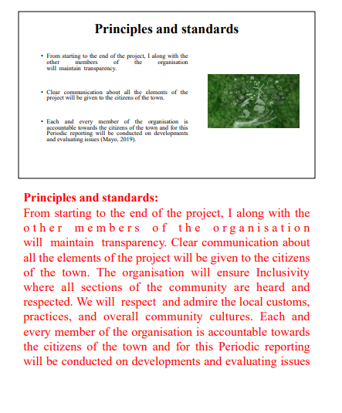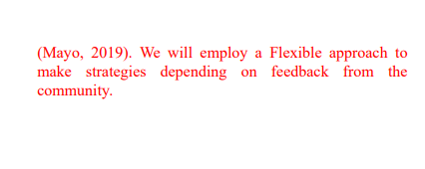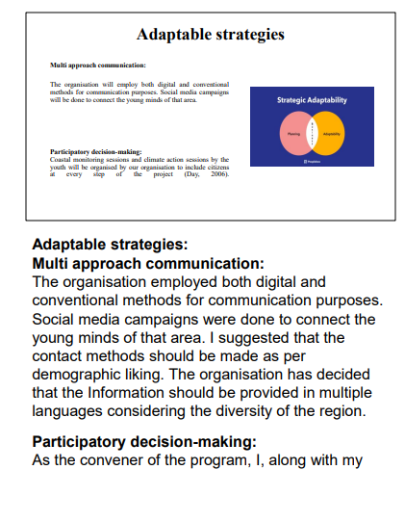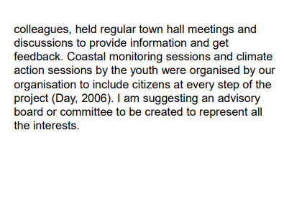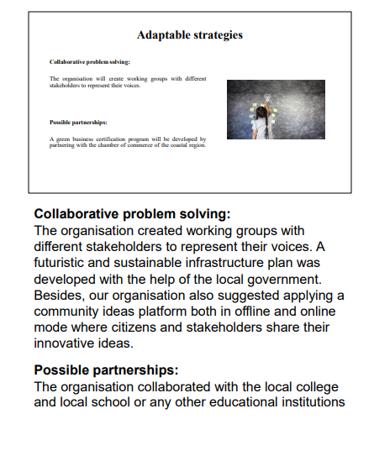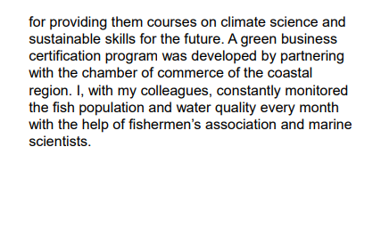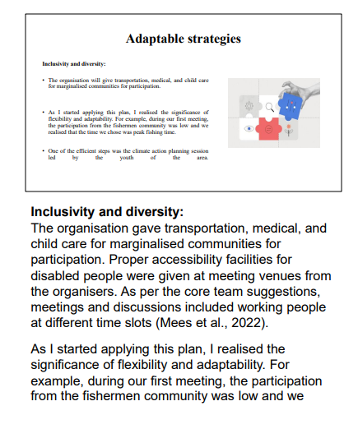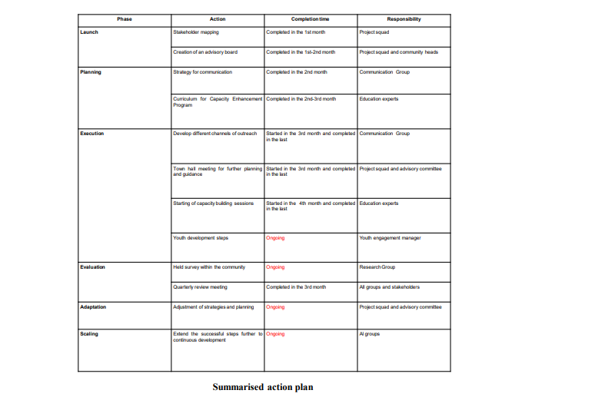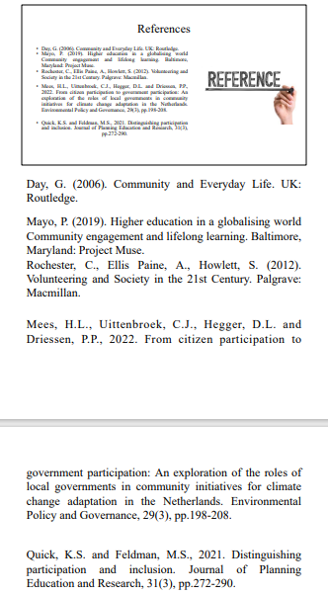

References :
- Allen, J.A. (2019). The Cambridge handbook of organizational community engagement and outreach. Edited by J.A. Allen. Cambridge: Cambridge University Press.
- Arnstein, S.R., 2020. A ladder of citizen participation. Journal of the American Planning Association, 85(1), pp.24-34.
- Bacq, S. and Aguilera, R.V., 2022. Stakeholder governance for responsible innovation: A theory of value creation, appropriation, and distribution. Journal of management studies, 59(1), pp.29-60.
- Bahadorestani, A., Naderpajouh, N. and Sadiq, R., 2020. Planning for sustainable stakeholder engagement based on the assessment of conflicting interests in projects. Journal of Cleaner Production, 242, p.118402.
- Banks, S., Shaw, M. and Meade, R. (2016). Politics, Power, and Community Development. Edited by S. Banks, M. Shaw, and R. Meade. Bristol, United Kingdom: Policy Press.
- Brand, T., Blok, V. and Verweij, M., 2020. Stakeholder dialogue as agonistic deliberation: Exploring the role of conflict and self-interest in business-NGO interaction. Business Ethics Quarterly, 30(1), pp.3-30.
- Centre for Community Engagement Research https://www.gold.ac.uk/community-engagement-research/
- Chu, E., Anguelovski, I. and Roberts, D., 2021. Climate adaptation as strategic urbanism: Assessing opportunities and uncertainties for equity and inclusive development in cities. Cities, 60, pp.378-387.
- CTSA Community Engagement Key Function Committee Task Force (2011). Principles of Community Engagement. 2nd ed. NIH Publication.
- Day, G. (2006). Community and Everyday Life. UK: Routledge.
- Dmytriyev, S.D., Freeman, R.E. and Hörisch, J., 2021. The relationship between stakeholder theory and corporate social responsibility: Differences, similarities, and implications for social issues in management. Journal of Management Studies, 58(6), pp.1441-1470.
- Freeman, R.E., 2023. Stakeholder management: framework and philosophy. In R. Edward Freeman’s Selected Works on Stakeholder Theory and Business Ethics (pp. 61-88). Cham: Springer International Publishing.
- Gilchrist, A. (2009). The Well-Connected Community, a networking approach to Community Development. 2nd ed. Bristol: Policy Press.
- Greenwood, M.R., 2023. Community as a stakeholder: focusing on corporate social and environmental reporting. In Australasian Perspectives on Corporate Citizenship (pp. 31-46). Routledge.
- Heckert, A., Forsythe, L.P., Carman, K.L., Frank, L., Hemphill, R., Elstad, E.A., Esmail, L. and Lesch, J.K., 2020. Researchers, patients, and other stakeholders’ perspectives on challenges to and strategies for engagement. Research Involvement and Engagement, 6, pp.1-18.
- Kia, Z., 2021. Ecotourism in Indonesia: Local community involvement and the affecting factors. Journal of Governance and Public Policy, 8(2), pp.93-105.
- Khaledi Koure, F., Hajjarian, M., Hossein Zadeh, O., Alijanpour, A. and Mosadeghi, R., 2023. Ecotourism development strategies and the importance of local community engagement. Environment, Development and Sustainability, 25(7), pp.6849-6877.
- López-Navarro, M.Á. and Tortosa-Edo, V., 2023. The legitimisation of local environmental organisations by community members. Local Environment, 28(9), pp.1112-1130.
- Mayo, P. (2019). Higher education in a globalising world Community engagement and lifelong learning. Baltimore, Maryland: Project Muse.
- Mees, H.L., Uittenbroek, C.J., Hegger, D.L. and Driessen, P.P., 2022. From citizen participation to government participation: An exploration of the roles of local governments in community initiatives for climate change adaptation in the Netherlands. Environmental Policy and Governance, 29(3), pp.198-208.
- Mia, M.T., Islam, M., Sakin, J. and Al-Hamadi, J., 2022. The role of community participation and community-based planning in sustainable community development. Asian People Journal (APJ), 5(1), pp.31-41.
- Menon, S. and Suresh, M., 2020. Synergizing education, research, campus operations, and community engagements towards sustainability in higher education: A literature review. International Journal of Sustainability in Higher Education, 21(5), pp.1015-1051.
- Moon, J. (2004). A handbook of reflective practice and experimental learning: theory and practice. UK: Routledge
- National Coordinating Centre for Public Engagement. Avaible at: https://www.publicengagement.ac.uk/.
- Nursey-Bray, M., Palmer, R., Stuart, A., Arbon, V. and Rigney, L.I., 2021. Scale, colonisation and adapting to climate change: Insights from the Arabana people, South Australia. Geoforum, 120, pp.20-29.
- Patel, S.S., Rogers, M.B., Amlôt, R. and Rubin, G.J., 2023. What do we mean by 'community resilience'? A systematic literature review of how it is defined in the literature. PLoS currents, 12.
- PRBN (2023). Aviva partners with BITC to provide much-needed support for communities across the UK. Business in the Community. Available at: https://www.bitc.org.uk/news/aviva-partners-with-bitc-to-provide-much-needed-support-for-communities-across-the-uk/’
- Quick, K.S. and Feldman, M.S., 2021. Distinguishing participation and inclusion. Journal of Planning Education and Research, 31(3), pp.272-290.
- Rochester, C., Ellis Paine, A., Howlett, S. (2012). Volunteering and Society in the 21st Century. Palgrave: Macmillan.
- Scottish Community Development Centre https://www.scdc.org.uk/.
- Shilpa Pai Mizar (2019). Successful corporate-NGO partnerships.FM Magazine. Available at:
https://www.fm-magazine.com/issues/2019/apr/successful-corporate-ngo-partnerships.html
- Talbot, D., Raineri, N. and Daou, A., 2021. Implementation of sustainability management tools: The contribution of awareness, external pressures, and stakeholder consultation. Corporate Social Responsibility and Environmental Management, 28(1), pp.71-81.
- Wieland, M.L., Doubeni, C.A. and Sia, I.G., 2020, September. Community engagement with vulnerable populations. In Mayo Clinic Proceedings (Vol. 95, No. 9, pp. S60-S62). Elsevier.
- Yadav, S.K., Banerjee, A., Jhariya, M.K., Meena, R.S., Raj, A., Khan, N., Kumar, S. and Sheoran, S., 2022. Environmental education for sustainable development. In Natural Resources Conservation and Advances for Sustainability (pp. 415-431). Elsevier.
- Prentice, C.R. and Brudney, J.L., 2021. Combining Theories of Change and Evaluative Frameworks to Assess Nonprofit Performance. Nonprofit Policy Forum, 12(2), pp.263-283.
- Liket, K.C., Rey-Garcia, M. and Maas, K.E., 2022. Measuring Impact of Philanthropic Foundations: A Fuzzy Multicriteria Approach. Nonprofit and Voluntary Sector Quarterly, 51(1), pp.96-118.

