Name: Mafuta Lilian MANZUMBA
Student Number: 1706306
Module Title: BMSK4005 Professional Career Development
Assignment Title: Professional Career Development
Word count: 3832/4000 words
Module Lecturer Name: Mary March

Introduction
The aim of this assignment is to create a Personal as well as Professional Career Development Plan based on my past experience. It will outline my strengths, weaknesses, opportunities and targets. This assignment will also discuss my own personal reflective journey detailing what employability skills I already possess, need to improve one in order to increase my employability chances.
I’m a self-motivated, enthusiastic, caring, approachable and friendly individual who aspires to run my own Wedding Planning Business. This idea or desire has emerged after planning and organising my Son’s wedding almost three years ago. Originally, I’m from the Democratic Republic of Congo and therefore biolinguistics as I’m fluent in French, Portuguese and Lingala as well as English. Within the Congolese community here in London I have had the privilege of organising as well as planning a few weddings together with my family and I have enjoyed doing so. Hence the reason I want to become a Wedding planner. Prior to making this decision I have tried out different fields such as catering and nail technician. Currently I’m working as a Diner Lady in a local Primary School. My current job has enabled me to gain certain employability skills such as Time management, good communication, teamwork, solving problems, self-awareness and decision making.
I have recently turned 50 and I’m a mother of six children and have two beautiful granddaughters. Half of my life I had dedicated to raising my children and because I got married at a young age I sacrificed my personal career and dreams for my children. Two of my eldest children are graduates and now married and settled. The third eldest is in his final year at university and the final three are still in full time education. My youngest child is 11 and starting secondary school this September. Since my oldest two children are settled in their lives and my youngest no longer is too dependent on me I saw that this was the time and opportunity to reinvent and focus on myself and pursue a career or create my own business. I come from a background where women or mothers are considered to have the main responsibility of taking care of their husbands and children in other words to aspire to be good house wife’s without having any other ambitions or motivations. However, having lived in this country where opportunities have been given to all individuals regardless of their beliefs, socioeconomical backgrounds, gender, financial statues and sexual orientation, my family and friends have encouraged and motivated me to aim and achieve higher. For at least four years I was self-employed after undertaking a nail technician course whereby I became a qualified Nail technician. I enjoyed been my own boss and working within the comfort of my own home. I used my home address as my business address, had business card and an accountant dealing with my finances and tax returns. This is what stirred me to go into business as well as to study the course that I’m currently studying. I was referred by friends and families about the university and read about it online. As I have two children who are graduates, they encouraged me to do the same and told me that it was never too late to learn or try something new.
Self -Evaluation Review
Self -motivation
In order to get better understanding about what I’m aiming to do I have to understand the meaning of self-evaluation, self-motivation and identify what type of learner I’m and identify different learning styles which apply to me. This is important because even though my goal is to have my own business, I need to be aware of what employers look for when employing someone. The term “Self-motivation is the force that keeps pushing us to go on – it's our internal drive to achieve, produce, develop, and keep moving forward, Mind Tool.com”. Accessed 20/08/2018. In other words, it is a desire that drives us to continue to better ourselves, aim higher and not give up as well as progress until we achieve and exhale in meeting our objective. This is a vital skill essential needed in every aspect of our lives not just professionally but also personally, for example having the desire to eat healthy and exercise on a regular basis in order to maintain a healthy lifestyle. Without self-motivation we wouldn’t be able to go to work in order to provide for our families or create memories with our children such as going to the Zoo during the summer holidays. In order to motivate myself I look at what I have accomplished so far in my life and look at ways of how I could improve myself, reflect on if I’m happy or unhappy and make the effort to change my circumstances if I have to. By doing so I learn more about myself, my strengths, weakness and even challenge myself and push forward. As a mother I have learned to never give up regardless of the many challenges I have come across such as been financially strained, budgeting and managing my life on low income, taking care of six children and working part time to meet ends. Over the past few years my communication skills such as speaking, listening, reading and writing in English has vastly improved without having to rely on my children so much. I’m able to look for jobs online, fill out application forms and attend job interviews which has boosted my confidence and has made me very proud. Instead of relying on the Benefit system I decided to go back to work part time as soon as my youngest child started attending school full time. I motivated myself by encourage myself to come out of my comfort zone and associate myself with people who earned minimal wage but learned to work with people from different backgrounds in a small group. In order to push myself I felt that it was necessary that I go back to work as well as study to learn English in order to be more independent and gain experience about the working environment. This taught me how to prioritise and balance life between working and family. For the purpose of this assignment I carried out the Self -Motivation Quiz on the Mind Tool website and I scored 52/60. According to the results I’m very self-motivated and I’m doing exceptionally well. This is incredible and fantastic and reassured me even more. The questions are divided under four main subheadings: Self-Confidence and Self- Efficacy (scored 18/20), Positive thinking (scored 17/20), Focus and Strong Goals (scored 8/10) and Motivating Environment (scored 9/10). To say that I’m proud of myself is an understatement. According to the Quiz I believe in myself which enables me to have self -assurance, I challenge negative thoughts therefore I’m able to overcome barriers and I have an external factor which is my surrounding that enables me to achieve my goals and objectives. I can relate to this and confirm that this is so true as I’m surrounded by people such as my family and friends who see the potentials in me to accomplish great things. I’m a team player, approachable, nice and friendly. I listen and pay attention to the people around me I have been able to demonstrate this in the classroom during group work and group presentations.

Learning styles
There are numerous ways to learning or gather thoughts and ideas in order to improve oneself, according to Pitchard, (page 1, 2014) learning can be defined in many ways such as “ to gain knowledge of, or skills in, something through study, teaching, instruction or experience” as well as “a change in behaviour as a result of experience or practice”. In other words, learning is an on-going skill which we acquire long before we are even aware that we possess it and is enhanced through different means such as life events, our environment or surroundings and enables us to grow and mature at the same time gain experience for the future. An example would be learning how to communicate verbally and non-verbally effectively in a small group of people by promoting effective teamworking through participating in group discussions. By doing so our confidence is increased and we have a memory how to better ourselves in the future if we need to carry out another group discussion or a similar event. Everyone is different and learns through different ways, paces and through exposure to many other events. This is why it is important for myself to be aware of the different learning styles available and identify which one applies to me even if there are more than one way for me to learn. Within our society today there are additional mode of learning styles such as Kolb (1984), Honey & Mumford (1986) and finally the Neuro-linguistic programme. I carried out two learning styles questionnaires in order to identify how I learn. According to the Honey & Mumford (1986) learning style I’m a Reflector, meaning I learn by observing and take cautions before I carry out a task. I gather knowledge from past and present circumstances before making decisions and look at the wider picture. The learning style that I believe applies directly to me is the VAC learning style developed by Victoria Chislett (2005). It is divided into three parts; Visual learning style, Auditory learning style and Kinaesthetic learning style. I have been able to identify myself as an Auditory learner who learns by listening to information such as instructions by being given verbal information. However, depending on the circumstance or activity I’m also a Kinaesthetic learner because I’m also a vocational learner meaning I do prefer to be hands one at times instead of just listening to being told what to do. I’m also a visual learner who at times depends on visual images to stimulate or remember things such as graphs, PowerPoints and pictures. In order not to sole rely on remembering things through images, I like to take notes and refer back to them if I’m in doubts.
SWOT Analysis
The academic definition of “SWOT Analysis” is “ a study undertaking by an organisation to identify its internal strengths and weaknesses, as well as its external opportunities and threats” as per the Oxford Dictionaries.com (Accessed 23/08/18). For the purpose of this assignment I will create a SWOT analysis that applies to myself and will identify as well as focus on my own strengths, weakness, opportunities and threats.
SWOT Analysis
Strength  - I’m a good listener  - I’m honest and friendly  - I can balance working part time and look after my family  - I'm a very dedicated and loyal  - I have experience of doing Voluntary work and help out within my local church  - I can work under pressure and prioritise my work load  - I’m punctual and reliable  - Can communicate effectively  - I posse’s basic IT knowledge such as using a laptop, sending emails | Weakness  - I don’t know how or when to say “No”!  - I’m quiet and reserved at times  - I don’t possess enough qualifications to enable me to run my own business  - I’m not good at dealing with conflicts  - It takes me a while to warm up to people  - People sometimes mistake my kindness as a weakness  - Not confident enough to be a leader I prefer to be lead
Opportunities  - Currently studying at University level to gain a qualification  - There is a Gap in the market within my community for a Wedding Planner/Coordinator  - I have planned and organised a few weddings which has opened more doors for me and an increased client list | Threats  - I have to compete with current Wedding planners/Coordinators  - I have just about caught up with the evolving world of technology and Social Media  - My age can be a hindering factor as my competitors are younger and more skilled

Personal Development Plan
In order to help myself achieving the goal of becoming a business owner I need to give myself targets, long term and short-term goals and try to review them from time to time in order to verify my progress. This is normally accomplished by creating a Personal Development Plan which according to the REED website is defined as “a written account of self-reflection and improvement, which doubles up as a detailed action plan used to fulfil academic, personal, or career-based goals”, REED.co.uk” Accessed 31/08/18. The PDP below is specifically designed for myself and I will use it for future references whereby I will look back from time to time to reflect on and update my goals in the future or improve on if needed.

What do I want to learn | What do I have to do | What support and resources do I need | How will I measure success | Target date to review
How to run my own business | Attend a business course | Pay attention during lessons, ask my lecturers for help and advice | Completing my current course | 22/08/2018
How to become a good leader | Take charge when we do group presentation or group work | Discuss with my fellow classmates  Get feedback from my lectures  Look at leadership skills | Gain feedback from lecture | 22/08/2018
Work on my Time management skills | Make sure I’m punctual and not miss any lectures.  Arrive at least 15min before lessons start | Plan my journey well ahead the day before, use Google map to find alternative routes to go university, road works or tube closures look at weather forecast | This will be reflected on my attendance and punctuality record, | 22/08/2018
to keep up with Technology advancement and increase my IT confidence | Familiarise myself with basic IT knowledge such as sending emails, make the use of PowerPoint etc…Microsoft Office, creating Invoices | Access the library and make use of the computers, group presentation involving PowerPoint presentation, my personal email account, University email account, make use of planners and calendars on my Smart Phone | Feedback from group presentation, successfully complete my course | 22/08/2018

SMART objectives
in order for me to achieve my goal I need to break it down into smaller parts and focus on a detailed plan which will encourage me to keep it up and make it realistic. This will help me from not drifting away and ensures that I fulfil my goal and see the end results. Therefore, to enable myself to accomplish my goals I will make sure that my goals are:
- Specific: make sure it is straight forward, important and practical
- Measurable: make sure it has purpose and is encouraging
- Achievable: make sure it is pleasant and possible to achieve
- Relevant: make sure it is truthful, achievable and reasonable
- Time-bound: make sure to include a time limit or time frame
This method is widely used for educational as well as professional purposes in order to enable individuals as well as organisations to accomplish their goals, first implemented by George. T. Doran in 19881 and revised by Professor Robert.S.Rubin, Mind Tool.com. (Accessed 31/08/18)

Goal | Specific | Measurable | Achievable | Relevant | Time-bound
I want to start my own Wedding Planner/Business | I will start by planning the weddings of the clients that I already have | I will measure the success of how well I’m doing by adding more clients apart from the ones I already have | Create FB and Instagram page, word of mouth, encourage my current client to refer me to family and friends, attend networking events |  | 15/08/2019

JOHARI Window
In 1955 a psychological tool was established by Joseph Lufe and Harry Ingham in order to enable people to gain better understanding as well as educate them about different areas such as self-awareness, improving communication, personal development, group dynamics and many more “Self awareness.org.uk.” Accessed 31/08/18. It is a very straight forward and simple model to use and can be used to adapt to any circumstances as well as setting. Its format is divided into four or areas known as Open, Blind, Hidden and Unknown consisting of two dimensions “Others” and “Self”. Below is a table to demonstrate this:
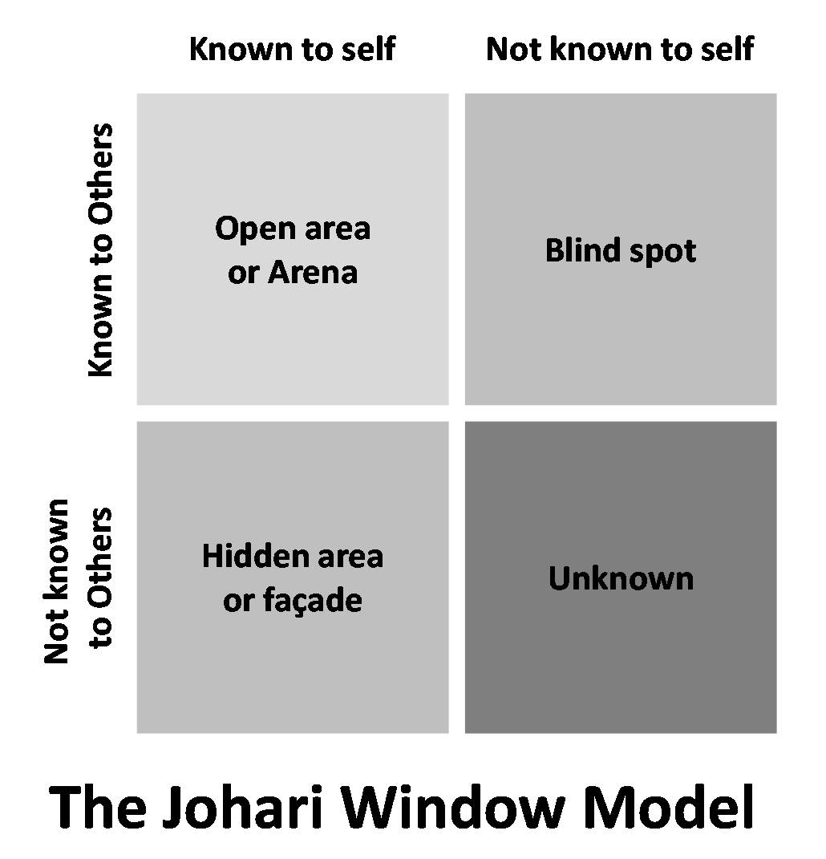https://www.communicationtheory.org/wp-content/uploads/2013/01/johari-model.jpg
Open Area: this is the area that is known to myself and other people around me as it is based on good and effective communication skills. It enables me to express my feelings, thougts and ideas. Through this area I’m able to deal with conflicts, misunderstanding and gain peoples trust.
Blind Area: this is the area known to other people but not myself. In other words this could be my area of weakness and makes me vulnerable as somone else may notice something about a behavuour that I have but I’m obliviant to it for example I may have the tendency of talking over people during a debate or discussion. Its either people will bring it to my by attention by telling me or they also may not say anuthing at all. Due to this I may come across as beeing uncooperative or rude.
Hidden area: this is the area that is known only by myself and not to others as it may be private, confidentail or intimate. I may choose not to disclose any personal information or it may not be relevant to work such as what I was doing over the weekend or my marital status.
Unknown area: This is the area that is neither know to myself or other people around me. This is most common when exposed to a new environment where I don’t know people and people don’t know me.
It is very vital to expand the Open Area within the work place or when working with people as it enables people to establish a trsutworthy working relationship. Through expanding the Open area with other areas such as the Hidden Area or Unknwown I can seek advice and consructive feedback from my team memebrs for example no one may know that I lack the confidence of speaking in front of people however, during the group presenation I may come out of my shell and do briliantly and better then anticipated. My team memebrs could provide me with feedback encouarging me to boost my self confidence as I did well.

Expectations of the World of Employment
In this section of my Portfolio I will briefly review my understanding of what is expected from me as an Employee in order to increase my employability chances based on the skills and qualifications that I have. According to the UK Higher Education Academy (2009), from the first day of employment I will be expected to be “honest, trustworthy, work safely, reliable, punctual, demonstrate good communication skills, teamworking skills, pay attention to details, be kind and patient towards others, articulate ideas verbally and in writing” and so forth. I will be obliged to put into practice policies and procedures outlined on the Job description and Person specification. There are laws put into place by the government whereby employers have to abide to such as the Equality Act 2010 and Rehabilitation of Offenders Act 1974. According to the Equality Act 2010 they would have to employ me regardless of my Disability, Gender reassignment, Age, Marriage and Civil partnership, Pregnancy and Maternity, Race & Ethnicity, Religion or Belief, Sex and Sexual orientation. They are also not allowed to unlawfully discriminate me in their arrangements, advertisements, interviews and in their selection criteria. I also have obligations such as making sure that I meet the criteria out lined in the Job descriptions and person specification. This means that I must have the essentials skills, qualifications and experiences required. As mentioned previously in the beginning, I’m currently working part time as well as studying plus I look after my children. Therefore, one of the many skills that I hold is prioritising and time management. I’m able to work under pressure and meet deadlines. As a mother and as a Diner lady I implement safe working environment and I’m a team player by listening to others and respect everyone’s views and opinions as they also matter.

Career Ambitions and Aspirations
My main objective within the next five years is to become a well-established and known Wedding Planner/Event Planner within as well as outside my community. Therefore, I have taken the initiative to go back into Education and gain the necessary qualifications to enable me to do so. In order to financially help myself start up I’m working part time and save money towards it. I have been self-employed previously which has given me the desire to go into Entrepreneurship and learn more about Business. Currently I have given myself long term and short-term goals.
Long term Goal:
- become a well-established Wedding Planner, ( in 5 years)
- expand my cliental outside of my community. In order to achieve this, accepts clients not just within my community (within next 2-5 years)
- Gain more experience and knowledge.
- Gain qualifications necessary. . (within next 2- 5 years)
- Continue working part time and save money towards the main goal (within 2- 5 years)

Short term goal:
- Prioritise all bills and make sure debts free. (within next six months)
- Create social media pages such as Facebook, Instagram, website to upload past events pictures and videos. . (within next six months)
- Create logo and print T-shirts with logo . (within next six months)
- Order Business Cards. (within next two months)
- Attend networking events . (within next six months) .
- Open Business Account with Bank . (within next six months)
- Advertise my service provision . (within next six months)

Conclusion:
Overall looking back at this Portfolio reflection, I have learned more about myself in terms of my strengths, weakness, limitations and expectations. A lot of planning, preparation as well as time and effort is needed in order to see the results of the final aim or goal. This reflection has helped me to identify what type of learner I’m and the different methods available to me in order to identify this. For future references I will be able to come back and look at it in terms of reviewing and improving myself further in the near future. I have a better understanding in regards to what is expected from me as an employee and what I can expect from any employer and be reassured that they have policies and procedures in place as required by law. From now on when I wish to apply for a job I have a better understanding of the purposes of job descriptions and Person specifications in relation to the specific job advertised. A reflective portfolio is not only needed for educational purposes but also for employment purposes as it outlines, professional and personal developments with time frames enabling an individual like myself to keep track and focus on accomplishing my target. There is always a link of how I can transfer skills that I already have gained through life experiences into the work place as a professional such as prioritizing and managing a small group of people in terms of leadership skills.

Reference list
Pritchard,A.,(2014) Ways of Learning. Learning theories and learning styles in the class room 3rd Edition. United Kingdom. Routledge (Page 1)

Mind Tool website https://www.mindtools.com/pages/article/newLDR_57.htm (last accessed 20/08/2018).
Teach.com website https://teach.com/what/teachers-know/learning-styles/ (last accessed 20/08/2018
Communication Theories website https://www.communicationtheory.org/wp-content/uploads/2013/01/johari-model.jpg (last accessed 31/08/18).
Self-Awareness website http://www.selfawareness.org.uk/news/understanding-the-johari-window-model (last accessed 20/08/2018)
Oxford Dictionaries.com https://en.oxforddictionaries.com/definition/us/SWOT_analysis (Last accessed 20/08/2018)
REED website https://www.reed.co.uk/career-advice/personal-development-planning-what-you-need-to-know/ (last accessed 23/08/2018
Legislation.gov.uk website https://www.legislation.gov.uk/ukpga/2010/15/contents (last accessed 31/08/18)
Legislation.gov.uk website https://www.legislation.gov.uk/ukpga/1974/53
(last accessed 31/08/18)
Higher Education Academy website https://www.heacademy.ac.uk/system/files/a_marked_improvement.pdf (last accessed 31/08/18)

