A Project portfolio – Assessment Information
Student name: | Simona Gabriela Ichim | Submission deadline: | 28/04/ 2026- 14:00 (2PM)
Programme: | BA (Hons) Leadership and Management Skills in the Workplace | Student ID number and email: | 2323378  2323378@student.uwtsd.ac.uk
Module: | Project Management | Contribution to Overall Module Assessment (%): | 100%
Module code: | LCLM5003 | Internal Verifier: | Md Kalam Samuel Ofori
Module Leaders: | Rexon Nting Doreen Nyaa Amundam | Word count or equivalent. | Part A (Poster): Equivalent  of 500 words  Part B (Reflection on  Feedback): 500 words  (10%+/-)  Part C (project management  plan): 2500 words (10%+/-)
Assignment Title: | A Project portfolio. | Return date for provisional marks and written feedback: | 28/05/2026

Contents
A Project portfolio – Assessment Information 1
Part A: Poster on the Severe Flood Warnings and Rebuilding the infrastructure: 3
Here is the poster as a picture as well: 4
Feedback from teachers and peers: 5
Plan for Project Management and development of the Main Transport Corridor which has issues caused by the flooding in the West Midlands 7
References on the sources: 13

Part A: Poster on the Severe Flood Warnings and Rebuilding the infrastructure:

Reopening the highway:
Steps Undertaken: Here are the steps that there should be undertaken to prevent for the damage to the area caused by the severe floodings:
one would be the closures of the road in a safely manner which it involves the investigators of the motorways and highways and companies of maintenance and upkeep to shut the roads down and to investigate the bridge and test them and these tests should be executed using special systems such as the laser one to verify for Lee kings and problems with stability and find alternative routes which should be established by the local authority.
Another step which should be undertaken is the cleaning of the streets which means absorbing or the water to be absorbed or any other impurities or later caused by the floodings Toby extracted with special machines and ultimately to carry out Rd sweeping and spraying with water and to clear up the spare debris.
Also the underground channels should be cleaned to maintain the upkeeping of the water flow in the drains and ventilations and also to prevent similar incidents happening when it is in case of floodings.
Three phases must be conducted amongst which the clear up phase also infrastructure phase and also involving the preventative phase.
Lasting resistance and compliance and making sure that everything runs smoothly to prevent other incidents which involves solutions involving a natural base and model 2 forecast near time errors of a catastrophic nature which are absolutely needed and must be conducted by the projects.
Always protection against the floodings which involves the worst affected zones such as Bewdley and Ironbridge, is the involving of the undertaking in terms of projects is in place door replace short time protections of the flood with Always protection against the flood high quality systems of defence such as the barriers and iron fences which are waterproof.
In a summary or an actual which the project plan is involved, the project involves the following:
agency of the environment which controls the levels of the rivers and lakes waterproof barriers and involving the financing the assets and what is necessary to plan the projects up
local councils which involve Shropshire and Worcestershire - which managed upkeep of the highways and motorways and closing up the roads in case it is necessary
also the river charities and corporations of utility is involved to join together in embedding the progress of conducting but preventive measures against natural flood and what is remained to repairs such as wires of electricity and various elements.

Here is the poster as a picture as well:
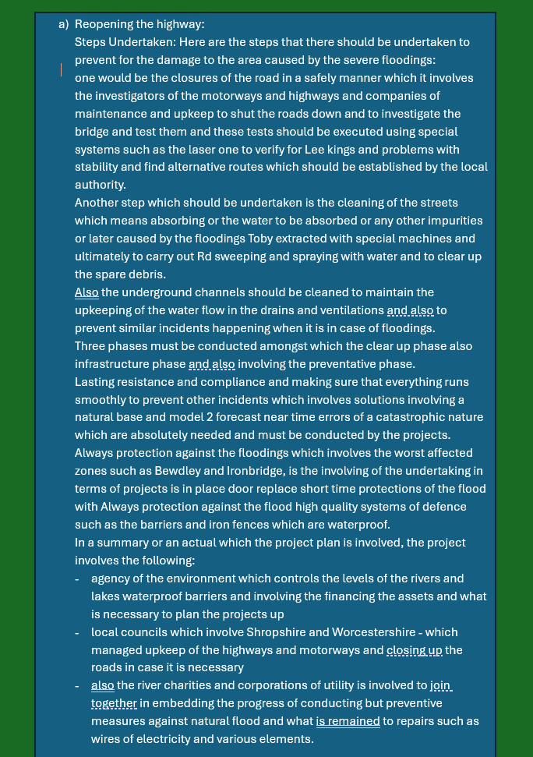

Feedback from teachers and peers:

After i got the teacher's feedback I need to remember the following:
This is what I was supposed to do. This is my scenario.
My job was basically to plan the project for one of these scenarios.
Now, I want to do point A, which has reopened the highway. But in terms of what I know everything that I need to have included in my poster. I haven't included any of that, so I was supposed to have included a gantt chart, flow chart, tables, images, etc. Um, the poster is quite short, remember what I've been doing all these weeks. So I haven't included in the project who is it going to benefit who is going to be reported to if any mistakes and I know if the local residents as they will benefit etc. Who's going to be doing what right? I need to include the project scope there.The scope of my project, so what is it exactly that I'm going to be doing?So I will need to present and give an overview, as the teacher said. A project could involve, me planning the project which is literally the project manager. I need to be now getting into the actual details of it, right? Yeah, so I didn't previously, but I will do my best to improve it in detail. I didn't mention the scope like how long will this reopen the highway? How long will it take and what to remember in regards to timings? It's an emergency in a project so it can't take too long. Some people have said 6 months. I think that's too long. Other people said about 12 weeks. I know and I think that's fair enough, but I didn't mention the time frame for the project, I know, the scope I've not included a gantt chart or anytime frames. In fact, I should know how long things will take? I am in a role of a stakeholder analysis which is needed to do that, who will be the stakeholders involved in a local council, the highways agency, the contractors, the local residents, the businesses, etc. So these are all my stakeholders. I needed to have included the A to Z work breakdown structure. What is the work that needs to be done in one of the different phases of each work. I know how many different phases is it split into, I did that about 3 weeks ago, I know, those sort of a slight that we did, I didn't include the RACI matrix, I know a lot of people didn't, but basically, who's responsible who's accountable, who is liable and I should know who I need to include, who I need to consult, right? I need to answer in full and finally include the risk analysis. What? When? How? Where? What are all the different risks that could happen to stop me from completing the project? I should know how I mitigate them, what's the likelihood of it happening? What would be the impact on my actual project itself, right? So this was my project plan. Unfortunately, I've just given myself an overview of it. I took the teacher's feedback which conveys that there's a lot that's missing and I should have included the necessary information. Okay. So I'm prepared to include a lot of so I've got a lot of catching up to do for my final outcome. I know the assignment specifications, trying to understand it, now in my reflection. So if I'm including this in my reflective feedback section that I've said I need to include, how come? How come I did it like this? Did I know what I was supposed to be doing? I know it is project management but I thought that was the plan proposal. So I was mainly thinking of the plan proposal. That's why I didn't and I know that it was what it was the it, a new activity version I have made and might be different than what I was supposed to do. And I had recognised to the teacher that I have tried and attempted again and did something to be done okay,I just sort of I know now, try to understand and, I will look through, look through this again. Now the teacher told me that the poster is finished and where I can start catching up in terms of some marks. It is right there, so remember, I'm going to do about 500 words. Also, for the final information in a project management plan. Before I actually do the actual project, I need to just do some, I know, reflect on the feedback that I received from the teacher. So this will be a good opportunity in my reflection section of my report.I know I didn't include all the things that I've said that I should have included. If I can just say I know that I should have included breakdown structure and then go through why I need to include the break breakdown structure I should have included, I know, risk analysis should have been included too. The reason that I need to include a risk analysis is because as the project manager this is my role to keep people safe within my project. Yeah, I know that I needed to include the risk analysis. Because as the project manager, it is my responsibility to ensure and the project is completed on time in budget in scope. And with the desired report quality I will improve, so I have to look at the project scope in order for me to achieve that. I have to identify and understand that all of the potential risks to put things the right way. I know what could happen? What could go wrong? What could be the impact on the project? What would be the likelihood of it happening? Is it far is it medium or low? Is it none? And then finally, what can I do? In case it does happen. What can I do to improve? So what would be if I don't help and the outcome of the decision of not helping and what actions can I take to make sure this is not going to have a bad impact on the project, right? So, for example, I know, if my contractors that I know and also the contract which is saying that I hire the contractors to help me, I know to complete the road. If there is another project where that is a long-term project that is going to be finished in 2 years. So my contractors may not want to stay, because mine is a short-term project. They want a long-term job. So if they all leave and go there, I need to be thinking. Well, where else can I get my workers? Is there another agency that I can contact? Yeah, so, a few things like that basically, what I've thinking of is what if that went wrong, okay? What can I do to stop the impact? If it's possible to do that? I need to put in my feedback on, although it's like 500 words or more. I think I will going to have a lot more. I'll write in my report, so I have everything that the teacher said essentially, what the teacher was saying there is included my feedback. Teacher was going to say, of having an open and honest feedback reflection, and say that I misunderstood, but I know now and then just everything that the teacher said, just go through it and explain in depth. Need more in detail stuff and to balance it out a little bit okay? Yes. in my final assignment I will do my best to include what is right. So the reason as well I haven't included is because I need to improve the things mentioned above.

Plan for Project Management and development of the Main Transport Corridor which has issues caused by the flooding in the West Midlands

The devastating flooding within the West Midlands area as per July 2025, has triggered severe bad consequences and potential damage to main transportation and movement Sites and infrastructure Most knowingly, the main corridor utilised For the moving of possessions and materials, including freight and also, passengers. Putting this corridor into place again is very crucial because of financial reasons including the restoring of the financial assets, the movement of the community and the passengers and local reliability. This plan of re-managing the project portrays and symbolizes a very important factor which is the rebuilding of the damaged public transport, the roots making sure everyone is safe and secure, everything is efficient, reliable and consistent and involves natural sustainability and effective working.

Description of the project involves the project itself called The highway reopening Project, and its main objective is to put back and make initial Restorations and next steps of improvement the main transportation and public corridor which has suffered by the flooding within the West Midlands and having the result as activation of safe and secure including eligible movements of freight and people in a period of 12 months.

The main project expertise is to tackle the flooding and damage which occur because of huge Atlantic weather which is a system with errors within the overall main involvement regarding the transportation route as it is very crucial and necessary in the absolute way for local connections and transportations.

It also has in its plan the verifying of the amount of damage the situation of the flooding has created and also looking at taking steps to analyze and build up draft repairs and at the actual ones afterwards and constructing up the corridor to prevent the floodings as it is complying with standards which boosts liability of the system which will prevent the Flood occurring again.
The outcomes which are to be shown at the following:
The completion of the rebuilding of the main character which suffered damage it is a must do in the checklist
Make reliable and better through Flood improvement campaigns and also improve flood security, which has its own characteristics which involves the embedding them into the building structure.
Minimise vulnerability and the risk And also the chances to have flood in the area devastating and catastrophical impact of it.
Rebuilding of local financial tasks and activities within the monetary sector.

The purpose and the scope of the project is that the testing and questionnaire are conducted at all times in terms of damaging and clearing of debris and other stones involving the damaged building system.
Also the rebuilding of surfaces of the streets and the drain and also the skeletons of the structures
The implementation and embedding of the flood prevention measures and tackling such as raised river sides waterproof pavements
During the building and process of it just manage the traffic using a two-way system separately for the cars to comply with
The employees must focus and the stakeholders must do the same regarding potential improvement of structures and verbal communication and also other types of communication are involved as well regarding the project improvements

Out-of-purpose elements are the following:

Fixing off irrelevant infrastructure for example elements outside the construction corridor and also involving long time flood security mini Project corridor reconstruction and beyond it as well up to date and improved systems which are not relevant to damage of the flood is essential to do so as well.

Here it is presented the work breakdown structure or the WBS:
This involves project management and also conducting of it sketching and planning ahead and forward thinking and involving the watching of the project and making analysis and reports regarding it on topics such as assessing testing and verifying the damage and negative impact on the project regarding the flood involving the questionnaire on the site and on the construction area and also involving crucial and critical tests and questionnaires regarding structural statistics and features. It also involves the people gathering altogether and doing a good job in a team and also setting up the site and putting it in place which involves destruction and the clearing up of the debris and deletion of the structures which have been damaged and having significant errors as well.
It has also involved the drainage and prevention of the floods to be fixed involving robust measures and disciplines involving putting in place new drains which are working and cleaned up and also river dams and also the Borders for the river which are designed especially to prevent the floodings and also involving the flood prevention special barriers.

Is a crucial way the implementation of verifying and checking of the building designs and sketches it is also called us infrastructure verification and prevention of the errors and involves the verification of the quality and its reliability which is due for inspection research and also ranking in terms of safety and security.

And turn eventually to setting up of the traffic And And the management of it and involving the Relevant parties using appropriate communication means Regarding the Signs and also the Ways of diverting the vehicles and also the Measures to put The stakeholders and the relevant department up to date

And also project finalizing and wrapping up it is very crucial as it is due for ultimate verifications and testing and also reports and documentation including paperwork and signing it and providing of the paperwork and act as a reliable employee and stakeholder.

A quad chart will involve the following:
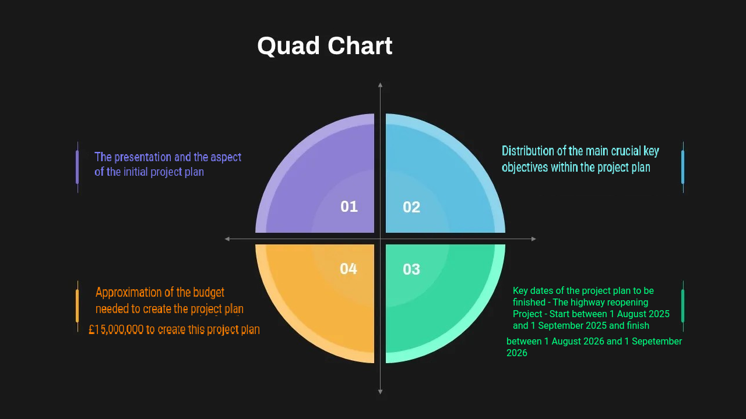
The portrayal and display including the aspect of the project which consists in one row involving its name the start and date the approximation of its budget and distribution of the key objectives and The Liability on the flood systems and the characteristics the measures of security and safety in the basic way and how the construction is finished and the cost which would be estimated around 15 million pounds and also some key dates of the project and also the name which is called The highway reopening Project. Additional details will be applied as well to this chart.

A gantt chart will include the following:
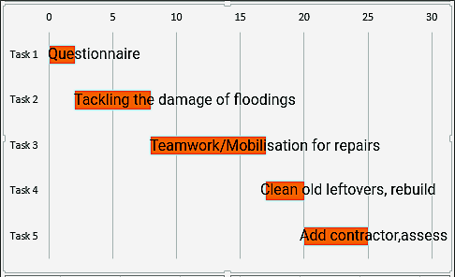
First of all is a section which has the timeline on it which is measured in months and also the tasks or the activities. As well it is includes a calendar which is portraying the range of the dates for example from August to September 2025 till August to September 2026 and activity which is conducted such as the questionnaire on the flood damage which has been created by the disaster or also the mobilisation of people which is to gather everybody to clean up everything left including the debris clearance and main and the beginning of rebuilding.
And the beginning of the next calendar months will be the principal rebuilding of the corridor and everything necessary which involves a lot of work and involving drain replacements and precautions regarding the flooding and by the middle of the Year verify the infrastructure and building skeleton and also the verification of the quality and The Liability and the latest research would be the employee sign in and sign out and involving as well the finalizing of the project.

The involvement and help acquired by the stakeholders and other employees within the construction for the project

Authorities which involve governments authorization and other local government people which may authorize the project and also the reliability and making sure that the project is ready to go and acceptance as well is also necessary within this involvement section involving the financing and be compliant and rules and regulations and involving annual meetings or even more frequent to start with and also the employees to have their involvement into reporting and doing step by step overviews and outlining the project limitation and allowance of certain possibilities within the area of constructions and involving as well verifications and consultations.

There are also things involved such as the services of urgency and prevention of avoiding of those kinds of services within construction and while it is the activity lasting to build up certain parts of the project which may need emergency or urgency assistance or help.

At the moment emergency is only needed only if it's a strict or urgent issue or it is to do with emergency services.

Meetings involving the Leadership and also the Making of the foundation of the building and also the Locals within the town and Logo shops and businesses involving External and internal communication And Speaking about it And also Feedback and support and involving limited management of the traffic control involving the updates for public information and also questionnaires.

Verifiers and the contractors are involved which have their job to verify and check the basic security measures and also on site procedures and involving the suppliers as well to supply and provide whatever necessary for the sides and materials as well to build and also carefully and easily to regulate the process including the meetings and also the employee calls and also it's necessary to have agency which deals with environmental issues and tests and volume prevention of errors and also working in a team especially engineering work planning and singing ahead running of the project and execution of the basic construction needs and also verification of the quality and reliability if possible meetings week by week and also reports and paperwork on the process or the progress of the project. The level of the project must be portrayed as well to show compliance with construction regulation.

Resources for the project:

The resources of the project may involve the kind of Resource and material involving the information and details and involving also notes of materials and including cost and how many should be in their HR department is involved with resources regarding human expertise and management of the project which involve assessing and testing and engineering work teams of construction and building and environmental assessment and natural disaster questionnaires and involving also professionals which assist on the project building basis and very regularly for example having 150 staff and for billion pound finally and annually.

The materials and kind of resources involved are the underground pipes which act as a drain conductors or water conductors and also flood prevention bars and dams and involving overflowing prevention with all faces necessary and all levels involving all monetary resources and allowance of the necessary amount of money for example 15 or 16 million pounds per year or per annum and also the computing technology or online this is including software and GPS mapping including putting the project on Google Maps and also adding GPS devices and Towers which may involve 200 million pound

Risk analysis within the project

The testing and discovery of risks is moderate in this project and is also having challenging parts such as the likelihood of the things happening, the impact on the project or its stakeholders minor major medium and also the planning ahead of how to prevent the events appearing again.
The building of the flooding prevention wall which involves the medium risk for example
The construction of the seasons of the storm and the temporary Pipes of drains and conductors involves high risk due to high water pressure
Postpone materials and the delay of getting them and the construction needs it is a medium to high risk as it involves the suppliers to be on time and also to not have the necessary material on the Builder when it is necessary.
May not have the necessary materials in stock then order new materials from different suppliers and warehouses where they made find them available and in stock as well and involves contractor verification and this also involves the delaying and the postponing of the contractor to come on time and also involves timing keeping issues and also other incidents my involve on the way because the contractors and other necessary people may be rushing and make things go fast.
In terms of environment and also the negative impact may be that the making of the materials in emergency time may involve a factory which may pollute the air and also the environmental surroundings which can be a nature hazard and these factories must adhere to regulations so you as a contractor may need to obey the rules by ordering the materials from another factory which is compliant with your company regulation so it can finish the project on time which involves a very high risk and also planning ahead of the costing in terms of financial and funding reasons and also can disrupt the Communities of enhance which can lead to the project to be criticized and also to be opposed by the people which live locally because they disrupt their activity while building the project and also it is a high risk as it is very polluting for the community and also fast communication and in advance planning is strictly required as the project will go smoothly and very easily and so check with the community is also a strict necessity.

Conclusion
The rebuilding of the main transport corridor within the area of West Midlands in England it is a crucial part of local recovery from the floods which occurred in here 2025 as this plan supplies understandable framework and analysis to guide and aids the successful and lock it delivery and distribution of the main project focusing on security reliability quality accessibility employee or stakeholder inclusivity and involvement within the task and resilience and promptness. Via effective and reliable and forward thinking and planning ahead allowance of resource in early stages and administration of risks the key Project has a goal to revive vital and crucial connections and it is done in a very efficient and professional manner via boosting the infrastructures basic needs and size to provide a better understanding of prevention and forecasting upcoming flooding and catastrophical events of such nature as therefore it is portrayed and actively advancing and backing up the long time rivalry and accessibility of the financial upkeeping of the West Midlands area.

References on the sources:

Bannister, J.M. 1991, Building construction inspection: A guide for architects, John Wiley & Sons.

Buckley, R. 2004, "Environmental impacts of motorized off-highway vehicles.", .

Douglas, J. 2010, Building surveys and reports, John Wiley & Sons.

Douglas, J. & Ransom, B. 2013, Understanding building failures, Routledge.

Gössling, S., Neger, C., Steiger, R. & Bell, R. 2023, "Weather, climate change, and transport: a review", Natural Hazards, vol. 118, no. 2, pp. 1341–1360.

Koetse, M.J. & Rietveld, P. 2009, "The impact of climate change and weather on transport: An overview of empirical findings", Transportation Research Part D: Transport and Environment, vol. 14, no. 3, pp. 205–221.

Lawton, J.S. 2007a, The urban environment: twenty-sixth report, The Stationery Office.

Lawton, J.S. 2007b, The urban environment: twenty-sixth report, The Stationery Office.

Markolf, S.A., Hoehne, C., Fraser, A., Chester, M.V. & Underwood, B.S. 2019, "Transportation resilience to climate change and extreme weather events–Beyond risk and robustness", Transport Policy, vol. 74, pp. 174–186.

O'Flaherty, C. 1997, Transport planning and traffic engineering, Elsevier.

Okiye, S.E. 2021, "Model for advancing quality control practices in concrete and soil testing for infrastructure projects: Ensuring structural integrity", IRE Journals, vol. 4, no. 9, pp. 295.

Price, C.A. & Doehne, E. 2011, "Stone conservation: an overview of current research", .

Richardson, B. 2002, Defects and deterioration in buildings: A practical guide to the science and technology of material failure, Routledge.

Vajda, A., Tuomenvirta, H., Juga, I., Nurmi, P., Jokinen, P. & Rauhala, J. 2014, "Severe weather affecting European transport systems: the identification, classification and frequencies of events", Natural Hazards, vol. 72, no. 1, pp. 169–188.

Warke, P.A., Curran, J.M., Turkington, A.V. & Smith, B.J. 2003, "Condition assessment for building stone conservation: a staging system approach", Building and Environment, vol. 38, no. 9-10, pp. 1113–1123.

Watt, D.S. 2025, Building pathology: Principles and practice, John Wiley & Sons.

