Steven Shears
2204133
Design Crafts
ADAD4018 Ways of Thinking

Manifesto

To master time creates beautiful work.
To utilise a great degree of patience is the link between a man and a craftsman.
Do not cut corners by any means. Do not let technology completely replace the skills of your hands.
Man has only got to open his eyes to the works of yesteryear and compare them to those of the present to understand that no modern technique can replace the traditions of the past.
Decoration is art, use it in everything you do, though not necessarily in abundance.
Become the missing link between the crafters of the past and the present age of lifelessness.
Be true to yourself and your own ways no matter how dated they may initially appear.
Be the craftsman in among the craft-less men.

I would describe myself as a modern day Victorian. By this I mean many things but that are by no means negative. Inspired through my whole life by the architectural, the decorative and the hand drawn.
I marvel at anything produced in the past. To me it is all art that few have been able to reproduce in recent decades. “Here were local men working at the highest level of their craft who ought to be respected”. (The lost houses of Wales, Lloyd).
I have always harboured a great deal of patience as patience is crucial in mastering any craft and producing anything worthwhile. All that inspires me is from a past age, a slower age where the masters took a great amount of time to ensure what they achieved is the best of their ability. “It took a man all day to make one stone” (The definite biography of Fred Dibnah, Hall).
One of my views is that regardless if it is a building, a painting or anything else for that matter is that simplicity is child’s work. For it takes great skill that not everyone owns to produce something that can be described as beautiful. For not many people would gaze up at a modernist building In comparison to a Victorian building and call that beautiful. For example my most favoured building (fig.1) is heavily adorned in decoration and as a result is a wonder of human skill and no one would doubt that.
Also another view I have is that whatever be produced, it should be something pleasing to the eye. Forget vast blank walls, forget functionality at once. Personally I don’t see why anyone would produce anything that doesn’t look good. There is no craftsmanship within functionality. For example a notable mistake in functional design, lacking in any soul or decoration is a building I have known well. (fig.2) This concrete monolith is the perfect example to everyone of why it’s so important to input detail into everything, despite what Adolf Loos proclaimed in his text Ornament is Crime (1913).
We live in the age where anything should be possible, with so much technology to assist us, but we design such dull and dead things. To me that does not make sense. Functionality should not overrule design. Personally I believe we should go back to the age of design and adorn everything we produce in detail, pattern, colour and life.
In conclusion my beliefs are that everything should be beautiful, richly adorned, beautifully made and a wonder to admire and study.
Because of this I set out to craft the best I possibly could achieve and I throw myself into whatever I do, in what excites me. I am not daunted by what is on paper In front of me for I know that given enough time, anything can be achieved. For I aim to be seen as a craftsman and nothing but that and with this I believe it will enable me to flourish.
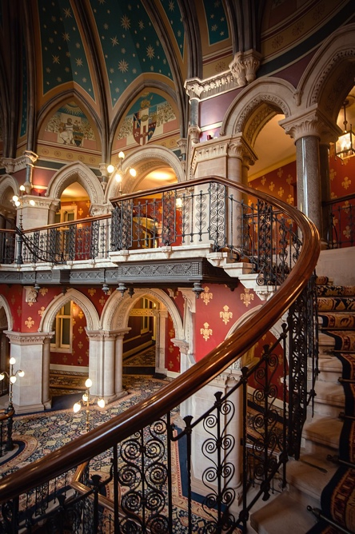
(Fig.1) top floor of the grand staircase at the St Pancras Renaissance Hotel, Wikipedia, 2021.

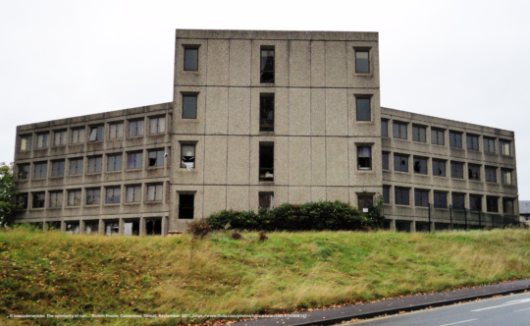
(Fig.2) bazzadarambler, The symmetry of ruin… Tricorn House, Cainscross, Stroud, September 2011, flickr.com/photos/bazzadarambler/6180806143

Reference list/ Bibliography

Bazzadarambler, The symmetry of ruin… Tricorn House, Cainscross, Stroud, September 2011, flickr.com/photos/bazzadarambler/6180806143
Hall David Fred: the definite biography of Fred Dibnah, London, Corgi, 2007.
Lloyd Thomas The lost houses of Wales, A survey of country houses in Wales demolished since c. 1900, London, SAVE Britain’s Heritage, 1986.
Loos Adolf Ornament and Crime London, Penguin Books Ltd, 2019.
Picture, top floor of the grand staircase at the St Pancras Renaissance Hotel, Wikipedia, 2021.

Steven Shears
2204133
Design Crafts
ADAD2018 Ways of Thinking.

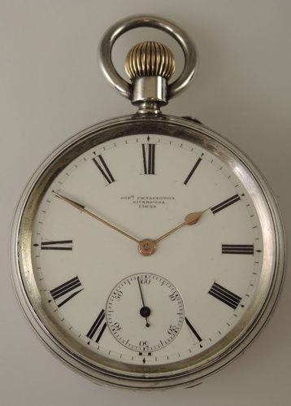

Item Analysis
Pocket watch & Companion

The pocket watch has to be one of the principal items of craftsmanship that epitomises the essence of beauty and workmanship. “They delighted at their precision and skill”. (Coleman, 2018.) This emphasises clearly how the craftsmen made sure that everything they created was to the best of their ability. Furthermore the achievements of the craftsmen inspires me in everything that I set out to create regarding precision and skill.
To begin with, the watch becomes a lifelong friend that travels everywhere with its owner. “Otto couldn’t wait to lift the pocket watch out of his pocket and show it to his friends”. (McHaney, 2015). This backs up the original point suggesting that the timepiece’s of immense importance to its owner that everywhere you go with it, you need to show it off to others. Because of this the watch clearly possesses great value to it’s owner, something of great personal importance, something that can be seen as a companion.
Another aspect that is linked with companion is that the watch possesses clear human-like features. It has it’s own face and hands, it comes alive when you wind it and dies with neglect in regards to forgetting to wind it up again. Its inner workings, like a human heart, are what powers it and keeps it ticking, as if it itself were breathing. In addition great care has to be ensured in maintaining the watch, just like a human has to look after their own health. Because of all these features, there’s a clear sense of why people become so attached to their watches. At this point they are more human than material.
Love for the watch is always evident and in many ways, the watch becomes more important than it’s owner. For example if danger came it’s way then the owner would in many circumstances think of the watches safety before their very own. Just as a mother would save her child before herself, the watch is a now a companion with huge importance, greater than a humans life.
As the watch epitomises the work of the past, where things were built better than today, I feel a need to preserve an essence of this in my work. One way is by incorporating parts of lost works into my creations. “ The twentieth century witnessed the deliberate destruction of more than 1500 large country houses, many of which are now recognised to have been of considerable architectural significance”, (Long, 2021). Linked to the pocket watch in terms of craftsmanship and beauty, the country house gets incorporate into my works. This further strengthens my ideas that everything made in the past needs to be preserved, as they are far superior than what’s made today.
Linking back to the watch, this equally should be preserved. It’s a thing of beauty. A product that contains a soul to warm to and a product that inspires. In fact it’s not even a mere product, for now it’s become a companion. A companion for life.

Reference list/ Bibliography

Coleman Terry, The Railway Navvies, Head of Zeus, 2018
Long David, Lost Britain, An A-Z of forgotten landmarks and lost traditions, Michael O’Mara Books Limited, 2017
McHaney Robert, The Journey of a Pocket Watch, Branden Books, 2016

Steven Shears
2204133
Design Crafts
ADAD4018 Ways of Thinking

Advertisement Analysis

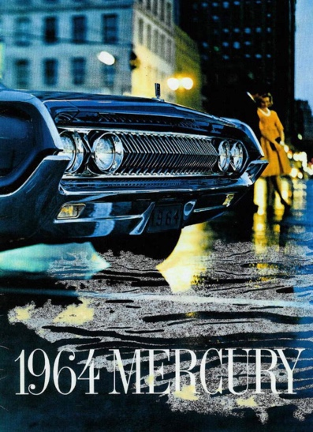

The advertisement, encompassing the Mercury automobile contains a lot more than meets the eye. Through the inclusion of subliminal messages, it packs in a lot more information than just the car itself.
To begin with the colour that’s the most dominant is blue. “Blue calls to mind feelings of calmness and serenity” (Colour and Meaning, Gage). This portrayal of calmness is key to the advertisements goals to showing the masses that driving it is a calming occasion. Also the feeling of calm portrayed can signify what life with the car can be like. No worrying about how to get anywhere as your life will be made easier with it. Altogether the usage of blue clearly tells the viewer a lot about what their life can be like with owning the vehicle.
The presence of the main contrasting colour plays a dominant part of the overall scene. This is yellow worn by the woman in the background. Although pushed into the background her role is of importance. “Its enthusiasm, and enlightenment and yellow is – in practical terms the opposite of dark and dull”. (The symbolism of Color, Conroy). This suggests the man would harbour a great degree of enthusiasm. Not only to get the car but to get the woman also whom he would be trying to impress by using the car to get her to become his girl. Yellow would get the viewer enthusiastic about owning the vehicle also.
Also, yellow’s used to grab attention. Not only the viewers towards the car, but to grab the attention to what’s an otherwise dark scene. The woman wearing this colour also is to lure the cars dominant clientele, young men, to want to obtain the car. She is key for this as women have been used to advertise various things for many decades.
Regarding women of the 1960s, the way the man’s looming over her suggests that he needs to look after her. Women were still seen as second rate citizens compared to men. “Women are nothing but mere machines for producing children “(Napoleon Bonaparte, Cutting Remarks, Leach). Although this statement’s from before the advertisement, these views men have had towards women have stayed the same over the years, and women’s role within society was not great during the 1960s. Linking back to the advertisement, it’s clearly the man dominating the woman, not the other way round. This shows that the man’s in charge and that he would purchase the car as women were not allowed to do so nor allowed to drive.
By the inclusion of both sexes, the advertisement showcases the car to both appropriately. The man wants the car for himself, plus to gain popularity with women, whereas women want their men to obtain the car for themselves to enjoy.
To conclude, the advertisement is very much of its time plus the way it’s advertised towards both sexes respectively. What’s clear is that it’s a very clever add that would greatly succeed in selling the car to the public.

Reference list/Bibliography

Conroy Ellen, The symbolism of Color, Newcastle pub. 1996.
Gage John , Color and meaning: art, science and symbolism, Thames & Hudson, 2013.
Leach Maria, Cutting Remarks: a miscellany of quotations from life and literature, Michael O’Mara, 2003.

