Globally Responsible Business

BMSP6001

Assignment 1 – Essay




Hannah Kilburn

1805552

Tutor – Alex Bell

“Business social responsibility should not be coerced; it is a voluntary decision that the entrepreneurial leadership of every company must make on its own.’
John Mackey, Whole Foods Market CEO

Executive summary
During this assignment, the key elements that will be highlighted include what business social responsibility is and some definitions to back this up, the different forms of responsibility that businesses have to consider such as sustainable business and carbon zero and the main debate on whether corporate social responsibility should be voluntary for different businesses and any global issues that they could be contributing to.
Introduction
In this assignment there will be highlighted and focused elements on what corporate social responsibility is and whether is should be voluntary to organisations or forced upon them to help them become a more ethical and balanced business by doing what seems right in this society. To begin with it is important to understand the meaning of CSR and what impacts it may have on an organisation, CSR can be described as “a self-regulating business model that helps a company be socially accountable—to itself, its stakeholders, and the public. To engage in CSR means that, in the ordinary course of business, a company is operating in ways that enhance society and the environment, instead of contributing negatively to them.” (Fernando, 2020) Corporate social responsibility is understood through the balance of economic, environmental and social imperatives and making sure that it keeps the shareholders and stakeholders happy and involved in any decisions. (Unido, 2020)
Businesses that look to enforce CSR are trying to improve the surrounding environment; globally, nationally and locally and to help the communities that they provide to and attempt to improve the economy. Companies are being held responsible for the social change and it is now important for businesses to be ethical and help improve a large global issue such as climate change and different forms of pollution. (Schooley, 2020)

Normative ethics
There are two forms of normative ethics that are highlighted when understanding the rights and wrongs in business. There is teleological which comes from the Greek term meaning goal or aim and deontological which comes from the Greek term meaning duty. Teleological focusses on the consequences of a decision where deontological focusses on the actual decision itself and to focus on what seems right to us. (Labossiere, 2018) There is a whole system of different norms and values that businesses should understand and attempt to improve or apply in their product or service and their production. There are different variants of business ethics that must be considered such as ethics in leadership, employees and the customers. The management of a company will decide exactly how the company will run from one day to the next and be in full control of how employees are treated and trained and how customers will view the product or service being sold, any decision this management ream makes will influence on different global scale issues. Employees will follow any instruction given to them and work on any rules and regulations that they have been shown. Having the correct business ethics and attempting to help the community and environment will lead to greater benefits to become a sustainable business.
Utilitarianism is a teleological ethic idea which Jeremy Bentham and John Stuart Mill discovered in the 18th and 19th century where the idea was to promote any actions that created happiness and good for everyone affected by the action, this acts upon the consequences of an action and to ensure the greatest of happiness. There is an issue with this form of ethical idea as it can be criticised that the elimination of suffering should take over the promotion of increasing the happiness of already happy people. (Duignan, 2020)
There are many global issues that could affect our future such as climate change, pollution, poverty and health inequalities. The future generations act is in place to try and combat any issues and try to create sustainable ideas for the future generations to interact and improve over time. (Welsh-Government, 2020)

What is social responsibility?
- “Social responsibility has become increasingly important to investors and consumers who seek investments that are not just profitable but also contribute to the welfare of society and the environment.” (Anderson, 2020)
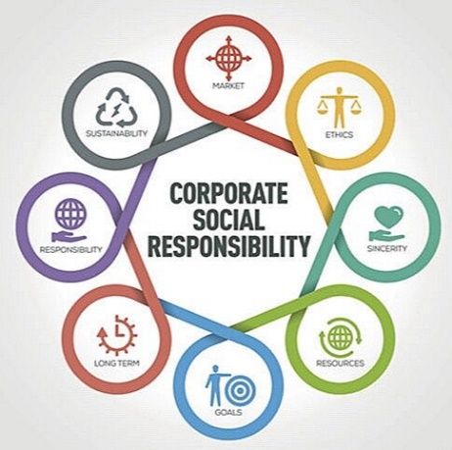

For Voluntary CSR reporting
Voluntary CSR includes a company choosing to take on their own social responsibility and create norms for the company that they believe is correct and works best for them as they are optional and activities. Businesses that choose to promote their corporate social responsibility are looking into the benefits of good deeds, encouraging their staff and promoting customer satisfaction in their product or service. It has been found that 55% of consumers are prepared to pay for a service or product if they are from a socially responsible business which promotes the idea that if companies choose to take part in CSR voluntarily then they may have the upper advantage of selling more of what they are providing.
There are some key benefits to CSR including –
- Increased customer satisfaction
- Improved public image
- Increased customer loyalty
- Increased creativity
It is said that CSR is great for a company and interacting will increase productivity and could potentially lead to improved sales which is every companies target. (Russell, 2018)
It is advised that companies include CSR to help their business and should take advantage of becoming a sustainable and ethical company that is responsible for creating a great environment for workers, customer satisfaction and to help the global and local community to help combat and reduce any global issues that cause major issues for businesses. The top countries that have taken on CSR include Denmark, Indonesia and the USA as they have taken the lead in passing law requirements and disclosing climate change issues. (Bureau, 2012)
Is it mandatory that large companies must give an insight on how they are taking care and looking after their environment, social concerns and the diversity that they are providing to their customers and employees, management is also another area that is highlighted and any sort of financial agreements must be declared as a mandatory purpose, although the main factors of corporate social responsibly is not yet been made mandatory. (Youmatter, 2020)
There are some key advantages to voluntary CSR, some of these include –
- Supply chain management – every companies supply chain should obey consistent ethical standards which lead to clear objectives leading to different beneficial factors for the management team, customers and employees.
- Maintaining relationships with business partners – if a company doesn’t stick to maintaining the correct values and human rights it can lead to disagreements with important suppliers and businesses partners that are key to providing a profit for the company.
- Safeguarding brand equity and reputation – any negative issues such as news stories on a company can have a detrimental effect of the reputation of a company and lead to long term negative effects. Ensuring that the company has a good reputation is important, although it can easily be shattered in less than a day, the voluntary CSR codes, norms, values, morals and principles can help build the equity and reputation of a company.
- Producing efficiency – when a company has clear-cut and secure guidelines the CSR codes encourage the suppliers and workers to produce the products and services in the most efficient way as possible. (Adhikari, 2014)

Mandatory Corporate Social Responsibility
In some respects it is seen that CSR should be made mandatory and every business should interact in all the aspects of social responsibility and share any key information with their shareholders and their stakeholders to keep the efficiency of the making of the products and services to its best standards.
In some countries such as China and India, they corporate social responsibility is taken as a progressive approach and is very important to consider for every company, and it can be seen as a legal requirement and they should all interact with the CSR codes, norms and morals. (Lin, 2019)
Companies of every size are always encouraged to produce reports on their production of products or services, the different ethical factors they are undertaking and whether they are following specific rules and regulations that they should be complying with. It is not yet been made mandatory for all companies in all countries to encourage CSR although in some countries is it looked down on if they aren’t contributing. In the UK, it has been mandated for large organisations to create a report on their greenhouse gas emissions and diversity and human rights under a 2006 companies act. 90% of businesses come under the SME sector and it is not mandatory for them to give any certain ethical and sustainable reports so that leaves only 10% of large companies applying their reports into the GRI Sustainability Disclosure Database. (Havrysh, 2020)
There is a disadvantage to making CSR mandatory as businesses will take on this approach which could lead to the managers having a reactive approach rather than a proactive approach which will lead to managers not following the correct practices in their business and only follow what they believe in right, rather than what is morally and ethically correct. (Justo, 2019)
Businesses cannot voluntarily get rid of all the immoral issues and global problems that everyone faces which impacts on business but if they start using CSR as a mandatory approach it can highlight companies that are impacting on the negative issues and they can be dealt with immediately rather than causing conflict between other companies who are following moral rules and regulations. Businesses could be responsible for reducing pollution, global climate change and implementing positive business ethics for a better working future for generations to come, this is why it is seen for businesses to have CSR in place as a mandatory affect to promote the benefits rather than impact the negatives, business system change is around 80% of the sustainability solution that so many companies want to change. Businesses should be allowed to run however they want to, although if they do not create specific reports on how they are affecting the global issues this could lead to many issues in the future, hence why some people believe CSR should be mandatory. (Dixon, 2019)
Having CSR as a mandatory effect could benefit the shareholders of a company for the long-term as it is based on the sustainability that it wants to promote, in some countries they have applied this mandatory approach for a minimum of 6 years once a business starts up to ensure they are providing the correct information and reports that aren’t impacting the world negatively. Those that apply mandatory CSR can be seen as a good model to other companies that want to create a positive social change in their community and social environment. (Juniarti, 2020)

Discussion
John Mackey believed that businesses should not have CSR as a mandatory implementation but one that is voluntary, and reports are made by the business if they choose to. CSR does not always have a positive impact on a business, although the correct morals are there to have a better social responsibility for the managers, workers and customers it shouldn’t be forced upon any company. the local government are committed to promoting corporate social responsibility to support the planet, their employees, their customers and their local communities as they want to ensure that they follow ethical and sustainable business practices which leads to more beneficial factors than negative ones. The government have created more voluntary work for people to help out with charity work and to support local small businesses to create a sustainable future. (Companies-House, 2018)
It can be argued that CSR is a good thing and does help with trying to lead sustainable ideas to businesses and create a better social environment and a better global environment in terms of minimising issues such as climate change and health inequalities that businesses can face. It should be important for large businesses to report their environmental impact as they could be harming the environment more than helping it and this should be analysed on a regular basis as it could lead to a more sustainable future for the next generation to take on.
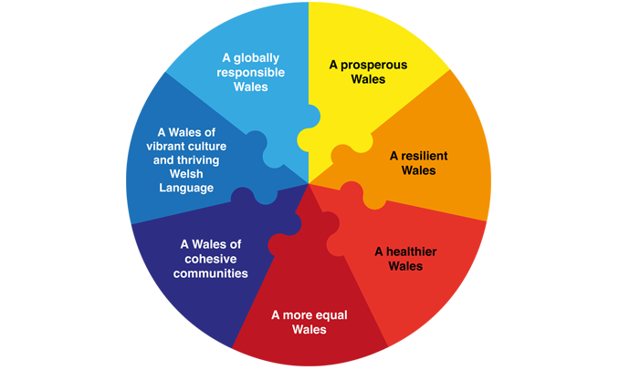
The future generations act is in place to improve social, cultural, environmental and economic well-being which is a great way to focus a businesses on what is expected of them. The act consists of 7 main goals that they want to achieve and work towards to become a better and more environmentally friendly company. (Futuregenerations, 2015)

Conclusion
Overall, the discussion of CSR is that there are more benefits of making it voluntary rather than forcing it on any business as it may not benefit them, especially if they are smaller businesses that are just starting up. Having a CSR report can be helpful to analyse the environmental impacts and to find new sustainable ideas that a business can follow in the future to help. Businesses are not just looking to make the biggest profit, but they want to ensure they produce the best quality products or services in the most efficient way with the right morals and ethical values which will impact on their employees and their customers satisfaction. Being a sustainable business seems to be a great advantage as that means people are helping and understanding the future generations act which is in place in Wales. CSR doesn’t need to be forced onto any company or business as it will not benefit everyone in the same way, making it mandatory could cause more issues than good points so it should be the companies choice on what they provide and what certain rules and regulations they should follow to look good to their suppliers, customers, managers and employees.

References
Adhikari, A. (2014). Retrieved from file:///C:/Users/HP/Downloads/RS103_Arjun%20Adhikari%20(1).pdf
Anderson, S. (2020, December 22). Retrieved from www.investopedia.com: https://www.investopedia.com/terms/s/socialresponsibility.asp
Bureau. (2012, Septmeber 1). Retrieved from www.economicstimes.com: https://economictimes.indiatimes.com/opinion/et-commentary/why-it-is-a-good-idea-to-mandate-corporate-social-responsibility/articleshow/16101647.cms?from=mdr
Companies-House. (2018, August 20). Retrieved from www.gov.uk: https://www.gov.uk/government/news/our-commitment-to-corporate-social-responsibility-csr
Dixon, F. (2019, May 16). Retrieved from www.corporate-sustainability.org: https://corporate-sustainability.org/voluntary-versus-mandatory-corporate-responsibility/
Duignan, B. (2020, November 20). Retrieved from www.britannica.com: https://www.britannica.com/topic/utilitarianism-philosophy
Fernando, J. (2020, November 17). Retrieved from www.investopedia.com: https://www.investopedia.com/terms/c/corp-social-responsibility.asp
Futuregenerations. (2015). Retrieved from www.futuregenerations.wales: https://www.futuregenerations.wales/about-us/future-generations-act/
Havrysh, N. (2020, April 30). Retrieved from www.medium.com: https://medium.com/age-of-awareness/mandatory-sustainability-reporting-what-countries-have-it-and-should-other-join-1eacf05f267c#:~:text=In%20the%20United%20Kingdom%2C%20quoted,and%20Director%27s%20Report)%20Regulations%202013.
Juniarti. (2020, July 24). Retrieved from www.emerald.com: https://www.emerald.com/insight/content/doi/10.1108/SRJ-03-2019-0114/full/html#:~:text=Mandatory%20CSR%20not%20only%20stimulates,risk%20of%20unexpected%20future%20costs.
Justo, A. (2019, May). Retrieved from file:///C:/Users/HP/Downloads/ShouldCSRbemandatoryvoluntaryorboth.pdf
Labossiere, M. (2018, May 14). Retrieved from www.creativitypost.com: https://www.creativitypost.com/article/infinity_war_deontology_vs._teleology-1
Lin, L.-W. (2019, May 27). Retrieved from www.law.ox.ac.uk: https://www.law.ox.ac.uk/business-law-blog/blog/2019/05/mandatory-corporate-social-responsibility-legislative-innovation-and
Russell, K. (2018, June 6). Retrieved from www.fronetics.com: https://www.fronetics.com/csr-four-benefits-corporate-social-responsibility/
Schooley, S. (2020, June 26). Retrieved from www.businessnewsdaily.com: https://www.businessnewsdaily.com/4679-corporate-social-responsibility.html
Unido. (2020, December). Retrieved from www.unido.org: https://www.unido.org/our-focus/advancing-economic-competitiveness/competitive-trade-capacities-and-corporate-responsibility/corporate-social-responsibility-market-integration/what-csr
Welsh-Government. (2020, December). Retrieved from www.Wales.com: https://www.wales.com/lifestyle/government/doing-today-what-world-will-do-tomorrow
Youmatter. (2020, June 3). Retrieved from www.youmatter.world: https://youmatter.world/en/definition/definitions-csr-report-important-examples/

