Eco Bike Hub database report

Abstract
By analyzing the requirements of Eco Bike Hubs, SQL server is used to design the database to support its business requirements; The database includes tables Branch, Staff, BicycleOwner, Bicycle, RentalPrice, Customer, RentalBooking, OwnerUseRental, TradePrice, TradeBooking, OwnerUseTrade, RepairPrice and RepairBooking, and adds primary key constraints, foreign key constraints and check constraints to ensure the effectiveness of the database; Firstly, SQL and NoSQL are compared. By analyzing their characteristics, SQL is more appropriate for this case; Secondly, it explains how to solve the problem with index and transaction; Finally, a distributed database solution is proposed.

Contents
Abstract 1
1. Difference between SQL and NoSQL 3
1.1 SQL 3
1.2 NoSQL 3
2. Index 4
3. Transaction 4
4. Distributed Database Solution 5
Reference 7

1. Difference between SQL and NoSQL
SQL database is mainly called relational database (RDBMS) - mainly represented by SQL server, MySQL, Oracle and PostgreSQL.
NoSQL database is mainly called non relational database or distributed database - mainly represented by CouchDB, mongodb and redis.

1.1 SQL
(1) SQL database is characterized by:
-Data relational model is based on relational model, structured storage and integrity constraints.
- SQL adopts the set operation mode. Not only the search result can be the set of tuples, but also the object of one-time insertion, deletion and update operation can also be the set of tuples.
-Use structured query language (SQL) to read and write data.
-Operations require data consistency, transactions and even strong consistency.
(2) Advantages:
- In SQL, if the data of multiple tables needs to be updated in the same batch, that is, if one table fails to update, the other tables cannot be updated successfully. This scenario can be controlled through transactions. Transactions can be submitted uniformly after all commands are completed to maintain data consistency.
-You can use the join table link method to query the data in multiple relational data tables with a simple query statement.
-Generalization and mature technology.
(3) Disadvantages:
-Data reading and writing must be parsed by SQL. There is a large amount of data, which is high, and the reading and writing performance is insufficient.
-Locking is required when reading and writing data or modifying data structures, which affects concurrent operations.
-Unable to adapt to unstructured storage.
-Expansion is difficult.
-Expensive and complex.

1.2 NoSQL
(1) NoSQL database features:
-Unstructured storage.
-Based on multidimensional relational model.
-It has unique usage scenarios.
(2) Advantages:
-High concurrency and strong reading and writing ability under big data.
-It basically supports distributed, easy to expand and scalable.
-Simple, weakly structured storage.
(3) Disadvantages:
-The ability of complex operations such as join is weak.
-Transaction support is weak.
-Poor versatility.
-Complex business scenarios without integrity constraints are poorly supported.
In the requirements of Eco Bike Hubs for database, structured query is often required, and the scale and growth rate of its data are predictable. It is also necessary to ensure the transaction and consistency requirements of data, so it is more appropriate to select SQL database.

2. Index
The following is the indexing statement.
CREATE INDEX idx_Staff_Salary ON Staff(Salary);
CREATE INDEX idx_RentalBooking_BDT ON RentalBooking(BookingDateTime);
CREATE INDEX idx_RepairBooking_BDT ON RepairBooking(BookingDateTime);
CREATE INDEX idx_TradeBooking_BDT ON TradeBooking(BookingDateTime);
The RentalBooking, RepairBooking and TradeBooking tables store the customer's rental, repair and trade bookings. In daily life, there is often a query on the booking of a day. Therefore, the index is established according to BookingDateTime in these three tables.

3. Transaction
3.1 Sometimes bicycle repair bookings are recorded but the details of the specific return date(s) as requested by customers are not registered in the system.
Since the table rentalbooking contains both fields rentalbookingno and returndate, the above situation will not occur in this database.
3.2 Customers are able to book bicycle hire times that are not registered as possible schedules available.
Start the transaction. First execute the judgment statement to judge whether the bicycle status is rentable. If it is rentable, insert data in the table rentalbooking, and finally submit the transaction.

4. Distributed Database Solution
(1) Staff
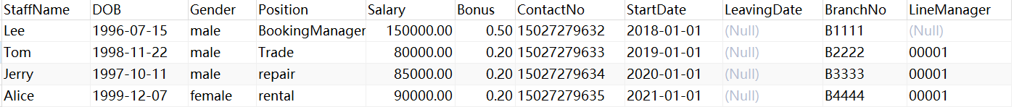
vertical fragmentation. The Staff table is divided into personal information and work information. Personal information includes columns StaffName, DOB, Gender, ContactNo, and work information includes columns Position, Salary, Bonus, StartDate, LeavingDate, BranchNo, LineManage.

(2) BicycleOwner
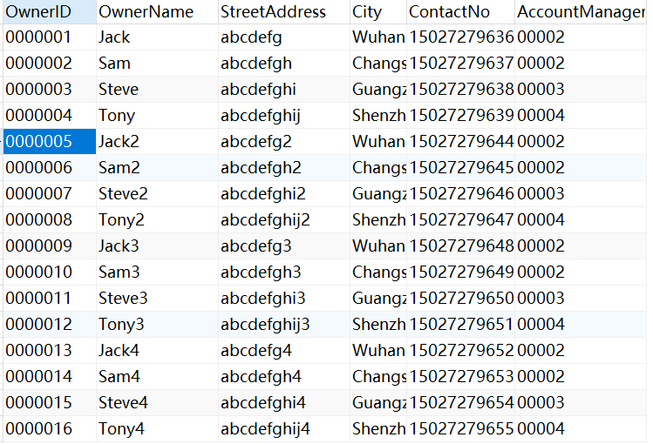
horizontal fragmentation. Cut the table BicycleOwner horizontally according to its account manager. For example, the account manager of 0000003,0000007,0000011,0000015 is 00002, forming a horizontal fragment.
(3) Bicycle
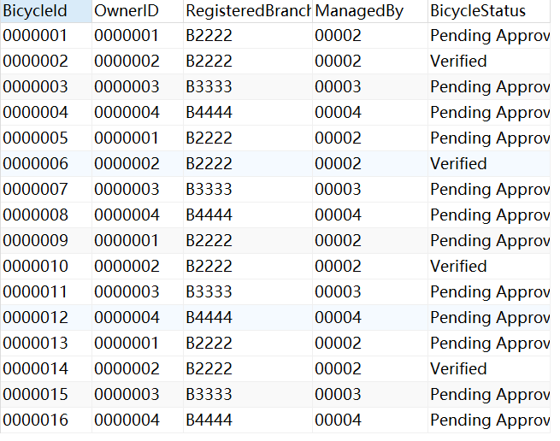
horizontal fragmentation. Cut the table Bicycle horizontally according to the BicycleStatus column.

(4) TradePrice
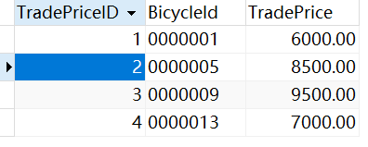
horizontal fragmentation. Cut the table TradePrice horizontally according to the price range. For example, a horizontal fragment is formed when the trade price does not exceed 7000.

Reference
[1]杨春. 在线车辆租赁信息管理系统设计与实现[D].大连理工大学,2018.DOI:10.26991/d.cnki.gdllu.2018.000008.
[2]赵鲁瑜,康埕铭,廖朦朦,陈国庆.基于共享汽车租赁市场的管理系统设计与实现[J].内蒙古科技与经济,2021(22):86-87
[3]雷健. 基于分布式架构的智能车辆管理系统设计与实现[D].浙江大学,2015..

