
Name : Harsh Dineshbhai Solanki
Student ID - 2432128
Programme : MSc in Public Health and Social Care in Practice
Module: Quality Assurance and Service Improvements
Module Code: LCHS7006
Lecturer: Arif Ahmed and Brian Mashumba

Improving Maternity Care Quality: Analysis of Shrewsbury and Telford NHS Trust Failures

Table of Contents

1. Introduction 5
1.1 Background to the Case Study 5
1.2 Problem Identification 5
1.3 Aim and Objectives of the Report 5
1.3.1 Aim 5
1.3.2 Objectives 5
1.4 Significance of the Study 5
2. Main Body 6
2.1 Comparative Analysis of the Quality Issue 6
2.2 Root Cause Analysis Using Theoretical Frameworks 6
2.2.1 Governance And Leadership 7
2.2.2 Staffing And Workforce Problems 8
2.2.3 Communication Failures 8
2.2.4 Organisational Culture 8
2.2.5 Most Critical Root Causes 9
2.3 Strategic Analysis of the Organisation 9
2.3.1 SWOT Analysis 9
2.3.2 Limitations of SWOT Analysis in Healthcare 10
2.4 Evaluation of Policy and System Failures 10
2.5 Critical Discussion of Quality Management Theories 10
3. Recommendation 14
3.1 Key Recommendations 14
3.1.1 Enhancing Staffing Levels and Consultant-Led Care 14
3.1.2 Establishing Strong Clinical Governance and Accountability Systems 15
3.1.3 Encouraging Open and Safe Organisational Culture 15
3.2 Implementation with Quality Improvement Tools 15
3.2.1 PDSA Cycle Application 15
3.2.2 Lean Methodology 16
3.2.3 Six Sigma Approach 17
3.3 Barriers to Implementation 18
3.4 Ways Obstacles Could Be Overcome 19
4. Conclusion 19
Reference list 21

List of Tables
Figure 1: Fishbone Diagram For Root Cause Analysis 7
Figure 2: Challenges Within The Healthcare Governance System 8
Figure 3: Five Whys Linking to Root Cause Analysis 12
Figure 4: Donabedian Model 13
Figure 5: PDSA Cycle 16
Figure 6: Lean Method In Healthcare 17
Figure 7: DMAIC framework 18

List of Figures
Table 1: SWOT Analysis 9
Table 2: Five Whys Analysis of Maternity Failures 11
Table 3: Donabedian Model Analysis of Care Failures 13
Table 4: Comparative Evaluation of Quality Theories 14
Table 5: Barriers to Implementation 18
Table 6: Strategies to Overcome Barriers 19

1. Introduction

1.1 Background to the Case Study
Healthcare organisations have a role in assuring that their services are safe, effective and patient-centred with accountability and transparency in clinical practice (Fukami, 2024). Nevertheless, governance, leadership, and organisational culture failure may result in serious patient harm and deteriorate the quality of healthcare provision in general (Patrician et al., 2022). One of the significant issues associated with malfunctioning in healthcare involves the scandal associated with the maternity ward at Shrewsbury Telford Hospital NHS trust (BBC, 2022). There have been more than 200 neonatal and maternal deaths which were preventable in the hospital due to critical gaps in the delivery of health care services and governance within the clinical setting.

1.2 Problem Identification
The maternity services were independently reviewed, and over 200 deaths of babies were identified, as well as many cases of brain injuries, which might have been avoided with proper medical care (BBC, 2022). Based on a thorough analysis conducted over 1,600 cases, it was found that clinical practice, communication, and organisational leadership failures were contributors to the poor patient outcomes (BBC, 2022). These results revealed severe gaps in the quality management systems in the organisation.

1.3 Aim and Objectives of the Report

1.3.1 Aim
The aim of the report is to evaluate different aspects that lead to failure throughout high-quality health care services and further recommend strategies of improvement based on evidence in enhancing governance and patient safety.

1.3.2 Objectives
- To find root causes with systematic analytical frameworks and tools.
- To examine the theories of quality management in the context of improvement of healthcare services.
- To assess policy and systemic failures in the healthcare quality outcomes.
- To give evidence-based and quality-based improvement recommendations.

1.4 Significance of the Study
The quality of healthcare can be improved by identifying the root causes and creating organised approaches to organisational change. Fishbone Diagram, the Five Whys technique, and the Donabedian Model are relevant and comprehensive frameworks that are applied popularly within the management of healthcare quality. These frameworks are further considered in assisting organisations in the health care sector to understand the interrelationship between different processes within healthcare, outcomes of patient health and organisational structure.
Besides root cause analysis, healthcare organisations need to conduct strategic analysis to determine internal strengths and weaknesses and external challenges. This report is a critical analysis of the maternity care failures in Shrewsbury and Telford Hospital NHS Trust. The report identifies the root causes of these failures in the light of well-known quality management models such as the Fishbone Diagram, Five Whys method, and the Donabedian Model. Another aspect of this work is that there should be more effective leadership within healthcare organisations. It assists in enhancing patient safety by using effective communication, effective teamwork as well as effective monitoring systems.

2. Main Body

2.1 Comparative Analysis of the Quality Issue
The maternity service breakdowns in Shrewsbury and Telford Hospital NHS Trust illustrate how organisational issues on a systemic level may result in serious healthcare outcomes (Ockenden, 2022). The enquiry found that the malfunctions were not due to single clinical errors but rather structural and cultural problems that had deep rooted in the organisation. These problems involved poor leadership, governance structures, a shortage of staff, and a lack of effective communication among the healthcare staff. In comparison, there are also challenges in the health care system of the NHS Foundation Trust located in the middle of Staffordshire. In this aspect, the organisation has been going through comprehensive failures within its governance and also involves a lack of proper culture within its organisation (Martin et al., 2023). However, the fact that the priorities in the case were given to normal childbirth, despite the existing clinical complications that demanded urgent medical care, was one of the most alarming in the case (Sood, 2019). This practice highly enhances the chances of foetal distress and brain injuries in infants. The delay in the use of caesarean section in various cases led to poor patient outcomes.
Another major cause of the deterioration of maternity care was communication failures. The exchanges between midwives and obstetricians, as well as other healthcare experts, are critical in the maternity services, especially during labour and delivery (Beier et al., 2025). Nevertheless, research found that there was generally poor information sharing amongst professionals, resulting in ineffective decision-making and a lack of coordination in clinical care.

2.2 Root Cause Analysis Using Theoretical Frameworks
A fishbone diagram is a popular method of analysis that assists organisations in establishing the root causes of complex issues (Kumah et al., 2024). This tool has been used in the healthcare field to classify the contributing factors into large areas, including leadership, staffing, processes, and organisational culture [Refer to Figure 1]. When the Fishbone analysis is applied to the maternity failures, a number of important factors contributing to the failures are identified at the Shrewsbury Telford Hospital NHS trust.
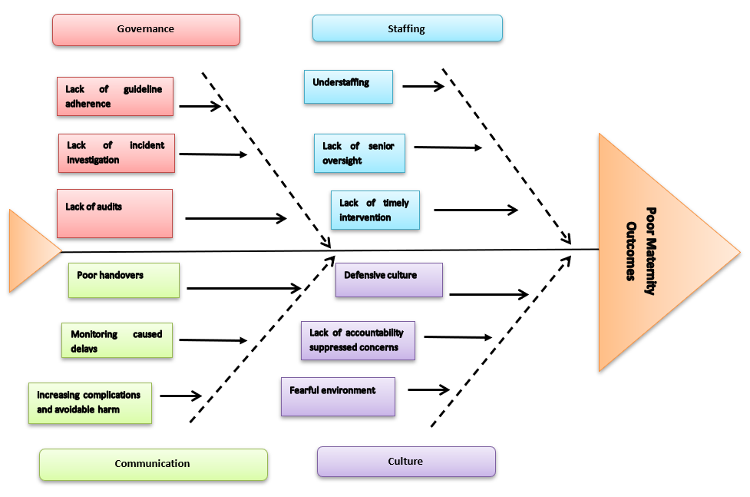

Figure 1: Fishbone Diagram For Root Cause Analysis

2.2.1 Governance And Leadership
Poor governance systems are a major cause of failure of maternity services (Onchonga et al., 2021) [Refer to Figure 2]. Shrewsbury and Telford Hospital NHS Trust lacked leadership that would develop efficient monitoring mechanisms that could detect any safety risks and clinical issues. Unsafe practices could be left without action unless there was strong leadership to check on the practices.
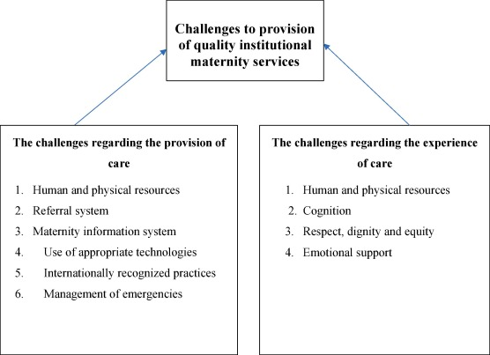

Figure 2: Challenges Within The Healthcare Governance System
(Source: Onchonga et al., 2021)

2.2.2 Staffing And Workforce Problems
A maternity unit experiencing staffing shortages poses a lot of operational pressures (Heise et al., 2025). Staff members who were overworked at the Shrewsbury Telford Hospital NHS trust had to cope with high workloads, and this diminished their performance in terms of offering safe and responsive care. Moreover, poor training opportunities constrained the staff's ability to handle obstetric emergencies.

2.2.3 Communication Failures
Another significant contributory factor was poor communication among the healthcare professionals at the Shrewsbury Telford Hospital NHS trust (BBC, 2022). The lack of effective communication did not allow for timely clinical decision-making and predetermined the appearance of mistakes in the course of labour and delivery.

2.2.4 Organisational Culture
An organisational culture that defended itself inhibited employees from reporting safety issues. The Trust had an organisational culture that deterred the reporting of safety concerns (Ockenden, 2022). Learning and early intervention in unsafe practices were not possible due to a defensive culture.

2.2.5 Most Critical Root Causes
Based on the above analysis it became evident that systemic governance failures and poor leadership were the most severe root causes that enabled unsafe clinical practices and poor oversight to take root over time. Moreover, there was a toxic organisational culture that prevented staff members from speaking up and caused delays in interventions and undermined patient safety.

2.3 Strategic Analysis of the Organisation

2.3.1 SWOT Analysis
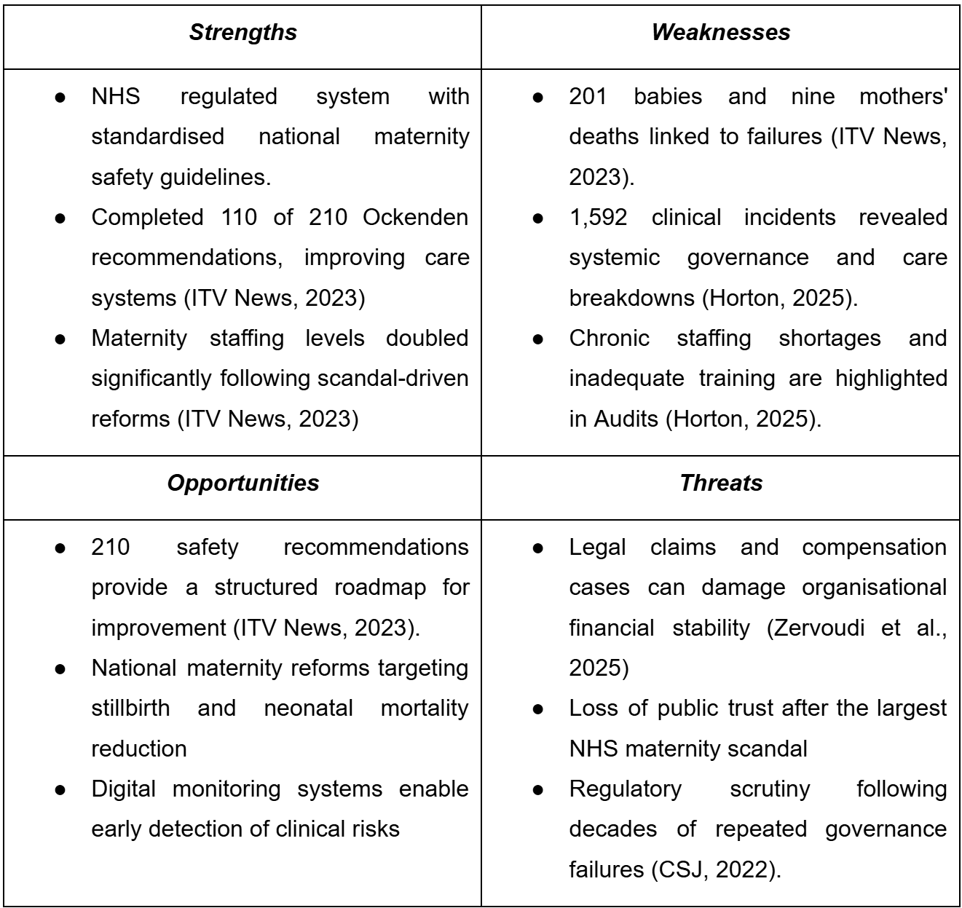

Table 1: SWOT Analysis
(Source: Author)
As per the strength of Shrewsbury NHS trust, it is a part of a healthcare system that is highly regulated. The organisation is further considered in providing an adequate access towards guidelines that are highly standardised and also have been implementing training frameworks adhering to programs of national safety (Shrewsbury, 2025). On the contrary, there is a lack of safety in the organisational culture of Shrewsbury NHS trust, and death of 201 babies and 9 mothers, which is further fostered by a lack of appropriate leadership. This also involves a lack of comprehensive monitoring, which further limited the organisation’s ability to analyse the risk has related to health care safety by effectively responding to it.

2.3.2 Limitations of SWOT Analysis in Healthcare
SWOT analysis in the health care sector can simplify complicated organisational problems, and there is no prioritisation of the identified factors. As per Webster et al. (2022), it is also overly dependent on subjective judgment, and thus can be biased and unable to effectively tackle dynamic healthcare settings and broader patient safety problems.

2.4 Evaluation of Policy and System Failures
The failures in maternity care also provide deeper insights into the flaws in applying the national policy frameworks within a healthcare organisation (Timothy et al., 2025). A key concern is connected with the uneven application of the Saving Babies Lives Care Bundle; a national initiative aimed at decreasing the incidence of stillbirth and enhancing the results of maternity safety (Andrews et al., 2024). Poor compliance with such guidelines constrained the success of national safety strategies on the local level. On the other hand, due to a lack of monitoring of the regulatory practices, there has been a failure within the organisational system (Gov.UK, 2022). The Care Quality Commission requires safety standards to ensure a safe working environment for healthcare providers (WHO, 2026). These problems underscore the problems that come up when national healthcare policies are not translated into local practice successfully.
The Gap between National Policy and Local Implementation
In spite of the fact that there are national policies and guidelines on the safety of maternity in the National Health Service, there is still an inconsistent implementation at the local hospital level (Geary et al., 2024). The lack of resources, leadership, and workforce may complicate the successful implementation of national standards, leaving a gap between the policy intentions and the real clinical practice.
Role of Regulatory Bodies
The Care Quality Commission is the body that oversees the healthcare quality and safety in England by way of inspections and performance ratings (CQC, 2019). Nevertheless, there are criticisms that regulatory interventions can be too late and are only introduced after failures have been noticed, which indicates weaknesses in early identification, measures of accountability, and ongoing monitoring of maternity services.

2.5 Critical Discussion of Quality Management Theories
The Five Whys Technique is a structured problem-solving approach to establishing the root causes of failures in organisations by posing questions of why a problem happened repeatedly (Safari and Das, 2022) [Refer to Figure 3]. With maternity services, the symptom that was presented was the existence of avoidable neonatal fatalities. Preliminary research revealed that complications that occurred during labour were not being recognised and dealt with in time.
Inquiry further showed that the healthcare professionals tended to focus more on natural childbirth methods when clinical risk factors showed that medical intervention was necessary (Lothian, 2022).On the contrary, the staff worked in a setting where particular methods of childbirth were greatly promoted, and that restricted the desire of clinicians to raise the issues or embrace alternative interventions. An organisation that involves a highly restrictive culture and pressures from the hierarchies reduces the courage among the healthcare providers in adaptation of any clinical interventions that are alternative or controversial (Wei and Mahadi, 2025). Simultaneously, the last phase of the analysis thus found leadership and governance failures to be the main root cause.
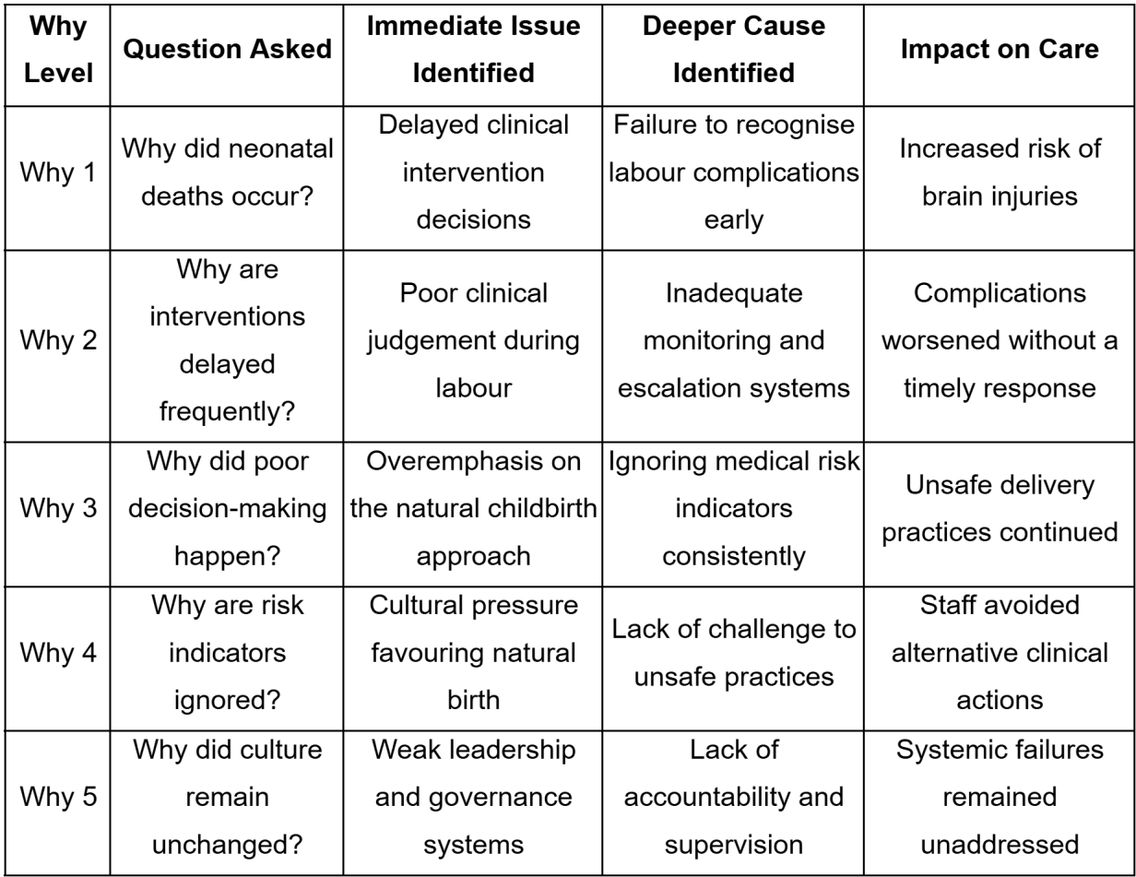

Table 2: Five Whys Analysis of Maternity Failures
(Source: Author)
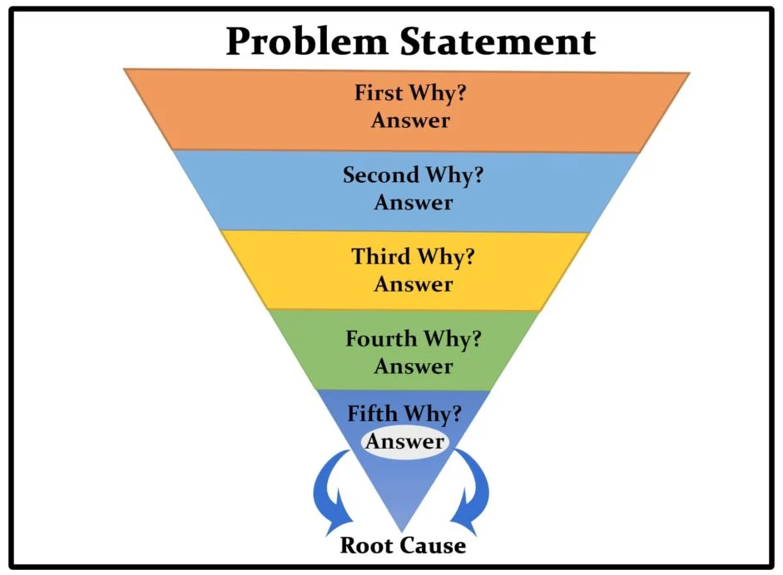

Figure 3: Five Whys Linking to Root Cause Analysis
(Source: Usmani, 2022)
One of the most well-known models that assess the quality of healthcare is the Donabedian Model, which analyses three interconnected elements: the structure, the process and the outcomes (Yang et al., 2025) [Refer to Figure 4]. Some of the structural weaknesses that were present in the case were poor staffing in the maternity services, poor professional training and development opportunities and poor managerial supervision. Process dimension has to do with the delivery of healthcare services and how clinical practices are being done (Donabedian, 2005). The outcome dimension is one that indicates the impact of structural and process weaknesses on patient health and organisational performance (McCullough et al., 2022). The failures in this case had drastic and avoidable consequences, such as preventable deaths in newborns, cases of brain damage in newborn babies and a serious loss in the confidence of the population in maternity care.
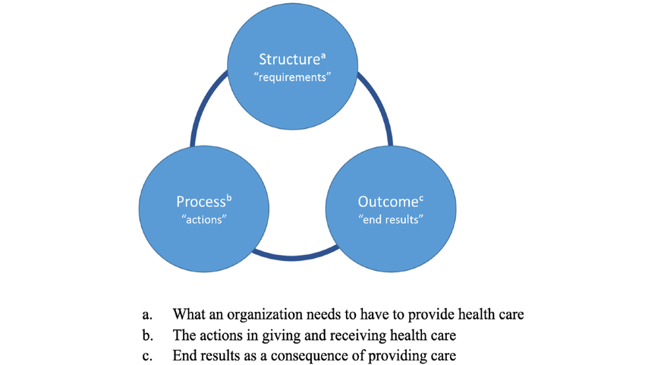

Figure 4: Donabedian Model
(Yang et al., 2025)
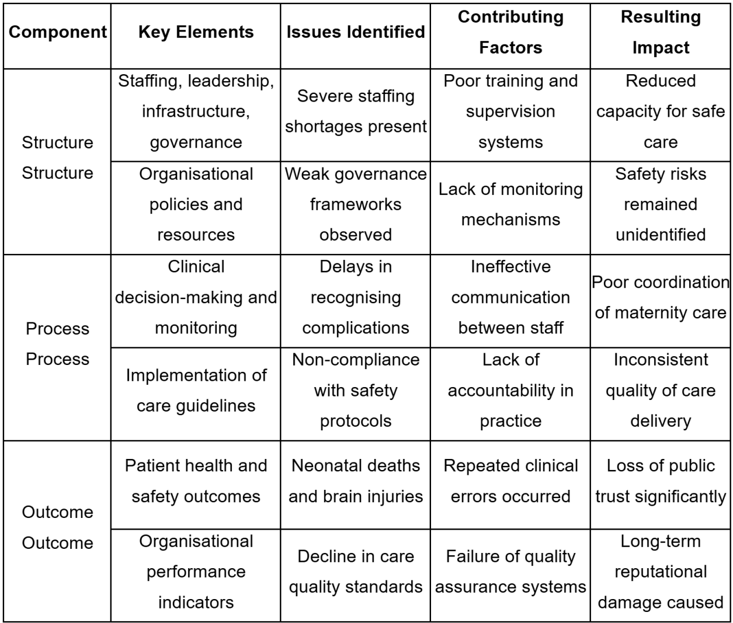

Table 3: Donabedian Model Analysis of Care Failures
(Source: Author)
Comparative Evaluation of Quality Management Theories in Maternity Care Failures
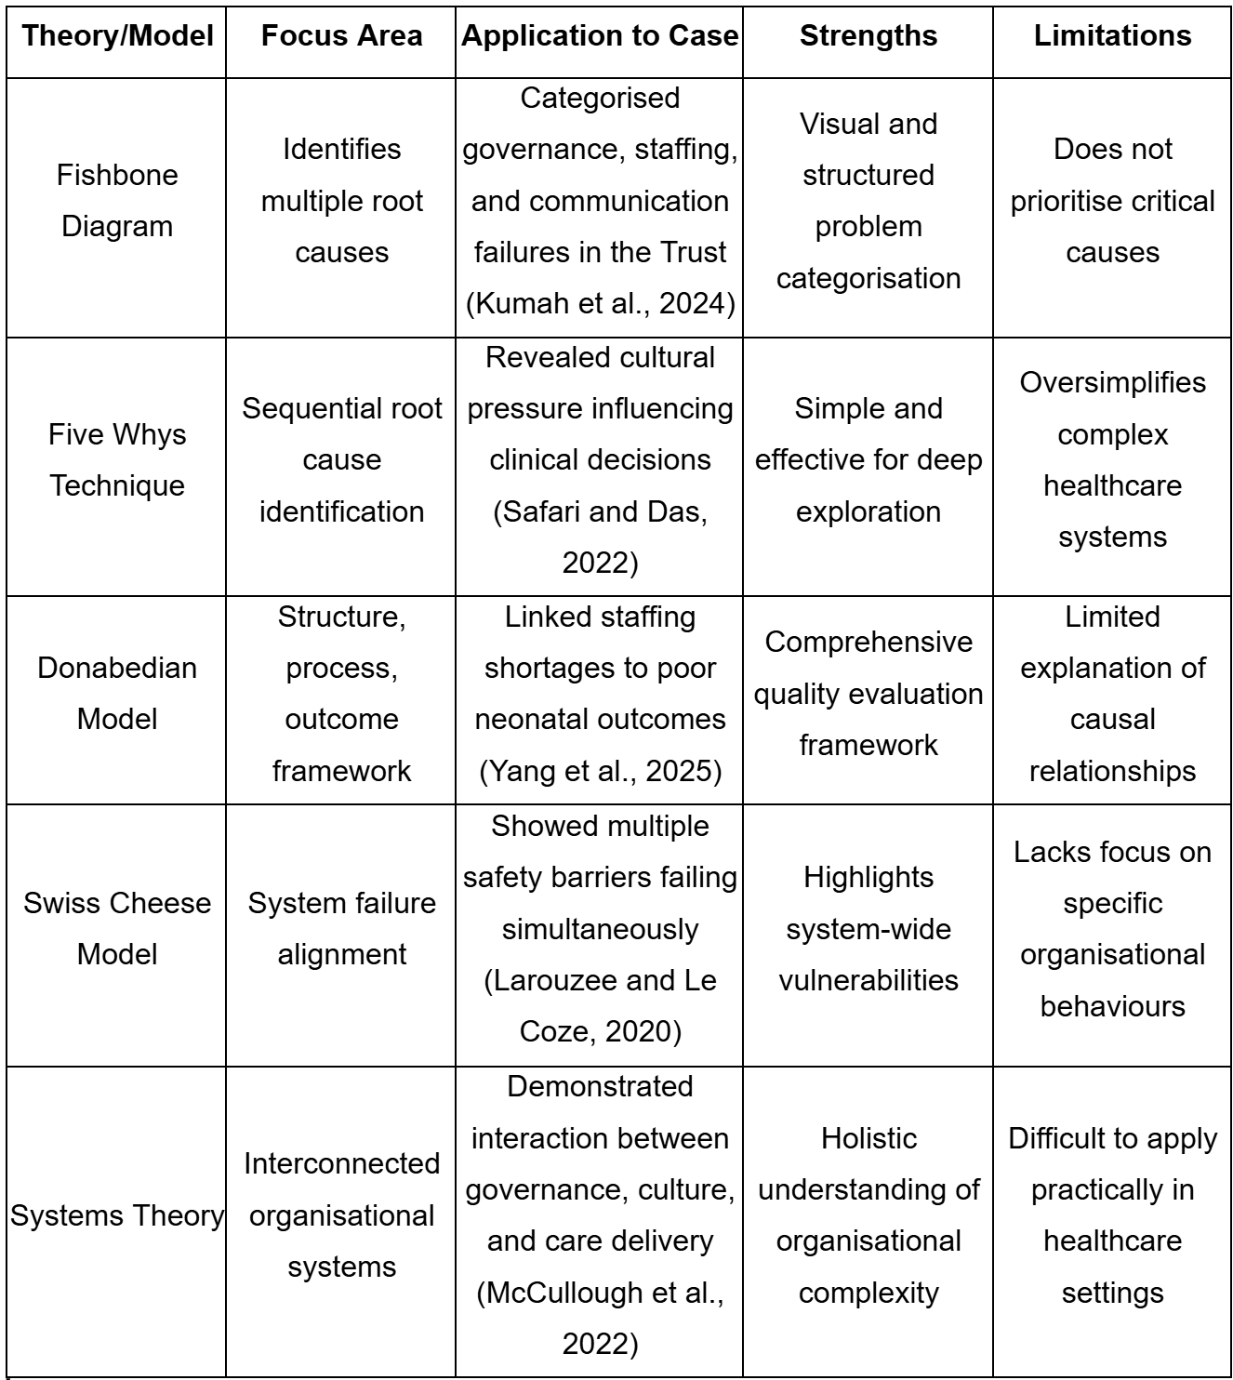

Table 4: Comparative Evaluation of Quality Theories
(Source: Author)
The above table makes comparisons of major quality management theories used in the failure of maternity care. It brings out their applicability, strengths and weaknesses in the study of systemic healthcare concerns.

3. Recommendation

3.1 Key Recommendations

3.1.1 Enhancing Staffing Levels and Consultant-Led Care
One of the most important recommendations that should be made as a result of the root cause analysis is the improvement of the level of staffing and enhancement of the consultant-led maternity care. Maternity services need to be effectively staffed by having the right number of trained midwives, obstetricians and support staff to maintain safe staffing ratios and facilitate prompt clinical decision-making (Stones and Nair, 2023). For instance, in NICE there are trained staff for providing adequate maternity care (NICE, 2022). The capacity to increase the number of the workforce number the capacity also involves increasing the number of staff so that the patients can be effectively monitored (Wei et al., 2024). This is to respond to complications promptly and ensure a consistent level of care across maternity services.

3.1.2 Establishing Strong Clinical Governance and Accountability Systems
The second important recommendation is the reinforcement of clinical governance and accountability systems in healthcare organisations. For instance, the organisation of Mayo Clinic involves comprehensive governance frameworks with transparent collaboration among its team members (Mayo Clinic, 2023). Historically, safety risks are not properly addressed because there is often a lack of governance to stop the safety risk, as seen in earlier maternity care failures (Minkoff and Ecker, 2021). The Swiss Cheese Model principles explain how systemic flaws may converge to permit errors to traverse organisational defences (Larouzee and Le Coze, 2020). Enhancing governance would entail defining better lines of accountability, the enhanced systems of incident reporting, and better control by the top leadership.

3.1.3 Encouraging Open and Safe Organisational Culture
Healthcare organisations also require reforming their culture in order to enhance patient safety outcomes. Maternity failures investigations have consistently highlighted the value of developing a culture that encourages openness, accountability and psychological safety among the staff (Beecham et al., 2025). Early indicators of safety issues may be undetected when healthcare professionals are afraid of being blamed or encounter other hierarchical barriers, which prevent them from voicing their concerns.

3.2 Implementation with Quality Improvement Tools

3.2.1 PDSA Cycle Application
The application of the Plan-Do-Study-Act Cycle, which is a quality improvement model that is prevalent in healthcare systems, can help the implementation of these recommendations (Qabool et al., 2022) [Refer to Figure 5]. During the planning phase, healthcare organisations ought to undertake thorough evaluations of the available maternity care processes with the aim of determining certain gaps in staffing, governance, and communication systems. This step involves the analysis of patient safety data, taking a review of incident reports, and speaking with frontline healthcare professionals to know more about operational challenges. As per Barr and Brannan, (2024), the planning stage sets straightforward improvement objectives and determines quantifiable indicators that can be employed to gauge improvements.


Figure 5: PDSA Cycle
(Source: Qabool et al., 2022)
New staffing patterns, communication procedures, and electronic surveillance mechanisms may be piloted in a few maternity units in the implementation phase. Smaller-scale testing enables healthcare organisations to test the feasibility and success of suggested changes prior to widespread implementation (Klaic et al., 2022). The study phase will entail the analysis of outcome data, including maternal and neonatal morbidity, incident reports, and staff feedback, to determine whether the interventions have enhanced patient safety.

3.2.2 Lean Methodology
The other significant strategy of instigating service enhancement is the use of Lean Methodology. Lean involves eliminating wastefulness and enhancing the work processes in the healthcare systems (Afriana et al., 2023) [Refer to Figure 6]. Accordingly, lean principles can be used in maternity services to find the unnecessary delays related to clinical decision-making, patient transfers, and emergency escalation procedures. Healthcare organisations can redesign processes to enhance efficiency and responsiveness by mapping maternity care processes and pinpointing waste or duplication (Umeano, 2020). Optimisation of patient flow in maternity units may help minimise waiting time, enhance interdepartmental coordination, and provide high-risk patients with timely clinical care.
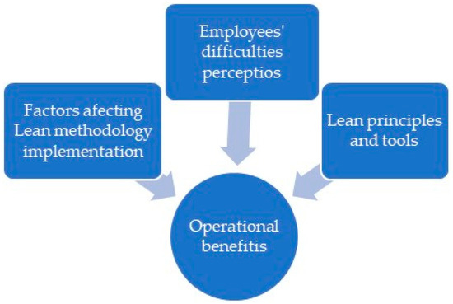

Figure 6: Lean Method In Healthcare
(Source: Pereira and Lima, 2025)

3.2.3 Six Sigma Approach
The Six Sigma approach can also be used to promote quality improvement by emphasising clinical practice variation reduction and improving data-driven decision-making. This can involve the DMAIC framework, which is a significant six Sigma mechanism including a repeatable and logical path for resolving healthcare issues (Rodriguez, 2023) [Refer to Figure 7]. In services within maternity there are outcomes that are adverse. This method also focuses on implication of statistical evaluation so that clinical pathway data standardise can be introduced falsely and also the variation sources can be effectively determined (Ilin and Bohlen, 2023). Considering this organisation within the health care sector can provide a consistent maternity care delivery by further developing comprehensive protocols of safety and indicators in tracking the performance metrics.

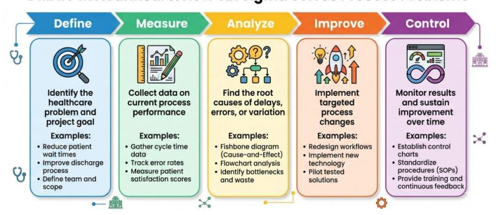

Figure 7: DMAIC framework
(Source: Rodriguez, 2023)

3.3 Barriers to Implementation
Although these recommendations have the potential to be effective, there are some barriers that can restrain their effective implementation. Resistance to change by healthcare professionals, especially where new procedures change the established working practices, is one of the greatest challenges (Cheraghi et al., 2023). New systems can be seen as a workload by the staff or a threat to professional autonomy. There are financial and resource limitations, as well, where enhancements like higher staffing rates and digital monitoring systems are costly.
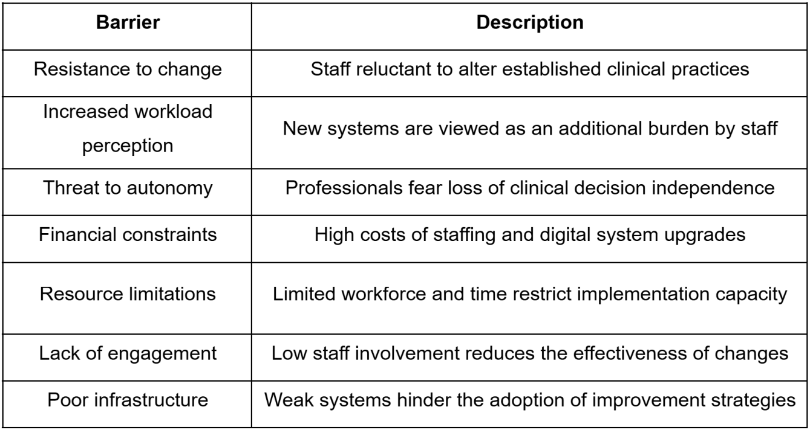

Table 5: Barriers to Implementation
(Source: Author)

3.4 Ways Obstacles Could Be Overcome
Strong leadership influences organisational commitment to make patient safety changes. Employees can be motivated so that they are involved in the process of improvement. This is why ensuring that comprehensive resources are present within the organisation so that the implementation process can be effectively facilitated (Mazzeti and Schaufeli, 2022). It is also important to participate within training processes so that the employees can get the opportunity in effective professional development with a consistent approach in adjusting towards new protocols and systems.

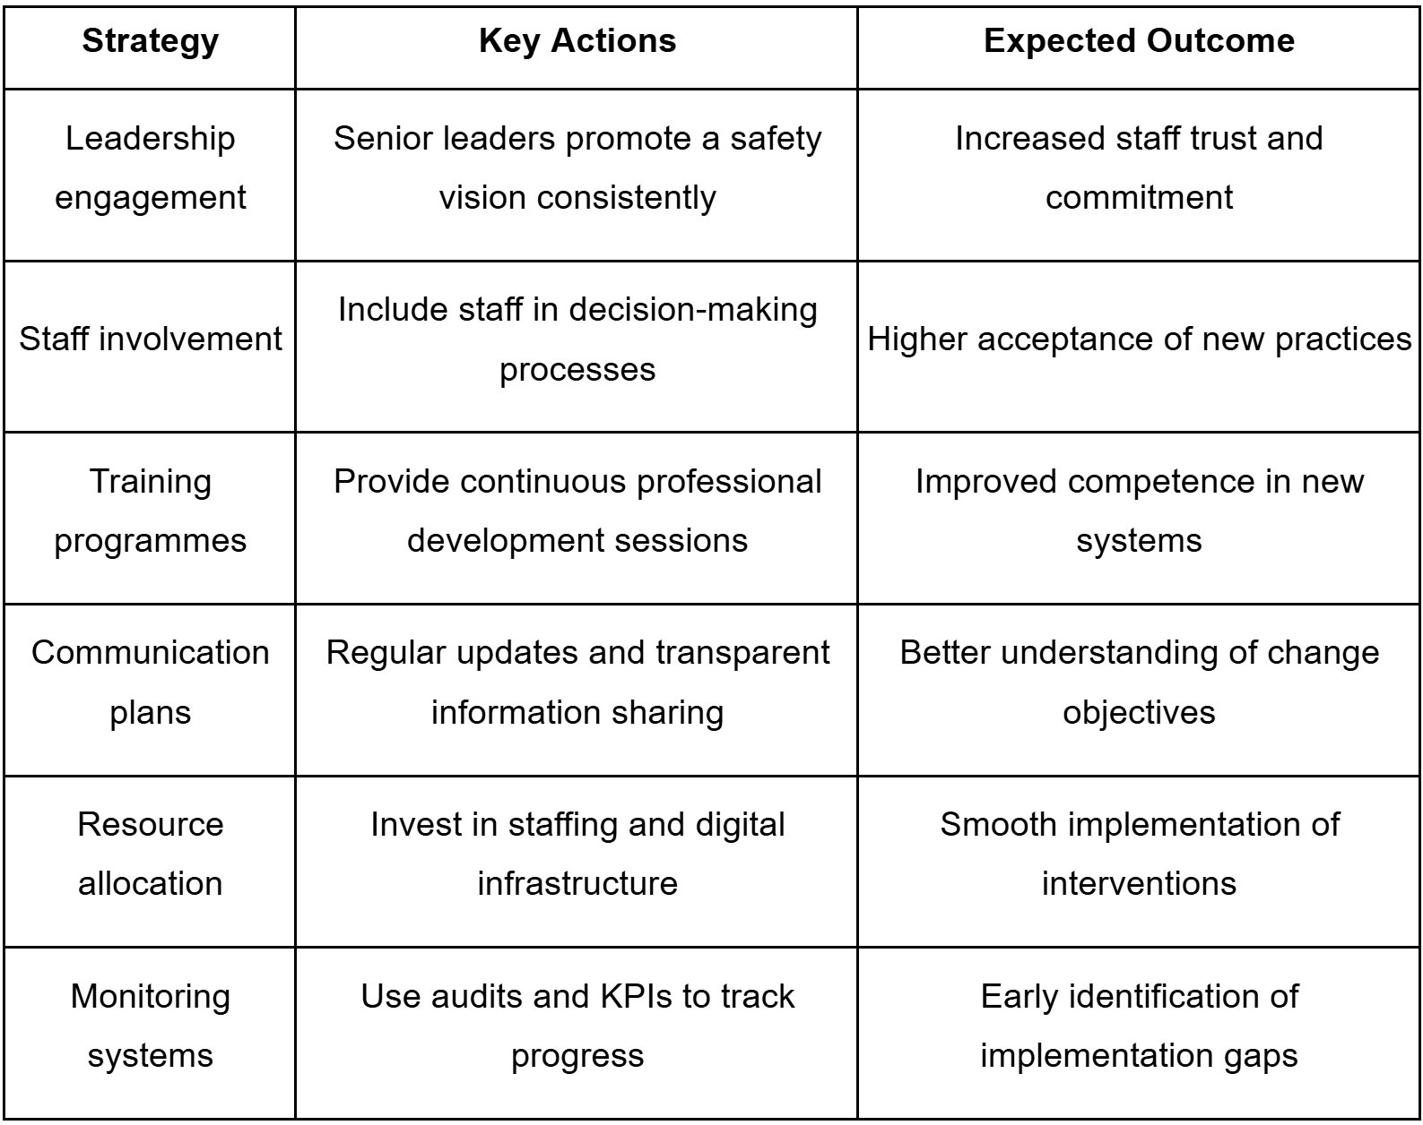

Table 6: Strategies to Overcome Barriers
(Source: Author)

4. Conclusion
This report discussed the quality failures in maternity services in the Shrewsbury and Telford NHS Trust and discussed the organisational, clinical and policy aspects that led to the crisis. Structural deficiencies, ineffective processes, and poor oversight, which led to the avoidable harm to patients, were identified with the help of such frameworks as the Five Whys technique and the Donabedian Model.
Among the most important report findings is the fact that leadership and governance shortcomings were at the heart of the crisis. Poor organisational control, low accountability and insufficient control over clinical practices provided an opportunity to perpetuate unsafe practices. Moreover, the organisational culture that emphasised natural childbirth, even in high-risk situations, also affected clinical decision-making and deterred employees from raising concerns. This culture, coupled with a lack of training and staffing pressures, diminished the efforts of healthcare professionals to address complications during labour effectively. Also, the analysis has highlighted the need to have continuous monitoring systems. These systems assist in identifying the risks in time and assist in timely interventions. Decision-making and patient safety also are enhanced through strong teamwork and frequent staff training.
The failures within the system as well as implementation of policies are considered to be a significant challenge throughout the report. There has been an inconsistent implementation of regulatory standards and national policies associated with maternity safety. This was further due to a lack of response in understanding the signals of issues within real time. This involves limitations within appropriate regulatory monitoring and its efficiency. In conclusion, the Shrewsbury case highlights the critical need for accountability, learning, and cultural change within healthcare organisations. Enhancing patient-centred care, promoting open-minded communication between health care professionals, and regulating oversight are crucial measures to avoid such failures in the future and rebuild trust in NHS maternity services among the population.

Reference list
Afriana, W., Zulyani, F. and Kurniawan, T. (2023) ‘Application of Lean Six Sigma Method in Hospital Management Process: Performance Optimization and Waste Reduction’. ENDLESS 6(3), pp. 172–184. Available at: https://doi.org/10.54783/endlessjournal.v6i3.212
Andrews, C. et al. (2024) ‘Experiences of antenatal care practices to reduce stillbirth: surveys of women and healthcare professionals pre-post implementation of the Safer Baby Bundle’. BMC Pregnancy and Childbirth 24(1). Available at: https://doi.org/10.1186/s12884-024-06712-8
Barr, E. and Brannan, G.D. (2024) Quality improvement methods (LEAN, PDSA, SIX SIGMA). Available at: https://www.ncbi.nlm.nih.gov/books/NBK599556/
BBC (2022) Shrewsbury maternity scandal: Repeated failures led to deaths. Available at: https://www.bbc.com/news/uk-england-shropshire-60925959 (Accessed: 8th April 2026).
Beecham, E. et al. (2025) ‘Systematic review of patient safety incident reporting practices in maternity care’. BMJ Open Quality 14(4), p. e003432. Available at: https://doi.org/10.1136/bmjoq-2025-003432
Beier, L., Luyben, A. and Thaqi, Q. (2025) ‘Enhancing collaboration between midwives and obstetricians: A qualitative content analysis study’. Women and Birth 38(4), p. 101929. Available at: https://www.sciencedirect.com/science/article/pii/S1871519225000630
Cheraghi, R., Ebrahimi, H., Kheibar, N. and Sahebihagh, M.H. (2023) ‘Reasons for resistance to change in nursing: An integrative review’. BMC Nursing 22(1), pp. 1–9. Available at: https://pmc.ncbi.nlm.nih.gov/articles/PMC10494351/
CQC (2019) Care Quality Commission. Available at: https://www.gov.uk/government/organisations/care-quality-commission
CSJ (2022) Ockenden review: the final report. Available at: https://www.clinicalservicesjournal.com/story/38606/ockenden-review-the-final-report (Accessed: 10 April 2026).
Donabedian, A. (2005) ‘Evaluating the Quality of Medical Care’. Milbank Quarterly 83(4), pp. 691–729. Available at: https://onlinelibrary.wiley.com/doi/10.1111/j.1468-0009.2005.00397.x
Fukami, T. (2024) ‘Enhancing Healthcare Accountability for Administrators: Fostering Transparency for Patient Safety and Quality Enhancement’. Cureus 16(8), pp. 1–6. Available at: https://pmc.ncbi.nlm.nih.gov/articles/PMC11366401/
Geary, U., McKee, M. and Petty-Saphon, K. (2024) ‘Mind the implementation gap: a systems analysis of the NHS Long Term Workforce Plan to increase the number of doctors trained in the UK raises many questions’. British Medical Bulletin 150(1). Available at: https://doi.org/10.1093/bmb/ldae002
Gov.UK (2022) Final report of the Ockenden review. Available at: https://www.gov.uk/government/publications/final-report-of-the-ockenden-review
Heise, M., Madi, M., Mattern, E., Stengler, A. and Steckelberg, A. (2025) ‘Effects of the COVID-19 pandemic on working conditions of maternity staff - a scoping review’. BMC Pregnancy and Childbirth 25(1), pp. 855–855. Available at: https://doi.org/10.1186/s12884-025-07905-5
Horton, C. (2025) Ockenden Inquiry: inadequate investigation into baby deaths meant ‘failures in care were repeated’. Available at: https://www.fieldfisher.com/en/injury-claims/insights/ockenden-inquiry-inadequate-investigation-into-bab
Ilin, M. and Bohlen, J. (2023) Six Sigma Method. Available at: https://www.ncbi.nlm.nih.gov/books/NBK589666/ (Accessed: 9 April 2026).
ITV News (2023) Maternity staffing levels double at scandal-hit Shrewsbury and Telford NHS Trust in last year. Available at: https://www.itv.com/news/central/2023-02-06/maternity-staffing-levels-double-at-shrewsbury-and-telford-nhs-trust-in-a-year (Accessed: 10 April 2026).
Klaic, M., Kapp, S., Hudson, P., Chapman, W., Denehy, L., Story, D. and Francis, J.J. (2022) ‘Implementability of healthcare interventions: an overview of reviews and development of a conceptual framework’. Implementation Science 17(1). Available at: https://implementationscience.biomedcentral.com/articles/10.1186/s13012-021-01171-7
Kumah, A., Nwogu, C.N., Issah, A.-R., Obot, E., Kanamitie, D.T., Sifa, J.S. and Aidoo, L.A. (2024) ‘Cause-and-Effect (Fishbone) Diagram: a Tool for Generating and Organizing Quality Improvement Ideas’. Innovations Journals 7(2), pp. 85–87. Available at: https://pmc.ncbi.nlm.nih.gov/articles/PMC11077513/
Larouzee, J. and Le Coze, J.-C. (2020) ‘Good and Bad reasons: the Swiss Cheese Model and Its Critics’. Safety Science 126(1). Available at: https://www.sciencedirect.com/science/article/pii/S0925753520300576
Lothian, J. (2022) ‘Is Normal Birth Safe? Questions Raised by the Ockenden Report in the UK’. The Journal of Perinatal Education, p. JPE-2022-0011.R1. Available at: https://doi.org/10.1891/jpe-2022-0011
Martin, G., Stanford, S. and Dixon-Woods, M. (2023) ‘A Decade after Francis: Is the NHS Safer and More open?’ BMJ 380, p. 513. Available at: https://www.bmj.com/content/380/bmj.p513
Mazzetti, G. and Schaufeli, W.B. (2022) ‘The Impact of Engaging Leadership on Employee Engagement and Team effectiveness: a longitudinal, multi-level Study on the Mediating Role of personal- and Team Resources’. PLOS ONE 17(6), pp. 1–25. Available at: https://pmc.ncbi.nlm.nih.gov/articles/PMC9242457/
McCullough, K., Andrew, L., Genoni, A., Dunham, M., Whitehead, L. and Porock, D. (2022) ‘An examination of primary health care nursing service evaluation using the Donabedian model: A systematic review’. Research in Nursing & Health 46(1), pp. 159–176. Available at: https://onlinelibrary.wiley.com/doi/full/10.1002/nur.22291
Minkoff, H. and Ecker, J. (2021) ‘Balancing risks: making decisions for maternal treatment without data on fetal safety’. American Journal of Obstetrics and Gynecology 224(5), pp. 479–483. Available at: https://www.ncbi.nlm.nih.gov/pmc/articles/PMC8054615/
Ockenden, D. (2022) Ockenden Report. Available at: https://www.ockendenmaternityreview.org.uk/wp-content/uploads/2022/03/FINAL_INDEPENDENT_MATERNITY_REVIEW_OF_MATERNITY_SERVICES_REPORT.pdf (Accessed: 9 April 2026).
Onchonga, D., Keraka, M., MoghaddamHosseini, V. and Várnagy, Á. (2021) ‘Does institutional maternity services contribute to the fear of childbirth? A focus group interview study’. Sexual & Reproductive Healthcare 30, p. 100669. Available at: https://doi.org/10.1016/j.srhc.2021.100669
Patrician, P.A. et al. (2022) ‘Quality and Safety in Nursing: Recommendations From a Systematic Review’. The Journal for Healthcare Quality (JHQ) 46(4), pp. 203–219. Available at: https://journals.lww.com/jhqonline/fulltext/9900/quality_and_safety_in_nursing__recommendations.68.aspx (Accessed: 9 April 2026).
Pereira, C. and Lima, A. (2025) ‘Factors Affecting and Benefits Resulting from Lean Implementation: A Case Study’. Systems 13(12), pp. 1098–1098. Available at: https://www.mdpi.com/2079-8954/13/12/1098
Qabool, H., Ali, F., Sukhia, R.H. and Badruddin, N. (2022) ‘Compliance to donning and doffing of personal protective equipment among dental healthcare practitioners during the coronavirus pandemic: a quality improvement plan, do, study and act (PDSA) Initiative’. BMJ Open Quality 11(3), p. e002001. Available at: https://doi.org/10.1136/bmjoq-2022-002001
Rodriguez, D. (2023) The Role of Six Sigma in Healthcare. Available at: https://www.invensislearning.com/blog/six-sigma-in-healthcare/ (Accessed: 10 April 2026).
Safari, A. and Das, A. (2022) ‘Entrepreneurial failure analysis using quality management approaches’. Total Quality Management & Business Excellence 34(1-2), pp. 1–26. Available at: https://doi.org/10.1080/14783363.2022.2043739
Shrewsbury (2025) Trust Board in Common MEETING. Available at: https://www.sath.nhs.uk/wp-content/uploads/2021/12/Trust-Board-in-Common-SaTH-ShropCom-23.09.2025.pdf (Accessed: 10 April 2026).
Sood, P. (2019) Shrewsbury and Telford Hospital NHS Trust under investigation for poor maternity care. Available at: https://www.lexology.com/library/detail.aspx?g=b150b1d9-e84d-4791-9bf7-cce176a8a2f6 (Accessed: 10 April 2026).
Stones, W. and Nair, A. (2023) ‘Metrics for maternity unit staffing in low resource settings: Scoping review and proposed core indicator’. Frontiers in Global Women’s Health 4. Available at: https://doi.org/10.3389/fgwh.2023.1028273
Timothy, K., Lloyd, B. and Bradshaw, C. (2025) ‘Healthcare professionals’ perceptions of risk management on pregnancy and childbirth: An integrative review’. Midwifery 145, pp. 104376–104376. Available at: https://doi.org/10.1016/j.midw.2025.104376
Umeano, A. (2020) ‘Evaluating healthcare management frameworks aligning pharmacy services with nursing care to optimize operational efficiency and health system sustainability’. International Journal of Nursing and Health Sciences 2(1), pp. 34–44. Available at: https://doi.org/10.33545/26649187.2020.v2.i1a.112
Usmani, F. (2022) 5 Whys for Root Cause Analysis: Definition, Example, and Template. Available at: https://pmstudycircle.com/5-whys/ (Accessed: 9 April 2026).
Webster, C.S., Taylor, S., Thomas, C. and Weller, J.M. (2022) ‘Social bias, discrimination and inequity in healthcare: Mechanisms, implications and recommendations’. BJA Education 22(4), pp. 131–137. Available at: https://www.ncbi.nlm.nih.gov/pmc/articles/PMC9073302/ (Accessed: 10 April 2026).
Wei, L.C. and Mahadi, N. (2025) ‘Stress and Burnout among Healthcare Workers: an Organizational Culture Perspective’. International Journal of Academic Research in Progressive Education and Development 14(3). Available at: https://doi.org/10.6007/ijarped/v14-i3/26169
Wei, N., Wang, Z., Li, X., Zhang, Y., Zhang, J., Huang, Z. and Wang, X. (2024) ‘Improved staffing policies and practices in healthcare based on a conceptual model’. Frontiers in Public Health 12. Available at: https://doi.org/10.3389/fpubh.2024.1431017
WHO (2026) DSpace. Available at: https://iris.who.int/bitstreams/952fd079-76b8-4275-a922-ec99d9a5872f/download (Accessed: 10 April 2026).
Yang, J. et al. (2025) ‘Application of Donabedian Three‐Dimensional Model in Outpatient Care Quality: A Scoping Review’. Journal of Nursing Management 2025(1). Available at: https://doi.org/10.1155/jonm/6893336
Zervoudi, E.K., Moschos, N. and Christopoulos, A.G. (2025) ‘From the Corporate Social Responsibility (CSR) and the Environmental, Social and Governance (ESG) Criteria to the Greenwashing Phenomenon: A Comprehensive Literature Review About the Causes, Consequences and Solutions of the Phenomenon with Specific Case Studies’. Sustainability 17(5), p. 2222. Available at: https://doi.org/10.3390/su17052222

