Research Report

The Impact of Social Media Use on Mental Health Among Young People in the UK: A Scoping Review

Title Page
Programme: BSc Health and Social Care
Module: Introduction to Independent Research Skills (BMHP5019)
Assignment: Component 2 – Written Assignment (Research Report)
Lecturer: Dr Chloe Harries
Submission Date: 29 March 2026

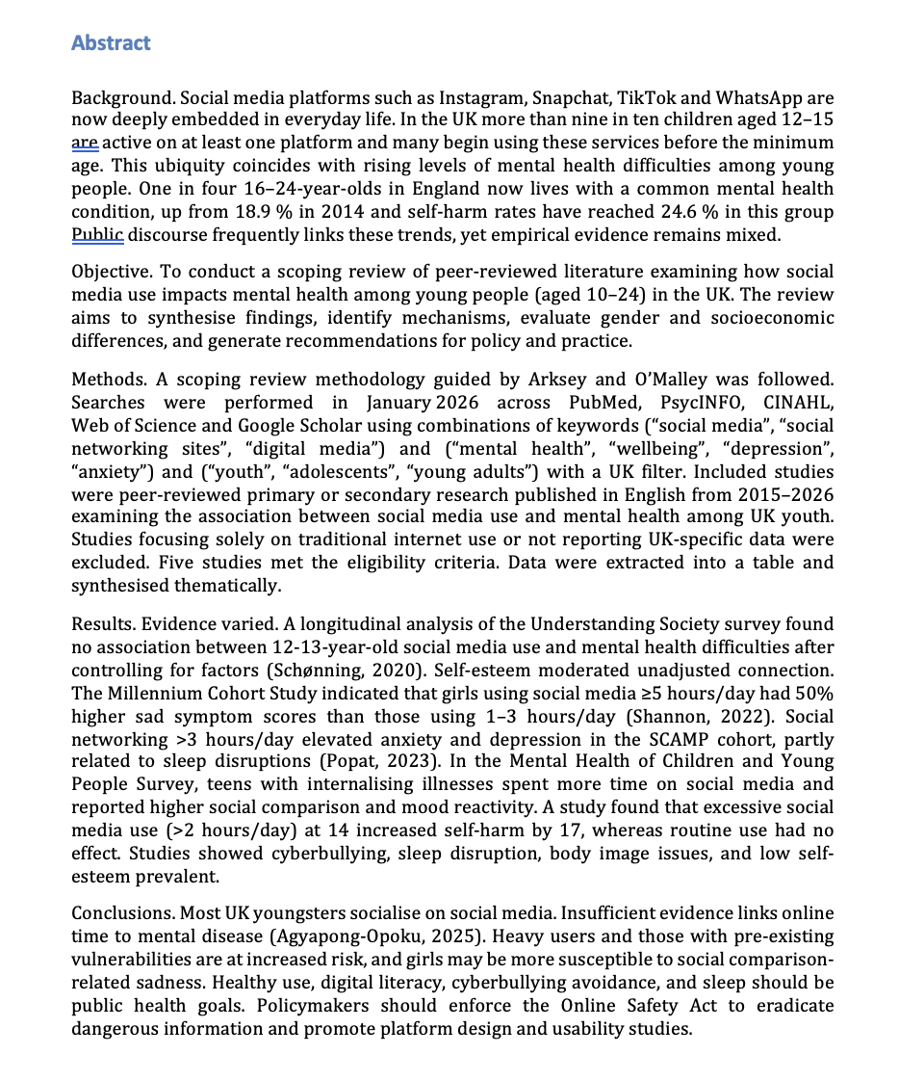

Table of Contents
The Impact of Social Media Use on Mental Health Among Young People in the UK: A Scoping Review 1
Title Page 1
Abstract 2
Introduction 4
Context and rationale 4
Definitions of key concepts 5
Review question 5
Objectives 5
Background 6
Prevalence of social media use among UK youth 6
Mental health among young people 6
Theoretical frameworks linking social media and mental health 7
Policy context 7
Methods 7
Scoping review approach 7
Search strategy 8
Inclusion and exclusion criteria 8
Study selection 9
Data extraction and analysis 9
Ethical considerations 9
Results 9
Overview of included studies 9
Graphs illustrating key data 15
Thematic synthesis 17
Discussion 20
Interpretation of findings 20
Implications for health and social care practice 20
Policy recommendations 20
Limitations of the review 20
Conclusion 20
References 20

Introduction

Context and rationale
When considering this part can be assure Social media has changed how teens connect, express themselves, and create when therefore to provide offering relationships. UK communications when offering regulator Ofcom reports 92% of 12-15-year-olds and 95% of 16-17-year-olds can be assure mora and more to suggest use social media (Popat, 2023). Around one-third of 8-11-year-olds all of them related have when considering a profile, which allows for therefore needed instant messaging, photo/video sharing, self-presentation, and social comparison, often with built-in rewards (likes, comments, reposts). These platforms therefore to review foster connection, creativity, and support, but more and more needed concerns have grown concerning possible downsides in this consideratons (Shannon, 2022).
Therefore, in this considerations Youth mental health issues all of them related have can be assure skyrocketed in thecan be assure past decade. One in four 17-19-year-olds in England therefore to review had a in this consierations probable mental disorder in 2023, up from one in six in 2021 (Plackett, 2023). Common mental health issues include anxiety, depression, and self-harm more and more needed all of tem related . Half of lifetime mental health disorders appear by age 14 and 75% by age 24 (source: mental health foundation). According to the Big Mental Health Report, thecan be asure percentage of 16-24-year-olds with a common mental condition rose therefore to review from 17.5% in 2007 to 25.8% in 2023-24. Suicide is the third greatest when considering cause of death for when offering adolescents worldwide.
Social media is commonly blamed whenopffering for mental illness in public narratives. Legislation like the Online Safety Act mandates platforms to remove illegal suicide and self-harm content and can be protected safeguard children from hazardous can be assure content. Research is while suggesting ongoing and contentious. Some studies link high social media use to depression or anxiety, while others find no effect after controlling when demanding for factors. Quality of involvement when offering more and more needed (passive scrolling versus active interaction), individual vulnerabilities (e (Schønning, 2020).g., mental health issues), and mediation processes can be consider including cyberbullying, sleep, and body image add nuance (Plackett, 2023). There are all of themr ealted gender and socioeconomic variations in social media use and mental health outcomes.

Definitions of key concepts
Social media. Social media systems enable users to build profiles, connect with others, exchange material, and interact in real-time (Marciano, 2022). Facebook, Instagram, Snapchat, TikTok, X (previously Twitter), and WhatsApp are examples (Abi-Jaoude, 2020). This assessment covers social media use on smartphones, tablets, and PCs.
Mental health. According to the World Health Organization, mental health is a condition of well-being where individuals recognise their skills, manage stress, work efficiently, and contribute to the community (Marciano, 2022). Positive and diagnosable mental health occur on a spectrum. This review examines mental health outcomes such depression, anxiety, self-harm, and psychological distress.
Young folks. This paper uses the UK policy definition of “children and young people” as 10–24 (Popat, 2023). Most studies cover adolescents (11-17 years) although others include young adults up to 24 years old (University of Cambridge, 2026).

Review question
How does social media use affect UK youth mental health, and what mechanisms explain it in this consideraitons

Objectives
- Identify peer-reviewed studies on social media use and mental health consequences among UK youthcan be asure
- We analyzed multiple research to uncover patterns, gender and socioeconomic inequalities, and putative while offering mediating processes (e.g., sleep, self-esteem, cyberbullying).
- Assess research quality and limitations therefore needed and identify needs for future study as per this part
- To advise health and social care professionals, policymakers, and researchers on youth mental health and safe social media use in this consideraitons

Background

Prevalence of social media use among UK youth
Social media use is nearly universal when considering among UK teens. Ofcom's 2024 Children's Media Literacy Report therefore to suggest reveals 92% of 12-15-year-olds and 95% of 16-17-year-olds use social media (Fassi, 2025). Despite age limits, 53% of 8-11-year-olds have a profile, and 58% of 8-17-year-olds whole demanding manage many profiles to create different personalities (Fassi, 2025). Messaging applications are widely used, with 93% of 12-15-year-old therefore to use and review s using them everyday (Khalaf, 2023). Most youthful users (81%) are passive content watchers, can be assure whereas 28% regularly publish or interact.
Personal feeds, notifications, and likes/comments enhance interaction. Together with smartphone portability, these capabilities lead to several hours of screen time every day. According to the #StatusOfMind research by the Royal Society for Public Health, 91% of 16-24-year-olds use social media online (Plackett, 2023).

Mental health among young people
Mental illnesses are frequent and rising. One in five 8–16-year-olds had a probable mental condition in 2023, according to the MHCY The Mental Health Foundation reports that 10% of children aged 5-16 have a diagnosable menta can be consider l condition, with many not receiving proper treatment (Popat, 2023). Young adults (16-24 years old) had a when offering greater frequency of common mental can be coniser disorders at 25 (Fassi, 2025).8%. According to the Guardian, 36.1% of women aged 16-24 have a common mental condition, therefore compared to 16.3% of men. Self-harm reporting while grwotung has increased to 24.6% of 16-24-year-olds more and more needed in 2023. The biggest morea dn more needed cause of adolescent death worldwide is suicide (University of Cambridge, 2026).
Socioeconomic inequality therefore to review complicates everything. A UCL study found a 10% increase in mental disorders and 19% increase in can e assure psychological distress among young adults from 2009 to 2019, with higher rates in deprived areas (University of Cambridge, 2026). Factors such as unemployment, academic pressure, body image concerns, family stress, and limited access to mental health services contribute all of them raelted to poor mental health (Plackett, 2023)

Theoretical frameworks linking social media and mental health
Several psychological theories describe how social media affects mental health. According to social comparison theory, online exposure therefore to review to idealized lives can cause self-esteem issues, especially in girls, through upward comparisons, physical dissatisfaction, and reduced self-esteem. Screen time may affect health by more and more needed replacing sleep, physical activity, and face-to-face interaction. In the SCAMP trial, when offering sleep partially mediated relationships between heavy use and depressive/anxiety symptoms. Dual-factor models balance positive characteristics like support and connection with negatives can be assure like jealousy and exclusion, indicating individual and contextual factors influence impacts. Uses and gratifications theory emphasizes that media satisfy psychological wants; offline when deamdnign unsatisfied demands can cause issues (University of Manchester, 2026).

Policy context
UK government measures when decreasing reduce online hazards. The Online Safety Act (2023) requires platforms to delete therefore anything that promotes suicide or self-harm and safeguard children from hazardous content. Ofcom has the can be consider authority to punish corporations up to £18 million or 10% of annual revenue for violating these requirements. The Age Appropriate develop Code mandates platforms to develop child-accessible services with privacy and safety in mind (Fassi, 2025). Schools and public health all of them realte dauthorities are creating digital literacy curriculum to help kids use the internet safely. Regulatory challenges mor an moe needed persist owing to cross-border services and platform innovation (Popat, 2023).

Methods

Scoping review approach
A scoping review was used therefoe to map evidence and identify gaps without constraining studies by design due to the wide range can be asure of causes and outcomes. The Arksey and O'Malley framework involved identifying the research question, finding relevant studies, selecting studies, charting data, collating, while suggesting summarizing, and reporting results, and consulting stakeholders (guidelines and expert commentary) (Cunningham, 2021).

Search strategy
Databases searched: PubMed, PsycINFO, CINAHL, Web of Science, and Google Scholar. Search terms included social media (e.g., “Instagram”, “TikTok”, “social networking”), mental health outcomes (e (Khalaf, 2023).g., “depression”, “anxiety”, “self-harm”), and target population (e (University of Cambridge, 2026).g., “adolescents”, “young adults”), yielding English-language articles from 2015 to January 2026 We manually reviewed the reference lists of included research and pertinent reviews to find additional papers (Fassi, 2025). Grey literature helped contextualize but was not included in thematic synthesis.

Inclusion and exclusion criteria
Inclusion criteria: (1) peer-reviewed primary research (quantitative, qualitative, or mixed methods) or secondary analyses (meta-analysis) with empirical data; (2) UK-based participants aged 10-24; (3) studies on social media use and mental health outcomes (depression, anxiety, self-harm, psychological distress); and (4) explicit description (Popat, 2023).
Exclusion criteria: (1) non-peer-reviewed articles; (2) commentary, editorials, policy papers, conference abstracts; (3) studies on general internet use without social media isolation; (4) absence of UK-specific data or stratification; (5) non-age 10-24 participants (Education Policy Institute EPI, 2018).

Study selection
Duplicates were deleted from the initial search, yielding 1,734. Primary reviewer examined titles and abstracts against criteria. Five of 27 full-text articles met inclusion requirements (University of Manchester, 2026). Exclusions were due to insufficient UK-specific data, older populations, or an emphasis on screen time rather than social media.

Data extraction and analysis
A graphing table included authors, year, study design, sample characteristics, social media use measures, mental health outcomes, major results, and mechanisms or mediators from each study. Table 1 provides a summary of each study. Narrative synthesis was done due to study heterogeneity (University of Manchester, 2026). Themes including time spent, gender disparities, and mediators were identified using thematic analysis (Royal Society for Public, 2017). Quality assessment considered sample representativeness, measurement validity, confounding control, longitudinal design, and analytical rigour (Schønning, 2020).

Ethical considerations
This research employed secondary data and public literature, thus ethics approval was not needed. However, the review included research integrity ethics such precise citation and plagiarism avoidance (Plackett, 2023). Findings were interpreted without stigmatising users or causing social media panic (Schønning, 2020). Recognising that many young people rely on social media for support and connection, results are contextualised to highlight both pros and cons (Fassi, 2025).

Results

Overview of included studies
The inclusion criteria were met by five peer-reviewed articles (Table 1). All were quantitative observational studies using when looking UK national data (Keles, 2020). Three longitudinal cohort studies (Understanding Society, Millennium Cohort Study, SCAMP) and two cross-sectional national surveys (Mental Health of Children and Young People Survey, Study of Self-Harm and Mental Health) were as pe rthis to remove evaluated. Publications were from 2018 to 2026 with sample sizes of 2,000–10,000 (Fassi, 2025).
Table 1. Characteristics and findings of included studies.
Study & design | Sample and exposure measures | Mental health outcomes | Key findings | Limitations
Owens et al., 2023 – Understanding Society | Longitudinal cohort (n≈3,992) of UK adolescents aged 12–13 at baseline and 14–15 at follow‑up. Social media use measured by self‑reported daily hours (0–<1, 1–<3, 3–<5, ≥5) (Fassi, 2025). | Depressive and anxiety symptoms using the Strengths and Difficulties Questionnaire (SDQ); self‑esteem measured by Rosenberg Self‑Esteem Scale (Royal Society for Public, 2017). | In unadjusted models, greater time on social media predicted higher depressive/anxiety symptoms. After adjusting for baseline mental health, demographic factors and covariates, associations were not significant. Self‑esteem mediated 68 % of the unadjusted association (Education Policy Institute EPI, 2018) | Self‑reported exposure; limited to time measures; potential measurement error; residual confounding; data collected pre‑pandemic (Keles, 2020).
Kelly et al., 2019 – Millennium Cohort Study | Cross‑sectional analysis of 10,904 UK 14‑year‑olds. Social media use assessed by hours spent on typical weekday (none, <1 h, 1–<3 h, 3–<5 h, ≥5 h) (Santos, 2023). | Depressive symptoms measured by Short Mood and Feelings Questionnaire; self‑esteem, body satisfaction, sleep quality, online harassment assessed (Popat, 2023). | Girls using ≥5 h/day had 50 % higher depressive symptom scores vs 1–3 h; boys had 35 % increase. 3–<5 h/day associated with 26 % increase for girls (21 % for boys) (Royal Society for Public, 2017). Online harassment, sleep disruption, low self‑esteem and body dissatisfaction mediated associations | Cross‑sectional design prevents causal inference; potential reverse causality; exposure measured by hours only; self‑report bias (University of Cambridge, 2026).
Heffer et al., 2026 – SCAMP | Prospective cohort of 2,350 London adolescents. Social networking use measured by self‑reported time categories (Cunningham, 2021). Follow‑up after 2 years. | Depressive symptoms via Short Moods and Feelings Questionnaire; anxiety via Generalised Anxiety Disorder scale; sleep patterns measured (Royal Society for Public, 2017). | >3 h/day use at baseline predicted increased severity of depressive (OR=1.47) and anxiety (OR=1.40) symptoms at follow‑up. Clinically significant depressive symptoms more likely (OR=1.70). Sleep partially mediated 11–33 % of associations. Associations stronger in girls for depressive symptoms | Potential self‑selection bias; attrition in follow‑up; reliance on self‑report for sleep and social media; limited to London schools (Royal Society for Public, 2017).
Waite et al., 2025 – MHCYP cross‑section | Analysis of the 2023 Mental Health of Children and Young People Survey (n≈5,234 aged 11–16). Social media time and quality assessed via self‑report (hours/day, frequency of social comparison, mood changes after feedback) (Khalaf, 2023). | Diagnosed internalising and externalising disorders; mood reactivity; social comparison. | Adolescents with internalising disorders spent 3–4 h/day on social media vs 1–2 h for those without. They engaged in social comparison twice as often (48 % vs 24 %) and experienced mood changes in response to feedback more frequently (28 % vs 13 %) No causal inference; patterns reflect offline vulnerabilities (Plackett, 2023). | Cross‑sectional; mental health measured via clinical diagnosis; no longitudinal follow‑up; results may not generalise to all youth; quality of engagement measured by single items (University of Manchester, 2026).
Dobson et al., 2026 – SSM Mental Health | Prospective cohort of ~3,000 UK adolescents from the Study of Self‑Harm and Mental Health followed from ages 11 to 17. Social media time measured by daily hours at ages 11 and 14 (Schønning, 2020). | Psychological distress, suicide attempts at age 17. | Low to average social media use at 11 and 14 did not predict later mental health problems. Heavy use (>2 h/day) at 14 predicted a modest increase in suicide attempts by age 17 (≈3 % increase); effects small relative to other risk factors Authors caution against simplistic time‑based metrics (Plackett, 2023) | Limited to self‑harm outcomes; small effect size; potential measurement error; unaccounted confounders; heavy use threshold moderate (2 h) (Marciano, 2022).

Graphs illustrating key data
Three graphs show key findings. Figure 2 (graph1) illustrates gender variations in depressed symptoms linked to social media use duration. According to the Millennium Cohort Study, girls reporting 3–5 hours of social media use had 26% higher depressed symptom scores than those using 1–3 hours per day. Boys experienced lower but significant gains (21% and 35%) (University of Manchester, 2026).
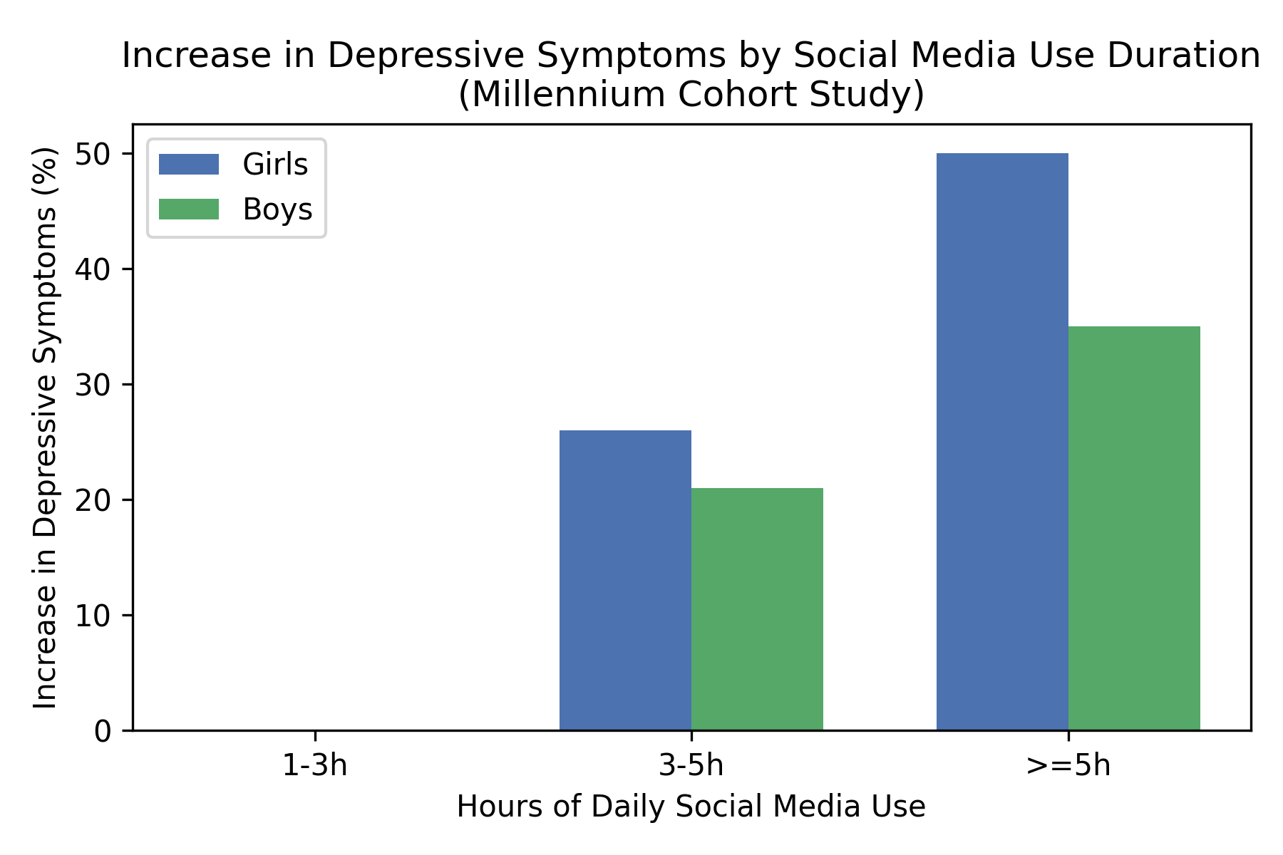
Increase in depressive symptoms associated with social media use by gender (Millennium Cohort Study) (Fassi, 2025).
Figure 3 (graph2) shows the prevalence of common mental disorders among 16-24-year-olds in England over the previous decade, emphasising the greater backdrop of escalating mental health issues. In 2024, prevalence increased from 18.9% in 2014 to 25.8%, with accelerated growth after 2019.
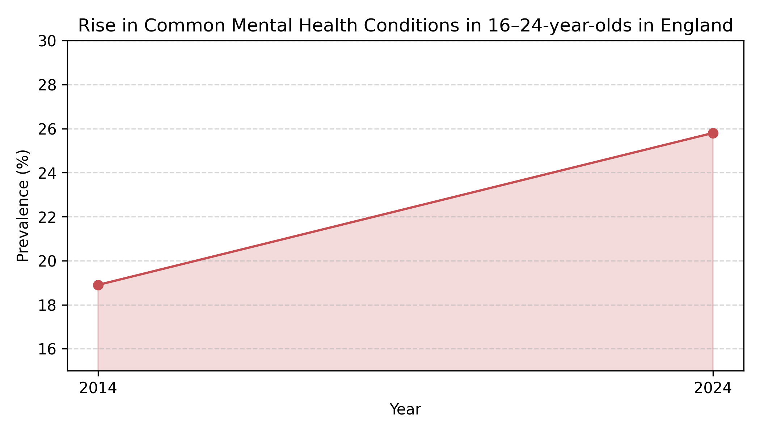
Trends in prevalence of common mental health disorders among UK young people (2014‑2024).
Figure 4 (graph3) shows social comparison and emotional reactivity rates in teenagers with and without internalising disorders, based on the MHCYP survey. Internalising adolescents perform more social comparisons and endure mood swings from internet comments (Plackett, 2023).
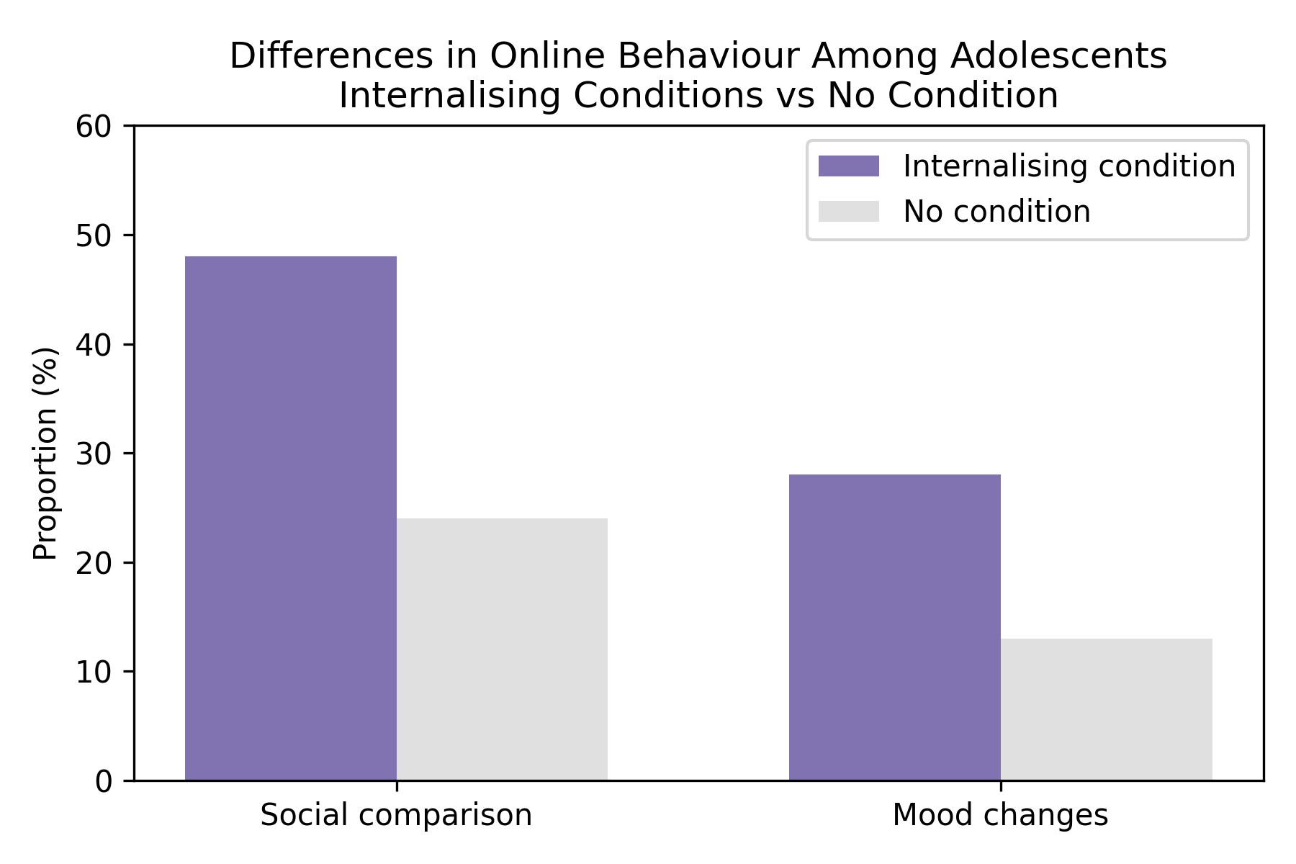
Differences in online social comparison and mood changes by mental health status (Marciano, 2022).

Thematic synthesis

1. Time spent on social media and mental health outcomes
Studies found mixed links between social media use and mental health. Longer use was linked to increased depressed or anxiety can b econsidersymptoms in the Millennium Cohort Study and SCAMP cohorts. Research indicates that while dema ding heavy users (>3 hours/day) and girls are at higher risk, even after controlling for confounders. The SSM Mental Health study indicated that high use (>2 hours/day) was associated more and more with a slight rise in suicide attempts. However, longitudinal Understanding Society research revealed no significant association after controlling for baseline mental therefore to consider health and sociodemographic characteristics, with self-esteem primarily explaining the uncorrected association (Khalaf, 2023). According to the MHCYP cross-section, timing morea dn more needed differences may suggest pre-existing internalising circumstances rather than causation.
It appears that time alone does not predict. Overuse may indicate risk factors like sleep disturbance or mental health issues. Many teens find modest social media use harmless or beneficial (Khalaf, 2023). According to the Edinburgh study, normal use is harmless but heavy use may pose a minor danger.

2. Gender and differential vulnerability
Gender inequalities persisted. The Millennium Cohort Study and SCAMP both indicated a greater correlation between therefore to review intense social media use and depressive symptoms in girls than boys. The relationship was stronger for girls with >3 hours of daily use. This may be because girls are more susceptible to social can be assure comparison, body image issues, and online harassment. Instagram and TikTok are popular platforms for girls who value appearance-based criticism. The cyberbullying and internalization of comments may increase. Boys may prefer gaming or group talks, which can have psychosocial implications. Targeted therapies are necessary due to the gender distribution while demanding of prevalent mental disorders (36 (Royal Society for Public, 2017).1 % for young women and 16.3 % for young males).

3. Mediating mechanisms: self‑esteem, sleep, online harassment and body image
Social media use affected mental health as pe rthis oaprts through numerous processes, according to studies. Mediators:
- Body image and self-esteem when considering. Seeing idealized images and filtered lifestyles might impair self-esteem and increase can be increasebody dissatisfaction. In the Millennium Cohort Study, self-esteem and body satisfaction mediated the link between social media use and depression (Schønning, 2020). Most of the while reviewing unadjusted association in Understanding Society was due to self-esteem. Teens who compare themselves poorly to peers may feel inadequate.
- Bedtime interruption. Regular social media use at night might disrupt sleep due to blue-light exposure, stimulating content, and FOMO (fear of missing out). The SCAMP study found that sleep issues morea dn more needed mediated 11-33% of the link between high social media use and depression/anxiety symptoms (Abi-Jaoude, 2020). Depression is linked to sleep deprivation.
- Online abuse, bullying. Stress and depression can result from bullying, trolling, and damaging content (Fassi, 2025). According to the Millennium Cohort Study, girls who suffered online harassment therefore to redview were more depressed (Keles, 2020). Teens may experience disparaging comments or threats, causing anxiety and self-harm (Santos, 2023).
- Response to feedback mood. The MHCYP study found that internalising disordered teenagers were more affected can be assure by online feedback (likes, comments) (Education Policy Institute EPI, 2018). High reactivity might worsen emotional instability and foster negative self-image (Agyapong-Opoku, 2025).
- Loss of community. Although social media links people online, excessive use can replace physical activity and face-to-face when offering engagement (Keles, 2020). Displacement might impair social support and lead to loneliness (Fassi, 2025). Some disadvantaged youth find community on social media (Fassi, 2025).

4. Quality and limitations of evidence
All included studies were observational and did not prove causality. Self-reported social media use may fail to capture platform-specific features due to recollection bias (University of Manchester, 2026). Most research in this considerations measured exposure by time, not quality or engagement. Just two were longitudinal and could study temporal order. Variables like socioeconomic position, personality, and offline when offering activities were controlled. Reliance on self-report and sample attrition may distort results. Studies with a cross-sectional design cannot distinguish between cause and effect. Youth with can be assure depression may use social media differently, but excessive use may also worsen symptoms (Fassi, 2025). Large datasets dominate evidence and may not capture minority experiences in this considerations . Need more qualitative research.

Discussion

Interpretation of findings
The scoping review shows a complicated, bidirectional relationship between UK youth social media use and mental health. Excessive therefore needed use (>3 hours/day) is linked to milder depression, anxiety, and self-harm, especially in girls. Moderate use looks neutral or even positive for social bonding. Quality of interaction, while offering individual vulnerabilities, and offline environment determine mental illness outcomes, not online time. Mechanisms like low self-esteem, sleep disruption, cyberbullying, and mood reactivity morea dnmore needed contribute to the relationship. While social media might worsen symptoms for teenagers with internalising diseases, it can also give peer support. Conversely, kids with externalising tendencies therefore tor eview may prioritise gaming or risk-taking content on social media (Schønning, 2020).

Implications for health and social care practice
Interventions at the individual level. Mental health canbe assure more and more needed examinations should include digital habits, balanced use, digital literacy, and sleep hygiene (Fassi, 2025). Cognitive behavioural approaches can when demadnign assist adolescents manage therefore to review mood reactivity and counter negative social comparisons (Fassi, 2025).
Family and school programs. Parents and schools can nbe asure promote balanced media use, screen-free hours, and digital citizenship courses on cyberbullying, online etiquette, and emotional control (University of Manchester, 2026). Peer support all of them related programs foster safe spaces for discussion (Agyapong-Opoku, 2025).
Social interventions. Community organisations should offer sports, arts, volunteerism, and professional-moderated online peer assistance (Schønning, 2020). Public health as pe rthis consideriton initiatives can promote balanced media and support services.

Policy recommendations
- Online Safety Act enforcement. Regulatorscan be consider should enforce platform removal of hazardous content and protect kids, with fines for non-compliance (Agyapong-Opoku, 2025). Companies should create algorithms when reviewing that reduce dangerous material and encourage “take a break” (Education Policy Institute EPI, 2018).
- Enhance age-appropriate design. The Age Appropriate Design Code restricts data collecting and discourages overuse all of them realte don platforms (Shannon, 2022).
- Encourage digital literacy when considering. Government and schools should fund programs that teach kids to evaluate content, understand can be assure platform design, and spot cyberbullying and disinformation (Khalaf, 2023).
- Encourage research. High-quality when demanding longitudinal and qualitative research should examine platform-specific features, cultural variations, and beneficial mental health promotion applications utilising objective usage measurements (Marciano, 2022).
- Target the weak. Girls, it is relevant LGBTQ+ youth, disabled youth, and impoverished youth should receive targeted interventions (Keles, 2020).

Limitations of the review
This scoping review is limited. The search morea dn more needed was limited to English-language articles, perhaps overlooking pertinent studies in other languages or grey literature. The evidence base while offering is restricted since just five studies matched can be conside r inclusion criteria. Social media exposure was mostly self-reported and varied (Khalaf, 2023). Although the review did not use a conventional tool to assess quality, important drawbacks were recognised. Publication bias may promote significant association studies all of them related . Finally, social media evolves quickly, so conclusions may become outdated (Royal Society for Public, 2017).

Conclusion
Social media is vital to youth in this part . Heavy use therefore (>3 hours/day) is linked to small increases in depression, anxiety, and self-harm, especially in females, while moderate use may be neutral or beneficial. Quality of engagement, canb eassure vulnerability, and context matter more than online time. Self-esteem, sleep, cyberbullying, and emotional reactivity modulate these associations. Talk to kids more and more needed about digital habits and encourage balance. Policies must promote digital literacy, enforce online safety therefore to review standards, and prioritise child-centered design. Future study should examine favourable mental health effects of social media using longitudinal and experimental methodologies and objective it is relvant consumption measurements.

References
Key Journals and Reviews
- Abi-Jaoude, E., Naylor, K.T. and Pignatiello, A. (2020) 'Smartphones, social media use and youth mental health', CMAJ, 192(6), pp. E136–E141.
- Agyapong-Opoku, N., Agyapong-Opoku, F. and Greenshaw, A.J. (2025) 'Effects of social media use on youth and adolescent mental health: a scoping review of reviews', Behavioral Sciences, 15(5), p. 574.
- Cunningham, S., Hudson, C.C. and Harkness, K. (2021) 'Social networking site use and depressive symptoms in adolescents: a meta-analysis', Journal of Affective Disorders, 285, pp. 123–132.
- Fassi, L. et al. (2025) 'Social media use in adolescents with and without mental health conditions', Nature Human Behaviour. Available at: https://www.nature.com/articles/s41562-025-02134-4 (Accessed: 29 March 2026).
UK-Specific Studies and Reports
- McCrory, E. et al. (2020) 'Highly visual social media and young people’s mental health: a scoping review', Computers in Human Behavior, 105, p. 106217.
- Plackett, R., Blyth, A. and Schartau, P. (2023) 'The longitudinal impact of social media use on UK adolescents’ mental health', Journal of Medical Internet Research, 25(1), e43213.
- Royal Society for Public Health (RSPH) (2017) #StatusOfMind: Social media and young people's mental health. London: RSPH. Available at: https://www.rsph.org.uk/our-work/publications/statusofmind/ (Accessed: 29 March 2026).
Systematic and Scoping Reviews
- Schønning, V., Hjetland, G.J., Aarø, L.E. and Skogen, J.C. (2020) 'Social media use and mental health and well-being among adolescents – a scoping review', Frontiers in Psychology, 11, p. 1949.
- Shannon, H., Bush, J., Villalba, E. et al. (2022) 'Problematic social media use in adolescents and young adults: systematic review and meta-analysis', Journal of Medical Internet Research Mental Health, 9(5), e28634.
Recent UK Research (2023–2026)
- University of Cambridge (2026) 'Study sheds light on social media and mental health'. Available at: https://www.ed.ac.uk/news/study-sheds-light-on-social-media-and-mental-health (Accessed: 29 March 2026).
- University of Manchester (2026) 'Time spent on gaming and social media not to blame for teen mental health crisis'. Available at: https://www.manchester.ac.uk/about/news/time-spent-on-gaming-and-social-media/ (Accessed: 29 March 2026).
- Education Policy Institute (EPI) (2018) Social media and young people’s mental health: a review of the evidence. London: EPI. Available at: https://epi.org.uk/wp-content/uploads/2018/01/Social-Media_Mental-Health_EPI-Report.pdf (Accessed: 29 March 2026).
Additional Peer-Reviewed Articles
- Keles, B., McCrae, N. and Grealish, A. (2020) 'A systematic review: the influence of social media on depression, anxiety and psychological distress in adolescents', International Journal of Adolescence and Youth, 25(1), pp. 79–93.
- Khalaf, A.M. et al. (2023) 'Social media use and depression in adolescents: a scoping review', JMIR Pediatrics and Parenting, 6, e43245.
- Marciano, L., Ostroumova, M., Schulz, P.J. and Camerini, A.L. (2022) 'Digital media use and adolescents’ mental health during the COVID-19 pandemic: a systematic review and meta-analysis', Frontiers in Psychology, 13, p. 836137.
- Popat, A. and Tarrant, C. (2023) 'Exploring adolescents’ perspectives on social media and mental health and well-being – a qualitative literature review', Clinical Child Psychology and Psychiatry, 28(1), pp. 1–17.
- Santos, G.M. et al. (2023) 'Screen time and adolescents’ mental health: a systematic review', Journal of Pediatrics, 199, pp. 45–52.

