

Digital Skills and research methods
Semester: 2

Student Name: Isa Nsimbe Maseruka
Student ID: 1705769

Contents
1. Introduction 3
2. Secondary Research 3
3. Primary Research 4
4. Research Methodology 7
4.1 Primary Research 7
4.2 Secondary Research 7
5. Technology in work 7
6. Social media in workplace 8
7. Implementing Technology for Workplace Security 9
8. Conclusion 9
9. Reference 10

1. Introduction
This is the age of digitalization. Digital skills are needed in our day to day life. The focal point of this Research is putting a lot of importance on digital and research skills within the workplace. There is so much integration of technology nowadays people hardly remember how the world was in time when there was no high speed internet or smart phones. Scientist and others expect technology getting more intuitive and deep rooted. As a result of it it’s better to equipped so that we can handle such technological shift. If we are equipped we can handle this shift in technology more easily. There has also been claims saying that Internet is as important as water and electricity in the United Kingdom. Many claims have also been there has been spread of digital skills in all areas of work. There has been a lot of transformation in several areas for example medicine, communication and entertainment where digital skills are very much prioritized. It needs no saying that digital skills are needed in almost every jobs. The old jobs which are now developed have made digital skills so important in the marketplace and they have also created new jobs. Some highly fear the gap created as a result of digital jobs. In UK there is need for 7, 50,000 people more who have digital skills. These people as a whole can improve the economy by 12 million GBP. So it’s a skill which is needed and which is need in workplace and also has immense prospect.

2. Secondary Research
As per Cornell University the ability for finding, utilizing, sharing and content which is created using technologies and the internet. By analyzing this definition we can say digital skills means digital literacy. There are many terms of human attributes which are associated with use ICT.As digital technologies have spread terms such as IT,ICt and computer literacy have become prevalent.(Bawden,2008). In another words we can say that starting from installing an app of your phone to coding for websites, app everything is considered as a Digital skill. Based on perspective of 21st century ‘Digital Competency’ is a pretty important concept based on specific skills and knowledge which is pretty essential for people in society. If we talk about the term digital which is labelled as a pretty discrete skill implying the fact that the skills of 21st century are not essentially pinned by ICT. If we talk about Digital Competency it covers stuffs such as management, sharing, collaboration, communication, creating content and knowledge, ethics, problem solving and the technical operations.(Ferrari 2012). A Dominant role is played by technology and they define which skills are important. In most of the cases there are concepts which consists of a specific domain part(Computer, CT and also internet) and they are combined with specific set of skills like Computer, ICT, Internet and also Multimedia. (Hattvelik,Ossetod, & Throndsen). A basic set of skills is processed by these concepts for using Computer and technology of Internet.

3. Primary Research
By Primary Research we mean the data collected from personal interaction with people. Here we have done a survey on different people working in United Kingdom. The survey relates to digital skills and use of technology in workplace. The survey was done through questionnaire and respondents responded according to different options in questions. So their responses were recorded and we can have an idea about the
Survey
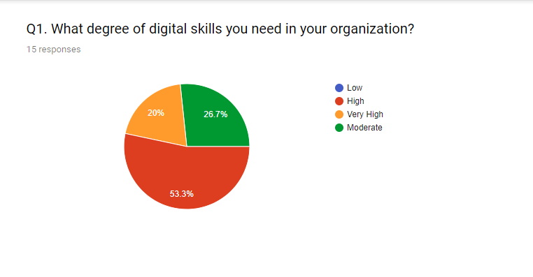
Here we can see that degree of skills needed in on organization is mostly high. More than 53.3% of the respondents answered that they needed high level of skills to compete in their workplace. So we can clearly see that digital skills are pretty much a necessity in today’s workplace. None didn’t respond that they don’t need digital skills. So we can say that digital skills are very important in today’s workplace and we can’t think of today’s workplace without Digital Skills.
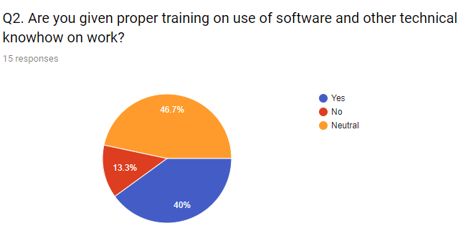
We know for use of technology we need to know the technical knowhow. So many people previously responded that they need a lot of digital skills in workplace. However only few responded that they are trained properly in the workplace. As a result it is seen that training related to use of software or other stuffs still needs a way to go. A small portion even said that they are not given proper training.
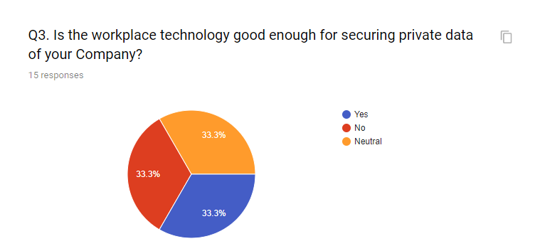

It’s very important for Companies to protect their personal information. We see mixed reactions all together. So we can say overall workplace technology still requires a lot oto do for securing internal data of the organization.

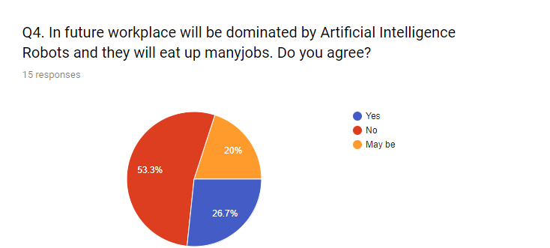
In this age of Machine Learning more and more Companies which are tech based are planning to move towards robots and drone. Its said by money that Robots might be replace human labor. Most of the respondents did not agree and others were neutral. So we can clearly say that though Artificial Intelligence Robots might highly dominate the workplace in future but it is expected that for controlling those robots we also need human.
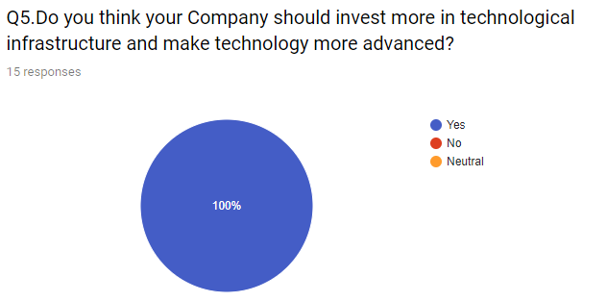
So we know that workplace is pretty much dependent on use of technology. But when it comes to training the employees perhaps more initiatives are needed. None of the employees is 100% contempt with the training provided by workplace for their day to day work. So it clearly shows that Companies should invest more in technological infrastructure.

4. Research Methodology

4.1 Primary Research
Primary Research involves collection of data by directly interacting with people here for primary research we used survey questionnaire method. The sample consisted of people working in different places in United Kingdom.

4.2 Secondary Research
For secondary Research we need secondary data. Secondary data is the data obtained after someone collects primary data. Like if someone finds the number of hospital beds by going to every hospital than that is primary data. On the other hand after that is published as a report and uploaded in Internet and when I use data from this source in any report it is called secondary data. For secondary Research there is use of internet, journal and other articles.

5. Technology in work
Some implication of workplace technology are as follows
i. Have a unique email id for Communication
Through Microsoft Outlook a Company provides its employees with a unique email address in name of Company. For example a Company name as traders will assign email id with an employee named mark known as mark@traders.com. Everyday a lot of emails is sent to different parties of business or clients. The creation of unique email id helps us to distinguish from the others. We see exclusive use of Web Mails in Companies since they are having a unique identity.
ii. Arranging Meetings, Presentation and Conferences
Web conferencing is widely used nowadays for meeting, presentations and conferences online. We can connect to conference by using telephone or we may also use Computers speakers and microphone through a VOIP connection. We know that distance is a huge barrier nowadays and in age of globalization. So through web conferencing different parties can be easily connected. It gives transmission and of images which are static and texts of 2 different locations. Some examples are Apple Facetime, Microsoft Skype who has taken video conferencing to a whole new level. The main benefit of video conferences is that travel costs are lowered especially for training the employees. So Web conference indeed removes the barriers of distance and helps to provide a flawless Communication.
iii. Storage of file or data
We live in such an age where importance of data simply can’t be ignored. It’s even said that in this age it is said the person who has more information or data has more power as a matter of fact. An organization deals with numerous data nowadays. So they are needed to be properly backed up. If they are not backed up properly than it might create a huge havoc. Companies nowadays use dedicated hosting or what they say is a personal server. All data are stored in the server and as a result it is connected to Computers within the organization. Each user who is given access to the data is given a unique id and password. By logging in the server the specific user can access the data he/she needs. Besides Companies also use cloud storage where a lot of data is backed up. Companies which are much smaller in size use Portable Hard Disks or other things. The more data is backed up the more we are safe.

6. Social media in workplace
Social media has a lot of impact in the workplace. Let’s discuss some of the following use of social media in the workplace
i. Facebook
As we know that Facebook is the most popular Social media. There is indeed a lot of its use in workplace. So let’s discuss how Facebook is used in workplace
Facebook Marketing
Companies can reach their target audience through Facebook boosting like if they want to reach a specific demographic.

Online Community Management
If a customer knocks a page than an online Community manager responds to all his queries and provide all the feedback needed. So as result it gives fast solution to customer’s problems.
ii.Twitter
Customer service
There are a lot of consumers who are twitter savvy so many companies provide solution to their customer’s queries via twitter.
Getting feedback
In case of many Australian business there is use of twitter for getting reviews, comments and feedback. It plays a vital role for improving business as a whole.
iii.Linked In
It is considered as the world’s largest professional network. So Linked in is commonly used for viewing employee profiles, posting jobs etc. Some uses of Linked In are shown below
Connections and networks
Like Facebook and Twitter through Linked In Companies can build a strong base of followers.
Promotion of Content
Like Facebook, Twitter Linked In can be a very useful platform for promotion of content.

7. Implementing Technology for Workplace Security
So for workplace security business rely a lot on technology. So some of the following things which are done for security with help of workplace technology are as follows
i. CC Camera
Almost in all business organizations and other places of work this has been common for ages. The areas which are covered by CC cameras now can also be accessed with help of an app in many cases. So if there is an event of theft or forgery the victims can easily be traced.
ii. Use of metal detectors for check ins
In many places for safety reasons or to prevent other people from carrying harmful devices it is used.
iii. Backing up important data
Information is one of the most important element in today’s age. If Information is lost than a lot of crucial element is lost. It’s very necessary to back up such vital information. Companies use cloud services, personal server to back up these data.

8. Conclusion
So finally we can say that in such age of Information technology we need to have proper digital skills. Technology is prime mover in process of economic development and in this age of digitalization we need to have digital skills. So there is no other alternative other than processing some digital skills.

9. Reference
i. The Importance of Digital Skills in the Modern Workplace Read more at: Https://www.skillsyouneed.com/rhubarb/digital-skills-modern-workplace.html. (n.d.). Retrieved March 27, 2018, from https://www.skillsyouneed.com/rhubarb/digital-skills-modern-workplace.html
ii. Emma, L. (2018, March 15). Importance of Technology in the Workplace. Retrieved March 15, 2018, from http://smallbusiness.chron.com/importance-technology-workplace-10607.html
iii. Video conference (video conferencing). (n.d.). Retrieved March 27, 2018, from http://searchunifiedcommunications.techtarget.com/definition/video-conference
iv.11 Ways Your Company Can Leverage LinkedIn. (n.d.). Retrieved March 27, 2018, from https://www.inc.com/young-entrepreneur-council/11-ways-your-company-can-leverage-linkedin.html
v. Pothos, K. (n.d.). Managing Security and Compliance in the Open Workplace. Retrieved March 27, 2018, from https://www.workflowotg.com/december-2014/256-managing-security-and-compliance-in-the-open-workplace

