Assessment Presentation
Name: Daniela Ciobotar
#1: ABOUT USING THE LIBRARY AND GATHERING INFORMATION
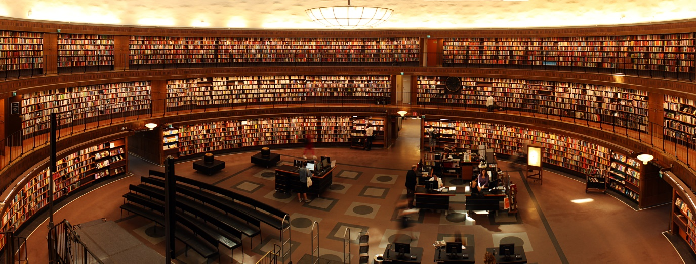
We live in an age of information and knowledge explosion. Libraries have a long history, and they have gone through many stages in their evolution, from closed libraries, with limited and exclusive access from ancient times, to today's libraries that offer you access unrestricted, online, heterogeneous collections, from traditional ones to documents digital or electronic and multimedia resources. Information and communication technology play a significant role in this process and in implementation of a knowledge management system in the library. This does not mean, however, that a knowledge management system can only be reduced to technology.
Culture is a form of human expression that takes into account all the experiences that have been accumulated throughout history. and thus be able to progress more easily.
Man, after inventing writing, had to find new ways of transmitting it, starting from scribbled clay or metal tablets, through writing on animal skins, then on papyrus and later on paper. So that they could be stored and read by those who wanted this, a solution has been found that has survived to the present day, and its name is the library.
One of the seven wonders of the ancient world is named after a library that housed almost all the science and culture of antiquity, namely the Library of Alexandria, an institution known to have existed for nearly a thousand years.
Everything that is human, all the knowledge of this world is in the books. Wisdom, science, poetry and the story of the world are in all the books that have been written and have been housed and cared for in the wonderful space of libraries, being the most precious treasure of humanity. Whoever enters a library and reads a book has a new life experience, which brings him new feelings and helps him to develop and find a meaning in life. The library is the only institution in the world that has not changed its program and purpose from the dawn of humanity to the present day.
Until recently, only library buildings had books as their source of knowledge for the entire creation of mankind. With the current generation, libraries have found a new home, that of the virtual world. which computers host. Thanks to the communication with the help of the virtual space, we can have access without moving to all the books that have been rewritten in digital format. Of course, there are no more browsing pages, the books no longer have the smell of print, but they are always available.
Although virtual libraries are more convenient and handy, their support still remains in the world's major libraries. In them, you are also greeted by the man trained in the work of books, the librarian, who in two or three words exchanged with him, will always know which book suits you. It's good to know that and follow his advice.
Reading is undoubtedly an act of human formation, through which children and young people acquire useful knowledge and skills throughout their lives.
The first steps in the world of books are usually taken in the world of the school library. Especially in rural or disadvantaged areas, home books are often missing and little schoolchildren inevitably end up in the school library. Being part of the school system, the library is a collection of documents (books, magazines, audio-visual materials, albums) with encyclopedic character, according to the level and profile of the school.
The library space contributes to the approach of reading and to the formation of the habit of reading. At first, teachers recommend books to students, but later desire and curiosity will direct students to the library. A school library has primarily a pedagogical, cultural function but also a function of communication and storage of information.
The school library is a source of real and current information in the life and world of students, and the librarian and teachers must find ways and methods to use books effectively, which are properly adapted to the process of modernizing education. Although the Internet and the world of technology have long been components of the challenge of the modern world, the library remains a cultural necessity, a symbol of knowledge and progress.
The world of the library is often the space in which the student discovers himself, in which he learns, studies, knows and looks at his universe. Books give him access to information, and school performance is enhanced by the systematic presence of students in the library. Not only the compulsory reading and the textbooks, but also new fields and areas of interest arouse the students' curiosity. The library therefore has the duty to ensure students' access to the permanent home loan of the necessary volumes but also a real support in the preparation of school reports, bibliographies or homework, being an irreplaceable training and learning space.
Given the above, the conclusion is that the library is a very important thing in everyday life. It has been used more in the past, when technology was not as advanced as it is today, but the library is still very useful. Admittedly, today's children are not so attracted to the library because they find all the information they need on the internet, which comes with both advantages and disadvantages. There is a lot of information on the internet, but not all of it is true. There is a lot of breaking news about anything, and the percentage of believing that news is quite high.

#2: TIME MANAGEMENT

Time is the most important resource we have today. You've probably heard "I don't have time" many times. At some point, we get to say it frequently either at work or at home.
There are people for whom 24 hours is never enough, while others manage to perform their daily tasks effectively. The difference between the first category and the second lies in efficient time management.
We live in the age of speed and we only have 24 hours to solve many tasks both professionally and in our personal life. In the current situation, many habits have changed because we live a new reality. In the work-from-home context, there are several distractions. Thus, the ability to manage your time efficiently makes the transition from failure to success.
Time management refers to a set of habits, skills, systems and principles, used to manage the time spent performing specific activities, in order to increase work efficiency and productivity.
Millions of articles and books have been written, and numerous podcasts, applications, courses, workshops, and trainings have appeared on this topic, but we need to understand that there is no one-size-fits-all universal time management strategy. What works for one team, company, business or individual does not work for another because we are different and have different ways of doing things. The good news is that all of these techniques, skills, or habits can be learned, developed, or implemented according to one's needs, goals, and desires. Traditionally, when we talk about time management, we often think about professional activity and less about what we do the rest of the time. However, some techniques learned for work can be successfully applied in personal life.
When we talk about professional life, whether we are employees, freelancers or entrepreneurs, the watchwords are "productivity" and "efficiency". If until now I only performed the usual tasks and time passed anyway, these 2 words can make the difference in terms of:
- keeping or changing jobs:
- career advancement;
- customer satisfaction;
- building a successful business or lamentable failure.

Time efficiency tips:

- Eliminate activities that are not included in the job description / tasks for which you are not paid (including personal activities - e-mails not related to your activity, time spent on social networks, etc.)
- Schedule more difficult tasks for the times of the day when you know you are more energetic. This way, you will work better and in a shorter time;
- Reduce the number of exchanges between different tasks. For example, read and reply to several emails once / several times during the day, at clearly defined time intervals. This solution is more suitable for solving an e-mail among other activities;
- Reduce time spent on activities (coffee making, cigarette break, etc.). If you have several colleagues, you can make coffee in turn, for everyone. This will save you time and strengthen your team spirit;
- Don't take too many tasks at once. Sometimes a high volume of tasks can demoralize / discourage you. Be realistic when setting your to-do list;
- Delegate - Leaders know how to delegate activities that others can do to focus only on those activities that matter, make a profit, or create strategies that move the company or business forward;
- Be creative, alternating pace. For example, after a difficult task, choose a lighter one to avoid the routine;
- Don't forget the breaks. Surely you have heard of the Romanian saying the long and frequent pauses, the key to great successes. Well, let's just say it's partly true. You can't be productive if you work tirelessly. Most people work efficiently for about 60-90 minutes with a 5-10 minute break.

#3: CV WRITING

The CV is an activity report that is sent to an institution or company in order to inform them about your people. The purpose of a good resume is to make an invitation to an interview. Your resume is proof of your ability to communicate and organize.
A very well done resume shows by itself what a valuable employee you could be. Likewise, a resume made in a way that is too subjective is a sure way to get you out of the fight right before you start. The CV does not serve to tell the story of life from A to Z, but is a document that, before being written, must be very well designed: it therefore requires or deep reflection. It is therefore necessary to follow some rules of presentation and writing. This does not mean that you have to faithfully copy the models proposed in the journals or in the practical guides.
From these models you can be inspired, adapting them to your personality and training. The paradox of a resume is that it must be very personal and, at the same time, respond to some well-defined rules. A competitive resume must oscillate between these two requirements.
There are several types of resumes, most of which are:
- Chronological CV
- Functional CV
The chronological CV presents in a sequential way the most recent activities and continues with the most distant ones in time. In this type of CV it is not necessary to mention all the activities, especially those not relevant for the job, but care must be taken that the CV does not contain unexplained elements of discontinuity which could lead to erroneous or unfavorable conclusions. . .
This type of resume does not benefit those with repeated career changes or those with little experience. However, it is particularly advantageous for those who are looking for a new job, having a solid work experience and a relevant evolution of previous jobs. It is the preferred type of CV for traditional fields (in education, health, management).
The functional CV, however, emphasizes the achievements without taking into account their chronology. This type of CV is suitable for those who want a change of career, or activity profile, when you want to highlight certain qualities that have not been used in the experience so far. It is also useful in cases where you do not have the experience at all.
Your resume is the first impression you make on your employer, and a good resume depends not only on what you write; how you present what you say is just as important. A poorly presented resume will reflect a careless image of your personality that will not bring you any benefit. Such a presentation rightly raises the question of whether you are truly motivated and no one wants to hire someone who sends a resume full of mistakes and poorly presented.


#4: PUBLIC SPEAKING

Public speaking can help you promote your job and grow personally. Most of us have various topics related to public speaking (surveys say that about 90% of people who have a speech are afraid) and what not many people say is that public speaking requires training. By considering a few tricks, preparing your speech well enough and being passionate, you will be able to successfully give a speech in front of colleagues or a room full of strangers.
The art of oratory can be learned by anyone who wants to advance in his career. However, public speaking has a lot of other benefits that should not be ignored before saying that you will never learn the practice of public speaking. Below are the most important of them:
•Drives shyness •Supports critical thinking •Improves communication skills •Helps with networking •Teaches you to be persuasive •Develops leadership skills •Develops your vocabulary and fluency •Reduces fear of spontaneous speech •Helps you learn to debate an issue •Will learn that what you say is not everything •Teaches you to be calm in stressful situations
From my point of view, public speaking has quite a consequence, not everyone can handle it. Some people are more shy and some are more daring, which makes them better at public speaking.
Indeed, you need some skills to do great in this, which is why there are even special courses to teach you.

