

Individual project report
Student Name: Georgiana Madalina Usurelu
Student Number: 2226304
Lecturer Name: Dr Essa Bah
LCBB4005_BIRM

The Global Business Environment
Table of Contents
Introduction 3
- History of Amazon 4
- PESTLE Analysis 4
  - Political factors 4
  - Economic factors 5
  - Social factors 6
  - Technological factors 6
  - Environmental factors 6
  - Legal factors 7
- Porter’s Five Forces Analysis 7
3.1. Threat of New Entrants 8
3.2. Threat of substitute products 8
3.3. Bargaining power of suppliers 9
3.4. Bargaining power of buyers 9
3.5. Rivalry among existing firms 9
Conclusion 10
References 10

Introduction
“Globalisation is the widening and deepening of interdependent relationship among people from different nations. The term sometimes refers to the elimination of barriers to international movements of goods, services, capital, technology, and people that influence the integration of world economies.” (Daniels, Radebaugh and Sullivan, 2018, p.49)
The business environment includes all forces outside the organization that can affect all aspects of organizational operations. (Brooks, Weatherston, and Wilkinson, 2010)
Founded by Jeff Bezos in 1994 and started as an online bookstore, Amazon is one of the world's largest multinational technology companies. Over the years, Amazon has expanded and offers a variety of products and services, including electronics, clothing, groceries, and web services. Amazon has a dominant position in the e-commerce industry and has successfully adopted various strategies to maintain its market leadership. This report uses the PESTEL framework to analyse Amazon's external environment and then Porter's Five Forces framework to examine the competitive landscape.

- History of Amazon
Amazon is a company that needs no introduction in the e-commerce world. The largest online retailer in the world, Amazon has grown and evolved since its inception in the early 1990s. Founded by Jeff Bezos, Amazon started as an online bookstore, which quickly became a phenomenon. Bezos' foresight and confidence in his vision for Amazon have proven to be right, with the company now selling virtually everything under the sun.
Despite facing rejection from his employers, Bezos remained steadfast in his plan and launched Amazon in Seattle in 1994. The name "Amazon" was inspired by the Amazon River in South America, with Bezos envisioning the company's size to mirror the river's enormity. In just a month after its launch, Amazon shipped books to every state in the U.S. and 45 other countries, hinting at the revolution that was to come.
Bezos' hands-on approach was instrumental in the company's early success. He was involved in every aspect of the business, even aiding in its delivery service, assembling orders, and driving packages to the post office. Amazon went public in 1997, increasing its awareness and providing an opportunity for investment. By 1998, the company had expanded its product lines to include music and video stores, toys, and electronics.
With acquisitions of online booksellers in the UK and Germany, and IMDb, a company that focused on calendars, address books, and reminders, Amazon began its predatory nature on its competitors early on. In under four years, Amazon became a force to be reckoned with, with a market capitalization equal to the combined values of bricks-and-mortar rivals Barnes & Noble and Borders Group. This growth highlighted the company's potential for dominance from the start. (D’Agostino, 2018)

2. PESTLE Analysis

A PESTLE study investigates the major external elements that impact an organisation (political, economic, social, technical, legal, and environmental).
It may be used to help professionals and executives in making strategic decisions in a range of settings. (CIPD,2021)

2.1. Political factors:
Political decisions have an impact on all aspects of the business environment.
Central governments, local governments, and international organisations make decisions on economic policy, competition policy, legislation, environmental frameworks, technology, and globalisation, among other things. Political change presents opportunities or threats to organizations. (Brooks, Weatherston, and Wilkinson, 2010)
According to Worthington and Britton (2006), “Understanding political systems, institutions and processes provides a greater insight into business decisions and into the complexities of the business environment”. (p.41)
Amazon's activities are influenced by the political environment in a variety of ways. For example, the corporation has experienced numerous regulatory obstacles in many nations, affecting its expansion goals.
Furthermore, Amazon has been criticized for its tax procedures, which have led to charges of tax evasion.
Moreover, political instability in some countries may have an impact on Amazon's supply chain and distribution networks.
However, Amazon always has to gain from the stability of political regimes, as they create opportunities for the expansion of Amazon's business. (Onyusheva and Seenalasataporn, 2018, p.54)

2.2. Economic factors:
As indicated by CIPD (2021), external economic factors that can help influence organizational decisions, maximize opportunities, and minimize risks include: inflation rates, interest rates, exchange rates, economic growth/decline, working hours, wage rates, cost of living, minimum wage, unemployment, credit availability.
In addition, changes in the international environment, such as bilateral and global trade relations, international competitiveness, the EU, and market globalization, affect organizations whether they are involved in international markets or not. It shows the impact of interest rates, inflation, and competition policy on an organization. Changes in government training policies can also affect the level of skilled labour available, impacting organizational productivity and causing competitors to gain share in previously safe markets. (Brooks, Weatherston, and Wilkinson, 2010)
Economic factors such as inflation, exchange rates, and economic growth have a significant impact on Amazon's operations.
Economic downturns can cause a decline in consumer spending, which can affect Amazon's income.
Moreover, changes in exchange rates can have an impact on the company's profitability, particularly in countries where Amazon operates.
Without a question, Amazon is inextricably linked to each country's economic realities. For example, there are high-income countries and low-income countries that motivate consumers to search and buy. Amazon has also benefited from the pandemic. Consumer interest in finding their needs on the Amazon website. Taxation affects a company's performance and operating costs. (Hatem, 2020, p.74)

2.3. Social factors:

Social factors such as demographics, lifestyle changes, and cultural values ​​influence consumer behaviour. Amazon has responded to changing consumer preferences with a range of products and personalized services.
(Hatem, 2020, p.74)

2.4. Technological factors:
The usage, or lack thereof, of technology has a significant impact on the competitiveness of enterprises, industries, and nations.
Employee attitudes and behavior can influence the extent to which technology is accepted, and some organizations fail because they are unable to adjust rapidly enough to the ways in which technology is evolving.
Technology acceptance and growth are related to other macroenvironmental elements such as economic health, which determines the cash available to organizations to invest in employing knowledge and creating and deploying new technology. (Brooks, Weatherston, and Wilkinson, 2010)
Over time, Amazon has used technology effectively, but also secure payments and a privacy policy.
The company's management protected its intellectual property by limiting cybercrime. As a result, the company did not skimp on developing its website or recruiting qualified professionals to ensure the privacy and reliability of its clientele globally.
In addition, live contact was available 24 hours a day, seven days a week. (Hatem, 2020, p.74)

2.5. Environmental factors:

“Sustainability involves meeting the needs of the present without compromising the ability of future generations to meet their own needs while taking into account what is best for the people and the environment.” (Daniels, Radebaugh and Sullivan, 2018, p. 334)
Businesses that exploit natural resources, emit air, or water waste, or make polluting items such as automobiles must be worried about their environmental effect. (Daniels, Radebaugh and Sullivan, 2018)
Amazon has come under fire for its environmental effect, notably in terms of packing and delivery. The corporation has worked to decrease its carbon footprint and has set a goal of reaching net-zero carbon emissions by 2040. Yet, environmental considerations may have an influence on Amazon's supply chain, particularly in terms of raw material availability. (Calma, 2020)
2.6. Legal factors:
According to Brooks, Weatherston, and Wilkinson (2010), laws governing utilities, environmental protection, e-commerce, transportation, human rights, investment are increasingly regulated at the international level. Therefore, it is important for multinational companies to be aware of all international and domestic laws of the territories where they produce, transport and trade.
Amazon being an organization active in the field of electronic commerce, globally, is subject to product limits as well as import and export regulations. Amazon will be able to capitalise on the possibility to enter new international markets more easily if it closely monitors these limits. In order to prevent data and security breaches, the organisation must also safeguard the personal information of its customers. Furthermore, to avoid legal implications, Amazon must adhere to the terms of its agreements with brands and suppliers. Amazon has previously breached agreements with businesses, harming both the relationship with the specific supplier and the company's overall reputation. (D’Agostino, 2018, p.33)

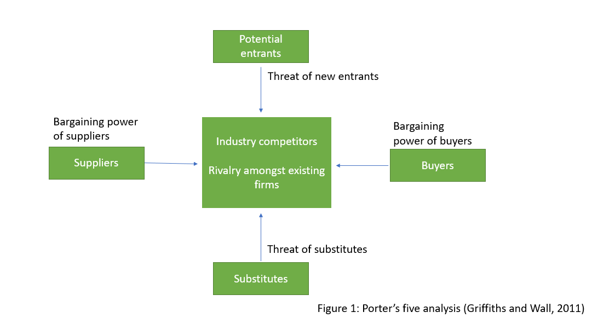
3.Porter’s Five Forces Analysis
The Porter's Five Forces study is a way for analysing a company's competitive environment. Porter claimed that, in addition to a PESTLE study, an industry structural analysis is necessary in order to analyse the competition's strengths and weaknesses and define the competitive structure of a certain market. Porter's Five Forces study (Figure 1), together with an evaluation of the degree of competitive rivalry, may recognise the threat of possible entrants and substitutes, as well as the strength of suppliers and buyers. (Griffiths and Wall, 2011)
3.1. Threat of New Entrants:
The threat posed by new entrants into a sector is determined by market obstacles and the predicted reaction of current rivals to the newcomer. Porter highlighted six potential causes of entry barriers: economies of scale, product differentiation, entry capital needs, cost advantages, access to distribution, channels, and legislative action. (Griffiths and Wall, 2011)
The threat of new entrants in the e-commerce industry is low. Although the market's cheap switching costs make it simple to enter and attract clients, it would be impossible for any brand to compete with a market leader like Amazon. Storage, distribution, marketing, website development, customer support, logistics, and other sectors would require considerable investments for effective e-commerce, such as Amazon. The pandemic recession makes it practically impossible to create a billion-dollar enterprise to compete with Amazon. Amazon has a strong brand since it is the market's largest internet retailer. Amazon differentiates itself by investing millions in customer experiences such as a user-friendly website, fast shipping, and simple returns. (Ningzhi, 2020, p.3)
3.2. Threat of substitute products:
The threat of substitute products has the potential to change the competitive climate in which the organisation works. A new product may render an old product obsolete. The fundamental concern for an individual business is the amount to which a substitute may intrude on its activities. The corporation may be able to reduce the dangers posed by substitutes by a product differentiation policy or by establishing a low-cost position in the industry. (Griffiths and Wall, 2011)
Substitute Threat (Moderate to High): When it comes to online-only merchants, the main substitute is purchasing the product in a physical store. Physical merchants provide a moderate to high threat to the online company under typical conditions. During the epidemic, however, customers' hesitation to buy in physical stores has lessened Amazon's and other merchants' threat of substitution. Additionally, the physical retail industry poses less of a threat because many small local businesses are shutting or ceasing operations because of the pandemic. (Ningzhi, 2020, p.4)

3.3. Bargaining power of suppliers:
Suppliers can constrain industry income by raising pricing or decreasing product quality. Porter considers a supplier to be powerful if there are few suppliers in a certain market, no alternative goods are accessible, the industry is not a significant consumer of the supplier's product, or the supplier's product is a critical input to the buyer's organisation. (Griffiths and Wall, 2011)
Supplier Bargaining Power (Low to Moderate): Products acquired for retail sales are frequently generic enough that a merchant might obtain another product from a different vendor. Despite this, specific medical products such as masks, vitamins, and sanitizers are in short supply during the pandemic owing to increased demand. Premium pricing are available upon request. Amazon can influence supplier prices on most products because of the volume it purchases. The majority of suppliers cannot locate another e-commerce website with the same level of visibility and customer traffic. Furthermore, Amazon's well-developed customer fulfilment infrastructure would deter vendors from pursuing forward integration. (Ningzhi, 2020, p.4)
3.4. Bargaining power of buyers:
In general, the higher buyers' bargaining power, the greater their capacity to reduce industry profits. Porter highlighted several variables of bargaining power, including buyer concentration and size, the relevance of purchases to buyers in terms of cost, the expenses of switching between suppliers, and the degree of standardisation. Buyers should be considered as competitors, but with a good relationship built on performance and honesty. (Griffiths and Wall, 2011)
Buyers' Bargaining Power (High): Consumers are price sensitive. The expenses of switching are modest. Also, the pandemic's economic collapse diminishes demand for consumer goods, boosting competition. Amazon's customer-centric strategy not only enhances its distinguished image, but also provides a varied selection of things on a single site where consumers can compare prices to acquire the lowest price with relatively outstanding quality in the market without visiting retail shops. (Ningzhi, 2020, p.4)
3.5. Rivalry among existing firms:
Lastly, the level of rivalry among enterprises might have an impact on the competitive environment in which the firm works. Rivalry is driven by the dynamics, but it also depends on company concentration and relative market shares, the rate of industry growth, the degree of product differentiation, and the height of existing barriers. The strategies employed by companies to gain an advantage over their competitors are referred to as jockeying for position by Porter. This generally takes the shape of price, marketing, product innovation, and service level policies. (Griffiths and Wall, 2011)
Competitive Rivalry (High): The number of rivals joining the business has expanded in recent years, with numerous retails, small size brands. As a result of the epidemic, the number of competitors may not grow as rapidly as in past years. As a result of declining foot traffic in traditional stores, corporations such as Walmart, Flipkart, and Alibaba have shifted their focus to online commerce. (Ningzhi, 2020, p.3)
Conclusion:
In conclusion, Amazon's operations are influenced by a variety of factors, including economic, political, social, environmental, legal factors. The company must navigate through various challenges, such as regulatory obstacles, tax procedures, environmental impact, and supplier bargaining power. On the other hand, Amazon benefits from stable political regimes, changing consumer preferences, and a strong brand image. While competition and substitution threats are high, Amazon's customer-centric strategy, diversified product range, and efficient fulfilment infrastructure provide a competitive edge. Overall, Amazon's ability to adapt to changing circumstances and maintain a customer-focused approach will be crucial for its long-term success in the e-commerce industry.

References:
Brooks I., Weatherston J., Wilkinson G., (2010) The International Business Environments: Challenges and Changes. Second Edition. Pearson Prentice Hall.
Calma J. (2020) ‘Amazon boosts climate commitments and greenhouse gas emissions’, The Verge, June 23. Available at: https://www.theverge.com/2020/6/23/21300427/amazon-climate-change-commitments-greenhouse-gas-emissions-jeff-bezos, (Accessed 2 March 2023).
CIPD (2021) Pestle Analysis. Michelle Battista. Available at: https://www.cipd.co.uk/knowledge/strategy/organisational-development/pestle-analysis-factsheet#gref, (Accessed 2 March 2023).
Daniels J., Radebaugh L., Sullivan D., (2018) International business: Environments and Operations. Edition sixteen. Pearson Education, Limited.

D’Agostino J. L., (2018) ‘Amazon, E-Commerce, and the New Brand World’, University of Oregon: Scholar bank. [Online]
Available at: https://scholarsbank.uoregon.edu/xmlui/handle/1794/23999?show=full, (Accessed 1 March 2023).
Griffiths A., Wall S., (2011) Economics for Business & Management. Third Edition. Pearson Prentice Hall.
Hatem M. A., (2021) ‘An analytical view of Amazon success in the worldwide’, Life Science Journal. [online]. Available at: http://www.lifesciencesite.com. 10. doi:10.7537/marslsj180621.10. (Accessed 1 March 2023).
Ningzhi L., (2020) ‘Amazon.com, Inc Strategic Audit’, Honors Theses, University of Nebraska-Lincoln.308. [Online]. Available at: https://digitalcommons.unl.edu/honorstheses/308. (Accessed 2 March 2023).
Onyusheva, I. and Seenalasataporn, T. (2018) ‘STRATEGIC ANALYSIS OF GLOBAL E-COMMERCE AND DIVERSIFICATION TECHNOLOGY: THE CASE OF AMAZON.COM INC’, The EUrASEANs: journal on global socio-economic dynamics, (1(8), pp. 48-63. doi: 10.35678/2539-5645.1(8).2018.48-63.
Worthington I., Britton C., (2006) The Business Environment. Fifth Edition. Pearson Prentice Hall.

