Louise Oliver 2105470 ECEY4001C
Human Development

Early Years Practitioner
Transition Booklet


Source-Ourladyrosary.durham.sch.uk

Contents Page no
1.An introduction on Transition 3
2.What is Transition? 4
3.How to use the handbook 5
4.The Role of the Adult 8
5.The needs of the child 9
6.Enviroment 12
7.Partnerships 13
8.Interventions 15
9.Proposed outcomes 17
10.References list 18

Introduction
The purpose of this handbook is to support early years practitioners through transitions. The handbook will include the meaning of transition, the the needs of the child, the role practitioner, the learning environment, partnership working and the proposed outcomes.
In early years transition is an important part of a child’s development and emotional wellbeing and the process of transition will impact on the child and their future. All children should be fully supported appropriately during all parts of transition. (PACEY professional occupational standards).
By giving children the experience of transition, it gives them the opportunity to experience different feelings and behaviors. By practitioners supporting them during this time it can have a positive impact and outcome on a child’s development. By a child having good transition and support it can have a significant effect on the child as they will be able to deal with change during different stages of their life. (Transition in early years working with children and families).
Schlossberg no date) defines transition as an event that involves a change to routine, change to relationships, change of roles and assumptions, and that is according to the website unthsc.edu.
According to Bowlby(no date) building a secure attachment between the child and adult is the most important and beneficial thing for a smooth transition. Bowlby’s transition theory looks at secure attachment and loss.

What is transition?
The general meaning of transition is moving from one setting to another and pupils will experience moves within the school setting. (Galton et al 1999).
Transitions are milestone events for children, and have a definite effect on their development, Early years matters (2018). Transition is a process and should involve the child, the parents and the practitioners.
Transition is a journey with lots of opportunities and change throughout a child’s life which will help the child’s growth and development.
The process of transition is seen as a phase of strengthen and to speed up development that are socially regulated (Fthenakis 1998).
A transition involves a change of status and culture. It requires leaving something behind such as familiar surroundings. Leaving your comfort zone, entering the unknown, a change of friendship group, leaving their parents for the first time when starting nursery or school, meeting new people such as staff and friends, finding out about the roles and rules of the new environment which they are at. (pollard and Filer 1996)
According to Dowling (2014) he states that children and adults feel safe with familiar surroundings and people they know. He also states that the values we place on ourselves are how safe and secure it makes us feel.
Why transition is important?
Erickson (no date) states why transition is important from home to school. The evidence shows there will be less successful outcomes with a poor transition, such as the child not engaging and poor attendance.
Christine Clarke (no date) mentions how important communication is between practitioners and parents during transition. She states that the system in Singapore encourages parents to actively become involved, so that they have a better understanding of how best to support the child during transition.

How to use the handbook
This is an information handbook about transition in the early years. It explains how transition works and how best practitioners and parents can support children through their journey from home to starting school.
By using this handbook, it will help explain to the practitioners the importance of their role and the things that can be put into place ready for the child starting school, and it will also give the staff time to prepare and get things ready for a smooth transition as possible. There are also some practical ideas which can be used as well.
It also explains about communication, which is a vital part for the child, parents, practitioners and any other staff involved, such as key workers, which have an important role to play during the transition and the child starting school.
The handbook looks at different areas of transition which are explained in the introduction and throughout the booklet. To conclude, it looks at the proposed outcomes during transition.

The Role of the Adult
The role of the practitioner is to help, support and guide a child through their transition at whatever stage of their life they are at. So, for example it could be from home to creche or preschool or from the nursery class to reception.
Reggio (no date) felt that the role of the practitioner was to learn as well as teach. He states that staff have a responsibility for their own staff development. By them improving their knowledge and understanding it will help them to improve their skills and engage in the child’s learning. He also states about the importance of reflective practice, not only for the child but for themselves.
Practitioners should make sure that policies and procedures are put in place ready for the children starting school, as this will make it a more successful and smooth transition. Also speak to the parents and ask them for as much information as possible, so the staff will have a good insight of the child’s needs and how best to support them. Policies are seen as ways to operate schools, the classroom local and national government levels and that is according to Aline-Wendy Dunlop. Effective communication is a vital part of the role. It helps to build positive relationships between staff and parents, which will be beneficial for the child.
Communication and management are effective ways of supporting transition in early years. According to Margetts (2002) transition is best based on a philosophy that children adapt better at school when they are more familiar with their new surroundings and environment. Also, by parents being kept well informed about the school and that teachers and other staff have been informed about the children’s previous experiences and development.
According to Bandura (1994) children build up resilience and self-efficacy in a successful transition, but if unsuccessful it can be a negative experience. Observing positive transitions of others can help them to see their own transition as a more pleasant and happy experience. Also, social and emotional support gives the child the opportunity to engage with a smooth transition so that they can understand and get used to settling into their new environment.
It can be an anxious and emotional time for a child and parents when the child starts their educational journey from leaving their home environment to starting school. This this process needs to be managed effectively by the practitioner and other staff involved in that new setting and that is according to (Croneri 2018).
The environment is also an important part of the practitioner’s role. Here are some examples of things that need to be considered when providing provision for the children. That is according to Biddulph (2006)
Are the range of activities being provided suitable for the child’s ability?
The layout of the environment and how easy it is to access resources
How easily the child can move around
Is there a quiet area or somewhere for the child to rest?
Availability of comfort objects and toys
Noise levels as the child have no control over the volume
Is the area clean and fresh?
Access to water if they are thirsty
Create a nurturing environment.
The practitioners should also consider:
How well they know the child
The type of environment the child prefers for example; a quiet or noisy environment
The knowledge and understanding they have of the child
The child’s emotions and how they respond to certain situations
How the staff talk to each other and the children
The relationships they have with the parents
Flexibility during the day for certain activities that are not planned
Reflect on a daily basis.

A key worker plays an important part in the transition of the child. They are the ones that work closely with them on a daily basis and provide them with opportunities to have new experiences which should be done in a positive manner, which will help the child settle in well and develop their confidence.

According to the website twinkl different ways of supporting your child starting school are; listen to any concerns or worries they might have or might be feeling and talk about them, Practice the school run, talk to them about what they can expect in a positive way, get them to try on their school uniform and help them to develop their practical skills.
The role of the adult is also to provide play opportunities for the children. Vygotsky (1993) states the teacher plays an active role, not only by using observation or waiting to see approach. Vygotsky (1978), Newman, Holzman (1983) can be interpreted for supporting and challenging play, as it is aimed to the child’s proximal development.
Learning and developing through play is what Holzman (1997) states about and how to implement it using creativity and interaction.
Children have to be given the opportunity to use raw materials for play in a suitable environment, so children can learn, experience and expand their knowledge. Brostrom (2005) states that it will help with their language, literacy and reading skills.
Mortimer (2004) looks at various methods for obtaining the needs and feelings of all children and the importance of working with parents who know their child intimately. Children with special educational needs won’t always be able to communicate by using words, instead they will use their physical ability to communicate. She then goes onto say about attachment theories by Bowlby (1988), cited in Mortimer (2004). Mortimer then states that the adults working and caring for the child will get to know and understand their individual needs.

The needs of the child
According to Dowling (2014) the key to meeting the children’s needs is to get to know the child and their needs as each an individual. By doing this it is beneficial to the child and the practitioner because you get to know their likes and dislikes which means you can plan for that child and they will achieve to the best of their ability.
Maslow states that for a child to be thrive and be successful in school, they need to feel safe at home, be well fed, need to be sleeping well and to be confident in themselves. The hierarchy of a child’s needs must be met before they are able to concentrate on their education and learning.
According to Maslow’s theory in early years, a key practitioner should be introduced into the school setting for the child and their family to familiarise themselves with that person, so that when the parents leave the child hopefully, they feel happy and comfortable which will help with the child’s education and well-being.

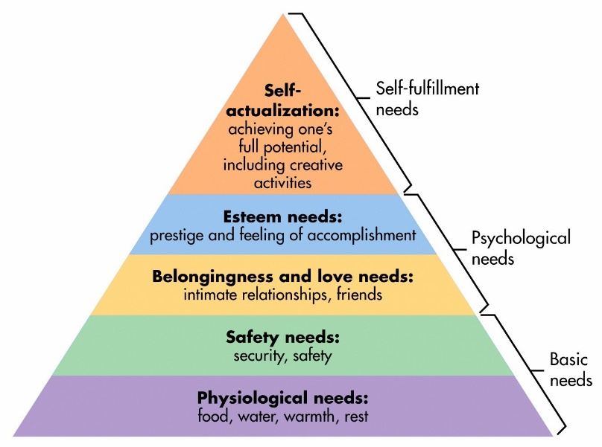 Maslow’s Hierarchy pyramid of needs
(Source bing.images 2021)

Lindon( 2009) believed that from the start parents are a cruical part in managing a childs transition.It is important they help staff to support the transition.This is good practice and helps proffessionals to establish partnerships with parents.
According to Robinson (2010) practitioners need to understand and respond appropriately when children and parents show a range of emotions during the transition.The practitoners aslo need to focus on the emotional well-being of the child as it is an important part of staff development.
Stability is a very important part of a childs early years development .Children will experience lots of transitions even before they get to school age.Good management of staff can help the process of adjustment for the children and their families.When a child starts school for the first time they will be anxious and it can cause seperation anxiety for both the parents and the child.Thats why staff should make the whole proccess as welcoming as possible.
Chalmers (2015) suggests that parents should stay with their children for the first few sessions to help them settle in.It also gives the child a chance to explore their new enviroment, knowing that there is a familiar person there to support them and this will help the childs confidence.This gives the parents and staff members the opportunity to get to know eachother and disscuss the childs routine.
According to the website twinkl, a holistic approach to the childs development in early years is important. By practiitoners using the holistic approach it will help with the assesment and planning because each child is individual and can help you to understand what a child has learned and achieved.

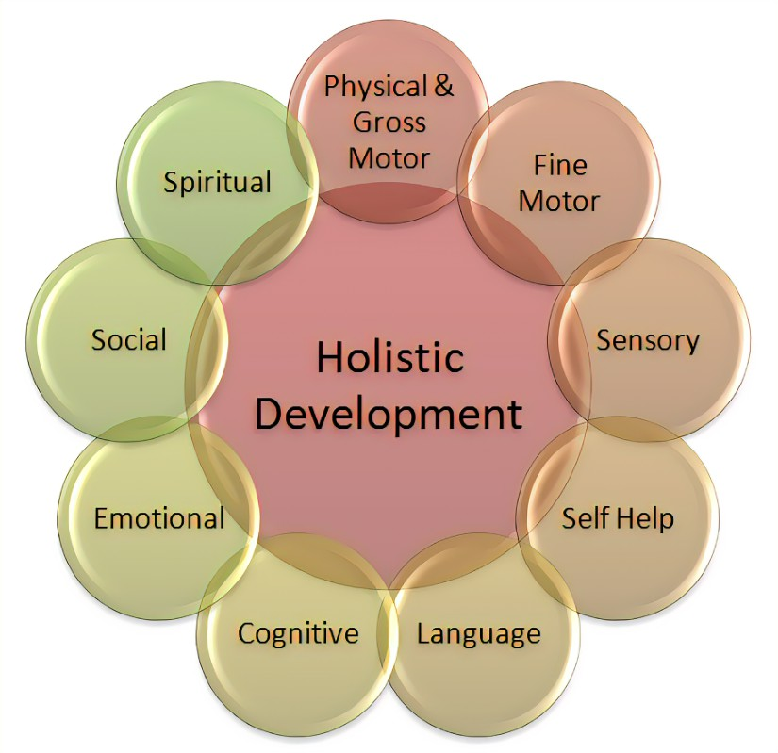

Holistic Development image
Google images

The Environment
The quality of the environment for creches and nursery schools, play are an important part in the children’s learning according to Reggio. He states the importance of role it has in learning and playing, for example, the layout out of the rooms, how it is organised, the actual building, the resources and equipment that is available and staff ratio to the number of children.
The teachers should consider the appearance of the entrance which the children use to come into school. Is it welcoming, and friendly, the layout should be practical, have they got lots of resources that will enable to children to explore and learn, as children are curious and that is how they learn new and different experiences? There could be a wall display of photographs of the new children starting in that class, but generally it should be a pleasant environment to be.
There should also be an outside space which the children can access, as being outdoors is very beneficial for lots of reasons, but it also gives the children the following opportunities;
To explore and investigate
Communicate
Make choices
Be involved in projects
Be creative
Time on their own if they want to
A chance to think and reflect.
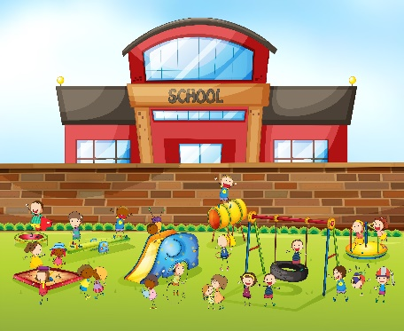
Source; Vecteezy-Google images (2021)

Partnerships
It is important to create links with parents, carers, multiagency workers and any other professionals, as it builds good foundations and bonds between them. By doing this it will help with developing communication which is key and that is according to the website earlyyearseducator.
According to Christenson (1999) the best way to approach partnerships is by working together and to share the responsibility for the children, which will help their education and social skills. Both parents and professionals have an important role and a responsibility in working together, as this will help with the transition and the emphasis should not only be on the school. The way in which parents, families and staff work together should help the social skills and academic development of the children.

The Thomas Coram Early excellence centre is a community in the centre of London. It gives examples of working partnerships in the early year’s environment. He states that the procedure is to maintain and develop good partnerships. It involves having a key worker system, communication with parents on a regular basis, allowing plenty of time for settling in period, focus on the children’s learning, meetings on a regular basis to discuss the child’s progress and informing parents on a daily basis. (Smidt 2005).

Knoph and Swick (2007) states that the first step to building positive learning experiences for the children is to involve the parents, and to develop good relationships and this will help to gain trust over time. Some examples of effective practice are;
Parents and professional practitioners have a duty to the child
Parents and professional practitioners are the most experienced and have the most knowledge of their child.
The contributions made by the practitioners and parents are valuable
It is a non-hierarchy partnership.

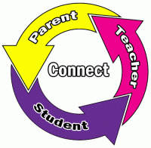

(Source: google images-itd-icon)

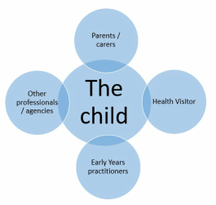
(Source:independentchildminders 2021)

Interventions
This handbook explains the practical interventions of transition in early years.
Early intervention is a good way of being able to identify any matters that may arise and can be used to support young children and people. Early intervention can prevent issues arising and any problems that may occur. Intervention in the early stages will help with social and emotional development and can improve children’s strengths and skills for the future and help them to have the best outcomes.
All children deserve the best possible start in life. It lays good foundations for a happy and healthy life, and it is an important part of their development which could have an impact throughout their childhood. Early intervention is a vital way of providing skills that will help them succeed. This is according to the website Early Intervention Foundation.
The website Early Intervention Foundation states that from birth until starting school is a critical time in a child’s life and their development, as they form bonds with their parents, develop language, skills and other areas of development such as; social, emotional and cognitive development. They also establish behavioral patterns. Early intervention and observation are important parts of identifying children who maybe showing a different level of development, and if there are any gaps in that child’s stage of development, which there could possibly be, if there has been no intervention. The reason why intervention plays a vital part in a child’s life is it help to develop the skills that are important for life.
The outcomes of intervention in the early years include, children’s well-being, the skills they need to lead a healthy and happy life, helps them to form good friendships and relationships, have a happy home environment, good social skills, it can help with their emotional skills, self-esteem, help them grow as a person and help them become more confident, and it will have a positive effect on their education.
According to Froebl (2016) children learn through autonomy and the practitioner should begin with what the child is learning. Frobel believed that all children want to do their best throughout their education and their life. He states that communication is an important part of a child’s learning and by talking that can help with their development. (nurseryworld.co.uk)

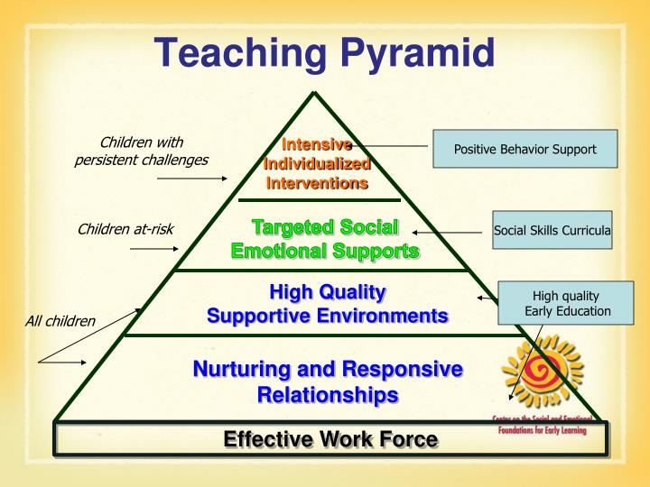

(Source; google images 2021)

Proposed Outcome
A child’s transition has been successful when the child shows they have settled well into their new environment and are familiar with their surroundings, when they are happy and when they show good progress and develop friendships and bonds between other children and staff, such as key workers.
They will become more independent and not rely as much on the practitioner or key worker. They will be more receptive to new challenges and different ways of thinking and it will also help with the child’s social, emotional and cognitive development.
Each child is an individual and they progress and develop at different rates. So, it is good practice that as practitioners they have a good knowledge and understanding of the child and their parents and supporting them both during transition, which will result in the best outcomes for the child.
The Welsh government states the importance of play during the foundation phase and the benefits it has on children, such as the development of positive learning, the ability to make mistakes without the feeling of failure, to develop their literacy and communication skills and to grow in confidence. (gov.Wales February 2021)
According to the website resourceforlearning.org; it states observation and assessment are vital for the child’s learning, as it provides practitioners and parents with information of the child’s development, which can be recorded and used for assessment and to set targets and to make sure the work provided is correct for that individual child, which will result in the best outcomes.

References
assets.publishing.service.gov.uk/government/uploads/sys…
Buddulph (2006) Child development from birth to 8 years. A journey through early year.
Croneri. Managing transitions in early years provisions. Available at: www.https//managing transitions in early years provisions.co.uk (Accessed on 13th November 2021)
Dunlop, A-W. (2007) Informing transitions in the early years, London.
Dowling, M, (2014) young children’s personal, social and emotional development,4th Ed. London; Sage.
Early Intervention Foundation (2021) Available at: www.https://www.eif.org.uk (Accessed 13 November 2021).
Early Years Matters (2018) Transition Available at: www.www.earlyyearsmatters.co.uk/eyfs/positive-relationships/transitions/(Accessed 10th November 2021).
Holistic Development of children during the early years, Available at; www.pintrest.co.uk (Accessed 23rd November 2021).
Indepententchildminders.weebly.com.Google images, Available at; www. Independentchildminders.weebly.com (Accessed 13th November 2021).
Lindon, J. (2009) parents as partners-positive Relationships in Early Years, London; practical-school.
Lindon, J. (2010) understanding child development 2nd Ed. London: Hodder Education.
Maslow Hierarchy of needs (no date) Available at: www.fututre learn.com/info/coursers/supporting learning-primary (Accessed 12th November 2021).
Monmouthshire.gov.uk (no date) Available at: www. https://Monmouthshire.gov.uk (Accessed 22nd November 2021).
Nurseryworld (no date) Available at: https://www.nurseryworld.co.uk
(Accessed 13th November 2021).
Ourladyrosory.durham.sch.uk, Available at; www.ourladyrosory.durham.uk (Accessed 13th November 2021).
Pacey-Professional association for child care in early years Available at: https://www.pacey.org.uk (Accessed 16th November 2021).
Smidt S (2005) Observing young children. The role of observation and assessment in early childhood settings,2nd Ed. Routledge.
St -Catherine’s. barnet. sch.uk. itd-icon. Available at; www.St-Catherines.barnet.sch.uk (Accessed 12th November 2021).
Resourceforlearning (no date) Available at: https://resourcelearnin.org.uk (Accessed 23rd November 2021).
Teaching pyramid. Culture as the social and emotional foundation in the early years. Google images (Accessed 16th November2021).
Thornton, L and Brunton, B (2007) Bringing the Reggio approach to your early years practice, Routledge.
Trodd, L. (2013) Transition in the early years working with children and families, London; Sage.
Twinkl.co.uk (no date) Available at: www.https://twinkl.co.uk>resource (Accessed 12th November 2021).
Unthsc.edu>sites (no date) Available at: www.https://unthsc.edu>sites (Accessed 19th November (2021).
Vecteezy, image or playground. Google images (Accessed 12th November 2021).
Ward,U.(2013) Working with parents in early years,2nd Ed. London; Sage.
Welsh government (20015) the importance of play during foundation phase Available at: www.gov.Wales (Accessed 21st November 2021)

