Management Accounting
LCBB5002
Assignment 2

Karolina Kwiecien
2113036

16/01/2023

Table of Contents
Introduction 3
Part A 4
Requirement 1 4
Requirement 2 5
Requirement 3 6
Part B 7
Conclusion 11
References 12

Introduction
The purpose of management accounting is to provide business leaders with data that will help them achieve organizational objectives. This data is gathered from a variety of sources and then categorized, measured, analysed, prepared, interpreted, and communicated (Burritt, R.L., et al., 2002). It helps management plan, organize, staff, direct, and control. Managers and other internal stakeholders might benefit from management accounting because of the financial and business information it provides (Ward, K., 2012). Management accounting's original objective is to provide useful information to management so that it may carry out its duties efficiently (Hansen, D.R. and Mowen, M.M., 2007). This report exemplifies how various instruments and methods may assist a company's management in choosing a viable long-term business plan.

Part A

Requirement 1
Given the lack of clarity on the time frame for either the original or actual Amana Ltd budget, it is safe to assume that the provided numbers regarding Amana Ltd.’s revenue, costs, and profitability is annualized. Therefore, the monthly information of revenue and cost is obtained by dividing the annual revenue and cost item by 12.
So, the following is the company's monthly control report, which includes the actual budget, the flexible budget, and the monthly activity variability:
Particulars | Actual Budget (Yearly)  Amount  (in £) | Flexed Budget (Yearly)  Amount (in £) | Actual Budget (Monthly)  Amount (in £) | Flexed Budget (Monthly)  Amount (in £) | Activity Variance (Monthly)  Amount (in £) | Performance Analysis (Favourable/  Unfavourable)
Revenue | 2,500,000 | 1,600,000 | 208,333 | 133,333 | 75,000 | Unfavourable
Variable Cost
Material | 250,000 | 280,000 | 20,833 | 23,333 | 2,500 | Unfavourable
Labour | 400,000 | 440,000 | 33,333 | 36,667 | 3,333 | Unfavourable
Overhead | 150,000 | 120,000 | 12,500 | 10,000 | (2,500) | Favourable
Contribution Margin | 1,700,000 | 760,000 | 141,667 | 63,333 | 78,333 | Unfavourable
Fixed Cost
Warehouse Rental | 200,000 | 170,000 | 16,667 | 14,167 | (2,500) | Favourable
Insurance | 100,000 | 100,000 | 8,333 | 8,333 | 0 | No Variance
Supervisor salary | 50,000 | 35,000 | 4,167 | 2,917 | 1,250 | Favourable
Total Fixed Cost | 350,000 | 305,000 | 29,167 | 25,417 | 3,750 | Favourable
Net Profit | 1,350,000 | 455,000 | 11,2500 | 37,917 | 74,583 | Unfavourable

Requirement 2
A review of Amana’s performance in 2020:
The monthly control report for 2020 from Amana Ltd. displays the various lines of annual and monthly revenue and expenses in real budget and flexing budget, figures that are necessary for evaluating the activity variation of the company's various lines of revenue and expenses. The difference between an organization's actual and flexible budgets for a certain time period is known as its activity variance, and it is caused by inconsistencies between the organization's real and planned business activities during that time period. There will be either positive or negative variation associated with this activity. When a company's actual sales revenue exceeds its expected sales revenue or its actual costs fall short of its expected costs over a given time period, the company experiences a positive variance in its operations, while an unfavourable variance occurs when the company's actual sales revenue falls short of its expected sales revenue or the company's actual costs rise above its expected costs (Leone, A.J. and Rock, S., 2002).
Amana Ltd.'s 2020 monthly control report analysis indicates an unfavourable variation in revenue of £75,000, indicating that sales revenue for the month was £75,000 less than planned revenue. The report's study also shows that the company's variable overhead expenditure will have a positive variance in 2020, while its material and labour costs will both be higher than expected. Amana Ltd.’s management may need to spend an extra £3,333 per month on direct labour costs and an extra £2,500 per month on material costs to maintain the company's current level of operations, as shown by the company's unfavourable variation in both types of expenditures. However, a positive variation of £2500 in the company's variable overhead expenditure indicates that the business is saving that much money per month. As a consequence of negative activity variation in sales income and variable expenses in 2020, Amana Ltd.’s monthly contribution margin decreased by £78333 in 2020, implying a fall in contribution margin of £78333 per month. Although the firm's fixed expenses fell by £3750 per month in 2020 (as shown by the favourable activity variance), the firm's net profitability fell by £74583 per month (the unfavourable variance), indicating that the firm lost an average of £74583 per month in profit due to a precipitous drop in sales revenue.
The assessment of Amana Ltd.'s monthly control report for 2020 indicates that the firm is likely to have a deteriorating performance in 2020. For 2020, the company's sales revenue, contribution margin, and net profit all indicate significant unfavourable variances.

Requirement 3
This section of the report contains the pertinent suggestions that have been provided to the CEO of Amana Ltd. in order to enhance the overall performance of the organization. The examination of the monthly control report of the firm indicates that the company is likely to see a decline in its financial performance in the year 2020 due to the precipitous drop in sales revenue and profitability. The leadership of Amana Ltd. is required to focus their attention on the revenue structure and cost structure of the firm in order to facilitate an improvement in the company's overall financial performance and the following is a discussion of the recommendations made to the CEO of Amana Ltd. in an effort to improve the company's financial results:
Revenue structure:
A revenue structure that helps the organization to discover new revenue possibilities (Remeňová, K., et al., 2020). The revenue variance analysis of Amana Ltd.’s monthly control report indicates a negative trend, pointing to falling revenues for the firm in 2020. A decrease in both the total sales volume and the selling price per unit of souvenirs sold by the company in 2020 contributes to the fall in revenue of the business in that year. Early in the year 2020, a worldwide epidemic known as Covid-19 broke out, prompting governments throughout the world to take precautions against its spread. The United Kingdom was one of these countries, instituting lockdowns across the country and instituting social distancing rules in public spaces, both of which contributed to a significant decline in the company's revenue (Gössling, S., et al., 2020). These mandatory lockdowns and social distancing protocols led to a decrease in the number of tourists visiting the UK in 2020, which in turn led to a decrease in the number of souvenirs purchased by consumers, which in turn led to a decrease in the per-unit price and sales volume of souvenirs for the company in 2020. Employing a variety of marketing intelligence tools and approaches is the first suggestion for increasing the company's profits. This will allow the business to accurately predict its future sales by keeping tabs on the target market's shifting tastes, preferences, and demands. The total volume of items sold by the company and the marginal selling price paid per unit in the market at a specific time effect a business's periodic sales budget. In turn, the many forces and circumstances that affect demand in the target market have a significant impact on these two drivers. As a consequence, Amana Ltd will be able to minimize the monthly activity fluctuation in its revenue structure thanks to the use of marketing intelligence tools and approaches to generate an appropriate sales budget. As a second piece of advice, businesses may consider moving their distribution processes online, as several small and medium-sized companies in the UK have done so in order to keep their sales operations running throughout the epidemic. It is necessary, therefore, to improve the firewall of the company's present website in order to move the company's sales activity to internet-based online platforms.
Cost Structure:
The cost structure of a company is the sum of its individual costs, both fixed and variable. Businesses utilize cost structure analysis to determine pricing and pinpoint wasteful spending (Rezvanian, R. and Mehdian, S., 2002).
The monthly control study of Amana Ltd in 2020 reveals an unfavourable variation in the firm's contribution margin, indicating that total variable costs have grown this year. The research shows that Amana Ltd.’s management is inefficient in that the business loses £2500 per month on its material costs and £3333 per month on its labour costs. The global spread of the covid-19 epidemic has led to widespread government lockdowns, which in turn have led to the closure of industrial businesses worldwide. This has led to a shortage of raw materials and a subsequent increase in their market price. Amana Ltd.'s labour expenses will rise in 2020 as a result of the covid-19 requirement that businesses pay greater salaries to their workers in order to retain their services. In contrast, the favourable variance for fixed costs of £3750 in 2020 shows that the company's fixed costs have decreased. The first item of guidance that we can provide is to get into a long-term contract with the suppliers. If you do this, you can legally bind them to keeping the existing price of raw materials over the period of the contract. This is the first piece of advice that we can offer. Equally important for controlling labour costs is for the corporation to enter into long-term contracts with its personnel. The second piece of advice is to avoid the greater supplier concentration risk that comes from sourcing all raw materials from a single Chinese manufacturer by collecting raw materials from several suppliers. The third suggestion is that the corporation use scientific quality management approaches, such as Six sigma, to cut down on the several types of manufacturing waste that arise throughout the production and distribution phases.

Part B
The Make or Buy decision analysis is a key component of management accounting, as it helps companies decide whether they should handle the manufacturing and distribution of their goods in-house or contract it out to an outside company (Cooper, R. and Slagmulder, R., 2004). This analysis pertains to a crucial business choice facing Amana Ltd: whether to sell its products via its own website or via a third-party internet-based e-commerce platform. The executives at Amana Ltd need to make a decision on whether or not to handle distribution in-house using their own website, or whether or not to hire a third-party, specialist e-commerce platform for the job.
Each of the strategic business options that are offered to the organization comes with a set of advantages as well as a number of disadvantages. Amana Ltd. will have full authority over the distribution system that is used by the business as a direct result of the company's decision to sell its products via its very own website. This will allow the company to better understand the requirements and preferences of the target market, which will allow the company to make any necessary adjustments to its product and pricing policies. These advantages of internal distribution do come at a cost, however, since the firm will have to upgrade the firewall on its current website in order to keep track of the additional incoming and outgoing network traffic caused by the rise in online sales. The organization must also recruit competent workers to take care of the website's upkeep and security.
In contrast, outsourcing the sale of the company's goods to a third-party retailer like Amazon would not only cut down on the company's marketing costs but will also save the company from having to spend money upgrading its website. Having less say over product price and distribution is one downside of opting to sell via Amazon. The evaluation of the bottom-line profitability of the company is the central focus of the process wherein the ideal strategic business option is chosen in the event of a make or purchase choice. In this case, Amana Ltd has to make a strategic decision based on how the different revenue and cost structures under consideration will affect the company's bottom line.
The following is a profitability study based on changes in the revenue structure and expense structure of the firm under both alternatives:
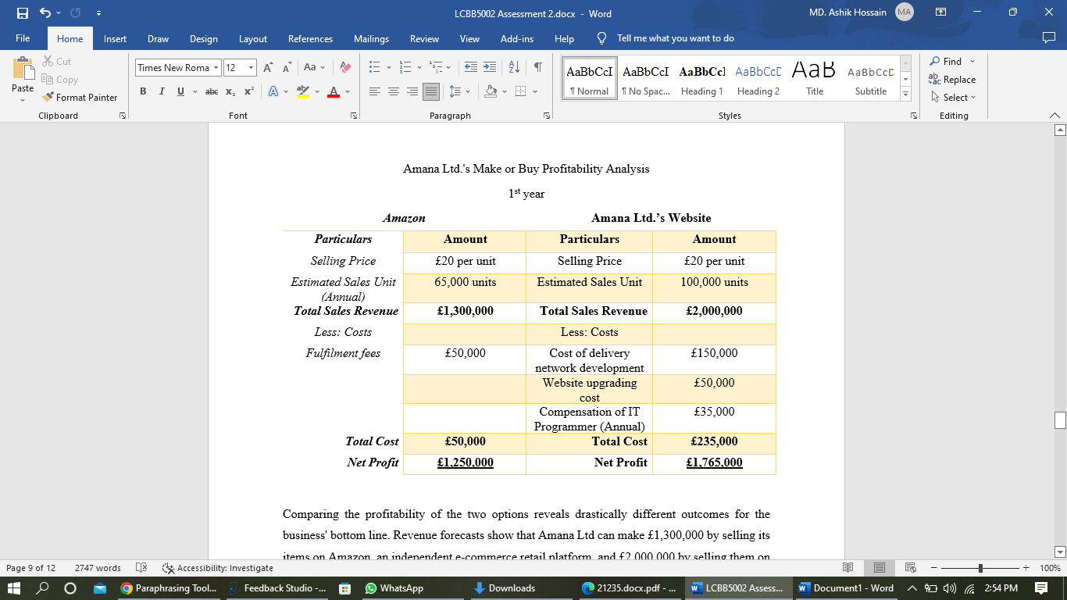
Comparing the profitability of the two options reveals drastically different outcomes for the business' bottom line. Revenue forecasts show that Amana Ltd can make £1,300,000 by selling its items on Amazon, an independent e-commerce retail platform, and £2,000,000 by selling them on its own websites. In light of this information, it can be deduced that if management chooses to offer its items via its own website, it will be able to make £700,000 more in sales income for the shareholders. Since the company may expect to sell 35,000 more pieces annually via its present website, the yearly sales volume will increase from 65,000 units under Amazon's alternative to 100,000 units through the firm's website alternative, resulting in a 35% increase in income.
According to the assessment of several cost structures, Amana Ltd. would pay more if it distributes its items through its website rather than other channels. According to the cost structure analysis, the entire cost of establishing the company's website alternative will be 235,000 pounds, much more than Amazon's 50,000 pounds. At the start of the company's existence, operating under its own website is expected to be costly. This is because the corporation will need to make considerable efforts to upgrade the website's firewall and establish up a distribution network to sell items directly to clients in an effective and efficient way. Amana Ltd will generate £1,250,000 net profit if Amazon's alternative is used, compared to $1,765,000 if its website is used. Although the commercial online option has higher costs, it ultimately triumphs. Amana Ltd., based on a one-year profit analysis, should go with the website option to sell its products online since it will bring in £515,000. This is recommended since it will increase product sales.
Both options assume a similar sales structure in the second year of online sales business operation, but the company's alternative has a much lower total cost because Amana Ltd needs to pay only the annual remuneration of the full-time IT Programmer responsible for maintaining the business's entire website. In contrast, under Amazon's option, the corporation would continue to pay the same amount each year since Amazon will still be responsible for fulfilling customers' online purchases and shipping out the goods to them. Therefore, Amana Ltd.’s profitability analysis for the second year in business is,

It is anticipated that the overall cost of the company's website alternative will drop from £235,000 in the first year to £35,000 in the second year. This will result in an increase of £200,000 in the company's profit if the company's management decides to go with the website alternative. Amazon's bottom line has not been harmed by recent shifts in the company's sales or spending habits. According to the profitability analysis, Amana Ltd.’s website will bring in £715,000 more in revenue during the second year of business.
Therefore, despite higher operating and investment costs at the beginning of the business, Amana Ltd should choose the Company's website over other options when selling its products to consumers online because doing so will increase sales revenue for the company, which will lead to higher profitability for the company.

Conclusion
When it comes to making business decisions, management accountants rely on the financial data provided in management reports (Staniskis, J.K. and Stasiskiene, Z., 2006). Management accounting's significance in the areas of planning and control can only be grasped with a firm grasp of the discipline (Ahrens, T. and Chapman, C.S., 2007). This report exemplifies how various instruments and methods may assist a company's management in choosing a viable long-term business plan.

References
Burritt, R.L., Hahn, T. and Schaltegger, S., 2002. Towards a comprehensive framework for environmental management accounting—Links between business actors and environmental management accounting tools. Australian Accounting Review, 12(27), pp.39-50.
Hansen, D.R. and Mowen, M.M., 2007. Managerial accounting. South-Western.
Leone, A.J. and Rock, S., 2002. Empirical tests of budget ratcheting and its effect on managers’ discretionary accrual choices. Journal of Accounting and Economics, 33(1), pp.43-67.
Gössling, S., Scott, D. and Hall, C.M., 2020. Pandemics, tourism and global change: a rapid assessment of COVID-19. Journal of sustainable tourism, 29(1), pp.1-20.
Cooper, R. and Slagmulder, R., 2004. Interorganizational cost management and relational context. Accounting, organizations and society, 29(1), pp.1-26.
Rezvanian, R. and Mehdian, S., 2002. An examination of cost structure and production performance of commercial banks in Singapore. Journal of Banking & Finance, 26(1), pp.79-98.
Staniskis, J.K. and Stasiskiene, Z., 2006. Environmental management accounting in Lithuania: exploratory study of current practices, opportunities and strategic intents. Journal of Cleaner Production, 14(14), pp.1252-1261.
Ahrens, T. and Chapman, C.S., 2007. Management accounting as practice. Accounting, organizations and society, 32(1-2), pp.1-27.
Ward, K., 2012. Strategic management accounting. Routledge.
Remeňová, K., Kintler, J. and Jankelová, N., 2020. The general concept of the revenue model for sustainability growth. Sustainability, 12(16), p.6635.

