University of Wales Trinity Saint David
School of Engineering

Technical Report of Workshop Session 9/2/2018
MX400384

Benjamin Morgan
1702304

23/04/2018

Contents
1 Introduction 1
2 Research and Laws 2
3 Equipment 3
4 Working Procedure 4
5 Conclusion 6
6 References 7

Introduction
In this report I will aim to write a report on a workshop undertaken on the 9/2/2018. In the report I will explain health and safety laws that must be followed within the workshop and what equipment was used to follow the laws. I will also talk about the work completed in the workshop session and the processes and tools used. To conclude the report I will talk about the skills I have learnt and developed.

Research and Laws
When working within an engineering workshop there are multiple health and safety laws that must be abided by. Some of these laws are the responsibility of the employer, one of these laws is the Personal Protective Equipment at Work regulations 1992. This law states that “from 01/01/1993 employers and self-employed must provide correct personal protective equipment to all employees.” (Health and Safety Executve (HSE), 1992) Personal protective equipment is classed as any equipment that reduces possible damage from risks at work. According to The Health and Safety Information for Employees Regulations 1989 all employers must show the HSE approved poster or provide the alternative leaflet. To assess what PPE is appropriate for the given area a risk assessment must be completed by the employer. Once the risk assessment has been completed “the employer is required to describe all risks that are present and who oversees and controls these risks.” (Health and Safety Executive (HSE), 2009) From this risk assessment the correct PPE required for this workshop session was determined as; steel toe cap boots, dust coats and gloves. When work is being undertaken by students we must follow the laws stated in “Manual Handling Operation Regulations 1992” these regulations illustrate the correct process for lifting objects. It states, “before the object is lifted you should question the best places where a good grip can be obtained, will you need help to lift the object, is the area you wish to place the object clear?” (Health and Safety Executive (HSE), 1992) . We also have to follow rules set out by the Personal Protective Equipment at Work Regulations 1992, these rules dictate that, “Employees must use PPE as shown to them in training, make sure that all PPE is looked after and stored correctly when not being used and that they must alert the employer to and damaged PPE.” (Health and Safety Executve (HSE), 1992)

Equipment
During this session the tools used were; Vernier calliper, a ratchet socket set. The Vernier calliper is an accurate measuring tool, it is able to measure distances to ±0.01cm. To uses this tool, you slide the grips of the calliper to the edges of what is being measure until the grip it has is just enough to slide, the grip must not be too tight as the measurement could be incorrect. The ratchet socket set is a 3/8th inch set which has multiple socket sizes that can be fitted. It can be locked to a certain rotation so that the bolt being adjusted can only be tightened or loosened.

Working Procedure
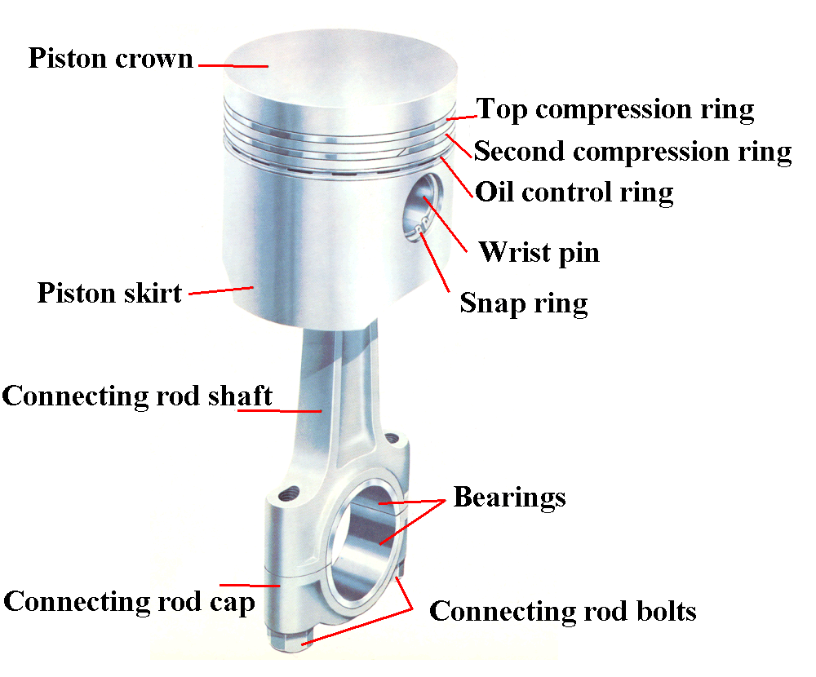
The aim for this workshop session was to remove all 4 pistons and the crankshaft from the block of the engine for examination, the sump will also have to be removed for this to be possible. The first step to complete this task is to remove the sump from the bottom of the engine. This is done by undoing multiple bolts fixing the sump to the bottom of the engine. Once the sump has been removed the oil pickup can be removed by undoing 2 bolts. When this has been removed the crankshaft and the conrods are visible, the pistons are attached to the conrods, therefore to remove them the conrods must be detached from the crankshaft. This is a simple process as they are held on by 2 bolts. After undoing the 2 bolts that connect the conrods to the crankshaft the piston will drop out of the engine, care must be taken to ensure that they don’t drop onto the floor and get damaged. When the pistons are out of the engine, their diameter can be measured. This is done to check if the pistons are circular and if they were the correct size for the bore of the engine block. The pistons were measured in 2 places; the crown and the skirt. The Vernier calliper was used to take these measurements, the pistons in the engine being worked on were the incorrect size and they did not fit correctly, this means that there was no compression in the engine and the pistons we able to move within the engine, this caused unwanted vibrations and rattling. Once the pistons had been fully examined the crankshaft can be removed from the block, there are 5 bearings holding the crankshaft to the block of the engine, they each have 2 bolts through them, once these are undone and the bearings removed the crankshaft can be removed. The crankshaft is a heavy component so care must be taken when lifting it. Once the crankshaft is placed safely onto a surface It can be inspected, when inspecting it, the journals should be checked for any wear. The crankshaft that was inspected had no damage to it.
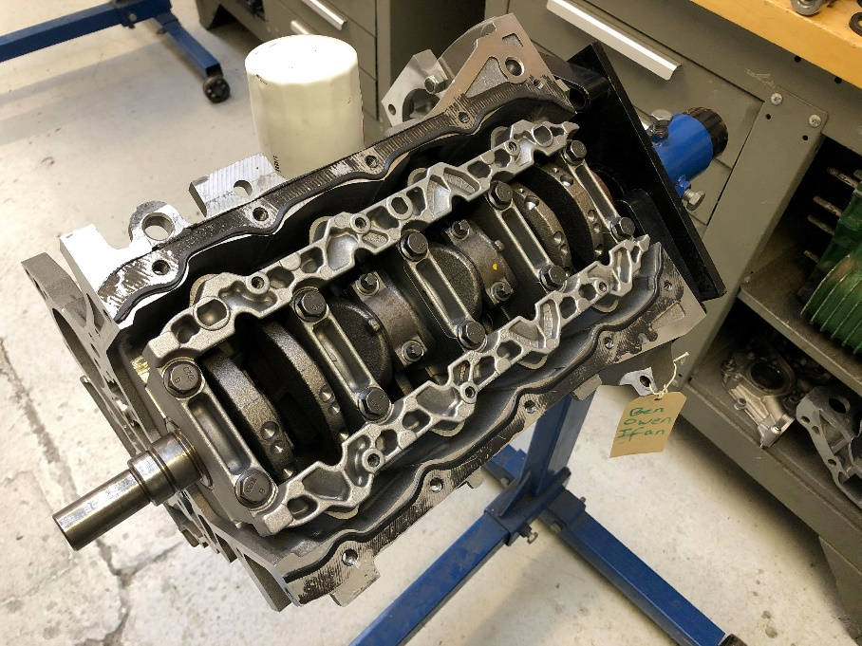
Figure 1 - Diagram of Piston and Conrod
Figure 2 - View of engine, sump removed
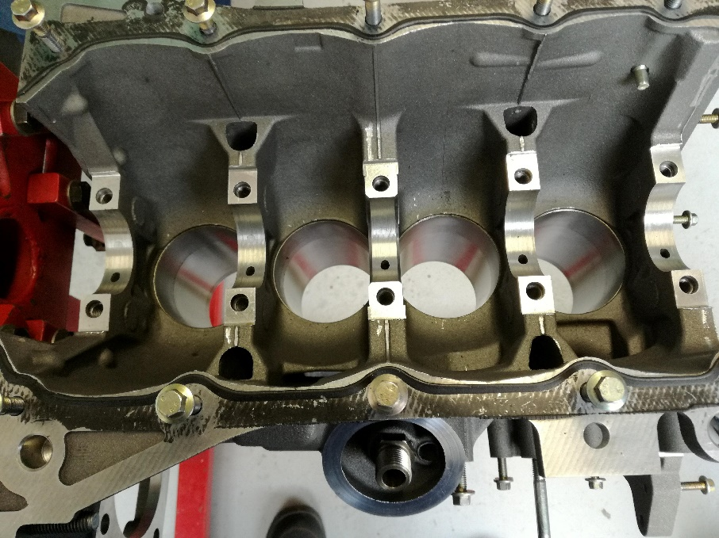
Figure 3 - Crankshaft Removed

Conclusion
During this session all the aims set were completed to a high standard of work. From this session I developed my ability to work to a professional standard with proper working practises. I also developed my ability to accurately use measuring equipment and work as part of a team. All health and safety laws were followed and correct PPE was provided and used. From this workshop session I learned about how the internals of the engine are assembled and how to correctly and efficiently take apart and reassemble this section of the engine.

References
Health and Safety Executive (HSE), 1992. Manual Handling Operation Regulations 1992. s.l.:HSE.
Health and Safety Executive (HSE), 2009. [Online]
Available at: http://www.hse.gov.uk/pubns/lawleaflet.pdf
[Accessed 23 April 2018].
Health and Safety Executve (HSE), 1992. Personal Protective Equipment at Work Regulations 1992. s.l.:HSE.
Figure 1 - http://2.bp.blogspot.com/-nG5JrlnZt0c/UCZBFQtt73I/AAAAAAAAADY/SKB3ZX1aIUI/s1600/piston.gif

