The future of hospitality and is it profitable to be green?

Student name: Elena Gianina Iftimoae
Student Id: 2114228
Module Title: Sustainable Hospitality & Tourism Management
Module code: BMIH5006
Lecture name: Ruth Taylor- Davies

Executive Summary
This report examines the evolving landscape of the hospitality industry with a focus on the profitability of adopting green practices. It analyses Milton Friedman's traditional doctrine of profit maximization in the context of contemporary environmental and social challenges, revealing a paradigm shift toward the Triple Bottom Line approach, which incorporates economic, environmental, and social dimensions into business strategy. Hilton Hotels is spotlighted as a case study, demonstrating the economic viability and competitive advantage gained through sustainable initiatives. Key environmental sustainability models, such as Doxey's Irridex and Butler's Lifecycle, are discussed for their relevance in strategic planning. The report acknowledges the challenges but asserts the feasibility of the hospitality industry becoming genuinely green, advocating for financial resilience as essential for sustainable development. The hospitality industry's future depends on integrating sustainability as a core component of business models, ensuring profitability aligns with planetary and societal well-being.

Table of Contents
Introduction 4
Milton Friedman's Doctrine 4
The Financial Primacy in Hospitality 4
Environmental Responsibility in Hospitality 5
The Triple Bottom Line 6
The Role of Environmental Models in Sustainability 7
A Case Study in Green Profitability – Hilton Hotels 8
Comparative Analysis of Green Practices in the UK Hospitality Industry 9
Can the Hospitality Industry Ever Be Truly Green? 9
Financial Resilience as the Pillar of Sustainable Hospitality 10
Future Recommendations 10
Conclusion 10
References 12

Introduction
The hospitality industry stands at a crucial point, where traditional operational models are increasingly examined under sustainability and corporate responsibility. This report analyses the viability of integrating green practices within hospitality, addressing the prime question of whether environmental stewardship can align with fiscal growth. The report will critically examine Milton Friedman's principle that the sole social responsibility of business is to increase profits and merge it with the modern paradigm of the Triple Bottom Line. Through comprehensive analysis and specific industry examples, primarily focusing on Hilton Hotels, the report aims to analyse the future of the hospitality sector in embracing sustainability without compromising profitability.

Milton Friedman's Doctrine
Milton Friedman’s assertion that the social responsibility of a business is to increase its profits encapsulates the economic ethos of the mid-twentieth century. Still, its applicability in the contemporary hospitality sector is increasingly contested. Today’s global economy is witnessing a paradigm shift towards sustainability, where the doctrine of profit maximization is no longer viewed in isolation but rather in conjunction with environmental and social governance. The hospitality industry, with its vast consumption of resources and significant environmental footprint, is under substantial pressure to adapt to this shift. Contemporary hospitality businesses must navigate a complex landscape where the expectations of shareholders, stakeholders, and a broader socially conscious public converge. While Friedman’s principle undeniably remains a fundamental aspect of business, its relevance is being reinterpreted (Inkson and Minnaert, 2022). Companies that fail to consider the long-term impact of their operations on the environment and society may encounter consumer backlash, regulatory penalties, and a tarnished reputation, all of which can affect profitability. The industry's leading players, including Hilton Hotels, are acknowledging that sustainable practices can coexist with solid financial performance, demonstrating a more nuanced approach to Friedman's doctrine. Through innovation and strategic sustainability initiatives, they are proving that it is possible to honour the ethos of profitability while also contributing positively to society and the environment.
Through a sustainability perspective, the UK hotel industry represented by brands such as Premier Inn and InterContinental Hotels Group is actively rethinking Milton Friedman's profit imperative. These organisations are proving that sustainability and profitability are complimentary rather than antagonistic by incorporating social responsibility and environmental care into their main business plans. The emphasis has shifted from generating short-term profits to creating long-term value while balancing shareholder returns with social advantages. Their proactive efforts in sustainability provide a modern take on Friedman's theory, bringing economic goals into line with the new moral paradigms of the twenty-first century.

The Financial Primacy in Hospitality
Finance has historically dominated hospitality, with shareholder value maximisation guiding corporate choices. But a closer look shows that the financial bottom line is no longer the main predictor of corporate success. The hotel business, which relies on consumer goodwill and service, must now reconcile financial goals with ethical and sustainable practises. Sustainability strategies may require upfront investments, affecting short-term financial results. Sustainable practises are now recognised to provide long-term financial advantages including operational efficiency, brand reputation, and consumer loyalty. Businesses prioritizing sustainability may experience increased profitability through energy savings, waste reduction, and an improved public image (Zhao et al., 2022). In the hotel industry, ‘value’ is being redefined. Value creation now includes social and environmental consequences as well as economic margins. Progressive hospitality companies are using this wider sense of value to innovate, distinguish, and acquire market share, showing that financial primacy is no longer the industry's single driving premise.

Environmental Responsibility in Hospitality
According to Edgell Sr (2019), the question of whether environmental responsibility in hospitality is a business imperative or driven by consumer demand is not binary but rather a confluence of both elements. On one hand, businesses are recognizing the intrinsic value of environmental stewardship as part of their operational ethos. On the other, consumer demand for sustainable practices is surging, with a Nielsen report indicating that 73% of global consumers are willing to change their consumption habits to reduce environmental impact (Nielsen, 2019). In the hospitality industry, this translates to an operational shift where green initiatives are as much about responding to market expectations as they are about proactive corporate citizenship. Environmentally sound practices, such as reducing waste, conserving energy, and sourcing locally, have become key factors in customer decision-making processes (Yadegaridehkordi et al., 2021). Consequently, the industry is witnessing a competitive push towards sustainability, with initiatives ranging from eco-friendly accommodations to sustainable food and beverage services. Incorporating environmental stewardship is also viewed as a strategic approach to risk mitigation, addressing the prospective challenges posed by climate change and the scarcity of resources. For example, The Coed Hills Rural Artspace in the Vale of Glamorgan, UK, is an example of how corporate imperatives and environmental care may work together. This institution uses its dedication to sustainability as a core component of its identity as well to meet customer demand. Coed Hills' operating philosophy is characterised by its concentration on organic farming, use of sustainable construction materials, and commitment to protecting the surrounding ecology. It is an immersive retreat where visitors may fully immerse themselves in living sustainably. Coed Hills sets the standard for ecological participation in business and is evidence of the hotel industry's capacity to prosper economically while promoting environmental responsibility.

The Triple Bottom Line
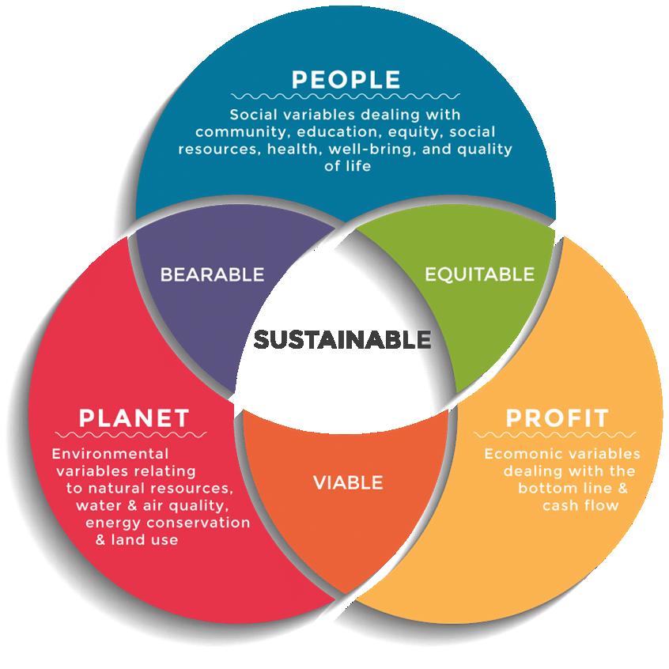
Figure 1: Triple Bottom Line
(Source: Dalibozhko and Krakovetskaya, 2018)

John Elkington's Triple Bottom Line (TBL) strategy adds ecological and social implications to financial reporting. Hospitality, with its large environmental impact and many stakeholder interests, is ideal for this approach. The wider social and environmental impacts of a hotel business's operations are also considered when using TBL. Hospitality companies investing in energy-efficient equipment may incur initial expenditures but save costs over time and benefit the environment. A healthy workplace and community participation may also improve a company's reputation, employee morale, and customer loyalty. Hilton Hotels, among others, has adopted TBL because sustainable development may spur innovation, open new markets, and provide companies an edge. Corporate responsibility measures include lowering carbon emissions, waste, and fostering local culture and economic growth.

The Role of Environmental Models in Sustainability
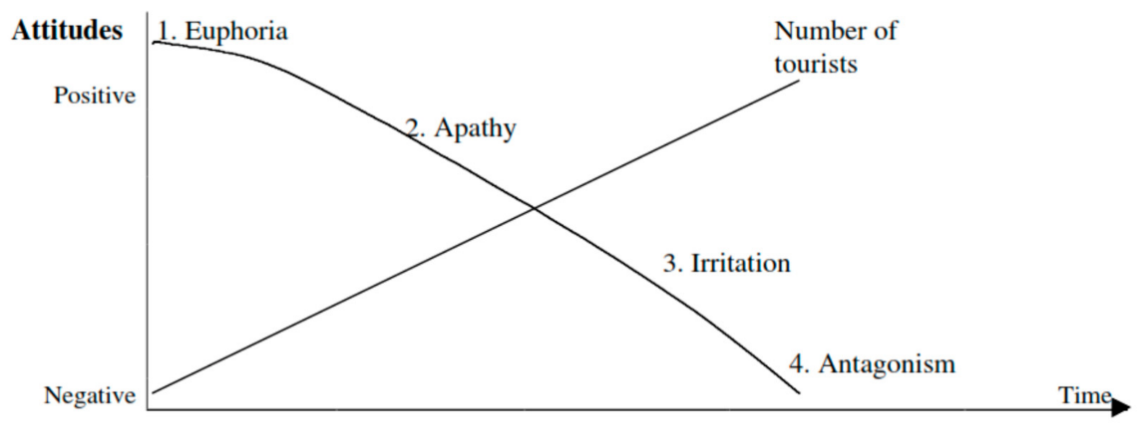
Figure 2: Doxey's Irridex
(Source: Szromek, Kruczek and Walas,2019)
Environmental models like Doxey's Irridex and Butler's Lifecycle model play a critical role in enhancing sustainability within the hospitality industry by providing frameworks to understand and manage the impacts of tourism on destinations. Doxey's Irridex model outlines the stages of community irritation caused by tourism development, from euphoria to antagonism (Haski-Leventhal, 2018). In applying this model, hospitality businesses can anticipate and mitigate negative environmental and social impacts before they escalate, fostering a more sustainable and harmonious relationship with host communities.
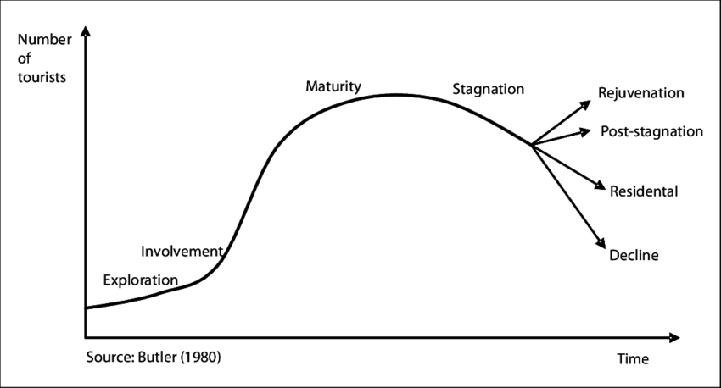
Figure 3: Butler's Lifecycle model
(Source: Nordin and Westlund,2009)

According to Sloan, Legrand and Chen (2017), Butler's Lifecycle model presents the stages of a destination's development, from exploration to stagnation. This model is invaluable for planning long-term sustainable growth strategies in hospitality. By understanding which stage, a destination is in, businesses can tailor their strategies to maintain destination viability, balancing economic objectives with environmental and cultural conservation. These models underscore the importance of proactive environmental management in the hospitality industry. When applied effectively, they enable businesses to predict changes, plan for sustainable development, and implement practices that reduce negative impacts, ultimately contributing to a more resilient and sustainable tourism ecosystem (Cooper, 2022).

A Case Study in Green Profitability – Hilton Hotels
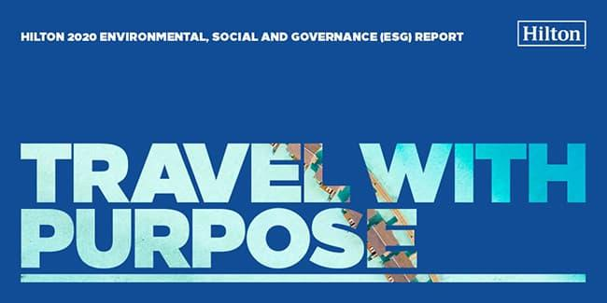
Figure 4: Travel with Purpose
(Source: Chan,2021)
Hilton Hotels has emerged as a forerunner in the hospitality industry's shift towards sustainability, showcasing that environmental responsibility can go hand-in-hand with profitability. The company’s "Travel with Purpose" initiative exemplifies its commitment to the Triple Bottom Line, aiming to cut its environmental footprint in half and double its investment in social impact by 2030 (Aksoy et al., 2019). Hilton has made significant strides in reducing energy consumption, water use, and carbon emissions through the implementation of energy-efficient technologies and rigorous resource conservation programs. For instance, they have invested in smart, energy-efficient building designs and operations, such as LED lighting and high-efficiency appliances, which reduce operational costs and lower environmental impact.
Moreover, Hilton's LightStay system, an in-house brand standard of sustainability measurement, monitors and reports on energy use, waste, and water use, allowing for targeted sustainability efforts (Zientara et al., 2020). This system has reportedly saved Hilton millions of dollars in operating costs, affirming the financial viability of its green strategies.

Comparative Analysis of Green Practices in the UK Hospitality Industry
Some UK hotel companies are leading environmental initiatives, while others are just starting. A comparative research shows an increasing tendency towards ecologically sound operations due to legislative frameworks and customer demand for sustainable travel. Leading hotels like The Savoy in London have thorough sustainability programmes that reduce waste, save water, and source sustainably. The Savoy's renewable energy and environmental collaborations have established a high benchmark in the UK industry (Savoy and McKeown, 2022).
Smaller boutique hotels may evolve swiftly, offering plastic-free rooms, locally sourced organic cuisine, and support for local conservation programmes (Wickham et al., 2021). These practises attract eco-conscious customers, improve operations, and assist the community. UK hospitality firms are saving money by adopting green practises, according to Fernández-Robin et al. (2019). Government incentives for energy efficiency, trash disposal cost reduction, and luring clients ready to pay more for sustainable solutions are examples. Several UK hospitality sustainability leaders are examples of the sector's green shift. The Savoy in London leads ecological activities including energy efficiency and sustainable buying. Sustainable construction pioneers include Cornwall's Eden Project Hotel, which was built using ecological principles. Using renewable energy and locally farmed food, Bournemouth boutique hotel The Green House is ecologically conscientious. Waste reduction and animal conservation have improved at Scotland's Gleneagles Hotel. Finally, the Scarlet Hotel in Cornwall uses renewable energy and sustainable water systems to blend luxury with environmental concern. These businesses exemplify the UK hotel industry's dramatic sustainable change.

Can the Hospitality Industry Ever Be Truly Green?
The hotel industry's goal of being green is commendable but difficult. Becken (2019) notes that the industry's dependency on travel and tourism, which is frequently criticised for its carbon footprint, is a major obstacle. However, strategic innovation and rigorous sustainability practises are helping the sector reduce its environmental impact. Technology and sustainable design are making hotels more energy-efficient and resource-conserving (Gu, Xie and Zhang, 2019). Given the vast geographical distribution of hospitality activities, multiple regulatory systems, and considerable resources required to accommodate international travel needs, totally neutralising environmental effect is difficult. True sustainability in the industry should include socio-economic issues like community engagement and fair work practises. A holistic approach that integrates sustainable supply chain management, ethical sourcing, and tourism to benefit local people and the environment will strengthen the industry's eco-friendly activities (Batat, 2022).

Financial Resilience as the Pillar of Sustainable Hospitality
Legrand, Chen, and Laeis (2022) say financial resilience is essential to sustainable hospitality. It allows firms to afford cutting-edge eco-friendly technology and upfront costs for sustainable activities. A strong financial basis allows workers to get continuing training and development to maintain and enhance sustainability measures. Financial health helps organisations adapt to changing rules and customer preferences, which favour eco-friendly operations (Khalid, 2023). Thus, without financial resilience, the hotel sector may fail to meet long-term sustainability objectives since solvency and profitability may take precedence over environmental care.

Future Recommendations
- Invest in renewable energy sources like solar and wind power to reduce carbon footprints (Kumar, 2020).
- Collaborate with suppliers to promote sustainable practices from farm to table.
- Utilize IoT and AI for efficient resource management and to minimize waste.
- Participate in or create programs to compensate for unavoidable emissions.
- Develop packages that promote local culture and natural conservation, reducing long-distance travel impact.
- Educate employees and guests on sustainability, creating a culture of environmental consciousness.
- Regularly assess environmental impact, set tangible goals for improvement, and transparently report progress to stakeholders (Tavanti, 2023).
- Allocate a portion of profits to fund innovations in sustainable hospitality.

Conclusion
While the principles of profitability and shareholder value remain fundamental to the hospitality industry, the scope of these objectives has undoubtedly expanded to include environmental stewardship and social responsibility. As demonstrated by the actions and commitments of industry leaders like Hilton Hotels, sustainability is not only ethically imperative but also increasingly aligned with long-term profitability and industry resilience. By embracing models such as the Triple Bottom Line, and by being responsive to consumer demands and environmental imperatives, the hospitality sector can indeed stride towards a greener future. Financial resilience, underpinned by sustainable practices, emerges as a key strategy to ensure the industry’s enduring success and positive global impact.

References
Aksoy, L., Alkire (née Nasr), L., Choi, S., Kim, P.B. and Zhang, L. (2019). Social innovation in service: a conceptual framework and research agenda. Journal of Service Management, 30(3), pp.429–448. doi:https://doi.org/10.1108/josm-11-2018-0376.
Batat, W. (2022). The Rise of Positive Luxury. London: Routledge. doi:https://doi.org/10.4324/9781003163732.
Becken, S. (2019). Decarbonising tourism: mission impossible? Tourism Recreation Research, 44(4), pp.419–433. doi:https://doi.org/10.1080/02508281.2019.1598042
Dalibozhko, A. and Krakovetskaya, I. (2018). Youth entrepreneurial projects for the sustainable development of global community: evidence from Enactus program. SHS Web of Conferences, [online] 57(1), p.01009. doi:https://doi.org/10.1051/shsconf/20185701009.
Edgell Sr, D.L. (no date) Managing Sustainable Tourism: A legacy for the future. Routledge. Available at: https://doi.org/10.4324/9781315688343.
Fernández-Robin, C., Celemín-Pedroche, M.S., Santander-Astorga, P. and Alonso-Almeida, M. del M. (2019). Green Practices in Hospitality: A Contingency Approach. Sustainability, [online] 11(13), p.3737. doi:https://doi.org/10.3390/su11133737.
Hilton (2020). HILTON 2020 ENVIRONMENTAL, SOCIAL AND GOVERNANCE (ESG) REPORT CONRAD MALDIVES RANGALI ISLAND. [online] Available at: https://cr.hilton.com/wp-content/uploads/2021/04/Hilton-2020-ESG-Report.pdf.
Khalid, A. (2023). Sustainable Marketing and its Impact on Society: A Study of Marketing Strategies and Opportunities Promoting Eco-Friendly Lifestyle. [online] Social Science Research Network. doi:https://doi.org/10.2139/ssrn.4570227.
Kumar, M. (2020). Social, Economic, and Environmental Impacts of Renewable Energy Resources. Wind Solar Hybrid Renewable Energy System. [online] doi:https://doi.org/10.5772/intechopen.89494.
NielsenIQ (2019). A ‘natural’ rise in sustainability around the world. [online] NielsenIQ. Available at: https://nielseniq.com/global/en/insights/analysis/2019/a-natural-rise-in-sustainability-around-the-world/.
Nordin, S. and Westlund, H. (2009) ‘Social capital and the life cycle model: The transformation of the destination of Åre’, Tourism (Zagreb, Croatia), 57(3), pp. 259-.
Ofori, D. (2021). Opportunities and Challenges of Green Marketing. Green Marketing in Emerging Markets, pp.251–276. doi:https://doi.org/10.1007/978-3-030-74065-8_11.
Savoy, C.M. and McKeown, S. (2022). Opportunities for Increased Multilateral Engagement with B3W. [online] JSTOR. Available at: https://www.jstor.org/stable/resrep41412.
SAGE Publications Ltd. (2021). Strategic Corporate Social Responsibility. [online] Available at: https://uk.sagepub.com/en-gb/eur/strategic-corporate-social-responsibility/book255155.
Sloan, P., Legrand, W. and Chen, J.S. (2022). Sustainability in the Hospitality Industry. doi:https://doi.org/10.4324/9781003081128.
Srivastava, A.K., Dixit, S. and Srivastava, A.A. (2021). Criticism of Triple Bottom Line: TBL (With Special Reference to Sustainability). Corporate Reputation Review, 25. doi:https://doi.org/10.1057/s41299-021-00111-x.
study.sagepub.com. (n.d.). Additional case studies and snapshots | Online Resources. [online] Available at: https://study.sagepub.com/inkson/student-resources/chapter-2/additional-case-studies-and-snapshots [Accessed 12 Nov. 2023].
Szromek, A.R., Kruczek, Z. and Walas, B. (2019). The Attitude of Tourist Destination Residents towards the Effects of Overtourism—Kraków Case Study. Sustainability, 12(1), p.228. doi:https://doi.org/10.3390/su12010228.
Tavanti, M. (2023). Assessing and Measuring Sustainability Impact. Sustainable development goals series, pp.453–473. doi:https://doi.org/10.1007/978-3-031-36907-0_17.
Wickham, M., Donnelly, T. and French, L. (2020). STRATEGIC SUSTAINABILITY MANAGEMENT IN THE EVENT SECTOR. Event Management. doi:https://doi.org/10.3727/152599519x15506259856318.
Yadegaridehkordi, E., Nilashi, M., Nizam Bin Md Nasir, M.H., Momtazi, S., Samad, S., Supriyanto, E. and Ghabban, F. (2021). Customers segmentation in eco-friendly hotels using multi-criteria and machine learning techniques. Technology in Society,
Zhao, L., Chau, K.Y., Tran, T.K., Sadiq, M., Xuyen, N.T.M. and Phan, T.T.H. (2022). Enhancing green economic recovery through green bonds financing and energy efficiency investments. Economic Analysis and Policy, 76, pp.488–501. doi:https://doi.org/10.1016/j.eap.2022.08.019.
Zientara, P., Bohdanowicz-Godfrey, P., Whitely, C. and Maciejewski, G. (2020). A Case Study of LightStay (2010–2017)—Hilton’s Corporate Responsibility Management System. Energies, 13(9), p.2303. doi:https://doi.org/10.3390/en13092303.

‌

