

Krishna Nileshkumar Bhut
Student Number: 2240406
May 2023

Module:
Practice Based Research
(LCHS7001)

Lecturer’s Name:
Dr Aishat T. Bakre

Assignment Title:
Written Report

Table of Contents
Introduction 2
Rationales 3
Research Question 4
Research Aim 4
Research Objective 4
Research Methodolog 4
Research Design 5
Recruitment, Sampling & Study Participants 5
Data Collection Procedure 6
Data Analysis Technique 7
Ethical Considerations 8
Result 8
Theme 1: Factors Influencing Eating in Postgraduate Student's Eating Behaviour 9
Sub-theme 1- Social Factors 9
Sub-theme 2- Reliance on Junk Food 10
Sub-theme 3- Travelling 10
Discussion 11
Conclusion 12
References 12
Appendix 16
Appendix 1 16
Appendix 2 17

Introduction
The well-being of postgraduate students is a developing concern in the ever-changing landscape of higher education, as it has a substantial impact on both academic achievement and overall student success (Ozturgut et al., 2009). One critical aspect of their well-being is eating behaviour, a complex interplay of psychological, social, and environmental factors (Abdoli et al., 2023). This study embarks on a comprehensive exploration of the multiple influences shaping eating behaviour among postgraduate students within the context of a public university, employing a qualitative approach through focus group discussions.
A crucial question that drives this research is: What are the key elements that significantly impact postgraduate students' eating habits at a public university? In order to provide an answer, one can dig deeply into their perspectives, experiences, and difficulties in an effort to disentangle the complex network of factors influencing their food preferences.
The primary aim of this research is to identify and understand the multifaceted factors impacting the eating behaviour of postgraduate students, shedding light on the complexities that go beyond mere nutritional considerations. By doing so, we strive to contribute valuable insights to the development of targeted interventions and support mechanisms that enhance the overall well-being of this student demographic.
The importance of this study extends beyond the academic realm, reaching into the broader context of public health and university policy-making. As postgraduate students navigate the challenges of higher education, their dietary habits play a pivotal role in determining their physical and mental health (Rogler et al., 1991). By gaining a nuanced understanding of the factors influencing their eating behaviour, universities can tailor their support services to foster a healthier and more conducive environment for academic success (Lisnyj et al., 2021).
In the subsequent sections of the paper, a comprehensive overview of the existing literature on eating behaviour in the context of higher education was provided, laying the groundwork for the research. The methodology employed was then outlined, detailing focus group discussions and the selection criteria for participants. Adopting a "show, don't tell" approach aimed to immerse the reader in the lived experiences of postgraduate students, avoiding unnecessary detail while presenting a vivid picture of the factors shaping their eating behaviour. Through this exploration, meaningful insights were sought to contribute to the ongoing discourse on student well-being in higher education.

Rationales
The selection of this research topic, "A focus group discussion examining the factors influencing eating behaviour among postgraduate students in a public university." is grounded in the recognition of the pivotal role that eating behaviour plays in the overall well-being and academic success of postgraduate students (Milyavskaya et al., 2011). As higher education institutions increasingly acknowledge the importance of holistic student support, understanding the factors shaping the dietary choices of postgraduate students becomes imperative for informed intervention strategies (Al-Fattal, 2010).
While some studies touch upon the general eating habits of university students, they often lack the depth required to unearth the nuanced influences specific to postgraduate life (Burke, 2015). This research aims to address this gap by employing a qualitative approach, using focus group discussions to capture the rich and diverse experiences of postgraduate students and elucidate the factors shaping their eating behaviour.
Moreover, the focus on public universities is deliberate, as these institutions serve diverse student populations with varying socioeconomic backgrounds and access to resources. Understanding the factors influencing eating behaviour in this context is crucial for tailoring support services that accommodate the diverse needs of postgraduate students.
The outcomes of this study are expected to provide a nuanced understanding of the challenges and opportunities related to eating behaviour among postgraduate students in public universities, offering valuable insights for universities, policymakers, and healthcare professionals alike. Through addressing this gap in the literature, this research aspires to contribute to the creation of focused interventions that improve graduate student's academic performance and general well-being in public universities.

Research Question
How do various factors shape the dietary choices of postgraduate students enrolled in a public university?
To what degree does the campus environment, particularly the accessibility of nutritious food options, impact the eating patterns of postgraduate students?

Research Aim
To conduct a thorough examination and gain insights into the diverse factors that shape the eating patterns of postgraduate students in a public university. The goal is to pinpoint crucial influencers and identify potential areas for intervention, ultimately fostering the adoption of healthier dietary habits among this academic population.

Research Objective
To identify and analyse the various elements that contribute to the dietary choices of postgraduate students within the context of a public university.
To assess the impact of the campus environment, specifically the availability of nutritious food options, on the eating patterns of postgraduate students

Research Methodolog
Qualitative research, chosen for its nuanced exploration, investigates the eating behaviour of postgraduate students in a public university. Strengths include in-depth exploration, allowing a thorough understanding of individuals' experiences, perceptions, and behaviours (Shiraz et al.,2020). The methodology's flexibility is crucial in studying dynamic behaviours like eating habits, adapting to emerging insights (Bisogni et al., 2012). Emphasizing contextualization, it uncovers nuanced connections in the social, cultural, and environmental factors shaping eating behaviour (Belon et al., 2014). Prioritizing participant perspectives, qualitative research captures diverse experiences, revealing insights overlooked by quantitative methods (Parker, 2014). Limitations include challenges in generalizability due to small sample sizes, potential subjectivity and bias in data interpretation, resource-intensiveness in data collection and analysis, and the risk of social desirability bias (Maqbool et al., 2023). Despite these constraints, the rationale for choosing qualitative research lies in its ability to provide a nuanced understanding of the complex interplay of factors influencing postgraduate students' eating habits (Vasileiou et al., 2018). Recognizing the dynamic nature of eating behaviours influenced by cultural, social, and environmental elements, qualitative methods contribute to a comprehensive analysis that complements quantitative findings, demonstrating a commitment to capturing the depth of this study in a public university setting (Curry et al., 2009).

Research Design
Qualitative research is a methodological approach focused on exploring and understanding complex phenomena by examining subjective experiences, perspectives, and social contexts (Flicket al., 2004). It delves into the depth of human behaviours and interactions, providing a nuanced understanding of the studied subject (Garcia et al., 2013). In the context of exploring the eating behaviour of postgraduate students, qualitative research allows researchers to go beyond numerical data, employing open-ended questions to uncover rich, context-specific details regarding the variables impacting their dietary decisions (Harris et al., 2009).
One specific qualitative method employed in this study is focus group discussions (FGDs) (Mishra, 2016). FGDs involve group interactions, enabling researchers to capture shared experiences, diverse perspectives, and group norms that influence eating behaviours among postgraduate students (Theobald et al., 2011). The strength of FGDs lies in their ability to leverage group dynamics, facilitating engagement and revealing insights that may not emerge in individual interviews (Musinguzi, 2016). The method is particularly time-efficient, with an average of 20 minutes allotted to each group, making it appropriate for postgraduate student's hectic schedules (McNeill, 2010).
However, FGDs come with limitations. There is a risk of certain voices dominating the discussion, potentially leading to biased outcomes (O. nyumba et al., 2018). Social desirability bias may influence participants to conform to perceived societal norms, and findings from FGDs may not be easily generalizable to a larger population (Lindert et al., 2021). Despite these limitations, FGDs are chosen for this study due to their efficiency, capacity to unveil cultural influences on eating behaviours within a diverse university context, and their ability to capture the complexities of factors shaping postgraduate students' eating behaviour comprehensively (Frohberg, 2017). The interactive nature of FGDs aligns well with the multifaceted and dynamic nature of the study, providing a holistic understanding of the subject (Starr, 2014).

Recruitment, Sampling & Study Participants
For the research on the eating behaviour of postgraduate students at the University of Wales, a total of 13 participants aged 24 and above were thoughtfully selected. The study employed a convenient sampling method, prioritizing accessibility and willingness to participate. Regrettably, two participants withdrew due to personal reasons, resulting in the adjustment of the second focus group to 5 participants. This modification, which divided participants into two distinct groups, aimed at facilitating a comprehensive exploration of individual perspectives within the dynamics of a group setting.
Recruitment strategies utilized various university communication platforms, including official emails, newsletters, and social media, alongside collaborations with academic departments and student organizations to enhance visibility and credibility. Personalized invitations were distributed, emphasizing the voluntary nature of participation and the significance of the study.
In terms of participant criteria, inclusion focused on postgraduate students at the University of Wales, ensuring a shared university experience. Additionally, participants aged 24 and above were included to create a more homogenous sample in terms of life stage. Exclusion criteria involved the exclusion of individuals with known eating disorders or medical conditions affecting eating habits, aiming to maintain the study's focus on everyday eating behaviours among postgraduate students.
Despite encountering some withdrawals, the focus group discussions (FGDs), each allocated an average of 20 minutes, proved instrumental in capturing diverse perspectives. Different members participated in each FGD session, ensuring varied viewpoints and experiences were considered. This approach enriched the qualitative data by fostering dynamic exchanges within the unique context of postgraduate student life at the University of Wales.
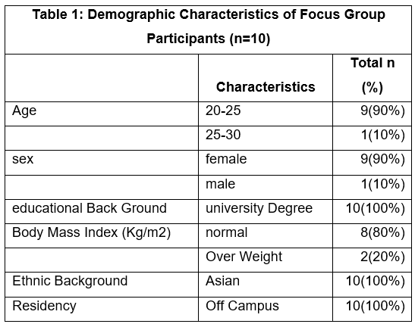

Data Collection Procedure
The focus group discussions unfolded within a designated classroom at the Birmingham City campus Building, chosen for its capacity to accommodate 13-15 participants comfortably. This venue, proximate to participants' places of worship, offered convenient access by foot or with a variety of transit options, in addition to parking spots that are available. Before delving into the sessions, participants completed a brief socio-demographic questionnaire (refer to Appendix 1) to provide foundational information, having previously signed and returned consent forms.
Each focus group discussion, lasting approximately 20 minutes, was meticulously facilitated by the researcher, who independently led the discussions after a brief introduction and welcome. A dual recording approach was adopted, with participants' responses audio-recorded using a Xiaomi Redmi Note 7 Pro mobile phone and moderators concurrently taking detailed notes. This method ensured a comprehensive capture of participant narratives, encompassing both verbal and non-verbal cues and group dynamics (O. nyumba et al., 2018).
The discussions adhered to a semi-structured format guided by a discussion guide featuring open-ended questions (see Appendix 2). This approach allowed participants to address the research questions organically, with additional queries posed as needed to clarify responses or maintain focus on the primary topic. During the course of their postgraduate studies at the University of Wales, participant's different perspectives on the complex elements impacting their eating behaviour were clearly explained by the dynamic interaction between audio recordings and comprehensive notes, which proved to be helpful tools.

Data Analysis Technique
Descriptive statistics for the focus group sample were calculated, and SPSS Statistics 20 was used to evaluate questionnaire data. Employing an inductive methodology, this research allowed themes and trends that naturally surface from the information, avoiding the imposition of predetermined concepts. This approach, aligned with the study's exploratory nature, facilitated a thorough comprehension of the various elements affecting postgraduate students' dietary habits (Asada et al., 2017).
Semi-structured focus group discussions served as the primary method for data collection, fostering open dialogue on eating behaviours, challenges faced by university students, and various perceptions (Hardcastle et al., 2015). Recorded and transcribed responses provided a foundation for comprehensive analysis, with thematic analysis applied to unveil patterns and recurring themes within the data (Guest et al., 2011).
The thematic analysis process involved several stages, from becoming acquainted with the data to generating the final report (Nowell et al., 2017). Initial codes were produced, and themes were identified, reviewed, defined, and named. This analytical framework structured the interpretation of the complexities inherent in postgraduate students' eating habits, offering a systematic and insightful exploration of the gathered data.

Ethical Considerations
In the qualitative study investigating the determinants of eating behaviour among University of Wales postgraduate students, ethical considerations were paramount, guiding every stage of the research. The study adhered to fundamental ethical principles, beginning with the acquisition of informed consent from participants. Emphasis was placed on upholding confidentiality and anonymity, safeguarding the privacy of participants' responses. The dignity and autonomy of each participant were respected, aligning with ethical imperatives.
Transparency in research practices was a cornerstone, with transparent explanation of the goals and design of the study. The research protocol underwent thorough scrutiny and obtained clearance from the University of Wales's ethical review board, affirming its adherence to ethical standards. Participants were assured of the voluntary nature of their involvement, granting them the autonomy to withdraw at any point without repercussions. This assurance aimed to prioritize the well-being and rights of the participants throughout the research process.
Pseudonyms were used in any reporting or publication to maintain anonymity and to further ensure confidentiality, identifiable information was carefully protected. These strong ethical guidelines were not only necessary for protocol, but also played a crucial role in encouraging a polite and thorough investigation of the variables affecting postgraduate students' eating habits. By putting participants' rights and well-being first, the ethical framework underpinning the study underscored its commitment to conducting research that is both academically robust and ethically sound.

Result
The study on factors influencing the eating behaviour of postgraduate students at the University of Wales revealed multifaceted challenges and considerations. Balancing university life emerged as a prominent theme, with participants highlighting the struggle to manage time for meals amidst study pressures, stress, and assignments. The tension between convenience and health was evident, as access to fast food and vending machines, coupled with a preference for quick and easy meal options, posed challenges to healthier choices. Cost served as a significant barrier, influencing food choices, especially regarding the affordability of healthier options.
International students faced unique challenges, including difficulties adapting to new food environments and a lack of availability of familiar foods. The intricate relationship between health and academic performance was underscored, with lifestyle changes and diet impacting body weight. Social influences on eating habits, particularly peer influence and observational learning, played a pivotal role. Participants expressed a need for increased awareness about nutritional content, educational initiatives, and suggestions for improvement, such as encouraging healthier options on campus, subsidizing organic alternatives, and enhancing awareness and education programs.

Theme 1: Factors Influencing Eating in Postgraduate Student's Eating Behaviour
This theme reflects the factors influencing eating in post-graduate student’s eating behaviour. These include three subthemes:
- Social factors
- Reliance on junk foods
- Travelling

Sub-theme 1- Social Factors
The participants think peer influencing and social interaction is one of the influencing factors. One of them commented:
“Sharing food with peers affects or influence eating habbit.” P2 FG2
Another participant reiterated that:
“At the university as we see the surrounding if people eating fruits and all it influences that we can bring food tomorrow” P1 FG2
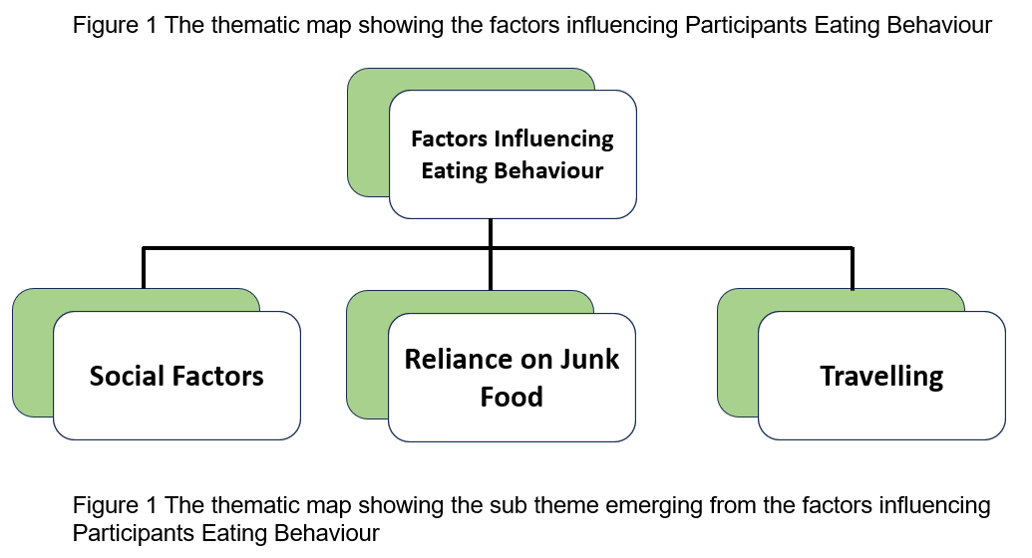

Sub-theme 2- Reliance on Junk Food
The participants perceived Reliance on the junk is a barrier for healthy eating for post graduate students in university. One of them commented:
“We can’t prepare proper whole meal, healthy meal. So, we just prepare/prefer like junk foods May be because of the time limits.” P4 FG1
Another participant reiterated that:
“Sometimes healthy food is more like expensive than junk food.” P2 FG2

Sub-theme 3- Travelling
The participants believe that one of the main elements influencing University of Wales postgraduate students' eating habits is travel. One of them made the following perception:
“I come from a far place so I have to do the travelling and stuff and those two days I might miss a part of a meal.” P2 FG1
Another participant reiterated that:
“I’m also coming from place from Chester I’m coming so I do miss some morning breakfast.” P1 FG1

Discussion
In this study, the concise summary of the most crucial findings illuminates the complex interplay of factors influencing the eating behaviour of postgraduate students at the University of Wales. The identified challenges, such as time constraints, stress, and the influence of peers, shed light on the intricate balance between academic demands and health considerations. The juxtaposition of convenience and health-related preferences, as well as the impact of cost on food choices, underscores the need for targeted interventions to promote healthier dietary habits among students.
The current study set out to investigate the variables impacting college students' eating habits. The results of this study showed that social influences, junk food dependence, and travel have the biggest effects on eating patterns among university students. These findings are consistent with the literature by Sallis et al. (2006).
The significance of these results lies in their potential to inform practical strategies for improving the overall well-being of postgraduate students. By understanding the barriers and enablers of healthy eating, universities can implement targeted interventions, such as awareness campaigns, educational initiatives, and the promotion of affordable and nutritious food options on campus.
Acknowledging the limitations of this research is crucial for a nuanced interpretation of the findings. The study's reliance on self-reported data and the limited generalizability due to the specific university context are acknowledged constraints. Future research should explore these factors across diverse university settings to enhance the external validity of the findings.
In light of the limitations, recommendations for further research include broader investigations into the cultural and contextual factors influencing eating behaviours among postgraduate students. Additionally, interventions addressing the identified challenges, such as time constraints and cost barriers, can be further developed and assessed for their effectiveness. These recommendations aim to contribute to the ongoing discourse on student well-being and inform practical strategies for universities to support healthier eating habits among their postgraduate student populations.

Conclusion
In summary, this study thoroughly investigates the various factors shaping the eating habits of postgraduate students at the University of Wales, recognizing their significant impact on both overall well-being and academic achievement. Utilizing qualitative focus group discussions, the research identified a range of challenges, encompassing time constraints, stress, financial barriers, and the influence of peers on dietary decisions.
The results highlight the necessity for specific interventions aimed at fostering healthier eating patterns among postgraduate students. The delicate balance between convenience and health, coupled with the financial considerations influencing food choices, underscores the crucial need for practical strategies to overcome these obstacles. The study proposes potential interventions, including awareness campaigns, educational programs, and the promotion of affordable and nutritious food choices within the university campus.
Despite acknowledging the limitations inherent in the study's focus on a particular university context and reliance on self-reported data, the research yields valuable insights that can inform university policies and support mechanisms. The significance of these findings lies in their potential to contribute to the ongoing discourse surrounding student well-being, guiding the formulation of effective strategies to improve the overall health and academic success of postgraduate students.
Looking ahead, future research should delve into the cultural and contextual factors influencing eating behaviours across a diverse array of university settings. Furthermore, interventions targeting the identified challenges should be refined and evaluated for their efficacy. By addressing these considerations, universities can cultivate a more health-conscious and supportive environment, ultimately enhancing the well-being and success of postgraduate students in higher education.

References
Abdoli, M., Scotto Rosato, M., Cipriano, A., Napolano, R., Cotrufo, P., Barberis, N. and Cella, S. (2023). Affect, body, and eating habits in children: a systematic review. Nutrients, 15(15), p.3343.
Al-Fattal, A. (2010). Understanding student choice of university and marketing strategies in Syrian private higher education. University of Leeds.
Asada, Y., Hughes, A. and Chriqui, J. (2017). Insights on the intersection of health equity and school nutrition policy implementation: an exploratory qualitative secondary analysis. Health Education & Behavior, 44(5), pp.685-695.
Belon, A.P., Nieuwendyk, L.M., Vallianatos, H. and Nykiforuk, C.I. (2014). How community environment shapes physical activity: Perceptions revealed through the PhotoVoice method. Social Science & Medicine, 116, pp.10-21.
Bisogni, C.A., Jastran, M., Seligson, M. and Thompson, A. (2012). How people interpret healthy eating: contributions of qualitative research. Journal of nutrition education and behavior, 44(4), pp.282-301.
Burke, C. (2015). Culture, capitals and graduate futures: Degrees of class. Routledge.
Curry, L.A., Nembhard, I.M. and Bradley, E.H. (2009). Qualitative and mixed methods provide unique contributions to outcomes research. Circulation, 119(10), pp.1442-1452.
Flick, U., Von Kardorff, E. and Steinke, I. (2004). What is qualitative research? An introduction to the field. A companion to qualitative research, 1, pp.3-11.
Frohberg, A. (2017). Local perceptions influencing the consumption of a diverse diet in vihiga county, Kenya. Unpublished Master’s Dissertation, Ghent University.
Garcia, D. and Gluesing, J.C. (2013). Qualitative research methods in international organizational change research. Journal of organizational change management, 26(2), pp.423-444.
Guest, G., MacQueen, K.M. and Namey, E.E. (2011). Applied thematic analysis. sage publications.
Hardcastle, S.J., Tye, M., Glassey, R. and Hagger, M.S. (2015). Exploring the perceived effectiveness of a life skills development program for high-performance athletes. Psychology of Sport and Exercise, 16, pp.139-149.
Harris, J.E., Gleason, P.M., Sheean, P.M., Boushey, C., Beto, J.A. and Bruemmer, B. (2009). An introduction to qualitative research for food and nutrition professionals. Journal of the American Dietetic Association, 109(1), pp.80-90.
Lindert, J., Neuendorf, U., Natan, M. and Schäfer, I. (2021). Escaping the past and living in the present: a qualitative exploration of substance use among Syrian male refugees in Germany. Conflict and health, 15, pp.1-11.
Lisnyj, K.T., Pearl, D.L., McWhirter, J.E. and Papadopoulos, A. (2021). Exploration of factors affecting post-secondary students’ stress and academic success: Application of the socio-ecological model for health promotion. International Journal of Environmental Research and Public Health, 18(7), p.3779.
Maqbool, B. and Herold, S. (2023). Potential effectiveness and efficiency issues in usability evaluation within digital health: A systematic literature review. Journal of Systems and Software, p.111881.
McNeill, W.N. (2010). The time-use of distance learners: A study of international postgraduate students engaged in professional career development (Doctoral dissertation, Institute of Education, University of London).
Milyavskaya, M. and Koestner, R. (2011). Psychological needs, motivation, and well-being: A test of self-determination theory across multiple domains. Personality and individual differences, 50(3), pp.387-391.
Mishra, L. (2016). Focus group discussion in qualitative research. TechnoLearn: An International Journal of Educational Technology, 6(1), pp.1-5.
Musinguzi, L.K. (2016). The role of social networks in savings groups: insights from village savings and loan associations in Luwero, Uganda. Community Development Journal, 51(4), pp.499-516.
Nowell, L.S., Norris, J.M., White, D.E. and Moules, N.J. (2017). Thematic analysis: Striving to meet the trustworthiness criteria. International journal of qualitative methods, 16(1), p.1609406917733847.
O. Nyumba, T., Wilson, K., Derrick, C.J. and Mukherjee, N. (2018). The use of focus group discussion methodology: Insights from two decades of application in conservation. Methods in Ecology and evolution, 9(1), pp.20-32.
Özturgut, O. and Murphy, C. (2009). Literature vs. practice: challenges for international students in the US. International Journal of Teaching and Learning in Higher Education, 22(3), pp.374-385.
Parker, L. (2014). Qualitative perspectives: Through a methodological lens. Qualitative Research in Accounting & Management, 11(1), pp.13-28.
Rogler, L.H., Cortes, D.E. and Malgady, R.G. (1991). Acculturation and mental health status among Hispanics: Convergence and new directions for research. American psychologist, 46(6), p.585.
Sallis, J.F. and Glanz, K., 2006. The role of built environments in physical activity, eating, and obesity in childhood. The future of children, pp.89-108.
Shiraz, F., Hildon, Z.L.J. and Vrijhoef, H.J.M. (2020). Exploring the perceptions of the ageing experience in Singaporean older adults: a qualitative study. Journal of cross-cultural gerontology, 35, pp.389-408.
Starr, M.A. (2014). Qualitative and mixed‐methods research in economics: surprising growth, promising future. Journal of Economic Surveys, 28(2), pp.238-264.
Theobald, S., Nyirenda, L., Tulloch, O., Makwiza, I., Soonthorndhada, A., Tolhurst, R., Bongololo, G., Sanou, A., Katjire, M., Kilonzo, N. and Yan, F. (2011). Sharing experiences and dilemmas of conducting focus group discussions on HIV and tuberculosis in resource-poor settings. International health, 3(1), pp.7-14.
Vasileiou, K., Barnett, J., Thorpe, S. and Young, T. (2018). Characterising and justifying sample size sufficiency in interview-based studies: systematic analysis of qualitative health research over a 15-year period. BMC medical research methodology, 18, pp.1-18.

Appendix

Appendix 1
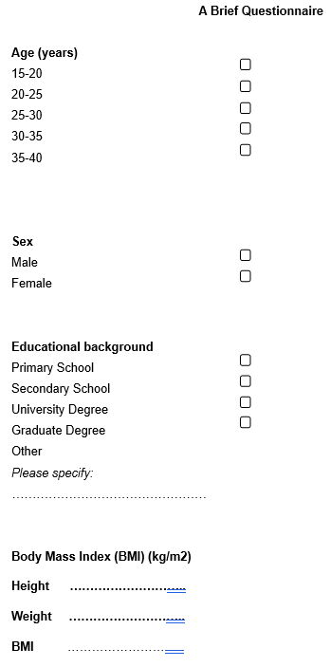
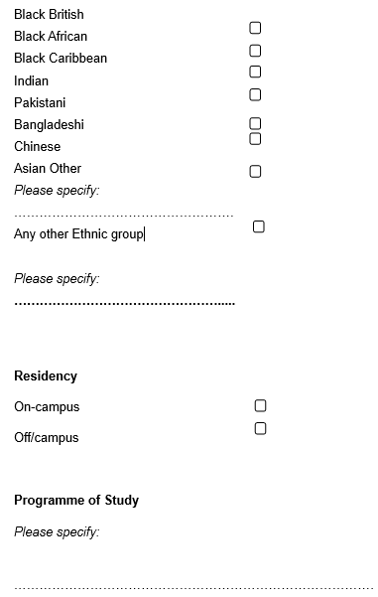

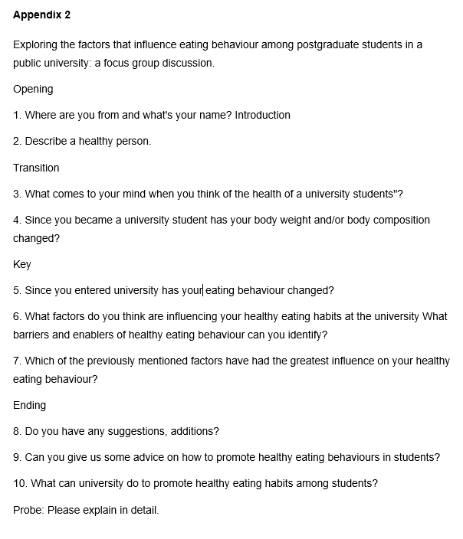
Appendix 2

