DATA HANDLING AND BUSINESS INTELLIGENCE

Student Name: Sava Mantchev
Student ID: 2028706
Lecturer Name: Anupam Mazumdar
Module Code: LCBB5000
Assessment 2
Date: 31.08.2022

TABLE OF CONTENTS
Part 1 3
1. Introduction 3
2. Evaluation of financial performance 3
3. Performance Test 6
Pivot table 6
If function 8
4. Conclusion 10
Part 2 11
1. Introduction 11
2. Conducting a survey 11
2.1 The total number of students liking vanilla-flavoured ice cream 11
2.2 Analysis of male and female students from the total number of students 11
2.3 Identification of the mean and median value of students liking chocolate and vanilla flavored ice cream 12
2.4 Outcome of regression test and cluster test 13
Clustering Test 13
“Regression Analysis” 15
2.5 Discussion of the methods of text and data mining 17
2.6 Advantages and disadvantages of Spas analysis 18
Advantages 18
Disadvantages 18
3. Conclusion 18
References 19

Part 1

1. Introduction
Data analysis is a key performance conductor which helps to determine business optimization through the implementation of various business models. It provides the statistics to the companies that can help to reduce the costs in the long term. Data analysis can be the indicator for the companies to perform well by analyzing the efficient ways of doing business and storing large amounts of data can help to minimize the reduction cost of the companies. The project aims to define sales and profits from 2009 to 2012. Defining the data analysis and the implementation of the excel functions consist of the value of the sales and profits of the analysis.

2. Evaluation of financial performance
The project is based on the financial performance of the superstore data that have been elaborated through ‘different regions and their sales and profits values’. The financial performance of the super store data (Brik and Static, 2021, p.45). Superstore data are reliable on the Data performance of excel. The row labels of the data set have the determination of the different regions of the provided variance, the sum of the selling price of the products. The data seat of the superstore consists of 8 regions data, sales variable data, 4 years value of sums, and the profit and loss of the years, cost of sales. This data set helps to determine the reducing cost of the regions, detriment the profits.
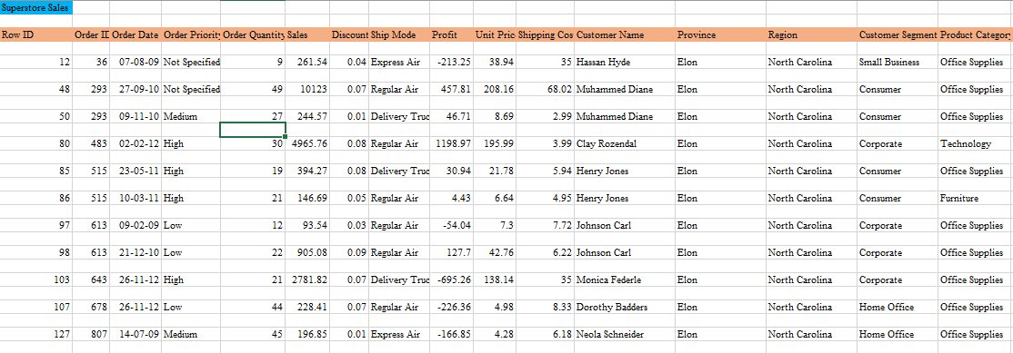
Figure 1: Superstore Data set
The superstore sales sheet of excel consists of the data variance of the different segments. The segments are divided into different sections named, row id, order id, order priority types, sales variance, discount, ship mode, profit, unit price and shopping cost etc. The data sheet has the regional, customer segment, product category, product and subcategory, and product variance that are needed for analysis.
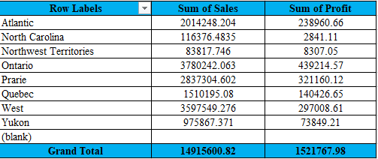
Figure 2: Financial Performance of Various Regions
The valuation of the performance level of the data set provides the data consistency of the names of the regions, the sum of sales and the sum of profits values. The row label data set consists of the different continent names. The analysis is based on the survey of the different regions named Atlantic, North Carolina, northwest territories, Ontario, prairie, Quebec, west and Yukon. The sum of sales variance is determined by the total sum of profits of the categorized values. The sum of sales is valued at 2014248.204, 116376.4853 for the two continents. The Ontario territory generated the cost of 83817.746 in the first year. The prairie continent had sales valued at 3780242.602.
Analyzing the data set for the superstore data variance it can be seen that the maximum sum of sales is valued at 3780242.063. It is considered profitable for the Ontario continent. The minimum sales are considered at 83817.746 in the first year. The minimum values are generated by the northwest territories which is considered not well. Considering the total profit margin of the data set it can be seen that the average profit valuation has been valued at 10.20%. The sum of profits by setting the sales variance by the continents has been valued at 439214.57 and 2841.11 (Brik and Static, 2021, p.45). The maximum profit is valued at 439214.57 and the minimum profit is considered at 2841.11 in the first year. Therefore, it can be assumed that the average profit margin for the data set has been valued to make the financial performance better and give data validity to their performance.
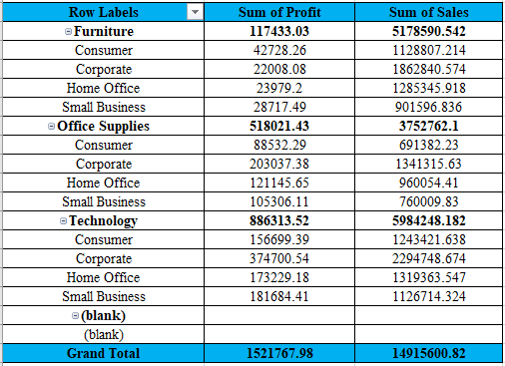
Figure 3: ‘Financial Performance for Different Equipment’
The valuation of the overall cost has been estimated with the use of the three major variables “Furniture, office supplies and technology”. The sum of the total value of each cost has been acquired and has a major reflection on the overall cost analysis (Wu et all. 2019, p.75). It has a major reflection on accumulating the value of the total sales and profitability at each value level. The value for total profit and sales value of the furniture are 117433 and 5178590. The total sales value of the furniture shows the increased value and reflects on increasing the total profit for the company. On the other hand, the value for the sum of the office supplies has a major reflection and creates an effective impact on the entire calculation.
The total sales value of the office supplies is 3752762 and the accumulated profit over the sales of the number of office supplies can be 518021. Total profit on their office supplies is lesser than total furniture value (Levants and Piccolo, 2020, p.82). Technology is the last factor and its total profitability and sales have been acquired as 886316 and 5924248. The overall changes in the effective analysis have shown that the value of the profit is analyzed based on the total sales of the technology.

3. Performance Test

Pivot table
The pivot table is used to summarize huge data sets, sort the data sets and recognize the groups, and total average data stored in a table. It provides the accessibility to transform the columns into the row and rows into the column (Brik and Static, 2021, p.45). It determines the groups individually and gives an understandable field for the data set. It can be used for advanced calculations. ‘The pivot table is important to disguise the filter and extract dignified information about the data set we are working with. It can allow everyone to make the data set easier in effective ways.
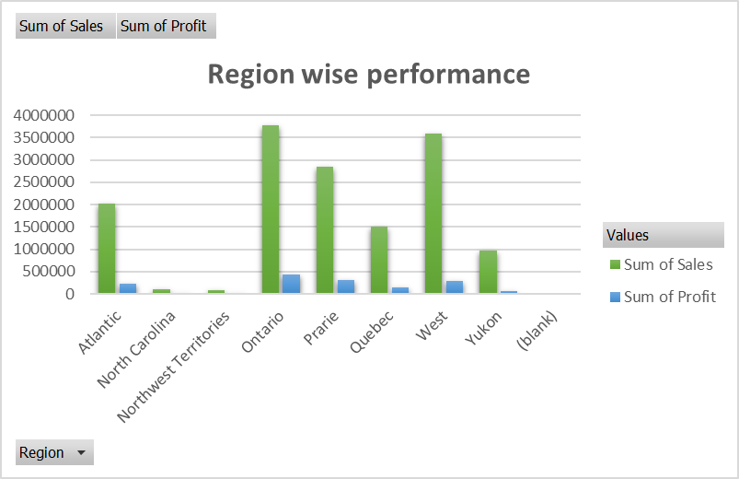
Figure 4: Regions-wise performance
Using the pivot table for the data set, it can be seen that the row label data set consists of the different continent names (Vasishta et al. 2018, p.71). The analysis is based on the survey of the different regions named Atlantic, North Carolina, northwest territories, Ontario, prairie, Quebec, west and Yukon. Analyzing the data set for the superstore data variance it can be seen that the maximum sum of sales is valued at 3780242.063. The Ontario territory generated the cost of 83817.746 in the first year. The prairie continent had sales valued at 3780242.602. It is considered profitable for the Ontario continent. The minimum sales are considered at 83817.746 in the first year. The minimum values are generated by the northwest territories which is considered not well. Considering the total profit margin of the data set it can be seen that the average profit valuation has been valued at 10.20%. The sum of profits by setting the sales variance by the continents has been valued at 439214.57 and 2841.11. The maximum profit is valued at 439214.57 and the minimum profit is considered at 2841.11.
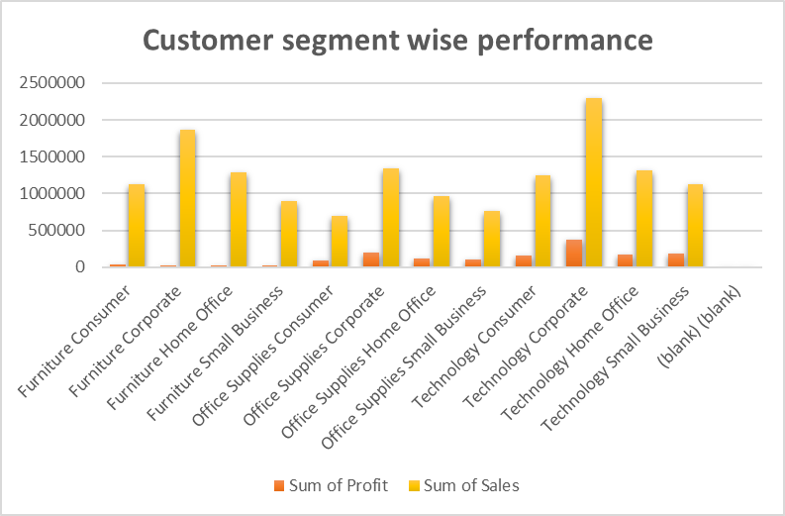
Figure 5: Customer-wise Performance
The valuation of the overall cost has been estimated with the use of the three major variables “Furniture, office supplies and technology”. The sum of the total value of each cost has been acquired and has a major reflection on the overall cost analysis. Total profit on their office supplies is lesser than total furniture value (Amerasinghe et al. 2020, p.85). ‘Technology is the last factor and its total profitability and sales have been acquired as 886316 and 5924248. The overall changes in the effective analysis have shown that the value of the profit is analyzed based on the total sales of the technology. The total sales value of the office supplies is 3752762 and the accumulated profit over the sales of the number of office supplies can be 518021. The total sales value of the furniture shows the increased value and reflects on increasing the total profit for the company. On the other hand, the value for the sum of the office supplies has a major reflection and creates an effective impact on the entire calculation.

If function
‘IF function’ is a logical function that can allow making logical comparisons between the expected value and real value. The total profit margin of the superstore in the eight different regions reelects the rate of 10% at the end of the financial period (Dabashi, 2018, p.45). ‘The if the function is based on the sales and profit of a particular region that satisfies the sales or profit level of the sales or profit of the company store’. The IF function is used to analyze the high and low performance of the store on the basis of profit margins from eight different countries.
“Row Labels | Sum of Sales | Sum of Profit | Sum of Product Base Margin | Average | IF function
Atlantic | 2014248.204 | 238960.66 | 546.63 | 12.79% | High performance
North Carolina | 116376.4835 | 2841.11 | 38.79 | 0.91% | Low performance
Northwest Territories | 83817.746 | 8307.05 | 29.57 | 0.69% | Low-performance
Ontario | 3780242.063 | 439214.57 | 1110.69 | 26.00% | High-performance
Prairie | 2837304.602 | 321160.12 | 862.4 | 20.19% | High performance
Quebec | 1510195.08 | 140426.65 | 399.18 | 9.34% | Low-performance
West | 3597549.276 | 297008.61 | 1005.26 | 23.53% | High performance
Yukon | 975867.371 | 73849.21 | 279.79 | 6.55% | Low performance
.
Grand Total | 14915600.82 | 1521767.98 | 4272.31 | 100.00%”
Table 1: Functional performance
IF function allows considering the profitable margin for the company is valued at 10.20% at the end of the year. Therefore, it can be a realtor with the sales and profit of the regions that can have been also selected previously. Using the data set for the IF function it can be seen that the profits of the Ontario region are valued at the highest level of the profit margin which reflects 26% and the northwest territories consist of the minimum value of profit margin at 0.69%. ‘The successive attained profits have the marginal data parable of the attended profit margin of more than 10.20% has undefined as a high performance again’.
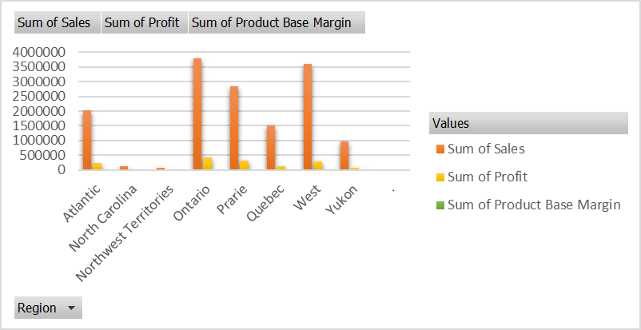
Figure 6: Functional performance
The highlighted charts and tables help to understand the values more effectively and efficiently. The failed ad high performance of the regions has been evaluated in the report to make comparable results for the regions (Markeshia, 2018, p.56). The resulted value for the North Carolina northwest territories, Quebec and Yukon has been considered low performers over the years. ‘The low performance of the religions has filed to satisfy the profits level that is 10.20%’.

4. Conclusion
It can be concluded that the velocity and the simplicity of the data analysis include the modification of the data set. Data analysis gives the modelling and transforming result to a part of the research topic. “The concluded part of the final interface drawn from the data analysis review of the literature and findings have been evaluated”. Summarizing the interests’ findings from the results section gives the statistics purpose of the study. “It can be concluded that the store has generated maximum profit and sales from the Ontario region from 2009 to 2012”. The pivot table and the IF function have been analyzed to give the project a wider variation of the sales and sales over the years. It could be seen that some of the regions have failed to provide the targeted level of profit margins in the financial year. Therefore, data analysis techniques and tools have to be implemented by the different regions to improve their performance in the following years.

Part 2

1. Introduction
The data derived from the 200 students of a particular high school has been used to conduct the statistical analysis. The analysis has identified and depicted the relationship between video games and the scores achieved from the puzzle test. SPSS software has been used to perform the analysis of data sets including multiple ice cream flavours, descriptive statistics and regression has been represented as the value of“K-means”.

2. Conducting a survey

2.1 The total number of students liking vanilla-flavoured ice cream
The outcome of the test has helped in identifying the accurate preferences of the students in terms of ice cream flavours. In the test, it has been identified that students around the number of 48 actually preferred vanilla to the overall number of students.
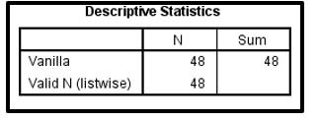
Figure 7: Students prefer the vanilla flavour of ice cream
In the above figure, the outcome from the descriptive test on the number of students liking vanilla as the ice cream flavour has been reflected (Arkes, 2019, p.56). The students who preferred the vanilla flavour were represented as 1 in the test and the outcome showed the actual number of students who preferred vanilla accurately as 48. The mean and median value derived in the analysis is based on the assumptions made about the respective ice cream flavours chocolate as 2 and strawberry as 3.

2.2 Analysis of male and female students from the total number of students
The analysis has also highlighted the number of male and female students on a whole. In the descriptive test, some assumptions have been made like the total number of male students has been represented as 0 and the total number of females is taken as 1 for the sake of the analysis (Yi and Xiao-li, 2018, p. 27). The assumptions are taken in the descriptive test on the basis of the data set that has represented the number of students of the school who are present at school on distinguished between gender.
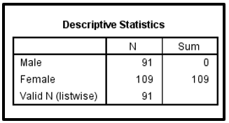
Figure 8: Outcome of the test on the basis of the total number of male and female students
The figure above reflects the number of students in the school by their gender. The accurate number of male students in the school at the time is 91. The number of female students that have been identified from the outcome of the descriptive test is 109.

2.3 Identification of the mean and median value of students liking chocolate and vanilla flavored ice cream
The data set comprised the number of students who prefer the chocolate and strawberry flavors of ice creams. The data set has been used to analyze the liking of the students by analyzing the values of mean and median (Chukhrova and Johannssen, 2019, p. 10). Some assumptions have been made on the test for the simplifications of the analysis, 2 has been representing the number of students who prefer the chocolate flavor and the ones who like strawberry has been represented by the number 3. The deriving of the accurate value of mean and median values in the descriptive analysis has been done by the SPSS software.
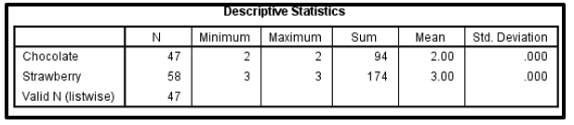
Figure 9: Outcome of the students liking chocolate and strawberry in the statistical analysis
Out of the total 200 students the students who like strawberries have been identified as 58 and the knees like the chocolate flavor as 47 in the descriptive analysis.

2.4 Outcome of regression test and cluster test

Clustering Test
The clustering test of K-means has been performed in the analysis of the data set of and the outcome that is labeled explicitly. The clustering test of K-means for this data set has been performed using the SPSS software. The multiple variables like flavors of ice cream, score of video games, puzzle test and the gender of the students has been considered and analyzed (Desboulets ,2018, p.26). In order to simplify the process of theterst some assumptions have been made such as 1 for vanilla, 2 for chocolate and 3 as strawberry. The male and female students have been represented as 0 and 1.
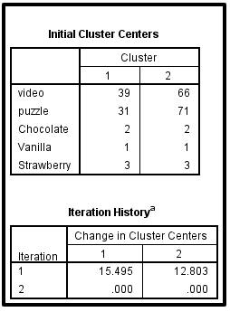

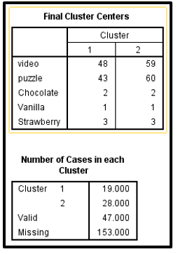
Figure 10: Results of K-Means cluster test
The above figure is reflecting the outcome of the test of K-means and has been performed with 2 clustered variables taken as variables (Xu and Lin, 2020, p. 11). The final cluster test has reflected the optimum engagement of students.

“Regression Analysis”
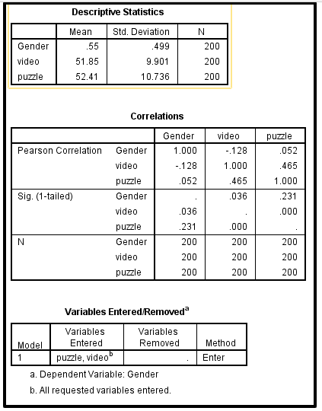
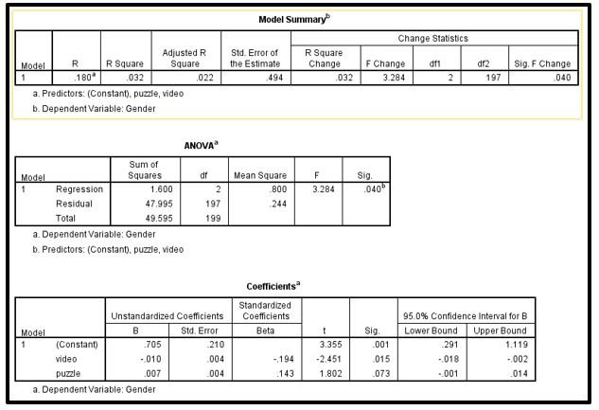
Figure 11: Regression output
The above figure has shown the outcome of the regression test. The analysis has been conducted by taking the students gender as dependent variables and the scores of video and puzzle as independent variables (Montgomery et al. 2021, p.6). The value of Square derived in the test is 0.032 which reflects the relationship of the dependent and independent variable is strong. The significance value shown in the anova table as 0.040whih is lower from the standard value. Hence the changes in the score of puzzle and video affects the students based on their gender but not too strongly.
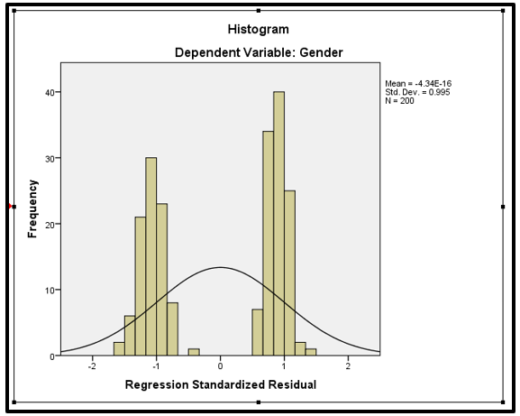
Figure 12: Histogram of the relation between gender and tests
The above figure reflects dependent and independent variables relationship with the help of the regression test.

2.5 Discussion of the methods of text and data mining
Text mining can refer to the process of identifying random and unstructured data sourced from online mediums and analyzing them. Data mining on the other hand analyzes the structure and well composes data and drives accurate results. Data mining focuses on the knowledge and results of the structured data and text mining more on the implication of the data sourced. Text mining is done on the data sourced from databases, websites, articles (Sungheetha and Sharma, 2020, p. 19). The information analysis in data mining is collected from official resources. Data mining is used for performing computing financial analysis and detecting intrusion. Text mining helps in calculating the chances of fraud, analyzing feedback of consumers and performing filters.

2.6 Advantages and disadvantages of Spas analysis

Advantages
‘Spas is also known as IBM SPSS statistic’. The software can provide the social sciences technologies and reflects the expanded data markets for the companies. This software can help to solve the data exposure for the companies and also help the companies to make the data analysis easier (Filardi et al. 2020, p.75). It reduces the complication in the data analysis and it helps to reduce the chance of making errors in the calculation. It can make the analysis easier and make the accessibility in the analysis functions “like descriptive statistics and pull-down menus”.

Disadvantages
SPSS analysis limitations are determined by the implication of the huge data set in the research project. It cannot be used for analyzing the huge data set (Asti via and Zumba, 2019, p.52). The SPSS is based on a huge data set, therefore conducting misguidance, miscalculation and miss fortune can lead the entire analysis misleading. Using SPSS for data analysis is not a good option nowadays. ‘The sampling error denotes the gap between the sample and the huge data and the actual data. Correlation versus cautions, construct validity, and simplified solutions have been found while using the software.

3. Conclusion
The statistical tools have been used to eliminate the occurrence of errors in conducting the analysis. The statistical analysis has been performed by implementing appropriate tools of analysis, and graphs and histograms have also been included to give an accurate visual representation. In the analysis conclusions have been made on the number of female students is higher than the number of male students and strawberry flavor has received maximum likes from the students.

References
Amerasinghe, S.L., Us, S., Dong, X., Zappa, L., Ritchie, M.E. and Goil, Q., 2020. Opportunities and challenges in long-read sequencing data analysis. Genome biology, 21(1), pp.1-16.
Arkes, J., 2019. Regression analysis: A practical introduction. Routledge.
Asti via, O.L.O. and Zumba, B.D., 2019. Heteroskedasticity in Multiple Regression Analysis: What it is, How to Detect it and How to Solve it with Applications in R and SPSS. Practical Assessment, Research, and Evaluation, 24(1), p.1.
Brik, D. and Static, Z., 2021. Excel VBA-based user defined functions for highly precise Colebrook’s pipe flow friction approximations: A comparative overview. Fact Universitatis. Series: Mechanical Engineering, 19(2), pp.253-269.
Chukhrova, N. and Johannssen, A., 2019. Fuzzy regression analysis: systematic review and bibliography. Applied Soft Computing, 84, p.105708.
Dabashi, K., 2018, July. Interactive mining for learning analytics by automated generation of pivot table. In International Conference on Applied Human Factors and Ergonomics (pp. 66-77). Springer, Cham.
Desboulets, L.D.D., 2018. A review on variable selection in regression analysis. Econometrics, 6(4), p.45.
Filardi, F., CASTRO, R.M.P. and Zamani, M.T.F., 2020. Advantages and disadvantages of teleworking in Brazilian public administration: analysis of SERPRO and Federal Revenue experiences. Cavernous EBAPE. BR, 18, pp.28-46.
Levants, S. and Piccolo, G., 2020. Insurance Role for Handling the COVID-19 impact on Business and Society. Journal of Applied Management and Investments, 9(4), pp.183-191.
Markeshia, J., 2018. Database creation through if, VLOOKUP, sum and sum if functions of Microsoft Excel. Priene Social Science Journal, 2(2), pp.27-34.
Montgomery, D.C., Peck, E.A. and Vining, G.G., 2021. Introduction to linear regression analysis. John Wiley & Sons.
Sungheetha, A. and Sharma, R., 2020. A novel CapsNet based image reconstruction and regression analysis. J. Innov. Image Process.(JIIP), 2(03), pp.156-164.
Vasishta, S., Nisenbaum, B., Beckman, M.E., Li, F. and Kong, E.J., 2018. Bayesian data analysis in the phonetic sciences: A tutorial introduction. Journal of phonetics, 71, pp.147-161.
Wu, Q., He, Z., Wang, H., Wen, L. and Yu, T., 2019. A business process analysis methodology based on process mining for complaint handling service processes. Applied Sciences, 9(16), p.3313.
Xu, B. and Lin, B., 2020. Investigating drivers of CO2 emission in China’s heavy industry: A quantile regression analysis. Energy, 206, p.118159.
Yi, S. and Xiao-li, A., 2018. Application of threshold regression analysis to study the impact of regional technological innovation level on sustainable development. Renewable and Sustainable Energy Reviews, 89, pp.27-32.

