Marketing plan is written for
The Ritz Carlton
Student Name: Khalilur Rahman
Student ID: 2211971
___________________
Marketing Essentials BMIH4005
Lecturer
____________ Chris Wilkin_____________

Contents
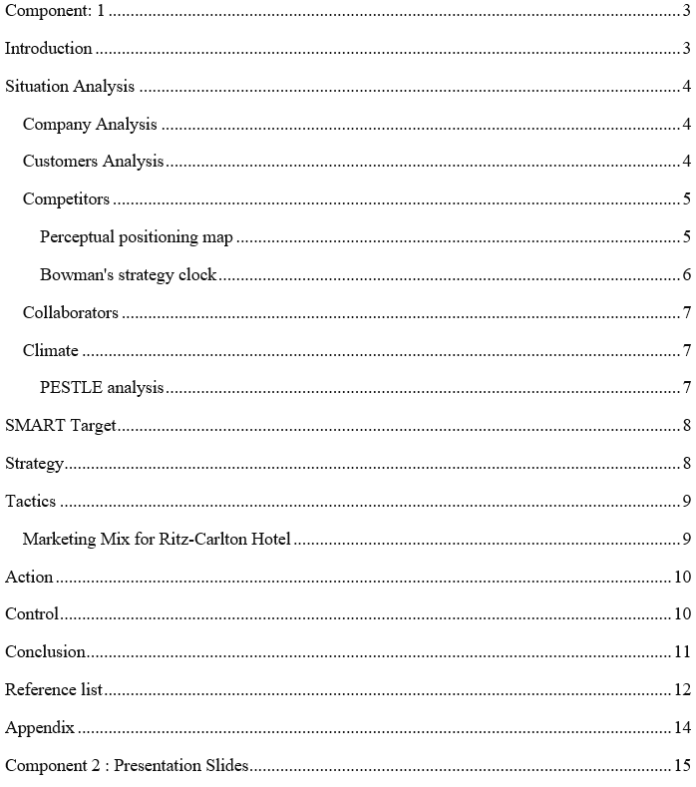

Component: 1

Introduction
This report is a marketing plan for the Ritz-Carlton Hotel, one of the leading hotel chain in the World. To identify major problems or marketing disruption, this report is intended to build a communications strategy based on the present context to lift bookings, revenue and market exposure. In this report, strategies like 5C's model SWOT Analysis, SMART targets, Value Proposition, Marketing Mix, PESTLE and other techniques are used to establish a marketing plan. In a fast-changing marketplace, the proposal will support Ritz-Carlton Hotel to formulate decisions and spread funds to continue expanding its company.

Situation Analysis
The internal and external environment evaluation can be supported by the 5 C's model that focuses on the company, clients, opponents, collaborators and the environment.

Company Analysis
Strengths:  Strong brand recognition.  Over 100 hotels.  Strong online presence via a website and mobile app. | Weaknesses:  Inadequate international presence paralleled to competitors.  Heavily lean on the World Market(Angla, 2021.  Too many luxury offerings.
Opportunities:  Can expand into new marketplaces like Asia.  Wide possibility for strategic partnerships and collaborations | Threats:  Intensified race for budget-conscious travellers.  Economic insecurity  Change in customer preferences

Customers Analysis
Businesses need to meet the wavering demands of different clients by identifying and offering required services to them. Ritz-Carlton Hotel welcomes guests from different background from tourists to businesspeople (Bowie et al., 2017). Whether luxury lodging for Tourists or family-friendly rooms and facilities or a rentable well furnished conference lounge for the work convenience of commercial travelers, Everyone can take the service from Ritz-Carlton Hotel.

Competitors
Ritz-Carlton Hotelencounters rigorous competition not only from international hotel chains but also from local businesses (Belch and Belch, 2021). The company requires distinct itself from its competitors via different pricing strategies, customer support service, and continuous service development to live on in the market.

Perceptual positioning map
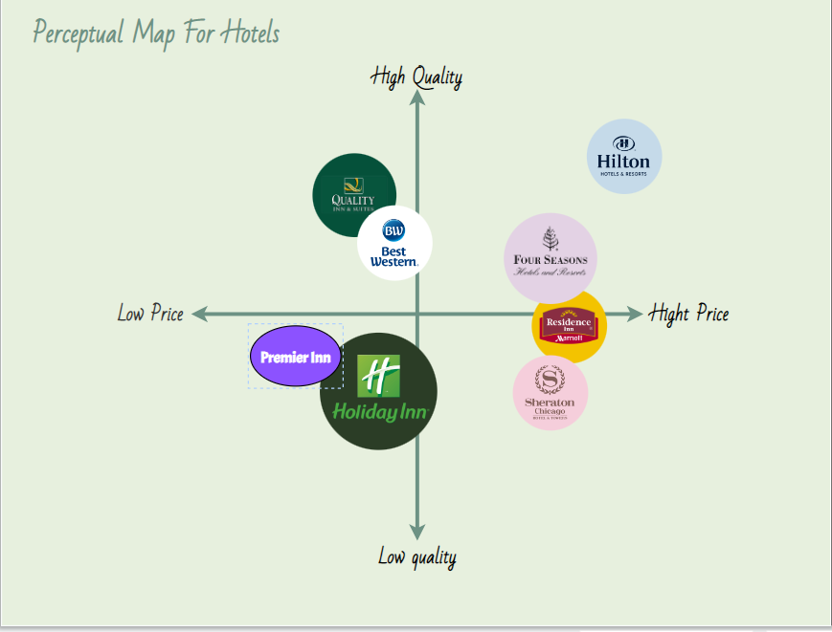
Figure 1Perceptual positioning map Source: (Keller, 2016)
From the map, it is seen that compared to low-end hotel brands, Ritz-Carlton Hotel can be regard as a hotel which falls in the high price range and offers luxury services for the money.

Bowman's strategy clock
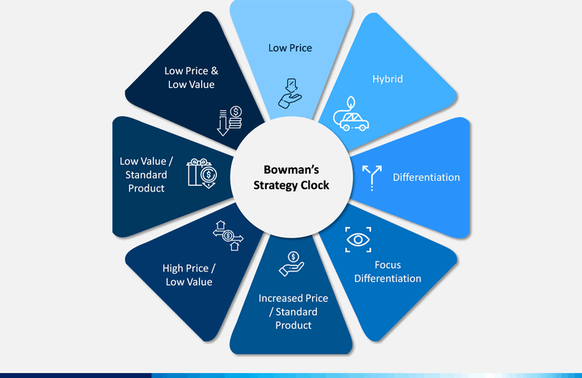
Figure 2 Bowman's strategy clock Source: (Pohan and Bowman, 2019)
Based on the Ritz-Carlton Hotel's present-day competitive circumstances the probable tactics can be supported by the use of Bowman's strategy clock (Bowman, 2021). For instance, Ritz-Carlton Hotel can go for the implementation of a "hybrid" strategy to integrate characters of high cost and distinction so that they can stand out from the competition by positioning the brand as an exceptional luxurious value for the money (Chaffey and Ellis-Chadwick, 2019).

Collaborators
Collaborators are the strategic partners who contribute a lot in the company's succeed (Clow and James, 2014). Ritz-Carlton Hotel can create business-to-business relations for smooth operation with operators and conglomerates as well as go for the franchise and strategic partnership with others
For business-to-business alliances, Ritz-Carlton Hotel can team up with travel agencies and the Airline industry to bring in more awareness for their hotels among potential guests (Donohoe and Kelly, 2020).
Ritz-Carlton Hotel may develop strategic partnerships with hotel chains in international marketplace to multiply the services area to their clients without high investment. Local enterprises like Coffee shop, and car rent providers to offer discounts to their customers (Hyman and Sierra, 2020).
Lastly, Ritz-Carlton Hotel can also adopt a franchising system through third-party proprietors to capitalise on the reputation of the Ritz-Carlton Hotel. As a outcome, the brand's reach can develop and profits can levitate (Karadag and Kim, 2021).

Climate
The climate is drawing on to define the macroeconomic viewpoints and influence on the operations and success of a firm (Karadag and Kim, 2021). By keeping an eye on different environmental concerns and adjust operational strategies accordingly gives an organisation a distinct competitive edge.

PESTLE analysis
Political: Changes in government tax system or service sector policy possibly will have across-the-board consequences on the hotel business (Keller, 2016).
Economic: Economic slowdown due to a shift in consumer expenditure pattern affect the demand for recreation and hotel rooms (Ritz-Carlton Hotel, 2023).
Social: consumer preferences for services and facilities and their anticipation to receive quality service from hotels can influence Ritz-Carlton Hotel.
Technological: New technological developments affect how Ritz-Carlton Hotel provides its services. For example, mobile check-in and smart room technology are redefining the meaning of convenience.
Legal: Ups and downs in employment or data protection regulation have a force on business operations.
Environmental: The feeling to be a part of sustainability in customers and businesses have an upshot on in what way Ritz-Carlton Hotel addresses eco-friendly concerns including green energy, trash management and so on (Smith and Pawal, 2019).

SMART Target
This plan aims to create an integrated digital marketing strategy to highlight the hotel chain's distinctness in the luxury hotel category and convenient locations for potential customers, resulting in a 10% growth in brand recognition during the next 6 months.

Strategy
To successfully communicate Ritz-Carlton Hotel’s value proposition to its customers, they need to use targeted digital marketing using social media platforms for promotions and collaborations with other strategic partners to attract attention in the market (Smith and Pawal, 2019). They can also use customer feedback and reviews as testimonials to ripen trust and reliability with potential clients.
In order to offer on this value proposition, Ritz-Carlton Hotel can promote its efficient operations and customised room designs as its most distinct value proposition for a pleasant stay (Wolny, 2022). Ritz-Carlton Hotel can bring a new segment into line as the value proposition. Ritz-Carlton Hotel can aim those consumers that has demographics with personalized marketing and promotion initiatives to establish itself as a reliable and favorite brand in the hotel market.

Tactics

Marketing Mix for Ritz-Carlton Hotel
Product: Ritz-Carlton Hotel will carry on to provide comfortable and luxury inn housings to its customers by emphasising uniform rooms and superior service quality across its vast all of its properties (Vaněk, 2020). To be innovative, they can introduce new wellness facilities to address the ever-changing demands of customers.
Place: Website and mobile application, online platforms of travel agencies and other partners are used as Distribution channels (Ritz-Carlton Hotel, 2023). The company can also experiment with new methods of distribution to come across the consumers wherever they are.
Price: Ritz-Carlton Hotel will remain to maintain its high pricing rate strategies (Ritz-Carlton Hotel, 2023). To stay competitive in the dynamic market, they must execute market research to identify the audience's preferences and price sensitivity. Additionally convenient pricing selections and different seasonal discounts can be used.
Promotion: Ritz-Carlton Hotel needs to use both traditional and digital marketing tactics. Strategies like SEO, social media ads, and influencer marketing can be used to increase its visibility and conversion rate (Keller, 2016). Video Podcast sponsorships or virtual events are other credible ways to attract prospective consumers.

Action
Gantt Chart for Ritz-Carlton Hotel
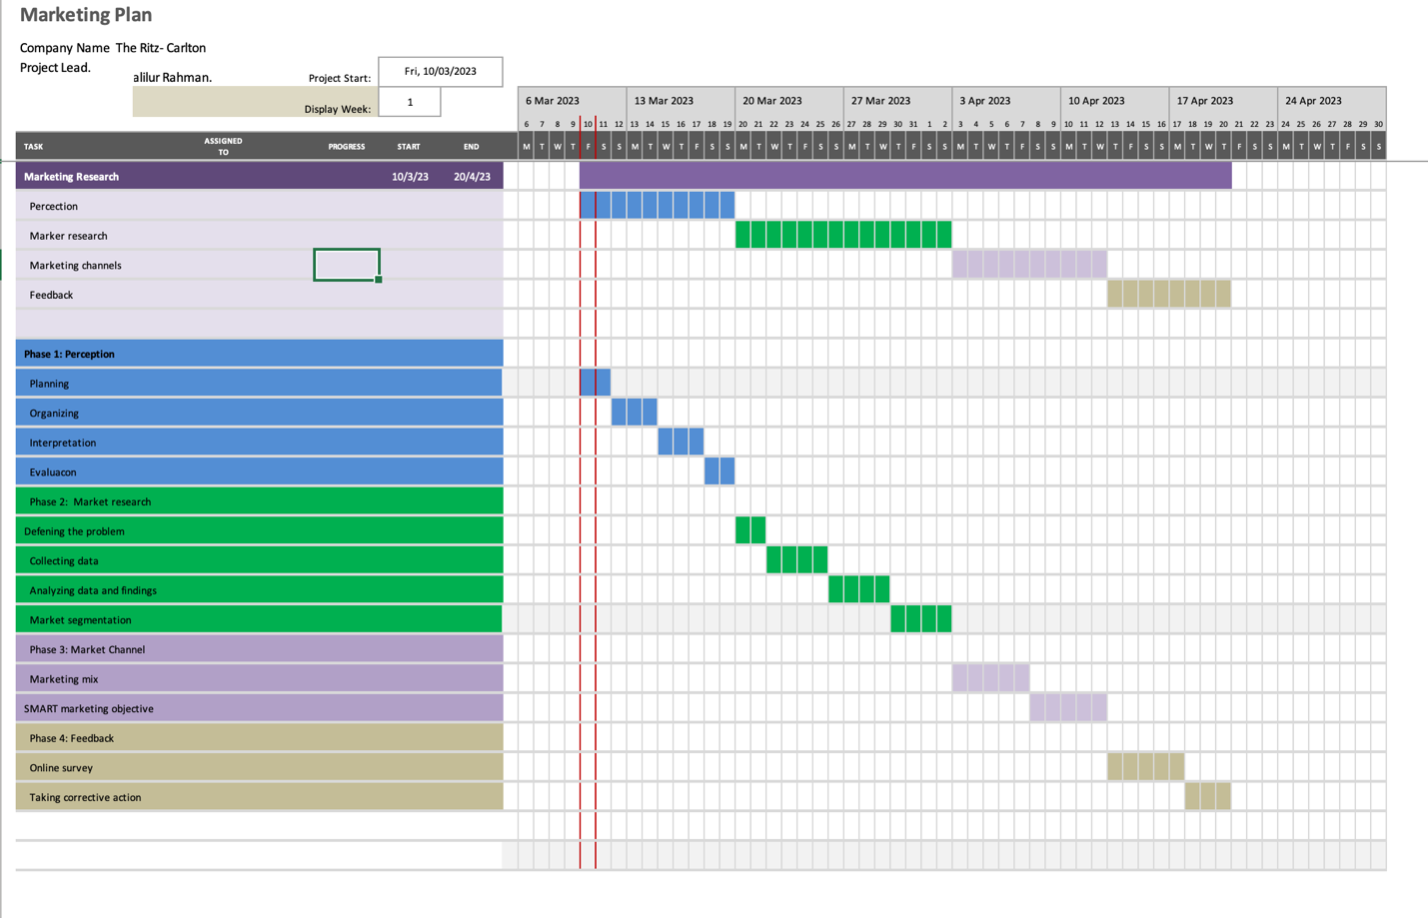

Control
Tracking revenue, profits, and ROI over time can be used to assess the plan effectiveness by identifying how the marketing plan conveyed to new customers. Another matric to measure effectiveness is the conversion rate (Ryan, 2021). It shows the percentage of bookings among website visitors. Long-term promotional accomplishment can be calculated by customer retention and loyalty. For instance. They can pin down repeat reservations.

Conclusion
Ritz-Carlton Hotelconfronts struggle from other businesses in the survival game to thrive. Ritz-Carlton Hotelmust steadily allocate the marketing budget to accomplish the supreme domino effect. Ritz-Carlton Hotel should lead regular market research for their digital marketing activities to create unique value propositions to communicate to their customers. Finally, Ritz-Carlton Hotel needs to expand by establishing strategic alliances with other companies in the tourism, airline, and event planning industries.

Reference list
Angla, L. (2021). Principles of Integrated Marketing Communications. 5th ed. UK: Cambridge University Press.
Belch, G.E. and Belch, M.A. (2021). Advertising and promotion : an integrated marketing communications perspective. 11th ed. New York, NY: Mcgraw-Hill Education.
Bowie, D., Buttle, F., Brookes, M. and Mariussen, A. (2017). Hospitality marketing. London: Routledge.
Bowman, I. (2021). The Strategy of Territorial Decisions. Foreign Affairs, 24(2), p.177. doi:https://doi.org/10.2307/20029958.
Chaffey, D. and Ellis-Chadwick, F. (2019). Digital Marketing: Strategy, Implementation and Practice. 7th ed. Harlow, England: Pearson.
Clow, K.E. and James, K.E. (2014). Essentials of marketing research: putting research into practice. Los Angeles: Sage.
Donohoe, S. and Kelly, A. (2020). Advertising and Promotion: An Integrated Marketing Communications Approach. International Journal of Advertising, 29(3), pp.501–504. doi:https://doi.org/10.2501/s0265048710201282.
Hyman, M. and Sierra, J. (2020). Marketing Research Kit For Dummies. 11th ed. London: John Wiley & Sons.
Jobber, D. and Ellis-Chadwick, F. (2020). Principles and practice of marketing. 9th ed. Maidenhead: Mcgraw-Hill Higher Education.
Karadag, I. and Kim, W.G. (2021). Comparing Market-segment-profitability Analysis with Department-Profitability Analysis as Hotel Marketing-decision Tools. Cornell Hotel and Restaurant Administration Quarterly, 47(2), pp.155–173. doi:https://doi.org/10.1177/0010880405281683.
Keller, K.L. (2016). Unlocking the Power of Integrated Marketing Communications: How Integrated Is Your IMC Program? Journal of Advertising, [online] 45(3), pp.286–301. doi:https://doi.org/10.1080/00913367.2016.1204967.
Pohan, K. and Bowman, C. (2019). An adaptive optimal combustion control strategy. Combustion and Flame, 100(1-2), pp.101–110. doi:https://doi.org/10.1016/0010-2180(94)00081-3.
Ritz-Carlton Hotel(2023). Ritz-Carlton HotelHome. [online] Ritz-Carlton Hotel. Available at: https://www.premierinn.com/gb/en/home.html.
Ryan, D. (2021). UNDERSTANDING DIGITAL MARKETING : marketing strategies for engaging the digital generation. S.L.: Kogan Page.
Smith, A. and Pawal, N. (2019). International abstracts of research in marketing. International Journal of Research in Marketing, 24(4), pp.350–359. doi:https://doi.org/10.1016/j.ijresmar.2007.09.005.
Vaněk, M. (2020). Evaluation methods of swot analysis. GeoScience Engineering, 58(2), pp.23–31.
Wolny, J. (2022). Marketing transformations: Re-thinking marketing, digital first. Journal of Direct, Data and Digital Marketing Practice, 16(2), pp.150–151. doi:https://doi.org/10.1057/dddmp.2014.57.

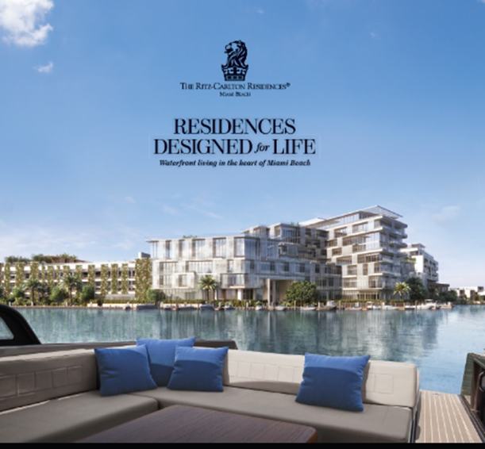
Appendix



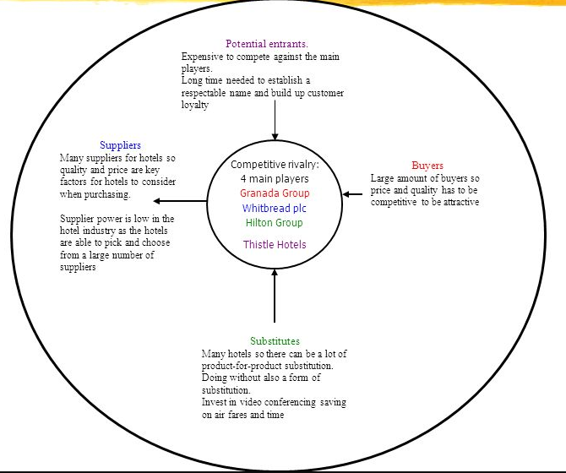

Component 2 : Presentation Slides
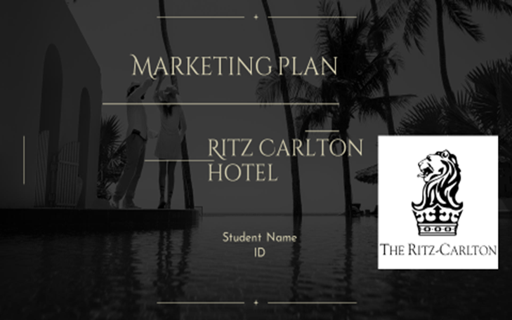
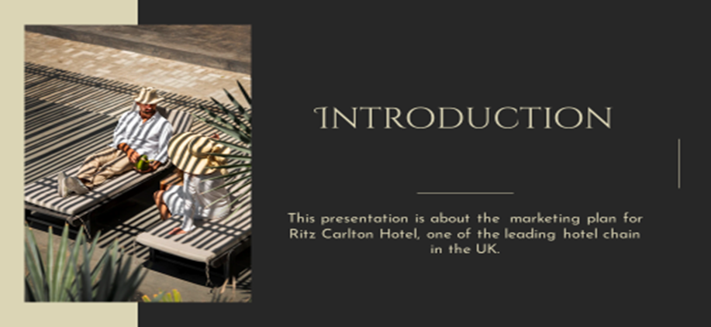
Introduction
This presentation is a marketing plan for Ritz-Carlton Hotel, one of the leading hotel chain in the UK. To identify major problems or marketing disruption, this report is intended to build a communications strategy based on present context to lift bookings, revenue and market exposure
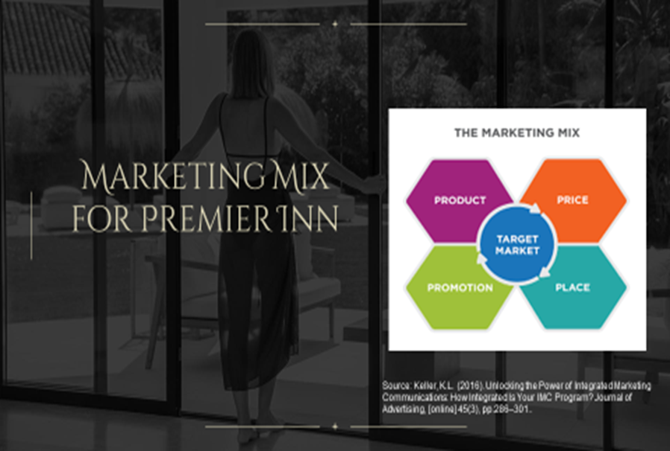
Marketing Mix for Ritz-Carlton Hotel
Product: Ritz-Carlton Hotelwill carry on to provide comfortable and luxury inn housings to its customers (Vaněk, 2020). To be innovative, they can introduce new wellness facilities to address the ever-changing demands of customers.
Place: Website and mobile application, online platforms of travel agencies and other partners are used as Distribution channels (Ritz-Carlton Hotel, 2023).
Price: Ritz-Carlton Hotel will remain to maintain its high pricing rate strategies (Ritz-Carlton Hotel, 2023).. Additionally convenient pricing selections and different seasonal discounts can be used.
Promotion: Strategies like SEO, social media ads, and influencer marketing can be used to increase its visibility and conversion rate (Keller, 2016). Video Podcast sponsorships or virtual events are other credibility ways to attract prospective consumers.

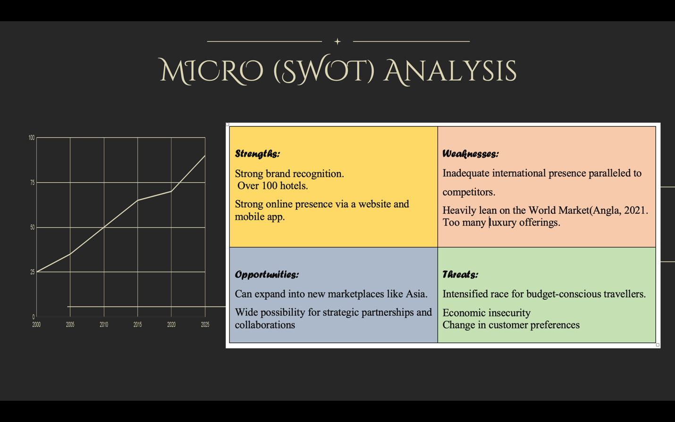
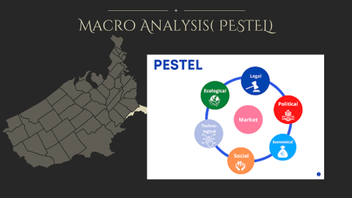

PESTLE analysis
Political: Changes in government tax system or service sector policy possibly will have across-the-board consequences on the hotel business (Keller, 2016).
Economic: Economic slowdown due to shift in consumer expenditure pattern have an effect on the demand for recreation and hotel rooms (Ritz-Carlton Hotel, 2023).
Social: consumer preferences for services and facilities and their anticipation to receive quality service from hotels can influence Ritz-Carlton Hotel.
Technological: New technological developments have an effect on how Ritz-Carlton Hotelprovides its services. For example mobile check-in and smart room technology are redefining the meaning of convenience.
Legal: Ups and downs in employment or data protection regulation have a force on business operations.
Environmental: The feeling to be a part of sustainability in customers and businesses have an upshot on in what way Ritz-Carlton Hoteladdresses eco-friendly concerns including green energy, trash management and so on (Smith and Pawal, 2019).
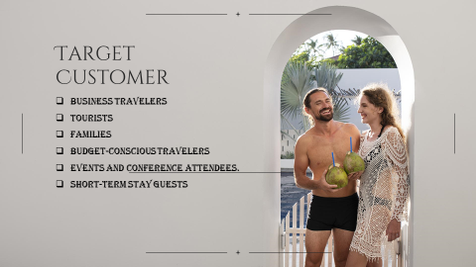

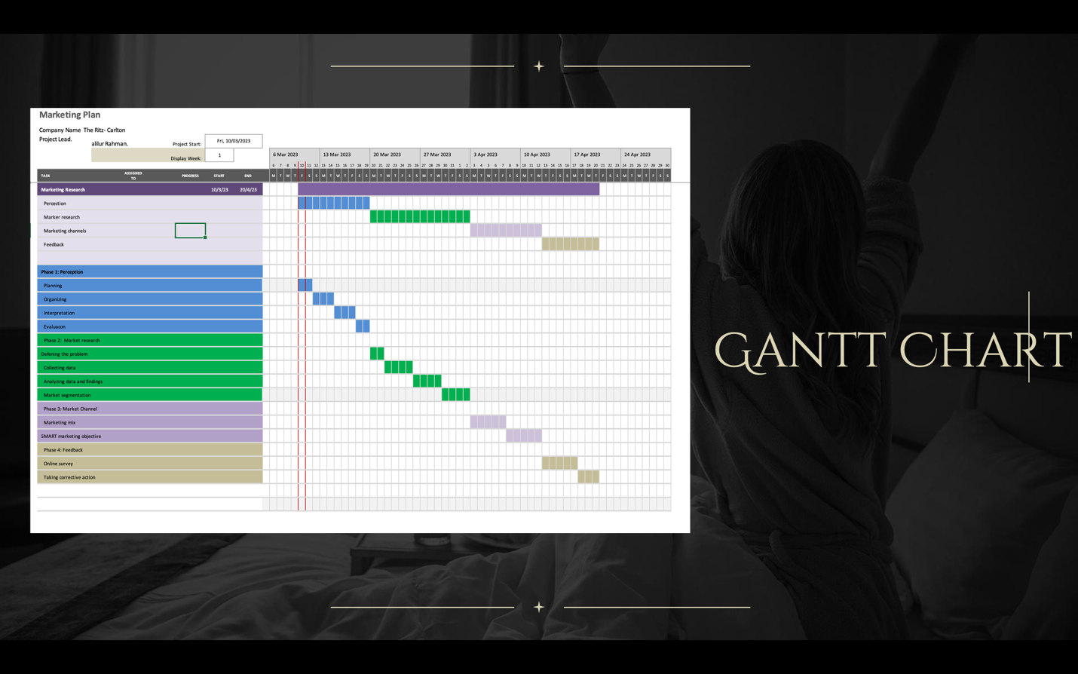

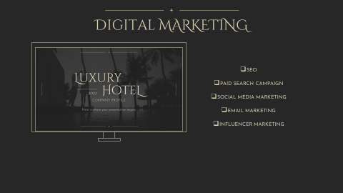

Digital Marketing
SEO Strategy: Search engine optimization (SEO) helps increase website traffic and visibility.
Paid Search Campaign: This helps increase website traffic and reservations (Belch and Belch, 2021).
Social media: Engage customers, create brand recognition, and generate reservations via social media.
Email marketing should be tailored and relevant after the basic marketing channels are established (Belch and Belch, 2021).
Influencer Partnerships: Social media influencers can help brands reach new audiences and generate buzz.

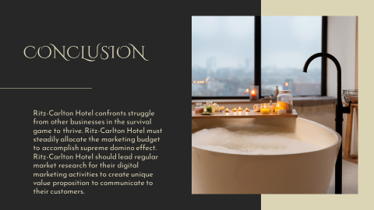

Conclusion
Ritz-Carlton Hotel confronts struggle from other businesses in the survival game to thrive. Ritz-Carlton Hotel must steadily allocate the marketing budget to accomplish supreme domino effect. Ritz-Carlton Hotelshould lead regular market research for their digital marketing activities to create unique value proposition to communicate to their customers.

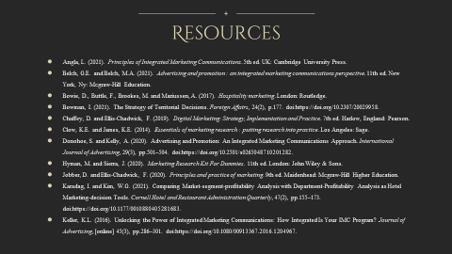
- Angla, L. (2021). Principles of Integrated Marketing Communications. 5th ed. UK: Cambridge University Press.
- Belch, G.E. and Belch, M.A. (2021). Advertising and promotion : an integrated marketing communications perspective. 11th ed. New York, Ny: Mcgraw-Hill Education.
- Bowie, D., Buttle, F., Brookes, M. and Mariussen, A. (2017). Hospitality marketing. London: Routledge.
- Bowman, I. (2021). The Strategy of Territorial Decisions. Foreign Affairs, 24(2), p.177. doi:https://doi.org/10.2307/20029958.
- Chaffey, D. and Ellis-Chadwick, F. (2019). Digital Marketing: Strategy, Implementation and Practice. 7th ed. Harlow, England: Pearson.
- Clow, K.E. and James, K.E. (2014). Essentials of marketing research : putting research into practice. Los Angeles: Sage.
- Donohoe, S. and Kelly, A. (2020). Advertising and Promotion: An Integrated Marketing Communications Approach. International Journal of Advertising, 29(3), pp.501–504. doi:https://doi.org/10.2501/s0265048710201282.
- Hyman, M. and Sierra, J. (2020). Marketing Research Kit For Dummies. 11th ed. London: John Wiley & Sons.
- Jobber, D. and Ellis-Chadwick, F. (2020). Principles and practice of marketing. 9th ed. Maidenhead: Mcgraw-Hill Higher Education.
- Karadag, I. and Kim, W.G. (2021). Comparing Market-segment-profitability Analysis with Department-Profitability Analysis as Hotel Marketing-decision Tools. Cornell Hotel and Restaurant Administration Quarterly, 47(2), pp.155–173. doi:https://doi.org/10.1177/0010880405281683.
- Keller, K.L. (2016). Unlocking the Power of Integrated Marketing Communications: How Integrated Is Your IMC Program? Journal of Advertising, [online] 45(3), pp.286–301. doi:https://doi.org/10.1080/00913367.2016.1204967.

