9

MODULE COD22E: LCMB7023
MODULE: HUMAN CAPITAL MANAGEMENT
ASSESSMENT COMPONENT 1: INDIVIDUAL REPORT
STUDENT NAME: Nicolae Mihai
STUDENT ID: 2124103@student.uwtsd.ac.uk
Teacher : Eno Maycock

TABLE OF CONTENTS
PART 1: DESIGNING THE TALENT ECOSYSTEM 2
Introduction 2
Current Tech Talent Ecosystem 2
Strategic “Build vs. Buy” Talent Model 3
Retention: Mentorship, Leadership & Lifelong Learning 4
Conclusion 5
PART 2: REFLECTION 7
Section A: Learning Journey using Kolb’s Reflective Cycle 7
Section B: Future-Proofing with AI 10
REFERENCES 11
PART 1 11
PART 2 13

PART 1: DESIGNING THE TALENT ECOSYSTEM

Introduction
This report aims at providing a holistic approach to a Talent Ecosystem strategy to Aether Innovations to solve the most pressing problems of flat growth, high turnover, and decreasing customer satisfaction. At present, Aether is using old, reactive recruitment techniques which are not ensuring the much needed innovational skill. This report assumes that the answer is not to hire aggressively, but to employ a strategic mix of Building (developing internal staff) and Buying (hiring external experts) talent, with deep-rooted retention strategies. This report will examine the external market environment and subsequently suggest a hybrid model of Build vs Buy, and lastly describe the learning and mentorship structure that is needed to retain high potential employees.

Current Tech Talent Ecosystem
The technology companies are currently characterised in the environment by a fierce War of Talent, wherein the demand of skilled professionals is much larger than supply (Driessen, Faelten and Moeller, 2023). Aether Innovations is not operating in a vacuum because it competes in the market where 76% of UK companies report considerable difficulties with filling IT and data positions (SIA, 2025). This low supply increases salary and creates significant bargaining power in the employees so that in case Aether cannot guarantee a strong value proposition on top of the basic salaries it will still lose the most competent employees to the companies that can.
This competition is added to by a Turnover Culture that is especially severe in the technology industry. Some of the lowest average tenure rates are also recorded by CIPD (2024) tech sector, and they tend to be slightly less than three years per position. The workers in this industry are very mobile and do not merely leave to get a better pay, but good growth opportunities. The cost of high turnover is disastrous in the case of Aether; a study conducted by Oxford Economics (2014) indicates that losing one specialised tech employee can cost companies over 30,000 pounds with regard to recruitment costs and productivity losses in the onboarding process.
Technical skills may be obsolete after every 2 to 3 years and this may apply to the fast moving technology industry. The inability of organisations to engage in consistent upskilling makes employees feel they have no choice but to move to other organisations, as a way of securing their future careers. According to Vibhas Ratanjee (2025), approximately 41% of employers cite the lack of time as the main impediment to staff development, which also starts the self-perpetuating cycle of staff leaving since they are not acquiring new skills. The present state of Aether is indicative of an immature environment: it is not utilising its talent pool through strategic or internal capacity building and this is weighing heavily on the flat growth and poor performance that are being manifested in the scenario.

Strategic “Build vs. Buy” Talent Model
The best way to address the two stagnation and high turnover crises is to shift the paradigm of ad-hoc hiring and follow a strategic model founded on the theory of Build vs. Buy, which is clearly expressed by Cappelli (2008). It is a revolutionary method of managing talent as it reacts to it as a supply chain management (Birou and Hoek, 2022). The same way that a manufacturer makes up his mind on whether to manufacture a part internally or use a vendor, Aether should make the decision on whether to manufacture talent (to develop staff internally) or to buy talent (to recruit in the external market).
The benefit of buying talent is that it is fast; it infuses new skills and new thinking into the company, which is essential when it comes to innovation (Addanki, 2024). Nevertheless, it has serious drawbacks: the outside hiring requires large pay rate premium, usually 18-20% above internal rates, and has a greater chance of so-called organ rejection with poor cultural fit (Zall, 2023). On the other hand, "Building" talent is a less quick approach that takes initial investment in Learning and Development (L&D). However, it has high long-term payoffs, such as a greater level of loyalty, extensive knowledge of the institution, and minimised chances of a mismatch, as the company is already familiar with the potential and personality of the employee. In the case of Aether Innovations, a binary decision cannot be used. Consequently, a 70/30 Hybrid Approach can be suggested as the best strategic solution.
The Buy Strategy (30%): Innovation Injectors.
Aether must aim at spending 30% of its recruitment budget on "Buying" external talent, but this has to be surgical. This is the category of the so-called Innovation Injectors: senior executives, change agents, and niche technical specialists (e.g. the person in AI ethics or Cloud Architects) (Charles, 2025). These are the functions that are very important to break the prevailing cycle of flat growth. Aether will not be able to afford the 12-24 months’ time that would be spent to develop internal personnel to fill these new high-tech roles; the market opportunity will be missed. Through external restrictions to such high-impact positions, Aether will be able to pay the market premiums to get top-tier talent without disrupting the entire wage system.
The Build Strategy (70%): The Retention Focus.
The other 70% of the strategy of Aether should focus on the Retention Focus. This entails the recruitment of young or middle-level professionals who have high potential and developing them to join the senior position. This can be directly countered by this strategy which is threatening to have high turnover in the scenario. The Build model is based on the restoration of the psychological contract, the unofficial list of expectations between the employee and employer (Aggarwal, 2025). When Aether invests in the development of an employee, he or she is paid back through commitment and tenure. This is a hybrid model that is both economically and culturally necessary. Buying all the talent is an unsustainable strategy; the recruitment expenses, as well as the new hire premiums, would further eat up the margins. Additionally, the external recruits tend to exit at a greater rate. Through its reliance on Building to fill most positions, Aether forms a consistent, faithful cultural heart, whereas the intended Buying keeps the company shaken and creative. This balance is what will result in customer satisfaction as well as agility to grow.

Retention: Mentorship, Leadership & Lifelong Learning
Aether should also use formal mentorship programme in order to transfer the knowledge between the Bought experts and the Built juniors to make this ecosystem work (Sokolowsky, 2025). The KPI ought to be a part of their job as they are required to mentor junior employees with high salary external experts. This is why they will be more expensive to the business and enhance the growth of internal talent faster. Also, Aether ought to roll out a programme called Reverse Mentoring whereby junior digital natives mentor top leaders on new trends and tools coming out of Gen-Z. This enhances the interaction with the younger employees, and they feel important and would not leave.
Secondly, retention needs to have definite Leadership Pathways. The high-potential employees usually quit as they become stuck in their jobs with no apparent upward movement (Conrad, 2025). Aether will need to draw out clear career ladders, with specifics of how a "Junior Developer" can become a "Tech Lead" or even "CTO" in 3-5 years. These should be two-track: both managerial career (managing people) and technical career (becoming a Principal Engineer) so that there is no threat of making great coders into unwanted managerial positions simply to get a promotion.
Thirdly, to fight the skills obsolescence, the strategy should be on "Lifelong Learning. Rather than ad-hoc training, Aether ought to introduce an "Internal Tech Academy" or an actual specific substantial monetary reward to employees that can be used on certified training (e.g., £1,000 per year) (Dinu et al., 2023). This sends a message to the labour force that they would grow in terms of market value at Aether. It is an important retention device; workers will be much less likely to run to a rival and take a little pay raise when they are already on the way to a valuable certification paid by their present company.
Lastly, these retention strategies are also directly related with customer satisfaction. The situation refers to declining customer satisfaction, which is usually a trailing marker of dissatisfied personnel. Magsi and Siddiqui (2025) research demonstrates the effect of the Service-Profit Chain: well-trained, satisfied employees prove to provide a higher quality of work and a high level of customer service. Stabilising the workforce by mentoring and learning will reduce the number of product mistakes in Aether and lead to better relations with clients, which will address the third problem identified in the scenario.

Conclusion
Finally, the current crisis of turnover and flat growth of Aether Innovations can be resolved by switching to a more proactive recruitment strategy focused on a so-called Talent Ecosystem. Through the suggested 70/30 Build vs. Buy model, the company is able to not only streamline its labour expenses but also be able to get access to the much-needed innovation skills instantly. Moreover, by backing up such a model through the implementation of organised mentoring, defined leadership development, and life-long learning programmes, high potential employees will be retained because of a strong retention culture. This approach will eventually have people consistent with performance, which would make sure Aether stabilises its workforce and resumes sustainable growth.

PART 2: REFLECTION

Section A: Learning Journey using Kolb’s Reflective Cycle
Introduction
This reflection uses the Experiential Learning Cycle developed by Kolb, which characterises learning as the ongoing process of understanding and changing experience, to assess my journey in the Human Capital Management module (Taneja, Kiran and Bose, 2022). Reflective observation, active experimentation, and development of abstract conceptualisation and concrete experiences helped me to explore how the theoretical knowledge and practical practise enhanced my knowledge on HR strategy and at the same time enhanced my personal development and professional growth.
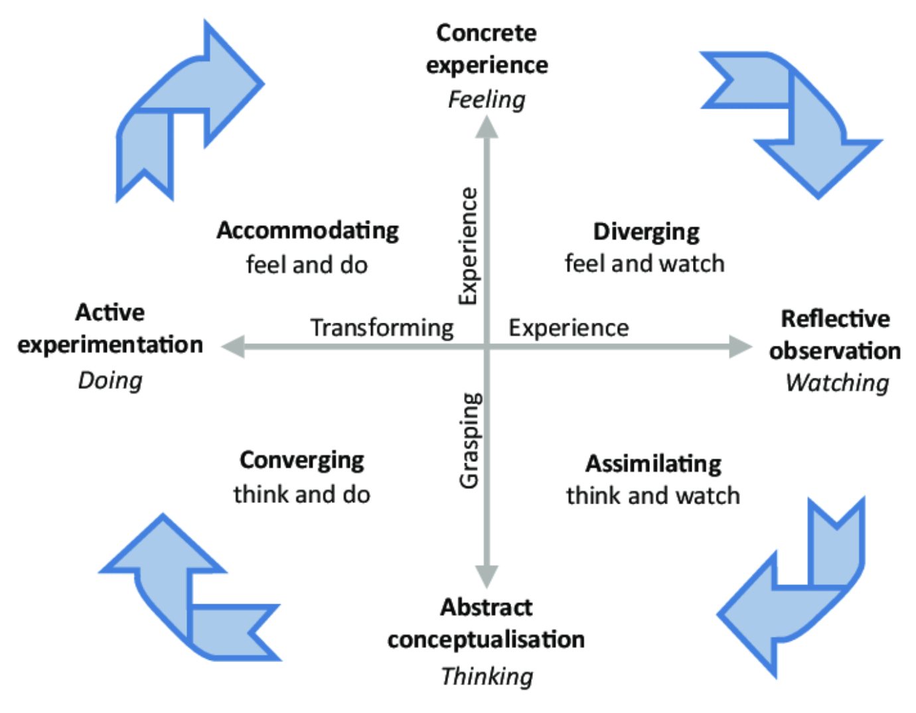
Figure 1: Kolb’s Experimental Cycle
(Source: Taneja, Kiran and Bose, 2022)
Concrete Experience
The experience I had with this module was based on the realisation that I was no longer viewing the theoretical knowledge of Human Resources in relation to the practical application of the intricate concepts. One of the most significant times was the case analysis of the Aether Innovations case study, during which I was to identify the organisational failures, i.e., high turnover and low growth, and provide a strategic solution. I also attended lectures that dissect the Build vs. Buy models and was able to contribute to seminars on the psychological contract between employers and employees.
Moreover, the module involved me in an active design of a talent ecosystem, which obliged me to act as a consultant. This did not only involve passive learning but I had to write certain interventions, i.e. mentorship, career pathways, and explain them with reference to the academic literature. This was a practical implementation of the study of solutions to a struggling technological firm, which gave me a real-life situation to apply the theoretical content I had been reading.
Reflective Observation
First, I was confused with the complexity of the strategic choices. Previously I had thought of HR as an administrative role that entailed hiring, firing and payroll. Nevertheless, when I delved into the situation of Aether, I realised that it was indeed people issues that were leading to failures in businesses. The change of my point of view occurred when I understood that the incapability of a company to be innovative was a failure of a talent strategy and not a technical failure.
Another insight that I made is that the principle of Build vs. Buy is more complex than I initially thought. My first thought was that Buying the best talent was the only apparent answer to an ailing company. After a moment, I came to understand that without a culture to help them, costly recruits would just leave the firm. This awareness gave me a more negative view of the "cheap" management solutions and a more positive view of the long-lasting cultural architecture.
Abstract Conceptualisation
In terms of connecting my experience with theory, my newfound understanding of theory has changed my in-depth thinking pattern of being fixed to a Growth Mindset as described by Dweck (2010). Like organisations need to shift the know-it-all culture to a learn-it-all culture in order to survive, I had to realise that my professional value was not only my existing knowledge but my ability to learn. The Build part of the talent model is simply an application of the Growth Mindset to the organisation-wide level: that potential can be built.
I have also enlightened myself on the concept of Innovation Culture. I came to understand innovation is not a system product, but people interrelating and feeling safe with each other. The Social Capital theories made me realise that mentorship and cross-functional teams are not only nice to have HR initiatives, but also the processes that deliver tacit knowledge and provide novelties of ideas. I now understand HR as the design of an ecosystem (not resources) management (Cullen-Lester and Pryor, 2025).
Active Experimentation
In the future, I will be keen to utilise these lessons by becoming more strategic in my personal career growth. I will cease to think of my abilities as a fixed one and will consider my career a Build project. I will also actively pursue mentorship, not as a passive method of being mentored, but by identifying senior leaders who can be my source of Reverse Mentoring, as I suggested in my report.
In particular, I will be dedicated to a systematic L&D strategy. I will also have subscriptions to credible journals in HR strategies (e.g., the CIPD People Management magazine) to keep up with the current trends in the market such as the War of Talent (Griffith, 2019). I will also seek chance in my place of work to spearhead small culture initiatives on the basis of the theory that small interventions in mentorship and learning may have disproportionately large effects on group performance and satisfaction.
Conclusion
Finally, this module has redefined my professional identity as an active administrator into a human potential strategic planner. Having adopted the growth mentality and ensuring that the steps mentioned above are put into practise, I am now in a position to create talent ecosystems that are not only efficient but also resilient, creative, and, above all, human-centred.

Section B: Future-Proofing with AI
With the development of Artificial Intelligence (AI) and its more and more powerful functions, I can state that most of the traditional features of the position of Human Capital Consultant are at risk of being automated. Already, AI tools can scan through resumes at a higher rate than humans, calculate the likelihood of turnover based on large amounts of data and even create simple training content (Madanchian, 2024). Nevertheless, I do not see this as a substitute of my position, rather as an evolution. The data-processing and heavy administrative workload can be transferred to AI, eliminating the monotony of the work.
My personal approach to remain relevant is based on doubling down on the skills that will never be automated by AI: empathy, intricate negotiation, moral judgement, and culture development. AI is able to inform me by the patterns of data who is likely to quit, yet something cannot sit in a room with the employee, perceive their frustrations, and train the employee towards a solution (Gkinko and Elbanna, 2022). These Human Capital skills of being able to gain trust and manoeuvre through organisational politics will be the high end asset of the future workforce.
AI will be my Co-pilot to enhance my abilities and not establish them. As an illustration, I will apply AI to analyse the complex workforce data and derive trends (the what), and in this manner, my time will be liberated to deal with the strategic interventions and counselling (the why) (Johnson et al., 2021). By portraying myself as the human strategist who will decipher the insights of AI to make ethical, culture-aware decisions, I will be certain about being the pilot of the ecosystem who will use AI as a strong tool to steer the course.

REFERENCES

PART 1
Addanki, S., 2024. Dynamics of Corporate Entrepreneurship in Technology Companies: A Study of Strategic Practices and Governing Frameworks Shaping Entrepreneurial Ecosystems. Doctoral dissertation. Massachusetts Institute of Technology.
Aggarwal, S., 2025. The Hidden Truth About Psychological Contract Examples at Work [2025 Guide]. Infeedo.ai. [online] Available at: https://www.infeedo.ai/blog/the-hidden-truth-about-psychological-contract-examples-at-work-2025-guidepsychological-contract-examples-at-work-2025 [Accessed 31 Jan. 2026].
Birou, L. and Van Hoek, R., 2022. Supply chain management talent: the role of executives in engagement, recruitment, development and retention. Supply Chain Management: An International Journal, 27(6), pp.712–727.
Cappelli, P., 2008. A supply-chain approach to talent management. Harvard Business Review.
Charles, 2025. AI is dominating recruitment decision making discussions right now… LinkedIn. [online] Available at: https://www.linkedin.com/pulse/status-quo-bias-hiring-why-companies-overvalue-familiar-charles-baker-5ovec [Accessed 31 Jan. 2026].
CIPD, 2024. Benchmarking Employee Turnover: What Are the Latest Trends and Insights? CIPD. [online] Available at: https://www.cipd.org/uk/views-and-insights/thought-leadership/cipd-voice/benchmarking-employee-turnover/ [Accessed 31 Jan. 2026].
Conrad, D.L., 2025. Beyond teacher leadership: Retaining educators with individual contributor career pathways. International Journal of Educational Reform. doi:10.1177/10567879251326545.
Dinu, E., Vătămănescu, E.M., Stăneiu, R.M. and Rusu, M., 2023. An exploratory study linking intellectual capital and technology management towards innovative performance in KIBS. Sustainability, 15(2), p.1356.
Driessen, M., Faelten, A. and Moeller, S., 2023. The Deal Paradox: Mergers and Acquisitions Success in the Age of Digital Transformation. London: Kogan Page.
Magsi, A. and Siddiqui, S.M.F.E.A., 2025. Enhancing consumer satisfaction and loyalty: the role of logistics performance, technology utilization, and employee competence in shaping store image. International Journal of Social Sciences Bulletin, 3(4), pp.468–492.
Oxford Economics, 2014. The Cost of Brain Drain. [online] Available at: https://www.oxfordeconomics.com/resource/the-cost-of-brain-drain/ [Accessed 31 Jan. 2026].
Ratanjee, V., 2025. 41% of employees say they have no time to learn: Rethinking upskilling. Forbes. [online] 28 Apr. Available at: https://www.forbes.com/sites/vibhasratanjee/2025/04/28/41-of-employees-say-they-have-no-time-to-learn-rethinking-upskilling/ [Accessed 31 Jan. 2026].
SIA, 2025. Tech talent shortage hits 76% of IT employers globally. Staffing Industry Analysts. [online] Available at: https://www.staffingindustry.com/news/global-daily-news/tech-talent-shortage-hits-76-of-it-employers-globally [Accessed 31 Jan. 2026].
Sokolowsky, J., 2025. Mentorship culture: What, why & how to cultivate a mentoring culture. Chronus. [online] Available at: https://chronus.com/blog/mentorship-culture/ [Accessed 31 Jan. 2026].
Zall, A., 2023. Hiring internally vs externally: What are the pros and cons? Workhuman. [online] Available at: https://www.workhuman.com/blog/hiring-internally-vs-externally/ [Accessed 31 Jan. 2026].

PART 2
Cullen-Lester, K.L. and Pryor, G. eds., (2025). The Social Capital Imperative: Revealing, Developing, and Leveraging Organizational Networks. Oxford University Press.
Dweck, C.S. (2010). Mindset: The New Psychology of Success. p.2006.
Gkinko, L. and Elbanna, A., (2022). Hope, tolerance and empathy: employees' emotions when using an AI-enabled chatbot in a digitalised workplace. Information Technology & People, 35(6), pp.1714–1743.
Griffith, K., (2019). Characterizing the ‘global war for talent’. In Research Handbook of International Talent Management (pp. 422–448). Edward Elgar Publishing.
Johnson, M., Jain, R., Brennan-Tonetta, P., Swartz, E., Silver, D., Paolini, J., Mamonov, S. and Hill, C., (2021). Impact of big data and artificial intelligence on industry: developing a workforce roadmap for a data driven economy. Global Journal of Flexible Systems Management, 22(3), pp.197–217.
Madanchian, M., (2024). From recruitment to retention: AI tools for human resource decision-making. Applied Sciences, 14(24), p.11750.
Taneja, M., Kiran, R. and Bose, S.C., (2022). Critical analysis of Kolb experiential learning process: Gender perspective. International Journal of Health Sciences, (I), pp.8713–8723.

