Academic and Employability Skills
Student Name: Iosif Tcaciu
Student ID: 20222775
Module code: BMSW4001
Assignment title: ACE practical portfolio
Lecturer : Joanna Walsh

Table of Contents
Task 1 Slide 1 Cover Page………………………………………………………3
Slide 2 Introduction……………………………………………………………………….4
Slide 3 Essentials Skills………………………………………………………………….5
Slide 4 - 5 Swot Analysis…………………………………………………………………6
Slide 6 - 7 - 8 Kolb’s Learning Cycle……………………………………………………8
Slide 9 Performance Development Plan……………………………………………….11
Slide 10 Conclusion……………………………………………………………………….13
Slide 11 References……………………………………………………………………….14

Task 1
Slide 1

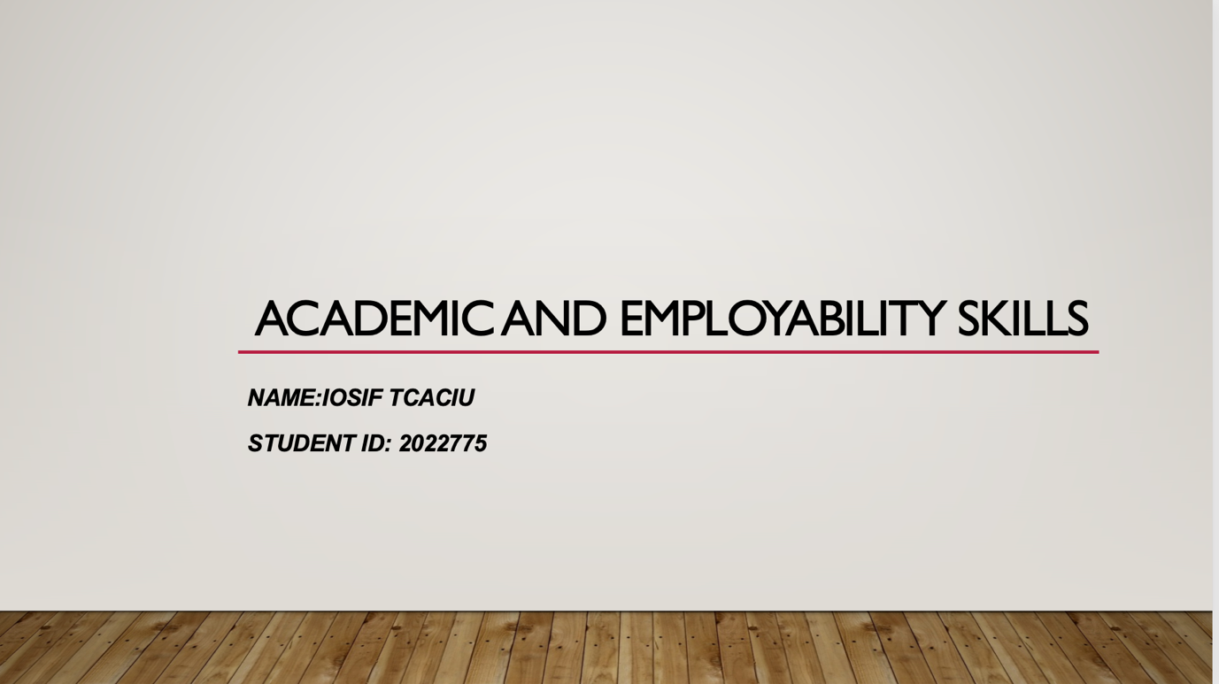
Slide 2
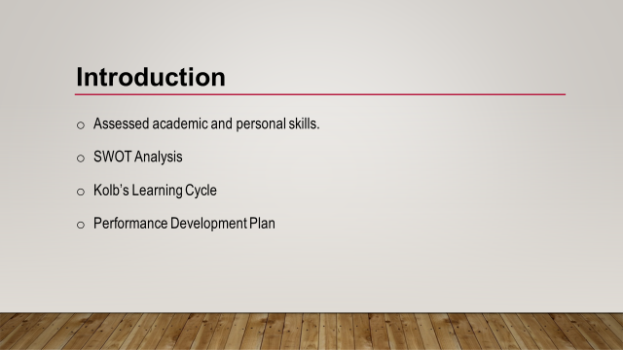
Introduction
The world is becoming more competitive and challenging day by day. Everything is rapidly changing, and skills are required not only for employability but also for facing the new ages and generations. Here, I have tried to evaluate my skills, learnings and strengths to a great extent considering the current world of jobs and employment opportunities. To analyse my situation, SWOT Analysis, Kolb’s Learning Cycle and Performance Development Plan have been utilised.

Slide 3
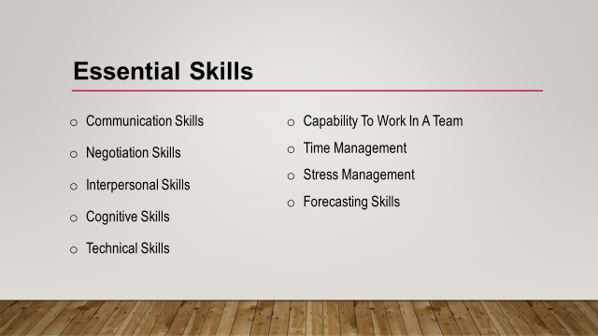
Essential Skills
My intended career is to become an entrepreneur and starting my own business. However, it is not an easy task, and it requires a lot of efforts and skills. The skills that I have learned from educational institutes will be beneficial in the long run. It will help me to understand right and wrong properly and to make effective planning and forecasting to a great extent (Amjad, Rani & Sa’atar, 2020). Diversified skills are required to become employable in the current world including communication skills, negotiation skills, interpersonal skills, cognitive skills, technical skills, forecasting skills, the capability to work in a team, time management, stress management, etc. The process of developing and shaping these skills require long-run plan and development processes.

Slide 4
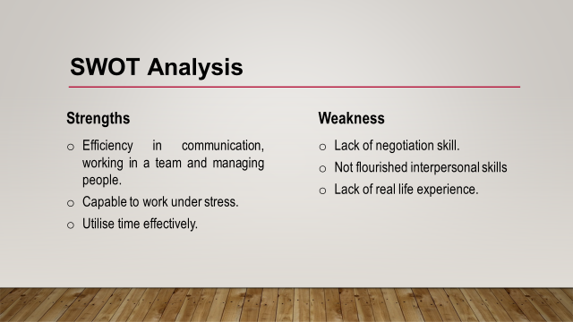
SWOT Analysis
Strengths
In my long academic life, I have learned to communicate effectively with people. Besides, I can also work managing people which refers to my capability to work in a team and as well as the leadership (Pang et al., 2019). Again, I can also work under stress especially in preparing presentation and taking exams. My academic and other activities taught me to manage my time effectively.
Weaknesses
A lot of weaknesses exist in me which make my career more challenging. I am not good at negotiation and I need a lot of improvements in bargaining and debating. My interpersonal skills are not flourished enough, and I need to brush up on my technical skills. Most importantly I must lack real-life experiences.

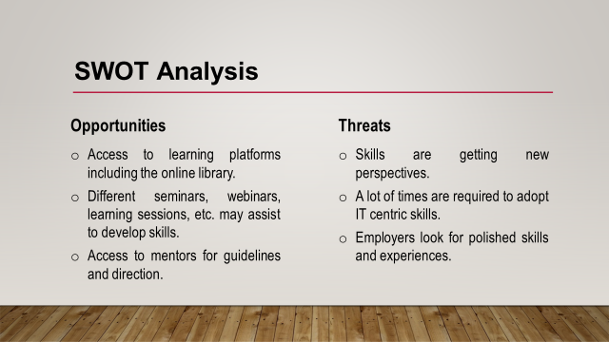
Opportunities
There exists a significant number of opportunities around me. I have access to an online library as well as journals which may help me to get flourished. Besides, I can also join seminars, webinars, conferences, learning sessions, courses, etc. to develop myself. Again, I also have mentors in my institute to get proper direction.
Threats
The world is now more challenging and competitive. Business organisations look for more polished skills and experiences. Again, the skills are getting changes and becoming technology-based to a great extent (Pang et al., 2019). All activities have IT versions that are difficult to cope with time.

Slide 6
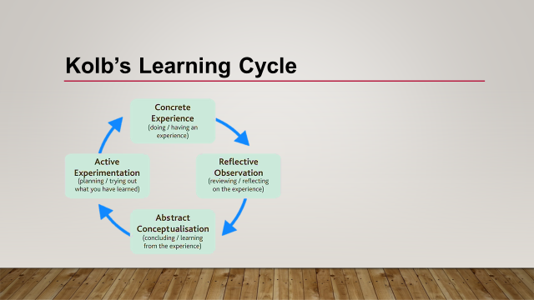
Kolb’s Learning Cycle
There is no doubt that different people learn in different ways and every person chooses the most comfortable ways while learning and adapting. According to Kolb’ Learning Cycle, four phases help to learn properly. I can relate it with my academic activities as well as other learning to a great extent (Morris, 2020). This model explains that we experience something and that try to evaluate it. Then we decide and plan to implement the learning in other activities. Therefore, the process of learning should be different at different stages. It is difficult to coach an individual about public speaking who never experienced or observed public speaking.

Slide 7
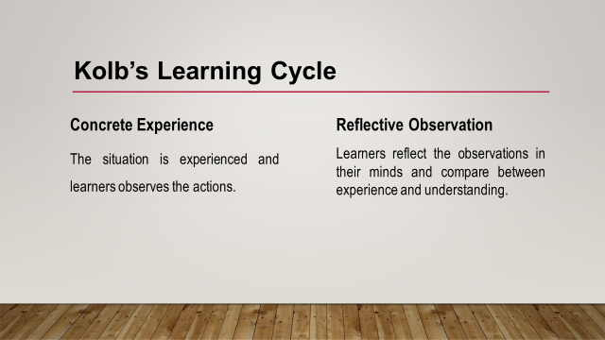
Concrete Experience
In learning something new, I prioritise concrete learning which refers to the experience I have learned from the surroundings. It is difficult for me to learn anything which I have never experienced before. Besides, the process is also not sustainable (Kuri, 2017). In academic activities, learning something by experience is more important to me. To become an entrepreneur, I visit markets, talk with customers, hear from other entrepreneurs, and build networking to a large extent.
Reflective Observation
After having experience, reflective observation is crucial which help to analyse the experiences in different situations (Morris, 2020). As a result, the learning can be utilised in different situations. It also helps to relate both understanding and learning.

Slide 8
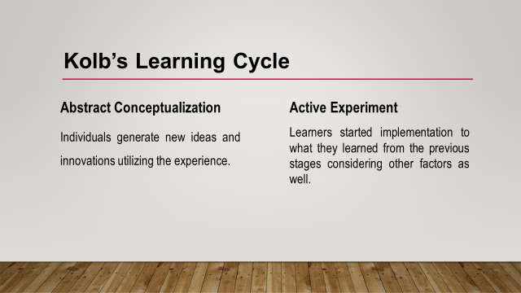
Abstract Conceptualisation
It helps to understand the learners the inner meaning or mechanism of an experience and leads to new ideas and innovation. The learner becomes capable to utilise the learning according to their own ways. It is important in business activities to generate ideas from experiences, and It helps me a lot in my career.
Active Experimentation
This stage is an implementation where learners start to implement their learning and bring out benefits or solve problems. In this world, people who can implement ideas and learnings are valuable for business organisations in the long run.

Slide 9
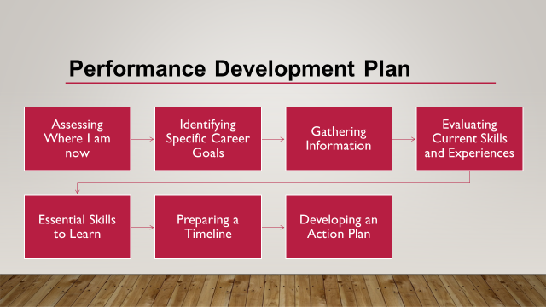
Performance Development Plan
The PDP or the personal development plan play a significant role in developing the performances of individuals. Generally, goals, improvement targets, progress measurement, strategy outline, etc. take place in the PDP (Hook & Jenkins, 2019). It will help me in developing my essential skills for employability within a short period.
There are many ways of preparing PDP for individuals. Here, a plan is prepared for me which may give me a boost in my career. These are briefly provided here.
1. Assessing Where I am Now
First, I need to find out my current situation. What I am doing right now, my experiences as well as skills. I am a student and pursuing a degree. I am an extrovert having skills like communication skill, time management skills, capability for team working, etc.
2. Identifying Specific Career Goals
It refers to how I want to flourish my career in the long run. I believe success varies from person to person. I want to see myself as an entrepreneur within the next five years. It is possible as I have passions and fascination to a large extent.
3. Gathering Information
In this stage, the necessary information regarding my career and goals should be collected. It will help to fix my responsibilities, day-to-day activities and to know the macro environments.
4. Evaluating Current Skills and Experiences
It is also essential to evaluate my existing skills and need to understand what skills I have for my career. Besides, I need to measure the experiences and gaps of skills for further decisions.
5. Essential Skills to Learn
I have to focus on new skills which are important for my career in the long run. It may include both soft skills and technical skills.
6. Preparing Timeline
The plan should have a specific timeline for accomplishing work activities on time. Otherwise, the result may get delayed, and it will not be possible to reach the target on time. Initially, the timeline covers five years.
7. Developing an Action Plan
Finally, an action plan is required to prepared which consists of pragmatic steps to fulfil the plan. It shows what to do for acquiring skills and other activities is a specific period.

Slide 10
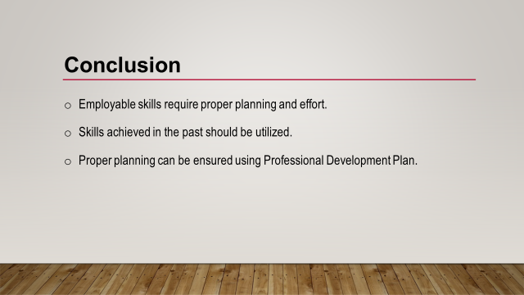
Conclusion
My intended career is to become an entrepreneur and starting my own business. However, it is not an easy task, and it requires a lot of efforts and skills. The skills that I have learned from educational institutes will be beneficial in the long run. It will help me to understand right and wrong properly and to make effective planning and forecasting to a great extent.

References
Hook, C. and Jenkins, A., 2019. Introducing human resource management. Harlow: Pearson.
Kuri, N., 2017. Kolb's Learning Cycle. Distributed by ERIC Clearinghouse.
Sugerman, D., 2018. Reflective learning. Dubuque, Iowa: Kendall/Hunt.
Taylor, B., 2017. Reflective practice for healthcare professionals. Berkshire, England: Open University Press.
Amjad, T., Rani, S.H.A. and Sa'atar, S., 2020. Entrepreneurial Marketing Theory: Current Developments and Future Research Agenda. SEISENSE Journal of Management, 3(1), pp.27-46.
Morris, T.H., 2020. Experiential learning–a systematic review and revision of Kolb’s model. Interactive Learning Environments, 28(8), pp.1064-1077.
Pang, E., Wong, M., Leung, C.H. and Coombes, J., 2019. Competencies for fresh graduates’ success at work: Perspectives of employers. Industry and Higher Education, 33(1), pp.55-65.

