Rhodri Jones
Student ID Number: 2118434
Module Title: L4 – Quality and business improvement.
Module Code: ACMA4004
Assignment Title: Lean & Six sigma methodologies for process improvement


https://media.noria.com/sites/Uploads/2019/7/10/072745ca-e28c-4132-9e93-e6843b2ea350_LeanManufacturing_05222019_extra_large.jpeg

https://2.bp.blogspot.com/-XcsjmH-6eSU/WH-DCLUkqHI/AAAAAAAABh8/lA76ZBjV-tkigdbD98nUi7ru9gdLxF4FQCPcB/s1600/Six-Sigma3.png

Contents:

Page 1: Title page

Page 2: Contents Page

Page 3: Introduction, introduction of six sigma.

Page 4: six sigma metrics

Page 5: DMAIC & DMADV processes

Page 6: Lean (JIT) Manufacturing

Page 7-8: Six Sigma & lean methodology comparison and conclusion

Page 9: References
Introduction
Within this report I will writing about Six sigma and lean manufacturing methodologies and writing about how the methods came to exist and how they have benefited businesses around the world by providing them a more efficient way of working. I will also be describing what the core principles for both six sigma and lean manufacturing are to show how the methods have developed and what aspects of the process data they take into account when it comes to being applied to a business structure and being used to create a more efficient production line and overall business, this will include references back to my own personal work and how the company I work for uses similar methods to the ones being mentioned today in order to create the best product for our customers. I will then be comparing both processes and talking about their similarities and differences and the pros and cons of both and how these are considered when companies apply these methodologies to their production process. After all aspects are taken into consideration, I will write a conclusion to support whether the six sigma and lean manufacturing methodologies benefit a businesses’ production efficiency and why they work so well or possibly not so well on the production line.

What Is Six Sigma?
Six Sigma is a process which is used by companies which focuses on removing defects from any products and it does this by also reducing the variation in the final products. This methodology is used for a specific process when creating manufactured parts, a service, or a working plan/process. Six sigma is based purely on a structure of using numerical data to determine any issues with the process, where the data is then displayed using bell charts and other methods of displaying numerical data such as excel, scatter and bar charts. As previously said numerical data is used very efficiently within six sigma as it is the most reliable form of data when looking at a production lines output and where along the line the efficiency is dropping which then highlights the area six sigma needs to apply itself in order to increase the processes’ final output quality.
Although six sigma is very data driven when it comes to decision making the methodology also looks at in depth the companies target market and what they would consider to be a high-quality product and one they would be satisfied in buying. They would use this data in the same way as the numerical data and apply solutions to the production line in order to make the product to the quality level the customer expects. This approach to assessing final product quality is uses across many companies including the company I work for called FSG which specializes in press tool making for many different industries including food, health care, motor, and aerospace. So high quality levels are crucial in our work otherwise the part could fail and lead to serious consequences for the company. So, to ensure our product is manufactured to a high quality like six sigma we like to use numerical data to check our products before sending them to the customer. Our most used process of assessing a product would be the use of a CMM machine which would precisely measure all dimensions of the part which we would then reference to the orthographic drawing we received of the customer to ensure all part sizes are within the tolerance set and if the quality is acceptable the part can be shipped off to the customer with a copy of our assessments as evidence.
Within six sigma there are some common metrics used to help identify how many products manufactured by the company have any issues or ‘’defects’’ which could then be passed onto the target market if nothing was to be done about the issue. These metrics are:
Defects per unit (DPU) – This is where a specific batch amount of the product are produced, and the number of defects recorded from that batch would be the DPU from that.
Defects per million opportunities (DPMO) – which would consist of the DPU x 1,000,000 which would leave the number of opportunities for potential error to occur.
Sigma level – This metric is used to monitor the variability in the short term based on the Defects per million opportunities.
First Pass Yield (FPY) – Which consists of a percentage of the final product which has been manufactured correctly without any rework required.
These metrics are a great example to how six sigma uses numerical data to make key decisions about what to change in the manufacturing process as by using these metrics they can potentially trace back to where the ‘defect’ has occurred on the product line and remove any doubts of questioning where the fault has come from. This also allows manufacturers to see how many defects they could manufacture while using their current manufacturing process which is also a key piece of information as no company wants to use a process which will produce mostly scrapped parts. Within FSG we also conduct similar assessments to high scale production jobs, and we assess the quality by randomly selecting multiple parts from the same batch for example every 50 parts we would assess 10 at random and record the results giving us a rough estimation to the potential defects we could face in the entire batch once it is completed. And if obviously we found that the quality of the part was not up to a suitable standard, we would stop production and rethink how to improve the process to create the best possible part for the customer.
Why is it called Six Sigma? Well considering the common metrics mentioned above you can calculate very accurately the total of defects per million opportunities. And using a sigma level of 6.0 with a shift of 1.5 this works out as the lowest DPMO of 3.4 with a 1.5 sigma shift which creates a quality level of 99.9% which is a very good level of consistency of quality. But with the six-sigma process you are always looking to improve as it would be near impossible to create a perfect process which created no defects but constantly working towards the idea of that is what six sigma represents and gives to a company looking to improve output quality and manufacturing efficiency. This is very similar in all industrial companies, within FSG we are always looking at making machining processes shorter while also maintaining the same high level of quality as in engineering time is money and every second being wasted is also money being lost.
What Makes Six Sigma So reliable when creating high quality products and processes?
To be a successful methodology for other companies to take onboard and implement into their processes the structure of the method must be concrete and must know exactly what the vision is at the end of the process. This is where six sigma uses DMAIC and DMADV processes depending on what stage the company is at and where they want to go moving forward.
DMAIC is the process which would be used when the company already has an existing product and process, but the product is not being manufactured to an acceptable standard and needs improvement to be successful. This process would be the most common method used within FSG as we often get parts sent to us via orthographic drawings and sometimes prototypes with customers wanting us to improve the overall function of the product and produce it in less time while maintaining the product function. The Process would include ‘Defining’ the problem which needs improving, we would then ‘Measure’ the level of quality in previously produced batches and see if we could improve this, ‘Analyze’ our findings, ‘Improve’ areas identified as causes for concern, implement ‘Control’ measures to ensure the improvements made to the processes are carried throughout the rest of the products life unless further improvements are needed.
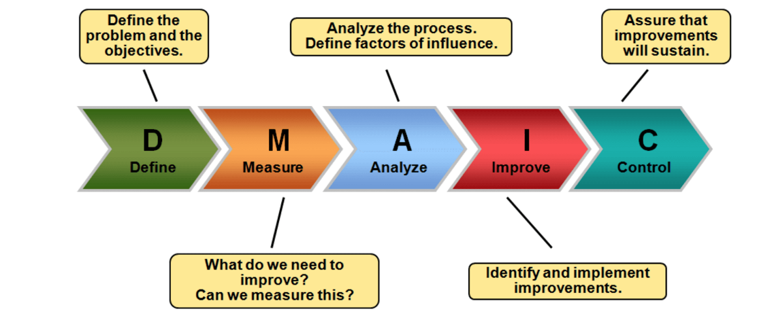

https://th.bing.com/th/id/R.2011a852bdd11381cacd003c0343f7b0?rik=jd3u9dGXEDgyyg&riu=http%3a%2f%2fmohamedelgendy.com%2fblog%2fimg%2fdmaic_process.png&ehk=hJ7pqpnK2aRKGW9n0TC6tR90GQbhn5xR6i1YG%2b0GIkk%3d&risl=&pid=ImgRaw&r=0
DMADV is a process which would be implemented if the product the product wants to create does not yet exist and the life plan of the product needs to be created from scratch, such as the research, design, creation process, and target market for that product. When using this process as a company it is vital that you have a clear understanding of where you want that product to go in the future and aspects of it you want to be prioritized to satisfy the target market. Similar to DMAIC, DMADV means, ‘Define’ ‘Measure’ and ‘Analyze’ but due to this process being used to create a product from scratch it has to ‘Design’ and ‘Verify’ the product before manufacturing to ensure all previous steps are correct and suitable.
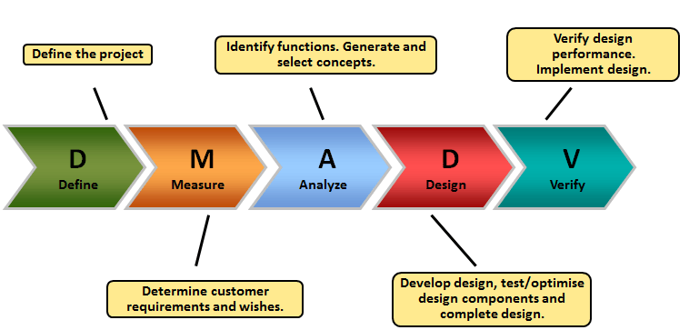

https://i.pinimg.com/originals/51/1f/95/511f95e7b987ddb3061f1df569ca0b5e.png

Lean Manufacturing
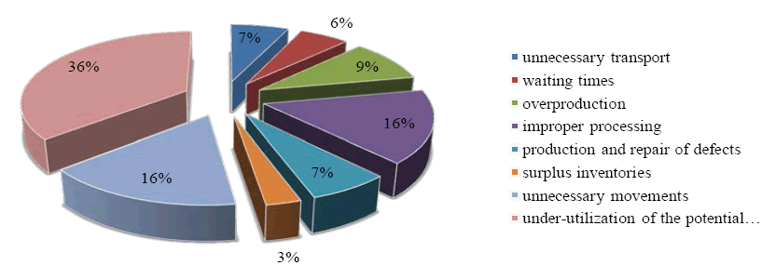
Lean Manufacturing or ‘Just In Time’ (JIT) manufacturing is a manufacturing process which works mainly using the concept of supply and demand and making products to order instead of manufacturing mass amounts of a single product to avoid the risk of over producing and creating large amounts of waste. JIT originated in Japan in the 1970s within the Toyota plants by Taiichi Ohno who had the simple idea of meeting customer demands with minimum delays. JIT helped Toyota become one of the most well know car manufacturers in the world thanks to the ability of the process reducing waste materials and how the process helped increase the quality output due to more focus being put into the work as there was no rush needed unlike large mass production.
Most important types of waste in industry: 2017

https://www.omicsonline.org/articles-images/arabian-business-management-review-waste-according-6-216-g006.png

The chart above shows the percentage of waste most companies produce across all aspects of the products life without the use of JIT while in the manufacturing stage before it is delivered to the customer. The JIT process allows companies to skip some of the extra stages of the regular process to save time and money for the company. JIT can reduce these waste percentages due to its supply and demand structure means that there is no need for overproduction, surplus inventory to be kept and no need for unnecessary movements such as back and forth a storage lockup the product is efficiently manufactured and delivered straight from the line with no need for storage. Within FSG where I work, I believe implementing JIT would benefit us massively as the company unnecessarily stores large amounts of excess materials and old tools which are not needed anymore, and the space could be used more efficiently which would lead to more efficient working and the possibility of creating more work for the factory as there would be more space to store the materials for the jobs. However, the company odes also implement some JIT methodologies as the company mainly works on a supply and demand basis with our customers so whatever order the customer requires, we would give them a date for collection and begin working on completing the tool ready for that date as soon as material is sent in. However, an issue we sometimes face is the pickup for the completed job does not arrive so we are forced to hold on to the job for longer than planned which can cause issues as it obstructs the working area and disorganizes the factory costing efficiency. JIT benefits the factories quality massively as due to no rushing of mass production the workers can take time and ensure the product is manufactured correctly and is up to a suitable standard for the customer and is suitable for required use.
Comparing Six Sigma And Lean Methodologies
Both six sigma and Lean manufacturing aim to create a more efficient working environment and a help companies create a much higher quality product by looking at the companies existing manufacturing plan and using the companies’ current ambitions work with them to implement and even remove specific parts of the process to make the company work more efficiently while still maintaining customer satisfaction. However lean manufacturing compared to six sigma gives more control to the company with regards to their costs and ability to eliminate waste and create a more flowing production compared to six sigma. But six sigma provides a much more in-depth analysis when it comes to using numerical data and using that data to adjust the manufacturing process of that product reducing the chance of any errors with a higher success rate compared to lean manufacturing. Six sigma also never stops improving the current process as it is forever looking for new ways to make the company more efficient and stand out to customers over time six sigma can develop a company’s manufacturing process to be working at 99.9% efficiency with no error if done correctly.
Six sigma compared to lean manufacturing also has different approaches to how to take on changing a process such as DMAIC and DMADV which allows the six-sigma process to be applied to either a brand-new product which need to be started from scratch or a product which is already being manufactured and is just needing improvements to be made to the process as the quality of the final product isn’t a good enough standard.
Compared to six sigma lean manufacturing could show a quicker impact as with the reduction of unwanted storage and excess waste material the company would see a difference slightly quicker due to all the money being saved and being reinvested into other aspects of the company and production to make the product quality better. But six sigma would have a more in depth look at the processes issues and will also have numerical data to see exactly where the process is struggling most and in the long term would be the better option.
Conclusion
After conduction research into both Six sigma and lean manufacturing for this assignment I have discovered many benefits to using both methodologies as an engineering company. But if using the company, I work for as a template for a company which needs to use one of these methodologies to improve its overall efficiency and product quality, I would choose the six-sigma methodology. I would choose to use the six-sigma methodology as it provides more variety in options the company can go down whether they want to use DMAIC for an already existing product or process which would be the more realist option as FSG works for many outside companies from around the world which come to us looking to improve the manufacturing processes and quality for their products and using the DMAIC process would just allow the company to collect the most possible date on the existing process and use all of that to then identify the potential issues with both the machining process and also possibly the design of the product in order to implement improvements to the processes to reduce the number of errors in any future batches and also while improving the products quality in any way possible. Six-sigma would also benefit FSG massively as we are a company which is never happy to settle, and we are always looking for new ways to improve and be better than our competitors and using six sigma and maintaining a 99.9% efficiency rate is a positive step for the company.

References Page.
Six sigma Information:

Jordan Jenkins Power point presentation ‘’introduction to Six Sigma’’

Six sigma DMAIC & DMADV processes
DMAIC vs. DMADV - What is the Difference? - Six Sigma Daily

Jordan Jenkins power point presentation ‘’introduction to Lean manufacture’’

Lean Manufacturing (JIT) Information
JIT Just-in-Time manufacturing (cam.ac.uk) : university of Cambridge.

DMAIC Image:
https://th.bing.com/th/id/R.2011a852bdd11381cacd003c0343f7b0?rik=jd3u9dGXEDgyyg&riu=http%3a%2f%2fmohamedelgendy.com%2fblog%2fimg%2fdmaic_process.png&ehk=hJ7pqpnK2aRKGW9n0TC6tR90GQbhn5xR6i1YG%2b0GIkk%3d&risl=&pid=ImgRaw&r=0

DMADV Image:
https://i.pinimg.com/originals/51/1f/95/511f95e7b987ddb3061f1df569ca0b5e.png

LEAN manufacturing Pie chart showing waste in manufacturing:
https://www.omicsonline.org/articles-images/arabian-business-management-review-waste-according-6-216-g006.png

