

REPORT
Submitted By: Md Aminul Islam Shihan
ID: 2131467
UNIVERSITY OF WALES TRINITY SAINT DAVID

Submitted to : Anita Nan
Subject: Effective Team Work And Communication

Table of Contents
1- Introduction 3
2- Models of Communication 3
2.1 Shannon and Weaver (1948/49) 3
2.2 Schramm (1954) 4
2.3 Berlo (1964) 5
3- Communication Skills 6
3.1 Verbal 6
3.2 Non-Verbal 6
3.3 Listening 7
4- The Advantages and Disadvantages of Communication Technology 7
Advantages 7
Student Learning 8
Disadvantages 8
Case Study Example 9
Recommendations 9
5- Conclusion 10
References 11

1- Introduction
Communication is the exchange of feelings, ideas, or simply messages from one person to the other (Osborne and Hammoud, 2017). Communication generally involves two parties such as the message sender and the message receiver. Business organisations should continue to prioritise communication as one of their top goals. It explains the dedication of the workforce, how they share knowledge, and how corporate goals are achieved (Burgoon et al., 2021). But when the industry develops, some issues do as well, and they could have an impact on organisational effectiveness.
Most issues are caused by inadequate communication and other processes that result in misunderstanding and ultimately result in the failure of otherwise good ideas in many firms (FitzSimons and Björklund Boistrup, 2017). There are several communication hurdles in the workplace, which may have a negative effect on both the relationships that currently exist between managers and employees and employees' productivity. These problems could emerge from the organisation in question not paying enough attention to a certain group of its personnel.

2- Models of Communication

2.1 Shannon and Weaver (1948/49)
The Shannon-Weaver theory of communication was developed to describe the quickest and most efficient means of communication between two points. It incorporates eight elements that affect communication: the source, message, encoder, decoder, channel, receiver, feedback, and noise (See figure 1) (Kang and Sung, 2017).


Figure 1: Shannon and Weaver Communication Model

It is possible to send a message from the transmitter to the receiver through a channel. It is crucial to choose the right means of transmission for a message to be sent (Burgoon et al., 2021). It refers to the path a message takes to get to its recipient and can be oral, written, electronic, auditory, visual, etc. Noise, which is an interference or distortion that can change the message being transmitted by the transmitter or the sender in such a manner that it is misread, comes into play as the message passes through a channel (Osborne and Hammoud, 2017). For example, Yesterday, the noise caused by an aeroplane flying over our office building affected people’s attention during the meeting.

2.2 Schramm (1954)
Schramm described communication as a two-way process. Messages are relayed from an encoder to a decoder with the assistance of an interpreter by way of an encoder, who then helps the interpreter decode the message (See figure 2). A communicator and a receiver are both involved in communication.
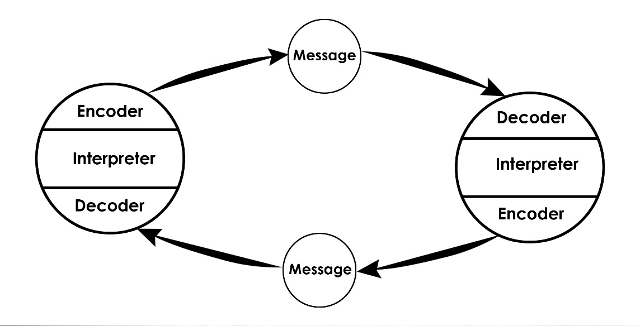
Figure 2: Schramm Communication Model

On the other hand, group communication involves a small number of people who exchange information, work out issues, and build relationships. Group norms, informal and non-formal groups, and groups, in general, are all involved. In accordance with Schramm's model of communication, this sort of communication might also be described as a two-way process (Kang and Sung, 2017).
Rather than correctly determining the communication's meaning, Schramm suggested that the sender and receiver interpret the message together. However, because this technique is mostly used on the Internet, feedback is not instantaneous and typically takes time. Because they both involve two-way communication, Shannon and Weaver's model and Schramm's Interactive model, often known as the convergence model, are comparable (Burgoon et al., 2021). The majority of the time, nevertheless, new media like the internet adopt Schramm's paradigm. People can express their opinions and engage in discussion about any mass media content, including videos, news, etc., here.

2.3 Berlo (1964)
The Sender-Message-Channel-Receiver (SMCR) (see figure 3) communication model proposed by Berlo is based on the Communication model of Shannon Weaver. The efficiency of the communication was increased by the characteristics he identified that affected each component individually. Additionally, the model focuses on message encoding and decoding, which take place before the message is sent and before it is received, respectively (Osborne and Hammoud, 2017).

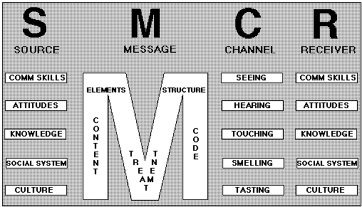
Figure 3: Berlo's Communication Model

To define the communication process, Berlo's model primarily uses four components. Sender, message, channel, and recipient are all of these things. Numerous variables have an impact on each component. The Shannon and Weaver communication paradigm is modified in this model. The model tries to describe the variables that have an impact on each of the four communicational elements and goes on to explain that these variables determine whether or not communication is effective (Kang and Sung, 2017).
It can be applied to examine those who have a bad influence on the victim's life. According to the social customs of the area from which the sender is original, the perpetrators have specific attitudes toward the victim as well as a degree of hostility (Burgoon et al., 2021). They speak out their message, which displays bigotry and victimisation, among other things, with this in mind. Social media, their physical presence, and their words, spoken or written are just a few of the ways this message is spread. Some prejudices and preconceived notions cause bullying and discrimination against the victim (Pearson et al., 2017).

3- Communication Skills

3.1 Verbal
There are three divisions under verbal communication skills: written, email, and oral. One of the main aspects of communication that requires strong skills is verbal interaction. The business world of today is increasingly globalised, with employees from all over the world. Speaking abilities are significant and should be regarded seriously, particularly in jobs where this ability is heavily emphasised (DeVito, 2019).

3.2 Non-Verbal
It is possible to use nonverbal communication alone or in addition to verbal communication. Expressive behaviours, body language, and nonverbal expression are all examples of nonverbal communication. Additionally, gestures can be anything from pointing and waving to using your fingers to represent numbers (Pearson et al., 2017). Voice tone comes under non-verbal communication skills. For example, a presenter during a quarterly presentation in my workplace, spoke in a louder voice to grab the attention of the attendants who were not listening carefully and started to discuss the financial figures presented in the slides.

3.3 Listening
In the business world, listening skills or active listening are vital in establishing relationships between engaged parties that lead to success at work (Ng, 2018). Thus, it is imperative that the speaker's words be fully heard by the addressee as well. To teach listening skills where they need to be improved, one can employ audio or video cassettes. A greater grasp of the message being transmitted emotionally and intellectually can help you build and maintain relationships, which in turn will help you develop empathy (Fulk, 2017). For example, one of my colleagues has been dealing with mental stress for the past few months. My supervisor was keen to help her and understand her situation. She was not only given a 3-day leave but also provided with psychological support to improve her condition.

4- The Advantages and Disadvantages of Communication Technology
Many people now have access to peer-to-peer communication thanks to the development of communication technologies. In fact, communication technology has been successful in bringing people together in areas that were previously completely cut off from the rest of the world (Wang et al., 2021).

Advantages
Communication has improved considerably as a result of the advent of internet technologies. This is a result of how simple and inexpensive the technology is for users to use. Millions of people's poverty levels have been reduced because of technology (Alawamleh et al., 2020). For instance, thanks to the internet, western businesses can focus on activities that play to their core competencies while contracting out work for other services to international businesses. People all around the world are now able to conduct more business with one another thanks to the internet and communication technologies, which are advantageous to everyone. For instance, online marketplaces like eBay and Amazon have constructed ordering platforms for consumers to purchase goods from the majority of industrialised countries. A student in the United States, for instance, can purchase textbooks from a vendor in locations like Hong Kong at a lower cost. Just ten years ago, people did not have the opportunity that exists now. People can create virtual accounts on other websites like Paypal that can be used for a variety of global transactions. Through the usage of such an account, people can shop online without worrying about using their credit or debit cards. For instance, online marketplaces like eBay and Amazon have constructed portals where customers may order goods from the majority of industrialised countries. For instance, a student in the United States can purchase textbooks from a vendor in locations like Hong Kong for a lower cost (Shibli-Rahhal and Kreiter, 2021). People did not have access to this option even ten years ago. People can now create virtual accounts on other websites, such as Paypal, that can be used for a variety of international transactions (Jiang and Lu, 2018). With such an account, people may shop online without worrying about using their credit or debit cards, thanks to technology.

Student Learning
In order to make the material presented to pupils more comprehensible and entertaining and to encourage specific activities, instructors actively employ CT. As a result, focusing on gaming activities is a useful strategy for achieving educational objectives in primary and secondary schools. As a component of the learning process, contemporary ICT offers the chance to talk about a game. Students' interest in the exercises is increased by the game's ICT-based format. ICT use can therefore be seen as an additional motivator for students who engage in the learning process (Alawamleh et al., 2020).

Disadvantages
Large databases needed to be created in order to save private information due to the use of the internet for trading. Having access to the private data of hundreds of millions of online traders has increased identity theft, which is defined as the act of taking another person's private information with the express intention of utilising it to access money or credit (Jiang and Lu, 2018). Because the internet has become a major trading tool, identity theft has increased over the past few years. Users end up exposing themselves to identity theft crimes despite the advantages of using the internet for shopping and accessing personal and financial information. There are many positive uses for the wealth of knowledge that is available online. The internet, which is quickly overtaking other sources as the primary informational resource for all individual and social requirements, has been a great source of fresh ideas for many individuals (Shibli-Rahhal and Kreiter, 2021).

Case Study Example
Now I will share my own experiences with communicating related to work. In the healthcare facility where my friend works, he occasionally ran into problems brought on by poor communication. He once attempted to persuade an elder to invite his grandchildren over by giving him a call during practice. He didn't comprehend the resident's negative relationship with his kid and the fact that he didn't want his involvement in the matter. The communication barrier identified here is an emotional disconnect. When patients cannot complete basic duties, it is difficult to maintain their dignity. Other others feel that their relatives have abandoned them. My friend as a nursing assistant, could not fully comprehend the patient’s feelings in this case as these problems are not relevant to him. From this example, it can be evaluated that communication with elder patients is a vital part of my friend’s job, which was not seemed to be successful in this scenario. Following are the recommendations to improve communication with the patients in order to overcome such situations while providing care.

Recommendations
As noted above, communication is the key priority in businesses (Burgoon et al., 2021). Through professionalism and proper communication, patients’ health outcomes can be improved by nursing assistants. Nursing professionals need to regularly practise and improve their verbal and nonverbal communication skills in order to connect with patients in an efficient manner. Body language, therapeutic touch, and tone of voice all fall under nonverbal communication. Being able to listen to patients and reflect appropriately is verbal communication (Shibli-Rahhal and Kreiter, 2021).
As highlighted above, active listening is vital in establishing relationships between engaged parties that lead to success at work (Ng, 2018). Here active listening assures that summarizing and paraphrasing will be correct. While giving patients care, paraphrasing is a crucial communication tool that shows patients that the healthcare professional is paying close attention to what they are saying. Both when gathering the patient's medical history and at the conclusion, when reviewing what the patient has said to ensure that it has been understood correctly, it is advisable to employ paraphrasing (Ng, 2018).

5- Conclusion
The report discussed different communication aspects and related models such as Shannon and Weaver's communication mode, Schramm's model, and Berlo's model of communication along with some real-life examples in order to provide a better understanding of poor communication impact at the workplace. It is concluded that communication is the key priority in attaining positive business outcomes such as productivity and performance in the workplace. However, if there are obstacles to effective communication, the targeted employees will not be thinking similarly or concentrating on the defined company goals. To overcome these obstacles and simplify the nature and method of communication, leaders must take evidence-based action.

References

Alawamleh, M., Al-Twait, L.M. and Al-Saht, G.R., 2020. The effect of online learning on communication between instructors and students during Covid-19 pandemic. Asian Education and Development Studies.
Burgoon, J.K., Manusov, V. and Guerrero, L.K., 2021. Nonverbal communication. Routledge.
DeVito, J.A., 2019. The interpersonal communication book. Instructor, 1, p.18.
FitzSimons, G.E. and Björklund Boistrup, L., 2017. In the workplace mathematics does not announce itself: Towards overcoming the hiatus between mathematics education and work. Educational Studies in Mathematics, 95(3), pp.329-349.
Fulk, J., 2017. Social construction of communication technology. Academy of Management journal.
Jiang, J. and Lu, Z., 2018. Learning attentional communication for multi-agent cooperation. Advances in neural information processing systems, 31.
Kang, M. and Sung, M., 2017. How symmetrical employee communication leads to employee engagement and positive employee communication behaviors: The mediation of employee-organization relationships. Journal of Communication Management.
Ng, K., 2018. Implementation of New Communication Tools to an Online Chemistry Course. Journal of educators online, 15(1), p.n1.
Osborne, S. and Hammoud, M.S., 2017. Effective employee engagement in the workplace. International Journal of Applied Management and Technology, 16(1), p.4.
Pearson, J.C., Nelson, P.E., Titsworth, S. and Harter, L., 2017. Human communication (p. 416). New York: McGraw-Hill Education.
Shibli-Rahhal, A. and Kreiter, C., 2021. Development and evaluation of novel tool to assess communication skills in adult triadic interviews. Patient Education and Counseling, 104(10), pp.2412-2417.
Ting-Toomey, S. and Dorjee, T., 2018. Communicating across cultures. Guilford Publications.
Wang, B., Liu, Y., Qian, J. and Parker, S.K., 2021. Achieving effective remote working during the COVID‐19 pandemic: A work design perspective. Applied psychology, 70(1), pp.16-59.

