

Digital modelling and simulation of logistics systems to support lean management
By
Graham Jones
2313935

Degree Apprenticeship in Logistics and Supply Chain Management
16th April 2025
Modelling and Simulation (ACMA 5018)

Use of Generative AI in Assessment

RESEARCH | For this assessment, you can use Generative AI to support you in research, including searching for bibliography, using tools to summarise, compare and interrogate materials. | Yes ​☒​  No ​☐​
STRUCTURE | For this assessment, you can use Generative AI to support you in structuring your submission, including creating a draft argument structure, identifying parts and headings, etc. | Yes ​☒​  No ​☐​
PROOFREADING | For this assessment, you can use Generative AI to check your own text/creation for grammatical and syntactical mistakes, including rephrasing of your own work within specific standards. | Yes ​☒​  No ​☐​
WRITING | For this assessment, you can use Generative AI to create text for submission. | Yes ​☐​  No ​☒​
CREATIVE | For this assessment, you can use Generative AI to create creative materials, such as images. | Yes ​☐​  No ​☒​
PROGRAMING | For this assessment, you can use Generative AI to create and check code. | Yes ​☐​  No ​☒​
NONE | For this assessment, you are not allowed to use any type of Generative AI support. This includes research support, structure support, writing/proofreading support and creative support. | Yes ​☐​  No ​☒​

AI Acknowledgement
I confirm that I have not presented any AI-generated materials as my own work in this portfolio.
Graham Jones (16th April 2025)
Student ID: 2313935

Abstract
In the current fast paced business climate organisations looking to develop new products, improve current practices or expand production do not have the time or the resources for trial and error based development. As such these organisations are now increasingly looking towards modelling and simulation based projects to quickly and accurately analyse up and coming projects.

Table of Contents
- Introduction………………………………………………………………………………….4
- What is Modelling and Simulation?..........................................................................4
  - Benefits of Modelling and Simulation………………………………………….5
  - Challenges of Modelling and Simulation………………………………………5
  - Uses within logistics and supply chains – SCOR……………………………6
  - Uses within logistics and supply chains – Value stream mapping……….7
- Examples of Modelling and Simulation software
  - Simul8………………………………………………………………………………..8
  - AnyLogic…………………………………………………………………………….9
- Modelling and Simulation within Tata Steel Colors………………………………….9
  - The problem………………………………………………………………………...9
  - Recommendations…………………………………………………………….…10
- Conclusion…………………………………………………………………………………10
- References…………………………………………………………………………………11

Introduction
In this report we will be looking at modelling and simulation developments and specifically how they can incorporated into supply chains and logistic activities. Taking a look at current software on the markets and case studies of where they have been used in the past. Finally we will asses a problem at Tata Steel Colors and make recommendations into how modelling and simulation can aid the project.
What is Modelling and Simulation
Modelling and simulations are used as a digital prototypes to assess and predict the outcomes of real world processes or physical objects, to aid designers, engineers, user, etc in understanding any complications they may encounter and analyse how the process or an object will operate before committing to any physical development work.
Firstly a model is created, this is defined as a system used as a surrogate for another approach that can be utilised to gain a greater understanding and insight into certain aspects of the real world (Sanchez, 2007). From this a simulation can be created, which will be the digital representation of the physical process, system or object.
There are many basic modelling and simulation frameworks which can be applied to various sectors, which when used in conjunction with each other can create a full business model. Dealing with the entire operations processing from supplier to customer using the likes of Design Chain Operations Reference model (DCOR), Product Life Cycle Operations Reference model (PLCOR), Customer Chain Operations Reference model (CCOR) and Supply Chain Operations Reference model (SCOR).

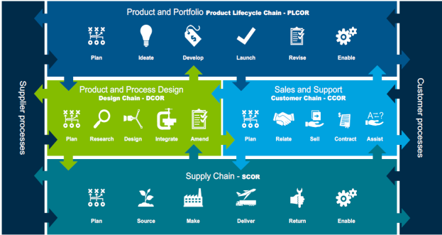
Fig 1 – examples of modelling and simulation frameworks
Benefits of modelling and Simulation
Modelling and simulations can be very beneficial to the current fast paced business environment most organisations operate within. With an accurate model a simulation can run many scenarios and experiments in a matter of minutes, which in the past could of taken hours, days or weeks in a real world trial. Alongside this if a project or scenario is not successful within the simulation a quick reset can be used to restore the model to original state and new theories tested without disruption or damage to live processes or equipment.
Data can also be easily be stored and shared with other team members or joint venture partners to aid in knowledge sharing and development without the need for people to be in physical attendance during the simulation period.
Challenges of Modelling and Simulation
The main challenges for Modelling and simulation revolve around the set up of such projects. Firstly costs are very high in acquiring the necessary IT equipment, software and training for operators to use effectively. Also the vast amount of accurate data that will need to be acquired and then stored to get the most efficient and accurate simulation.
But once these start up hurdles are over come costs are quite low as the simulation is low maintenance and also data will be acquired and stored ad-hoc during projects.
Uses within logistics and supply chains - SCOR
To look specifically at how modelling and simulation can aid the logistics and supply chain activities we will explore a few solutions.
The supply chain operations reference model (SCOR) is a framework that can be used to measure, develop and analyse a company's supply chain's performance from its supplier's to their customer's. The model encompasses a series of business principles into its framework and focuses on five key factors within the supply chain planning, sourcing, making, delivering and return (Armas 2024).
Planning – Focusing on creating a balance between the supply and demand by accurately forecasting customer demands by analysing historical data and market trends, aligning production capacity to deal with these demands, ensuring resources (Materials, human, etc) are sourced and used the most efficiently.
Sourcing – The objective of this factor is to ensure that all necessary materials are available on time, at the best cost to the business and arrive with the expected quality, allowing the supply chain to react to the business requirements as the market demands by working closely with and reviewing suppliers performances.
Make – The manufacturing process is vital as this where the most value is added to the product or service. Additionally it will also include inspections and tests that need to be carried out on goods and also the maintenance plans for any manufacturing assets and equipment to guarantee that assets are functioning at the optimal and most efficient levels.
Deliver - Distribution is the penultimate step of the SCOR model and is critical to achieving a good customer experience. Successful distribution translates into on-time deliveries, reduced costs and happy customers, which is essential in a competitive fast paced market. Correct delivery includes the receipt and processing of orders, as well as the maintenance and packaging of products for transit. This step ends with the delivery of the product to the customer, which also has to be taken care of in detail with good customer service and trained workers in place to resolve any possible complaints.
Return – The final stage is having processes in place to deal with the reverse flow of goods from customers back to manufacturers or distributors in the case of rejection from the end user. This phase must establish procedures to facilitate the return of products, inspection of returned goods to determine the next stage (re-use, repair, recycle or disposal), action the next stage after inspection and analyse the performance to identify trends and improve for future dealings.
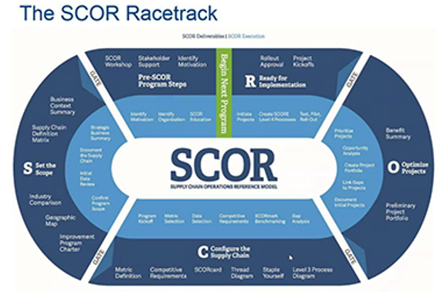
Fig 2 – SCOR racetrack
Uses within logistics and supply chains – Value stream mapping
Value stream mapping (VSM) is a lean manufacturing technique to analyse, design, and manage the flow of materials and information required to bring a product to a customer (Mukherjee 2025). Value stream mapping is thought to of been initially developed by the Toyota motor corporation during the 1990’s and using a standard set of icons to represent work streams and information flows.
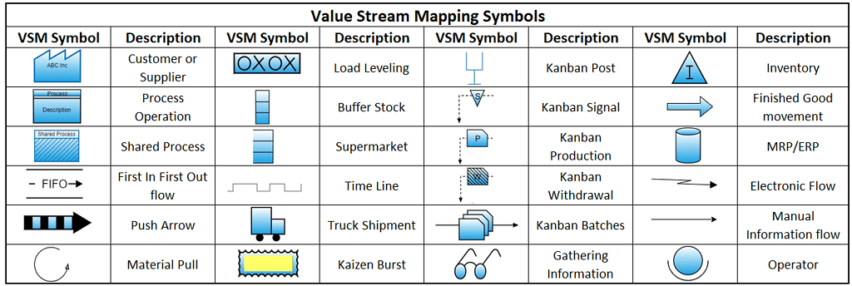
Fig 3 – Examples of VSM icons
Process and items are mapped out to identify actions and process that are adding value or not adding value from a customers point of view, then development takes place to remove or replace any processes that are deemed to not add any value to make the stream as efficient and effective as possible.
Value stream mapping works best when included within a continuous improvement (CI) project to reduce waste and make production or processes more lean. VSM is very good at helping to identify improvements to the seven main causes of waste within supply chains (Overproduction, Inventory, motion, defects, over-processing, waiting & transportation).
Examples of Modelling and Simulation software
Simul8
Simul8 has been a market leader in simulation modelling for over 30 years offering their consumers a range of services from basic models to digital twin software. As quoted on their website “Simul8 offers an intuitive, scalable, and simulation platform, to uncover bottlenecks, test ideas, and implement solutions with confidence.”
Case study Fiat Chrysler Automobiles – Simul8 software was used to improve Chrysler’s Brampton assembly plant production rate from 930 units to 969 units per day. Chrysler's simulation team used a base simulation of their Brampton Assembly plant to understand the impact of changing line speeds. With each manufacturing plant having its own base simulation, process improvement changes can be easily made to any aspect of the simulation to help visualize the wider impact on the entire assembly process. Using Simul8, Chrysler were able to utilize real factory data in their simulation. This data had been collected from the plant floor using their Factory Information system which collects the data from PLC, a real-time recording system which records line speed, cycle time, MTTR and MTBF. The simulation ran over a one month cycle and used existing data imported from Excel, ensuring that the results would be as accurate as possible. This also allowed for the simulation to be validated through comparing Simul8's results to actual throughput numbers and identify if decreasing the cycle times at these stations would improve throughput. (Simul8 2025)
The project was a success and Chrysler were able to increase their revenue by $1,000,000 per day, additionally the simulation shown Chrysler that by making these increases there would be no knock on side effects on the overall processes.

AnyLogic
Much like Simul8, AnyLogic are a large market leading supplier of simulation solutions to a vast amount of companies over many industry sectors. Also offering a range of products including agent based modelling, discrete event modelling and system dynamics.
Case study Amazon – AnyLogic were tasked with helping Amazon determine the best places to set up new stores to meet their customers demand throughout the year. The simulation had to help find new potential locations and evaluate the effectiveness of current stores. The team combined deep reinforcement learning with the simulation model they built in AnyLogic. The simulation defined an optimal number of stores and specified the locations they should serve. The DRL-based AI agent enabled Amazon to see more effective fulfilment logistics options. (AnyLogic 2025). The result was 38% reduction in travel between customer location and stores, which was a significant reduction and enabled Amazon to grow there presence in the target areas.
Modelling and Simulation within Tata Steel Colors
Tata Steel Colors is a Downstream Operation (DSO) of Tata Steel UK (TSUK), the Shoton site is located in Flintshire, North Wales and produces six thousand tonnes of painted finished steel for the construction sector for general sale per week. To support this the site operates two Color Coat Lines (CCL’s), both CCL’s produce 500 tonnes per day No.1 CCL operates five days a week (Mon-Friday) and No.2 CCL operates seven days a week. With goods being received daily to support this operation and finished material being shipped via rail and road services. The site currently does not have any simulation or modelling software or tema within its resources.
The problem
The site is looking to increase the production of No.1 CCL to operate seven days a week like No.2 CCL as such the business will be looking to simulate and model this increased activity and evaluate whether the current operation levels of the support functions can handle the increased activity or will more resources need to be acquired to effectively run the operation. This would increase the side production, goods in and goods out by one thousand tonnes per week, an increase of 17%.
Recommendations
I would recommend that Tata Steel Colors develops a simulation team to run this modelling project and use Simul8 as the software of choice due to the similarities between this project and the recorded case study on the Fiat Chrysler Automobile group. Within the simulation we should not only look at the CCL capability to increase activity but also look at the sites infrastructure to handle an increase of external receiving of goods and delivery of finished goods but also the internal logistics of moving resources around the site to the various CCL’s and also storage capabilities for both raw materials and finished goods in current warehouses as there would be increased storage required for weekends when deliveries are not made. This simulation should be run for a years worth of time taking into account seasonal variables around customer demand and suppliers capabilities along with incorporating planned manufacturing downtime for maintenance along with un-planned issues that may arise.
Conclusion
Simulation and modelling in the current business climate is a valuable tool that all large business should be looking to invest into and utilise to accurately predict and plan future business plans and developments. Whilst initial start-up costs and training for users can be quite costly, once up and running the costs reduce dramatically and when compared to saving or increases in revenue that can be gained it seems worth the effort. From the case-studies I looked at whilst researching this paper there are many great success stories from a range of business operating in a vast variety of industries to prove the software can be used and customised to aid in various operational issues around the world.

References
AnyLogic (2025), “simulation driven solution for fulfillment logistics evaluation”, https://www.anylogic.com/resources/case-studies/simulation-driven-solution-for-fulfillment-logistics-evaluation/ (Accessed 16th April 2025)
APICS (2017). “Supply Chain Operations Reference Model SCOR Version 12.0”. https://www.apics.org/docs/default-source/scor-training/scor-v12-0-framework-introduction.pdf?sfvrsn=2 (Accessed 16th April 2025)
Armas, L (2024). “The 5 factors of the SCOR model”. https://www.educa.pro/en/articles/career-development/the-5-factors-of-the-scor-model/#:~:text=To%20achieve%20this%20goal%2C%20the,%2C%20manufacturing%2C%20delivery%20and%20return. (Accessed 16th April 2025)
Modern materials handling. “The SCOR Racetrack”. https://www.mmh.com/article/apics_to_update_industry_recognized_scor_model_in_its_20th_year. (Accessed 16th April 2025)
Mukherjee, J (2025). “Value Stream Mapping”. https://www.atlassian.com/continuous-delivery/principles/value-stream-mapping#:~:text=Value%20stream%20mapping%20(sometimes%20called,a%20product%20to%20a%20customer. (Accessed 16th April 2025)
Sanchez, P.J., 2007. FUNDAMENTALS OF SIMULATION MODELING. p.10.
Simul8 (2024), “About us”, https://www.simul8.com/about/press (Accessed 16th April 2025)
Simul8 (2025), “Case study Chrysler increases revenue by $1m per day - without increasing costs”, https://www.simul8.com/case-studies/line-balancing-chrysler-brampton (Accessed 16th April 2025)

