

Student name: | Catalina Medina
Student ID: | 1806473
Module Number: | BMSK4004
Module Title | Problem Solving and Decision Making
Lecture’s Name: | Yajesh Kumar

Table of Contents
Introduction 3
Identification of Problems 3
Analysis of Problems (Causes and Solutions) 4
Environmental Analysis PESTLE 5
Organisational Analysis 6
Decision making techniques 11
Monitoring and Reviewing Techniques 14
Pros and Cons of Solutions 15
Conclusion 16
Reference List 17

Problem Solving and Decision Making
Hotel Ambassador Bloomsbury

Introduction

Hotel Ambassador Bloomsbury is a very old infrastructure, it was stablished in 1835 and was used as a private hotel. During war times it was used as a hospital however as time has passed it has adopted a modern format and now serves as a luxury hotel in the streets of London.
The aim of this essay is to analyse how different kind of problems can affect the way a certain place, in this case the hotel, and various consequences that would result in losing customers, losing money and even loosing employees.
By putting into action different methods of analysis in regard to the problems one can get to the main cause of each of the problems and in that way come to terms with the solutions that can be provided for the establishment to grow or even just get back on truck to be able to build a better reputation in the hospitality industry.

Identification of Problems
Based on the various problems that are being described in this assessment such as high employee turnover, less sales of rooms and situation affecting profit makings an analysis will be carried out.

Figure 1: Problems analysis process

- High employee turnover is one of most significant parts about growth and developments in the hospitality management parts of hotel industries. This process of turnover gestures by all staff or employees are a very serious issue in every field of business sector (Shull, 2017). This way of staff turnover in sectors of hotels can be affected by less skilled knowledge and low payment structures as compared to other salary structures of an organization. In this aspect, another reason for this issue is the bigger demand of customers and their daily fulfilment of this demands which increases stuff´s working hours and sometimes they can even be irregular hectic hours due customer’s satisfaction.
- Less sales of rooms in the Hotel Ambassador Bloomsbury industry is mainly due to changes of senior profile of management which can be considered as a major cause. Thus, it causes a major problem of low sales as senior department of management creates a huge influence in terms of sales and profits. Another most vital point for less sale of rooms could be a poor plan compensation which results in confusing information about goals and management of the business growth in the sectors of hospitality management businesses.
- In regards of this hotel business management makings profit can be affected by many factors (Perera, 2017). These problems can appear in many formats such as technological and innovative challenges, installing advanced technologies are a major factor of growth for this industry and it can make a huge difference in the profit making of the hotel industry. Seasonality concept is a primary factor of dealing loss in sectors of hospitality industries, during the season peak profits will go up however as these peak times pass the profit in this industry will be affected and go down.

Analysis of Problems (Causes and Solutions)

In context of various problems that are being discussed above such as employee turnover, less sales of rooms and less profit-making situations. This analysis can show the causes and solutions for each problem.
As stated by Newman (2017), this basis of turnover factors of employees are generally caused due to major ineffective process such as low-price structures of affordability and maintenance that can cause huge loss of hotel as well as staff turnover. This is also caused due to excessive pressure on customer handling and unsuitable work timings. This can be reduced through introductions of effective schemes for staff and employees such as incentives and bonuses, reducing turnover process through innovative working hours and resulting in more sales.
Fewer sales of rooms are other forms of huge factors of profits in terms of hotel industries. There are various options that can be the cause such as lack of facilities parking, sites for leisure activities; prices for the rooms are not that sustainable according to market standards and less number rooms with low holding capacity. These forms of activity can be reduced through the introduction of innovative infrastructures modules with latest facilities for customers such as modern car parking arena, modern receptions and various discounts options that help in the growth of the business.
Less profit-making situations is a huge factor for less business, this can be for many reasons such as political or hotel management changes. This issue includes macro and social political interference in the hotel industry. This creates a huge challenge for the growth of business (Mardani et al. 2015). Bookings and revenues are generally done through various channels of less advertising process and camping up with huge competition, resulting in less profit for the hotel business. This can be solved through various detailed analysis about threats and needs to increase security concern in these factors and also be ready for any threats and make it safe mode. This booking and revenues can be increased through different innovative modes of advertising process and other ways of promotions.

Environmental Analysis PESTLE

This analysis can be done through the process of PESTLE. This form of analysis can be done in the following way.
- This analysis of political factors can be done through various constitutional analysis of this country. These factors include protocols of their parliamentary systems. Thus, in perspective of this political factors, this has positive and negative part, in the positive side their political systems are stable and it is being split into local and national. Their negative parts such as uncertainty factors and well-hidden factors of corrupted policies.

- In aspects of economic factors, it can be analysed that UK economic conditions are stronger in terms of other countries. GDP factors are generally high in countries like the UK and their economic growth factors. It also has positive factors such as fifth largest domestic product globally and they have huge free market. Their major factors of negativity can be slow process of recovery and more money spent on public services providence and aid of financial parts.
- Technological factors most positive part can be that it has more developed skills of innovation and technologies and they are very much tending to growth of laws of very effective approaches to other property (Phadermrod et al. 2019). Their negative factors are in regard to developmental growth as it is less compared to the United States.
- Environmental factors are very much related to various forms of activity in the UK regions which creates huge impacts in the UK environment. There are diverse factors of governing bodies that are related to these terms of factors of environment such as local councils, newspapers bodies, charities and other bodies that are related to these formats of environmental management. Thus, it has created a huge impact in the growth of this process in this arena of factors of developments in UK, it has also enabled huge gathering of crowds. It also has increased structures of tourism factors of growth in regions of UK.

Legal Factors are generally based on factors about legal landscapes and properties. It has created a huge analysis factors in basis of growth of legal parts of UK. This has a huge detailed discussion about environmental legal factors of this country, and it is beyond this analysis (Perera, 2017). In this factor of legal analysis there to be found the Employment act that have been included in terms of protection to employee’s rights. Maternity and leave of paternity have lots of effects in parts of wage pay, sick pay, holiday pay and some other forms of rights that are placed as protected forms of rights.

Organisational Analysis

SWOT Analysis

Strengths | - Amicable behaviour exercised by staff  - First-rate restaurants known for efficient dining services  - Possesses civil ceremony license  - Modernised ambience  - Good quality Internet and wifi facility  - Presence of large beds and spacious bathrooms
Weaknesses | - Bedrooms are small in number  - Absence of enough car parking facilities  - Absence of facilities for leisure  - Exercises a considerable bias towards business clients  - Increase in employee turnover  - Lack of sales of rooms
Opportunities | - In possession of large C&E space in comparison to rival companies  - Location is convenient for tourists  - Adopting a family-oriented climate would necessitate an increase in clientele
Threats | - Prices pertaining to C&E are not cost-friendly  - Provides excessive offers  - As compared to offers, loyalty is not sufficiently given  - Offers almost 50% based on food and drinking services to attract customers.
Table 1: SWOT Analysis of Ambassadors Bloomsbury Hotel
(Source: Ambassadors.co.uk, 2019)
Analysis
Based on the afore-mentioned table it can be deduced that Ambassadors Bloomsbury has a considerable amount of strengths and weaknesses. In addition to weaknesses, certain threats should also be immediately addressed for a better functioning. It can be observed that clients belonging to a certain profession are prioritised. This can create losses for a hotel as it would alienate and overlook needs of other guests. Moreover, absence of satisfying number of bedrooms can lead to frustration amongst even business clients. This can be effectively improved by the adoption of a family-oriented atmosphere that supports clients belonging to different professions.
SWOT analysis is relevant for identifying problems related to Ambassadors Bloomsbury hotel such as organisation aims to generate solutions after studying various issues. According to Phadermrod, Crowder and Wills (2019), SWOT analysis helps an organisation to develop its internal functioning by pointing out specific strengths, weaknesses, opportunities and threats.

Porter’s Five Forces

- Competition and Rivalry
Ambassadors Bloomsbury hotel has quite a significant number of rivals such as Hilton Euston, Thistle Houston and Novo-tel. It has been observed that Hilton Euston provides comparatively elegant lodging arrangements with effective adoption of golden keys, wooden floor equipped rooms and restaurants with broad daylight. Moreover, Hilton Euston provides an Honours loyalty program to further implement customer service. Hilton Euston hotels often collaborate with Hilton Paddington hotel to cater to a large market as compared to Ambassadors Hotel.

- Power of Suppliers
This point suggests a requirement for an effective and reliable supplier-buyer relationship in a hotel. Ambassadors Bloomsbury hotel requires considerable internet facility to keep its customers entertained, also some guest rooms may require hypo allergenic mattresses and bedding. Moreover, electrical supply must be made entirely consistent in order to enable continuance of functioning of certain electrical appliances. Since, no relevant news reports were available regarding power cuts or damages, relationship between suppliers and hoteliers are preferably friendly.

- Power of Buyers
This point refers to the ways in which a buyer impacts output of a business organisation. In reference to Ambassadors Bloomsbury, there are specific types of customers that are entertained in that particular hotel. It can accommodate an approximate number of guests ranging from 10 to 250 (Ambassadors.co.uk, 2019). Moreover, since it is biased towards business clients seven separate meeting rooms have been built for that purpose. Thus, this particular hotel caters to business oriented guests, it can attract more customers by making it more family-oriented.
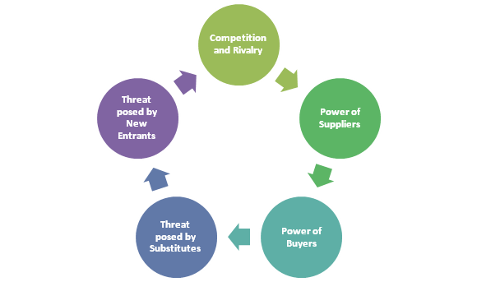
Figure 2: Porter’s Five Forces

- Threat posed by Substitutes
Large number of substitutes is present in relation to Ambassadors Bloomsbury. Hotels such as Hilton Euston, Novo and Thistle Houston are a relatively few examples. Out of the mentioned hotels, Hilton Euston is located quite close to Ambassadors Bloomsbury. This provides ample scope for customers to check out of Ambassadors Bloomsbury under the excuse of incompetency. Moreover, certain additional features are provided by Hilton which is significantly absent in Ambassadors Bloomsbury. Thus, improvements must be made for immediate success.

- Threat posed by New Entrants
New entrants are always a source of constant threats. Globalisation enables considerable impetus to businesses under the hospitality industry to house certain groups of consumers. Diversity must be entertained to gain considerable customers and increase respectability of company (Markova et al. 2016).
Hence, it can be witnessed that Porter’s Five Forces refers to an influential and effective strategy to examine a business organisation. As stated by Aithal (2016), this technique measures exact worth of an organisation in comparison to competitors. Ambassadors Bloomsbury hotel requires a Porter’s Five Force analysis method to identify issues for further improvement. Hence, a detailed analysis has been stated.

Fishbone
Fishbone analysis tool aims to investigate several causes behind occurrences of certain problems and pinpoint a root cause that needs to be removed. Fishbone analysis is necessary to understand problems related to Ambassadors Bloomsbury hotel and its issues of employee turnover and decrease in numbers of rooms being sold. Solutions regarding afore-mentioned issues can be formulated using sufficient brainstorming sessions (Luo, Wu and Duan, 2018). This method is then followed by a comparison of potential solutions discovered by brainstorming. Finally, a system of continuous division of causes leads ultimately to a root cause.
Ambassadors Bloomsbury hotel prioritise certain groups of clients and excludes other clients. This decreases enough customers or guests, hence, considerable affecting generation of revenue. As a result of this, employees often receive less payment which leads to frustration. Moreover, sales of rooms are also insufficient as this specific hotel caters to a certain specialised group of clients.

Funnelling
This particular technique suggests a method that enables narrowing down of questions to reach a specialised question. This specialised question serves to enquire, in a comparatively detailed level, one particular cause that hampers smooth functioning of an organisation. In relation to Ambassadors Bloomsbury, this technique can prove to be a relevant problem-solving tool. This is further evident by availability of multiple issues pertaining to said hotel.
Based on afore-mentioned SWOT analysis and Porter’s Five Forces method, certain issues pertaining to Ambassadors Bloomsbury have been identified. Issues in relation to Ambassadors Bloomsbury are employee turnover, insufficient sale of rooms, lack of parking spaces and lack of sustainability of C&E prices. Funnelling can be used as an important method for questioning employees of Ambassadors Bloomsbury to arrive at a particular problem. This problem needs to be removed by adopting relevant decision-making method.

Decision making techniques
SMART Goals
After undertaking considerable research, various issues have been discovered. One of several issues involve excluding customers belonging to professions other than business. This issue can be properly mitigated by making Ambassadors Bloomsbury more family oriented. As argued by Shull (2017), SMART goals are an important decision making techniques in terms of creating solutions. Thus, in order to solve this certain issue, solutions need to be developed as follows:

Objectives | Specific | Measurable | Attainable | Realistic | Time bound
1.Making changes in website | Inclusion of family oriented facilities. | It requires hiring of web developers. | It needs less amount of time and labour | It would attract large number of customers. | It requires one month.
2.Amicable attitude of Staff Members | Seminars and workshops have to be arranged. | HR management can be responsible for this task. | Meeting rooms are available for use | It would increase customer satisfaction. | It requires one month.
3.Recreational activities for Children | Building of playhouses | Hiring of builders and architects | It can be completed within a few months | It would attract families with children | It requires more than six months.
Table 2: SMART Goals
- Making changes in website: This goal is specific as it lacks ambiguity. Ambassadors Bloomsbury consists of a working website that provides facilities such as online booking of rooms. Moreover, announcements regarding special offers and discounts are also displayed. Certain family packages and recreational facilities must be created to attract families. Due to specificity imbibed within this goal, it is highly measurable. Moreover, it is also attainable by employing website developers to create creative changes. Thus, this goal is highly realistic as it offers a time bound way in realisation of solutions.
- Amicable attitude of Staff Members: This goal is specific as it requires training staff members with reference to behaviour meted out to families. It is measurable as seminars and workshops are frequently conducted.
- This goal can be attained by a discussion with HR management of hotel groups in order to effectuate this measure. Hence, it is considerably time-bound as not more than a month would be required.
- Recreational activities for Children: This goal is specific as it requires building of a separate space for children. This goal is measurable as it requires constructors to build a playhouse based on a design. Thus, this goal is attainable by allocating significant amount of time. It is realistic as it would attract more families with children. Not more than six months would be required for fulfilling such a goal.

80/20 Action Plans
This is another important decision-making technique in order to arrive at a specific measure. This plan is effective for Ambassadors Bloomsbury as it divides solutions into namely, 20 and 80. 20 refer to a specific percentage of solutions that consists of few most important goals. However, 80% consists of majority of goals that are of less sufficiency in terms of effectiveness. Hence, this can be practically applied to decision making as it would help to arrange goals according to decreasing number of priorities. It has been proven to ensure selecting a few goals from innumerable number of goals.
This technique, if applied in relation to Ambassadors Bloomsbury, would provide certain benefits. These benefits are stated below:

- Amongst multiple issues, certain specific issues would be effectively chosen. For instance, in relation to Ambassadors Bloomsbury, various issues enhance employee turnover rate. There are various issues such as lack of bedrooms, absence of leisure facilities, lack of car parking sites and lack of reduction of car parking rates. However, preference of business oriented clientele is considered necessary.
- This technique can also assure working on concretising goals that are of enough necessity would be prioritised.
- Low value tasks such as giving away more than 50% of discounts on food and drinks are to be avoided.
- This technique would help in creating a family friendly atmosphere for customers in order to attract more customers.
- Main goal associated with problem solving in relation to issues regarding Ambassadors Bloomsbury is catering to a different clientele. This would sufficiently increase employee retention as more income would be generated.
- Considering effective solving of main issue, issues of secondary importance would be given sufficient priority.
In this way, it can be concluded from a thorough discussion of 80/20 action plan that problems need to be sorted at first and then relevant solutions need to be developed.

Monitoring and Reviewing Techniques

Several monitoring and reviewing techniques that can be utilised by organisations are as follows:
- Meetings
This technique is important as it involves engaging in face-to-face interactions with employees of Ambassadors Bloomsbury. This would develop communication skills amongst employees. Moreover, it would encourage them to be more expressive. Hence, effectiveness of changes made can be assessed by managers to compel employees to speak up. This sufficiently helps in gathering considerable information regarding perks received by employees due to a certain innovative technique.

- Feedback
Employee feedback is a much-revered technique that brings maximum number of results. Impacts of solutions can be properly assessed by creating a space in company website for employees to post feedback. Feedbacks possess an ability to maintain anonymity. Therefore, due to this nature of anonymity, a sufficient number of employees feel encouraged to express them.
Customers, too, would be made to give feedback. This would ensure authority figures to maintain their good social standing by producing satisfying results. Hence, feedback creates an atmosphere of scrutiny where every individual would be responsible for behaving according to their best selves.

Example of feedback Monitoring and control of the Hotel
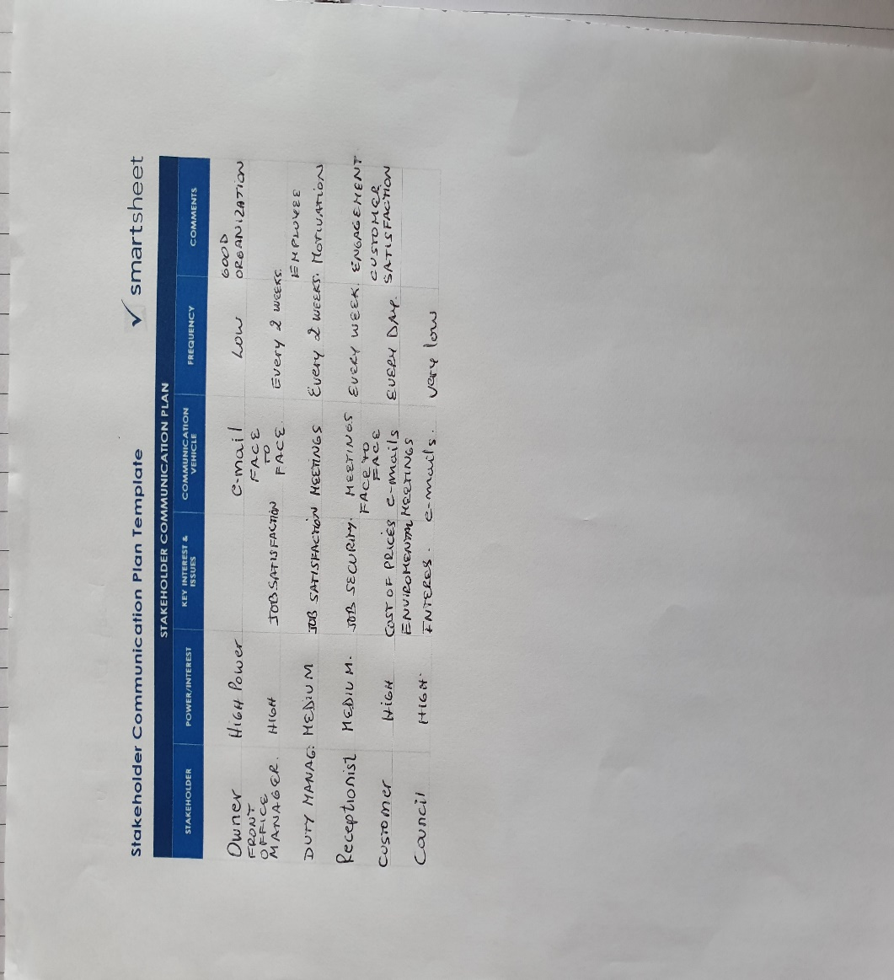

- Preparing Reports
HR management of hotels must create annual reports, and this should include strengths and weaknesses of a company. A report must contain sufficient information regarding organisational functions, external relations and contributions made by a company in terms of reducing the effects of climate change.
Most companies prefer to exclude mistakes or errors made in order to maintain a clear image. Ambassadors Bloomsbury hotel, in general, have to create an effective annual report. Annual reports, contrary to popular belief, do not merely serve to attract investors. A company can be benefitted as a record of past activities would be efficiently kept

- Interviews
Interviews serve as effective tools for gathering individual opinions of employees. Employee retention is widely considered to be a serious issue that requires implementation of certain measures. Meetings can be regularly held for monitoring impacts of certain solutions.
However, a major drawback of meetings proves to be suppression of opinions of employees who are demure by nature. Such employees must be engaged in a personal interview with an HR manager. Although, face-to-face interviews are time-consuming, HR managers can allocate a certain period of time from their work schedule to answer employee queries.

Pros and Cons of Solutions

Certain solutions were created in order to implement changes. These changes serve to omit certain issues to catapult Ambassadors Bloomsbury to success. Some of them are as follows:

- Making changes in website
Advantages: This would attract large numbers of customers. Moreover, it would even gather many foreign tourists. This would be made possible due to the prevalence of internet facilities in all countries. Moreover, online bookings have gradually acquired a frequency that was previously unimagined.
Disadvantages: With an increase in foreign influx, employees previously unaccustomed to change, would feel sudden pressure. This might induce employees to seek employment elsewhere.

2. Amicable attitude of Staff Members
Advantages: It attracts large numbers of population to Ambassadors Bloomsbury. It would create opportunities for delivering first-rate customer service and a larger revenue would be generated to meet specific requirements of employees. It would further increase company reputation.
Disadvantages: Employees who are reserved by nature would receive considerable flak for being incompetent. Moreover, certain customers might interpret lack of amicability as disrespectful. Therefore, certain employees would be isolated.

3. Recreational activities for Children
Advantages: Families with children would be encouraged to visit Ambassadors Bloomsbury. Small children would enjoy engaging in sports and games. This would prompt them and their families to visit this hotel frequently.
Disadvantages: Certain group of clients would feel disturbed by subsequent noises made by children. Clients who seek to enjoy solitude would cease to arrive at such a hotel. Therefore, by encouraging a family-oriented atmosphere certain other client would have to be foregone.

Conclusion

Interior design and other designs of this hotel are being taken care in a world class manner. Thus, it being a huge hotel, better customer services should be given even though the hotel has diverse forms of meetings conference rooms about 250 members and other 7 rooms for different forms of business workshops. These formats of analysis have given a scope of regarding various hotels in lands of UK and it has also given a brief approach about profitability and growth of business of hotel management in this arena of hotel sectors. In this topic various problems have been analysed through hotel significant parts and their growth in business. Hence it has also given solution about growth analysis through various analyses.

Bibliography

Newman, V. ( 2017). Made-to-measure Problem-solving. Abingdon: UK: Routledge.
Perera, R. (2017). The PESTLE analysis. Sri Lanka: Nerdynaut.
Shull, R., (2017). Rush to policy: Using analytic techniques in public sector decision making. Abingdon: UK: Routledge.
Journals
Aithal, P.S. (2016). Study on ABCD analysis technique for business models, business strategies, operating concepts & business systems. International Journal in Management and Social Science, 4(1).
Luo, T., Wu, C. and Duan, L. (2018). Fishbone diagram and risk matrix analysis method and its application in safety assessment of natural gas spherical tank. Journal of cleaner production, 174, pp.296-304.
Mardani, A., Jusoh, A. and Zavadskas,, (2015). Fuzzy multiple criteria decision-making techniques and applications–Two decades review from 1994 to 2014. Expert systems with Applications, 42(8), pp.4126-4148.
Markova, E., Anna, P., Williams, A.M. and Shaw, G. (2016). Migrant workers in small London hotels: Employment, recruitment and distribution. European urban and regional studies, 23(3), pp.406-421.
Phadermrod, B., Crowder, R.M. and Wills, G.B. (2019). Importance-performance analysis-based SWOT analysis. International Journal of Information Management, 44, pp.194-203.

Ambassadors.co.uk. (2019). The Hotel.
Available at: https://ambassadors.co.uk/en/hotel.html>
(Accessed: 31th July 2019)

