

Student name: Richard Oji
Student ID: 2013435

Assignment title: Causes of teenage pregnancy in the UK

Module name: Introduction to Research
Module code: (BMHP5005)
Lecturer name: DR. Laila Surani

Contents
1. Introduction 3
1.1 Rationale of study 3
1.2 Aim: 3
1.3 Objective: 3
2. Background of teenage pregnancy research………………………………………………4-5
3. Methods 6
3.1 keywords terms and sites used 6
3.2 Data collection / Search Strategy 7
3.4 Data analysis 7

3.5 Ethical considerations…………………………………………………………………………7-8
4. Results 9
5. Discussion of the findings about the aim of the research 10
5.1 Recommendations for future policy and health and social care practice………..….……10
5.2 Importance of the findings for health and social care……………………………………….11
5.3 Limitations of the research…………………………………………………………………11-12
6. Conclusion 12
References……………………………………………………………………..………….13-14

1. Introduction
This assignment is based on the research topic ‘Causes of Teenage Pregnancy within the UK’. Teenage pregnancy is known to highly affect lower-class poverty areas; however, it also affects families who are uneducated and lack job opportunities. In 1999, females of 18 years and under had an extremely low birth rate compared to present society. Several factors contribute to the number of teenagers becoming pregnant which include inadequate parental supervision, limited communication between parents and their teens, negative interactions with family members, single-parent families, and significant misunderstandings between family members. There is evidence that investments in contraceptive services have been made to assist individuals in many different areas (LawTeacher, 2013).

1.1 Rationale of the study
This topic was chosen due to the high rate of teenage pregnancy in the UK. This literature research review is meant to have an informative purpose for families from lower class backgrounds on ways to prevent teenage pregnancy within their households. It also aims at building ways of positive communication between teenagers and their parents, so that a form of trust and support network is developed. Another reason for doing this research is that it would help develop positive parental supervision. Doing this research is also a way of raising awareness of teenage pregnancy.

1.2 Aim:
- To find out the cause of teenage pregnancy within the UK
- To be able to tackle ways to lower teenage pregnancy incidence.
- To develop ways for teenagers to be able to access health services
- To prevent unplanned pregnancies.

1.3 Objective:
There will be a secondary literature review on the causes of teenage pregnancy within the UK and ways to protect teenagers’ sexual health. A series of health prevention strategies for reducing teenage pregnancy in the UK will be provided.
The aim of the research will be achieved by:
- Systematic research will be administrated
- Identifying the findings of each of the relevant articles that have been research
- The themes of each research would be Identified

2. Background of teenage pregnancy research
Studies have shown that teenage pregnancy has negative consequences for both younger fathers and mothers as well as their children. Teenage mothers are less likely to complete their education, are more likely to raise their children alone and in poverty, and are more vulnerable to mental health issues than older mothers. The cost of infant mortality is 60%. better amongst youngsters than teen moms. As youngsters, they're a better threat of dwelling in poverty and are more likely to have injuries and behavioural issues (Nuffieldtrust, 2022).
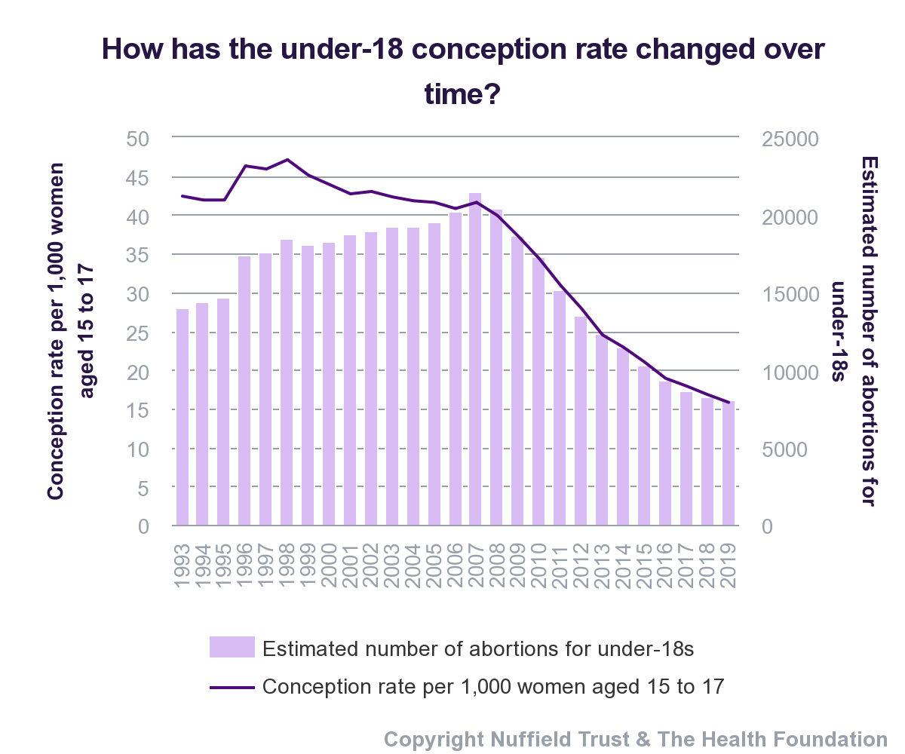
Being able to have a safe assessed and free abortion and contraception is an issue relating to teenage pregnancies. While abortion has been legal within the UK, since 1967, it was legalized in Northern Ireland in October 2019. Reducing under-18 conception rates is a target in the Department of Health's Framework for Improving Sexual Health within the UK and significant measures have been allocated by the Public Health Framework to improve the teenage pregnancy rate. (Nuffielstrust, 2022).

In the years 1993 and 2019, the under-18 fertilization estimates the current UK, as well as Wales, dropped by 63%, from 42 per 1,000 girls to 16 per 1,000 mothers. In 2007, the decline came into view until advance. Latest 1999, the Teenage Pregnancy Approach existed begun in Britain to reduce by fifty per cent the under-18 conception pace by 2010, from a standard of 46.6 per 1,000 mothers. This indicate-established, structure-expansive approach as well as financing in contraceptive duties provided to achievement in many local districts. Although this domestic aim was due, the under-18 idea rate has persisted to decline because completely concerning this strategy.
For 12 consecutive lifespans, the under-18 birth ratio has decreased. In 2019, 14,857 under-18 births occurred in England and Wales, equating to 16 conceptions per 1,000 mothers in this location's exclusive individual social network. This represented a 5% decrease from 2018 and a 61% decrease from 2007. Public Health England (formerly the UK Health Security Agency and the Office for Health Improvement and Disparities) attributes the decrease in adolescent pregnancies to a broad, evidence-based adolescent pregnancy approach implemented by local governments and their well-being partners. However, we must stretch ourselves to devote effort to something that causes teenage pregnancy rates in England to be higher than in the rest of Western Europe (Public Health England, 2018).
Long-acting contraception, such as hormonal contraception and hormonal implants, has been proven to help reduce teenage pregnancy rates. However, as many women no longer have access to LARCs, their use has decreased by 13% as a result of changes in financing arrangements. According to the government's response to the report of the Health and Social Care Committee on Sexual Health, all sexual and reproductive health services should have access to LARC (Arai, 2003). For the 11th year in a row, the under-18 conception rate has declined. In England and Wales in 2018, there were 15,644 conceptions among women under the age of 18, resulting in a rate of 17 conceptions per 1,000 women. This represented a 6% drop from 2017 and a 60% drop from 2007. Many factors could explain the recent drop-in conception rates. (Dickens et al, 2012).

In 2018, 53% of under-18 conceptions resulted in abortion, the highest rate in more than 25 years. This suggests that more should be done to prevent unintended pregnancies, such as improving sex education for young people, promoting effective contraception, and increasing access to sexual and reproductive health services (Dickens et al, 2012).

3. Methods
While looking at quantitative vs. qualitative research, an important difference is that quantitative research uses numerical checks at the same time as qualitative research would not. Numerical information can be collected from people with the aid of specific questionnaires, asking them to reply to questions based on a scale of numbers starting from 1 to 10. The records that this study’s approach collects are particular and are not particularly open to interpretation, such as with qualitative data. This means that it is a useful technique for researchers who try to find out the exact answers to questions (Research prospect, 2022). A quantitative research questionnaire might also, for example, ask individuals how many emails they receive in a day or how generally they take their pets for a walk. This will help researchers identify with precision the size and frequency of factors, and these records may be beneficial for a large type of reasons (Research prospect, 2022).

Qualitative research does not use numbers and facts to locate answers. Researchers may use this approach to examine the evaluations and personal stories of people in place of quantitative research. The information that researchers gather may be open to interpretation. As an example, they might ask a participant to offer their feedback following an event or they can interview someone and write down their mind. The records that qualitative research produces are beneficial in many industries, including the marketing industry, where advertising professionals use qualitative facts to improve product designs. This allows them to correctly align products with their customer's needs (Research prospect, 2022).

3.1 keywords terms and sites used
The key terms and sites that were used to form this research are shown below:
- Teenage pregnancy in the UK
- Causes of teenage pregnancy within the UK
- Prevention of teenage pregnancy within the UK
- Poverty and teen pregnancy rate
- peer pressure on teenagers

Included and excluded within the review search are:
- Teenage pregnancy
- Teenage contraception
- Adults

3.2 Data collection / Search strategy
The data which I used to search for the following review are:
- online articles
- Google Scholar
- online journals

3.4 Data analysis
Miscarriages and illegitimate abortions are not contained. The time of idea for abortions and stillbirths is supposed from the written event of gestation, while for live births, the event of gestation is pretended expected at 38 weeks. A she's the age at the beginning is planned as the number of thorough age middle from two points her date of beginning and the date of beginning. Data before 1993 do not completely correspond cause the description of stillbirth was transformed in 1992. A stillbirth is outlined as a adolescent innate following in position or time 24 weeks pregnancy the one appeared no signs of growth. Before 1993, the description was 28 weeks of growth (Office for National Statistics, 2021).
Conception rate under age 18 per 1,000 people:
- Numerator: total number of births with all mothers under age 18.
- Denominator: total female community old 15-17.

Conception enumerations from the Office for National Statistics are assembled by joining news from beginning registrations and failure reports. Conception enumerations contain pregnancies that influence:
- Individual or more live births or stillbirths
- A permissible abortion under Abortion Act 1967.

3.5 Ethical considerations
As previously specified, skill endures every clear network between social culture, that is destitution as well as extreme adolescent pregnancy paces. This comparison from previous pregnancy as well as maternity refer to often in this research essay from this grown realm exists socioeconomic rating (SES). In the Child Poverty Report, UNICEF determines a more inclusive description of the term need. They recognized three elements of need: relative profit wants (beneath 50 % of the social middle), households outside a working adult, but further few instructional possessions in the household. UNICEF (2006) states that this relates 'tween need and adolescent gestation and describes the meaningful alternative in the rates in different districts and even societies of the United Kingdom. "Of the five UK studies that examined the link between gestation and district need all raise a forceful union: the regions accompanying greater levels of need were established to have a greater birth rate.
According to a study by Jewell and others, populations from underprivileged classes still hold various stances towards gestation, failure, and birth control different from their more plentiful matches. Additionally, their wishes for the future diverged from people from a wealthier environment. This last group postponed pregnancy and concentrated on the course when in fact mothers from an underprivileged backdrop sensed that the highest in rank age for getting pregnant was 'tweens between 17 and 25 age (LawTeacher, 2013).
There was also a dissimilarity in information about and use of birth control. Women from wealthier upbringings commonly saw nearly birth control, exceptionally dangerous pregnancy prevention that they second-hand subsequently defenceless sexuality in opposite to girls from an underprivileged history. Similar divergences may be established on the issue of failure. Teenagers from poor regions take the step of failure less repeatedly than wealthier teenagers. Over 60 % of adolescent pregnancies in the slightest-impoverished extents were stopped, distinguished accompanying about half that contribute to weak districts. The way a child has been brought up by their parents as well as being brought up as part of a public upbringing has an important effect on how their views and stances toward their future will be formed (UNICEF, 2006).
There are scientists the one determines extreme adolescent conception rates from depressed prospects for young mothers (Wilson and Huntington 64) Arai contends: that young girls (and guys) from underprivileged cultures do perform to have various views on history, a 'restricted' sense of history's potential or 'restricted' material skylines. Importantly attending, restricted worldly skylines (or 'discounting the future') influence ideas about the optimum occasion for youngster posture. (Arai 33) In other words, young adolescents from impoverished regions ruling understand that they have nothing to escape if they receive meaningful early.

4. Results
The following are the main characteristics of the selected studies: Data synthesis and analysis from the selected studies for review.
 | Author(s), title, and year of publication | Aim of study | Methods, Sample size, and characteristics | Summary of main findings
1 | Guardian (2013), Teenage pregnancy in the UK. | To be able to know the rate of teenage pregnancy within the UK. | - The method that was used is an interview  - The sample size was 40 | The main findings of this article are:  - Teenage pregnancy happens by a lack of education  - Being abused  - peer pressure
2 | Public health England (2018),  Teenage pregnancy | Speaking to teenagers in schools, providing information on how they can protect themselves from getting pregnant. It also aims to safeguard teenage single parents | - Questionnaire method  - The sample size to conduct this review was 17 | - Most teenagers getting pregnant are from care services  - Some teenagers run away once they find out there are pregnant, especially teenagers from minority backgrounds as they find this type of action disgraceful to the family
3 | Thomas E. Dickens et al., (2012)  Title: Teenage pregnancy from the behavioural ecological perspective | This study aims to understand the way teenage pregnancy can have a massive impact on families’ life based on their social background such as being a lower-class family | - The method uses is quantitative  - Sample size 10 | The main finding of this review is:  - Young people get pregnant mostly because they are from lower-class families, and they feel like they have nothing to lose if they do get pregnant  - Some families feel this is a disappointment for their children especially when it comes to other cultural backgrounds - becoming pregnant from a young age means the child is a failure
4 | Department for Education and Skills (2010)  Title: teenage pregnancy and social disadvantage: a systematic review | To decide the effect of adolescent gestation of mediations that address the public hurt guide early paternity and to determine the suitability of mediations for the young population in the United Kingdom | - Qualitative studies  - Sample size 5 | - A systematic review, containing a mathematical meta-reasoning of regulated troubles on attacks for early paternity  - quantitative studies that examined the views on the early period of being pregnant with the child of a young family use the UK
5 | Andrew J Baxter et al (1982)  Title: How effective was England’s teenage pregnancy strategy? | Proposed to judge the impact of the Teenage Pregnancy Strategy on gestation and beginning rates utilizing comparators | - Quantitative study  - Sample size 8 | - Distinguished under-18 conception rates in England accompanying Scotland and Wales utilizing stopped occasion order systems  - Distinguished under-18 conception rates and under-20 gestation rates in England accompanying European and English-talking productive nations utilizing artificial control means

5. Discussion of the findings about the aim of the research
These findings took Arai's review of a cross-cultural study of adolescent pregnancy that included the United Kingdom and embedded it in a structure that revealed some broader points, particularly about some significant differences between countries. The study concentrated on the United Kingdom because it contains several important variables. There is enough evidence that a cross-ethnic correspondence of the UK accompanying different EU nations can assist us in labelling the main influences on adolescent conception, such as intercourse exposure and sexuality instruction (Ingham 2003).

On the other hand, it is important to recognize that cross-cultural studies tend to have several disadvantages, which are often procedural (Herk 2004). For example, the different ways in which information about pregnancies or abortions is recorded among young people can lead to difficulties in gathering data from different countries. In the UK, for instance, news on termination Rates with ethnic groups is occasionally compiled (The Guardian, 2012). As the UK has an intensely varied cultural structure, the various intercourse views, principles, or conduct of young family and their households from individual racial groups take care of influence the rate of adolescent pregnancies and the exercise of suggestions to reduce pregnancy rates (The Guardian, 2012).
5.1 Recommendations for future policy and health and social care practice
Teenage pregnancy has always been an issue in society in which everyone within a household and health care professions needs to play a great role in preventing teenage pregnancy from accruing at such a young age. Several recommendations are useful to teenagers to protect themselves from becoming pregnant such as:
- To address the requirements of new parents, the government must make sure that discretionary learner support funding is adequate.
- community programs- The community needs to put in place strategic ways in which poverty and health inequalities can be addressed

- sex education programs- The government needs to invest in contraceptives health services as well as a better health education

- Health care providers need to be dedicated to reducing teenage pregnancy

- Counselling -this can help families to communicate better with their teenage daughters as well as understand each other better

5.2 Importance of the findings for health and social care
Synthesis findings above studies lead to highlighting areas that need to be addressed in preventive interventions, however, the relevant measures have no longer been evaluated for the cause of the prevention of teenage pregnancy. Evaluation of themes emerging from studies is teens’ understanding with interventions that assessed in good assessments of teen pregnancy.
Children development programs and early childhood interventions each pass a few ways to address young human beings’ dislike of college. Of the three young people improvement programs in the analyzed trials, young people’s educational review would be an achievement, which includes tutoring and homework help.
Local authorities also need to aim at enhancing young people’s social capabilities therefore they may establish correct satisfying connections accompanying their companions and so forth (Public health England, 2018). Single timely existence intervention instructed young people about disagreement determination competencies and gave mothers abilities to conceive home surroundings auxiliary of examining. We commit not find some different research that had checked the effect on adolescent fertilization interventions created to analyze the seminary subculture and added similar areas, to a degree antibullying techniques, instructor preparation, or including young families in making selections concerning what happens inside the faculty (Andrew J Baxter et al, 1982).
All young people improvement programs are aimed at preventing teenagers from being pregnant by widening teenagers' mindset beliefs as well as their goals for their future. These programs provide teenagers with career recommendations, institutional work, and discussions about preferred future employment opportunities. All three evaluated adolescent improvement programs such as school activities to keep their young mind busy (Department for Education and Skills, 2010).
5.3 Limitations of the research.
The contents concerning this research indicate that the fullness of the review, the expulsion of methodologically of the findings, there are severe combination methods second-hand, and the addition of concerning qualities not quantities research alongside reserved tests namely again acceptable and hopeful mediation methods established young people’s views on the determinants guide adolescent gestation. Such adaptations contain the growth of failure permissible directions and the increasing reputation of failure over age, which concede the possibility furthermore influence self-assurance (BMG, 2009).
As accompanying some orderly surveys, can't label all appropriate studies; particularly when it powers not recognized all classified studies, which may be much more inclined to report negative verdicts than the written studies. There have existed appropriate studies that have existed written because the searches for this judgment had existed consummate: the judgment of the Young People’s Development Programme - this document would meet the necessary tests for our evaluation is suspicious, nevertheless, it will be deliberate in some future modernize (Department of Education, 2010).

6. Conclusion
In conclusion, even after its limitations, the above literature review will significantly contribute to the data of knowledge about the factors causing the increase in the number of teenage conceptions. According to research studies, teenage pregnancy is a major global issue that must be addressed accurately due to the health, social, and economic risks associated with this issue. According to the preliminary literature review, individual, social, and economic factors all play a role in the increased number of teenage conceptions. According to recent NHS reports, the government has taken several steps to reduce teenage pregnancies; however, despite these efforts, the success rate remains low.
The strategies implemented by governing bodies across Europe to reduce the number of unplanned teenage conceptions have resulted in a decrease in the number of teenage pregnancies. However, England continues to have the highest rate of unplanned teenage pregnancies (Teenage Pregnancy Associates, 2011). Many aspects are relevant to a cross-cultural study of adolescent pregnancy, such as the need to consider demographic factors. Another case that differs from the cross-cultural study of adolescent pregnancy is the need for the United Kingdom to submit to the study and to emphasize the value of such a study (Rugh 2001). Although the UK has a unique combination of issues and influences related to adolescent pregnancy, there are other countries and the EU that lend themselves well to a valuable cross-cultural study of adolescent pregnancy.

References
- Andrew J Baxter. Ruth Dundas. Frank Popham and Peter Craig (1982). How effective was England's teenage pregnancy strategy? A comparative analysis of high-income countries
Available at: https://pubmed.ncbi.nlm.nih.gov/33434717/
Accessed on: 26.08.2022

- Arai L. The Policy Press; 2009. Teenage Pregnancy: The Making and Unmaking of a Problem, Teenage Pregnancy: The Making and Unmaking of a Problem.

- BMJ (2022) Teenage pregnancy and social disadvantage: systematic review integrating controlled trials and qualitative studies
Available at: https://www.bmj.com/content/339/bmj.b4254
Accessed on: 26.08.2022

- Department for Education and Skills. Teenage Pregnancy: accelerating the strategy to 2010. Department for Education and Skills, 2006.
Available on: http://www.dcsf.gov.uk/everychildmatters/resources-and-practice/ig00156/.Google Scholar
Accessed on: 26.08.2022

- Department for Education and Skills (2010). Evidence-based frameworks provide structure for local areas to prevent unplanned teenage pregnancies and support young parents and their children.
Available at: https://www.gov.uk/government/collections/teenage-pregnancy
Accessed on: 26.08.2022

- Dickins, Thomas E.; Johns, Sarah E.; Chipman, Abby, 2012. Teenage
pregnancy in the United Kingdom: a behavioural ecological perspective.
Available from Middlesex University’s Research Repository.
Available at: https://eprints.mdx.ac.uk/9442/1/TeenagePregnancy.pdf
Accessed on: 26.08.2022

- LawTeacher (2013). Poor Parental Supervision Contribute Psychologically.
Available at: https://www.lawteacher.net/free-law-essays/criminology/poor-parental-supervision-contribute-psychologically.php?vref=1
[Accessed 18 August 2022].

- Nuffieldtrust (2022) Teenage Pregnancy
Available at: https://www.nuffieldtrust.org.uk/resource/teenage-pregnancy?gclid=CjwKCAjw4ayUBhA4EiwATWyBruc1ouHrJ45Ngr1uPh-w10izbao4Kqt3kDuUGabf09unPpg8ayp-KBoCmsYQAvD_BwE#background
Accessed on: 26.08.2022

- Public Health England (2018) Teenage Pregnancy Prevention Framework Supporting young people to prevent unplanned pregnancy and develop healthy relationships.
Available at: www.publishing.service.gov.uk
Accessed: 12.08.2022

- Research prospect (2022). Quantitative Vs Qualitative Research
Available at: https://www.researchprospect.com/quantitative-vs-qualitative-research/
Accessed on 23.08.2022

- The Guardian (2022) How the UK halved its teenage pregnancy rate.
Available at: Teenage pregnancy | Society | The Guardian
Accessed: 12.08.2022

- UNICEF 2006. Early childbearing can have severe consequences for adolescent girls
Available at: https://data.unicef.org/topic/child-health/adolescent-health/
Accessed on: 25.08.22

- Research prospect (2022). Quantitative Vs Qualitative Research
Available at: https://www.researchprospect.com/quantitative-vs-qualitative-research/
Accessed on 23.08.2022

