`

Leadership

Md Monzurul Amin Patwary
Student ID: 1604185

Leadership
Leadership is the power to lead or control a group of people or an organizational employees to achieve the goal. Leadership can be defined in many different situation and place. It can organizational, political, social, student leadership.
“Leadership is the art of getting someone else to do something you want done because they wants to do.” - Dwight D.

Different theories of leadership

Trait theory
Trait theory says that the leadership development never achieved by only practice, if it doesn’t come from inside naturally. Armerding (2013) believes that leadership effectiveness depends on specific traits of personality, physiological, demographic and sociability. A successful leader has some qualities that are not be found in a non-leader. The researchers have identified these qualities which create a difference between the successful leader to unsuccessful one (Charteris-Black, 2011). The major characteristics of a successful leader are one`s crave for achievement, motivational skill, trustworthiness, innate abilities, mental stability and knowledge about the organization. Charteris-Black (2011) thinks that the trait theory is directly related to the great man theory that focuses on the interpersonal skill of a leader. Different types of traits enable a leader to respond differently in a various situation where the way to respond remains consistent in the situations. 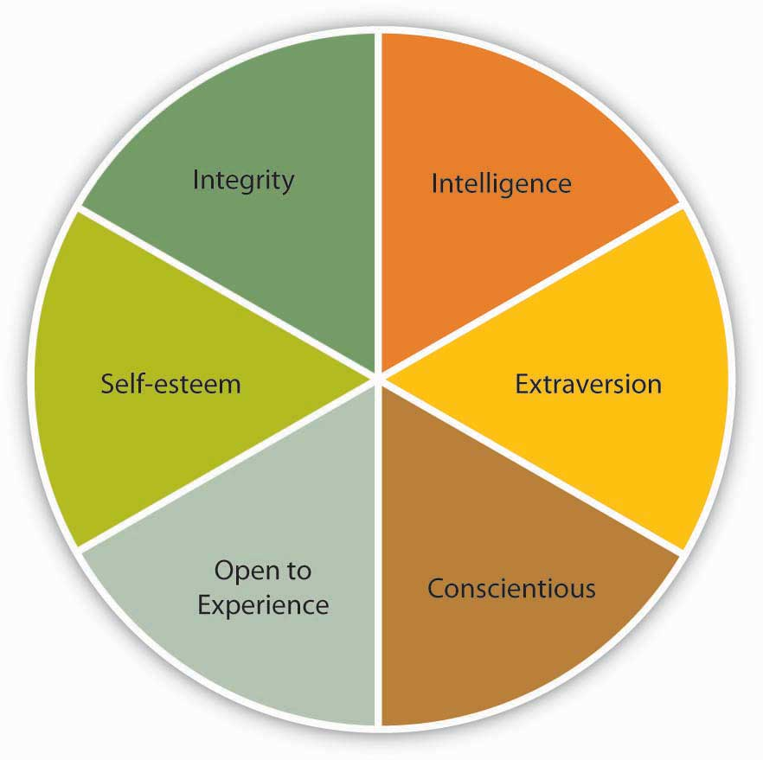

Behavioral theory
Behavioral theory gives completely different view about the leadership than trait theory. Kelly (2010) says that this theory focuses on the action of the leader than their inborn traits. Behavioral theory generates new dimension of leadership skill by leadership development process. Two important types of research are made in the field of behavioral theory in mid-90`s.

Figure 2 behavioral theory (Kelly, 2010)
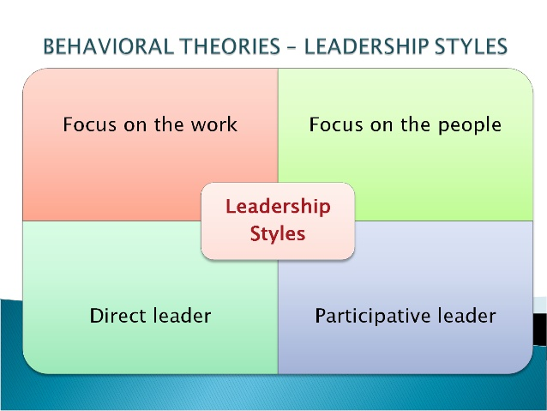
Figure 3 leadership styles (Brouwer and Johnson, 2014)

LMX theory
LMX theory describes the difference between the different dimensions. This are the dimension of manager and employees. Perrin-Jassy (2014) states that a leader makes a relationship with each employee separately and this relationship determines the responsibility of subordinates. Besides, a leader has developed two types of relationship – one in group and other is outside the group. This relationship is based on some interpersonal factors of respect, support, trust, loyalty, and obligation.
In Group | Strong relationship | More preference
Out Group | Weak relationship | Less preference

Leaders classify different groups of employees and behave differently to each group. The subordinates of in-group enjoy more preference and attention than out-group. They also enjoy more access to the facilities and resources of the organization. On the other hand, the subordinates of out-group don`t enjoy as attention, preference, and access as in-group. For example, a senior employee enjoys more flexibility in getting leave than a younger one. The leader makes these groupings based on some factors like similar mentality, age, gender, race etc. Sometimes, these types of grouping can create biases in the organization.

Figure 6 Process of LMX theory (Perrin-Jassy, 2014)

At the very beginning, the leader assesses the trait, characteristics, skill and the potentiality of subordinates in role taking step. In rulemaking stage, the manager evaluates the actual performance of subordinate and their trustworthiness, integrity, and loyalty. In the final step, the manager makes a category of employees and gives preference accordingly.
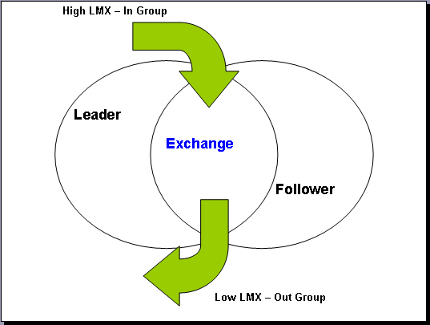
Figure 7LMX theory (Perrin-Jassy, 2014)
.

Path-Goal theory
Brouwer and Johnson states that the ways a leader behave with his subordinates are dependent on the performance, motivation, and satisfaction of themselves. The leader helps the subordinate in achieving goals by reducing the impediments in completing the task. A dynamic leader promotes the skills of the employee by complementing and taking action to reduce their inefficiencies.

Figure 8 path-goal theory (Brouwer and Johnson, 2014)

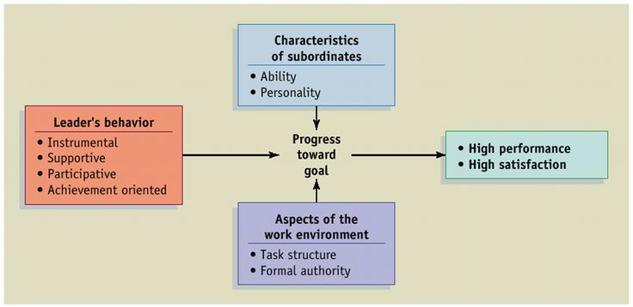
Figure 9 path-goal theory (Brouwer and Johnson, 2014)

Authentic Leadership
Glanz defines authentic leadership as the ways of developing leadership through mutual trust, own dedication and integrity. The positive attitude is integrated with self-awareness to run the organization ensures increased team performance.

Figure 10 components of authentic leadership ( Glanz, 2014)
Self-awareness is the way of knowing about the one`s strong zone and the weakness for the self-development purpose. One can collect the information about himself from the feedback of other`s people and the environment. Self-actualization and self-observation are the key tools for knowing inner characteristics. Authentic leadership does not promote to hide one`s weakness; rather it tries to improve the situation by revealing facts. Ethical leadership is promoted in this model which is ensured by integrity and fairness. Hirschmann (2014) states authentic leadership encourages to use morality and value in work activities. Balanced processing assists a leader to know about the biases so that the leader can track the biased information in decision making (Belloc, 2015).

Charismatic Leadership
As per the view of Perrin-Jassy charismatic leadership is the way to lead the employees’ very politely, charm fully, persuasiveness and all the personality of a good leader. The commitment of the leader is the crucial factor in charismatic leadership. They are almost similar with the transformational leader except for the main focus and the target group of people. For example, Nelson Mandela was an example of a charismatic leader. With his amazing personality and attitude, he motivated the people of South Africa to reduce the racism (Kelly, 2010). The charismatic leader leads the people from the front focusing on the goal with high commitment. Another key nature of these leaders is that they can forecast the future and judge situation with a high degree of values. The communication skill of charismatic leadership is so powerful that audience can easily be mesmerized. The charismatic leaders are also competent in negotiating with different parties. They know the need of their subordinate and provide strong guidance accordingly.

Figure 11charesmatic leadership (Perrin-Jassy, 2014)

Evaluation of being a charismatic leader
If anyone have to be become a charismatic leader he or she would have some attributes which can make them different from the others. The attributes can be like
- A well-defined goal, mission and vision
- Should have the exact detail of the organization and the employees
- Highly risk taking mentality
- Role model behavior
- A very strong communication and negotiation power
If I want to assess my qualities of being a charismatic leader, I have found some qualities of myself and some restrictions. I can easily read the environment and culture of the organization and take immediate actions according to the environment. I know that taking calculative risk is the key to long-term success and able to manage risk. But, I have some restrictions in terms of visionary ability and negotiation power. In forecasting the long future environment, I need to increase the ability to visualize the upcoming event and develop plans to tackle the changes. Besides, I need to increase the negotiation power which can be developed by increasing the communication skill and articulation. So, I need to develop a lot in these cases to be a charismatic leader with a great personality that will help to become a role model.

How to reflect leadership style
Organized and detailed vision: A well-organized vision should consider all internal and external factors of an organization. The information collected from different parties including employee, supplier, buyer, government and other agencies will help to know about the internal and external factors. Besides, the goal of the organization should critically analyze so that the vision will match with the goal.
Communication skills requirement: Sometimes a well-developed vision fails to achieve the desired outcome for improper communication. As the strategies are implemented by the lower level of management, the strategies should be kept as simple as can. In the case of confusion, we should clarify the actual meaning of the terms.
Compensation policy and motivation: Motivating subordinates is very crucial for goal attainment as everyone works for reward and recognition. So, we should motivate the employees by financial reward and recognition. A proper compensation policy encourages the employee to work diligently (Glanz, 2014).
Interpersonal relationship: To develop a strong relationship with subordinates, their skills, strengths, weakness, need etc. should be understood properly. In setting the goals, these factors should be considered to avoid interpersonal conflict. Besides, we should implement participatory leadership in the organization that considers everyone`s opinion. But, when we take a decision, we shuld give more priority on the organizational well-being (Burns, 2012).

Reflection
Suppose, I am a leader of the selling section of a supper shop. There are fifteen employees work under my leadership. My organization set a target sell for my section. As I am the leader of that section I have made a plan to achieve that target before the deadline. For that I called a meeting with my co-workers. At first I try to identify the behavioral demands of them. Then I assign them their task according to that. I announced some gifts for their working excellence. As I tried to achieve the goal before time I have to do my best and have to take some risks. My workers was happy to work with me. I think in that occasion my tasks was kind of a good leadership.

Reference

- Burns, James MacGregor. Leadership. New York, NY: Open Road Integrated Media, 2012. Print.
- Burrow, Jim, Brad Alan Kleindl, and Michael B Becraft. Business Management. Print.
- Doherty, Catherine, and John E Thompson. Leadership. London: Hodder Education, 2007. Print.
- Erasmus, Barney, J. W Strydom, and Sharon Rudansky-Kloppers. Introduction To Business Management. Print.
- Giuliani, Rudolph W, and Ken Kurson. Leadership. New York: Miramax Books, 2007. Print.
- Iszatt-White, Marian, and Christopher Saunders. Leadership. Print.
- Johnson, David E. Residential Land Development Practices. Reston, VA: ASCE Press/American Society of Civil Engineers, 2008. Print.
- Osborne, Christina. Leadership. Print.
- Safire, William, and Leonard Safir. Leadership. New York: Galahad Books, 2000. Print.
- Scarborough, Norman. Effective Small Business Management. Pearson, 2014. Print.

