Table of Contents
Introduction 2
Research 2
planing and organisation 3
Design 3
Mind Maps 4
Website plans 5
Mobile phone app 6
Outline of our stages 7
References 8

Introduction
This assignment was a group effort where we needed to design and develop a prototype system for an Active Travel application.
The words Active Travel means walkings, cycling which is combined into typical ways for travelling such as using a bus, train or driving.
Our prototype will include a PC application and a tablet/phone app. We have chosen to do this has
The features on the mobile phone app and the website will include a step count, a map of the nearest places where they can park before they should think about walking or cycling. The rest of the way on their travels, weight loss, records how their behaviour around exercising has changed.
Each member of my group was given a role for each section of the assignment. However, each member of the group will provide assistance to make each section is completed.

Research
This project will be blind and other disability friendly. This is because I will have a section called accessibility. These features for a visually impaired will include font adjustment, magnification. The magnification section in the accessibility feature will allow the user to zoom in on the target area that they may want to see. The font size feature will allow the user to enlarge text on the mobile phone app so its more easier for the user to read. Other disability include people who suffer from colour blindness. The features for this will include invert colour, reduce the amount of white point but the user will be able to change the colour features to suit there own needs.

planing and organisation
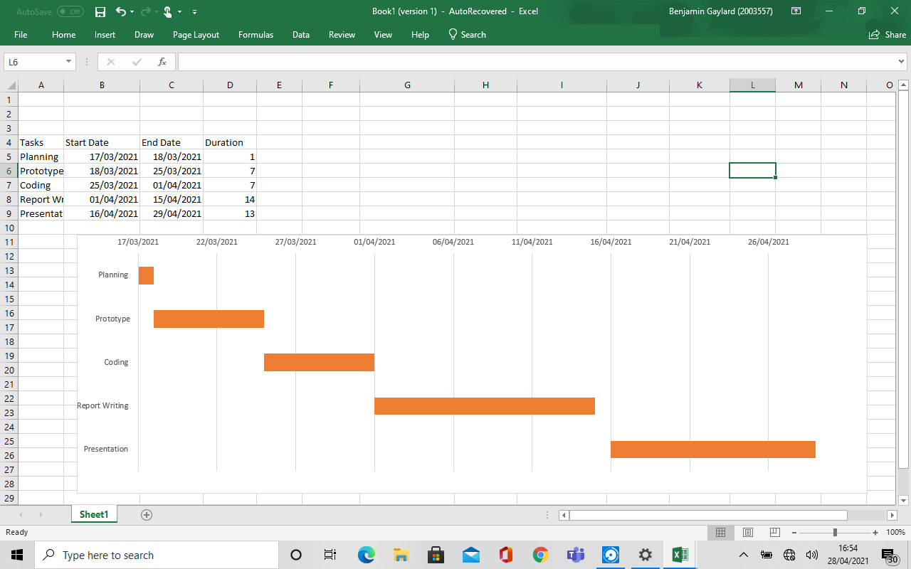
At the beginning of this project we planned so we knew wha we was going to do and so we could keep too time scales. By planning it provides a guide for what is going on. This means that the outcome should be better and should be more effective. However, an drawback to planning is that it may prevent action on what is going on. This means not everyone in the group will listen to the team leader and the plan may not be implementing what is going on.

Design

By using fitness websites or fitness apps, it is more accessibly for the user as they can monitor their diet more efficiently, the user can monitor their progress more quickly, track your step count, and it keeps you more motivated.
“Monitor their diet more easily” means that the user can monitor what they are eating and calculate how many calories, carbohydrates, protein, and fat the user is eating per day. The user will be able to track their daily intake easily, and the user will be able to maintain a healthy lifestyle.
“Monitor their progress more easily” means that the user can enter their workout/ health details and updates.
“Track your step count” means that the user can count how many steps they are doing on average per day/per month/per year. This will be able to help meet to target, and it will be able to allow work to make you more healthy.
“It keeps you more motivated” means that it is used as motivation to keep you on track, health goals.

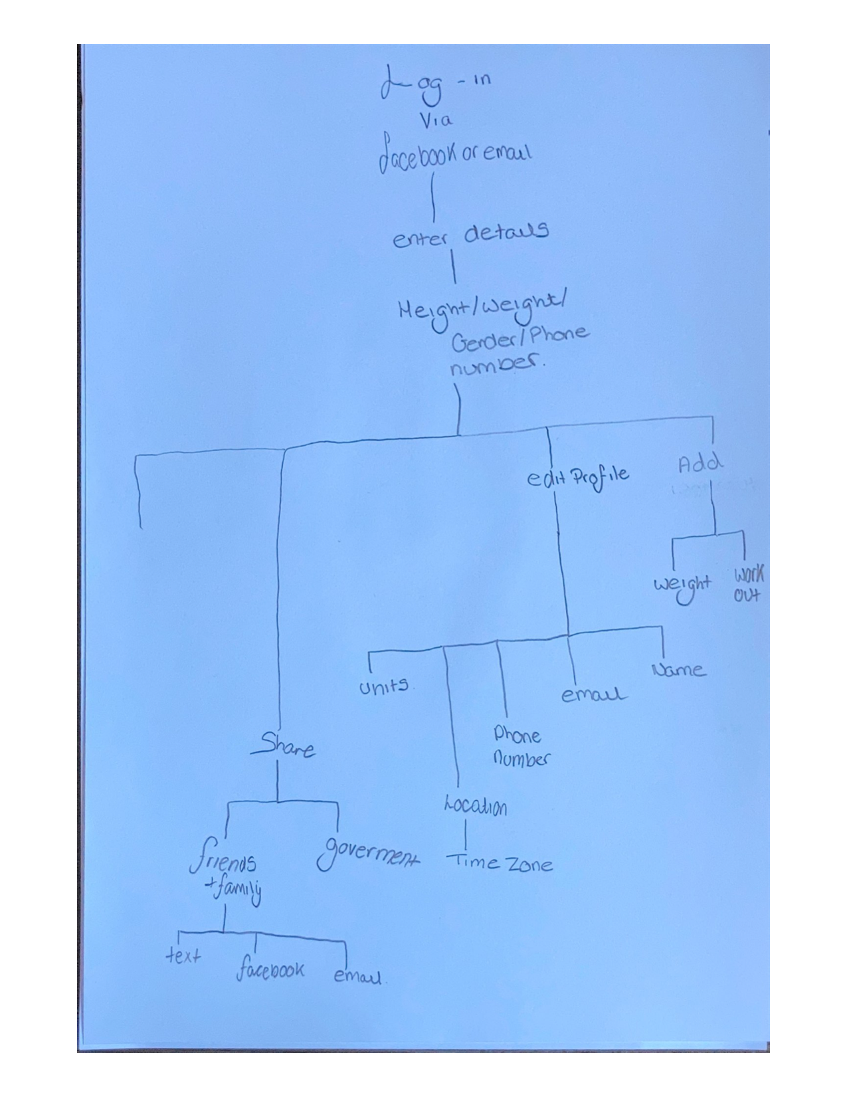
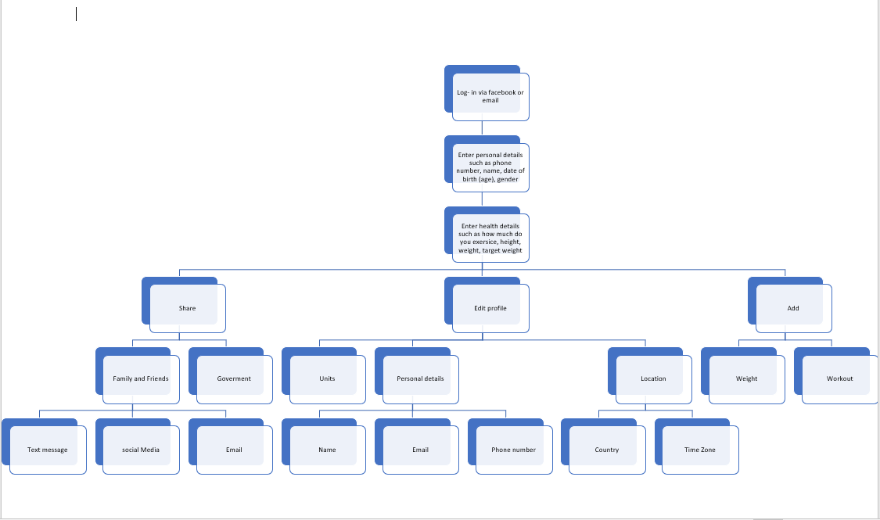
Mind Maps
By using mind maps and hierarchy to plan our work it is more effective way to plan as you can see what is going on using the process. Hierarchy means “ A system in which things are arranged according to their importance.” These will be organised which makes them easier to read and understand the stages of the process for the person who is creating it.

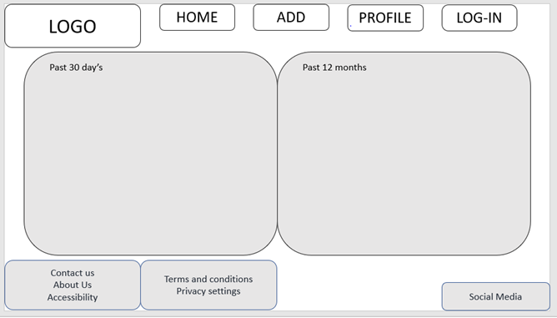
Website plans
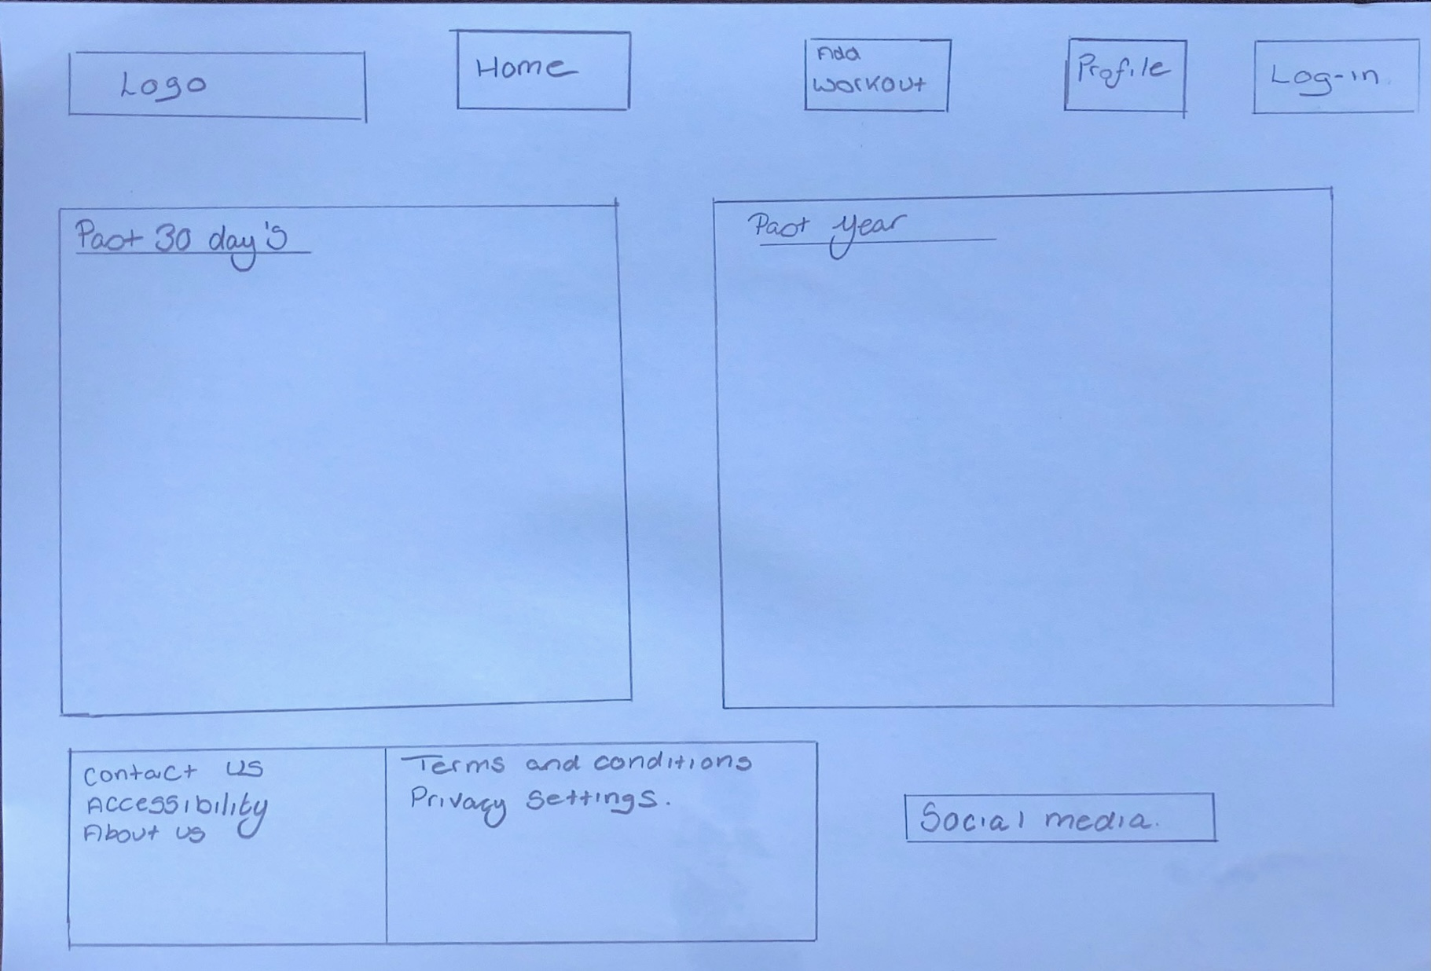
The below image is the original design which I drew on paper. This is beneficial as I could get an better understanding on what the website would like. This was also beneficial as I have dyslexia and personal I work better on paper. The new design is the own the left this. This one was created on powerpoint. All of the text will use hyperlinks. These will make the website more easier to navigate and it should make it more user accessibly friendly. The main colours for the background will be white and the information boxes will be grey. The text will be black. However, under the accessibility features there will be an option to change the text colour and the background. In the new design I changed the design of the boxes as it may be easier for someone with an disability to see. The features on the website include our social media pages where the user can share there progress or see the progress of other people. Also, an contact us link will be at the bottom of the page along with about us and the accessibility along with the terms and conditions and privacy settings. All of the features came from my ideas.
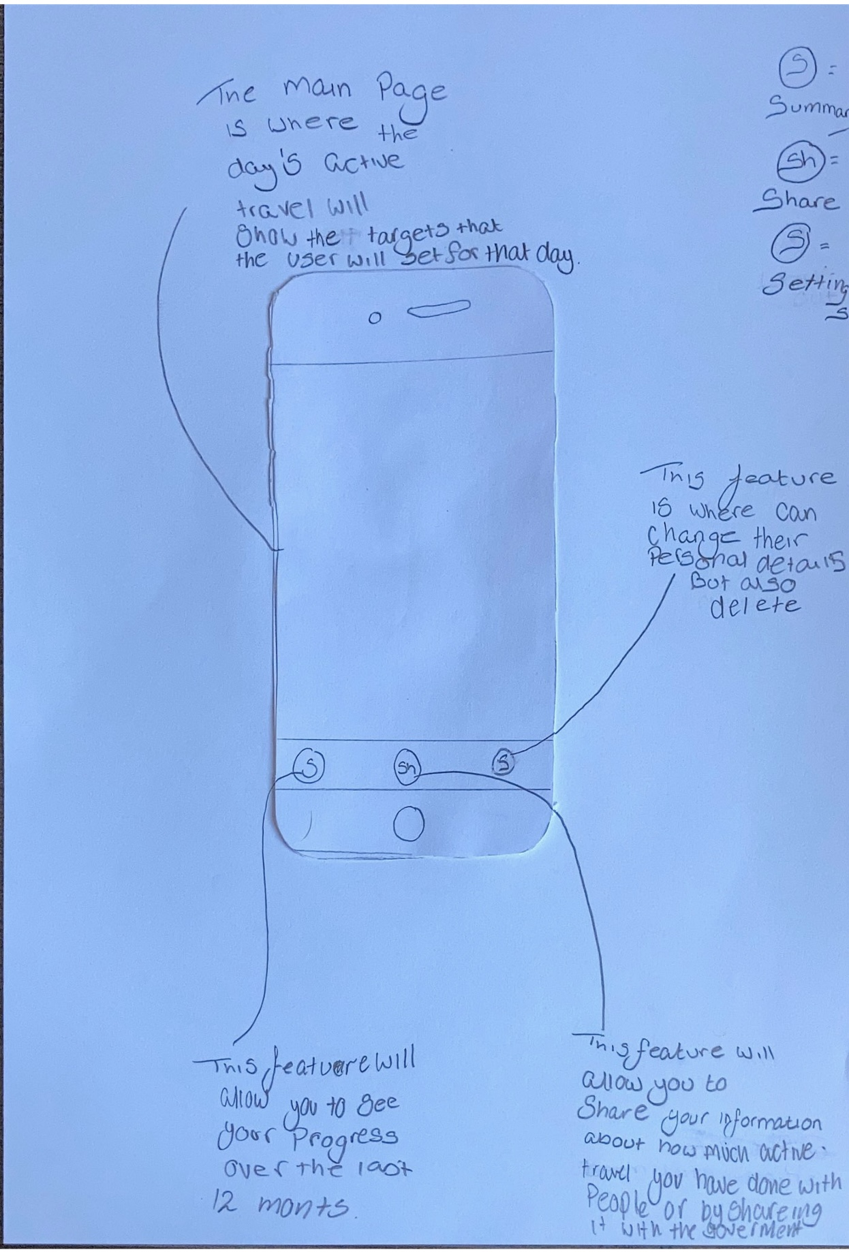

Mobile phone app

Again I ecided to create my first design on paper to see what I could improve on the second design. The first layout I came up with, but after having a look at different, I had inspiration from the apple fitness app, which is in the second design below.
The second design would be better for voice-over features which will help people who are hearing impaired but who wear hearing aids.
The in app features include add, share, settings and an summary page.
The add feature will allow the user to add a workout or add an updated weight.
The summary feature will allow the user to see there activity for the last 7 days but for that day too. This will be beneficial as whoo wants to lose weight as the monitor there what they are ding right and wrong.
The share feature will allow the user to share there fitness data to the government but there friends and family. The user will be able to share there information to friend and family via facebook, email or text. The reasons for these are that everyone for the family and friend will be able to. View there activity data.
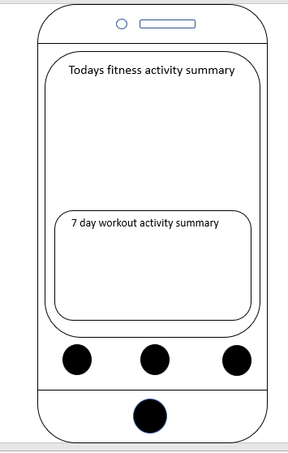
The settings feature is where the user will be able to change their personal data such as their name, phone number, location. The user will be able to change the time zone int the location as the user may be using the app in a different country such as Spain or America.

Outline of our stages

During this activity, communication was necessary; however, my group failed at this, which left me to do most of the work in the latter stages of our time frame. By doing this, it has affected how I have undergone this activity such as, my not being able to complete the tasks such as making Gantt charts, design process and research to the best of my ability which may affect this grades as it was rushed and not completed to a university standard but also the best of my knowledge.
If I were given this task in the future, I would prepare myself as I have realised that group tasks are not allowed to go correctly.

References
https://www.rnib.org.uk/rnib-business/website-and-apps
https://www.socialmediatoday.com/content/web-design-11-characteristics-user-friendly-website
https://www.visionofchildren.org/voc-blog/accessibility#:~:text=Accessibility%20for%20visual%20impairments&text=These%20accommodations%20include%20a%20zoom,area%20in%20a%20separate%20screen.
https://gov.wales/sites/default/files/consultations/2020-02/active-travel-guidance_1.pdf
https://project-management.com/advantages-and-disadvantages-of-gantt-charts/
https://courses.lumenlearning.com/wm-principlesofmanagement/chapter/reading-pros-and-cons-of-planning/
https://dictionary.cambridge.org/dictionary/english/hierarchy

