Student Name: Oleh Vasylyshyn
Student Id Number: 1917016
Module Title: Marketing Fundamentals LCBB4004
Module Assignment Title: Assessment 1 (1500-2000 Words) Written Report
Module Lecture’s Name: Tushara Balendran

UNIVERSITY OF WALES
TRINITY SAINT DAVID

August 2020

ADIDAS MARKETING ANALYSIS

Contest: Page no.

Background ……………………………………………… 2
- Introduction-Marketing ………………………………… 3
- Main Body- Marketing Process ………………………… 4
  - Pestel Analysis ………………………………… 5
  - Swot Analysis ……………………….…………… 7
  - Objectives ………………….………….……… 9
  - Strategies …………………………………….. 9
- Marketing segmentation, targeting and positioning…… 10
- Marketing Mix Analysis ………………………………… 11
- Conclusion and Recommendations……………………… 20
- References………………………………………………. 21

BACKGROUND
Adidas history is closely linked with his founder, Adi Dassler that in 1924 in a small German town, Herzohenaurach recorded ’’Gebruder Dassler Schuffabrik’’ , with the purpose to deliver athletes with the best possible equipment and in 1949 registered the present brand ’Adi Dassler adidas Sportschuhfabrik’’ with the shoe 3-Stripes.
His vision led him to developpe an innovative working doctrine, aimed to fulfil athletes needs throughout attentive feedback’s and personal meetings.

The revolutionary strategy, establish the first results in 1928, when Lina Radke won a Gold medal at the Olympic Games and in 1954 once the German national football team won the World Cup wearing the company shoe’s.
The sportive achievements and the innovative working strategy, lead the brand to increase athletes faith and a worldwide sponsorship .

The first results enhance brand influence and recognition, introducing to establish new promotional opportunities: in 1967 Franz Beckenbauer became the first company celebrity endorsement, and in 1970 Adidas designed ‘TELSTAR’ the FIFA World Cup Official Match Ball, which is still employed today.
The first era of the company ends in 1989 with the death of the founder and turn another with his wife Kathe and son Horst, who collected the legacy by continuing with his founder vision ‘expansion ,constant innovation and product diversification’ giving the company to the current well- known brand. (Thomas, 2014) (Adidas-history, 2020)

INTRODUCTION - MARKETING
Marketing according to The American Marketing Association (AMA) is a set of actions and procedures, aimed at pursuing, foresee, and placate the individual or organizational unfulfilled, physical and immaterial requirements.
The accomplishment of necessities engender the direct value for the costumer, business partners and the organization, videlicet the value is created by a business brand ’’name, logo or symbol, with the aim of defining the firm in minds of consumers’’ and through further researches which stimulate efficient monetary returns besides create the consumer behavior and relationship with the brand.
The resulting consumer behaviour researches allow business to chart a clear strategic planning and viable advantages from objectives and strategies as the future product implementations, packaging, price and promotion. (EntrepreneurHandbook, 2019) (AMA, 2017)

The concept of marketing according to Association of National Advertisers (ANA) can be presented in several types:
- Influencer Marketing: The brand focuses on influencer marketing, valuing individuals with wide following and influence, in order to achieve a greater market share. (celebrities, content creators, customer advocates).

- Relationship Marketing: Is a marketing resulting from the segmentation of consumer behavior researches that generate the future loyalty to the brand.

- Viral Marketing: Methodology of pursuing efficacious trends and encourage his spread from person to person as a virus or disease.

- Green Marketing: Marketing process that emphasizing on the practice and trade in sustainable products, which limit or eliminate their environmental harmful trail.

- Keyword Marketing: The marketing is designed to a specific located group of people, with the right message and timing. (Adidas-History,2020)

- Guerrilla Marketing: Procedure of practicing unconventional approaches, intentioned on results exploiting and costs cutting.

The purpose of the essay is to highlight the research of the courses and marketing strategies executed within the Business to Costumers company (B2C) Adidas brand in the national market, antecedent the COVID-19 outbreak and provide a critical analysis.

MAIN BODY- MARKETING PROCESS
Marketing process or basic marketing plan is one of the head and crucial techniques in any organizations. The aim of the practice is to generate a value for the consumers by satisfying their needs and wants.
The company in order to placate customers’ demands, have identify the internal and external opportunities from the designed target market, formulate objectives, strategies and commence researches on consumer behaviour in order to take efficient decisions and results. (Christ,2017)(McCoy,2017)(IEdu,2017)
The marketing process, could be effortlessly summarized in 5 stages ’’ Situational Analysis, Objectives, Strategies, Implementation, Control’’, in this essay I will particularly focus on two of them: Situational analysis and Strategies, while the remaining three will be provided with a briefly definition.

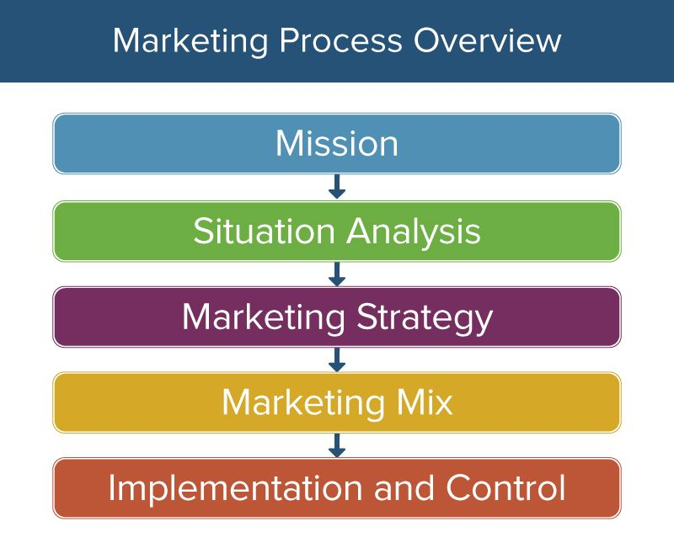 Fig.1 (Weller,2017)
As we can observe in Fig.1: The Company embark on internal and external market researches to determinate his position, consumers requirements and market opportunities. (Situational Analysis)
The research of internal and external, take place on consumption of the elements as PESTEL, SWOT and Porter’s five Forces; although on this essay I will merely highlight the precise analysis of PESTEL and SWOT according to Adidas.
- PESTEL: is a particular process of evaluation company’s external forces, with a direct impact on the business: Political, Economical, Sociological, Technological, Legal, Environmental factors. (Frue,2017)

- Political: Adidas as international retail leader in the sporting goods industry, has a quotidian mission to supplies, ships and distribute his products. This process puts the company under the international rules of supply chain, trade and health -safety. The company focus his manufacturing power mainly in third world countries, which present impoverished quality of life and minimal cost of labour. The domestic market analysis (Uk), display that the company creates employability and is subordinated to different regulations: consumer safety, anti- trust law, employment law, privacy law, labour laws, environmental law and the tax policies.(Adidas-Corporate Governance overview,2020)

- Economical: According to the Adidas financial annual report 2019, the net sales recorded a grew by 8% and reaching € 4.444 billion compared to the previous year. The company’s excellent performance provided better resolutions approaches to the present recession instigated by Covid-19 outbreak, involving the business to expand the efficiency of his online service. (Adidas-Annual Report,2019)

- Sociological: The company, operating in a global market, needs a constant and timely adaptation to new trends and consumer demands. The brand in order to satisfy his flamboyant market, proposes a wide range of designs for all age targets, gender and life style combined with a timely ability to trends adapting, as recent financial collapse triggered by Coronavirus, where the company managed to emerge positively, implementing its online services. In addition, the company has managed to effectively collect the current health care movement, offering a wide range of sports products from footwear to clothing and to attract and support in the past years, a several sporting competitions, I.e. Olympic Games and Premier League which in 2019 according to Score and Change, sponsored a 30% of sports kits, from high renown teams such ‘Arsenal, Manchester United, Fulham, Leicester City etc..’’ (Frue,2017)(ScoreandChange,2019)

- Technological: Since the year of his foundation 1949 the company mission was to provide the best possible product to the athletes. Today brand is continuing the original mission by improving performance and efficiency of his products with revolutionary designs and materials; digital portals provide the firm with the opportunity to improve his online sales and productivity ,by creating a high quality web sites, or social platforms.(Adidas-History,2020)

- Legal: The company pursuing his mission on satisfy his costumers, invest in research and development, that generate new trend products and create patents, created to protect company from impersonation and opponent's interference. The relationship with the sports world as sponsorships or celebrity endorsement, subordinate the firm to marketing and brand regulations on regional and national base.(Frue,2017)

- Environmental: The Company signed the Un Fashion Industry Charter for Climate Action, Adidas is dedicated in the utilization of sustainable materials and energies in the manufacture processes, with the aim to reduce supplier’s gas emission, water waste, achieve climate neutrality and chemicals decrease utilization. (Adidas-Environmental Approach,2020)

- SWOT: Is the the company evaluation analysis, used to develop strategic forecasting over the practice of internal and external forces to the business: ‘’Strenghs, Weaknesses,Opportunities and Threats’’.(Bhasin,2019) (Weller,2017)

- STRENGHS ( INTERNAL FORCES) : The company is renowed worldwide as a leader in sports goods industry, and manufacture a vast range of footwear, cloting and accessories.

- Legacy: The brand has a long history of quality and innovation and pursuing his mission to deliver best possible product since the year of his foundation 1949, which increase brand loyalty.

- Diversification: The firm offer a vast range of products from footwear to clothing and accessories. Use the down line stretching to reach new targets marketing (Reebook).(Adidas-Home,2020)

- Financial position: The company create $4.4 billions in profit in 2019 and the turnover is used to improve through researches and development the firm’s strong financial position.

- Distribution: Adidas present direct and indirect channel of distribution: the company sell from their own stores and website however relies on other retailers ’’JD, Footlocker, Sport Direct etc..’’.

- Brand: Strong brand recognition through activity: as celebrity endorsements or sponsoring major sports organizations ‘’FIFA, UEFA,NBA and Olympics’’ that increase the company awareness internationally.

- Collaborations: The company build strong relationship with suppliers and sustainable organizations ‘’International Labor organization, International Finance Corporation, UN etc..’’ and create a strong competitive advantage with competitors.

- WEAKNESSES (INTERNAL FORCES):

- Premium target: High prices outstanding to advanced technology and production, made the reasonable purchasing of brand products to restricted market, in the developing countries.

- Production: Adidas focus the 93% of his manufacture power, in third world countries whit minimal labor cost and large disposal of resources. The company risk to increase the dependency on foreign countries, and the bad perception of foreign markets regarding quality in the west developed nations.

- Limited product: Adidas in 2005 acquired Rebook to extend his product line, however the two brands focus mainly on footwear, clothing and accessories leaving gaps in the market, which could be profitable for the rivals.

- OPPORTUNITIES (EXTERNAL FORCES)

- Lifestyle Changing: With the new trends and movement in developed countries and the enrichment of developing nations, is highlighted an increase of premium products and services.

- Market Development: New developing countries could be a future strategy for the company in order to expand the brand opportunities.

- Product Expansion: Expanding the present vast range of products, allow to new opportunities and to increase a competitive advantage from competitors.

- THREATS (EXTERNAL FORCES)

- Competition: Adidas as a global brand encountering intense competition from others brands, Nike is the first competitor for the premium target market products. Moreover the global rivalry, on domestic market is recorded a customary opposition from local players, substitutes and market penetrators. (Christ,2017)

- Supplier Power: The production is mainly condensed in foreign countries, allowing suppliers to have more trading power then the company.(Christ,2017)

- Regulations: The company his subordinated to foreign government laws and regulations where the business focus its manufacture power, ’ Import regulations, duty and tariffs that influence the price of the products’. (Adidas,2020)

- OBJECTIVES: Adidas since his foundation pursuing the main goal on provide quality products and services by attentive focus to his target marketing, athletes and consumers needs and wants. The today organization goals are to play a role of a responsible and sustainable business within respect of human rights, the environment and the constant progress. (Adidas,2020)(Christ,2017)

- STRATEGY: Adidas in order to encounter its customers demand and create valuable products, uses target market researches and is constantly attentive to improve the brand efficiency. The sustainable management, consumer centricity and employees empowerment allows the business to increase productivity, furthermore the ceaseless innovation create a direct impact on consumer behaviour, that once seen satisfied his requirements promotes and increase brand loyalty.(Adidas,2020)(Christ,2017)(Bhasin,2017)(Weller,2017)(Wood,2008)

SEGMENTATION-TARGETING-POSITIONING
The business with the aim of increase competitive advantage use marketing strategies to identify costumers, divide them in small groups and create a brand image in mind of consumers. (Mbaskool,2020)

Segmentation: Adidas divide his costumers on demographic and psychographic factors.

- Demographic: Costumers are divided by age, income, family size and economic status. Adidas focus mainly on young consumers 14-40 years of age group, but is also present for the segment group age between 40-65 years. The company also create a sub-brand ‘ADIDAS NEO’ aimed to target only 14-19 years age group and provide stylish, new product for the young costumers with competitive prices.

- Psychographic: The company in order to create premium positioning products, target high-middle class providing the clientele with superior quality products and services that justify higher prices.

- Targeting: The company subsequently costumers division in smaller groups, necessitate to decide opportune future business strategies and apply them on specific targeted group of consumers. Adidas use a differentiated targeting strategy, to reach children, young adults and adults passionate on sport fitness. Whilst the company emphasis on the group age 14-40, most of his costumers are of 15-30 age group from high-middle class.(Heartofcodes,2018)

- Positioning: Adidas Once upon time divided and specifically identified the costumers, has to create marketing plans and set objectives that provide benefits to the brand image in minds of users.

- Benefit positioning: The brand focus on quality and performance of his products and receive direct feedback’s from costumers and athletes which improve the process of innovation.
- Heritage: The 71 years historic company provide trust and brand awareness.
- Celebrity Endorsement: The celebrities provide brand personality and increase recognition.

MARKETING MIX ELEMENTS
The Fig.2 Illustrates the factors intrinsic the marketing mix in Adidas, whose analysis identifies the future strategies and facilitate the realization of the set objectives and goals.
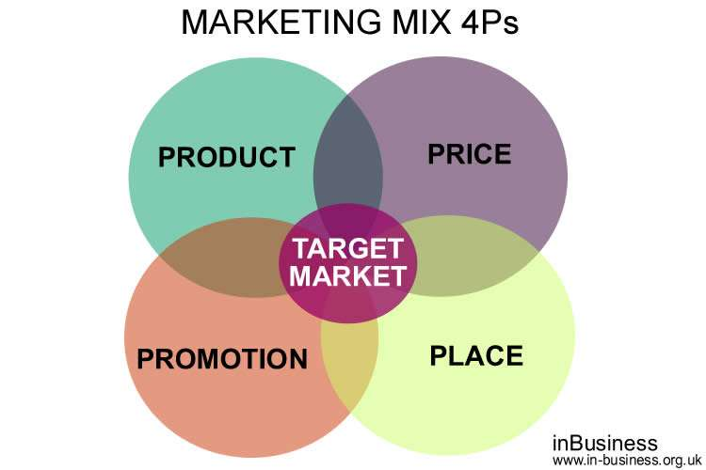

Fig.2(Bowyer,2017)

- PRODUCT: Adidas since the 1949 follows his founder father Adi Dassler vision: offer the best possible products and services to the athletes

.

Today brand follow different product marketing mix strategies, the corporate branding strategy, line feeling and brand extension: offering to his target marketing a vast range of products with different size and designs, not only shoes but also clothing and accessories across different sportive disciplines such as ‘Football, Basketball, Golf, Rugby, Tennis, Running, Swimming etc..’ (Adidas,2020)(mbaskool,2020)(Weller,2017)(Entrepreneurhandbook,2019)

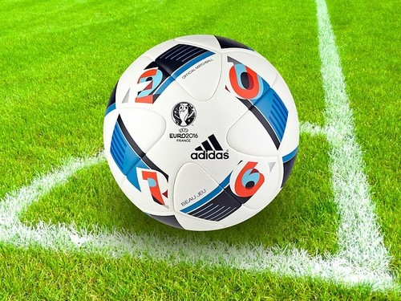

Fig.3 (Mbaskool,2020)

As we can observe in Fig.3 Adidas brand is linked with UEFA competitions sponsorship ball since 1968 and with FIFA from 1970 with the famous ‘Telstar Durlast’. (Adidas,2020)

Fig.4 (Adidas,2020)

In Fig.4 we can observe a perfect example of adidas streetwear, revolutionary lifestyle introduced in 2000’s inspired by its sportwear range of products.(Mbaskool,2020)

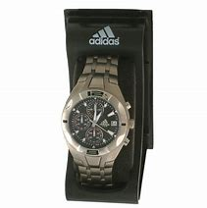
Fig.5 (Adidas,2020)
Fig.5 show an example of corporate branding, within the brand provide a different variety of products.

- PRICE: Adidas use different marketing mix strategies in pricing, the innovations and uninterrupted products improvement, leads the company to create high quality goods from quality raw materials and generate premium pricing strategies, also the company utilize a differential pricing to different market targets and Odd even pricing, a particular price strategy which allow consumers psychologically think on saving money on products.

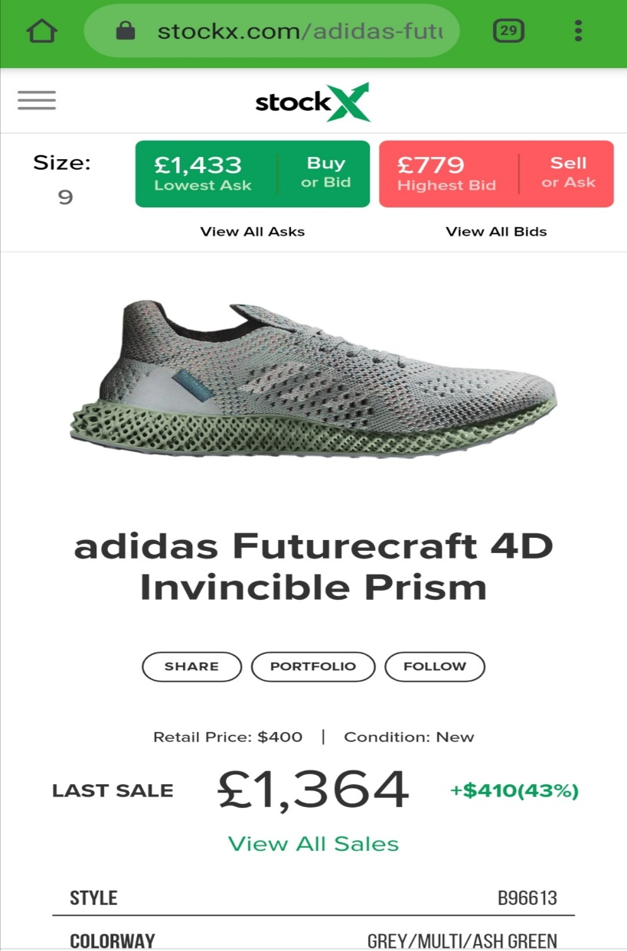
Fig.5 (Stockx,2020)
Fig.5 Illustrate an example of price skimming or premium prices, with superior quality products intended exclusively to a niche market.

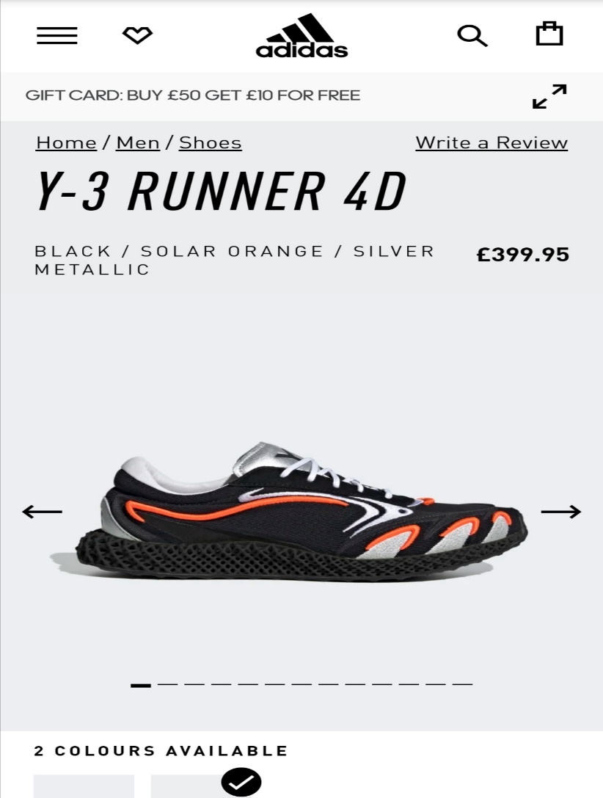
Fig.6(Adidas,2020)

Fig.6 highlight an extra two marketing pricing strategy: The price is lower than fig.5 and Adidas consumer psychologically could thing on make a huge saving of money ‘Odd Even pricing’ and the product is proposed to a different target market ‘middle-upper class’, with different price ‘Differential pricing’.

- PLACE: Adidas has made his products available internationally with direct channel marketing of distribution with his 1,333 own stores across the world and e-commerce stores. However the company provide his products to the target marketing also with indirect channel of distribution, relying on different retailers to mass merchandise his products.
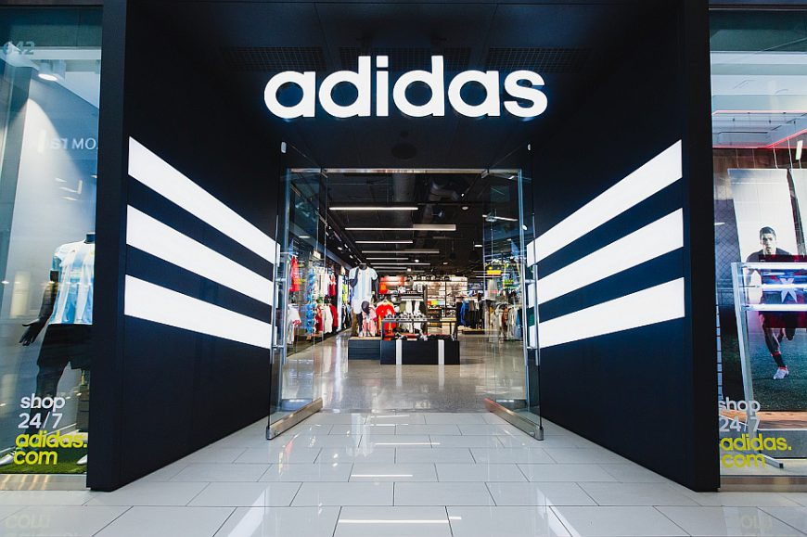
Fig.7(Adidas,2020)

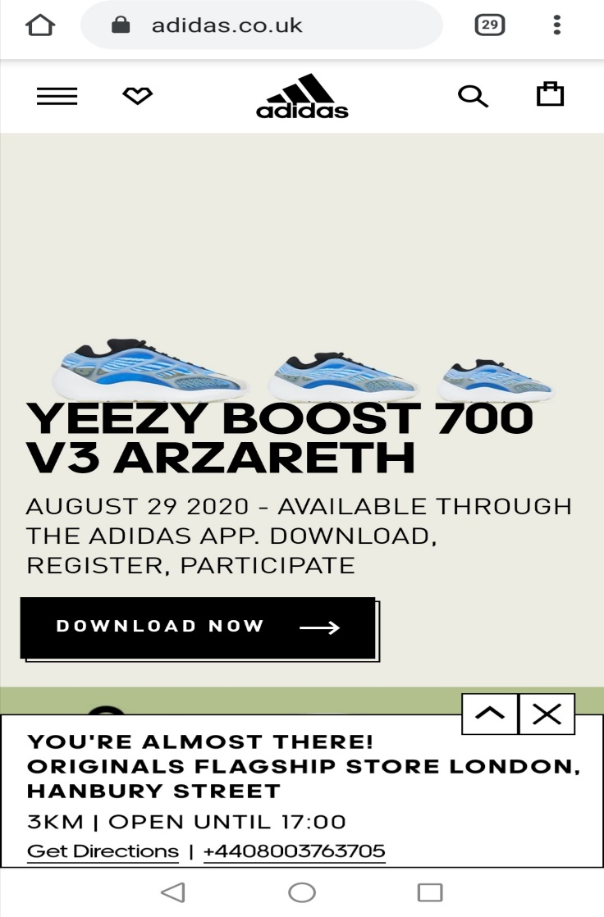Fig.8(Adidas,2020)
Fig.7-8 Show a typical adidas store and web-site, part of Adidas direct channel of distribution, which follow a selected distribution: the most recent products are available only in selected stores.

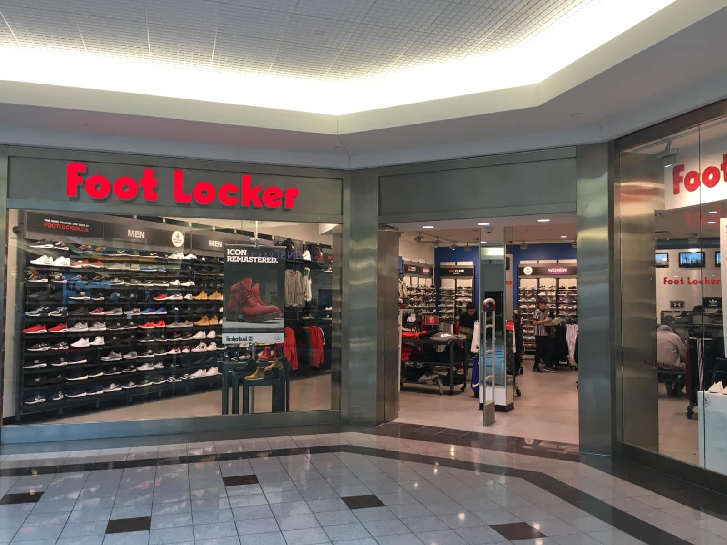
Fig.9(Bing,2020)

Fig.9 Exemplify brand’s indirect channel of distribution, Foot Locker with JD and Sportswear are the most renown Adidas retailer, which implements the German firm marketing strategies of intensive distribution.

- PROMOTION:
Adidas is fully engaged in the promotion and advertising his products, the company use a mix marketing strategy to cover all the brand promotional strategies from commercial campaigns in Tv, print, billboards and social media:
- Celebrity endorsement: The brand advertise his products through celebrities, remarkable is the commercial campaign with David Beckham, Haile Gebrselassie and Muhammad and Laila Ali in 2004 with the slogan ‘Impossible is nothing’.(Adidas-group,2020)

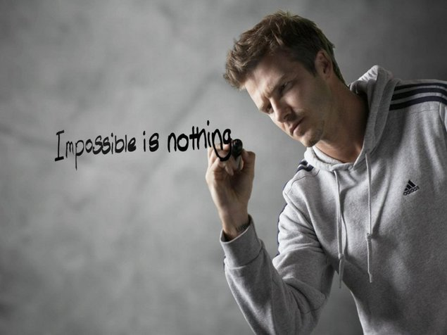
Fig.10 (Adidas,2020)

- Advertising: Adidas in addition to the traditional channels such as Tv, Prints and Social Media, uses through collaborations with Sony and other virtual creators, video game virtual platforms to better promote the brand and reach the target marketing. Fig.11(InstantGaming,2020) (Mbaskool,2020)

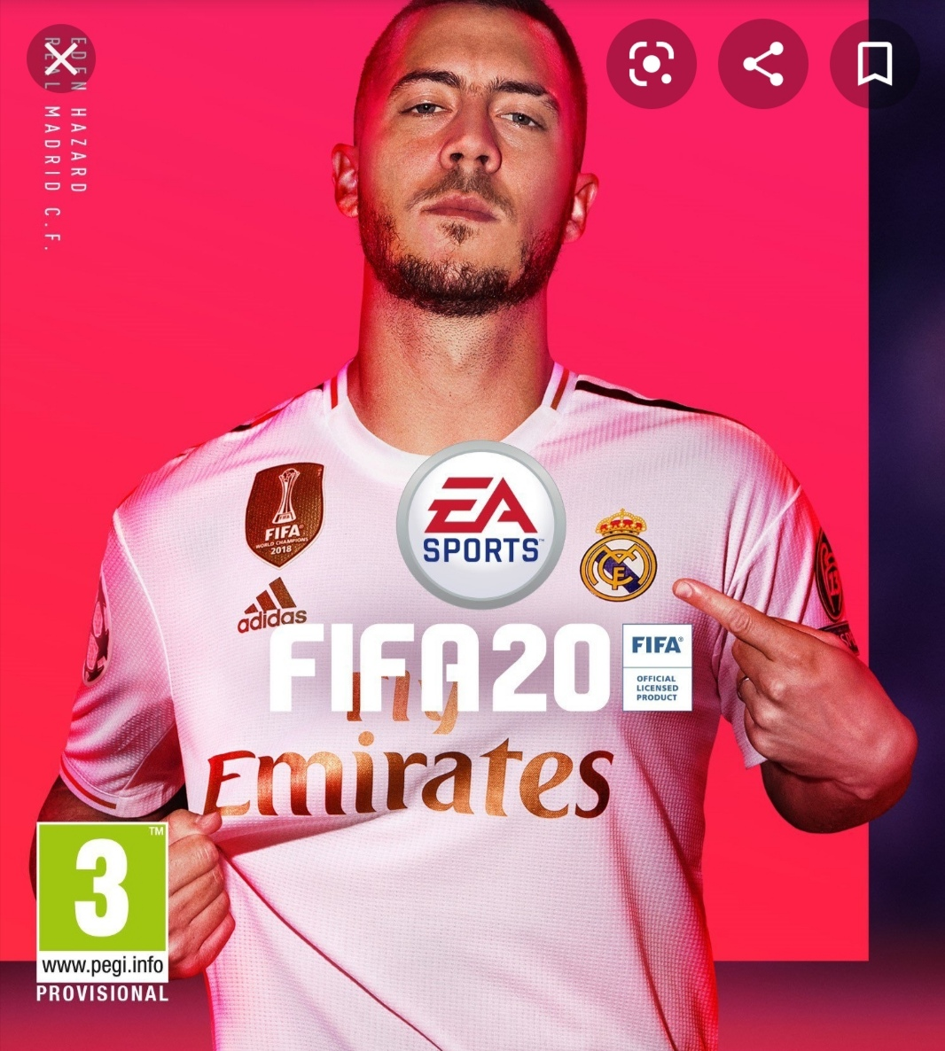
Fig.11 (InstaGaming,2020)

- IMPLEMENTATION:Is a process when the company execute startegic decisions in order to achieve strategic objectives. During this process the management has to ensure the efficient use of the workforce, marketing strategies and resources. (Wood,2008) (Cooper,2000)

- CONTROL: Is a set of methods that companies have to monitor in order to achieve strategic objectives. I.e ‘value market indicators, comparison, formulation of proposals to eliminate or change values, etc..’ . (Wood,2008)

CONCLUSION AND RECCOMENDATIONS

Adidas is a 71 years brand that during his history achieved many planned results in marketing strategies which increase the brand awareness and brand loyalty of his costumers, bringing the firm to lead the global sports industry. Despite the brand leadership, Nike its biggest competitor is considered the best in premium products manufacturing. As a recommendations to reduce gap with his main competitor, Adidas can turn his weaknesses in strengths by investing in research, shifting and fully automating its production power from developing to developed countries, allowing the German company to eliminate the strong trade power of third world governments; use Encirclement marketing strategy from the product life cycle, in order to incorporate healthy drink industry to increase diversification products offer and taking away a big fragment of market from Nike, in addition continue with global market expansion in developing nations.

REFERENCES

Adidas (2019) Financial Statements and Management Report of Adidas AG. Available at: URL https://report.adidas-group.com/2019/en/group-management-report-financial-review/business-performance/financial-statements-and-management-report-of-adidas-ag.html. (Accessed 12 August 2020)

Adidas (2020) Corporate Governance Overwiew. Available at: URL https://www.adidas-group.com/en/investors/corporate-governance/corporate-governance-overview/. (Accessed 12 August 2020)

Adidas (2020) Environmental Approach. Available at: URL https://www.adidas-group.com/en/sustainability/managing-sustainability/environmental-approach/. (Accessed 12 August 2020)
Adidas (2020) General Approach. Available at: URL https://www.adidas-group.com/en/sustainability/managing-sustainability/general-approach/#:~:text=adidas%20has%20also%20set%20targets%20for%202020%20and,million%20in%202018%20and%20one%20million%20in%202017.
(Accessed 13 August 2020)

Adidas (2020) History. Available at: URL https://www.adidas-group.com/en/group/history/ . (Accessed 12 August 2020)

Adidas(2020) Home. Available at: https://www.adidas-group.com/en/. (Accessed 12 August 2020)

American MarketingAssociation(2020)What is marketing? Available at: URL https://www.ama.org/the-definition-of-marketing-what-is-marketing/. (Accessed 14 August 2020)

Bhasin (2017) Marketing Strategy of Adidas. Available at: URL https://www.marketing91.com/marketing-strategy-of-adidas/. (Accessed 14 August 2020)

Bhasin(2019) Adidas Swot Analysis. Available at: URL https://www.marketing91.com/adidas-swot-analysis/. (Accessed 16 August 2020)

Bowyer(2017)Marketing Mix 7Ps Example. Available at: URL https://www.in-business.org.uk/marketing-mix-7ps-example-marketing-mix-7ps-pdf/. (Accessed 16 August 2020)

Christ (2017) What is the meaning in marketing strategy. Available at: URL https://bizfluent.com/info-7774221-ice-cream-marketing-strategy.html. (Accessed 16 August 2020)

Cooper, L.G(2000) ‘Strategic marketing planning for radically new products’. Journal of marketing, 64 (1) pp. 1-16

Entrepreneur Handbook (2019) What is Marketing. Available at: URL https://entrepreneurhandbook.co.uk/what-is-marketing/. (Accessed 16 August 2020)

Frue(2017) Pestle Analysis of Adidas. Available at: URL https://pestleanalysis.com/pestle-analysis-adidas/. (Accessed 16 August 2020)

Heartofcodes (2018) STP Analysis of Adidas. Available at: URL
http://heartofcodes.com/positioning-of-adidas/. (Accessed 16 August 2020)

IEDU (2017) 5 steps of Marketing process. Available at: URL https://www.iedunote.com/marketing-process. (Accessed 16 August 2020)

Instatgaming (2020) Adidas. Available at: URL https://www.instant-gaming.com/fr/4502-acheter-cle-origin-fifa-20/. (Accessed 16 August 2020)

Mbaskool (2020) Adidas Marketing Mix. Available at: URL https://www.mbaskool.com/marketing-mix/products/17006-adidas.html. (Accessed 16 August 2020)

McCoy (2017) How to write a basic marketing plan. Available at: URL https://bizfluent.com/13368637/how-to-write-a-basic-marketing-plan. (Accessed 16 August 2020)

O’Connel (2020) Number of retail stores of the adidas Group worldwide 2008-2019, by store type. Available at: URL https://www.statista.com/statistics/268442/number-of-retail-stores-of-the-adidas-group-worldwide-by-store-type/#:~:text=This%20timeline%20depicts%20the%20number%20of%20retail%20stores,family%20business%20in%20Herzogenaurach%2C%20Germany%20in%20the%201920s.
(Accessed 16 August 2020)

ScoreandChange (2019) Overview of the 2019/2020 Premier League sponsors. Available at: URL https://www.scoreandchange.com/overview-2019-2020-premier-league-sponsors/. (Accessed 26 August 2020)

Stockx (2020) Adidas Futurecraft 4D Invincible Prism. Available at: URL https://stockx.com/adidas-futurecraft-4d-invincible. (Accessed 26 August 2020)

Thomas (2014) Entrepreneurial lessons from Adi Dassler- The Founder of Adidas. Available at: URL https://www.gameplan-a.com/2014/10/entrepreneurial-lessons-from-the-founder-of-adidas/.
(Accessed 16 August 2020)
Weller (2017) The Definitive Guide to Strategic Marketing Planning. Available at: URL https://www.iedunote.com/marketing-process.
(Accessed 16 August 2020)

Wood, Pearson Prentice Hall (2008) The marketing plan handbook.

