

University of Wales Trinity Saint David

Certificate of Higher Education in Business Skills for the Workplace

Module name: DIGITAL SKILLS
Task 3
Module code: LCLM4002
Student name: Mihaela Grosu
Student id: 2321296

Submission date: 01/04/2024

Table of Contents
Task 3: Report 3
Introduction 3
Role of social media tools on recruitment of staff 3
Conclusion 6
References 7

Task 3: Report
“The role that social media tools such as LinkedIn and Facebook can have in the recruitment of staff”

Introduction
In this digital age, social media has provided recruiters with several opportunities through which they are able to spread information regarding any job openings. Social media has also enabled recruiters to have both passive as well as active candidates. Traditional recruitment methods cannot be found that much beneficial as organisations are not able to reach out to Idar number of candidates through the traditional method. On the other hand, there are several online job courses as well as advertisements that provide organisations to reach out to talents in every corner of the world. Most importantly job seekers can also get knowledge about job openings who are actively looking for information. This report is going to evaluate the role of different social media tools like Facebook and LinkedIn in recruiting staff.

Role of social media tools on recruitment of staff
Role of LinkedIn in recruiting staff
The world has become extremely digital and insert scenario a platform like LinkedIn has become highly impactful in the recruitment as well as staffing sector. This platform is capable of drastically affecting the recruitment sector as it exhibits a spectrum regarding professionals from different fields. Over the years this LinkedIn platform has revolutionised Different techniques that enable recruiters to allure, bring, and assess talents from different parts of the world. In this report, it has been investigated how LinkedIn has become so impactful in the recruitment sector. According to reports, “LinkedIn holds the title of being the largest professional networking platform worldwide” (Linkedin, 2024).
In a very short period of time, LinkedIn has built a very strong user base. It can be stated that they have almost 1 billion registered members from almost 200 countries as well as regions across the globe as of 2023. Before 2023 there were 900 million users on LinkedIn platforms. As per the analysis, it has been understood that 60% of the users of LinkedIn are from the age group of “25 to 34”, along with that, “42.8% of LinkedIn users are women, with 57.2% being men” (Linkedin, 2024). LinkedIn is a platform where organisations and job seekers both are present, to the people who are looking for jobs suitable as per their skills and academic knowledge. With that job seekers can identify workplaces that are aligned with their skills and knowledge. This platform is beneficial for both Recruiters and job seekers. The revenue LinkedIn has been able to generate from job advertisements is 6.79 billion according to the calculation of 2024 and this platform generated only 5.13 billion in 2022 there is a massive growth in the revenue of linkedin in the last few years (Davis et al. 2020).
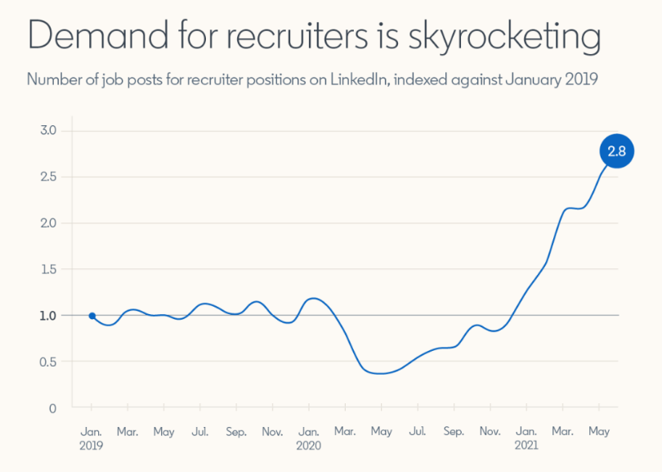
Figure 1: The demand for recruiters increasing in LinkedIn
(Source: Linkedin, 2021)
It has been identified that LinkedIn is used by at least 75 million organisations and most of them used this platform to recruit people. Not only that but also the organisation that is available on this platform because they see this as a media centre for publishing information regarding job roles. It is not that LinkedIn only has information about Jaws but also this platform has so many influencers you can motivate job seekers and also help them in finding out their suitable job roles. As per reports, LinkedIn has almost 18 million influencers and they also have 65 million decision makers present, 10 million of C-level executives can also be identified. In order to understand the geographical distribution of this social media platform it has been identified that “the U.S. (211 million), the countries with the highest number of LinkedIn users are India (117 million), Brazil (70 million), and China (50 million)” (Zhao, 2021). Reply one has made it easier for both recruiters and job seekers to get to each other.
Role of Facebook in recruiting staff
Facebook is another effective recruiting tool, using this tool recruiter have potential job candidates over the years. Recruiters can easily use Facebook for Sourcing, attracting converting as well as hiring new employees in an organisation. Analysing the characteristics of Facebook recruiting it has been understood that it is mainly of the form included in social recruiting and it has become one of the vital parts of recruitment marketing as well. Facebook recruiting has become so important because there are so many new trends going on in the HR industry (Schneider and Harknett, 2022). It can be stated that the way HR people used to recruit employees has totally changed. Nowadays one of the biggest trends that can be seen within recruitment in the recruitment industry is the use of different social networks in order to get connected Which talents. Not only that but also recruiters are attracting as well as converting talent by using Facebook. There are several benefits of using social recruiting and for the benefits, Facebook has become a popular social recruitment platform.
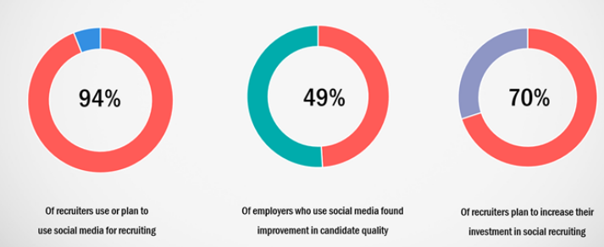
Figure 2: Importance of posting jobs on social media
(Source: Talentlyft, 2023)
From the above pie chart, it has been understood that it has become extremely important for recruiters to use different social media platforms to advertise job openings. The figure also states that recruiters who use social media platforms have been able to find improvement in the quality of candidates. Social media has also provided recruiters to plan how they should increase investment for recruiting employees in an organisation. One of the major reasons for using social media platforms like Facebook for recruiting is the audience. A huge number of people actively use Facebook and reaching out to job seekers has become easier for recruiters in case they use the Facebook platform to advertise job openings.

Conclusion
In conclusion, it can be stated that social media platforms have a vital role to play in the recruitment sector. As the world has become extremely digitised from every perspective, in such situation recruiters can use the benefits digitalisation has provided them. Before social media platforms, recruiters used to provide job advertisements in newspapers or different magazines and articles. Nowadays, social media has provided recruiters with opportunities to provide information about job openings in an organisation on those platforms. The platforms have a huge audience and organisations can easily reach out to their potential employees from the platforms, in this way these platforms are playing their role in the recruitment sector.

References
Davis, J., Wolff, H.G., Forret, M.L. and Sullivan, S.E., (2020). Networking via LinkedIn: An examination of usage and career benefits. Journal of Vocational Behavior, 118, p.103396.
Linkedin, (2021). New Data Shows a Soaring Demand for Recruiters and Where You Can Find More of Them. Available at: https://www.linkedin.com/business/talent/talent-strategy/data-shows-soaring-demand-for-recruiters(Accessed 23 March, 2024)
Linkedin, (2024). The Impact of LinkedIn on the Recruitment and Staffing Industry. Available at: https://www.linkedin.com/pulse/impact-linkedin-recruitment-staffing-industry-ben-miranda-5eoac#:~:text=LinkedIn's%20pivotal%20role%20in%20talent,that%20staffing%20agencies%20can%20access. (Accessed 23 March, 2024)
Schneider, D. and Harknett, K., (2022). What’s to like? Facebook as a tool for survey data collection. Sociological Methods & Research, 51(1), pp.108-140.
Talentlyft, (2023). What is Facebook Recruiting? - TalentLyft. Available at: https://www.talentlyft.com/en/resources/what-is-facebook-recruiting#:~:text=Simply%20put%2C%20%E2%80%9CFacebook%20recruiting%E2%80%9D,vital%20part%20of%20recruitment%20marketing. (Accessed 23 March, 2024)
Zhao, X., (2021). Auditing the “Me Inc.”: Teaching personal branding on LinkedIn through an experiential learning method. Communication Teacher, 35(1), pp.37-42.

