DS 1 Template

My Screenshots/Photos
- Please add 4–6 screenshots or photos of your digital life.
- You can use your phone or laptop.
- For each screenshot, write one or two sentences explaining what it shows.

Screenshot/Photo 1
[Insert Photo/Screenshot below]
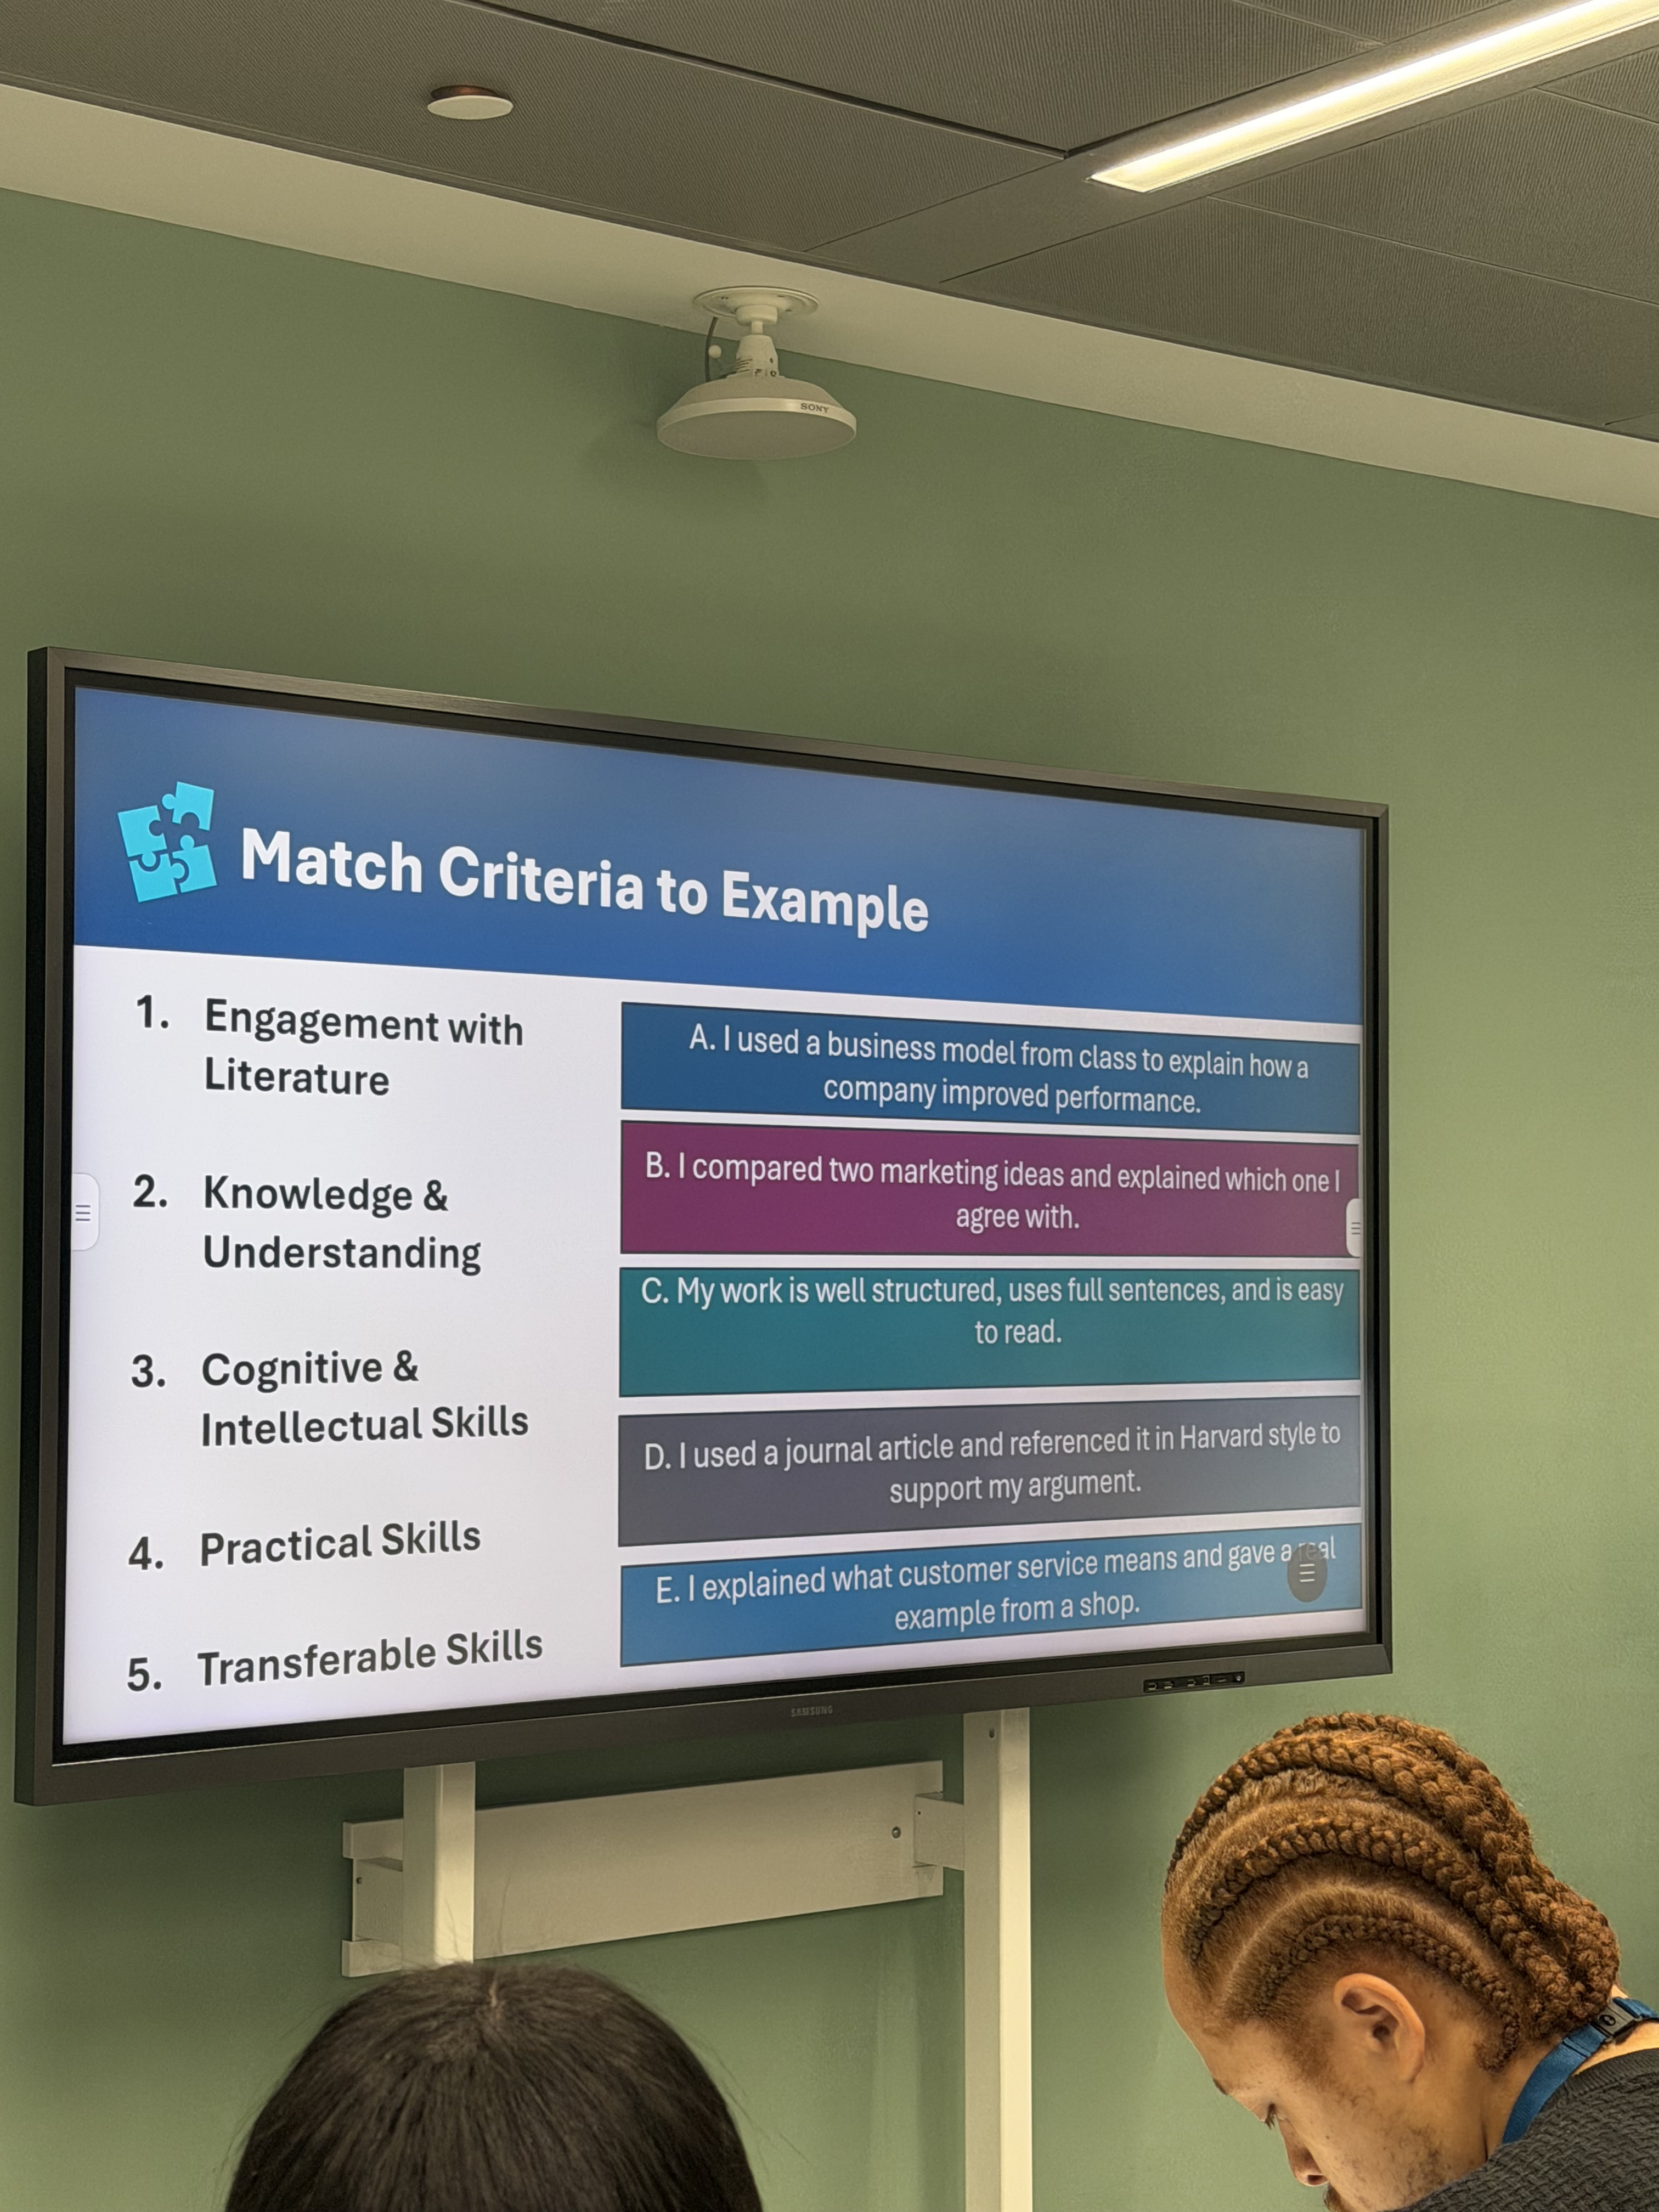 the way we use the screen in university to help us learn. makes learning a lot more visible to understand.

Screenshot/Photo 2
[Insert Photo/Screenshot below]

The laptop is our learning device at university easier for the lecturer to check on our work and progress. And submit our assignments.

Screenshot/Photo 3
[Insert Photo/Screenshot below]
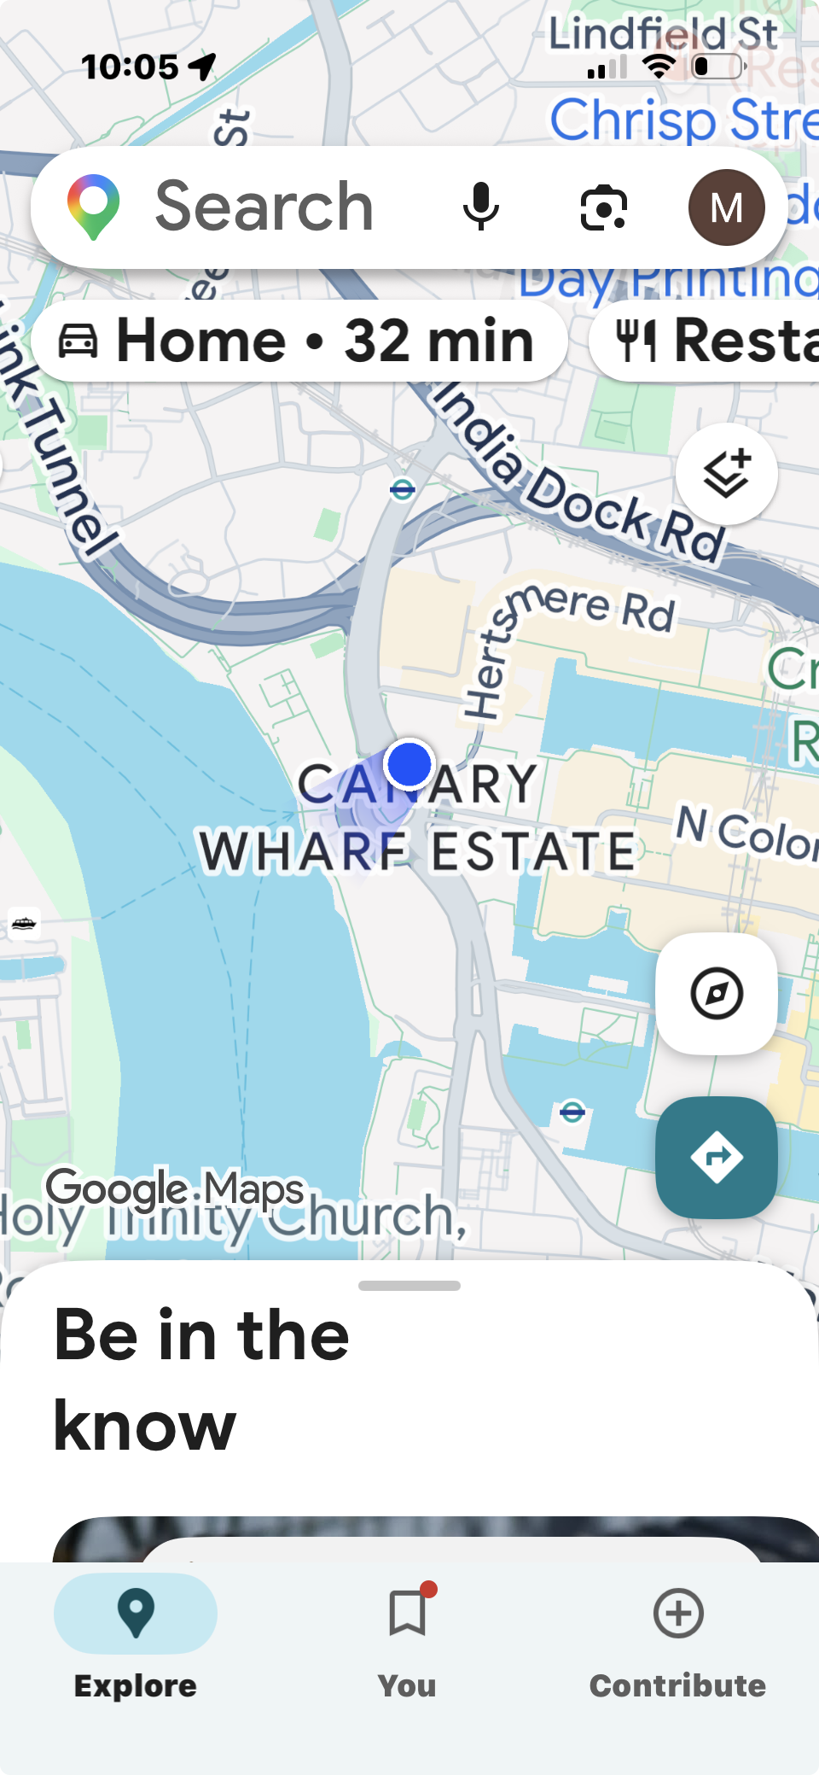
Googe maps is digital app to get around and navigate your way around and plan your journeys

Screenshot/Photo 4
[Insert Photo/Screenshot below]
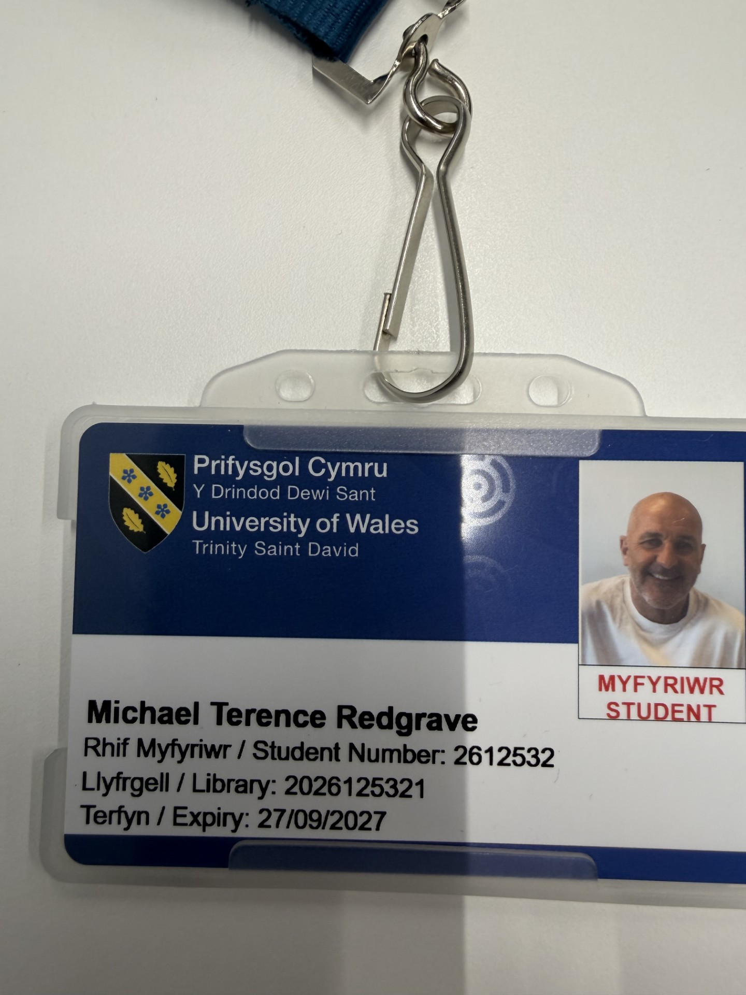
My student digital ID card gives me acsess to university classroom and lecturer hall.

Screenshot/Photo 5
[Insert Photo/Screenshot below]

[Write what this shows of your digital life]

Screenshot/Photo 6
[Insert Photo/Screenshot below]
[Write what this shows of your digital life]

My Short Reflection
- Write 5–8 simple sentences about your digital life.
- You can use the sentence starters below if helpful.
I use digital tools to help me organise my daily life.
I want to improve my digital skills something im very new to.
I feel out of my depth using computers and get anxious when I don’t understand.
My children are there to help me with homework but want paying ha ha
I know the more I use the laptop ill get more confident

Sentence starters
- I use digital tools to …
- I feel confident when I …
- I want to improve …
- I often use these tools: …
- I sometimes feel nervous about …
- I hope this module will help me …
- Digital skills are important for me because …
You can write more if you want.

Submission Checklist
Before you submit, please check:
​​​ ☐ I added 4–6 screenshots
☐ I wrote short sentences for each screenshot
☐ I wrote my short reflection
☐ My work is my own
☐ My file opens correctly
​​☐ My file opens correctly

