
EFFECTIVE TEAM WORK AND COMMUNICATION

Names: Mihaela Gliescu (2124585)

George Dehelea (2124303)

Jaime David Rojas Garcia (2125624)

Donatas Keliauskas (2120434)

Rudolf Balog (2119447)

Module: BMSW4002

Lecturer: Soban Sadiq

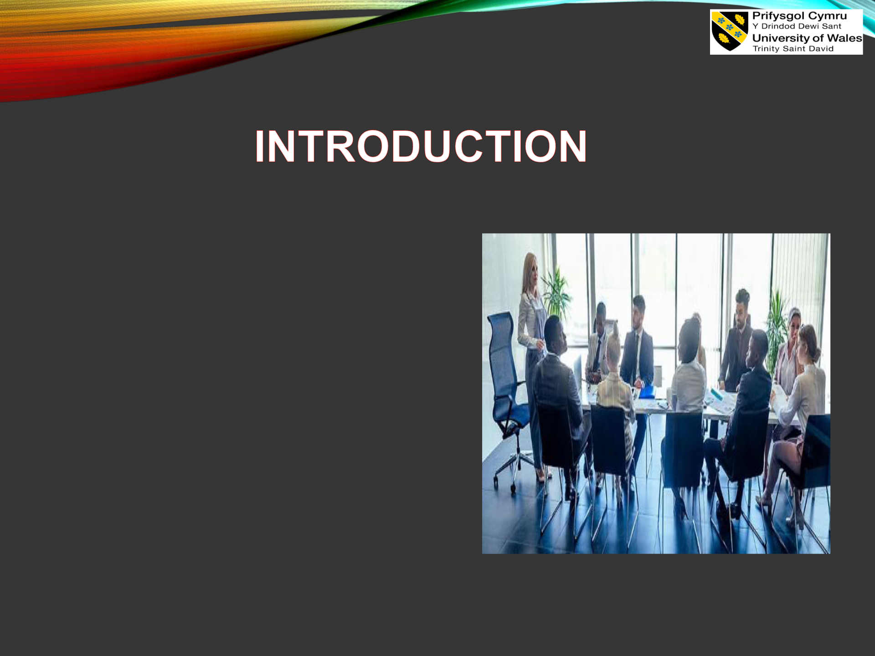
Mihaela Gliescu

- effectiveness of teamwork and

communication in the organisational context.

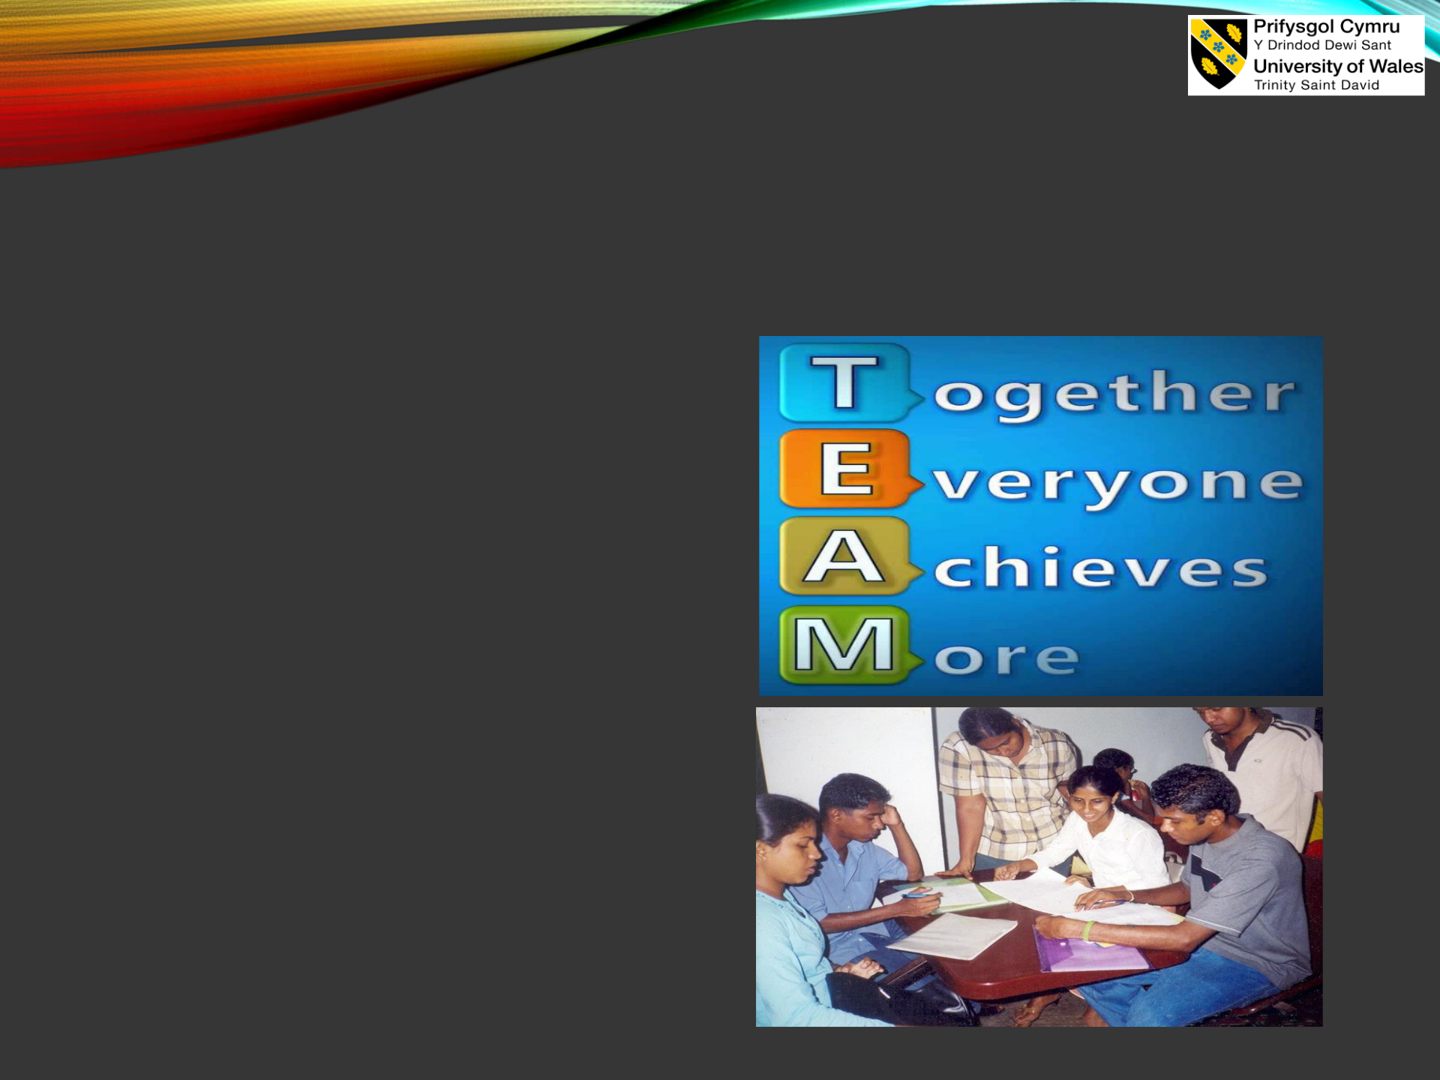
Mihaela Gliescu
DEFINITION OF TEAM IN

ORGANIZATION

- It has been investigated that the team inside an organisational culture is considered as the group of people who mainly perform the interdependent task regarding a specific project (Samuel, 2022).


Mihaela Gliescu

BENEFITS OF TEAM WORKING

- The key benefits of the team working are problem solving,

innovation,workplace

management, risk management and overall

organisational growth (Goodman, 2022).

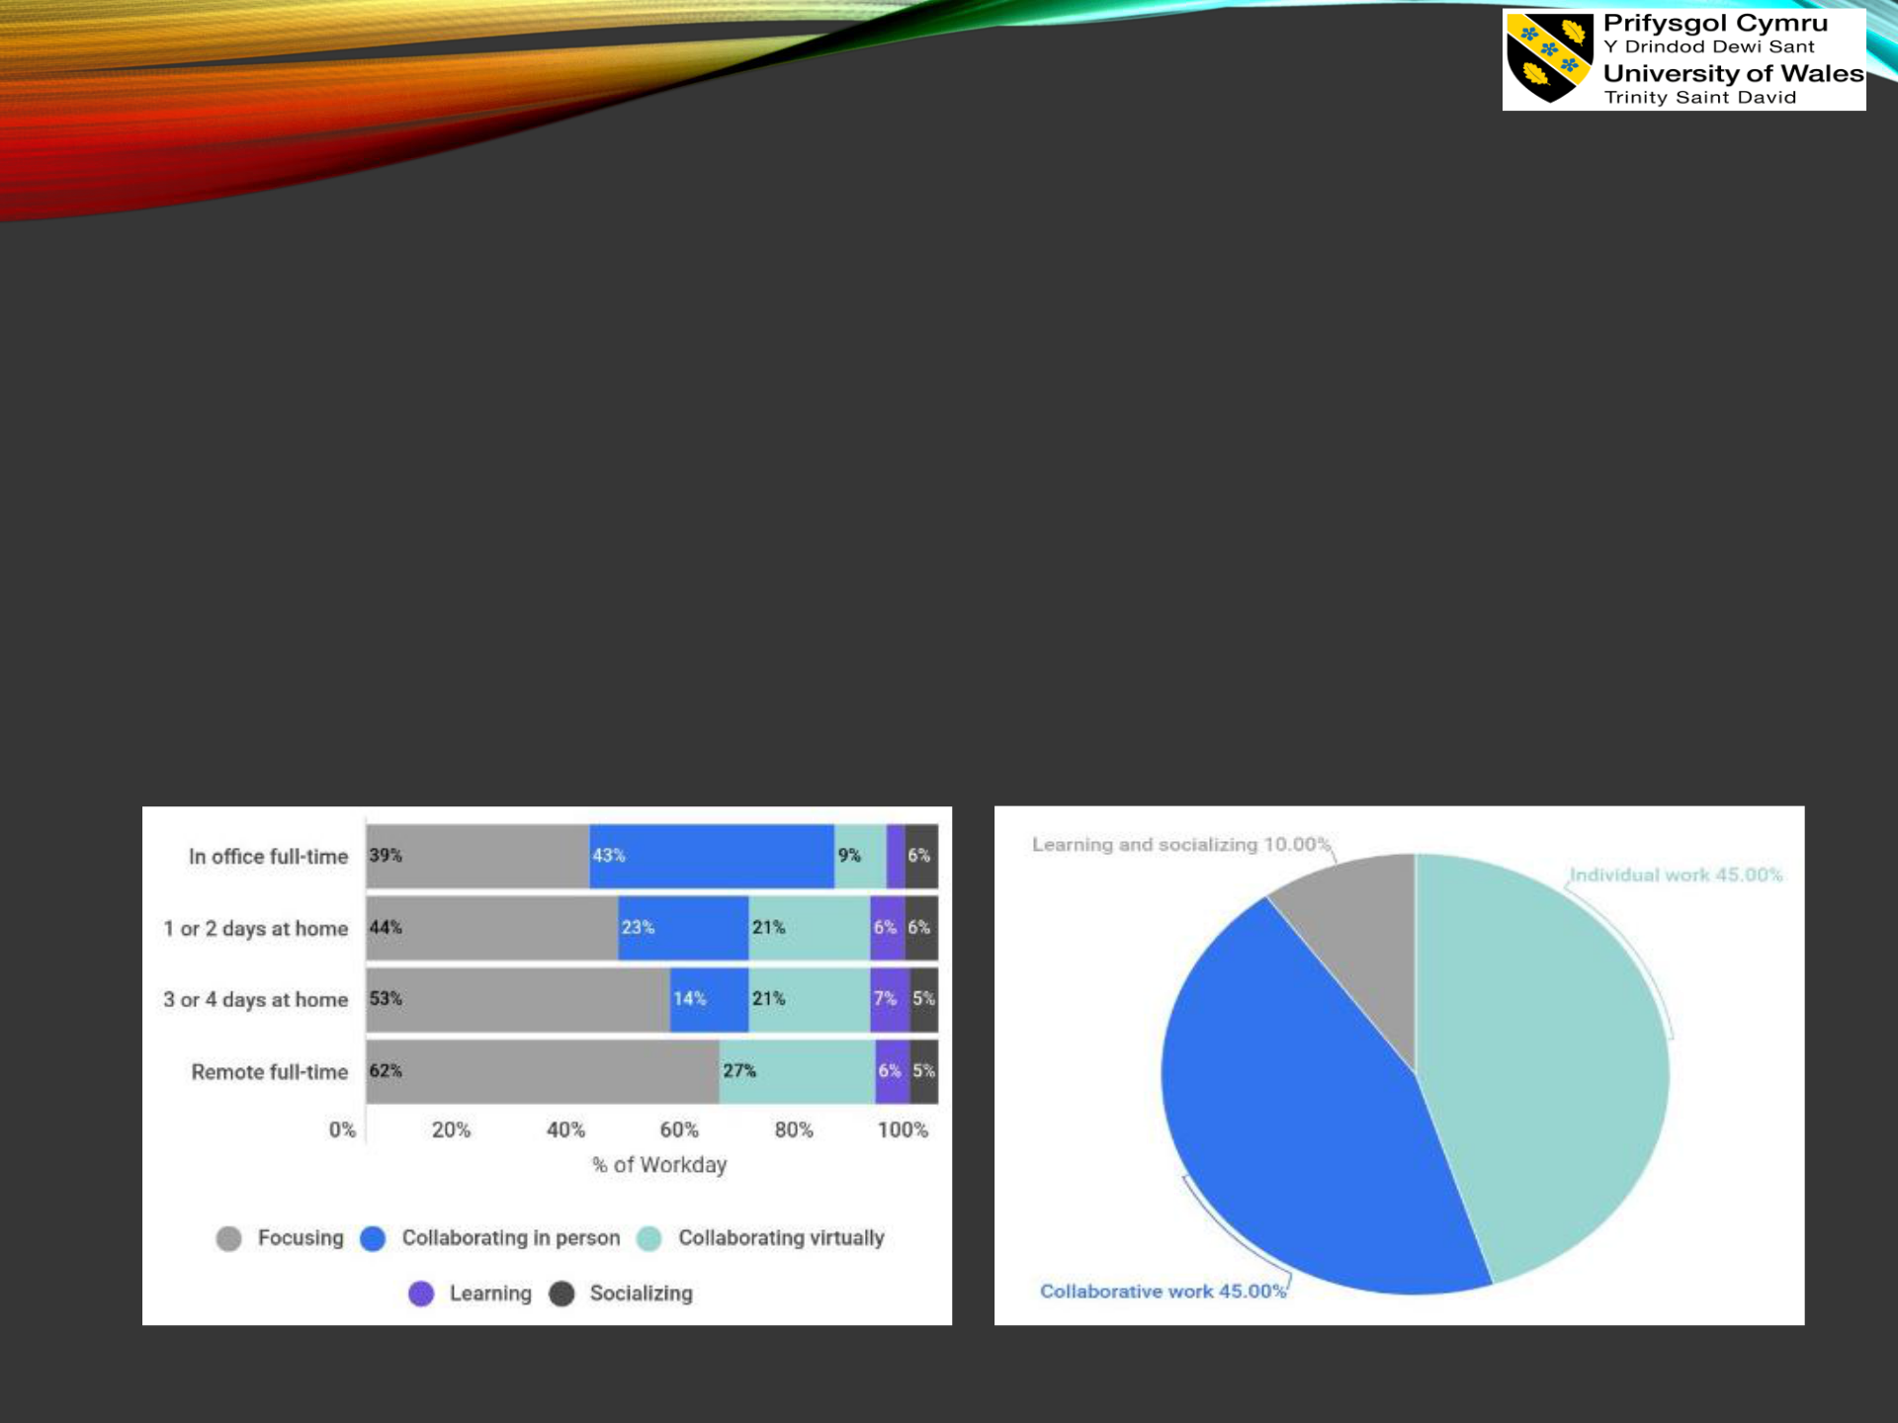
Mihaela Gliescu

BENEFITS OF TEAM WORKING

- Help to ensure high productivity of the company respectively (Peeters, Van De Voorde and Paauwe, 2022).

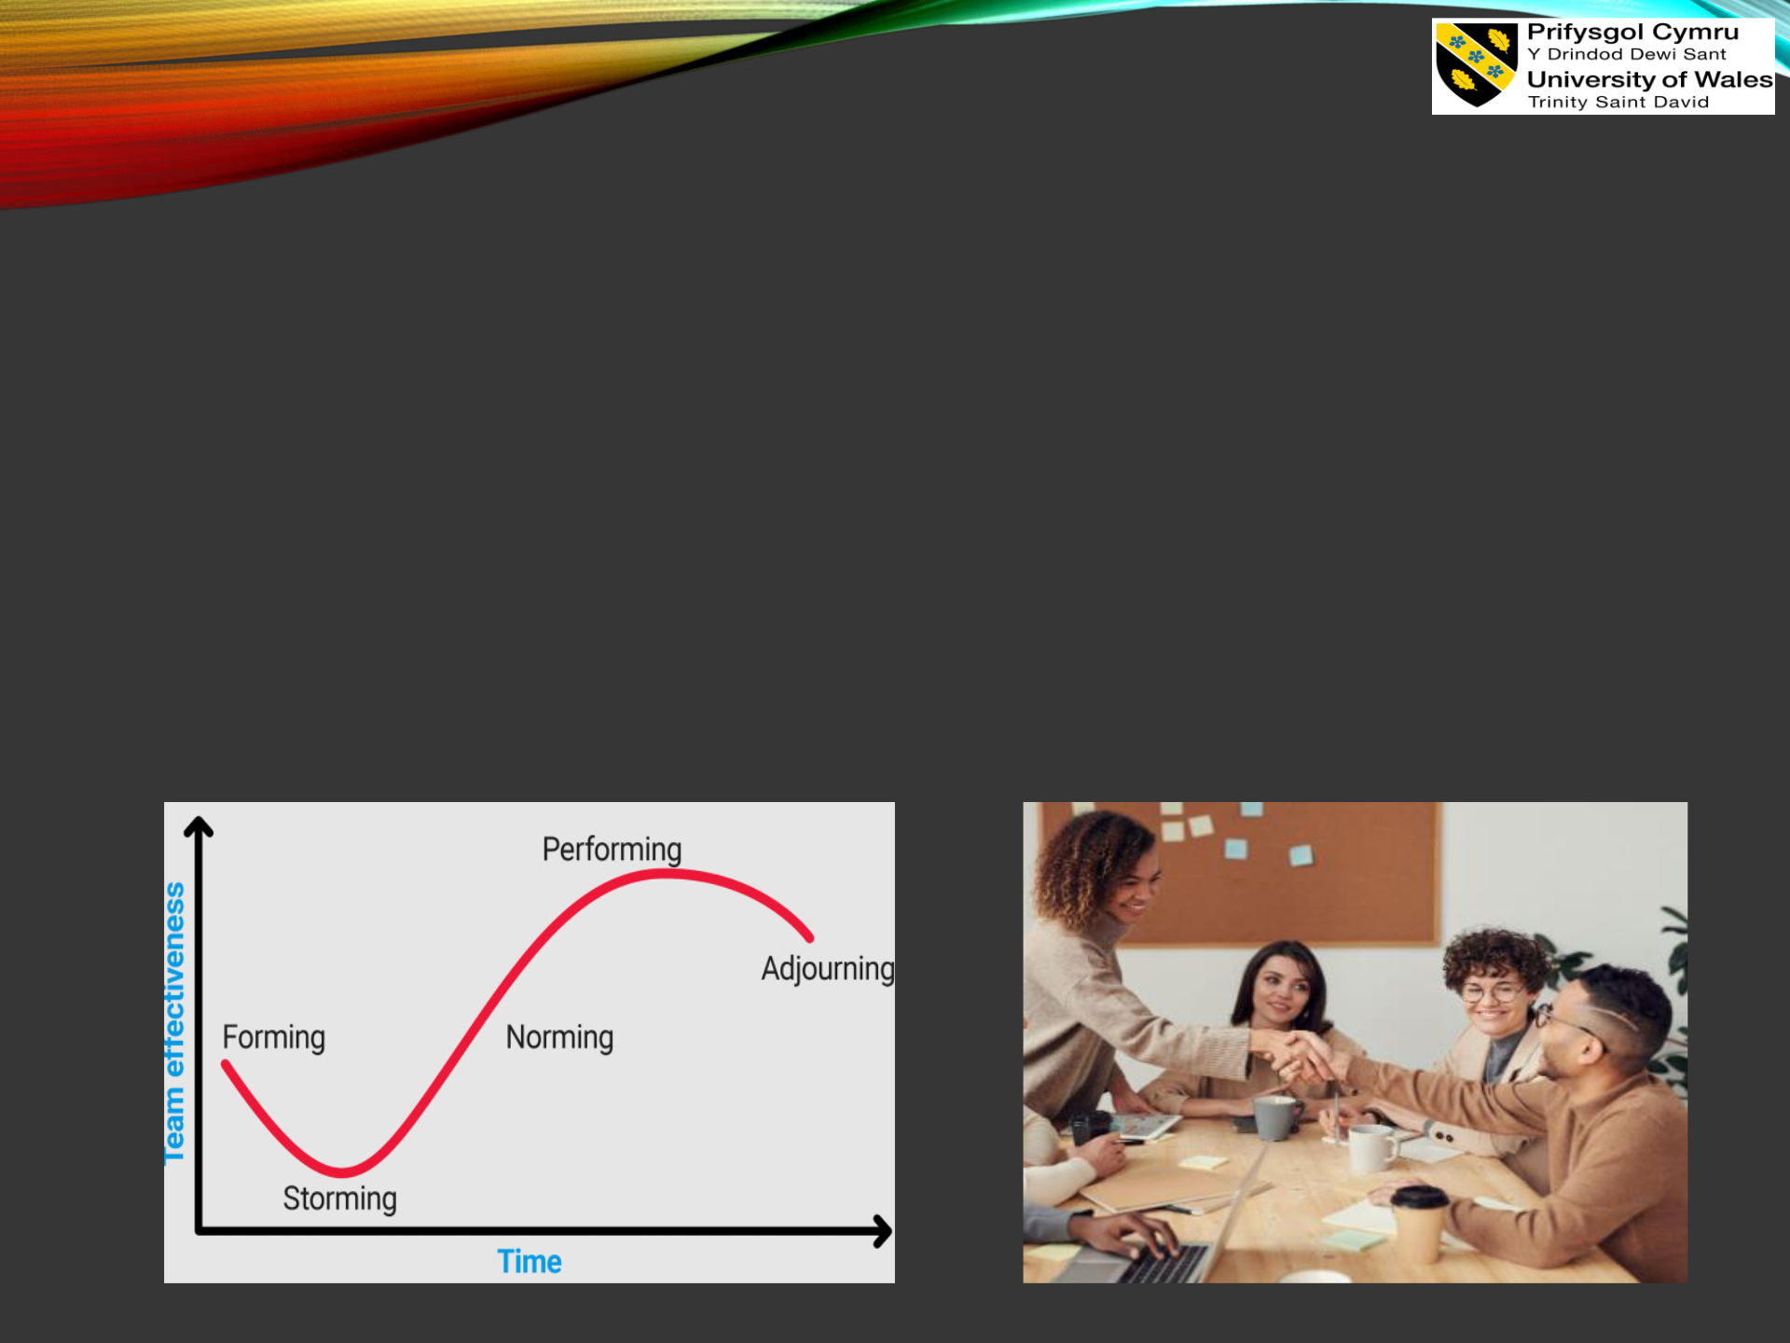
George Dehelea

STAGES OF TEAM DEVELOPMENT

- It has been identified that Tuckman's team development model would help to consider the systematic five stages of team development such as forming, storming, norming, performing and adjourning (Unger-Aviram, Katz-Navon and Vashdi, 2022).

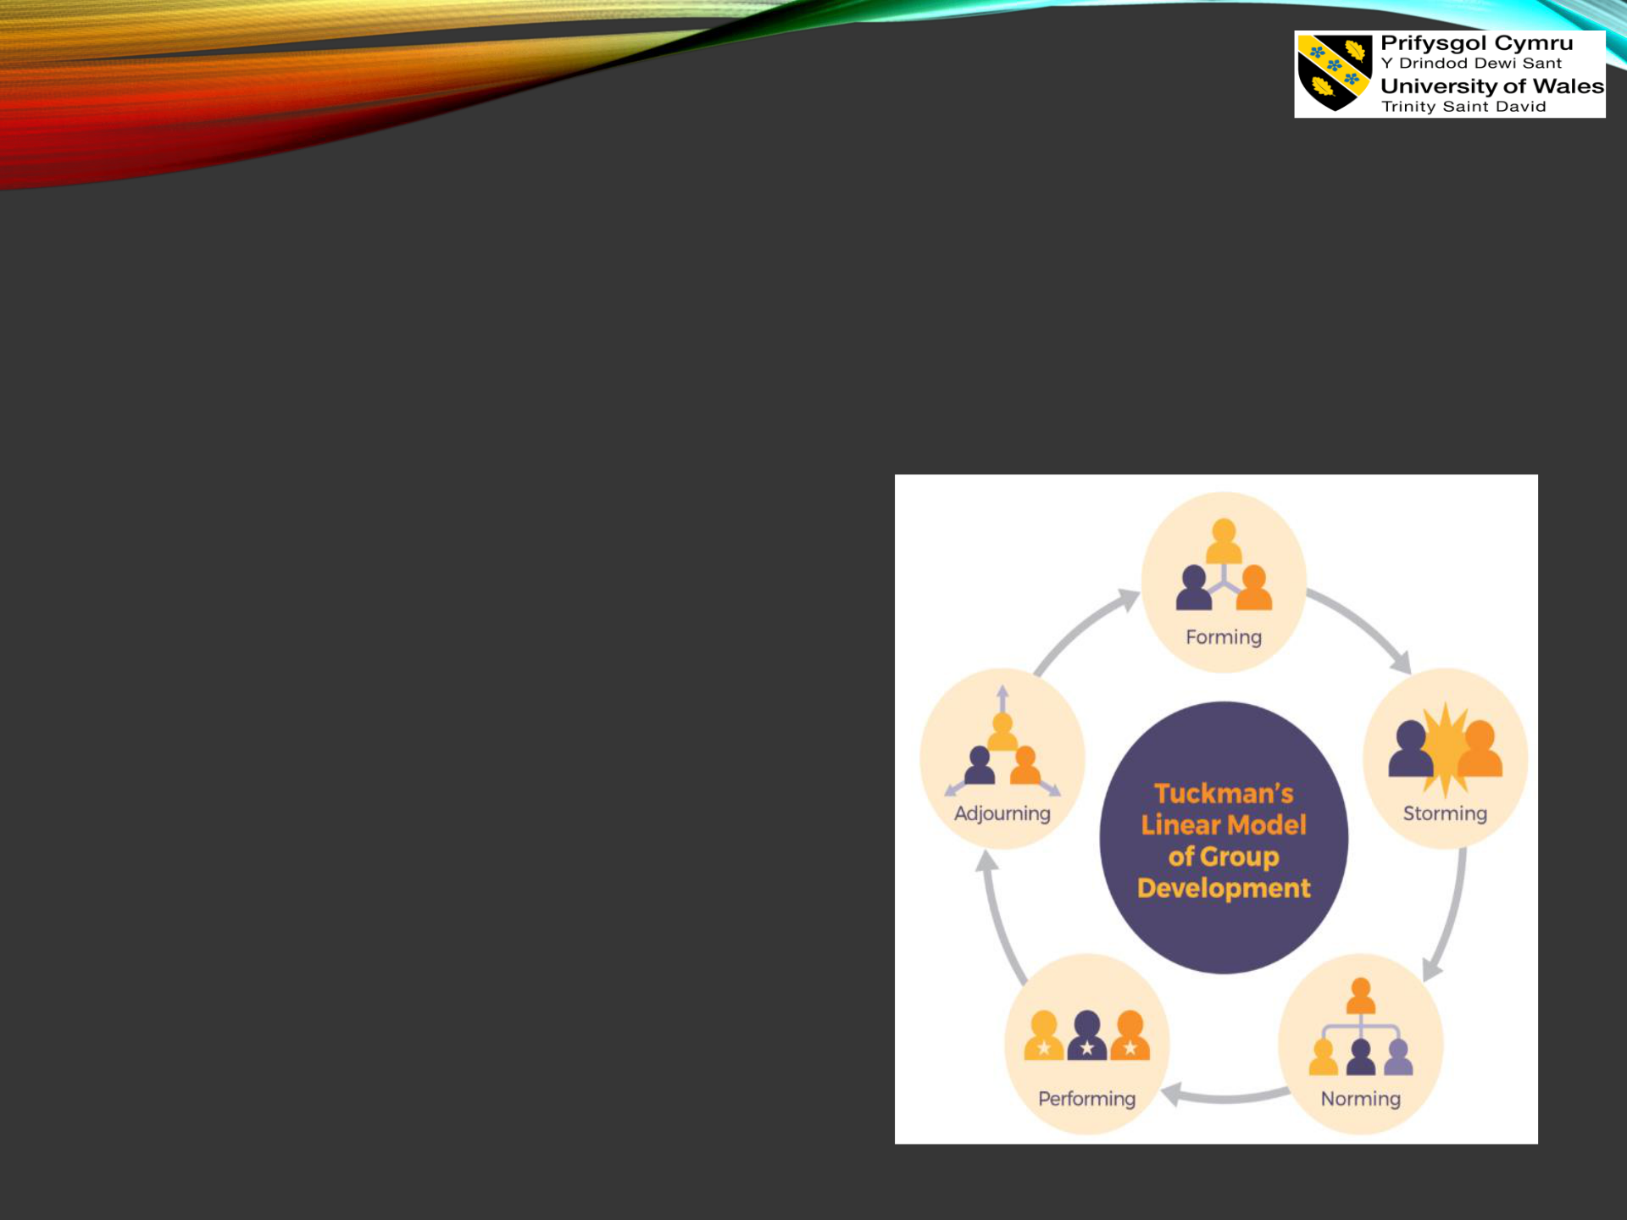
George Dehelea

STAGES OF TEAM DEVELOPMENT

- Performing: In the performing stage, the team would become potential and thereby make significant progress towards the key goal respectively.

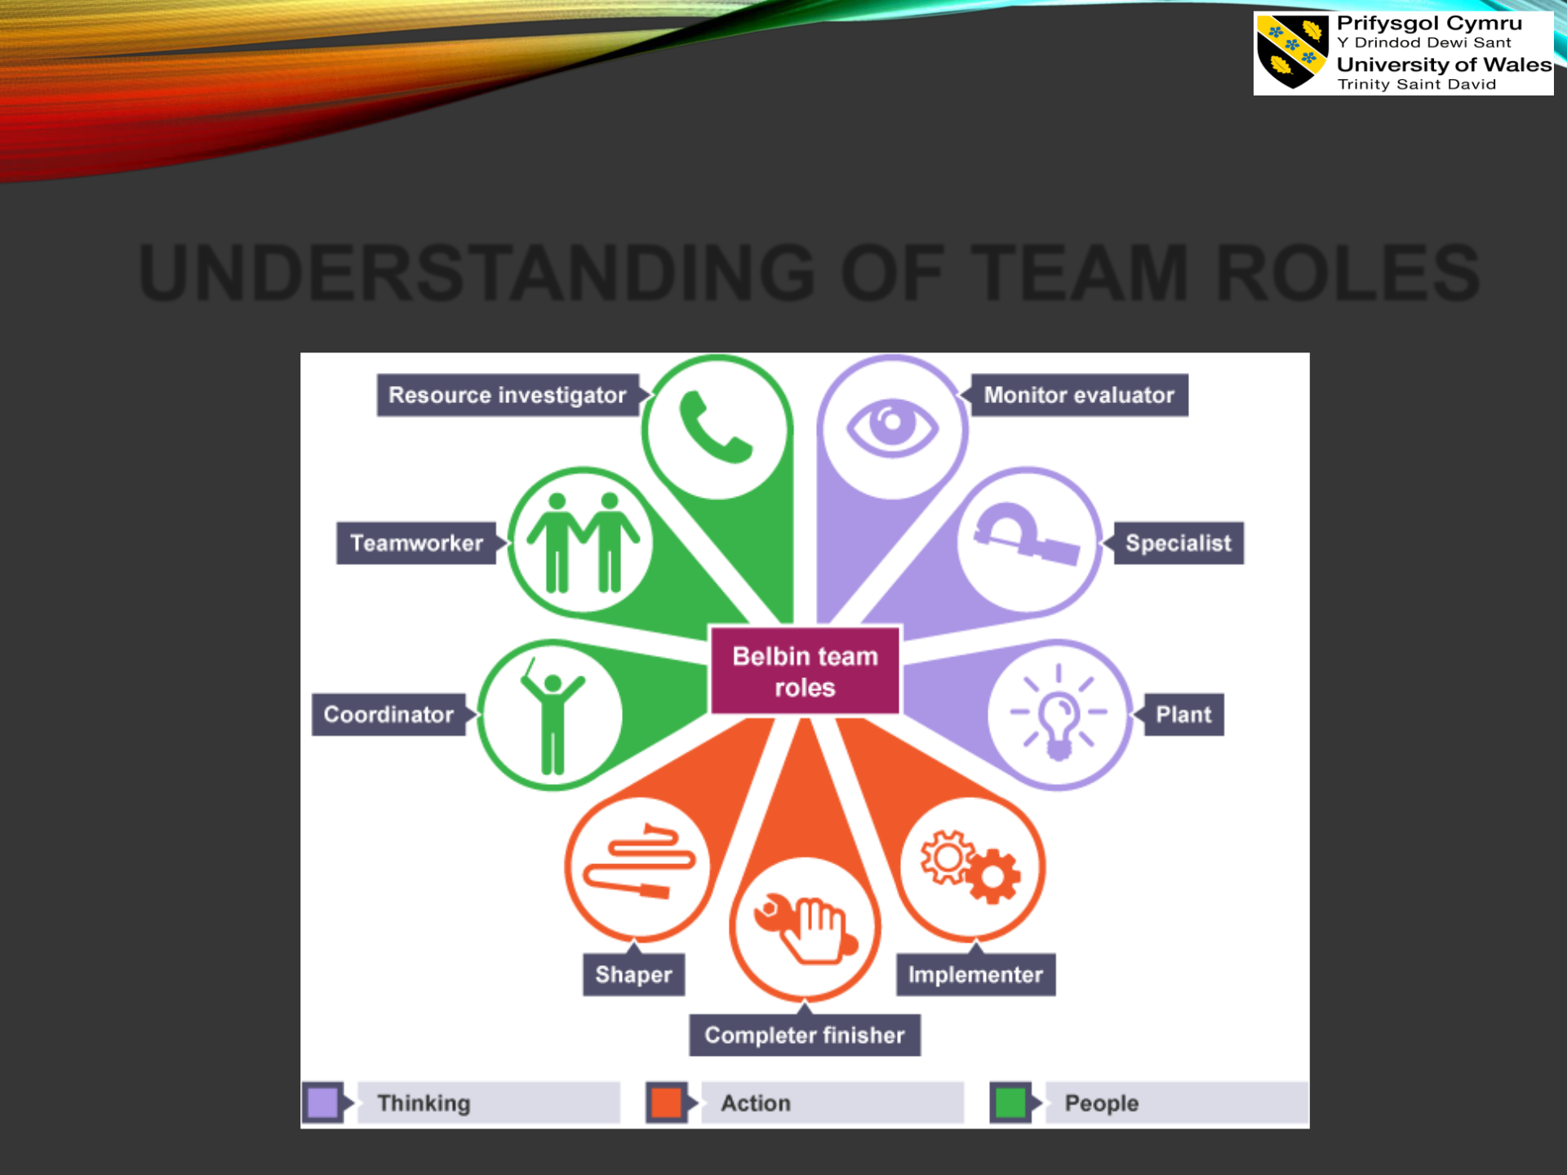
David Rojas Garcia

UNDERSTANDING OF TEAM ROLES

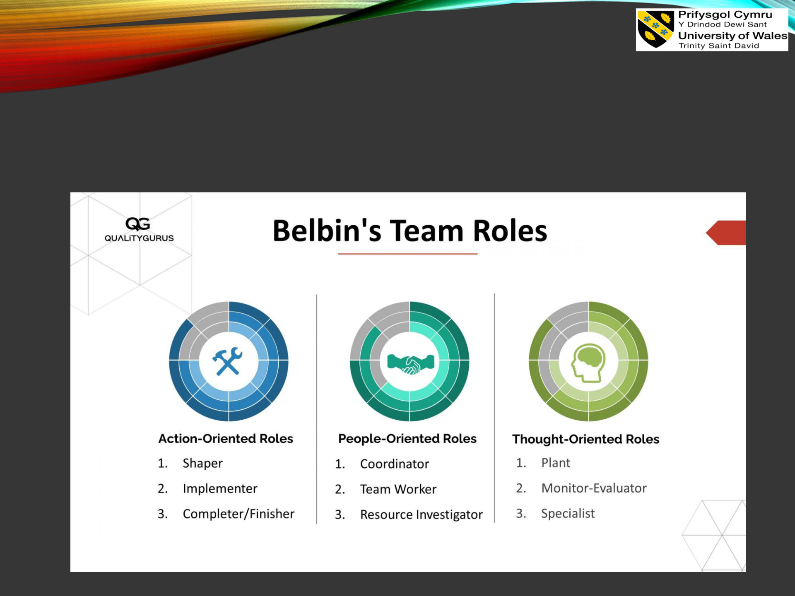
David Rojas Garcia

UNDERSTANDING OF TEAM
ROLES

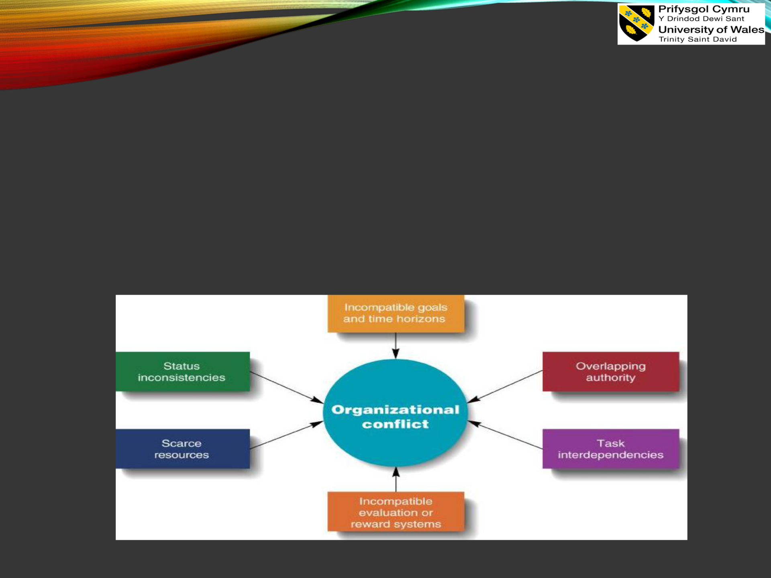
Donatas Keliauskas

ANALYSING THE WAY OF

MANAGING CONFLICT

- Further, it can be stated that without a productive conflict within the team culture, proper issues and difficulties could not isolate (SHRM, 2022).

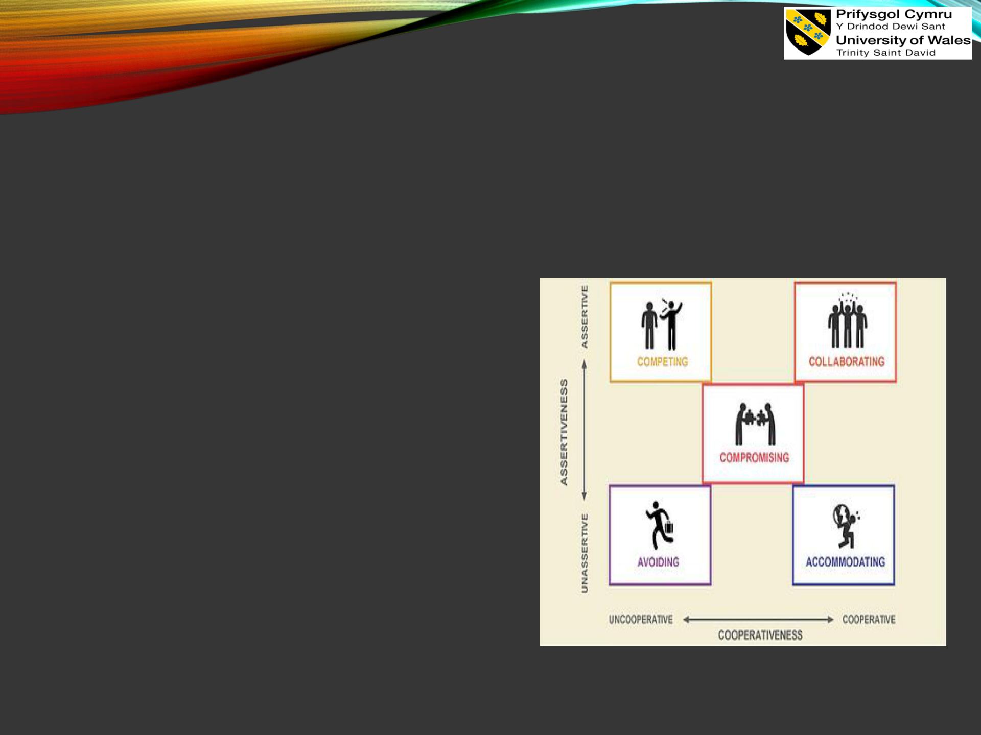
Donatas Keliauskas

ANALYSING THE WAY OF MANAGING
CONFLICT

- Considering the previous analysis, the model of conflict management could be discussed, which helps to manage

organisational would conflict effectively

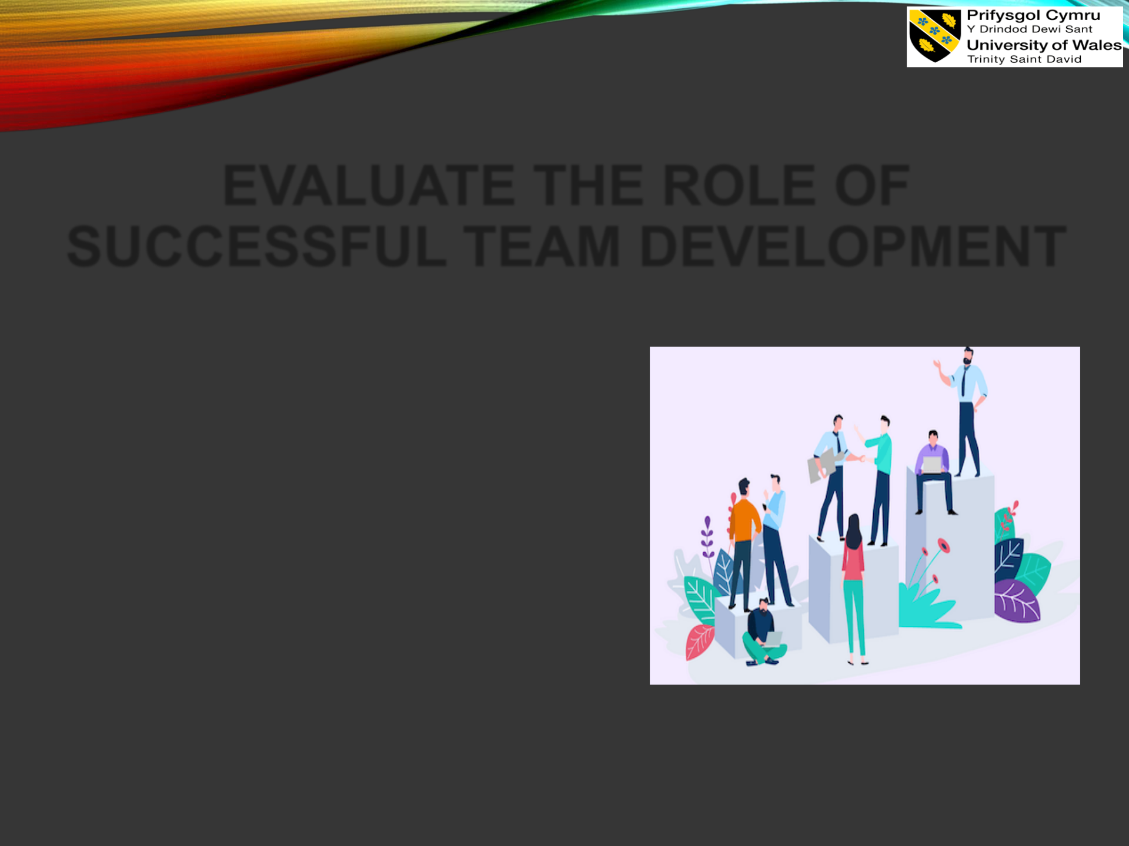
Rudolf Balog

EVALUATE THE ROLE OF
SUCCESSFUL TEAM DEVELOPMENT

• successful team development would help to maximise team
performance by increasing the

motivation and encouragement

among the employees (Llopis,

2022)

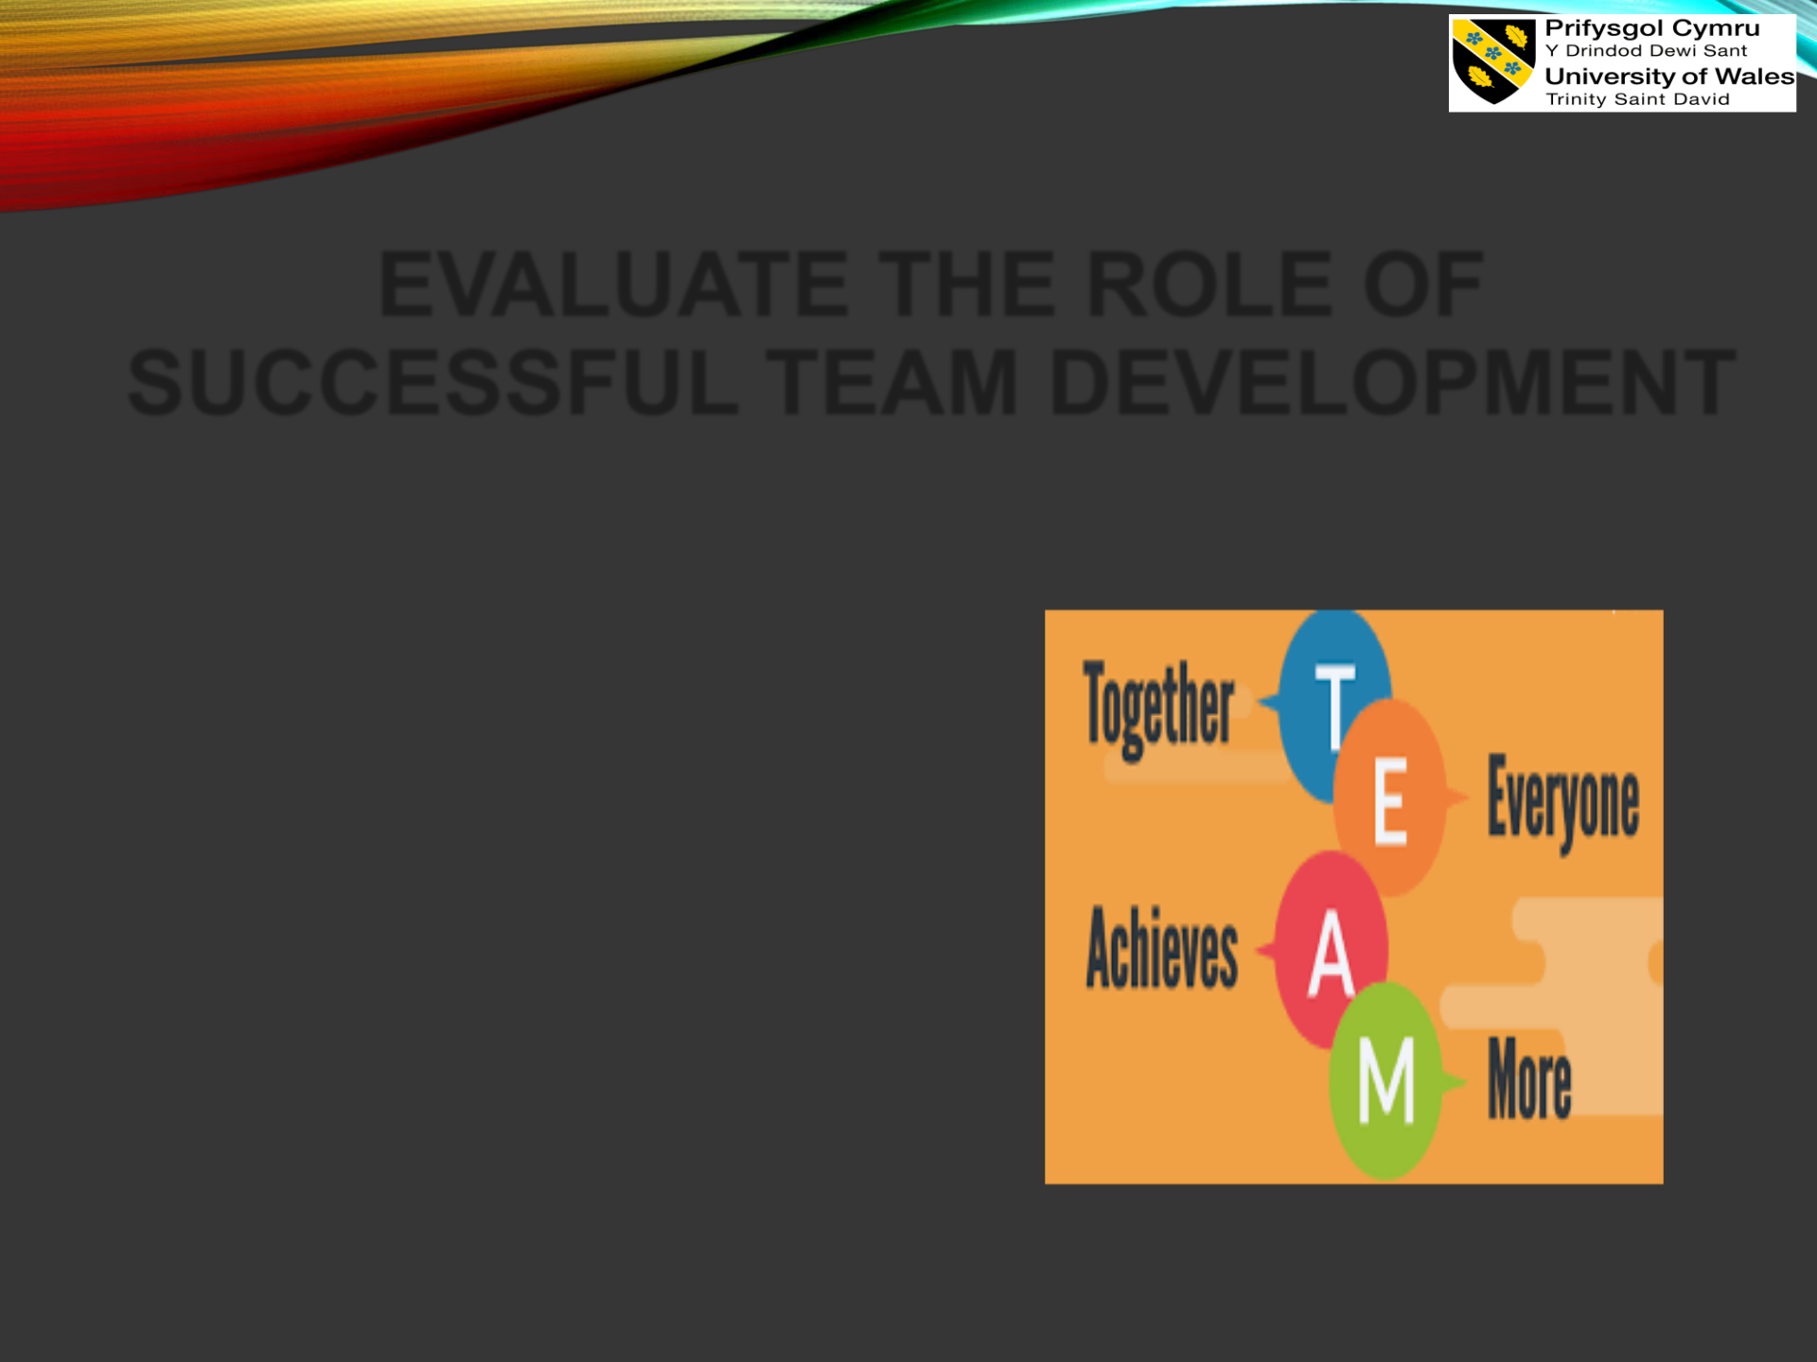
Rudolf Balog

EVALUATE THE ROLE OF SUCCESSFUL TEAM DEVELOPMENT

- It has been identified that a successful team help to develop potential skills and knowledge among the employees and thereby improves organisational productivity as well (Bryant, 2022).


Rudolf Balog

- The following presentation is based on effective teamwork and organisational communication and considering this, several important elements regarding teamwork in the organisation have been provided.

- Hence, at the end of the presentation, it can be stated that effective team development is necessary for organisational competitiveness and long-term growth respectively.


REFERENCES

- Amaresan, S. (2021) 5 Conflict Management Styles for Every Personality Type, Hubspot.com. Available at: https://hubspot.com/service/conflict-management-styles (Accessed: 12 August 2022).

- Arora, S. (2021) How to successfully manage organisational conflicts, The Economic Times. Available

at:https://economictimes.indiatimes.com/small-biz/hr-leadership/leadership/how-to-successfully-

manage-organisational-conflicts/articleshow/71660300.cms?from=mdr (Accessed: 12 August 2022).

- Belbin (2022) The Nine Belbin Team Roles, Belbin.com. Available at: https://www.belbin.com/about/belbin-team-roles (Accessed: 12 August 2022).

- Boskamp, E. (2022) 37 Workplace Collaboration Statistics [2022]: The Importance Of Teamwork –

Zippia, Zippia.com. Available at: https://www.zippia.com/advice/workplace-collaboration-statistics/#:~:text=About%2075%25%20of%20employees%20rate,top%20reason%20for%20workplace %20failures (Accessed: 11 August 2022).

- Bryant, A. (2022) How to Build a Successful Team, Nytimes.com. Available at: https://www.nytimes.com/guides/business/manage-a-successful-team (Accessed: 12 August 2022).

- Goodman, P. (2022) 15 Advantages of Teamwork in the Workplace, ToughNickel. Available at: https://toughnickel.com/business/15-Advantages-of-teamwork-in-the-workplace (Accessed: 11 August 2022)



