Business Environment
Electric Vehicles in Europe
Student Name: Maria Taleva
Student ID: 1812411
Tutor’s name: Rexton Nting
Module name: The Global Business Environment
Module N0: LCBB4005

Table of Contents
1 | Introduction | 3
2 | Part A | 3
3 | Part B | 7
4 | Conclusion | 10

Introduction:
Global business is currently growing through a process where the scenario of international market & its scenario are changes drastically. Business & all of its aspects are currently associated with the environment where they are belongs to. A century ago, people follows the method to run their business seems to be modified & changed now days are a lot. In order to set up an business organization, one need to have good knowledge regarding his goals, environment, competitors, market condition, position, strength & obviously weakness as well (Dale, 2015). Beside this, an experience related to the subject matter is must. Considering the global business environment now it can be said that the current scenario of this environments are too much competitive. Those who has enough information & sufficient number of good skilled man powers will be able to sustain in the market for a long time being (Heizer, 2016).
From the assignment brief, we’ve found that the discussions that are taking place here is all about global business environment & the analysis of an industrial environment as well. A well-known car making company named as ‘’Volvo’’ has taken several business strategy which is bringing a drastic change in world car manufacturing industry. Choosing the hybrid car or electrified vehicle system will reduce the dependency on natural resources & also can be helpful for the establishing the world pollution free together (Volvo, 2018).

Part A
In global business arena all the organization like Volvo wants compete with their best efforts. As decades changes, so the taste of the peoples choices are remain the same. Along with it, the main aspects that’s are directly associate with shaping the global business environments are political, economic, social, technological, environmental & legal factors. As global economy & business environments are influenced by these factors, so the organization must need to ensure that they have enough concentration on the components. In order to shaping the business, each of these components has distinguished roles to play. Some of them are as follows;
Political:
This factor is directly dealing with the politics of the day prevailing within the country where the manufacturer is established. From the history of business it has been always found that if the political condition is good enough then the business can grow in a fastest way , in reverse vice versa has taken the place. Political factors is a kind of factor which is directly associated with the existence of the organization. As business policies are always instructed by the government of a country so an organization must have to follow the norms. Behind this, political stability is always positive things for an organization as the economy is also depends on it as well(Ivanov et. Al. 2016).

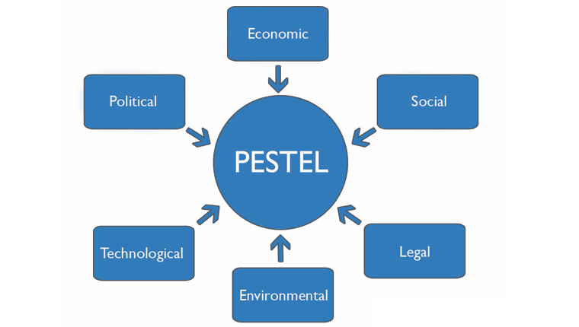
Economic:
The factors those are related with economic aspects generally indicates the factors including economic growth, exchange rates of money, reserve condition, interest rates, disposable rates & so on. Hence, it also indicates the organizations financial condition as well (Disabandara. 2017). In the case of Volvo, they have discovered that the increasing cost of fuel prices affects their industry a lot. People are currently looking for more efficient system in this regards (McNeil, 2015). The more the cash flow & budgeting are taking into consider & placing in a good manner, the more the profit will be earned. Investment on a good project can lead the organization towards the long term success as well.
Social factors:
In business point of view, social factors are playing a huge role so far .Though this dimension generally refers to the environment which represents the characteristics of demographic norms & values. Its generally consisted of population growth rate, age distribution of a certain society, income of the people, career attitudes & buying power of the general by which the organization can overcome their distinguish barriers along with select the target market as well. In car manufacturing business, one must have the clear concept regarding it. The social components & environments may vary country to country so doing the business in global basis it is very important to work on this factor more (Hanninen et al, 2017).
Technological Factors:
From the beginning of 21st century, the evolution of modern science in takes a huge position all over the world, especially in the business sector. Now a days, nobody can think a single moment without the technology. It is believed that the organization which adopts the technology in a more effective way they can use it in efficient way as well. Technology refers to a scientifical evolution where peoples can reduce their all over lead time & can do their job in more faster way. In an industry like car manufacturing, more than 80% of task has been dependent on the technology. Here, technology is a thing that may effects on the operation on the industry & production together & can drive the market both favorably & unfavorably (Stevenson & Sum, 2015).
Environmental factors:
In current years, the issues regarding environmental facts come to the forefront due to the global warming. Once people doesn’t have enough knowledge regarding environment, even the business industries has very little knowledge about the environmental effects. Beside this, the rapid growth of industries & factories has polluted the environment in very crucial way. Though people understand it lately but the good news is they understand it. Now a days , people have taking this issues into serious consideration. Due to scarcity of resources, low level of fossil fuels, decreasing number of natural gases is creating a huge trouble in industries production system .In the case of car manufacturing, it demands a lot of spaces & resources, as it takes a lot so they have liability on the society too. Currently, organizations are doing several social & environmental related works which is marked as ‘’Corporate Social Responsibility’’ (Pomering, 2017).
Legal factors:
Legal factors are directly connect with the law of a country. Some people may think that it overlaps with the political factor but there is a thin line between them, legal factors are more specific which indicates the ethics & laws in a row. Several articles & rules regarding discrimination law, health & safety law, consumer protection law, copyright & patent law are directly observed & regulate by this factors (Ahrens and Guetz, 2015).

Beside all of this, in order to shaping the major forces regarding the global business environment and gain an understanding of the changing global business environment we must have clear idea on several business model by which we can understand the reason behind going for electrified car in the case of Volvo. For the purpose of understanding the fact & evaluation of it, the author choose porter’s five forces model for better understanding in a more efficient way.
Porter’s five forces framework is a kind of model which helps an organization to measure their possibilities & competition within the industry both in national & international arena. Generally when an organization is planning to enter a new industry sector then this model can ensures the best outcomes. Generally it has 5 components, such as’ threats of new entrants /competitor, bargaining power of supplier, bargaining power of buyers, threats regarding substitute products & existing rivalry of the organization (Stevenson & Sum, 2015). In the case of Volvo, this forces has directly associated with their new strategy “Electric vehicles in Europe: gearing up for a new phase?” or going electrified car launching system.
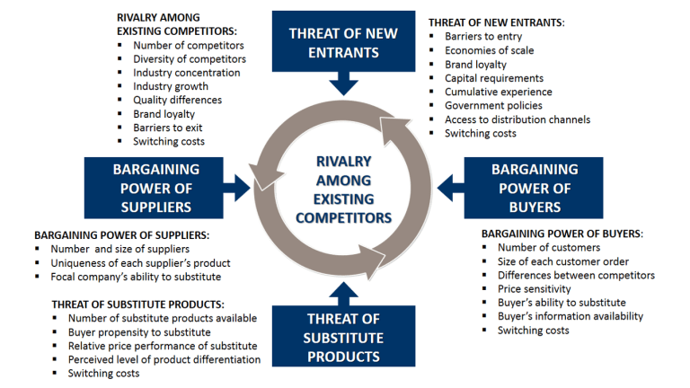
Threat of new entrants:
For an organization like Volvo, they must have to keep in mind that they many competitors which they knows about. But as they are moving forwards to a new system, a new entrants in the same business can be a potential threat. Though several factors are considered here, but system or barrier of entry in a new business are countable here. Hence, all must have to keep it mind that customer satisfaction is the last opportunity actually (Ahrens and Guetz, 2015).
Supplier’s bargaining power:
The bargaining power of supplier’s has the direct influence on the manufacturers business & profit policy. The less the number of suppliers, the more the power of them (Ahrens and Guetz, 2015). In a car manufacturing industry, several parts & machineries which is counted as raw materials can be imported from distinguish supplier. In this issues, before adopting a new strategy Volvo must have to ensure that their supplier won’t fall.
Bargaining power of buyer’s:
In a business, the most powerful components & part is the ’’Buyer’’ for whom all the strategies are taken. As customer has several options to choose the desired product so the organization have to ensure that they will able to capture their eyesight & satisfaction together. For this, implementing loyalty program, differentiating services &other promotional activities can be useful here.
Threat of substitute product:
Now a days consumer are always looking for the best product in a reasonable price. As the consumer has several options to choose so they can move anytime .The thing that they always look for the product quality & its price. Considering this, same product from other seller can be supplied to them. Here, if the substitute product is upgraded than the organization’s one then it will drive them to a profit issues (Devine and Shrives, 2017).
Rivalry among existing competitors
Rivalry occurs when number of potential competitor are increasing. Rivalry plays a huge role in an business environment where the organization’s are require to take more care of themselves. Though it seems to be competitive for the organization due to rivalry but it has several good features as well (David, 2011).
Porter’s five forces model has several limitations as well. In distinguished survey, it has been found that this model only assumes classic perfect market, In addition, this model is also assuming relatively static market structure as well. Several significant things like electronic linking of information system, strategic alliance are not taking into order in this model too
Though Volvo is one of the most renowned car manufacturing organization but from the last several years they found that increasing the price of fuel impact negatively in their business & the increasing number of environmental pollution free services has good possibilities of creating market, so they choose to change their strategy & for this they decided to create more electrified car. They knows that if they can adopt the change in real time then they will surely achieve more competitive advantages as well (Wilson, 2014).

Part B
From the last century the system of communication between countries to countries are drastically improved. There are several reason that help the automobile industries to grown up. Availability of raw materials, low labor cost, technological advantage, skilled manpower & low cost of fuel has the influence on this industry. Considering all of this, the reason behind engaging in international business was to expand sales volume, acquiring resources, minimization of risk & finally to earn the profit (Harryson & Sob erg, 2017).
Apart from this, it has to be said that the automobile industry is a huge industry where the amount of investment is very big in number & the structure of the market is full of perfect competition (Kurtulus and Toktay, 2011). As Volvo is now moving forward to adopt a new strategy they must have need a clear concept about their micro-economic & macro-economic foundation as well. The thing micro-economic foundation refers to the meaning of how Volvo or other organization or individual makes their decision, how they dominate the local market & how it creates the impact. In the sense of automobile industry, each steps or decisions create a huge impact on the overall process of the organization. Producing all the car in electrified category will also create several competitor in near future who also do the same. On other side, macro-economic foundation of automobile industry shows how the organizations are acting towards the global business environment collectively (Hanninen et al, 2017).
Though it has been found that there are several types of market structure exist like monopolistic, perfect competition, oligopoly & monopoly. In monopolistic market structure there are a huge number of manufacturer are present where they produce differentiated product where they are compete only by pricing, on other contrary, Perfect competition is the kind of structure whether the number of buyers & seller is huge & the competition is healthy (Heizer, 2016). On the other hand, monopoly refers to a single seller & oligopoly is consisted of few seller with homogeneous products. Along with it, the structure of the market has both positive & negative impacts on the organization. When an organization do their business as monopolistic system then they have to generate several products in different pricing whether they must have a huge plan. Reversely, perfect competition of marketing structure let the organization to do the business in healthy competition (Ivanov et. Al. 2016). As the automobile industry is a huge one, so there are several opportunities for the business executives & entrepreneurs too. In near future, it can be said that most of the car manufacturing company will move towards the electric car production for saving the environment. In this case investment on environmental friendly technology, more powerful battery making, renewable energy sources will be effective in long run. As car manufacturing business needs huge investments so the entrepreneurs must have several chances to associate with this industry. Investment on the sector could be a good choice for the future purpose as the world is now going towards the green economy (Hanninen et al, 2017).
In current situation, the major features of the current economy or international business policy supports the adoption of future changes. As people are now looking for more advanced technology with pollution free system, more utilities with less spends so the manufacturer also needs to keep this thing in mind. From the very beginning of car manufacturing history, there were several industry were also linked with it (Stevenson & Sum, 2015). . Among them, natural oil & gas the mostly significant. But, now a days people are trying avoiding this elements as this natural resources are not enough in number. On the other side, it takes too much cost for both parties as well, so, considering these significant facts most of the manufacturer must have to take decisions like Volvo.

Conclusion:
In Europe, we have seen peoples are rising their voice for the environment. Due to public demand not only the car manufacturing company but also all types of industries are changing their business policy considering the global economy (Ahrens and Guetz, 2015). In this era, electric vehicle is one of the signature changes by which the people can shows their utmost supports towards the environment. converting the public demands into the business policy will surely help the organization to run in long term manner.

Reference list:
Mollenkopf, D.A., Frankel, R. and Russo, I., 2011. Creating value through returns management: Exploring the marketing–operations interface. Journal of Operations Management, 29(5), pp.391-403.
Burke, R., 2013. Project management: planning and control techniques. New Jersey, USA.
Burke, R., 2013. Project management: planning and control techniques. New Jersey, USA.
David, F.R., 2011. Strategic management: Concepts and cases. Pearson/Prentice Hall.
Global economy 2017, "Economic condition of Australia," AHw, accessed August 22, 2019, http://www.ahiw.gov.au/globaleconomy-aus/
Dale, B., 2015. Total quality management. John Wiley & Sons, Ltd.
Goleman, D., 2017. Leadership That Gets Results (Harvard Business Review Classics). Harvard Business Press.
Gummesson, E., 2015. 14. From relationship marketing to many-to-many marketing. Handbook on Research in Relationship Marketing, p.301.

