Portfolio: Brad Roberts

Prior Learning Assessment and Recognition
Sarah Loxdale - BMP7105

BRADLEY M. ROBERTS
3114 Navajo Lane ∙ Provo, UT 84604
(801) 376-4820 ∙ brad.m.roberts@gmail.com

EDUCATION
Philadelphia University
Master of Science, Global Fashion Enterprise May 2015
Bachelor of Science, Economics Philadelphia, PA
- Emphasis on traditional weaving methods and design
I chose to attend a university for my master’s program that had more hands-on learning. At the time learning this way felt important after graduating from university without tangible skills. I continue to feel strongly that handwork is worth preserving and has transformational potential for those who engage. While I have used my weaving skills very little to date, I find it a powerful tool for connecting with others and constantly informative. I am eager to preserve and revive the craft with future endeavors supported by doctoral research.
- Relevant Coursework: Prototyping, Supply Chain, Global Marketing and Sourcing, Product Evaluation
All the course work for the GFE master’s degree focused on production down to the finest detail. I appreciated learning to understand construction methods in textiles along with supply chain dynamics, standardization, testing of product etc. Learning at Philadelphia University was less theory and more application. As an aspiring educator and an appreciator of pedagogy I appreciated the mentorship and ownership of a small school and found it complimentary to my rigorous large university undergraduate degree. The classes I became most passionate about were in fact creative and hands-on: prototyping and weaving.

Brigham Young University Apr 2011
Bachelor of Science, Economics Provo, UT
- Double Minor in Management and Strategy
I started my undergraduate degree as a pre-med student. I still think the sort of hands-on skills that save lives as extremely meaningful. I quickly saw, however, that I had other opportunities to pursue in business because of family connections. I recognized that I wanted more flexibility having started a family young and felt encouraged about the brevity and rigor of the economic degree at Brigham Young University (BYU) along with an appreciation for high level strategy and the corresponding minor. As part of the strategy program, I found opportunities to connect with people and to see first-hand the existence lived by young bankers and consultants. Long hours away from home and late nights also didn’t fit the lifestyle I was looking for. At this point entrepreneurship started to appeal deeply.
- Relevant Coursework: Strategy Core, Financial Management, Price Theory, Managerial Accounting, Managerial Economics, Growth and Developmental Economics, Econometrics (STATA), Excel
The skills gained as an undergraduate were far less artistic but provide a framework for critical analysis and numerical application of ideas. The skills in use today that are an outgrowth of this time would be critical thinking, communication and presentation, strategy, review and analysis of financial documents, word processing and excel. I use these skills daily but am rarely energized by the analytics and have therefore sought to transition my skillset to more interactive and manual creativity.

EXPERIENCE
Heirloom Art Co Feb 2013 – Present
Founding Partner / Brand Development Provo, UT
- Lead a talented and highly creative team in the development of proprietary product, content and events
Taking the lead role in brand development for several entrepreneurial retail endeavors has honed more of the relational and creative skills that come naturally to me. At this point I took more of a creative direction role blended with founder/president responsibilities. I learned the value of nurturing, inspiring and trusting a team. Together we built a meaningful brand that also allowed for lots of experimentation. Hosting events, creating content, and designing spaces is the backbone of the research I hope to pursue within experience design.
- Develop collaborative relationships with vendors, artisans, brands, and educators to enhance experience.
Learning to source and create collaboratively is one of my most valuable on the job skill sets. Developing relationships rather than transactions has been the key motivator to look beyond my own businesses and see a need to educate and share experiences more broadly.
- Maintain and enhance brand identity and vision across all promotional channels.
Understanding the core objectives or job to be done has helped hone the effort and streamline the narrative any one brand presents. This is an evolutionary process where the brand becomes the guide, and the customer becomes the hero allowing the customer to influence the brand as well as be influenced. This harmonious relationship is what sustains the endeavor.

One Enterprises, LLC (Private Equity) Jun 2012 – Present
Partner Provo, UT
- Collaborate with Partners and Executives to deliberate current and future investments and strategy.
For over a decade I have participated in investment presentations from nearly every industry with diverse leadership and style. Watching others present has instilled a humanity to the work of investment and contributed to a refinement of vision for the near constant idea flow forming within me allowing for quick dismissal and effective development of ideas.
- Determine analytic processes to systemize portfolio data and maximize management skill.
Working with a family office has a unique dynamic. Blending family and corporate culture can be problematic. In a family that avoids contention at all costs, while trying to make costly investments has led to some stagnation and individual discontent. Recognizing the import and permanence of relationships is key while augmenting the work culture with systems and processes has been a healthy way to process decisions and develop a corporate culture. This is an ongoing process and one that requires a lot of time.
- Consult portfolio managers and partners with a targeted emphasis on retail/brand management.
One joyful element of professional growth has been a growing trust within my sphere of mastery within retail and brand development. As people recognize my ability to build, inspire and contextualize vision, portfolio companies often seek out my developed eye and experience-based knowledge.

Called to Surf Nov 2010 – Feb 2013
Purchasing and Creative Director Provo, UT
- Implemented initial branding, opening inventory and store build out including fixtures.
I find great satisfaction in knowing that I helped establish the core of a brand and the structures of a business that is now flourishing. Though I left to pursue other things, my relationship with the current owners of the company is one that provides me joy. Amateur as the efforts were the skills gained were meaningful and continue to influence everything I do.
- Promoted to oversee all purchasing and branding.
Though I was in the role of partner at the time we really tried to develop job titles and descriptions that were replaceable. With no prior experience I formed the groundwork for purchasing and branding that would lead growth by later successors.

J. Lyne Roberts and Sons Construction Oct 2006 – Aug 2007
Site Supervisor Provo, UT
- Managed a team of up to 10 workers on different projects under direction of the Foreman.
Construction work taught me several things. First, that I don’t want to work in the elements in Utah. Second, that leading manual labor projects is lower in my hierarchy than intellectual creativity developing content and creativity. I still think I could become a remarkable architect and would enjoy myself, but it is less compelling than a more wholistic influence on culture than buildings alone, though I have used my construction knowledge in many business and personal buildouts.

SERVICE
RAH (Recreation and Habilitation Services) Apr 2008 – Present
Board Member Provo, UT
- Initiate brand development projects strategy intent on financial sustainability
Interacting with the community at this level has helped me maintain a soft heart in a competitive business landscape. Recognizing that some things have small but extremely necessary impact has allowed me to prioritize time and resources to develop what really matters at an individual, community and professional level.
- Allocate resources for client (disabled adult) activities and center management.
Working to raise funds with limited reach and allocated those limited funds has been meaningful in recognizing the value of humility and gratitude both personally and culturally.

Beaux Arts Academy and Institute of Classical Art and Architecture Oct 2018 – Present
Board Member Provo, UT
- Contribute to curriculum development discussions and promotional efforts.
Being involved with these two organizations has likely had more impact on my creative and philosophical development than any other endeavor outside of my spirituality. The philosophy within the sphere of the classical arts has helped me blend spirituality with creative work in practice I seek to apply as a creative director, experience designer, brand developer, and even in my roles at home as husband and father.
- Organize events and opportunities for students to showcase their work.
The connections made within this realm lead to all kinds of stimulating and fulfilling endeavors both personally and professionally.

Job Description: Brad Roberts

Note: The task of creating a fluid job description is difficult at this stage of my career. Professionally I am wearing many hats. The ones listed don’t include volunteer work as board member and as lay worker in my congregation though I put significant time into both. My employer is supportive of both my educational pursuits and of wearing multiple hats at this point though the hope is to continue to delegate roles that require too much time. Today, the following job descriptions are in full force with some flexibility of time commitment.

Founder / Chief Growth Officer (CGO) – Heirloom Art Co.
As the executive focused on growth initiatives, the core focus is to identify and initiate additional sources of revenue within existing operations and identify, develop, and present new channels for growth. The first opportunity is within products. Identifying new products to replace saturated items, categories, or collections and curate new categories of products or collections that are relevant. In addition, identify products that should be developed and carry out the development through prototyping. Second, augment existing channels for additional revenue potential including social media, website, store, pop-up, and experiences. Third, cultivate connections with collaborators and vendors looking for ways to contribute to profitability and brand awareness.
The CGO will report quarterly at the executive meeting and bimonthly at the founders meeting.

Partner – One Enterprises
A partner at One Enterprises has the responsibility of attending and contributing to investment discussions and assumes the role of consultant liaison with assigned portfolio companies. As liaison to portfolio companies, the partner will maintain at least a quarterly connection and report back on the current state of said companies’ growth and needs. In addition to maintain the relationships with founders, partners and executives you will develop and propose metrics or key indicators of the company’s progress along a pre-determined trajectory set at the time of investment.

Experience Designer / Educator / Coordinator – Shops at Riverwoods
In conjunction with the Experience Design Management (ExDM) program at Brigham Young University (BYU) the Shops at Riverwoods has developed an Internship program called Experience Designers in Residence. Below is the description.
A new internship specifically designed for BYU Experience Design students. The focus will be using retail as a catalyst for connection in a real and dynamic environment. The Shops at Riverwoods hopes to become a premier example of a community centric lifestyle center. Most of our tenants are local and the stores represent flagship locations for each company. Flagship stores present a remarkable opportunity for experience centric retail.
Under the direction of experience design doctoral student and passionate shopkeeper Brad Roberts and in coordination with founders/owners at Heirloom Art Co, Teak, Blickenstaff's, Called to Surf, Lonely Ghost, Walker Family Goods etc. we will attempt to bring the experience economy to life in our own town.
DETAILS:
Duration: May through December (This is flexible and still under consideration)
Commitment: 10-12 hours / week of flexible work-from-anywhere (store/home/school/blend) hours with 2 additional hours / week for coordination and designer development in person or via zoom.
Remuneration: Unpaid with employee discounts and rigorous mentoring (Opportunities for paid shifts in one of the stores will also likely be available)
As an intern you will:
Design and implement everyday events specific to one or more participating shops.
Develop and host regular small gatherings through a consistent event series.
Coordinate with owners to design, produce and implement large collaborative events.
Help lead (during fall semester) a case competition for the entire EXDM society.
Receive mentorship on talent development, Storybranding, trust and inspire leadership.
Engage in all relevant retail activities, merchandising, visual display, customer engagement, social media marketing.
The coordinator will meet with and mentor interns weekly. In addition, the coordinator will provide connections and acquire resources for interns to implement approved experiences.
The common characteristic of these roles is decision-making under conditions of autonomy, experimentation, collaboration and incomplete information. This creates an appropriate context for Level 7 reflection because professional judgement is required rather than the simple application of predetermined procedures.

Learning Area: Experience Design in Retail

Rationale and Scope
Experience Design in Retail is the distinct area of experiential learning selected because it represents the strongest intersection between my professional practice and my intended future research. Over approximately the last eight years at Heirloom Art Co, I have moved from being primarily responsible for building and managing a retail business toward a broader role in which products, spaces, stories, content, events, people and community are considered together. Much of this learning was not acquired through a single formal qualification. It emerged through repeated cycles of designing, implementing, observing, reflecting and revising within an operating business.
The term "experience design" is deliberately broader than retail marketing. Pine and Gilmore (1999) argue that experiences can constitute a distinct source of economic value, while Schmitt (1999) identifies sensory, emotional, cognitive, behavioral and relational dimensions of experience. Bitner's (1992) servicescape framework demonstrates how physical surroundings influence behavior and responses. These perspectives provide a theoretical vocabulary for professional observations that initially appeared intuitive: that product, environment, language, events, people and digital content can combine to shape how a person understands and participates in a place.
However, these models also need to be questioned. A producer can design conditions for an experience but cannot fully control how another human being interprets them. Experience is partly emergent. Employees and customers bring their own expectations, histories and purposes. Consequently, my developing understanding is that the practitioner does not "design" the whole experience so much as design conditions in which particular forms of interaction, discovery and participation become more likely.
This distinction is important to my future research. The question is not simply whether experience design can increase commercial performance. It is whether retail can become a setting for meaningful human interaction while remaining economically sustainable. That question requires a synthesis of commercial, spatial, organizational, cultural and human perspectives.

Learning Outcomes
- Critically analyze how I learned to lead and implement experience-design initiatives through collaborative teams, delegation, autonomy and iterative experimentation.
- Critically evaluate how brand narrative, content and communication became tools for aligning internal teams and shaping customer experience across physical and digital channels.
- Analyze how product selection, merchandising, sourcing and the physical environment function together as components of a designed retail experience, and evaluate the relationship between qualitative observation and quantitative performance evidence.
- Synthesize the learning from leadership, narrative, merchandising and environment into a human-centered framework for retail experience design and evaluate how this framework informs future practice-based research.

Learning Outcome 1 — Leadership and Implementation
A major part of my experiential learning has been discovering that experience design cannot be implemented through vision alone. In the early stages of building Heirloom Art Co, I was inclined to focus on the quality of the idea: the environment, product, visual language or experience I believed customers should have. As the organization developed, I learned that implementation depended on whether other people could understand the intention, make decisions independently and translate the idea into consistent action. The transition from doing more myself to developing people who could carry the work became a significant leadership transition.
This is where Mezirow's (1991) concept of critical reflection becomes particularly useful. The learning was not merely the acquisition of a new management technique. It challenged an underlying assumption: that quality depended primarily on my own direct control of the work. Through repeated experiences of limited capacity, delegation and imperfect implementation, I began to reconsider that assumption. The more important leadership capability became the creation of shared understanding and the development of others' capacity to act. In Mezirow's terms, this is closer to a change in a meaning perspective than to simple accumulation of experience.
Schön (1983) helps explain the practical mechanism. Experience design projects rarely unfold exactly as planned. A team member interprets a brief differently; a supplier introduces a constraint; an event attracts a different audience; or an operational issue changes the available options. Reflection-in-action allows the practitioner to recognize the emerging situation, reconsider the problem and adapt without abandoning the underlying purpose. I learned to see these moments not only as interruptions but as sources of information about the robustness of the original idea.
Andrew Roberts' argument that experience can be overrated provides a useful challenge to my own interpretation. Roberts argues that repeated activity does not automatically produce improvement; theory, feedback and deliberate learning are necessary to prevent experience from simply reinforcing existing mistakes (Roberts, 2013). This is especially relevant to leadership. Ten years of managing people would not necessarily mean ten years of learning to lead. It could mean the repetition of the same habits. The stronger claim is therefore that professional experience becomes educational when it is deliberately examined, compared with alternative explanations and converted into changed practice.
This insight changes how I interpret delegation. I previously saw delegation largely as a capacity problem: there was more work than I could personally do. I increasingly understand it as a learning and organizational-design problem. If the objective is only to reduce my workload, delegation can create fragmented execution. If the objective is to develop shared judgement, delegation becomes a mechanism for building organizational capability. The evidence required to substantiate this claim should therefore include not only examples of tasks being delegated but evidence of changes in decision quality, ownership, speed, consistency or team capability.
The critical conclusion is that leadership learning occurred through a combination of experience and reflection rather than experience alone. Theory provides a language for understanding why the change occurred, while evidence can demonstrate whether the claimed change was real. This is a more defensible Level 7 account than simply stating that professional experience made me a better leader.

Learning Outcome 2 — Brand Narrative, Content and Communication
A second major area of learning has been the relationship between brand narrative and experience. As the team and activity around Heirloom Art Co expanded, the need for a shared story became more apparent. Initially, the experience could feel corporate because much of the work took place behind the scenes. As the business became more deliberate about connecting customers and employees to a common purpose, branding shifted from being primarily a visual exercise toward being a mechanism for coherence.
Schmitt (1999) argues that experiential marketing extends beyond functional communication to include sensory, emotional, cognitive, behavioral and relational dimensions. Pine and Gilmore (1999) similarly position experiences as something organizations stage rather than simply products they sell. My professional learning has been to see brand as the connective tissue between these encounters. A product, an event, a photograph, a social-media post and a physical display can feel like unrelated outputs unless they communicate a recognizable underlying proposition.
Writing became particularly important. Product descriptions, social posts, event invitations, website copy and internal briefs require the same underlying capability: translating an intention into language that another person can understand. This changed my understanding of content. Content is not only a promotional output; it can be a tool for organizational thinking. When an idea could not be explained clearly, it often indicated that the idea itself had not been sufficiently developed.
The learning can also be viewed through Mezirow's (1991) theory. A key question is whether communication changed my own meaning perspective. Earlier, I tended to understand brand as an outward expression of identity. I increasingly came to understand it as a shared interpretive framework: a way for employees, collaborators and customers to understand what the organization is trying to create. This shift changed how I approached briefs, editorial content, events and physical presentation.
There is, however, a danger in overestimating narrative. A compelling story cannot compensate indefinitely for poor product quality, operational failure or an incoherent physical environment. Brand therefore needs to be treated as one component in a larger experience system. Bitner's (1992) servicescape perspective reinforces this point: the physical and social environment influences how the service or experience is interpreted. If the narrative promises craftsmanship, discovery or community but the physical environment and employee behavior contradict that promise, the experience becomes fragmented.
The future development of this learning is to move from intuitive judgements about resonance toward more systematic evidence. Engagement metrics, conversion, repeat participation, customer interviews and qualitative feedback can be used to test whether the meaning intended by the organization is actually being constructed by customers. The objective is not to reduce brand to metrics but to use metrics and qualitative evidence to challenge assumptions.

Learning Outcome 3 — Merchandising, Sourcing and Physical Experience
My third area of learning concerns merchandising and sourcing. My formal education in Global Fashion Enterprise provided applied exposure to prototyping, construction, sourcing, supply chains and product evaluation. Professional practice subsequently showed me that product is not simply an item placed inside a retail environment. Product selection can establish the vocabulary through which a customer begins to understand a place.
Bitner's (1992) servicescape framework is useful because it positions the physical environment as part of the experience rather than as neutral background. In practice, the selection and arrangement of books, objects, textiles, furnishings and other merchandise contribute to an overall impression before a customer necessarily engages with an employee. The customer moves through a sequence of encounters: noticing an object, recognizing something beautiful or unfamiliar, approaching it, reading its story, considering alternatives and deciding whether to purchase. Each choice contributes to the larger composition.
This learning also revealed the value of combining qualitative and quantitative knowledge. I learned to watch what customers picked up and put down, how they moved through a shop, which displays invited stopping, and which arrangements seemed to create curiosity. At the same time, retail performance can be expressed through indicators such as sales, conversion, average transaction value and inventory movement. Neither form of knowledge is sufficient on its own. Quantitative results can reveal a pattern without explaining why it occurred; qualitative observation can provide a plausible explanation without establishing whether an effect is commercially significant.
Mezirow's theory adds another layer. The question becomes whether my assumptions about what customers value were ever subjected to critical reflection. For example, if I assumed that a beautiful object would automatically sell, repeated instances of low conversion could create an opportunity to question the premise itself. The reflective process is stronger if I actively seek evidence that could disprove my interpretation rather than only collecting examples that confirm it.
Roberts' (2013) distinction between experience and theory reinforces this point. A retailer can spend years looking at customers and still fail to identify the causal mechanism behind what is observed. The value of theory is that it can suggest alternative ways of interpreting the same behavior. The value of evidence is that it can test those alternatives. The value of experience is that it provides access to real situations in which the theories can be examined.
My sourcing relationships also became part of the learning. Working with artisans, vendors and brands taught me that sourcing is relational rather than purely transactional. The quality of a product is only one dimension; the story of its maker, the method of production, scarcity, materiality and the relationship between producer and retailer can influence the meaning of the experience. My formal study of traditional weaving was therefore significant even when I was not directly using weaving as a production skill. It changed how I understand making, materiality and the value of tangible work.

Learning Outcome 4 — Synthesis: Human-Centered Experience Design
The fourth learning outcome brings leadership, narrative, merchandising and environment together. Over time I have become less interested in designing isolated retail components and more interested in the complete human experience. A visit to a shop may include a physical journey through space, a conversation with an employee, discovery of a product, an event, a workshop, digital interaction before or after the visit, and a memory that influences whether the person returns. Experience design therefore requires a systems perspective.
Pine and Gilmore (1999) provide an economic argument for staging experiences, Schmitt (1999) provides a framework for experiential marketing, and Bitner (1992) demonstrates the role of environment. Yet these perspectives can also encourage the practitioner to think of experience primarily from the producer's point of view. Mezirow (1991) offers a useful counterweight because transformative learning requires critical examination of the frames through which experience is understood. Applying that idea to retail means asking not only "How can I design a better experience?" but "What assumptions am I making about what a better experience is, for whom, and to what end?
This question has changed my professional thinking. The aim is not to manufacture emotion for its own sake, but to create conditions in which meaningful human interaction can occur. Simple experiences—walking into a welcoming place, discovering a well-made object, attending a workshop, learning a craft, sharing food or discussing an idea—may have greater human significance than a highly engineered spectacle. The professional challenge is to understand which elements genuinely contribute to that significance and which merely create novelty.
The strongest synthesis is therefore provisional rather than absolute: retail can function as a platform for human connection when product, place, story, participation and relationships are considered as an integrated system. My professional experience provides examples that support this proposition, but the academic task is to investigate its boundaries. When does designed experience become meaningful rather than manipulative? How can commercial objectives coexist with genuine community value? What forms of measurement can capture human outcomes without reducing them to simplistic metrics?
These questions also demonstrate the movement from professional learning to future research. The portfolio is not intended to prove the final answer. It establishes the experiential foundation from which a research problem can be formulated. This is consistent with the module's purpose of explaining the value of prior learning to future practice-based research.
Conclusion: Future Outcomes

The focus here is what is the core of the future learning. Focusing on more intentionally designing experiences is the next phase of work. We have learned a lot through hosting multiple forms of experiences. The first and simplest is simply walking in the store, followed by workshops, events, pop ups, new locations and a digital journey that has endless possibilities.

As a practitioner in experience design, I have learned so much over the past eight years. What I have found is that the best experiences are the most natural and are connected to the human story itself. Friendship, love, honor, devotion are just a few of the core experiences we share as humanity and all of those can be explored and developed into simple meaningful experiences, we would be so very happy to pay for. We do so every day by cooking a meal at home, reading a new book to our children etc.

I have learned that the most human experiences are connected to human goodness. My learning is by no means complete and now I can see that it never will be. I am being inspired by studies in well-being and human wholeness. The work being done to deepen these elements and understand the science behind them will work in tandem to help accomplish the future work in human centric experience design.

Evidence

Example of merchandising work digitally on the website and the copy writing that accompanies it. Evidence of a skill developed and being displayed publicly.

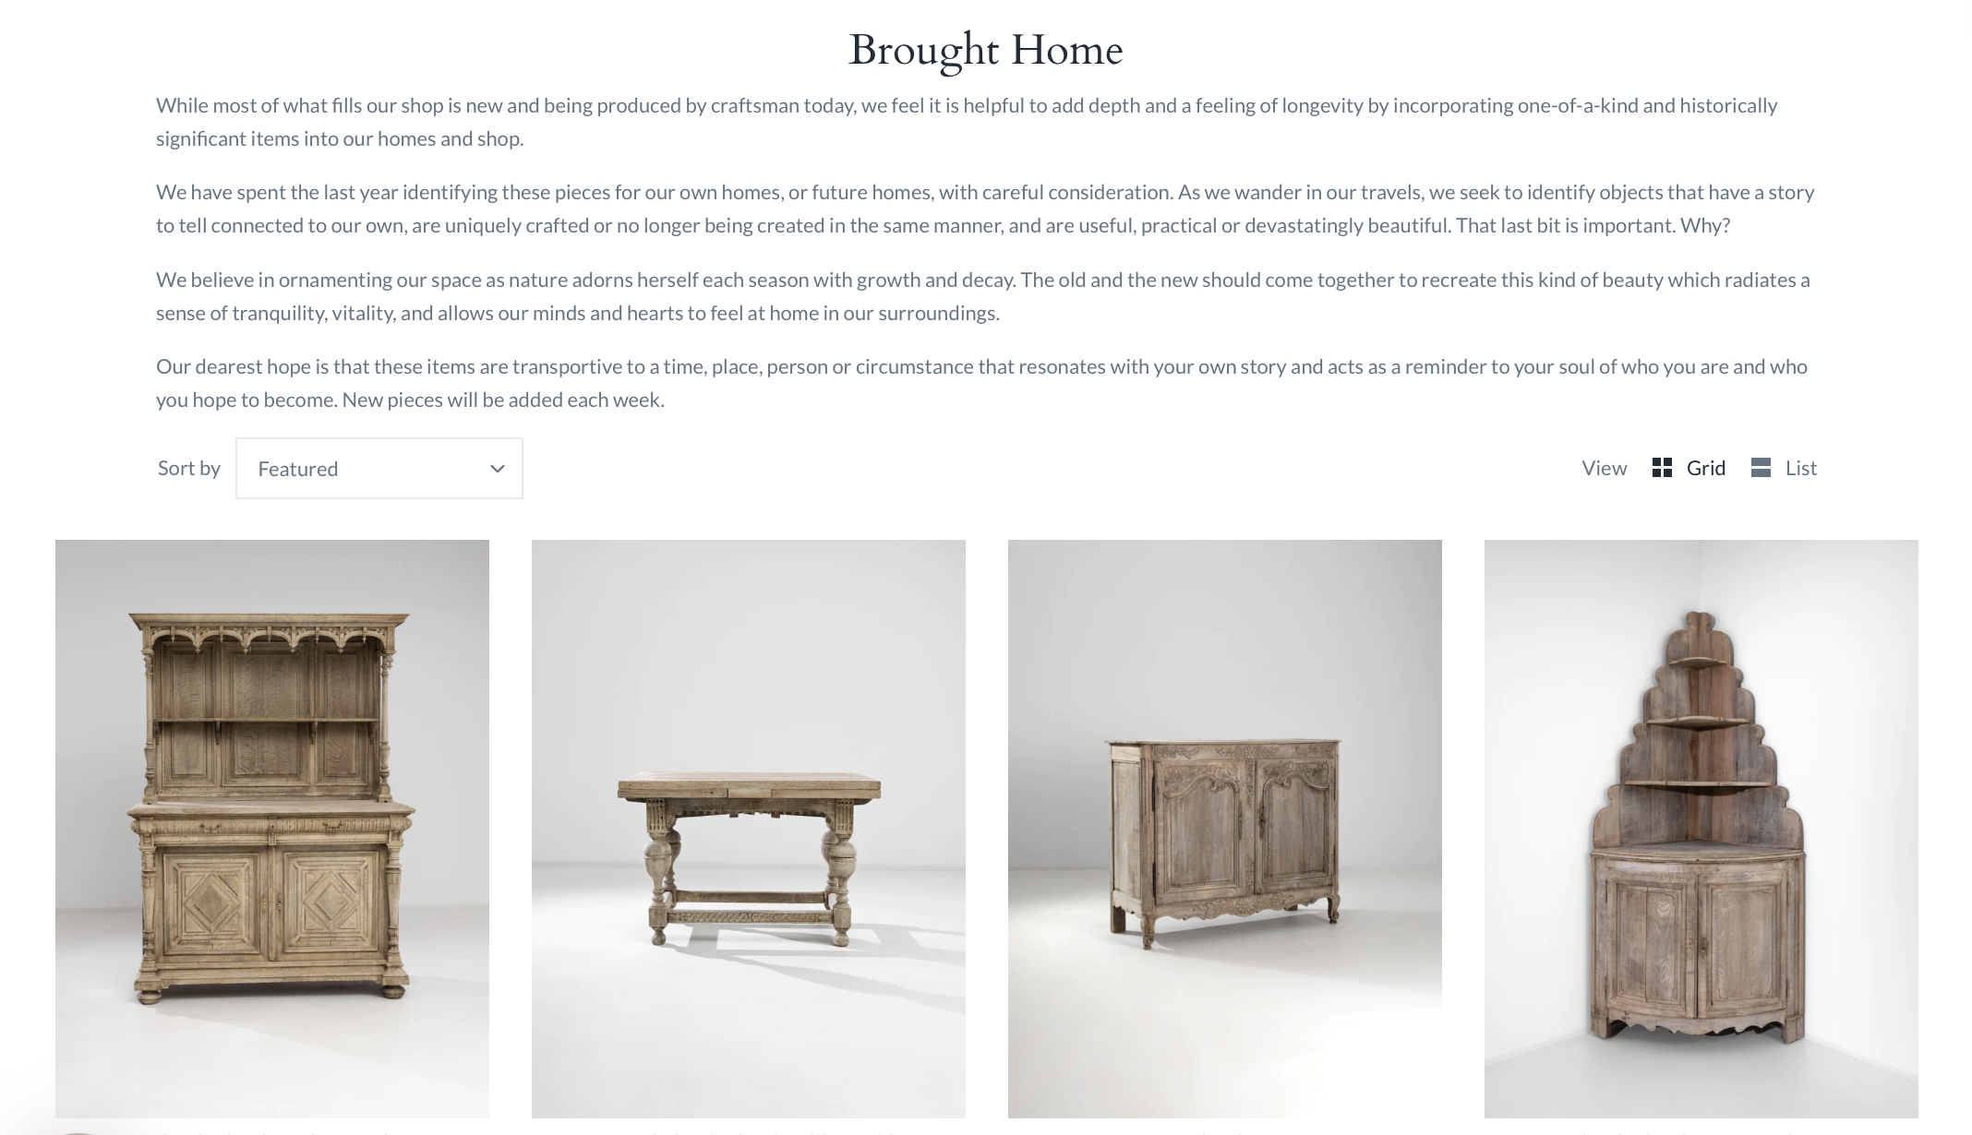

Example of social media marketing efforts and the results of years working to build an audience. Metrics like followers (displayed at the top) and likes (displayed on the photos) allows for feedback and review of efforts in almost real time.

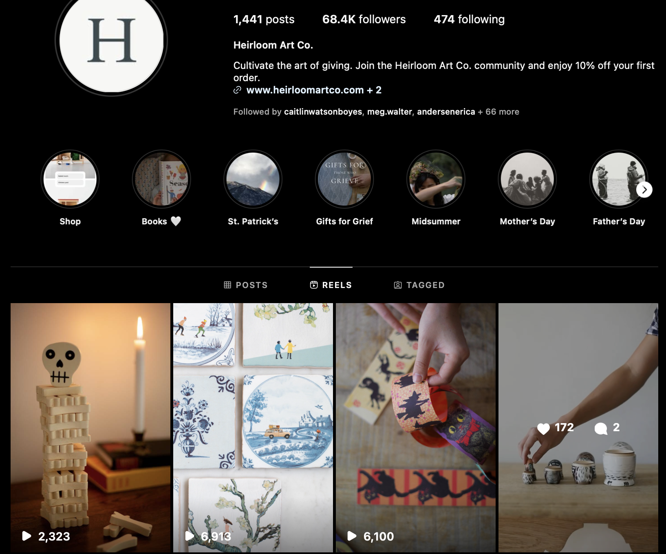

Example of a blog post and comments expressing qualitatively the experiences of customers interaction with a piece of writing not intended to be direct marketing but part of a larger narrative.

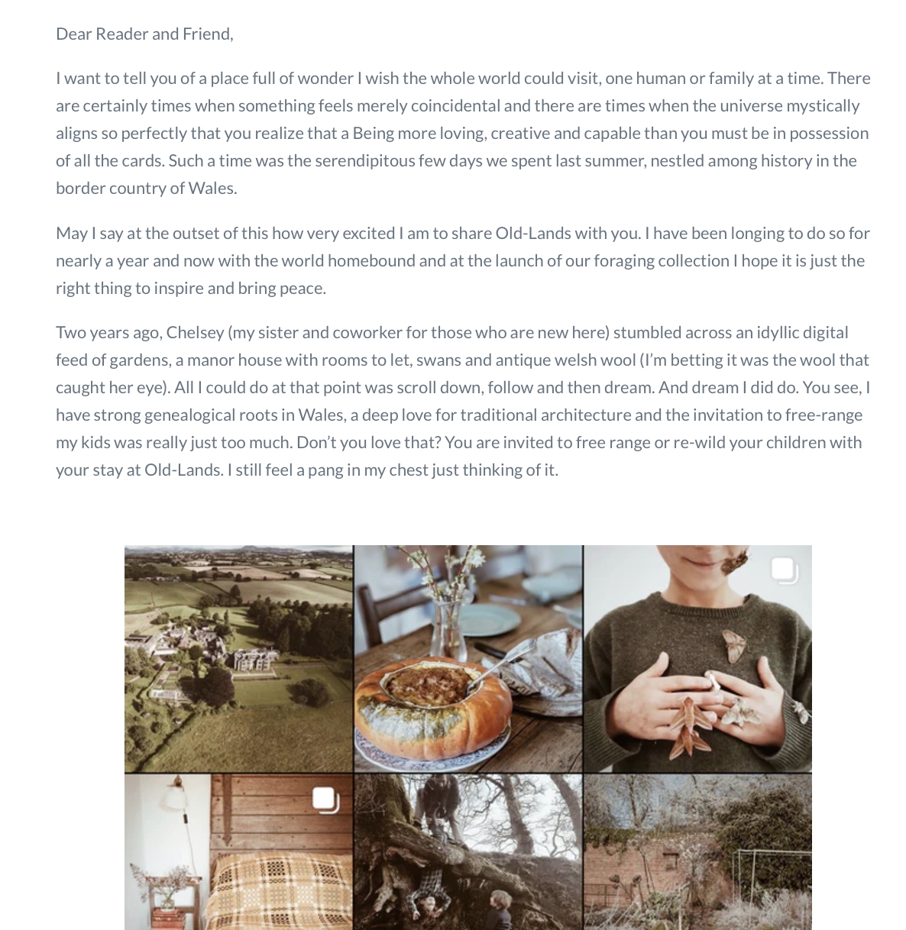

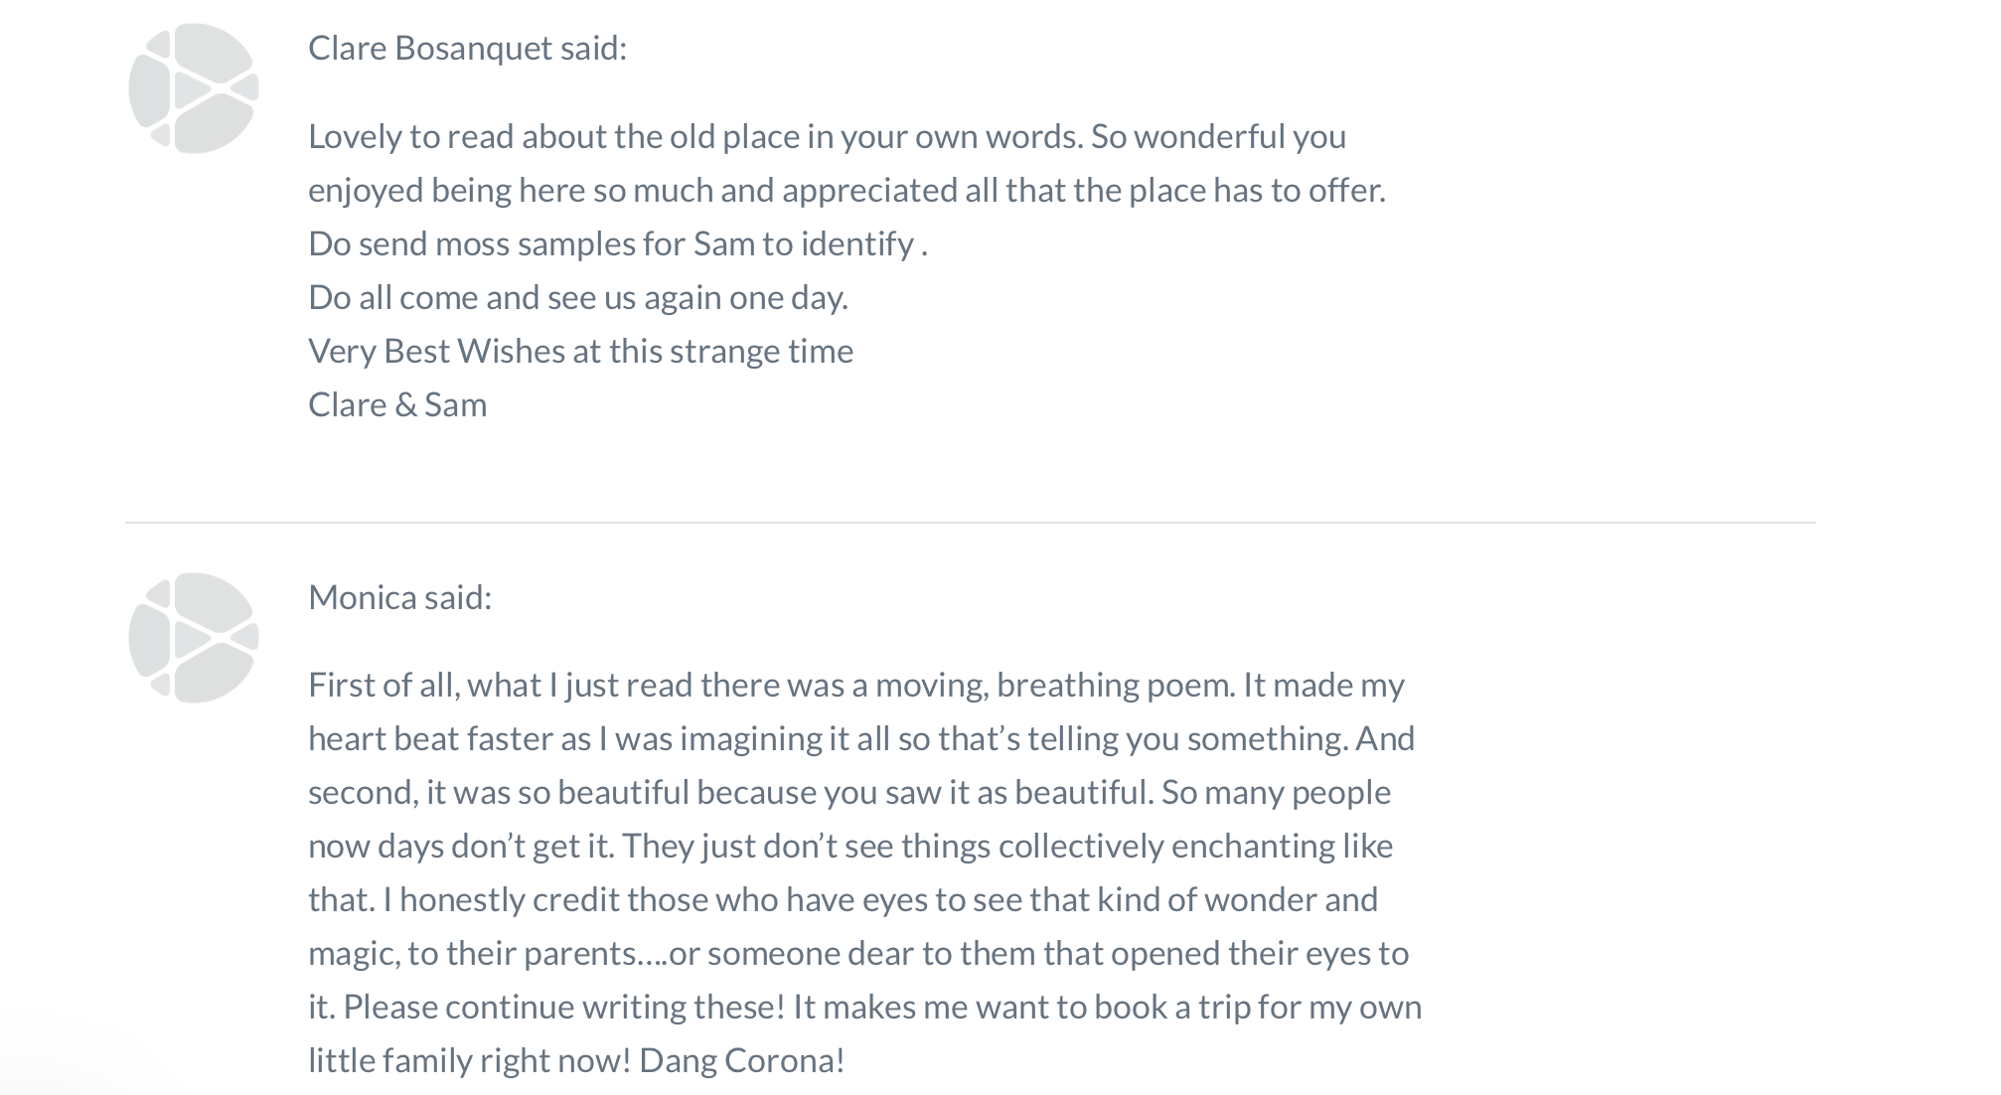

Reference List

Bitner, M.J. (1992) ‘Servicescapes: The impact of physical surroundings on customers and employees’, Journal of Marketing, 56(2), pp. 57–71.
Clark, M.C. and Wilson, A.L. (1991) ‘Context and rationality in Mezirow’s theory of transformational learning’, Adult Education Quarterly, 41(2), pp. 75–91.
Kolb, D.A. (1984) Experiential Learning: Experience as the Source of Learning and Development. Englewood Cliffs, NJ: Prentice-Hall.
Mezirow, J. (1991) Transformative Dimensions of Adult Learning. San Francisco: Jossey-Bass.
Pine, B.J. and Gilmore, J.H. (1999) The Experience Economy: Work Is Theatre & Every Business a Stage. Boston, MA: Harvard Business School Press.
Roberts, A. (2013) ‘Why your planning probably sucks’, in Jones, F. and Dean, M.R. (eds.) Business Millionaire: How to Turn Your Idea Into a Million Dollar Business. Victoria: Source Publishing and Production Group, pp. 59–77.
Schmitt, B. (1999) Experiential Marketing: How to Get Customers to Sense, Feel, Think, Act, Relate. New York: Free Press.
Schön, D.A. (1983) The Reflective Practitioner: How Professionals Think in Action. New York: Basic Books.

