Charmaine Griffiths
Goetre Primary School
Reflective Journal
(2127 words)
Introduction
I work at Goetre Primary School, which is set in the heart of the Gurnos Estate in Merthyr Tydfil. The Gurnos Estate is well-known for being one of the largest council estates in Wales, characterised by high levels of unemployment, poverty, and substance misuse compared to more affluent areas.
Currently, there are 469 students in the school. Of these children, 241 are entitled to Free School Meals, and 77 pupils are on the ALN (Additional Learning Needs) register. The school operates with a double-form entry from Nursery to Year 6 and includes two LRB (Learning Resource Base) classes. Additionally, we have introduced an Early Years Nurture class to address the complex needs of children entering Nursery and Reception in recent years.
Historically, the school was divided into a junior and an infant school, joined in the middle by the kitchen. This layout means we are fortunate to have two halls, which can be used for PE by each phase group. Each year group is scheduled for a morning or afternoon slot in the hall once a week for PE sessions.
I currently teach a Reception class of 26 pupils. Within this class, 70% of pupils are entitled to Free School Meals, two pupils are EAL (English as an Additional Language), and four pupils have IDPs (Individual Development Plans) and are on our ALN register. Two of these pupils have begun to access our new Early Years Nurture Class, which has been running since March. They attend this class for half of the day due to their profound needs. In my class, there is myself and one teaching assistant (TA).
Reflecting on the physical activities and PE sessions in the school prior to undertaking SKIP training, it is my opinion that the junior end of the school has historically had stronger PE sessions. There are multiple male TAs in the junior end who are highly involved in sports and clubs in the community. They bring their expertise and enthusiasm into the school, running after-school clubs and taking PE sessions for junior pupils. This academic year, the football after-school club has also been extended to Year 1 and 2 pupils and is run by two male TAs who work in the junior part of the school. Observing some of these sessions, I have seen that these staff members are highly trained and skilled in delivering such sessions.
In the Foundation Learning part of the school, all staff are female, and I feel there is a high number of staff who feel less confident in delivering PE sessions. When I joined Goetre five years ago in Reception, the arrangements were such that teachers did not teach PE. During the PE slots, the teacher stayed in the class with half of the children to teach PSE (Personal and Social Education), while the TA took the other half to the hall for PE. The groups would then swap. It was not unusual to hear TAs exclaiming that they did not like doing PE. Unfortunately, although I have always enjoyed sports throughout my life, at that time, I accepted the way in which PE sessions were run in the Early Years and did not deliver PE sessions myself until this year when I started the SKIP training.

Day 1 Reflection
After the first SKIP training session, I returned to school and made changes to our timetable so that I could deliver PE sessions, using my new knowledge and bank of games and ideas. I also spoke to the second Reception class teacher, with whom I work closely, and arranged for me to take her class for PE sessions weekly while she took my class for Forest School sessions (for which she recently completed training). It made sense for us both to work to our strengths and expertise. Prior to receiving SKIP training, PE was unfortunately a part of the weekly schedule that could, at times, get cancelled due to other commitments or work. Since receiving SKIP training and regaining my love and confidence for PE, I can now proudly say that we have not missed a single PE session.
I began by carrying out a baseline assessment of the children in my class (this will be discussed later). The baseline allowed me to group the children by ability according to their catching skills. My fellow SKIP colleagues and I then spent time ordering quality resources that would allow us to cater to and challenge all the different abilities within Foundation Learning. This would allow for appropriate constraints within PE lessons to help children move on to the next stage of development. Constraints you would see in our PE lessons are Task Constraints, which are external in relation to the body and include the rules or structure of a particular activity (Haywood and Getchell, 2019.) For example, in a catching lesson, the size of the ball may be altered, the distance between the children may be altered, or the children may be asked to roll the balls to one another depending on their ability/ catching stage.
Once the resources arrived and the baseline assessment was complete, I was able to begin my first SKIP session. To ensure the quality of the sessions, I split my class into two groups, meaning each group of 13 children gets a 45-minute session. The structure of my sessions is as follows: warm-up, skill demonstration, splitting the children into two "gardens" where in Garden One they work on the skill with me, and in Garden Two, they complete an obstacle course independently. We then rotate. Working with just five or six children in a garden at a time enables me to closely monitor, support, and adjust constraints during the sessions. By structuring my PE sessions in this way I am able to ensure that the children are encountering and practising their fundamental motor skills, this is essential as these skills do not occur by chance, they have to be instructed and practised (Goodway, Crowe and Ward, 2003.)
During one of my first catching sessions, I noticed that there were a lot of balls being dropped and shooting around the room. I stopped the children and modelled how to do a 'rainbow' throw to a partner. This created some more success in the children’s catching, but some children were still not catching successfully. I then adjusted the constraints and saw much more success. I gave some of my level 1 catchers scarves or a large ball to roll across the floor. For my level 2 and 3 catchers, I provided larger balls or objects such as giant dice and teddies. I instantly saw a lot more success in the children’s catching. For those who were proficient catchers, I moved their spots further apart and later challenged them to catch small balls.
SKIP training helped me to understand the importance of movement concepts and locomotor skills, developing basic competence in these skills is essential when engaging in meaningful physical activity and moving effectively in different sports (Goodman, Ozmun and Gallahue, 2019.) When planning my warm-up games, I now ensure that I challenge children to move in different directions, at different levels, and at different speeds. I encourage children to gallop, run, hop, skip and jump to develop these skills. Within the obstacle courses I set for children, I also ensure that these require them to move in different ways and develop their balancing skills in various ways. It has been particularly rewarding to see one child’s balance and confidence improve since the autumn term. Initially, she would not feel confident enough to balance across a wooden plank raised just an inch from the floor.
With an increased knowledge of the importance of developing children’s balance, a SKIP colleague and I approached our headteacher about investing money in our yard facilities. At that time, there was no fixed equipment in the yard. Our headteacher agreed that there was a need to improve the quality of physical activity available to the children during play times and arranged for us to meet with a representative from AD Play Wales to design an outdoor trail that would develop the children’s integral skills.
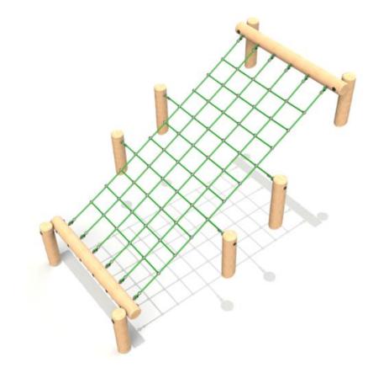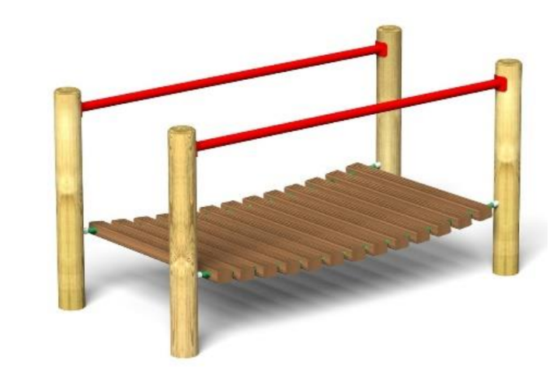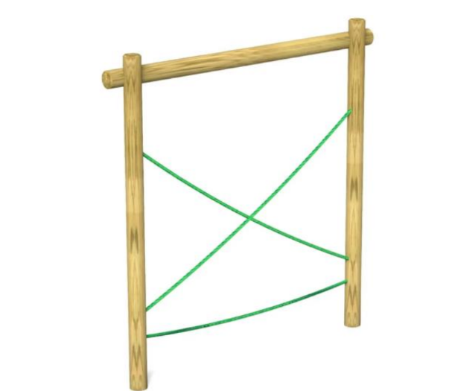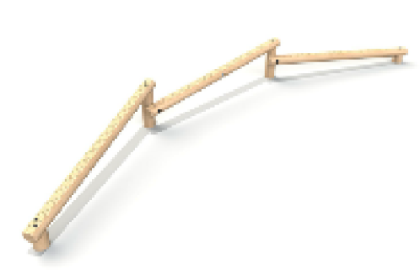

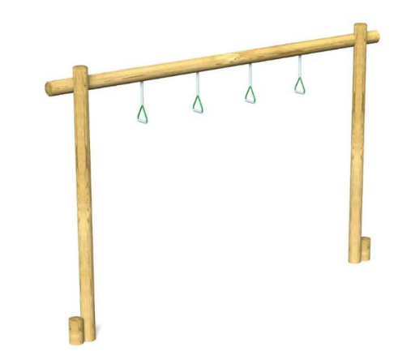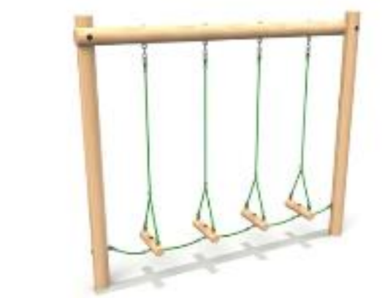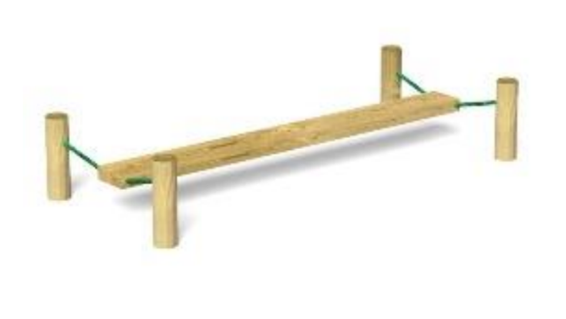

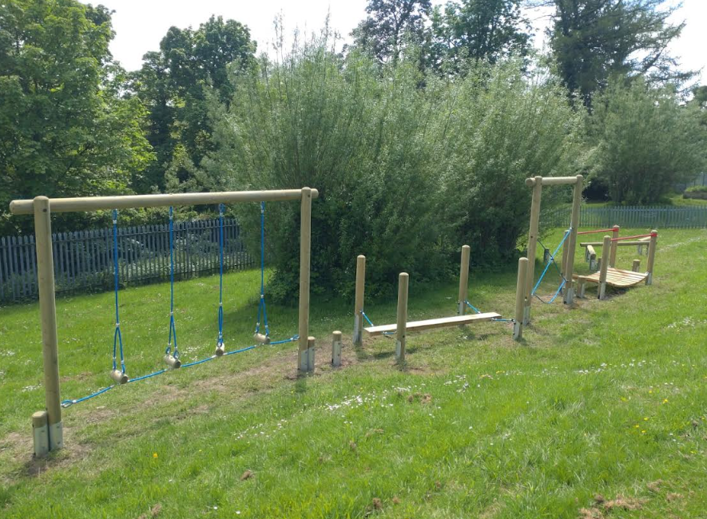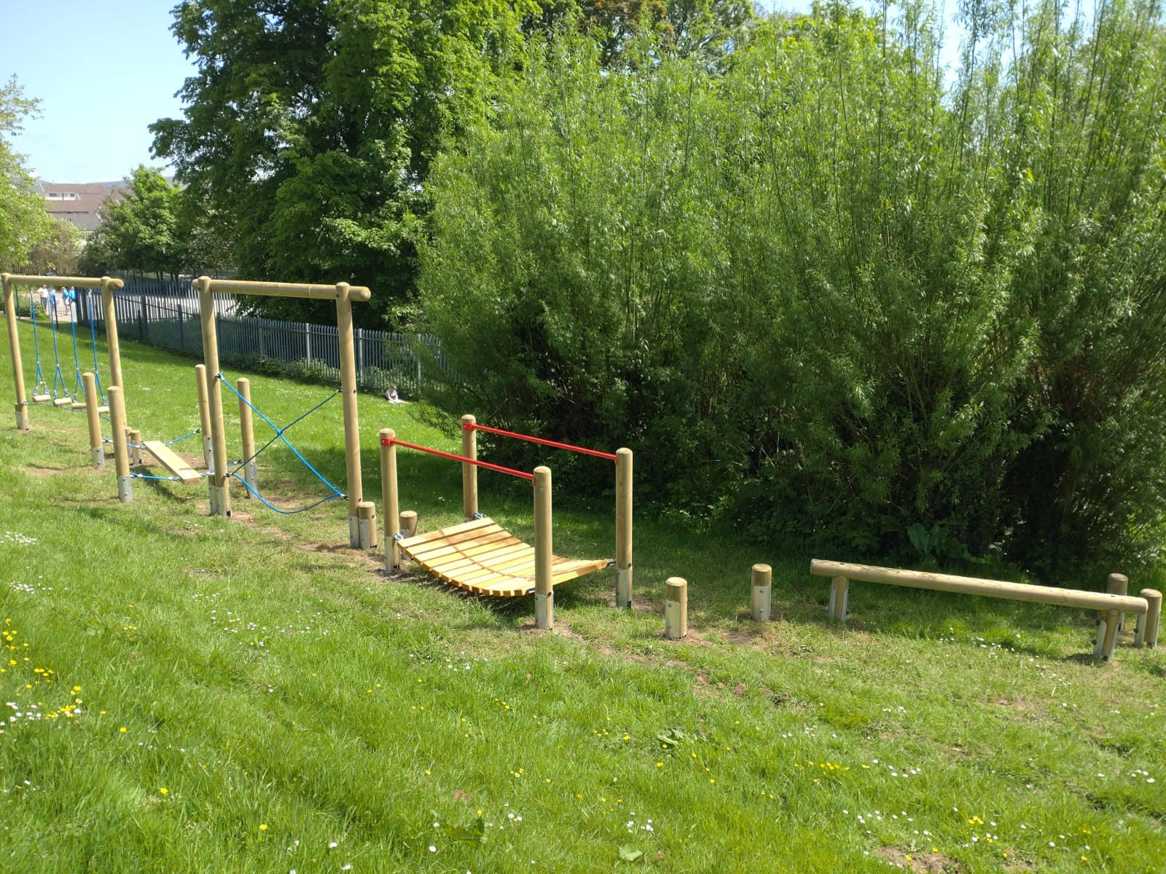
Here is the plan for the trail, and the two images show the trail almost complete. We are eager to begin using the equipment and offer children more opportunities to develop their balance, strength, and locomotor skills. The plan includes a climbing net to encourage children to climb using opposite arms and legs, which we learned is an important part of brain development. In 2003, Davies wrote about ,’The body in action,’ and in particular, ‘body action,’ skills. Our trail is designed to encourage the development of many of these skills, for example; Travelling- stepping, climbing, balancing. Weight taking and transference; swinging (many of our trail items require this in some form) . Flight; jumping and leaping.

Day 2 Reflection
Following day two of SKIP training, I returned to school and began teaching throwing within my teacher-led garden in PE sessions. For the first three weeks, I focused on the children’s underarm throw. We used beanbags and large 'snowball' balls for throwing, and I usually gave them a large target, such as a group of crates, to aim into. I found that creating a storyline to accompany our throwing game engaged the children more, and I often linked the task to our topic in some way. I quickly realised that children were either not stepping at all when throwing or stepping with the same leg. To encourage them to step, I gave each child a spot to stand on and told them they needed to step off the spot with their opposite foot as they threw. This approach worked in getting all the children to step, but not all were stepping contralaterally. For our next session, I had stickers on hand to support the children in stepping with the correct foot. After observing which hand the children comfortably threw with, I then stuck stickers on the foot I wanted them to step with. By the end of the session, every child was able to step with the correct foot. After a couple of weeks, about half of the children were independently throwing and stepping with their contralateral foot. The other half still needed some support to recognize which foot to step with, as they were naturally stepping with the same foot as their throwing arm. As the children developed, I increased the distance from the target and reduced the target size.
After spending three weeks on the underarm throw and contralateral stepping, I moved on to the overarm throw. The practice in stepping meant I could focus on the overarm technique with the children. I modelled a proficient throw and, in groups of six, supported the children in developing their overarm throw. Among the groups, I had a few proficient throwers whom I challenged by increasing their distance to the target and making the target smaller. I also placed hoops on the wall of the hall and encouraged them to hear their beanbags hit the wall, promoting a forceful throw. Many children were at stage one and two of throwing (chop/slingshot), and I found that holding up a high target helped encourage the correct release point.

Baseline Test and Post-Test Data
Below are the children’s baseline and post-test results. Since the baseline assessments, the children have been receiving one 45-minute PE session a week, along with daily opportunities to develop their ball skills, balancing, and locomotor skills within continuous provision on the classroom patio areas. Daily obstacle courses are set up in our patio area using tires, spots, large wooden blocks and planks, stepping stones, hoops. The results have shown significant improvement for almost all of the children involved. This data has given us the information we need to champion the SKIP approach in school and show SLT that two 45 minute sessions a week are effective in improving children’s fundamental skills.

Name | DOB | Balance R |  | Balance L |  | Standing jump (cm) |  | Stage of catching
 |  | Nov 23 | April 24 | Nov 23 | April 24 | Nov 23 | April 24 | Nov 23 | April 24
Hunter | Aug 19 | 2.2 | 7.3 | 3.2 | 8.1 | 81 | 86 | 2 | 3
Parker | June 19 | 1.6 | 4.5 | 1.8 | 5.6 | 78 | 83 | 3 | 4
Violet | April 19 | 6.5 | 10.3 | 2.7 | 12.4 | 54 | 79 | 3 | 3
Amari | Aug 19 | 2.6 | 6.1 | 3.1 | 4.2 | 40 | 66 | 2 | 3
Henson | June 19 | 2.7 | 5.8 | 3.8 | 9.2 | 38 | 41 | 2 | 3
Indie | Aug 19 | 24 | 30 (we stopped at 30.) | 16.7 | 30 | 50 | 82 | 4 | 4
Willow | Sept 18 | 2.1 | 6.5 | 1.8 | 7.4 | 70 | 79 | 2 | 3
Jenson M | July 19 | 1.2 | 4.3 | 1.4 | 3.2 | 49 | 64 | 4 | 4
Layla | July 19 | 4.8 | 8.3 | 2.8 | 9.2 | 40 | 42 | 2 | 3
Ella | May 19 | 8.8 | 25.4 | 20 | 26.7 | 47 | 53 | 2 | 3
Faith | Feb 19 | 11.2 | 15.2 | 6.5 | 10.3 | 21 | 45 | 1 | 3
Evie | Sep 18 | 21.6 | 30 | 30.2 | 30 | 82 | 88 | 3 | 4
Everly | March 19 | 6.4 | 26.1 | 21.4 | 30 | 57 | 87 | 4 | 4
Skyla | Nov 18 | 5.4 | 22.3 | 14.7 | 21.2 | 54 | 65 | 1 | 3
Archie | March 19 | 8.8 | 22.3 | 9.9 | 16.4 | 94 | 97 | 1 | 4

Next Steps:
At Goetre Primary, we are dedicated to deepening our understanding of child development. Physical development will remain a crucial aspect of our daily activities and will be incorporated into our monitoring cycle next year. We have established clear criteria for what constitutes a 'good' PE session, ensuring that every session provides children with the opportunity to develop their fundamental motor skills: stability/balance, locomotor abilities, and object control which are the building blocks to more advanced movement skills as they develop (Goodway, Crowe, Ward, 2003.) Goodway, Crowe and Ward (2003) found that children who received two 35 minute sessions a week over nine weeks improved significantly in relation to their locomotor and object control skills, therefore, we are now striving to ensure children receive two 45 minute sessions a week of quality PE/ movement activities.

WORD COUNT- 2123 words

Reference List:
Reference list (reading on the moodle page)

Davies, M. (2003). Movement and dance in early childhood. Sage.
Goodway, J. D., Ozmun, J. C., &amp; Gallahue, D. L. (2019). Understanding motor development: Infants,
children, adolescents, adults. Jones &amp; Bartlett Learning..
Goodway, J.D. &amp; Branta, C.F. (2003). ‘Influence of a motor skill intervention on fundamental motor
skill development of disadvantaged preschool children’, Research Quarterly for Exercise and
Sport, 74(1), 36-46.
Goodway, J.D., Crowe, H. &amp; Ward, P. (2003). ‘Effects of Motor Skill Instruction of Fundamental Motor
Skill Development’, Adapted Physical Activity Quarterly, 20(3), pp. 298-314.
Haywood, K. M., &amp; Getchell, N. (2019). Life span motor development. Human kinetics.

